Using REST API in IOS

Lab Assignment 2

PG #10

SG #14

By:

Sarika Bommavaram (10)

Gouri Priya Vangavargu (45)

**1. REST APIs used:**

Open Weather API: This API is used to detect current weather conditions of a particular city. The URL is given below.

<http://api.openweathermap.org/data/2.5/weather?q=Kansas>

Library for speech to text: We have used Dragon library for speech to text conversion. With this library if a person wants to know the weather conditions he can directly speak without typing.

2. Project Relevance of the API used:

Our project robo assist, we use this weather api and dragon library to assist a person to know the current weather conditions. The other subgroup used text to speech conversion. We will integrate these two, so that a visually challenged people can know the weather conditions.

3. Screen shots: This screen ask to speak the city for which you want to know the weather.

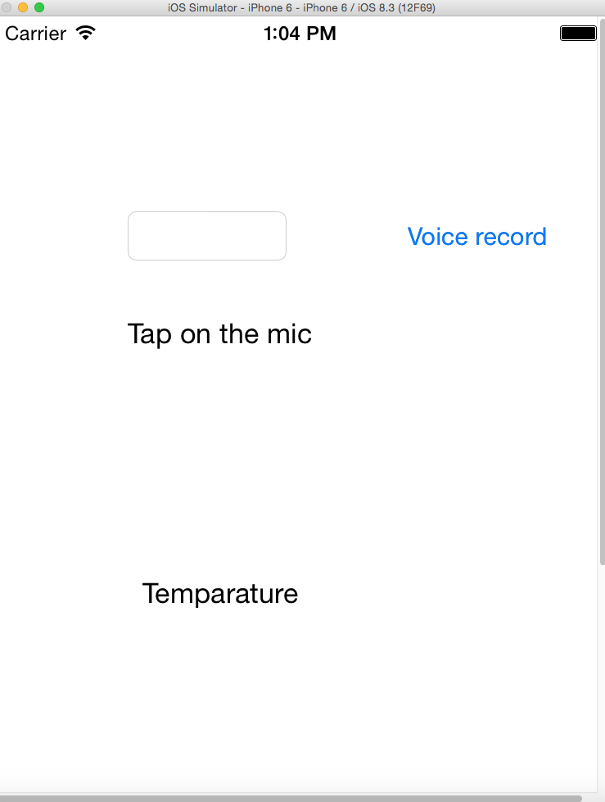

The below screen displays the temperature of city as below

