**ADVANCED SOFTWARE ENGINEERING (CS551)**

FOURTH INCREMENT REPORT



REDUCE RECYCLE REUSE

**Team Members:** Sarika Bommavaram (08)

Gouri Priya Vangavargu (50)

**PROJECT TEAM: PG8**

Sasidhar Malladi (32)

Sankalp Racharla (43)

**1.INTRODUCTION**

Main theme of fourth increment is Project Integration Management. Project Integration Management can be stated as “the processes needed to identify, define, combine, unify, and coordinate the various processes and project management activities within our project management process groups ". This involves in defining services developed by project team members and to combine these services in order to get a full-fledged android application which is usable by an end user.

The report of R3 (Reduce Recycle Reuse) for Increment 4 consists of integration of the application services which we have developed until now. The integration is most crucial stage as we have to manage dependencies of all classes and on produce it as one single application. This consists all the classes that we have used, sequence diagrams, Our REST services that we created by our own and few other REST services that we used from available services, different testing tools that we have used. In this increment we have mainly focused on integrating various services available in the application. We have also added on more extra feature for this increment i.e., in reuse service we can directly take a picture and we can post that thing for sale or we can also donate it.

By this we can propose our application can be used by an end user. It consists of service called as recycle, sorting guide, reuse, and reduce. In Reduce task we are just planning to show some static data that the different ways to reduce the litter. In Recycle task, we have implemented Google maps to show the nearby recycle centers dynamically. The community people can set the notification to notify on the selected date.

We are also proposing pickup service from service provider so that if anyone is not able to recycle the waste he/ she can request for pickup and recycling material will be taken by service provider. Notification is also given and also through messaging service person will be notified trash was picked up or if there is any delay in process.

In Reuse task, we have developed the services such as providing the facility for the donor to post the item that he wants to donate. If he wants to buy an item that he is in need, he will be very happy if he get it for free or for less price. For this purpose we have developed a service which asks user to take a photo of item and post it so that we can show our product if we are selling it.

**2.OBJECTIVES**

The main objective of this Iteration was to complete our project and also with implemented validations. By this our project will be ready to deployment and can be used in any android mobile by installing it. We have tried to work each and individual from front end to back end and we did it successfully. We have created REST services for Reuse and Recycle tasks. In this phase we are combining al our services which we have implemented successfully.

One has to handle Time, Quality, Communications etc., and focus on pulling everything together to reach project success. We have to carry out our project plan by performing activities involved in it. We have to oversee project work and activities involved in it to meet the performance objectives of the project. We have to coordinate changes that affect the project’s deliverables and organizational process assets. We must finalize all the activities to formally close the project. After formal closure of project main outputs must be taken care i.e. final products, services, or results.

**3.IMPORT EXISTING SERVICES/API**

In this phase we have created our REST services for the Login page, for Reuse task. Along with these services we are using some of the API’s like Google maps, text to speech converter etc.

→ **Google Maps API:**

This API is used to get the map to the user to the nearby recycle centers. It provides guidance to the user by providing the directions to the recycle center depending upon his choice of selected recycling centerand we are also using Google Maps for the service provider part. When the service provider gets all the list of collection points, if he click on a particular collection point he will be directed to show the direction to that collection point from his location.

→**Mongolab Rest API**:

This API is used to retrieve details of the schedule appointment. The data is retrieved using JSON parser and displays list view to the service provider.

→**TextToSpeech Converter:**

This API is used to notify the user about any activity. It provides the user with confirmation about the Activity

→**Sign up and Sign in REST service for Reuse task:**

We have created this REST service using C# and Visual studio and deployed the service in remote server. The community people sign up and can sign in if he has already sign up and post the item that he wants to give way.

**Link**:

<http://kcscecs551.kc.umkc.edu/aspnet_client/Group8/SignUp_In/SignUp_In/Service1.svc/checkDetails/sankalp/sarika>

→**REST service to upload items**:

This REST service is developed to enable the community people who wants to donate or sell the items based on a particular category. We even trying to retrieve the uploaded item details to the one who wants to buy from this REST service.

**Link**:<http://kc-sce-cs551.kc.umkc.edu/aspnet_client/Group8/Reuse/Reuse/Service1.svc/queryInfo/gou>

→**REST service for the service provider:**

The REST service is developed for the service provider to Login. Service provider password is already stored in the SQL server, if he enter the correct credentials then only he can login.

**Link**:

<http://kc-sce-cs551.kc.umkc.edu/aspnet_client/Group8/Recycle/Recycle/Service1.svc/queryInfo/45>

**4.DETAIL DESIGN OF SERVICES**

**4.1 SERVICE DESCRIPTION**

We have developed many services like pick up, notification, Reuse, list of Recycle centers etc. In this increment we have worked on the integration of several services. In that we used Google Maps API, if the service provider wants to know the direction to the collection point.

In the Reuse Module, It allows you to reuse the items by donating the items, so called as Giveaway. Firstly, it gives user a screen asking for Signup, if he is a new user and Sign In if he is the existing User. When the User Signup, it asks him the userid that he want to put for his account and Email ID and Password. Validation is done for 3 fields. For the Userid it should be maximum of 8 characters allows any numbers, symbols, characters. The Email ID is authenticated as email validation. And password should be at least of 8 characters with any symbols. When the user clicks on submit button, it passes all the details userid, email and password to SQL server using a REST Service. Then it navigates to Sign In page, where user needs to Sign In with already Set details.

After Sign In it asks the user whether he want to give away any item, if he selects that button then it opens a page where user needs to enter the details of his giveaway item. When user clicks submit, then the details are uploaded to SQL Server using a Remote Service. The other option after Sign In is for normal users if they needs any item to get Giveaway. Where all the items that are available for giveaway, it gives the details of all the Giveaway items with details of person who is giving away the item. Then the user can contact to the person by using his own resource.

Using calendar we have enabled the community people to set the notification in their mobile such that it will remind them when he has to call the service provider for the trash pickup.In our application we have given several services such as Recycle, Reuse, Reduce, sorting guide, pickup.

**4.2 SCRUMDO STORIES**

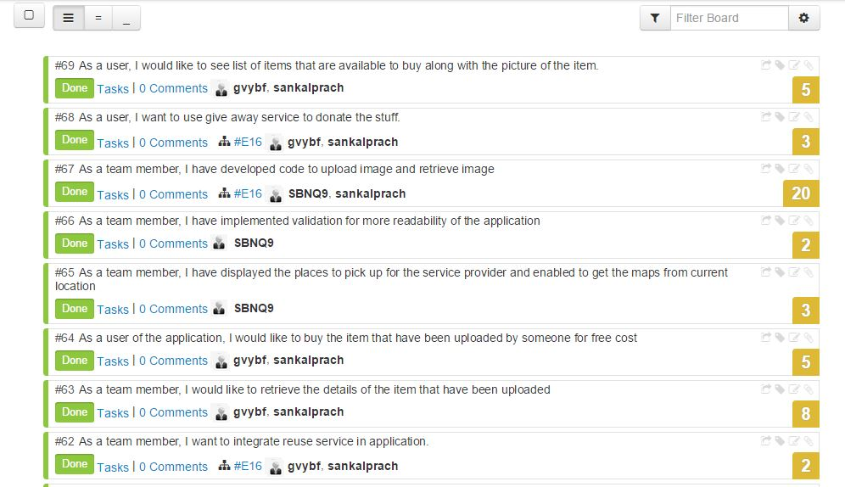

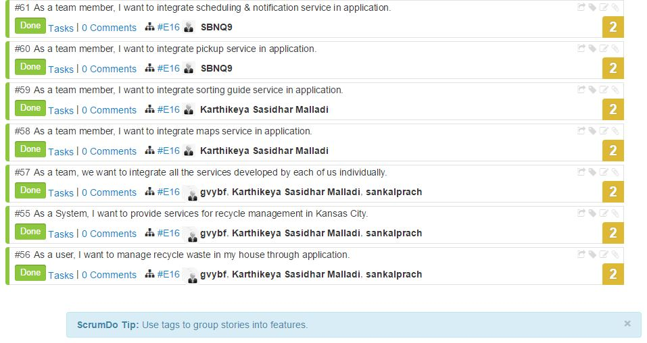

**Story #55:**This story is used to tell about all the services that have been developed in the android application R3: Reduce Recycle Reuse. All the three services are developed to manage Kansas City.

**Story #56:** The application is developed to enable the Kansas City residents to effectively manage the waste in their home. This story is the responsibility of all the team members.

**Story #57:** We have integrated all the services into an Application that we have developed individually.

**Story #58:** This story is about my service that I have integrated my Map services into the whole application.

**Story #59:** The sorting that I have developed individually have been integrated into the whole application.

**Story #60:** I have developed the pickup service individually, I have solved few problems that have identified while integrating into whole project.

**Story #61:** I have integrated the notification service into the application and resolved few problems along with some of the validations.

**Story #62:** We have integrated the Reuse service into the application that we have developed and enabled the service according to user preference.

**Story #63:** The user may want to buy an item that was uploaded by someone, in this we retrieved the data from the SQL server.

**Story #64:** If I am using the application to shop an item, I would prefer to get the list of items before I am going to buy.

**Story #65:** when the service provider clicks on the location that he has to go for pick up, he will be navigated to the maps.

**Story #66:** The validations are done for all the services for the user friendly.

**Story #67:** I have developed the code to upload the item that makes the person who wants to buy it very easy.

**Story #68:** With the help of this android application I can donate stuff easily which I no longer wish to use.

**Story #69:** The image of the item and the list of items that are available can be seen if you want to buy any of the item that have been uploaded.

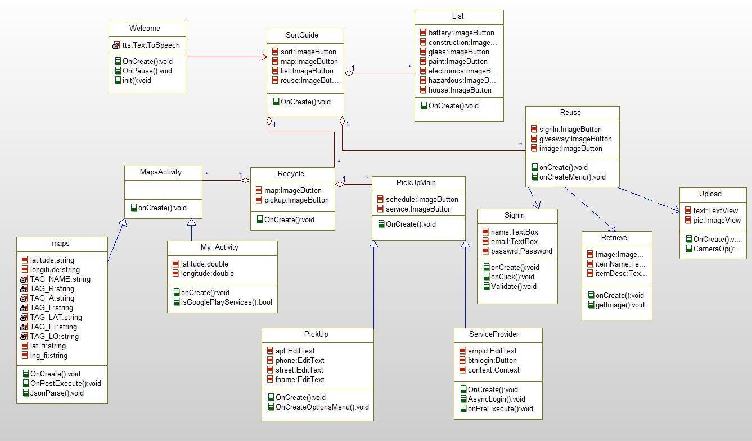**4.3 CLASS/SEQUENCE DIAGRAMS**

**CLASS DIAGRAM FOR R3**

**SEQUENCE DIAGRAM FOR R3**

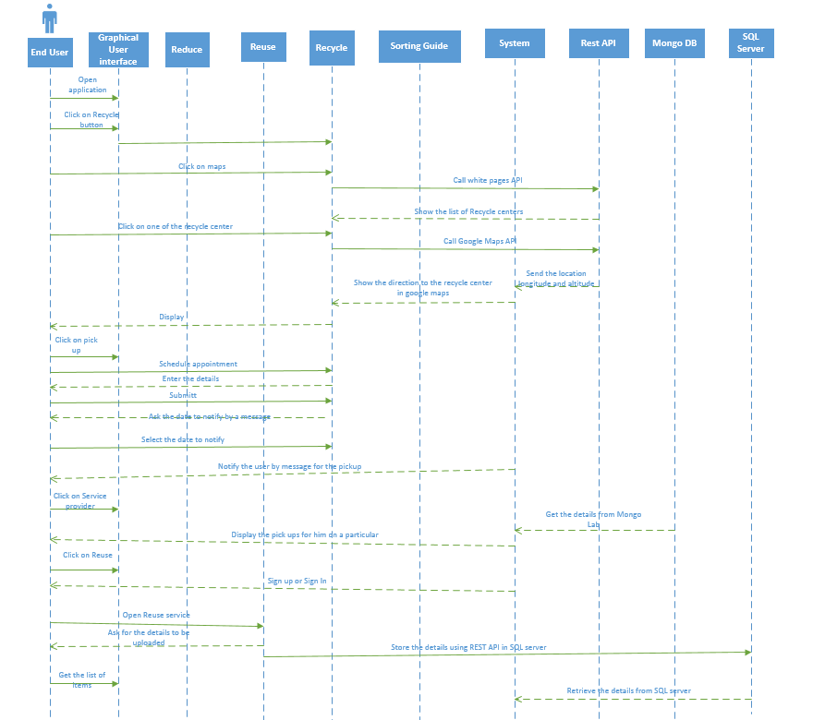

**4.4 DESIGN OF MOBILE CLIENT INTERFACE**

END-USER

Sorting Guide

Service Provider

Reuse

Recycle

Recycling Points

Several Products and ways to recycle

Welcome Screen Sign In or Sign up

Enter Employee ID

Pickup

Page for Service Provider

Sign Up

Sign In

Schedule

Enter Zip Code

Shop

Give Away

Credentials

Select a date

List of recycle points

Mongo DB

Upload

Item

SQL Server

Notification Service

Maps & Directions

**5. IMPLEMENTATION**

**5.1 IMPLEMENTATION OF USER INTERFACE**

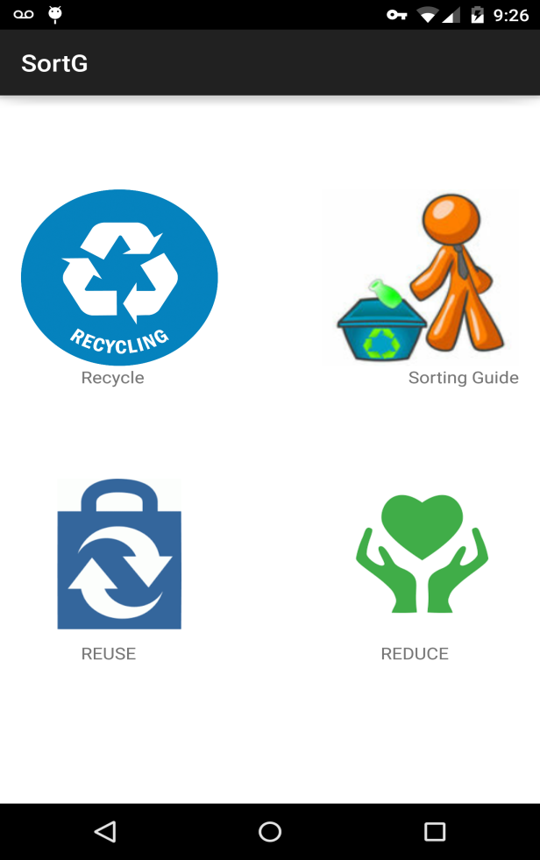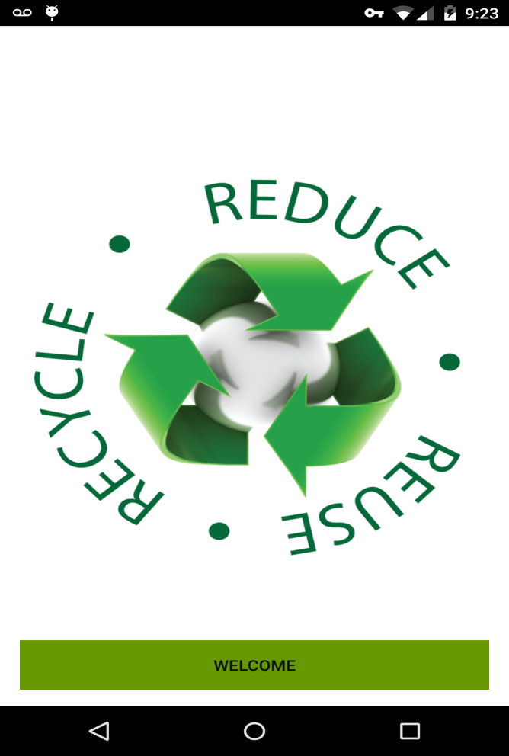 screenshot 1 screenshot 2

When you click on the application this is the first page end user will see and when user clicks on welcome button a voice message will come saying " welcome to recycle world" and it will navigate to the page i.e., shown in screenshot 2 with all the four services.

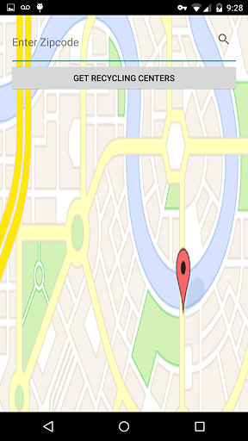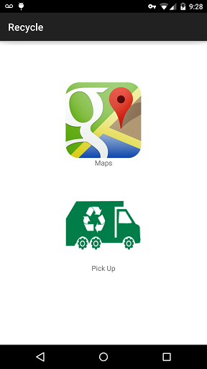

screenshot 3 screenshot 4

Once you click on Recycle button, It will display the screenshot 3 displaying pick up or Maps. If you click on Maps It will ask for the Zip code.

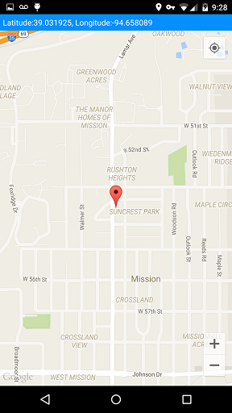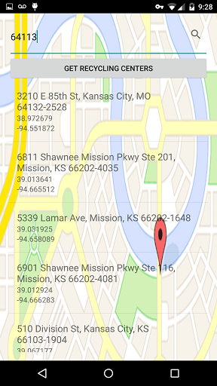

screenshot 5 screenshot 6

After entering Zip code it will display the list of recycle centers that are near to that Zip code and once you click a particular recycle center, It will show the directions to that place.

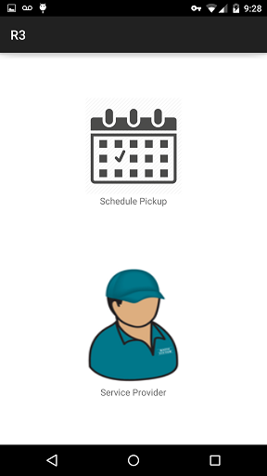

screenshot 7

Once you click on pick up it will display the above screen. If you want to schedule a pick up then you have to click on schedule pick up.

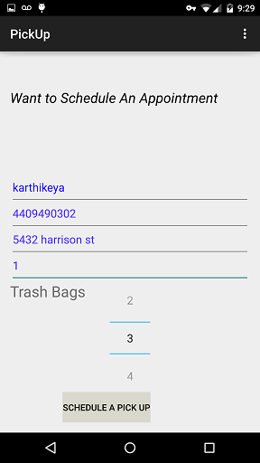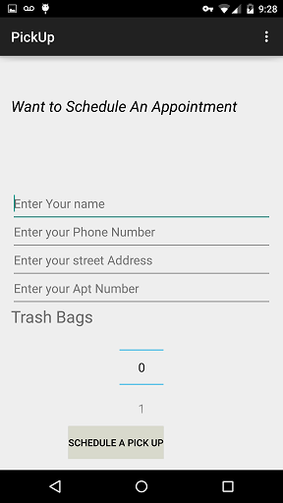

screenshot 8 screenshot 9

It will ask for details once you enter the details click on schedule pickup. It will navigate to screenshot 10.

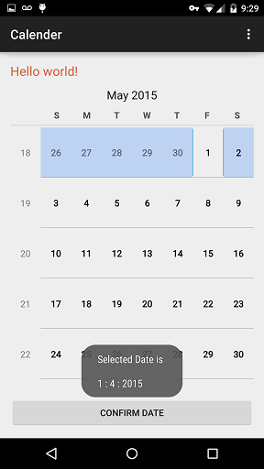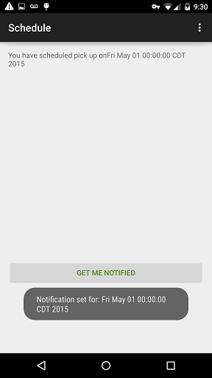

screen shot 10 screen shot 11

Here you have to select the date which you intend to select and click on Confirm date then you will be navigated to the page displaying screen shot 11. and by using get me notified we can send the message and notification to the mobile on that particular date.

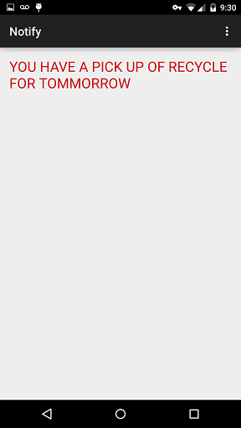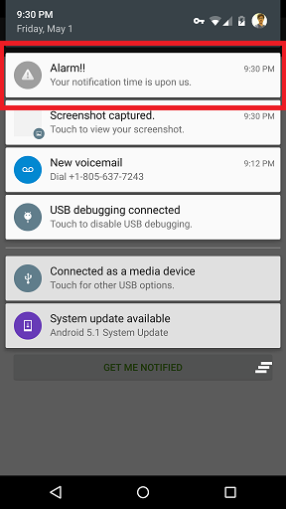

screenshot 12 screenshot 13

The above screen shots shows how the notification will be send to the mobile.

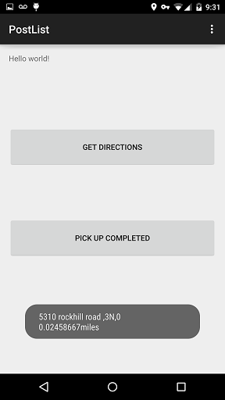

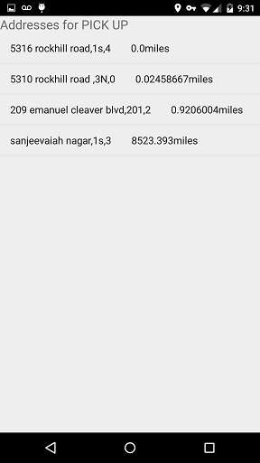

screenshot 14 screenshot 15 screenshot 16

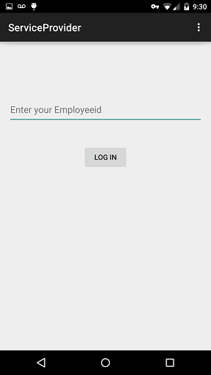

If you click on service provider in screen shot 7. Then it will ask for the employee id. After entering employee ID it will display the list of pickups on that particular day. Once he click on a particular address it will ask for whether to get directions or else to notify the user pickup is completed.

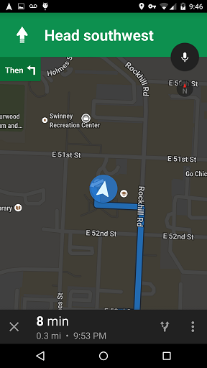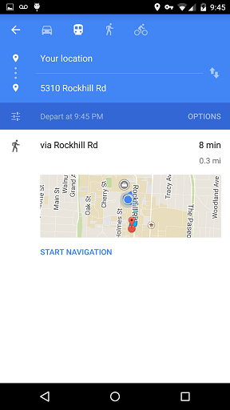

screen shot 17 screen shot 18

Once he click on get directions he will be directed to the pickup location from his current location and also provided with navigation support. If he want navigation it will navigate him to his chosen destination.

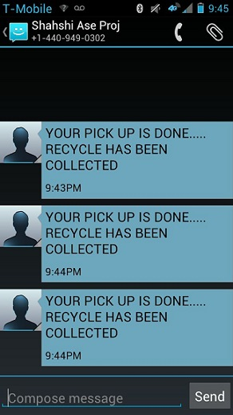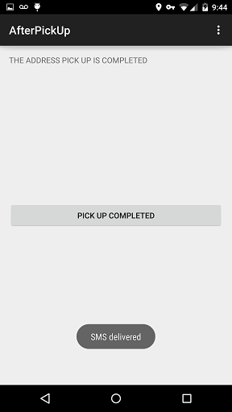

screenshot 19 screenshot 20

If pickup has been completed then the service provider will send a message to user that pickup is completed. After this a message will be delivered to his mobile number which can be seen above.

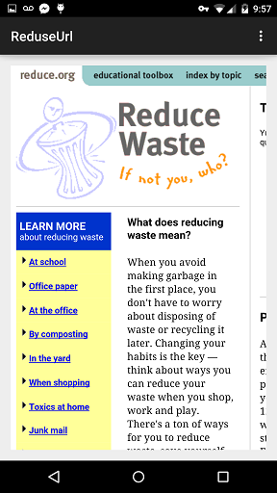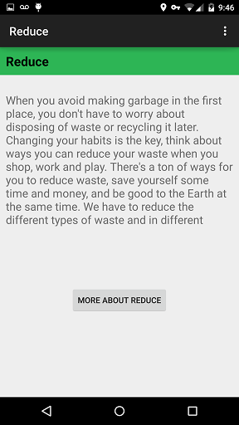

screen shot 21 screen shot 22

This reduce service is to provide extra information for the user to get user friendly environment. If he click on more about reduce he will redirected to the screenshot 22.

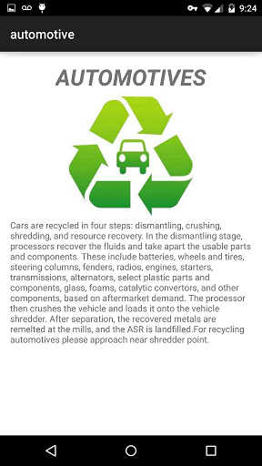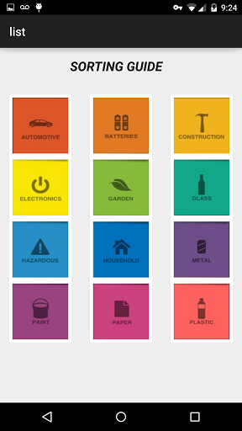

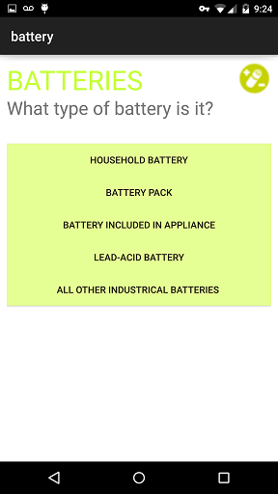

This picture shows us regarding list activity which consist of several image buttons each having specific functionality. User can click on image button to retrieve information according to the problem. Each and every functionality will work as provided in screen shots. All activities are shown below.

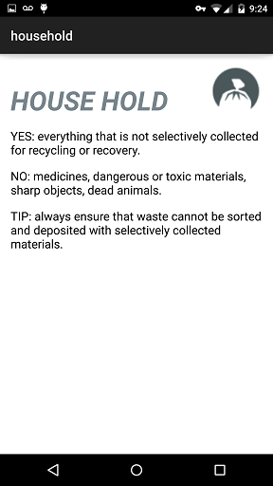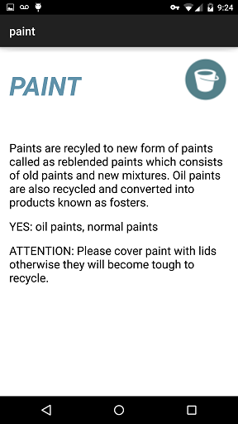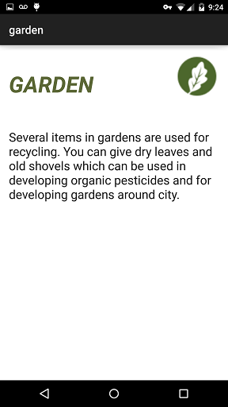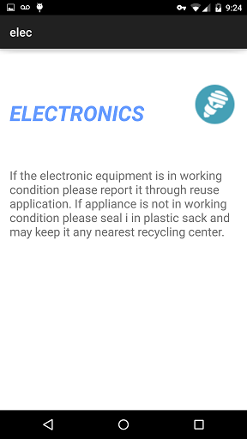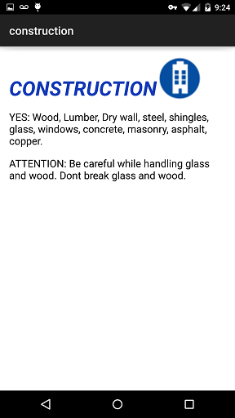 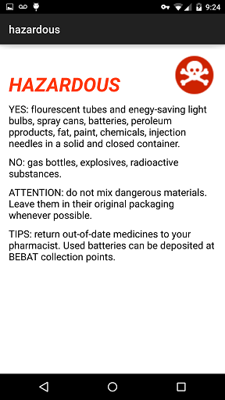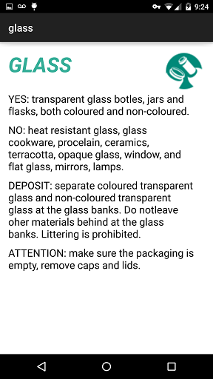

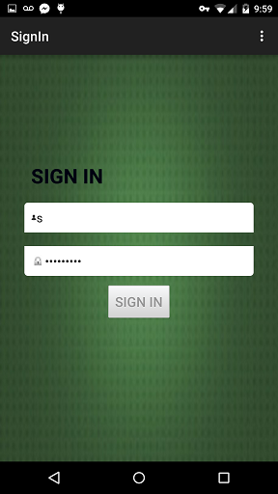

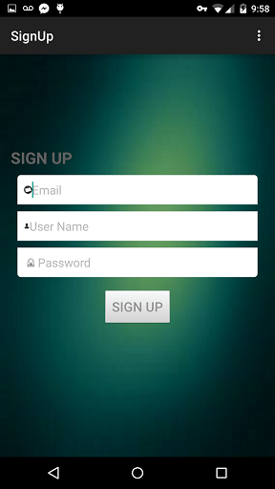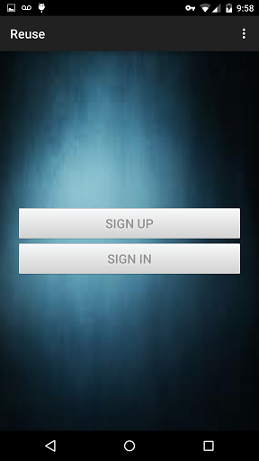

The above three screen shots are for reuse service if he wants to upload item or buy item he has to first sign in by providing credentials .

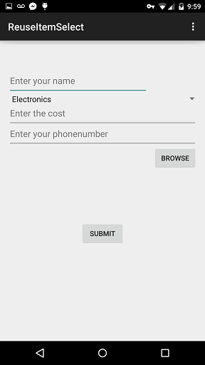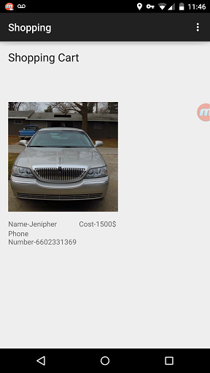

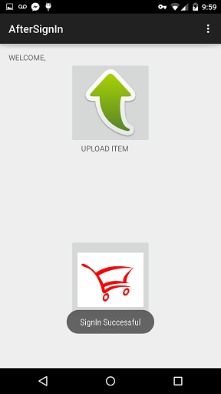

After sign in it will ask whether you want to upload an item or shop an item. If you click on upload an item it will ask to enter the details and select the picture of item and on submit it will store in SQL server. If we click on shop item it will display a list view consisting of several items where user can see the details along with image and contact user on his own by info provided for the product required.

**6. TESTING**

**6.1 Functional Testing using NUnit tool:**

The below screens are testing using NUnit tool for the items to be uploaded and sign up page of the community people.

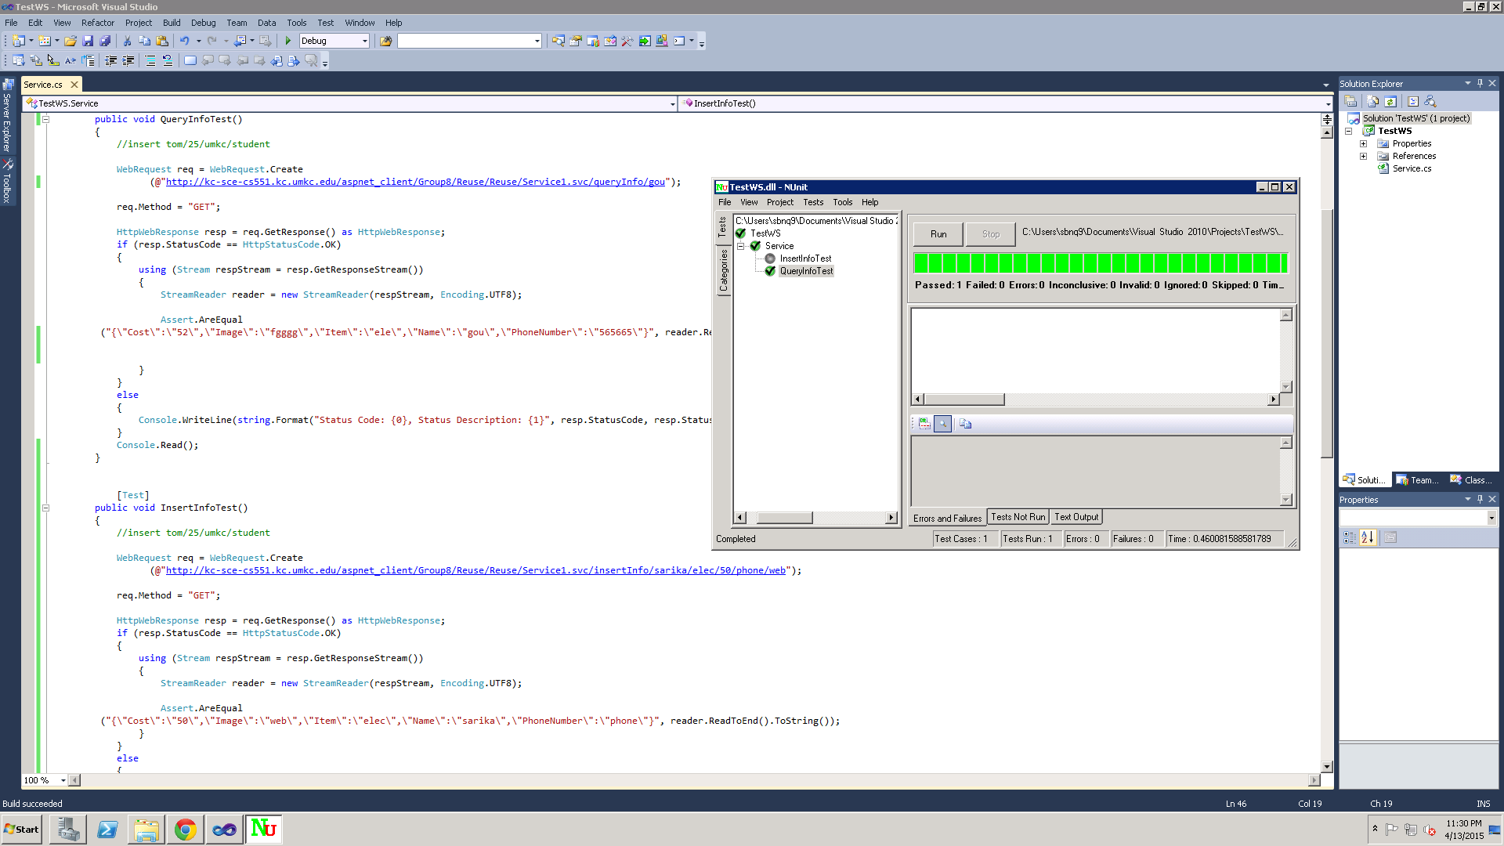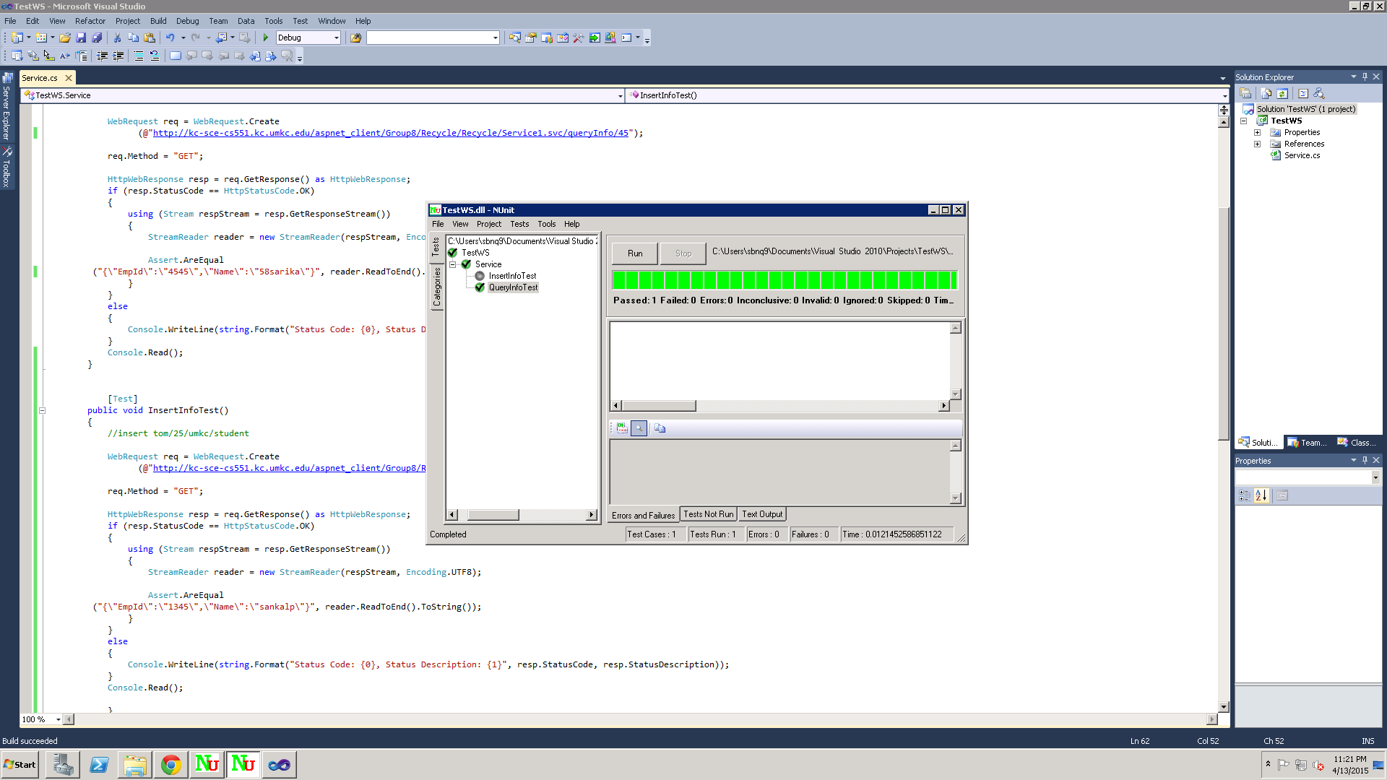

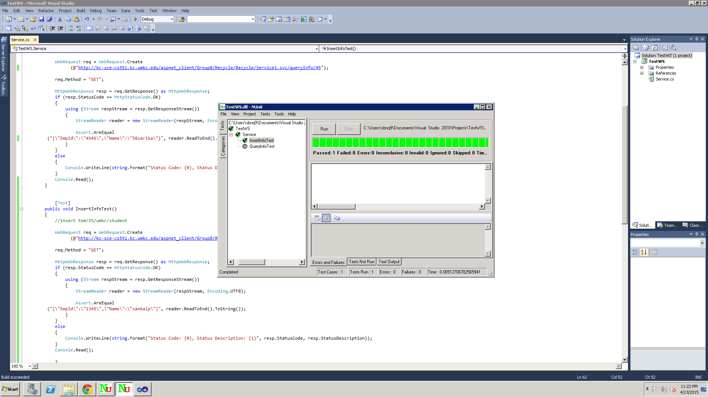The below screen shot is the NUnit testing for the Login page of the service provider.

**Performances Testing:**

We have tested each rest services with using 3 testing tools like load time analyzer which will give the time to process the URL, Firebug and Yslow Analyzer.

**Load Time Analyzer:**

It clearly displays the request and response time in table. For that we have to install load time analyzer add on to the google chrome. And it will show clock symbol in the right corner if we click the clock it will show the load times of the website of the given URL

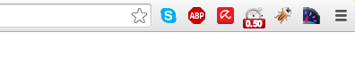

**Firebug:**

This tool is very famous in market as it gives the every single detail about the website of the URL. And we can do our analysis by selecting net bar in the tool so we can find the load time over there.

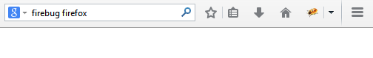

**Yslow Analyzer:**

It can be installed into our google chrome by adding yslow analyzer add-on.After installing it into chrome there will be a symbol indicates its installation, by clicking that we will go the window where we can find our analysis.



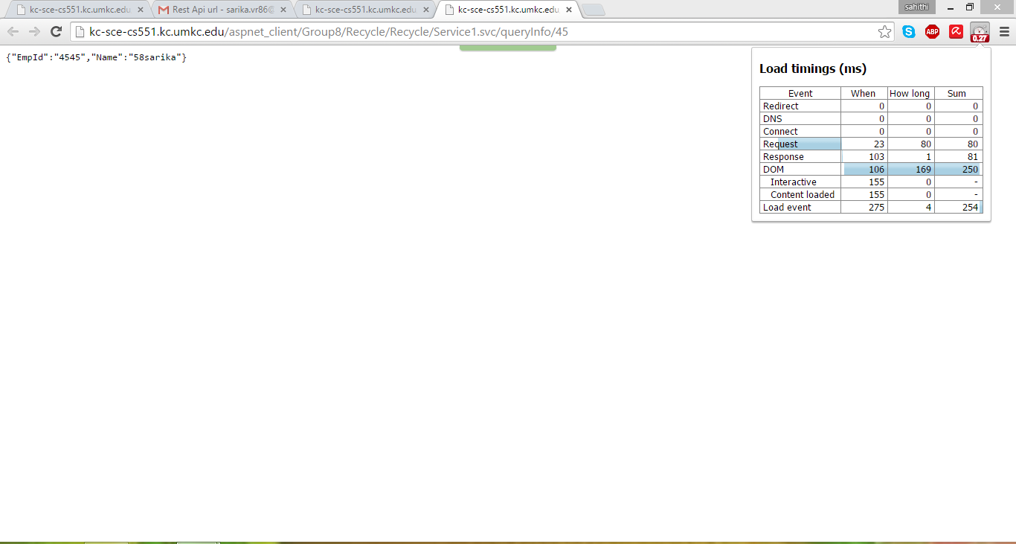For

<http://kc-sce-cs551.kc.umkc.edu/aspnet_client/Group8/Recycle/Recycle/Service1.svc/queryInfo/45>

YSLOW Analyzer:

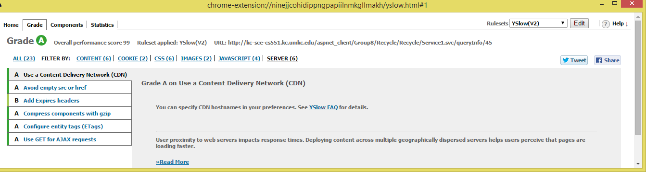

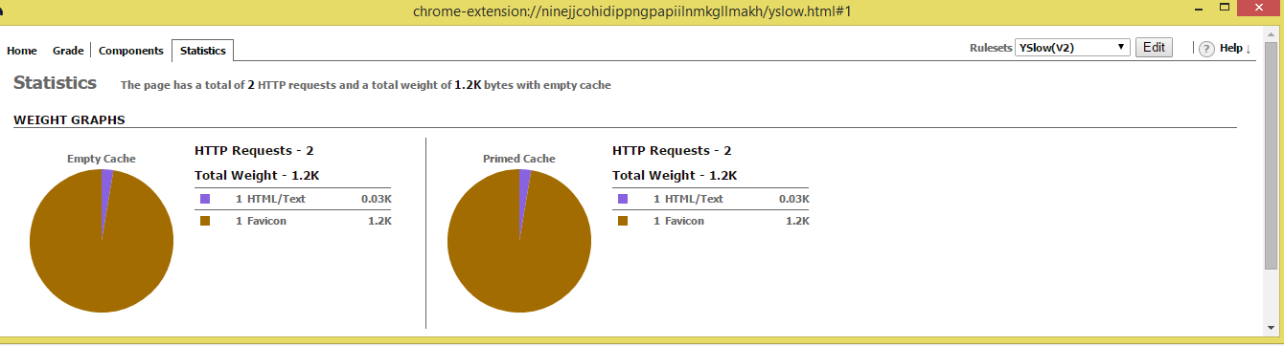

FIREBUG:

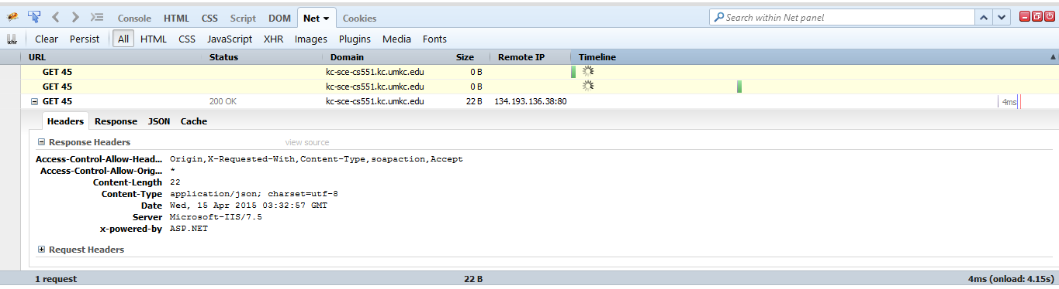

For rest service

<http://kc-sce-cs551.kc.umkc.edu/aspnet_client/Group8/SignUp_In/SignUp_In/Service1.svc/checkDetails/sankalp/sarika>

Load Time Analyzer:

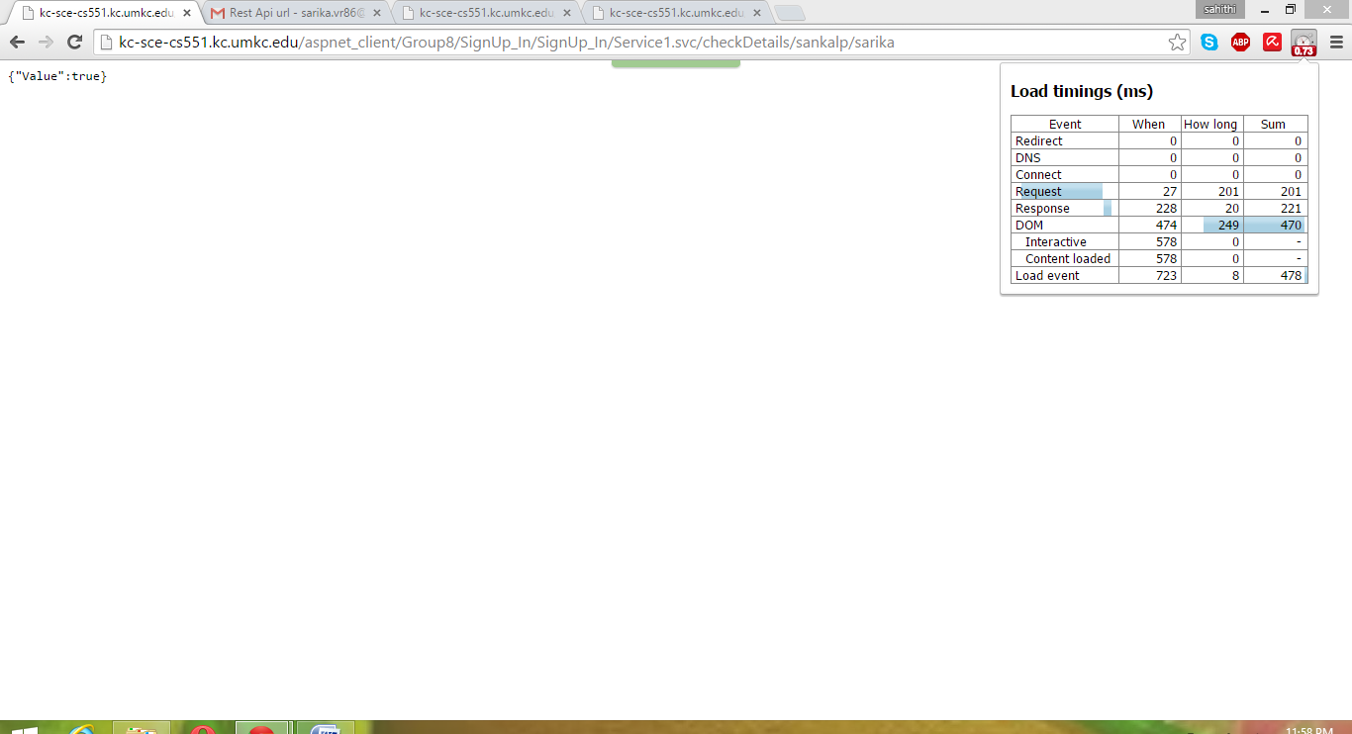

Firebug:

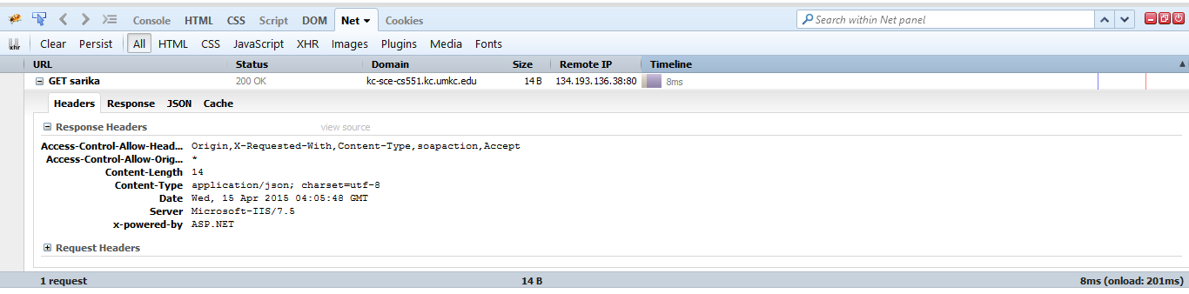

YSLOW Analyzer:

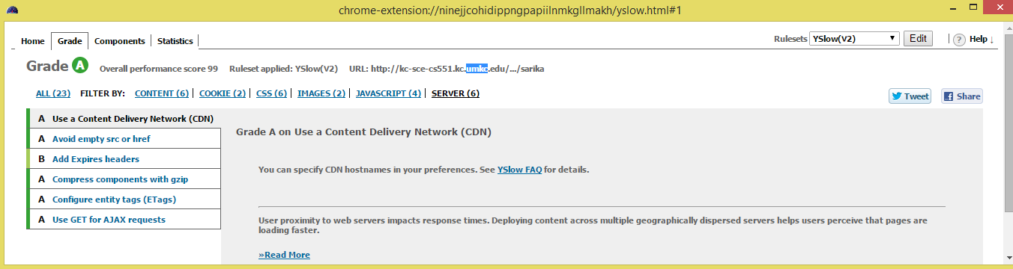

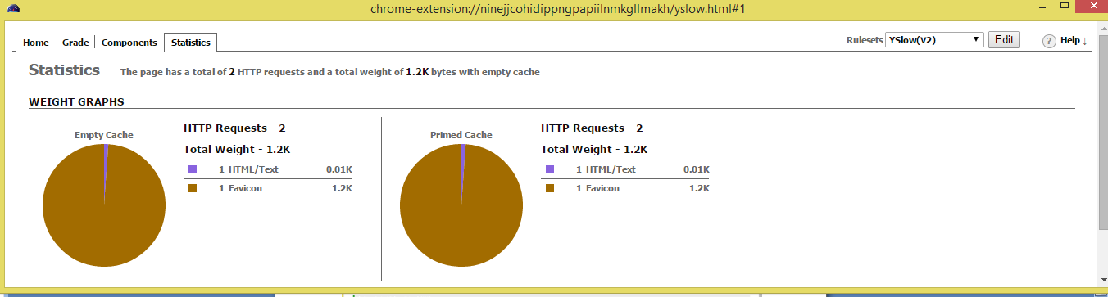

For

<http://kc-sce-cs551.kc.umkc.edu/aspnet_client/Group8/Reuse/Reuse/Service1.svc/queryInfo/gou>

**Using Load Time Analyzer:**

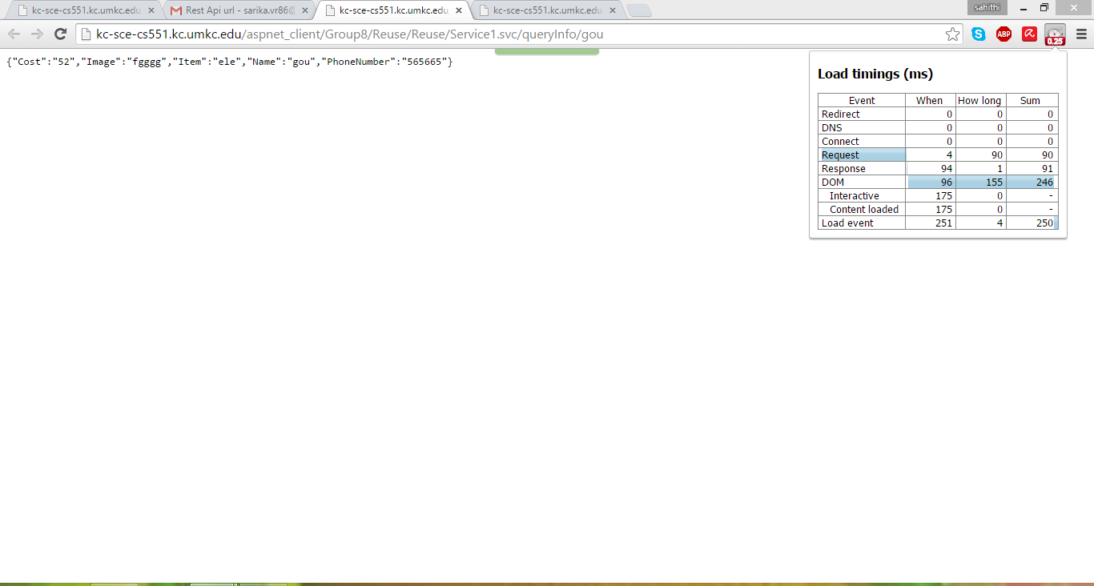

Firebug:

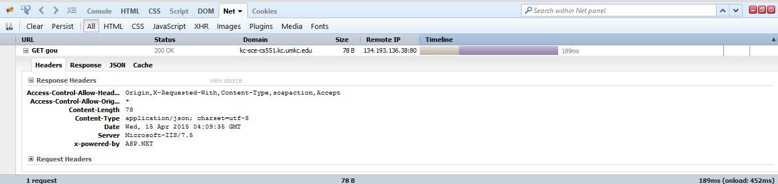

YSLOW Analyzer:

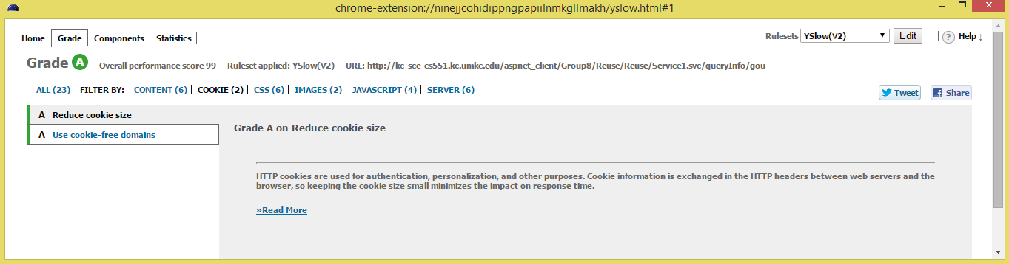

**7.DEPLOYMENT**

**SCRUM DO URL:**

https://www.scrumdo.com/projects/project/recyclespot/iteration/121733

**GIT HUB URL**

<https://github.com/SBNQ9/R3-RecycleReuseReduce>​