**CS 551 ADVANCED SOFTWARE ENGINEERING**

**Second Increment Report**

R3

REDUCE RECYCLE REUSE

**Project Team:** PG8

**Team Members:** Sarika Bommavaram (08)

Gouri Priya Vangavargu (50)

Sankalp Racharla (43)

Sasidhar Malladi (32)

**IMPORT EXISTING SERVICES/API:**

In this phase we are currently using services such as Maps, Providing locations address based on zip code, city of end user.

We are using several API's in our application. They are listed below

→ **White pages Pro API**:

This API is used locate the various recycling centers depending on users choice of location and also depends on type of recycling waste.

→ **Google Maps API:**

This API is used to get the map to the user to his destination. It provides guidance to the user by providing the directions to the destination depending upon his choice of selected recycling center.

→MONGOLAB REST API:

This API used to store the user enter details in mongo lab, so that we can use the details to perform required operations using the data

**TextToSpeech Converter:**

This API is used to notify the user about any activity. It provides the user with confirmation about the Activity.

**DETAIL DESIGN OF SERVICES:**

**Service Description:**

In this phase our application is implementing location, map and TextToSpeech service for end user. Here end user will provide his choice of location, application will provide list of nearest recycling centers to his given location and if user clicks on the locations provided he will get a map from his place to the selected recycling center. And for every page we used TextToSpeech service which notifies you about any activity or any confirmation.

And developed for Pickup service, where user can enter details about the where to pick up and how many trash bags are there to pick and scheduling a date according to one wish. Made a connection to Mongolab service to store the details so that the service provider can pick up the waste according to the schedule

Another service is about ReUse service, in which one can post their belongings which they don’t need anymore and want to give others whether it may be free or serving a cost. For this service we have developed pages to enter the details about the thing and store them in mongolab. And developed some code to select the images from gallery of the phone. And created a facebook page for r3 and we connected the page from an button to share it on facebook

**Implementation of REST Services:**

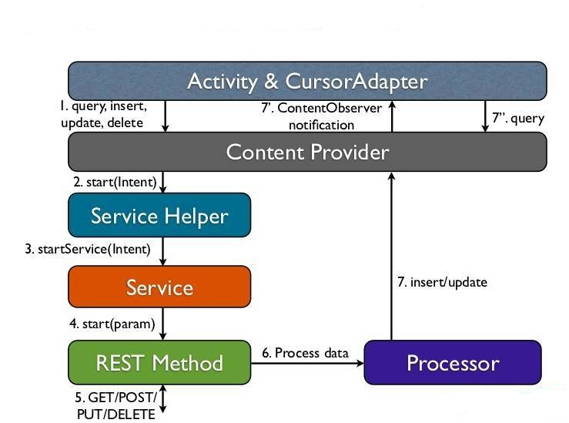

**SCRUMDO STORIES:**

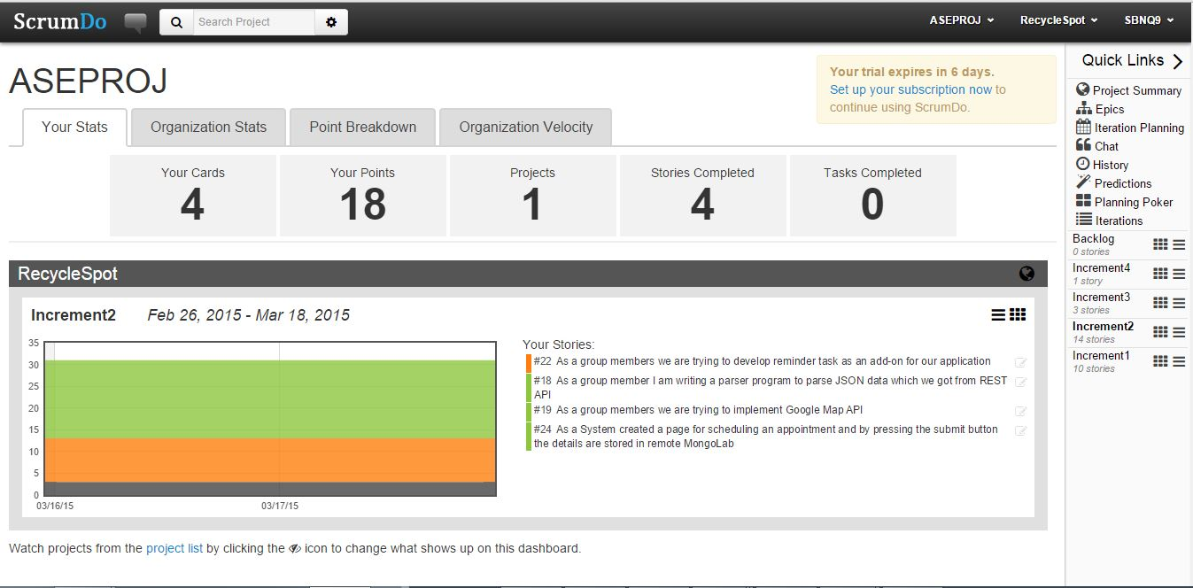

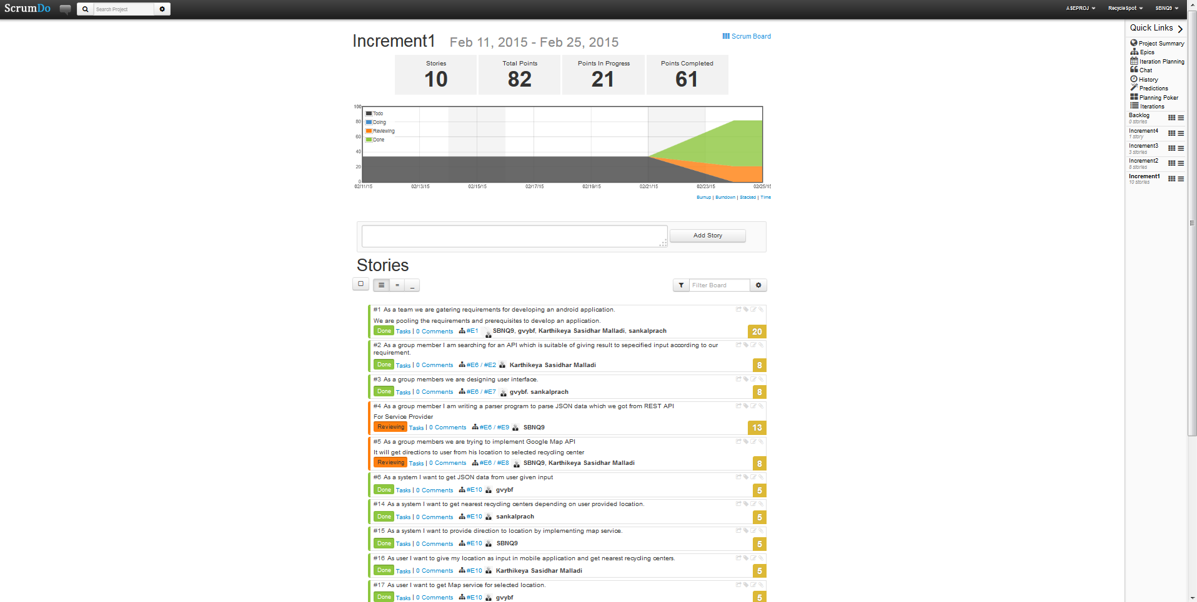

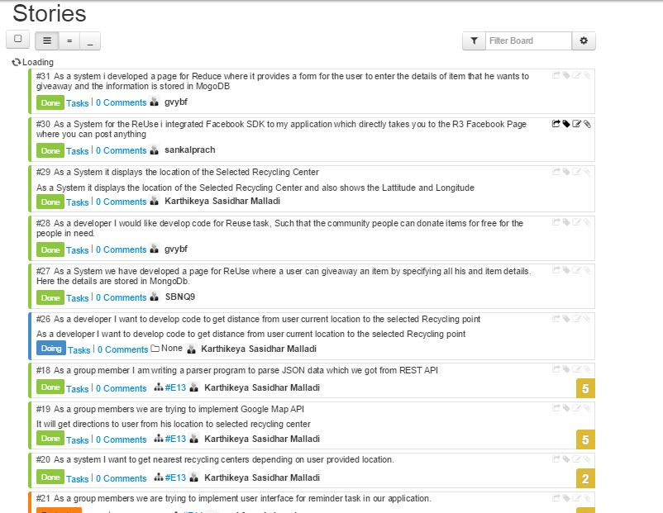

**CLASS/SEQUENCE DIAGRAMS:**

**Class Diagram for Scheduling Appointment Activity:**

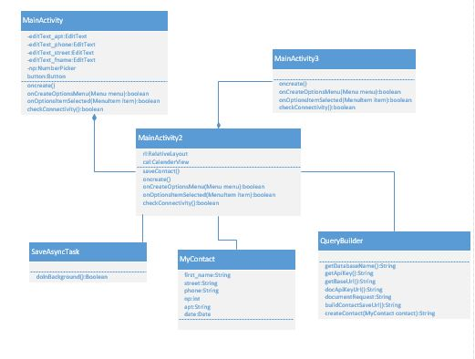

**Sequence Diagram for Scheduling Appointment Activity:**

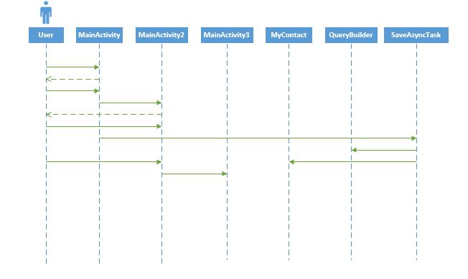

**Class Diagram for Parsing Activity:**

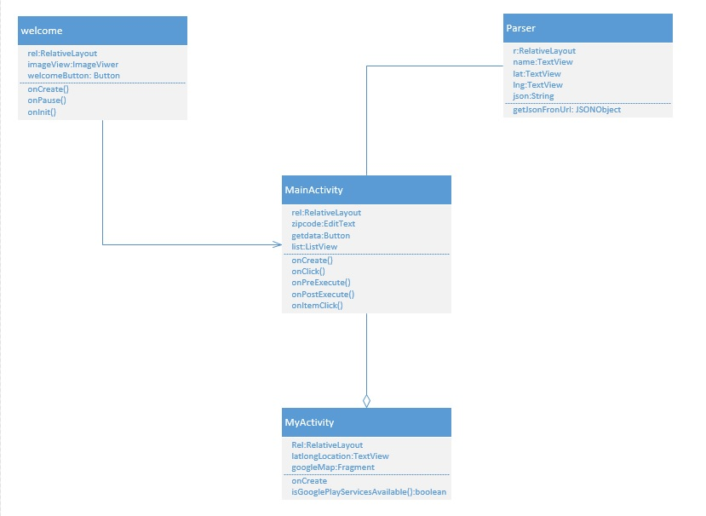

**Sequence Diagram For Parsing Activity:**



**Class Diagram For Reduce Task:**

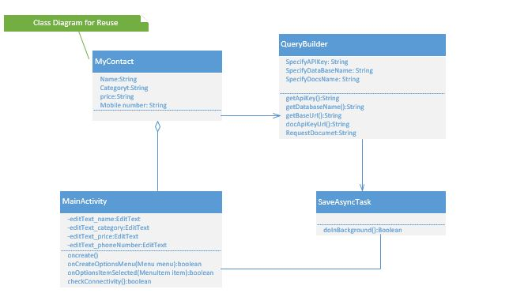

**Sequence Diagram For Reduce Task:**

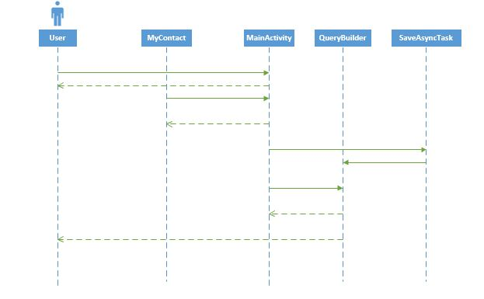

**Sequence Diagram For Post Activity:**

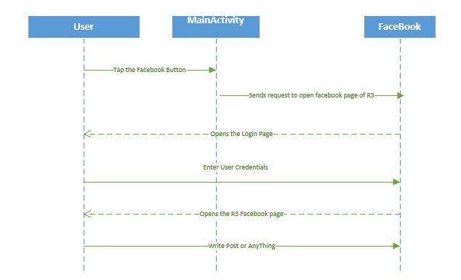

**DESIGN OF MOBILE CLIENT INTERFACE:**

PAGE FOR Service Provider

MONGO DB

SIGN UP

SIGN IN

REGISTRATION PAGE

Select a date

USER

SERVICE PROVIDER

COMMUNITY PEOPLE

Notification

Details

Pick up

Maps

Notify

Near addresses

Enter Zip Code

Types of Recycling Materials

**Design of Unit Test Cases:**

**Button Click Options:**

There are cases to select options through buttons and the functions need to be tested whether they are working properly. We are using these buttons to call other activity from existing. And we also have cases which tests whether the data is inserted in MongoLab.

**IMPLEMENTATION:**

**Implementation of user Interface:**

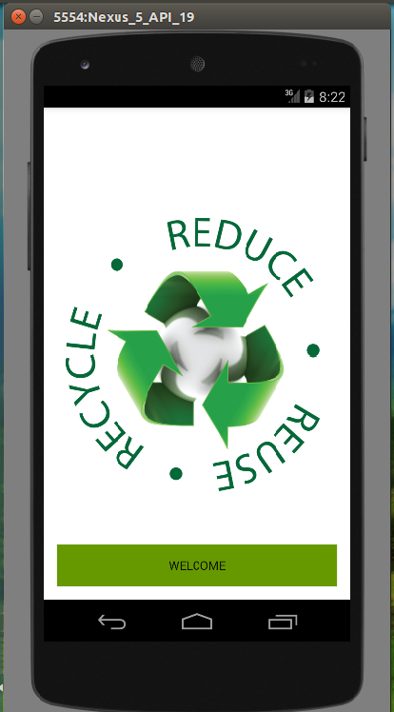 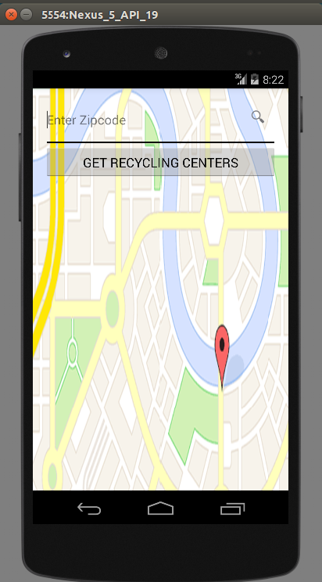 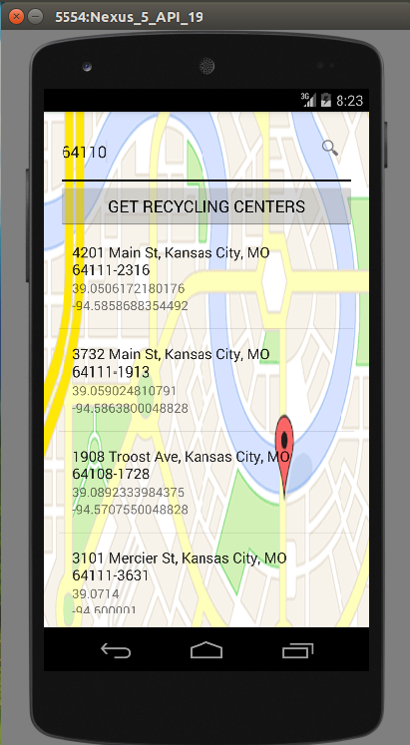

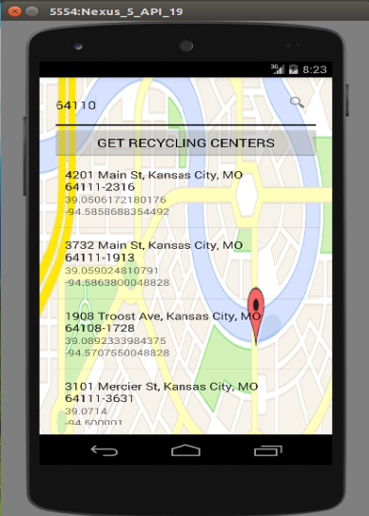 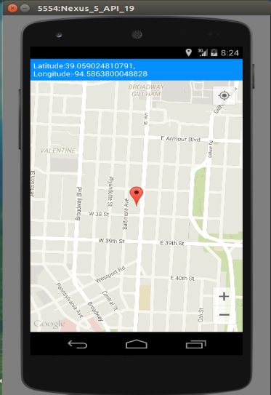

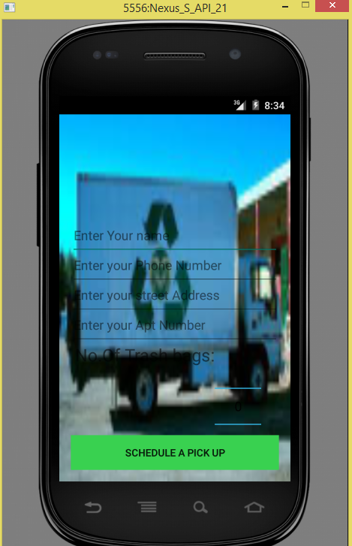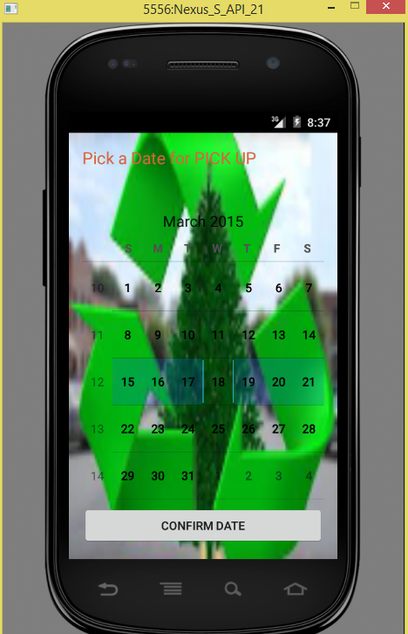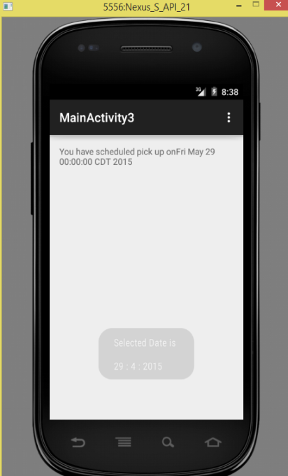

The above are the UI of our project developed till now and according to above diagrams when user gives their details and press schedule pick up button to choose the required date and confirm it for pick up.Then he will get confirmation about the pick up.

**TESTING:**

**Nunit Testing of MongoLab Connection:**

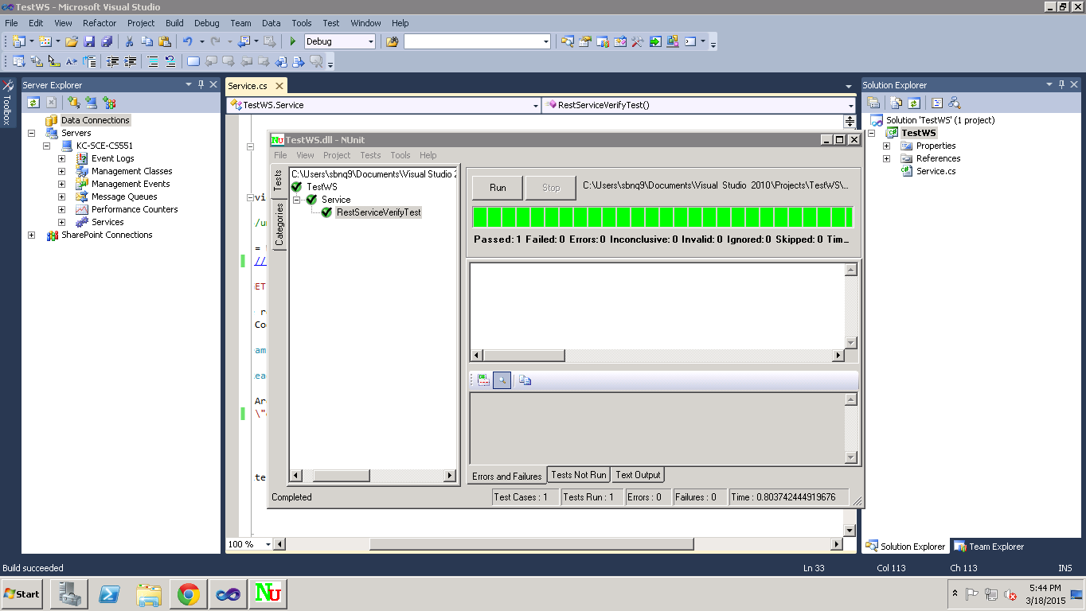

**Test Case 2**

**Object:** Verifying and Validating Welcome Activity

**Test Case Id:** TC R3– 03

**Test Case Name:** To check working of welcome screen and its functionality validation and verify text to speech functionality on button click.

**Test Procedure:** Look and get designed welcome screen. On click of button must transit to Main Activity.

**Data Matrix:**

|  |  |  |  |  |  |
| --- | --- | --- | --- | --- | --- |
| **S.no.** | **Description** | **Input Required** | **Expected Value** | **Actual Value** | **Result** |
| **1** | Working of Button  (Welcome Button) | Left Mouse click on Welcome button | Should navigate to Screen having search view with text to speech functionality running in background. | Displaying the next page with search view and text to speech running in background. | Success |

**Test Case 3**

**Object:** Verifying and Validating Main Activity

**Test Case Id:** TC R3– 04

**Test Case Name:** To check http connection is working and retrieving JSON data and after parsing data with parser class it must be displayed in list view.

**Test Procedure:** Look and get designed Main Activity screen. On click of button must produce a REST API call and retrieve JSON data according to user input and display in list view.

**Data Matrix:**

|  |  |  |  |  |  |
| --- | --- | --- | --- | --- | --- |
| **S.no** | **Description** | **Input Required** | **Expected Value** | **Actual Value** | **Result** |
| **1** | Working of Button  (GET RECYCLING CENTERS) | Left Mouse click on get recycling centers button | Should retrieve list of recycling centers according to entered zip code by user. | Displaying the list of all recycling centers available at desired zip code. | Success |
| **2** | Working of List Item | Left Mouse Click on desired location in list displayed | Should show the location in map. | Displaying the location in map. | Success. |

**TESTING:**

**Test Case 4**

**Object:** Verifying and Validating R3

**Test Case Id:** TC R3– 05

**Test Case Name:** To check the working of ImageView(FaceBook Page) and ImageUpload button.

**Test Procedure:** Look and feel of R3 is tested with positive behavior of application.

**Data Matrix:**

|  |  |  |  |  |  |
| --- | --- | --- | --- | --- | --- |
| **S.no.** | **Description** | **Input Required** | **Expected Value** | **Actual Value** | **Result** |
| **1** | Working of ImageView(FaceBook Page) | Left Mouse click on Facebook ImageView | Should navigate to Facebook Login Page | Displaying the FaceBook Login Page | Success |
| **2** | Working of ImageUploadButton | Left Mouse click on ImageUploadButton | Should open the MobileGallery to upload an image | Open the Gallery of MobileDevice | Success |

**TESTING:**

**Test Case 5**

**Object:** Verifying and Validating R3

**Test Case Id:** TC R3– 06

**Test Case Name:** To check the whether the Details of the Reduce Page are Inserted in MongoLab.

**Test Procedure:** Look and feel of R3 is tested with positive behavior of application.

**Data Matrix:**

|  |  |  |  |  |  |
| --- | --- | --- | --- | --- | --- |
| **S.no.** | **Description** | **Input Required** | **Expected Value** | **Actual Value** | **Result** |
| **1** | Working of Submit Button in Reduce Page | Left Mouse click on Submit Button in Reduce Page | Should Insert the details provided by the user in to the Remote Db MongoLab | Displaying the details inserted by the user in the MongoLab | Success |

**Scrumdo Url:** [**https://www.scrumdo.com/organization/aseproj/dashboard**](https://www.scrumdo.com/organization/aseproj/dashboard)

**Github URL:** [**https://github.com/SBNQ9/ASEInc2**](https://github.com/SBNQ9/ASEInc2)