**CS 551 ADVANCED SOFTWARE ENGINEERING**

**Third Increment Report**

R3

REDUCE RECYCLE REUSE

**Project Team:** PG8

**Team Members:** Sarika Bommavaram (08)

Gouri Priya Vangavargu (50)

Sankalp Racharla (43)

Sasidhar Malladi (32)

**1. INTRODUCTION**

The summary report of R3 (Reduce Recycle Reuse) for Increment 3 consists of all the classes that we have used, sequence diagrams, Our REST services that we created by our own and few other REST services that we used from available services, different testing tools that we have used. In this increment we have mainly focused on creating our REST services for all the tasks in Recycle and Reuse. We have also added on more extra feature for this increment, once the service provider pick up the trash then he will send a message to the community people that the trash has been collected.

We have added a new service to the application. It is named as sorting guide. Through this user can know what things must be recycled. Main use of the service is to classify the several categories in recycling materials and by this he also know that what type of products are accepted at recycling points and what precautions must be taken so that they will not deplete resources in recycling materials. Thus they will have a thorough understanding regarding materials. For example consider a use case that user faces while using the application. User want to recycle old car so first question he faces is how he can recycle such a thing, next question is what use in recycling a car is. Sorting guide provides this information so that user can get the solutions for his questions and through the method suggested in sorting guide he can recycle products which he want to.

In Reduce task we are just planning to show some static data that the different ways to reduce the litter. We are planning to implement this in the last increment. In Recycle task, for Increment 3 we have implemented google maps to show the nearby recycle centers dynamically. The community people can set the notification to notify on the selected date. From the service provider part we have created login page and have created own REST service. Service provider Login in page is created in such a way that, he will be able to login only if he has the four digit code that was previously assigned to him. If he click on the date he will get all the list of collections that he has to collect on that particular date. In Reuse task we have log in page for the Donor, such that he can log in and post the items that he wants give for free view all the list of items based on the selected category and if we wish to buy that item, we can contact the person whoever posted that through his mobile number.

**2. OBJECTIVES**

The main objective of this Iteration was to complete more than 75% of our project and to do some of the validations. We will come up with all the validations in the next iteration.

We have tried to work each and individual from front end to back end and we did it successfully. We have created REST services for Reuse and Recycle tasks.

**3. IMPORT EXISTING SERVICES/API**

In this phase we have created our REST services for the Login page, for Reuse task. Along with these services we are using some of the API’s like Google maps, text to speech converter etc.

→ **Google Maps API:**

This API is used to get the map to the user to the nearby recycle centers. It provides guidance to the user by providing the directions to the recycle center depending upon his choice of selected recycling center and we are also using Google Maps for the service provider part. When the service provider gets all the list of collection points, if he click on a particular collection point he will be directed to show the direction to that collection point from his location.

→**Mongolab Rest API**:

This API is used to retrieve details of the schedule appointment that we used in the second increment. The data is retrieved using JSON parser and displays list view to the service provider.

→**TextToSpeech Converter:**

This API is used to notify the user about any activity. It provides the user with confirmation about the Activity

→**Sign up and Sign in REST service for Reuse task:**

We have created this REST service using C# and Visual studio and deployed the service in remote server. The community people sign up and can sign in if he has already sign up and post the item that he wants to give way.

**Link**: <http://kcscecs551.kc.umkc.edu/aspnet_client/Group8/SignUp_In/SignUp_In/Service1.svc/checkDetails/sankalp/sarika>

→**REST service to upload items**:

This REST service is developed to enable the community people who wants to donate or sell the items based on a particular category. We even trying to retrieve the uploaded item details to the one who wants to buy from this REST service.

**Link**:

<http://kc-sce-cs551.kc.umkc.edu/aspnet_client/Group8/Reuse/Reuse/Service1.svc/queryInfo/gou>

→**REST service for the service provider:**

The REST service is developed for the service provider to Login. Service provider password is already stored in the SQL server, if he enter the correct credentials then only he can login.

**Link**:

<http://kc-sce-cs551.kc.umkc.edu/aspnet_client/Group8/Recycle/Recycle/Service1.svc/queryInfo/45>

**4. DETAIL DESIGN OF SERVICES:**

**4.1 Service Description:**

We have developed many services like pick up, notification, Reuse, list of Recycle centers etc. In this increment we have worked on the development of the services to get the data that is stored in the Mongolab to display the list of collection points to the service provider. In that we used Google Maps API, if the service provider wants to know the direction to the collection point.

Using calendar we have enabled the community people to set the notification in their mobile such that it will remind them when he has to call the service provider for the trash pickup.

In Reuse task, we have developed the services such as providing the facility for the donor to post the item that he wants to donate. If he wants to buy an item that he is in need, he will be very happy if he get it for free or for less price.

**4.2 SCRUMDO STORIES:**

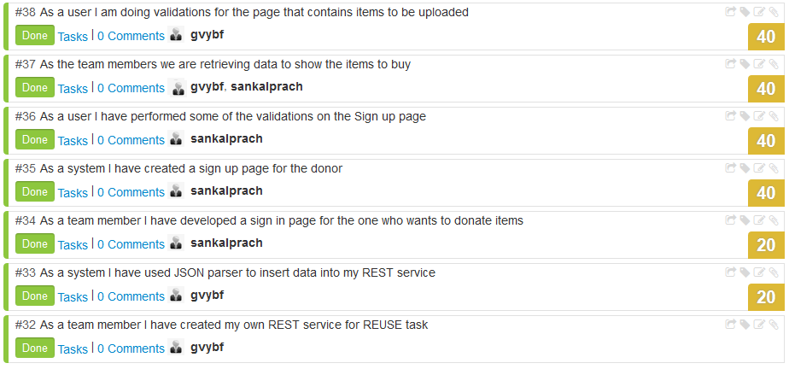

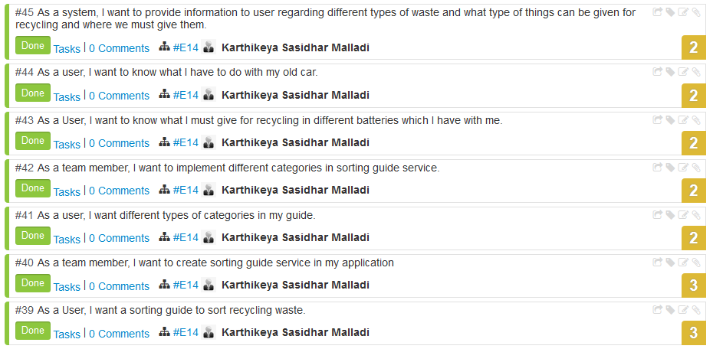

**Explanation for ScrumDo stories:**

**Story #32:** AS a team member have developed the REST service for the community people who wants to upload the item details that he wants give away.

**Story #33:** As the REST service can not be directly used to show the output as it is in JSON format, It is converted to normal data using JSON parser.

**Story #34:** AS part of uploading the item community people has to sign up. So, have developed the Sign up page for the community people.

**Story #35:** Once the donor sign up, he can sign in to post the item that he wants to give away

**Story #36**: From the user interface perspective, the sign up page should be interactive. Hence have done some valiadtions to enable the user to use it correctly

**Story #37:** We are trying to retrieve the data from the REST service about the uploaded item details and to show to the the who wants to buy the item based on his selected category.

**Story #38:** AS the developer I have done some validations on the page, which conatins items to be uploaded.

**Story #39**: From the perspective of the user or client, he is suggesting a requirement of sorting guide. By following traditional waterfall model approach this comes under requirements phase.

**Story #40:** From the view of team member as per requirement, I want to create a sorting guide service for my application.

**Story #41**: From the perspective of user, User suggests his/her requirements stating different categories in sorting guide

**Story #42**: From the view of team member as per requirement, I want to develop sorting guide which consists of several categories suggested in requirement phase by user.

**Story #43:** This is an example use case in which user wants to get recycling methods for different batteries which are available with him.

**Story #44**: This is an example use case in which user looking for information to recycle his/her old car.

**Story #45**: It explains service sorting guide from perspective of system. As a system it must provide information regarding different types of waste for recycling.

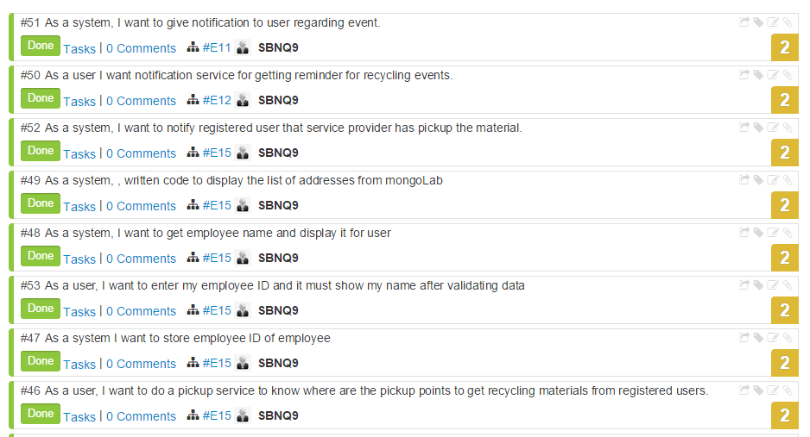

**Story #46:** I want to do a pick up service for scheduled appointment on that day and developed code such that the appointments addresses are shown in list for service provider so that he can go and collect.

**Story #47:** I have developed a REST SERVICE by deploying the visual studio and using remote database to store and retrieve the employee details.And I have wrote a authenticate method in which it will display the name from given Id in browser window as json format.

**Story #48:** If authenticate passes, the name will be displayed in next activity and the current location of the service provider is also provided so that it can be used for getting directions to the nearest address to collect the recycle bags.

**Story #49:** I established a connection to mongolab where I stored the appointment details and retrieve them from collection and displaying them as listview by using story 46 so that service provider can select one location in future I want to display these as in sorting order with their distances from current place.

**Story #52:** After selecting the address service provider will go to the address then he will click the button that pick up is completed which will send a message to the user phone number which he has entered during the scheduling.

**Story #50:** For Pick up scheduling service I have added nalarm task that he will get alarm day before the scheduled date.

**Story #51:** He also notification which will redirect him to the app to remember the scheduled appointment

**4.3 CLASS/SEQUENCE DIAGRAMS:**

**Class diagram for the Pickup service**

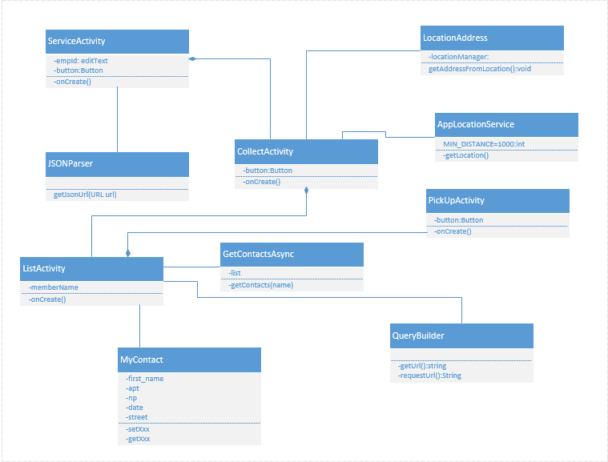

**Sequence Diagram for service provider:**

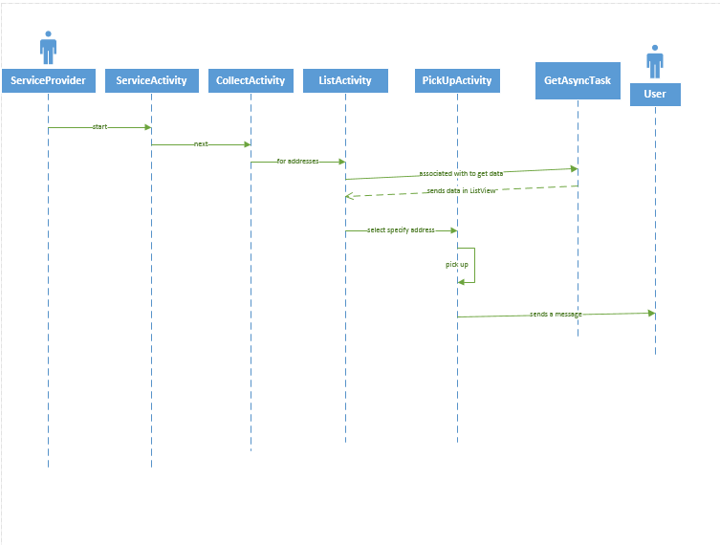

**Class diagram for schedule service:**

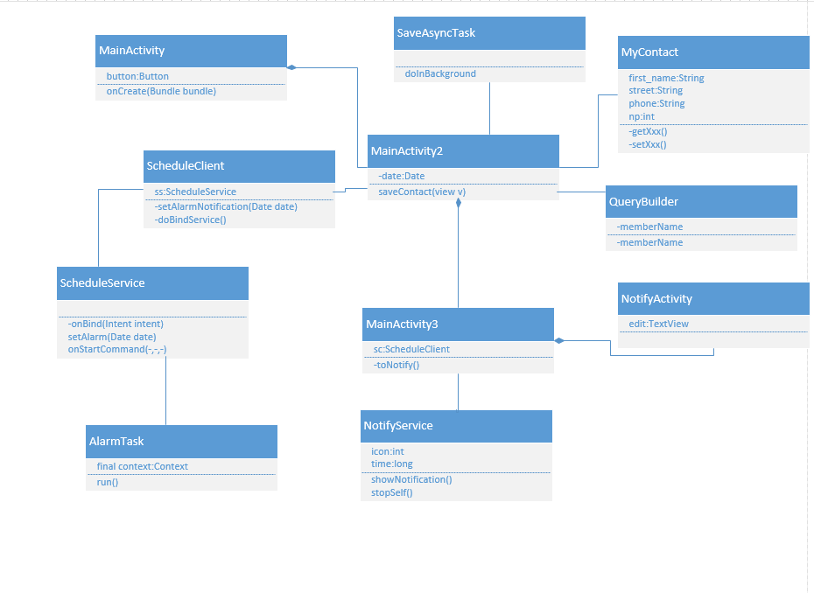

**Sequence diagram for schedule service:**

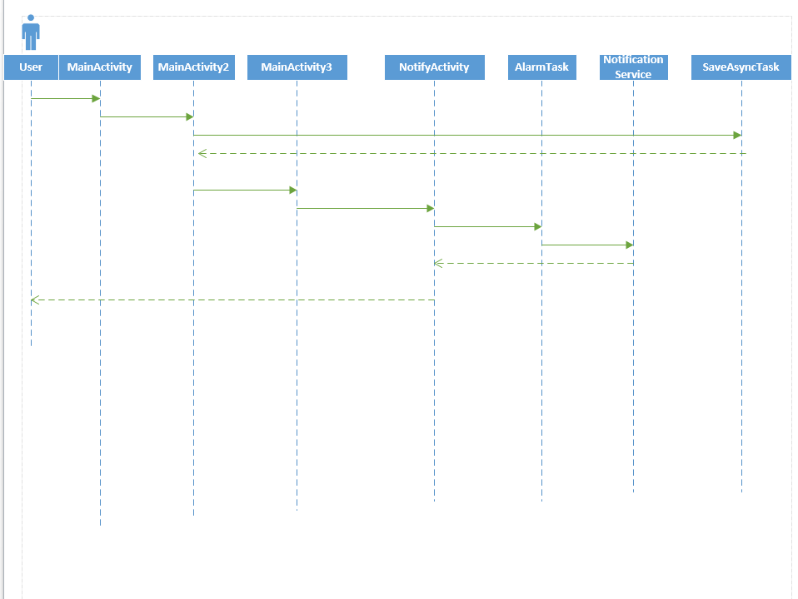

**Class diagram for sorting guide:**

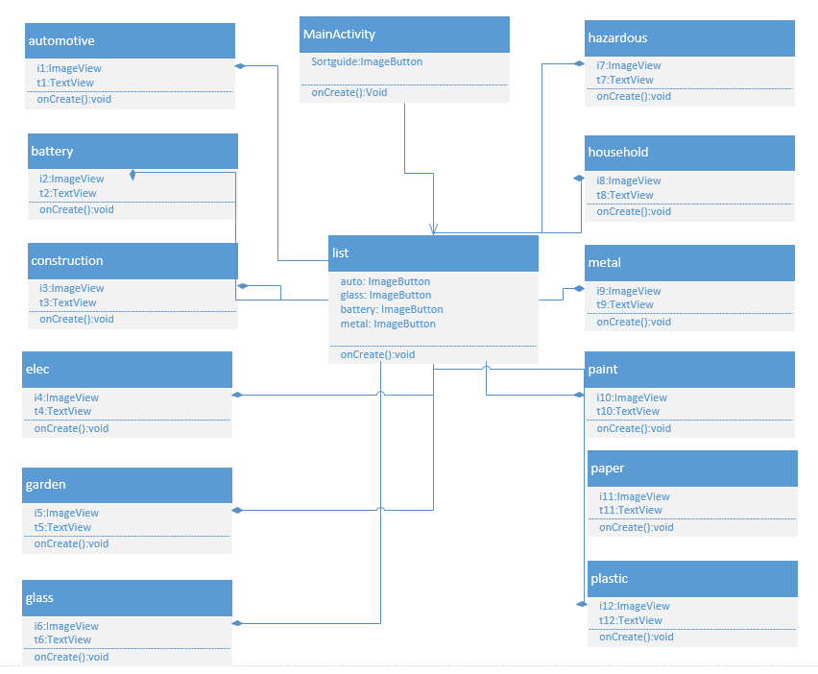**Sequence diagram for sorting guide:**

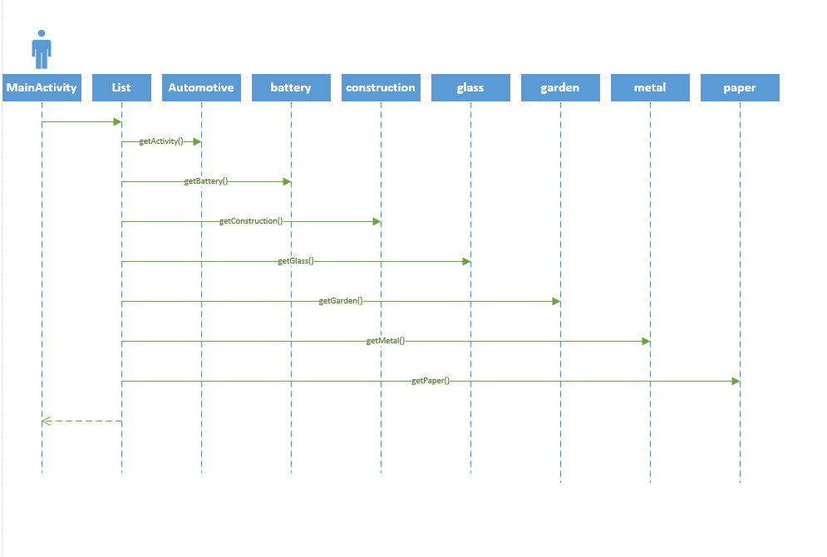

**Class diagram for the items to be uploaded by the donor:**

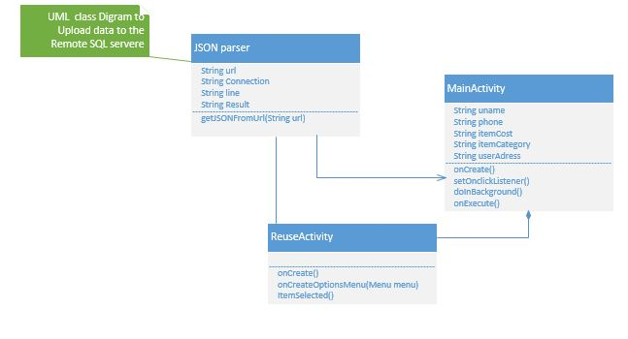

**Sequence diagram for the items to be uploaded by the donor:**

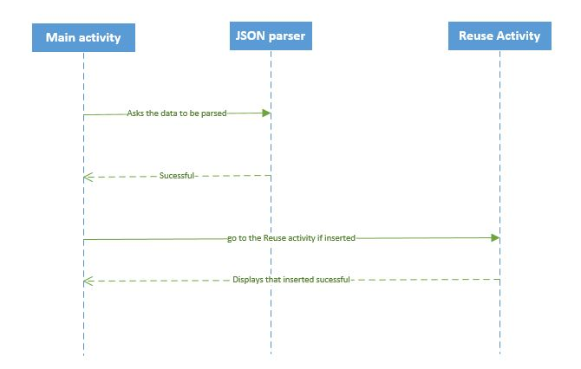

**Class diagram for the Sign up and Sign in of the donor:**

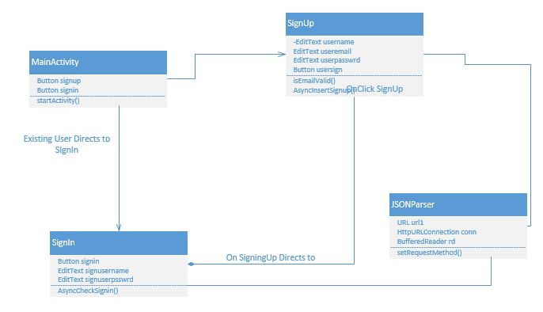

**Sequence diagram for the Sign up and Sign in of the donor:**

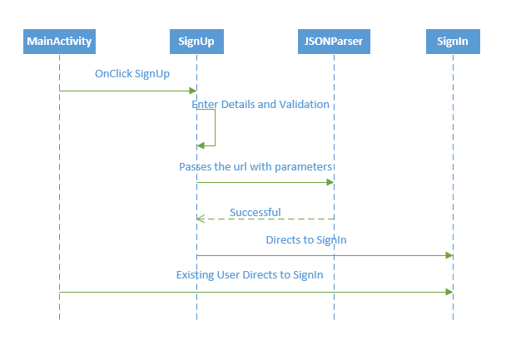

**4.4 DESIGN OF MOBILE CLIENT INTERFACE:**

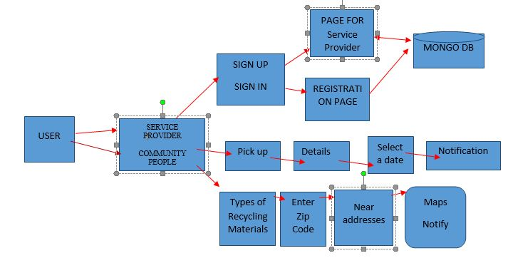

**5. IMPLEMENTATION**

**Implementation of user Interface:**

The below screen shot is for login of service provider. The service provider has to enter the Employee id that is provided by his supervisor. If that is correct he redirects to the second screen provided in the screen shot displaying the service provider name.

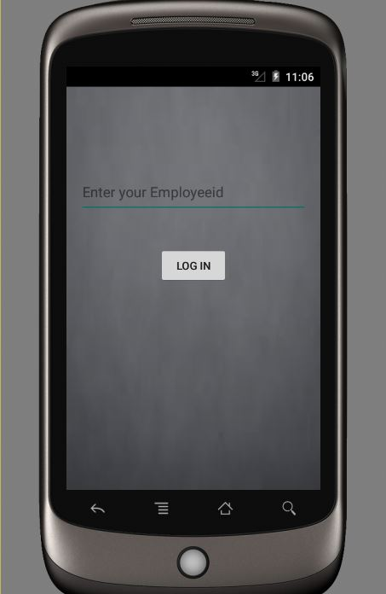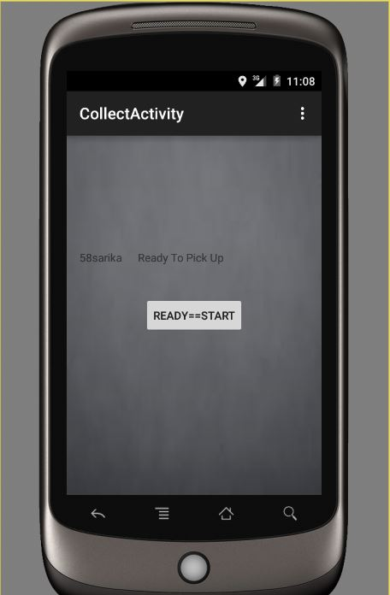

**Screen shot 1**

If the service provider clicks on Ready to pick up then it displays list of addresses that he has to pick up on that particular day.

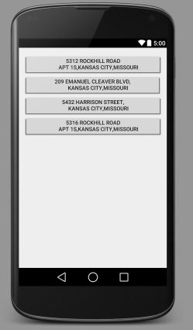

**Screen shot 2**

The community people can schedule the appointment by providing the required information as shown in the below screen shot. When he clicks on “Schedule a pickup” then it redirects to select date then he can confirm the date, on which day he wants the service provider to come and collect the trash.

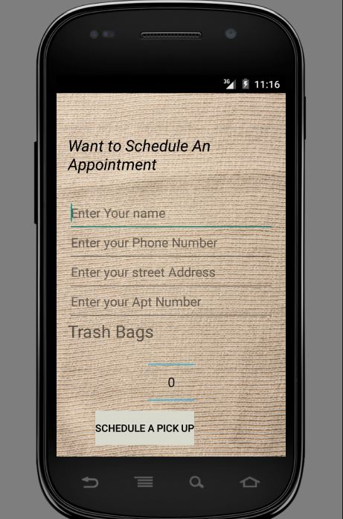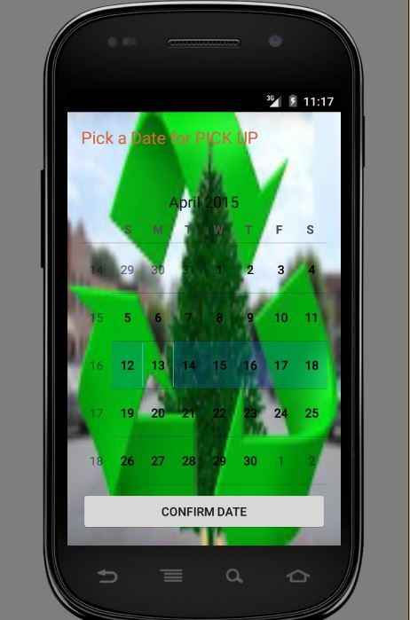

**Screen shot 3**

The community people can even set the notification on which date he wants to get notify of that he has to remind of his trash. When he click on “Get me notified” the notification will be set in his mobile for that particular date.

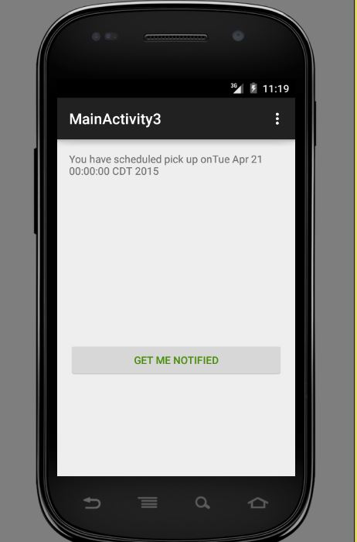

**Screen shot 4**

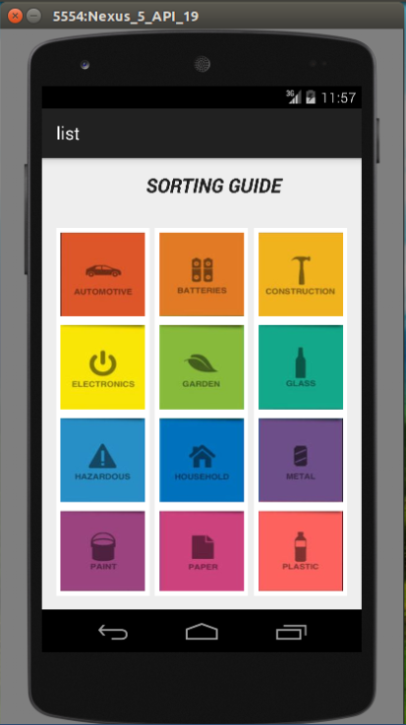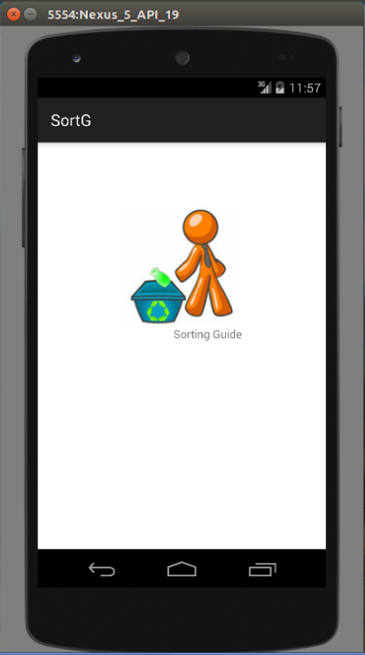

**Screen shot 5 Screen shot 6**

This picture shows us regarding list activity which consist of several image buttons each having specific functionality. User can click on image button to retrieve information according to the problem.

This is the main page where our service sorting guide will start. The above shown is an image button by clicking on this image button we can transit to next class activity by name list.

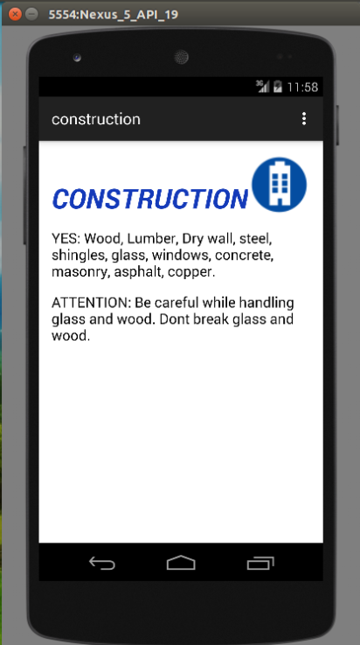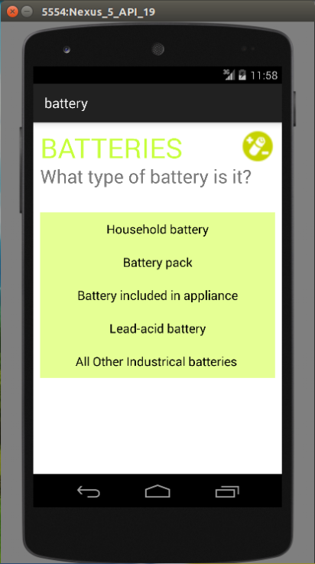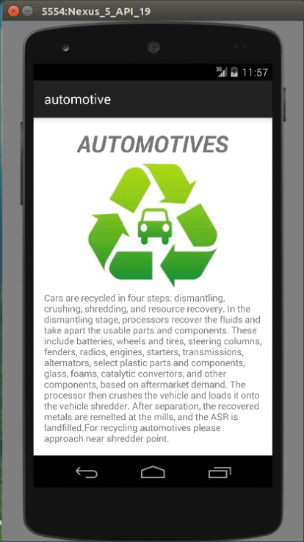

**Screen shot 7**

The above provided three screen shots gives information about design and implementation of 3 class activities. First one is automobile activity which gives information regarding automobile recycling. Battery class in turn consists of 5 different activities which explain about different battery types and their associated recycling activities. Third class is about construction recycling which gives info that what are materials present at construction site which can be used for recycling.

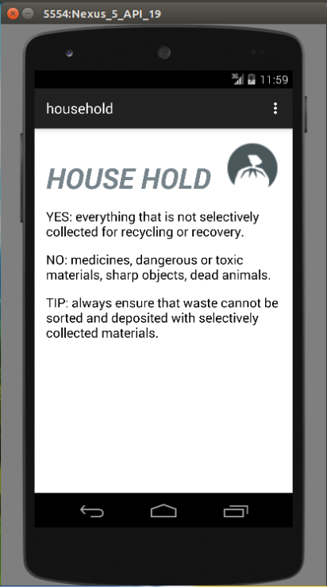

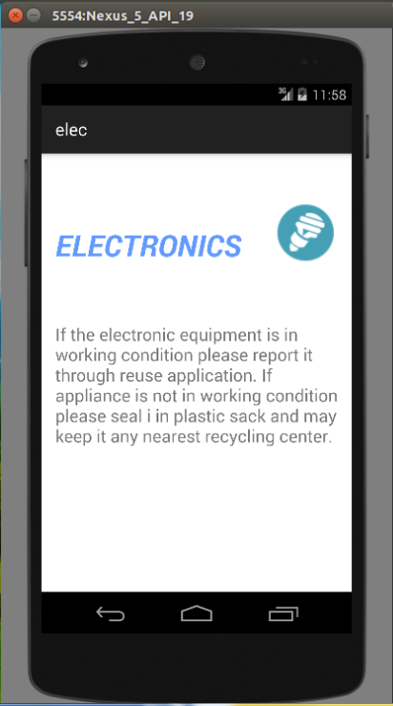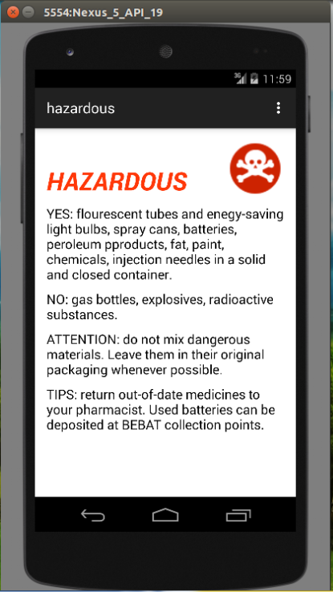

**Screen shot 8**

The above provided three activities provide information and design of three classes. These consists of several interactive image views and information providing text views. First image provides information regarding what are all types of goods we can recycle from our house. It also provides info of what we must not give for recycling from house hold recycling goods. Second image provides information regarding hazardous materials and how can they be recycled and what are items which we must not recycle and some tips to deal with specific type of materials. Third image consists of information regarding electronics.

**Screen shot 9**

**Screen shot 9**

The above provided images give information regarding interactive design &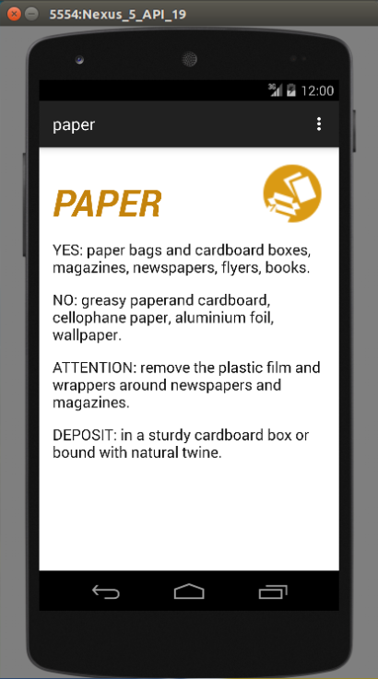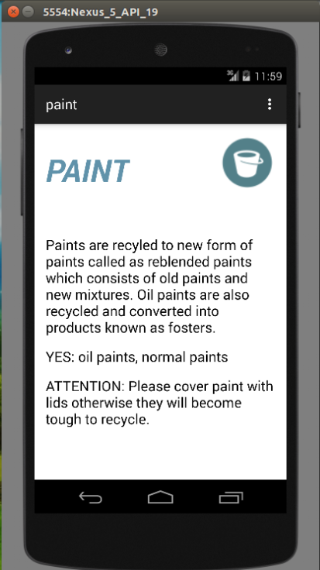 implementation of three classes in our service. First image provides information regarding recycling materials in category of paper which will also include things such as cardboards. It will also give things we must recycle in this category and what we must not recycle in this category. Second image gives vivid information regarding paint category and what are precautions we must take when we are recycling paint products. Third image gives information regarding glass category products such as bottles and jars and what are precautions we must take when we are recycling glass products and what are items which can be recycled and which must not be.

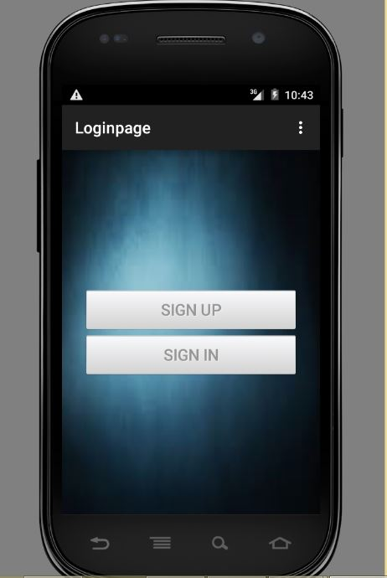

**Screen shot 10**

If the community people wants to post the details of the items that he is going to give way or sell, he has to sign in, if he already has an account. Otherwise he has sign up by clicking on the sign up button.

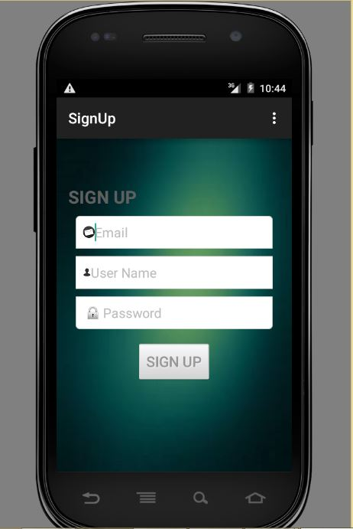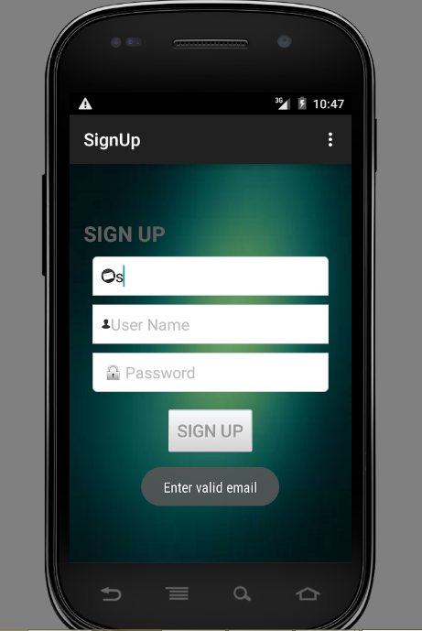

**Screenshot 11**

When the user clicks on Sign up button he is redirected to the sign up page. He has to give his Email, user name and password. If he enter wrong email address, it will show enter valid email.

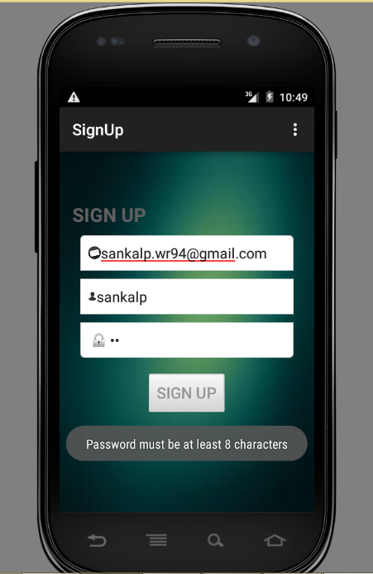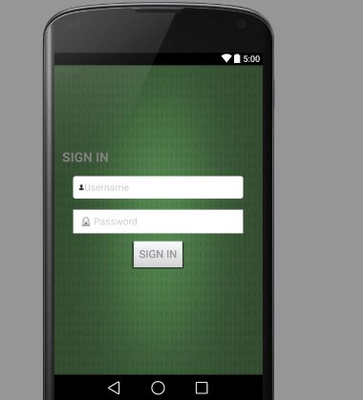

**Screenshot 12**

The user password should be of 8 characters and when he clicks on sign up it will redirect to the sign in page, where he can use his user name and password that he has created. If he clicks on sign in button, it will redirects to the page where he can enter the details of the item that he wish to giveaway.

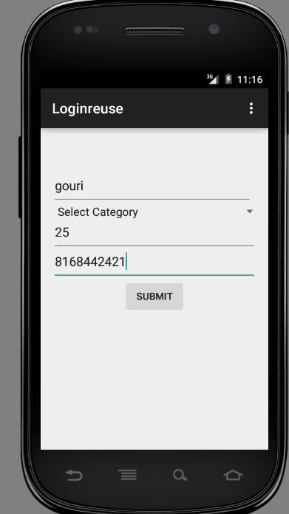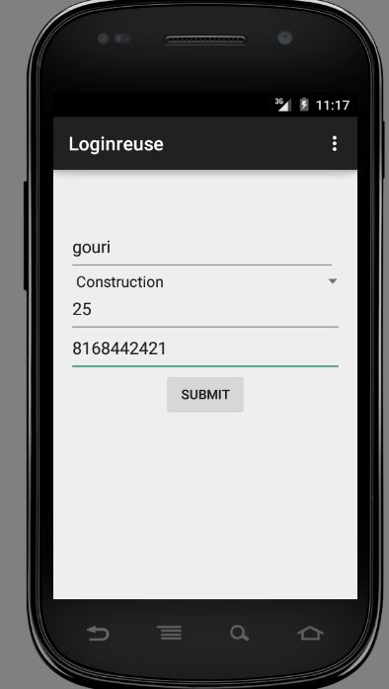

**Screenshot 13**

The donor has to enter the details of the item that he is going to post and has to select the category of the item that from a list of 12 categories.

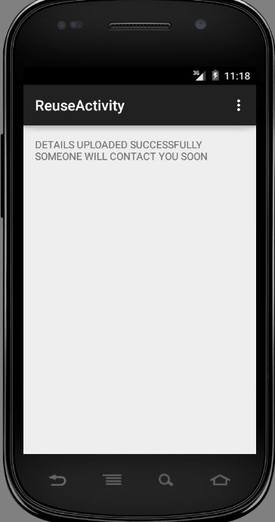

**Screenshot 14**

Once the donor clicks on submit button then he is redirected to the above page saying that someone will contact him soon, if he wants to buy the item based on his need for that particular item.

**6. Testing:**

**6.1 Functional Testing using NUnit tool:**

The below screens are testing using NUnit tool for the items to be uploaded and sign up page of the community people.

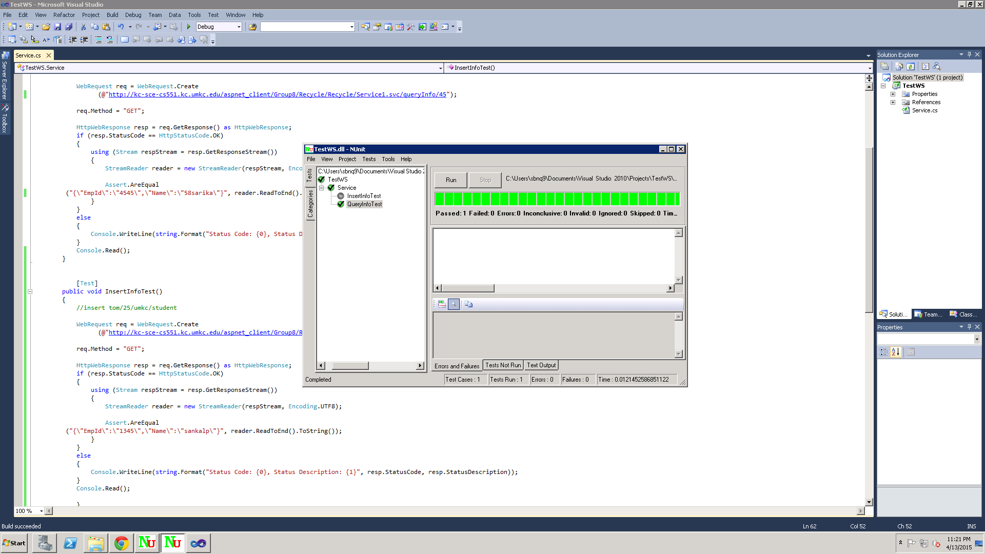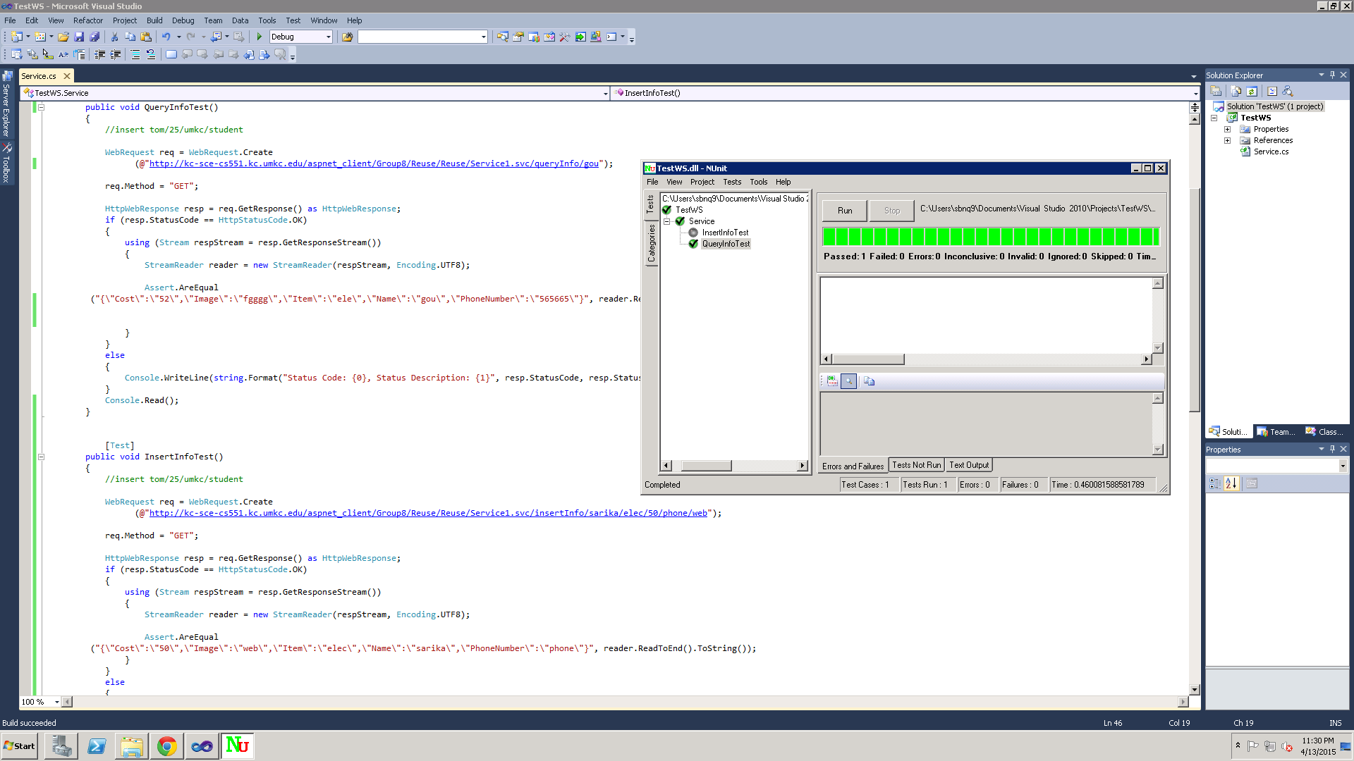

The below screen shot is the NUnit testing for the Login page of the service provider.

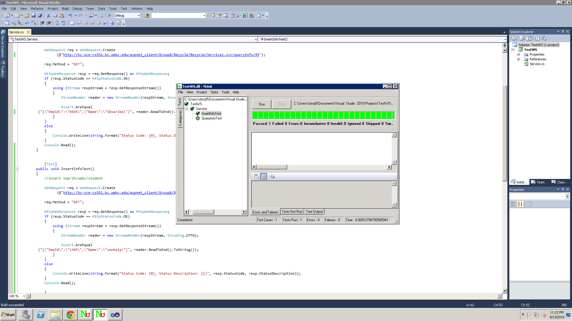

**6.2 Performances Testing:**

We have tested each rest services with using 3 testing tools like load time analyzer which will give the time to process the URL, Firebug and Yslow Analyzer.

**Load Time Analyzer:**

It clearly displays the request and response time in table. For that we have to install load time analyzer add on to the google chrome. And it will show clock symbol in the right corner if we click the clock it will show the load times of the website of the given URL

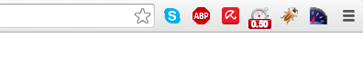

**Firebug:**

This tool is very famous in market as it gives the every single detail about the website of the URL. And we can do our analysis by selecting net bar in the tool so we can find the load time over there.

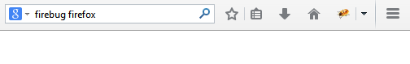

**Yslow Analyzer:**

It can be installed into our google chrome by adding yslow analyzer add-on.After installing it into chrome there will be a symbol indicates its installation, by clicking that we will go the window where we can find our analysis.



For

<http://kc-sce-cs551.kc.umkc.edu/aspnet_client/Group8/Recycle/Recycle/Service1.svc/queryInfo/45>

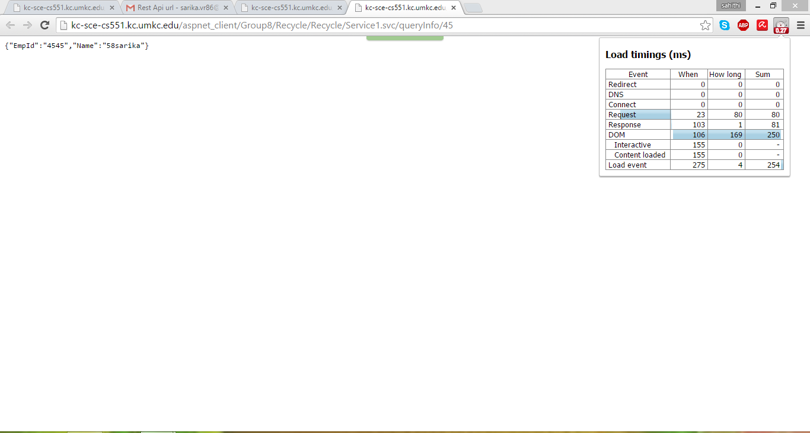

After loading the web site by clicking the clock symbol

YSLOW Analyzer:

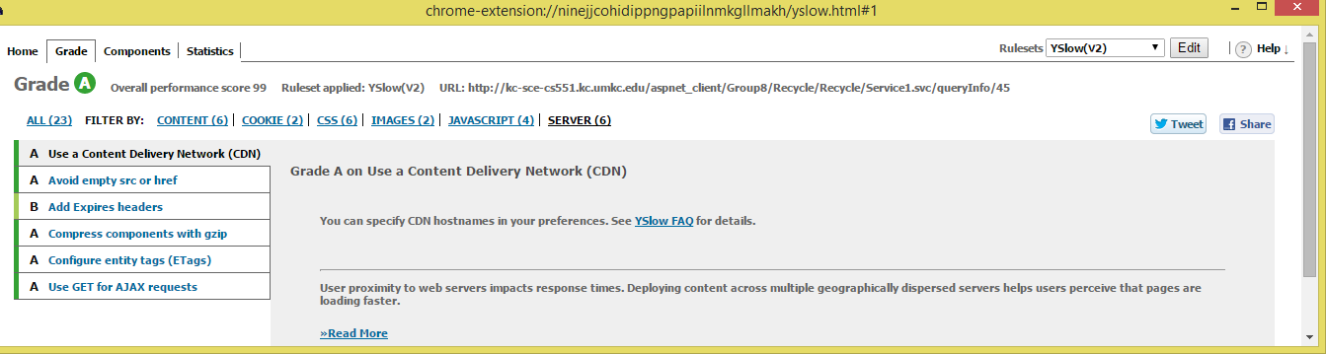

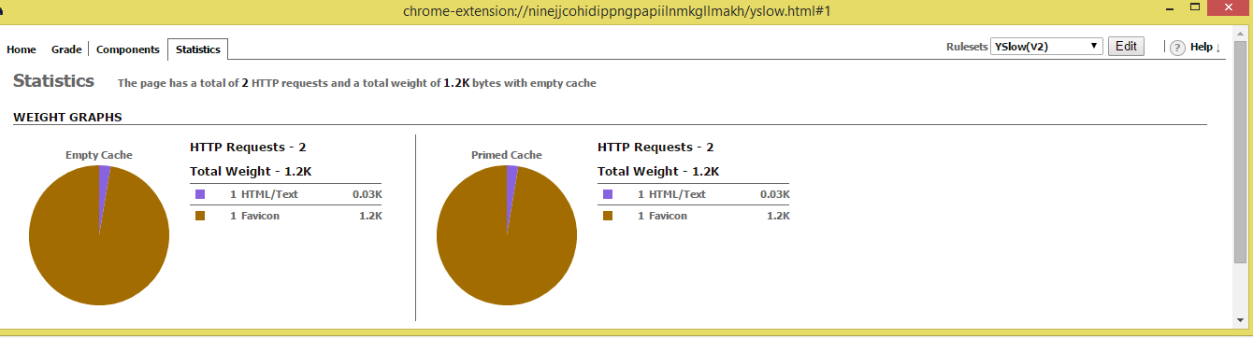

FIREBUG:

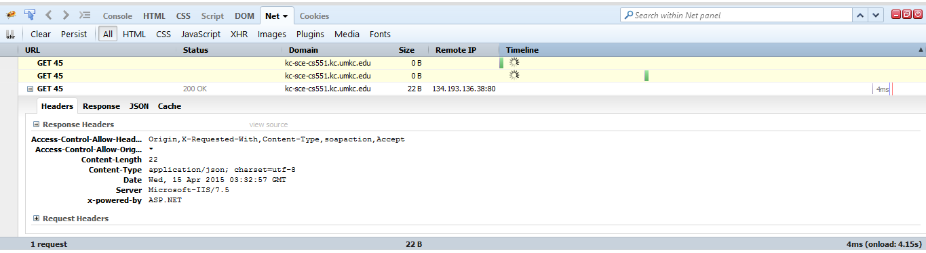

For rest service

<http://kc-sce-cs551.kc.umkc.edu/aspnet_client/Group8/SignUp_In/SignUp_In/Service1.svc/checkDetails/sankalp/sarika>

Load Time Analyzer:

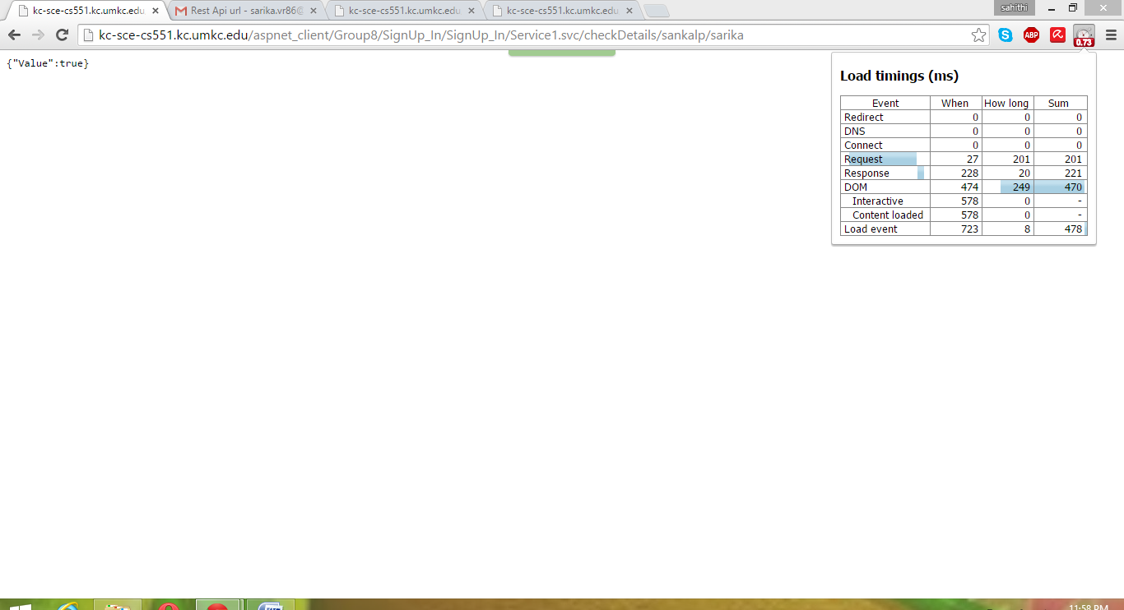

Firebug:

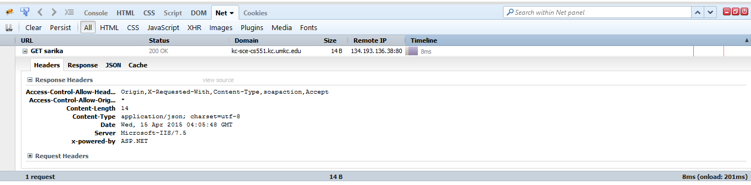

YSLOW Analyzer:

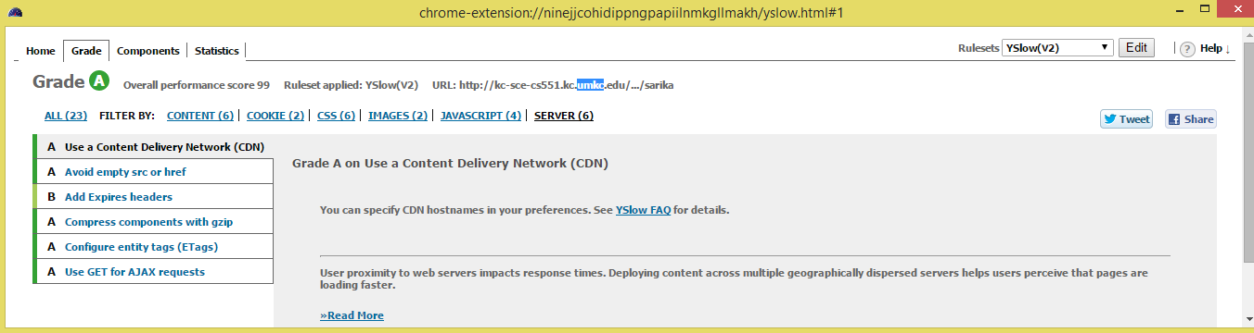

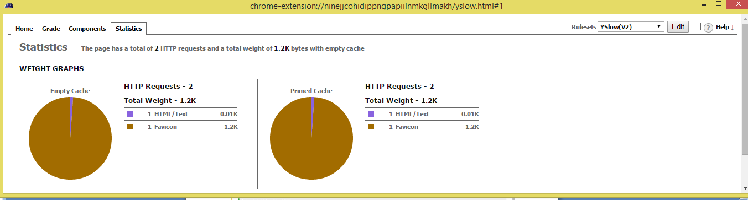

For

<http://kc-sce-cs551.kc.umkc.edu/aspnet_client/Group8/Reuse/Reuse/Service1.svc/queryInfo/gou>

**Using Load Time Analyzer:**

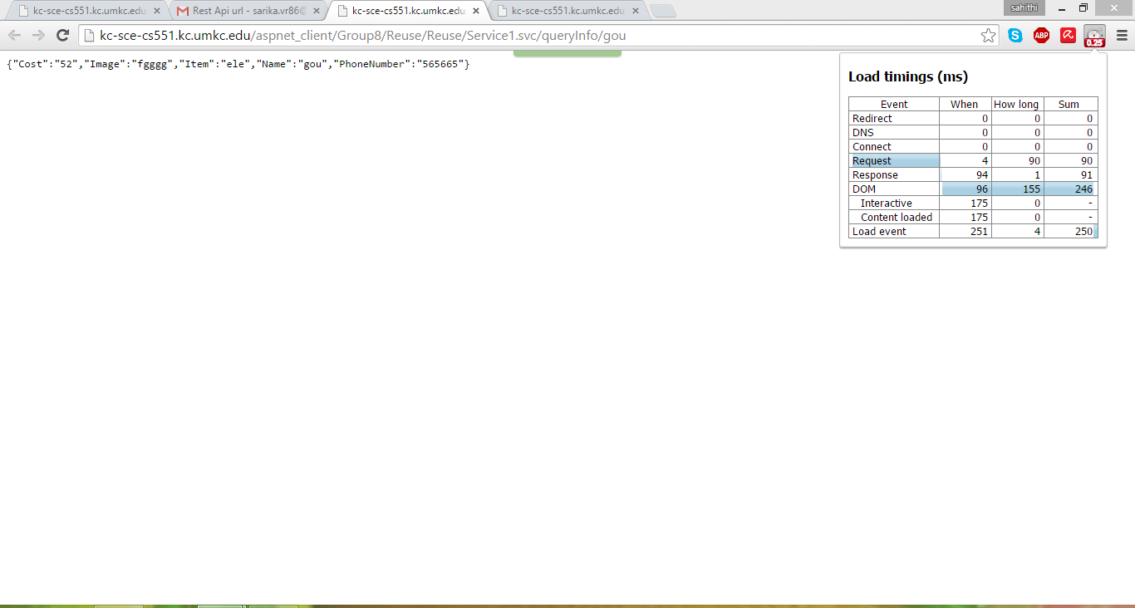

Firebug:

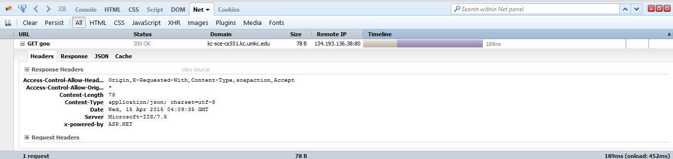

YSLOW Analyzer:

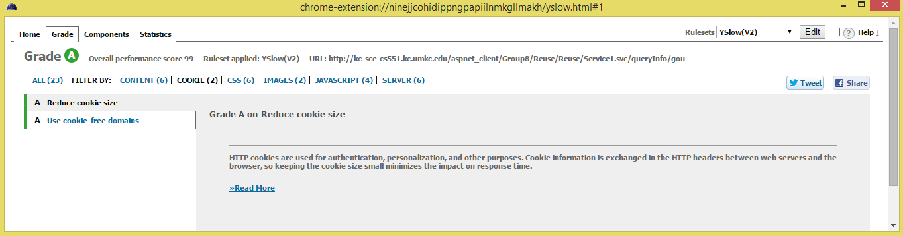

**7. Deployment:**

**ScrumDo URL**:

[https://www.scrumdo.com/projects/project/recyclespot/iteration/121731#](https://www.scrumdo.com/projects/project/recyclespot/iteration/121731)

**Github URL**:

<https://github.com/SBNQ9/ASE_Inc3>