**Project management report:**

**PG8(Sarika Bommavaram, GouriPriya Vangavargu,Sashidhar Malladi,Sankalp Racharla)**

We have used SCRUMDO tool which uses agile methodology for project development. Agile methods allow the development team to focus on the software itself rather than on its design and documentation. We are four people in our group, have divided our work has set the work as stories in different iterations. Thus we have set four iterations for four increments.

It’s very easy to edit specifications and work to be done according to the changes while developing the project.

Iterations graphs are like:

**Iteration1:**

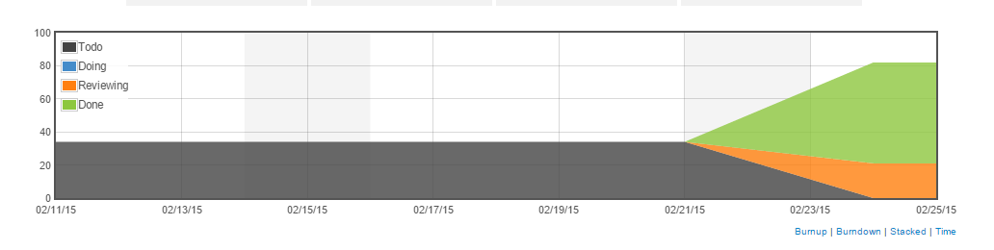

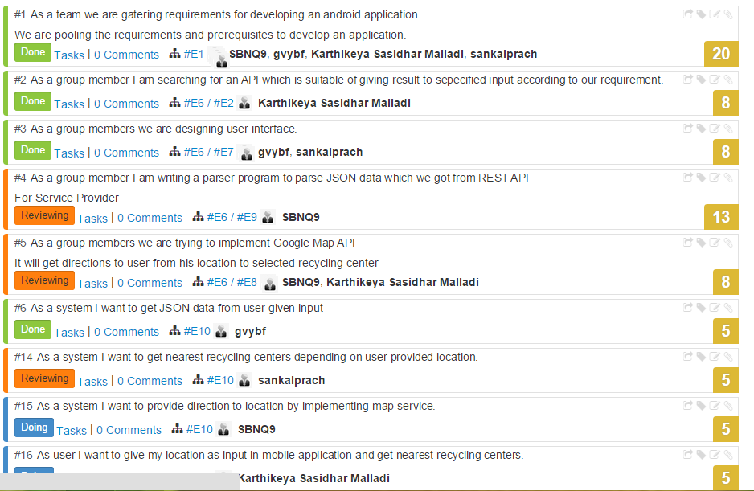

**Increment2/Iteration2:**

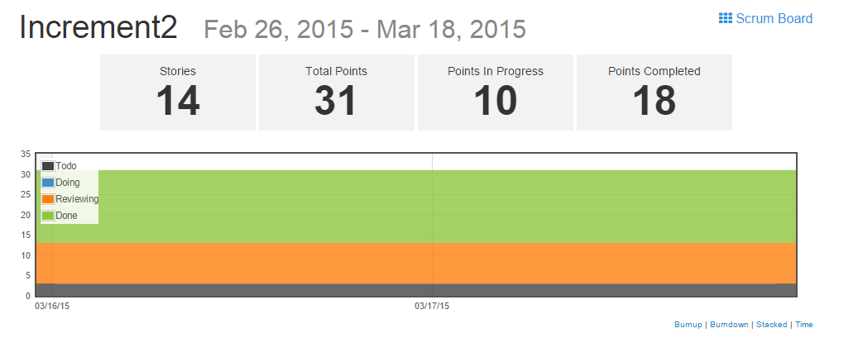

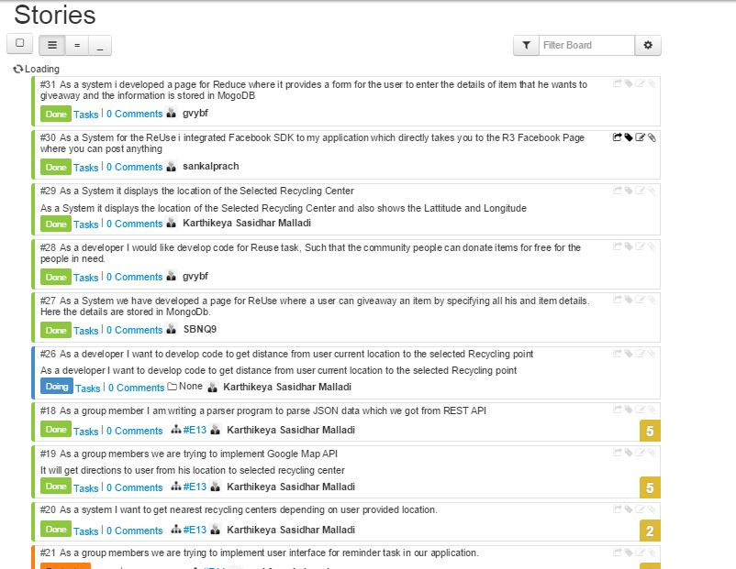

**Increment3:**

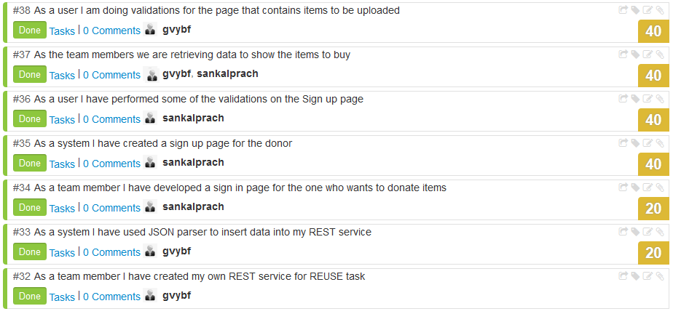

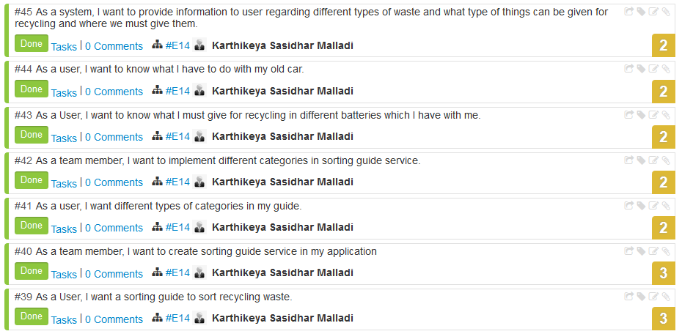

**Explanation for ScrumDo stories:**

**Story #32:** AS a team member have developed the REST service for the community people who wants to upload the item details that he wants give away.

**Story #33:** As the REST service can not be directly used to show the output as it is in JSON format, It is converted to normal data using JSON parser.

**Story #34:** AS part of uploading the item community people has to sign up. So, have developed the Sign up page for the community people.

**Story #35:** Once the donor sign up, he can sign in to post the item that he wants to give away

**Story #36**: From the user interface perspective, the sign up page should be interactive. Hence have done some valiadtions to enable the user to use it correctly

**Story #37:** We are trying to retrieve the data from the REST service about the uploaded item details and to show to the the who wants to buy the item based on his selected category.

**Story #38:** AS the developer I have done some validations on the page, which conatins items to be uploaded.

**Story #39**: From the perspective of the user or client, he is suggesting a requirement of sorting guide. By following traditional waterfall model approach this comes under requirements phase.

**Story #40:** From the view of team member as per requirement, I want to create a sorting guide service for my application.

**Story #41**: From the perspective of user, User suggests his/her requirements stating different categories in sorting guide

**Story #42**: From the view of team member as per requirement, I want to develop sorting guide which consists of several categories suggested in requirement phase by user.

**Story #43:** This is an example use case in which user wants to get recycling methods for different batteries which are available with him.

**Story #44**: This is an example use case in which user looking for information to recycle his/her old car.

**Story #45**: It explains service sorting guide from perspective of system. As a system it must provide information regarding different types of waste for recycling.

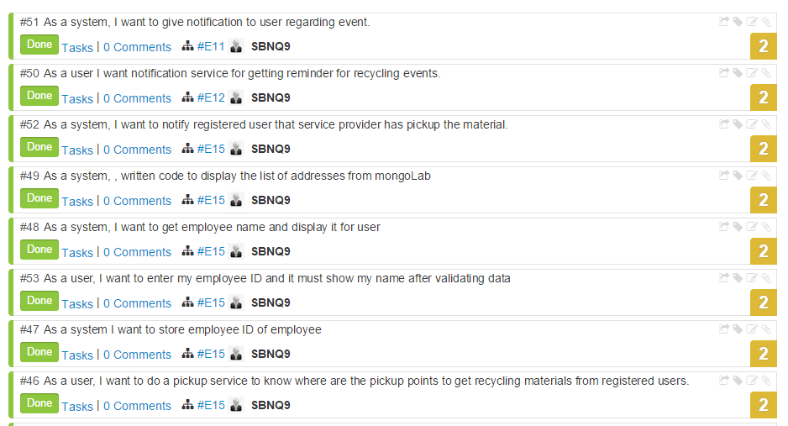

**Story #46:** I want to do a pick up service for scheduled appointment on that day and developed code such that the appointments addresses are shown in list for service provider so that he can go and collect.

**Story #47:** I have developed a REST SERVICE by deploying the visual studio and using remote database to store and retrieve the employee details.And I have wrote a authenticate method in which it will display the name from given Id in browser window as json format.

**Story #48:** If authenticate passes, the name will be displayed in next activity and the current location of the service provider is also provided so that it can be used for getting directions to the nearest address to collect the recycle bags.

**Story #49:** I established a connection to mongolab where I stored the appointment details and retrieve them from collection and displaying them as listview by using story 46 so that service provider can select one location in future I want to display these as in sorting order with their distances from current place.

**Story #52:** After selecting the address service provider will go to the address then he will click the button that pick up is completed which will send a message to the user phone number which he has entered during the scheduling.

**Story #50:** For Pick up scheduling service I have added nalarm task that he will get alarm day before the scheduled date.

**Story #51:** He also notification which will redirect him to the app to remember the scheduled appointment

**Increment4:**

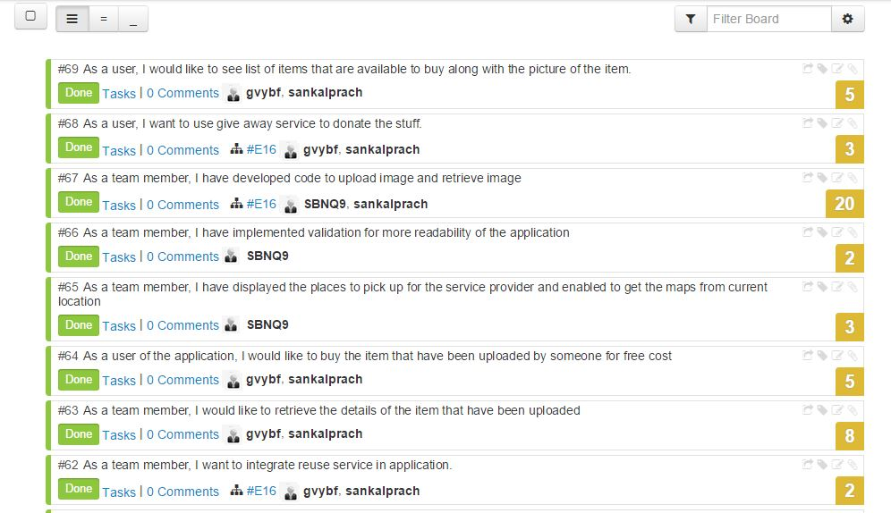

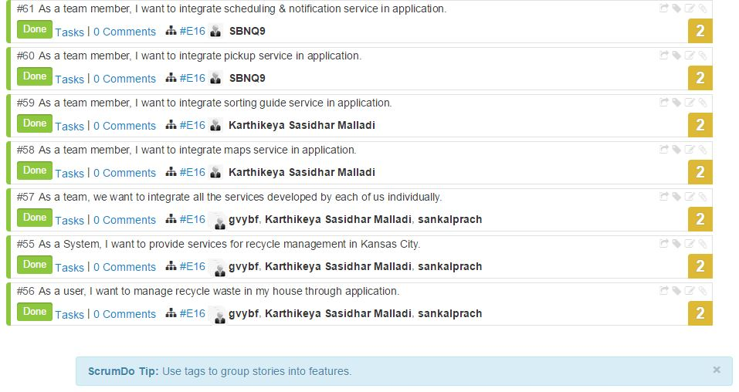

**Story #55:** This story is used to tell about all the services that have been developed in the android application R3: Reduce Recycle Reuse. All the three services are developed to manage Kansas City.

**Story #56:** The application is developed to enable the Kansas City residents to effectively manage the waste in their home. This story is the responsibility of all the team members.

**Story #57:** We have integrated all the services into an Application that we have developed individually.

**Story #58:** This story is about my service that I have integrated my Map services into the whole application.

**Story #59:** The sorting that I have developed individually have been integrated into the whole application.

**Story #60:** I have developed the pickup service individually, I have solved few problems that have identified while integrating into whole project.

**Story #61:** I have integrated the notification service into the application and resolved few problems along with some of the validations.

**Story #62:** We have integrated the Reuse service into the application that we have developed and enabled the service according to user preference.

**Story #63:** The user may want to buy an item that was uploaded by someone, in this we retrieved the data from the SQL server.

**Story #64:** If I am using the application to shop an item, I would prefer to get the list of items before I am going to buy.

**Story #65:** when the service provider clicks on the location that he has to go for pick up, he will be navigated to the maps.

**Story #66:** The validations are done for all the services for the user friendly.

**Story #67:** I have developed the code to upload the item that makes the person who wants to buy it very easy.

**Story #68:** With the help of this android application I can donate stuff easily which I no longer wish to use.

**Story #69:** The image of the item and the list of items that are available can be seen if you want to buy any of the item that have been uploaded.

**Overall Project Report:**

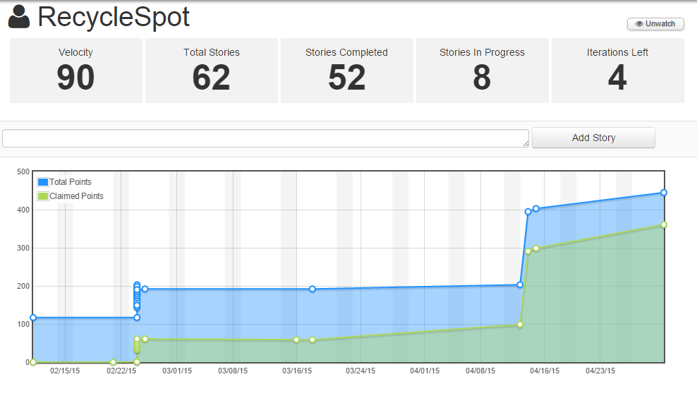

The entire project scrum work and tasks can be viewed in the following link:

**URL:** [**https://www.scrumdo.com/projects/project/recyclespot/summary**](https://www.scrumdo.com/projects/project/recyclespot/summary)