

**Tribhuvan University**

**Faculty of Humanities and Social Sciences**

**Online Auction System**

**A PROJECT PROPOSAL**

**Submitted to**

**Department of Computer Application**

**Ratna RajyaLaxmi Campus, Kathmandu**

***In partial fulfilment of the requirements for the Bachelors in Computer Application***

Submitted by:

Sonik Badal (Roll No: 17)

Under the Supervision of

**Kriti Nemkul**



**Tribhuvan University**

**Faculty of Humanities and Social Sciences**

**Ratna RajyaLaxmi Campus**

# Supervisors’ Recommendation

I hereby recommend that this project prepared under my supervision by Sonik Badal entitled “**Online Auction System**” in partial fulfilment of the requirements for the degree of Bachelor of Computer Application is recommended for the final evaluation.

Kriti Nemkul

**SUPERVISOR**

Lecturer

BCA Department

Faculty of Humanities and Social Sciences

Ratna RajyaLaxmi Campus



**Tribhuvan University**

**Faculty of Humanities and Social Sciences**

**Ratna RajyaLaxmi Campus**

# Letter of Approval

This is to certify that this project prepared by **Sonik Badal** entitled “**Online Auction System”** in partial fulfilment of the requirements for the degree of Bachelor in Computer Application has been evaluated. In our opinion it is satisfactory in the scope and quality as a project for the required degree.

|  |  |
| --- | --- |
| Kriti Nemkul, Lecturer  BCA, Ratna Rajyalaxmi Campus | Buddhi Prasad Sapkota, BCA Co-Ordinator  BCA, Ratna Rajyalaxmi Campus |
| **Internal Examiner** | **External Examiner** |

# Acknowledgement

The satisfaction that accompanies that the successful completion of any task would be incomplete without the mention of people whose ceaseless cooperation made it possible, whose constant guidance and encouragement crown all efforts with success.

We are grateful to our project guide **Ms. Kriti Nemkul** mam for her guidance, inspiration, and constructive suggestions that helped us for preparing this project.I take this opportunity to express a deep sense of gratitude to every BCA teacher for their guidance, monitoring, and constant encouragement throughout which helped us in completing this task through various stages.

# Abstract

The project entitled **‘Online Auction System’** is a web-based project. This project has designed and implemented an application that will be able to create auctions and place bid on them. This system can add users, create auctions, place bids, and stores them in a database. This system only provides authority to verify, delete users to the admin. In this system the backend is developed using PHP, the frontend using HTML, CSS, Bootstrap, and JavaScript. MYSQL is used as a database. This project will help users to post their product and get good value in return.

**Keywords: -**

***Auction, Web-based application, HTML, CSS, PHP, Bootstrap, JavaScript, MySQL***

**Table of Contents**

Supervisors’ Recommendation i

Letter of Approval ii

Acknowledgement iii

Abstract iv

List of Abbreviations vii

List of Figures viii

Chapter 1: Introduction 1

1.1. Introduction 1

1.2. Problem Statement 3

1.3. Objectives 3

1.4. Scope and Limitation 3

1.5. Development Methodology 4

1.6. Report Organization 4

Chapter 2: Background Study and Literature Review 5

2.1. Background Study 5

2.2. Literature Review 5

Chapter 3: System Analysis and Design 7

3.1. System Analysis 7

3.1.1. Requirement Analysis 7

3.1.2. Feasibility Analysis 8

3.1.3. Data Modelling (ER-Diagram) 10

3.1.4. Process Modelling (DFD) 10

3.2. System Design 13

3.2.1. Architectural Design 13

3.2.2. Database Schema Design 14

3.2.3. Interface Design 15

3.2.4. Physical DFD 17

3.3. Algorithm details 18

Chapter 4: Implementation and Testing 20

4.1. Implementation 20

4.1.1. Tools Used 20

4.1.2. Implementation Details of Modules 21

4.2. Testing 23

4.2.1. Test Cases for Unit Testing 23

4.2.2. Test Cases for System Testing 25

Chapter 5: Conclusion and Future Recommendations 28

5.1. Lesson Learnt / Outcome 28

5.2. Conclusion 28

5.3. Future Recommendations 28

References: 29

# List of Abbreviations

CSS – Cascading Style Sheet

DFD – Data Flow Diagram

ER – Entity Relationship

HTML – HyperText Markup Language

HTTP: HyperText Transfer Protocol

JS – JavaScript

PHP – Personal Home Page

UI – User Interface

# List of Figures

Figure 1: USE-CASE Diagram of Online Auction System 7

Figure 2: Gantt chart of Online Auction System 9

Figure 3: ER Diagram of Online Auction System 10

Figure 4: Context Diagram of Online Auction System 10

Figure 5: Level- 1 DFD of Online Auction System 11

Figure 6: Level-2 DFD of Patient Management in Online Auction System 11

Figure 7: Level-2 DFD of Report Management in Online Auction System 12

Figure 8: Architectural Design of Online Auction System 13

Figure 9: Schema Design of Online Auction System 14

Figure 10: Login/Register Page Interface Diagram of Online Auction System 15

Figure 11: Index Page Interface Design of Online Auction System 15

Figure 12: Create Auction Page Interface Design of Online Auction System 16

Figure 13: Dashboard Interface Design of Online Auction System 16

Figure 14: Physical DFD of Online Auction System 17

Figure 15: Item Based Recommendation of Online Auction System 19

Figure 16: Login Module of Online Auction System 21

Figure 17: Register Module of Online Auction System 21

Figure 18: Create Auction Module of Online Auction System 22

Figure 19: Bid Module of Online Auction System 22

# Chapter 1: Introduction

## **Introduction**

A world that loves to participate in real-time activities would certainly appreciate the idea of an online auction system that opens 24/7. Unlike the traditional auctioning method, this modern system brings together buyers and sellers from across the globe to a single location. Since the items are listed for a few days, bidders can think and study the deal before bidding. Since there are no geographical or time restrictions, the number of bids received will be more. The cost for conducting an auction online is less when compared to physical auction sales and the price of the items is also low. This way both parties the buyer and the seller benefit. Retailers, distributors, and liquidators can test new products, quickly sell off excess inventory and get new customers. Auctions taking place between customers, companies, and businesses have gained popularity.

A few decades down the line, auctions were carried out in auction houses and the bids were made with the auctioneer delegating the bids. This method required the physical presence of the bidders, thus it resulted in several limitations. This led to the use of online auctions, which allows for the auctions to be carried out over the internet from anywhere in the world. The advent of online auctions presented its own set of downsides due to the lack of proper evaluation techniques for the products and the sellers. The current systems do not allow for a proper description of the kinds of sellers and the kinds of products that they sell. These systems do not provide enough detailed information to evaluate the types of sellers and their products. This results in the buyers' uncertainty, thus resulting in the reduced effectiveness of online auctions and making people opt for offline auction markets. Most current auction systems do not fully provide product descriptions or fully evaluate the different types of sellers that participate in the auctioning process. Online systems come from a background where there is no full evaluation of the shilling activities that take place in different auction systems. The evaluation of shilling activities goes a long way in providing certainty about the different types of sellers. This can be achieved through the provision of shill scores or shill ratings for each seller in an auction system. By providing the sellers' shill rating, the different bidders can easily make choices for the different sellers when they decide to bid for their products.

Online auctions are very useful for businesses, regardless of their type and size. Founded in 1995, eBay takes the credit of being the major online auction host. Many businesses have taken off because of the auction space offered by eBay. Bidders go through the product descriptions, shipping information, and images of the item before bidding. Advancements in technologies and the implementation of new features have made online auctioning simple than ever. From the initial development process to the integration of the online auction system, developers and software engineers encounter many challenges and difficulties. They think, plan, analyze, design, redesign, test, and correct errors to set up the most up-to-date online auction system for their clients.

Basic processes involved in the Online auction system are Registration for both seller and buyer, Identifying the auction type, auction rules, names, product information, prices, etc, Scheduling times for auction sessions including starting and closing time, Bidding that includes collecting bids and validating the collected bids, Closing the Auction and finally Trade Settlement.

There are also legit business people and store owners who have quality items in the locality of the auctioneer, but they do not meet for business because the auctioneer is not informed about the items available. This is a great frustration indeed!

This project shall handle this issue by creating an online platform where a user will be able to post items online for auction. The items will be accompanied by the item's name, selling price, and a picture presentation for the bidder to see.

The customers will be assured of getting the right products since they will take their time to analyze and compare a range of listed items and choose appropriately according to their needs or desires. This will save time that buyers take in searching for items, and therefore, they will save themselves from worsening of conditions, which may lead to wastage of time. This will also save money that is spent on traveling and bidding for undesired items. Bidders will, at the end of the day, have a reason to smile with this online system.

This system will run on the internet because of the dynamic nature of the internet, and anybody can access it from smartphones, computers, personal digital assistants, and many more digital gadgets. This is a sure promise that the system will serve many people in the country, and in the future, it will reach out to the whole world.

## 1.2. Problem Statement

The problem that usually arises in the normal conventional auction is that their people will have to leave their homes to auction and this is a big risk that might lead to robbing and other various attacks after or before biding. In the process of auctioning, at times dispute arises in the midst of the people which also leads to another problem in the house. People do not have enough time to sit for auctioning. The participation of the general public is also very limited. But despite the increased numerous the online auction, there are problems that are still present in some online auction and bidding systems out there. In the context of Nepal there are no any auction sites for general public to use and create an auction. Sites like PPMO, Kathmandu Online Auction cannot be used by general public to start an auction.

## 1.3. Objectives

The objectives of Online Auction System are:

1. Create an online system where sellers can create an auction for their products.
2. To help bidders bid in the auctions created by the seller.
3. To show every placed bids and bidding user details in created auction.

## 1.4. Scope and Limitation

This system is designed to save everyone time by being able to create auction from anywhere, anytime. This system also provides users access to place bid on auctions. User can also edit their profile. Users can also view the list of users who have placed bids and their bid amount.

However, this system won't be useful if there is no network connection. This system is also developed only as a web application. This system also doesn’t alert anyone via email. This system also provides no any guarantee that seller is going to sell or bidder is going to buy the product.

## 1.5. Development Methodology

This system is made following waterfall model. The Waterfall methodology follows a chronological process and works based on fixed dates, requirements, and outcomes. The waterfall model is one of the earliest models of software development in which tasks are executed in a sequence manner where we start from the top with feasibility and flow down through various tasks with implementation into the live environment. Requirements flow into the design, which in turn flow into building or implementation and finally on into tests.[1]

## 1.6. Report Organization

**Chapter 1** consists of introduction, problem statements, objectives, scope and limitations regarding the project.

**Chapter 2** contains background study and literature review. It shows the analyses done to an existing system in brief

**Chapter 3** consists of requirement analysis which includes function and non-functional requirement, feasibility study includes technical, economical, operation and schedule feasibility, data modelling includes ER diagram, process modelling includes DFD diagrams.

**Chapter 4** summarize on implementing and testing, tools used for preparation of the project. Testing includes unit testing and system testing.

**Chapter 5** includes lesson learnt/outcome, conclusion and future recommendation.

# Chapter 2: Background Study and Literature Review

## 2.1. Background Study

Globally, there are many such types of systems like eBay, eBid, Webstore, etc., yet none are helpful in the context of Nepal. Here in Nepal, the transaction between the buyer and the seller is carried out conventionally; meaning that people will offer their highest prices and the seller will sell to the one giving the highest value, which is a tedious way of bidding for products. This process will also be affected by the influence of personalities from bigger societies.

One of the concepts that online auctions started with was the idea that people could police themselves. But those with the intent to take advantage of others have found a way to bypass this mild safeguard as well. It was envisioned that with the opportunity to give "feedback" on each other as buyers and sellers, honesty would remain intact. However, some have found a way to inflate their ratings, which makes them appear trustworthy to do business with.

## 2.2. Literature Review

An auction is one type of economic activity that is done by several people every day. But auctions also have a long history that covers many areas of activity. For example, the U.S. government uses auctions to sell Treasury bills and timber and oil leases. The Indian government uses auctions for selling the "Telecom spectrum". One more example is to sell rights for mines, which also uses auctions [2].

Auction system are divided into four major categories based on their work and the way it was held. English auctions are carried out in real-time interaction. That is bidders who are physically or virtually present at the auction. The seller gradually raises the price; bidders drop out until finally, only one bidder remains, and that bidder wins the object at this final price. Oral auctions in which bidders shout out prices or submit them electronically are forms of ascending-bid auctions. [3] Dutch Auction is also an interactive auction format in which the seller gradually lowers the price from its high initial value to a low price until the first moment when some bidder accepts and pays the current price. That bidder wins the object. In this process, the seller or auctioneer shouts out the price, which gradually reduces. These auctions are called "Dutch auctions" because flowers have long been sold in the Netherlands using this procedure. [4] First Price Sealed Bid Auction is a kind of auction where bidders submit simultaneous "sealed bids" to the seller. The terminology comes from the original format for such auctions, in which bids were written down and provided in sealed envelopes to the seller, who would then open them all together. The highest bidder wins the object and pays the value of that bid. [5] Second Price Sealed Bid Auction For in an auction where bidders submit simultaneously sealed bids to the sellers. The highest bidder wins the object. But the difference between the first bid and the second bid is that the winner of the highest bid has to pay the value of the second-highest bid. These auctions are called Vickrey auctions in honor of William Vickrey, who wrote the first game-theoretic analysis of auctions. Vickery won the Nobel Memorial Prize in Economics in 1996 for this body of work.[6]

The earliest Internet auctions appeared in 1993, with auctions based on Internet newsgroups (Lucking-Reiley 2000). In 1995, the first Internet auction websites opened, with OnSale (www.onsale.com) and eBay (www.ebay.com) starting operations. Today, there are hundreds of websites available for online auctions. An incredible variety of goods and services are being auctioned on the Internet. Collectibles like stamps and coins,

computers, cars, and even locomotives and machine tools are also found on auction sites. [7]

# Chapter 3: System Analysis and Design

This project **Online Auction System** is developed following **Waterfall model** which is based on a linear sequential flow. This means that any phase in the development process begins only if the previous phase is complete. In this waterfall model, the phases do not overlap. [8]

## 3.1. System Analysis

This system provides good features for creating auction and placing bids. This system gives the right to admin only for approving and deleting the users.

### 3.1.1. Requirement Analysis

**i. Functional Requirements**

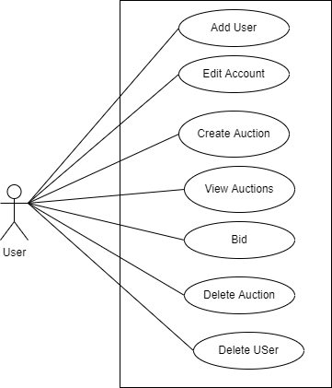

**Figure 1: USE-CASE Diagram of Online Auction System**

**Figure 1** shows the case diagram of this project. There is only one actor called user. User is allowed to create or edit account. They can also create an auction, view auctions and place bids. They can also delete auction, undo bidding and delete an account.

**ii. Non Functional Requirements**

**Availability:**

This system is developed as a web application and can be used online.

**Security:**

This system is secure, and no information will be available outside of the system for everyone’s privacy.

**Performance:**

This system is designed for smooth performance with optimization and good response.

**Reliability:**

This system has good privacy features and is reliable for users.

### 3.1.2. Feasibility Analysis

A feasibility study, as the name suggests, is designed to reveal whether a project/plan is feasible. It is an assessment of the practicality of a proposed project/plan. Feasibility of a new system means ensuring that the new system, which we implemented, is efficient and affordable. There are various types of feasibility to be determined.

**i. Technical**

The technical requirement for the system is economic, and it does not use any other additional hardware and software. This system can be operated by users with simple knowledge regarding the required technologies.

**ii. Operational**

The system working is easy to use and learn due to its simple but attractive interface. The user requires only basic training to operate this system.

**iii. Economic**

The system is economically feasible as most of the tools and resources required are cheap and easily available.

**iv. Schedule**

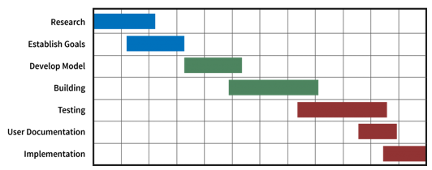

|----Week 1-4----| -----Week 5-7------|-----Week 8-10----|-Week 11-12--|

**Figure 2: Gantt chart of Online Auction System**

This project is completed realistically and achieved under a deadline. It was developed within a time limit. Hence, it is feasible in the respective schedule.

### 3.1.3. Data Modelling (ER-Diagram)

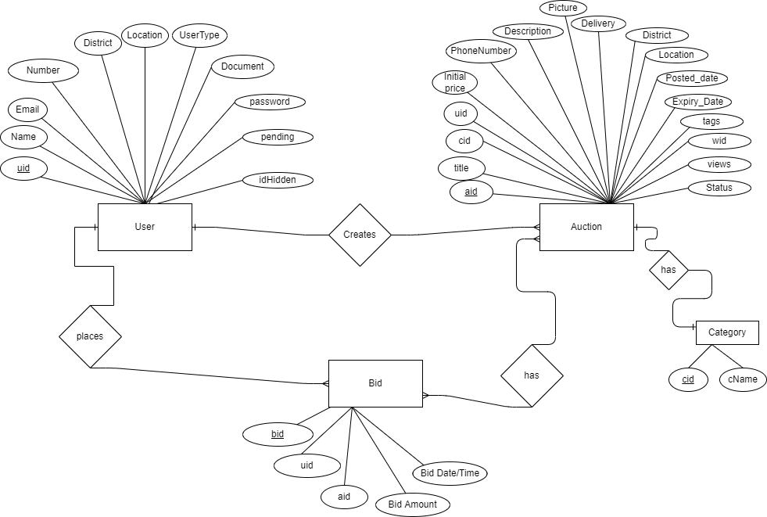

**Figure 3: ER Diagram of Online Auction System**

**Figure 3** shows ER diagram of this system named **Online Auction System.** This diagram shows four entities named Users, Auction, Category and Bid.

### 3.1.4. Process Modelling (DFD)

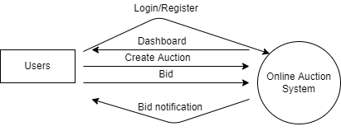

**Figure 4: Context Diagram of Online Auction System**

**Figure 4** shows context of this system named Online Auction System. This diagram shows one entity. Here user first login, then system provides them dashboard, the user can then create auction or place bid.

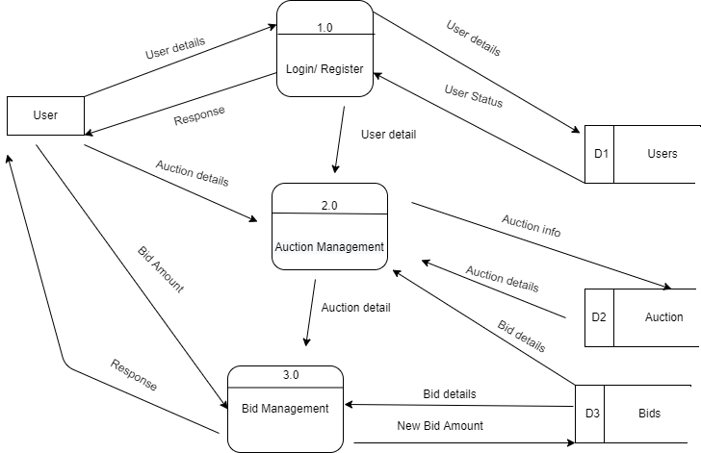

**Figure 5: Level- 1 DFD of Online Auction System**

**Figure 5**shows level-1 DFD of the Online Auction System. It shows one external entity called user. It also shows three data-store named Users, Auction, and Bids. Three different processes are also defined respectively, and the data-flow symbol is showing how every one of them is linked.

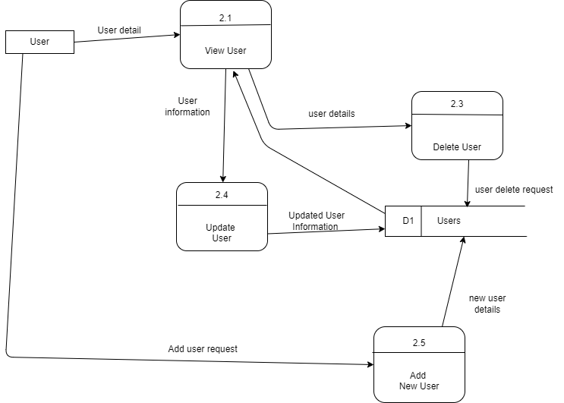

**Figure 6: Level-2 DFD of Patient Management in Online Auction System**

**Figure 6** shows the level 2 DFD diagram of the Auction Management process. It shows users can view and update details. He/she can also add or delete patients in the system.

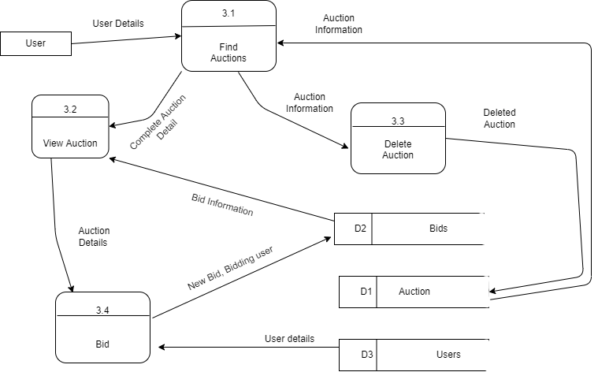

**Figure 7: Level-2 DFD of Report Management in Online Auction System**

**Figure 7** shows the level 2 DFD diagram of the Bid Management Process. It shows users can search and view or delete auctions. He/she can also place bid in them.

## 3.2. System Design

System design is the phase that bridges the gap between problem domain and the existing system in a manageable way. This phase focuses on the solution domain, i.e. "how to implement?" It is the phase where the SRS document is converted into a format that can be implemented and decides how the system will operate.

### 3.2.1. Architectural Design

**Figure 8: Architectural Design of Online Auction System**

**Figure 8 shows the architectural design of the Online Auction System. It shows three tiers called client, web, and database. The user interacts with the system from the client tier through the web browser. Web Tier, developed in PHP acts as a bridge between Client and Database tier. Database tier, developed using MySQL is used as a database.**

### 3.2.2. Database Schema Design

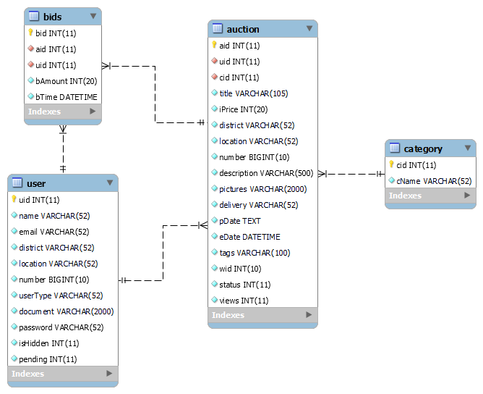

**Figure 9: Schema Design of Online Auction System**

**Figure 9** shows the schema diagram of this developed system. It consists of four tables, also known as entities. Each table contains many attributes, also known as a column, having specific data types. Every table has a primary key named ‘id’ and every table is connected with one or more tables with the help of a foreign key.

### 3.2.3. Interface Design

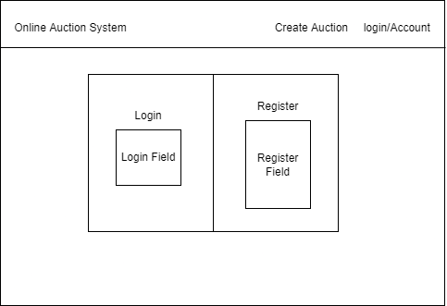

**Figure 10: Login/Register Page Interface Diagram of Online Auction System**

**Figure 10 shows the Login/Register page interface of the Online Auction System. User can Login and register from same page.**

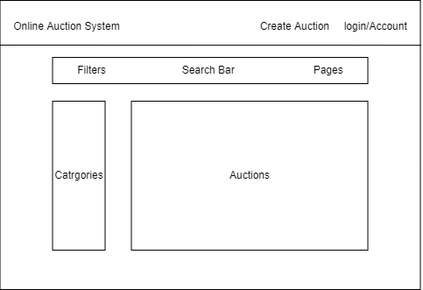

**Figure 11: Index Page Interface Design of Online Auction System**

**Figure 11 shows the index page interface of the Online Auction System.**

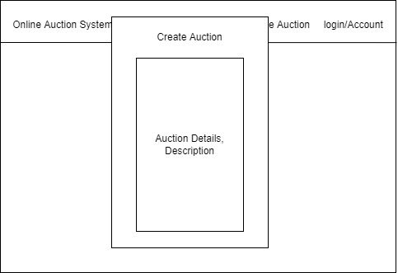

**Figure 12: Create Auction Page Interface Design of Online Auction System**

**Figure 12 shows the create auction page interface of the Online Auction System. User can create an action via this page.**

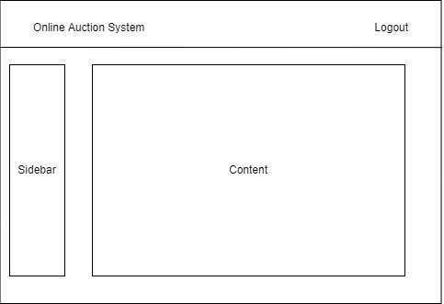

**Figure 13: Dashboard Interface Design of Online Auction System**

**Figure 13 shows the dashboard page interface of the Online Auction System. User can perform different activities via dashboard.**

### 3.2.4. Physical DFD

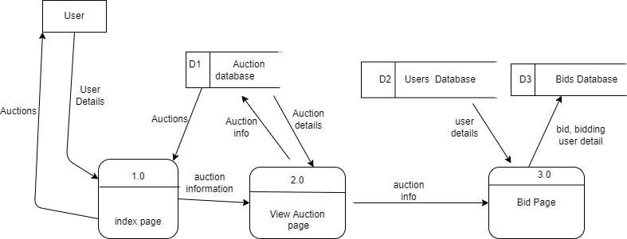

**Figure 14: Physical DFD of Online Auction System**

**Figure 10**shows the physical DFD of the Online Auction System. It shows one external entity called the user. User first goes into the index page. The user can then view or create an auction. The user can also place bid in an auction.

## 3.3. Algorithm details

Item based recommendations is one kind of recommendation method which looks for similar items based on the items users interact with. How it works is that it suggests an item similar to the item the user is looking and recommends accordingly. This solely depends on the choice of the users themselves, and the recommendations are made based on the items the user are viewing. If the similar items found are less than the items needed the algorithm suggest the items with the highest views.

Let’s understand this with an example. Suppose our user Ram wants to bid for something. Our job is to recommend him items related to the item he is currently looking. We will first know the item he is looking, let us call this item ‘A’. Next, we will search for other items similar to this item. Suppose we found out that item ‘B’, ‘C’ and ‘D’ are highly similar to ‘A’, therefore, there is a highly likely chance that Ram will also like item ‘B’, ‘C’ or ‘D’ because it is similar to one Ram is watching. Hence, we will suggest the item ‘B’, ‘C’ and ‘D’ to Ram. But if there is no any similar items as ‘A’ than we will suggest the items with highest views.

**Algorithm:**

Step-1: Start

Step-2: Set similarItems=0, A = Item user is viewing.

Step-3: similarItems += items similar to the A within same category as A.

Step-4: if similarItems >= 4, go to step-10

Step-5: similarItems += items similar to the A outside of category as A

Step-6: if similarItems >= 4, go to step-10

Step-7: similarItems += items with highest views within same category as A.

Step-8: if similarItems >= 4, go to step-10

Step-9: similarItems += items with highest views outside of category as A

Step-10: Recommend similar items

Step-11: End

**Source Code:** 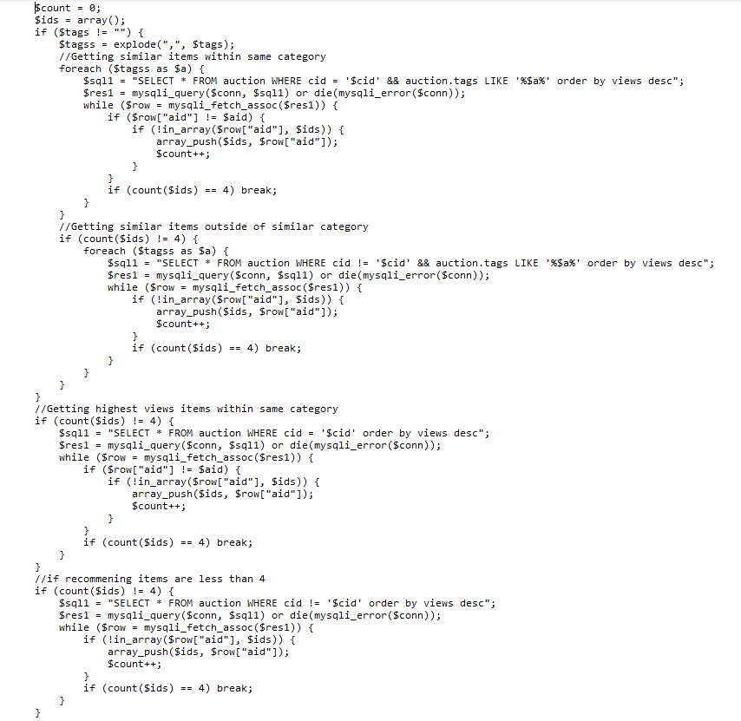

**Figure 15: Item Based Recommendation of Online Auction System**

# Chapter 4: Implementation and Testing

## 4.1. Implementation

### 4.1.1. Tools Used

**• Diagram Tool:**

The components of the system and the flow of the data and control between these components are demonstrated by diagram tools by using graphs. “Draw.io” and “Canva” are the diagram tool used in the project.

• **Web Development Tool**:

These tools assist in designing web pages with all aligned elements like forms, text, script, graphics, and so on. Visual Studio Code is used as a web development tool in the project.

The different frontend tools used for the completion of the project are:

* HTML 5
* CSS
* Bootstrap
* Javascript
* JQuery

The backend tool used for this project is:

* PHP

The database tool used for this project is:

* MySQL

The Server used for this project is:

* Apache(Xaamp 3.2.4)

### 4.1.2. Implementation Details of Modules

**Login Module:**

This module is used for verifying and logging-in registered users. It restricts unauthorized users and only allow authorized and registered users.

**Source Code:**

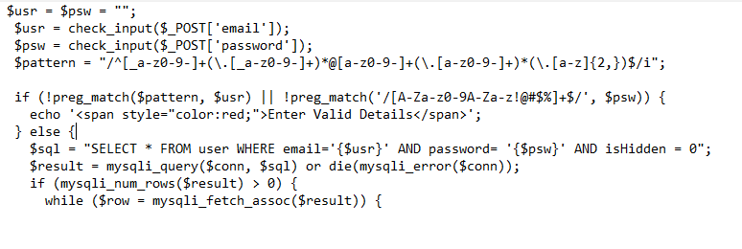

**Figure 16: Login Module of Online Auction System**

**Register Module:**

This module is used for registration of new users. This module asks basic personal detail and add/store to the system.

**Source Code:** 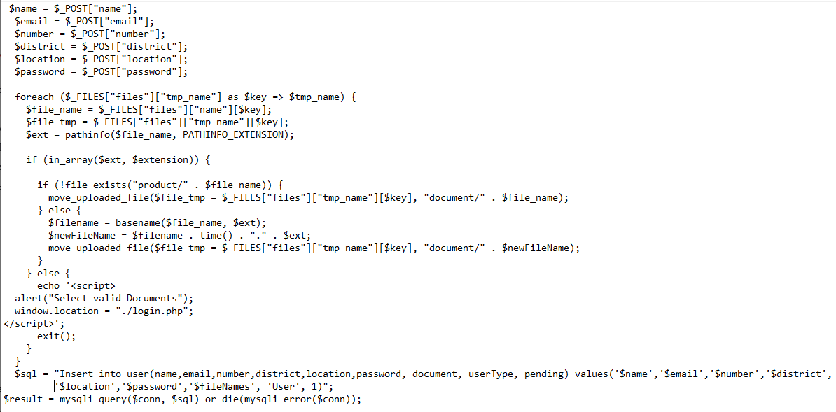

**Figure 17: Register Module of Online Auction System**

**Create Auction Module:**

This module is used for creating new Auction.

**Source Code:** 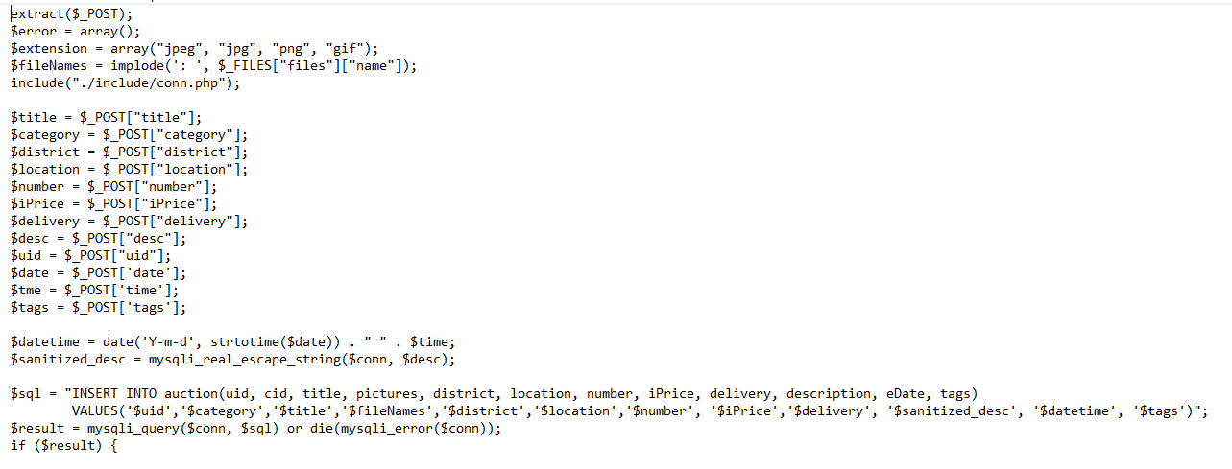

**Figure 18: Create Auction Module of Online Auction System**

**Bid Module:**

This module is used for bidding in auction. User can bid appropriate amount via this module.

**Source Code:** 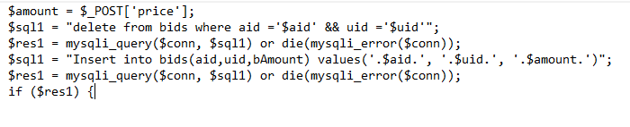

**Figure 19: Bid Module of Online Auction System**

## 4.2. Testing

In this stage, the validity of the program is checked. Testing is the process of debugging of the software that is discovering the errors or bugs and removing them. In course of testing, all algorithms used in the program are verified. Analysis on structure of programs, data flows across modules through all the possible paths and complexity of the system is undertaken.

### 4.2.1. Test Cases for Unit Testing

**Test case for logging-in with empty fields:**

Input: NULL

Expected Outcome: Fill all fields.

Obtained Outcome:

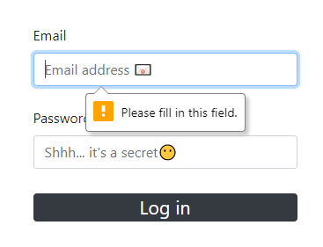

Remarks**:** Pass

**Test case for logging-in with incorrect details:**

Input: Random email and password.

Email: [aasd@gmail.com](mailto:aasd@gmail.com)

Password: aasds

Expected Outcome: Invalid details

Obtained Outcome:

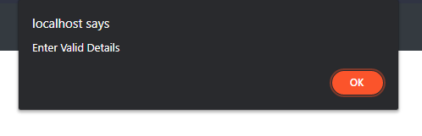

Remarks:Pass

**Test case for logging-in with correct details:**

Input: Valid email and password.

Email: [test123@gmail.com](mailto:test123@gmail.com)

Password: password

Expected Outcome: Redirect to index page

Obtained Outcome:

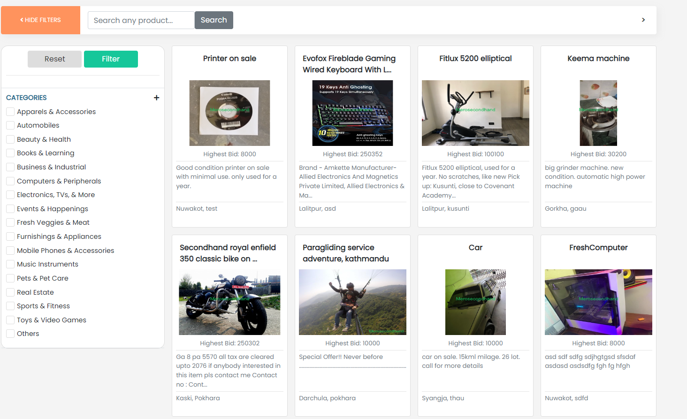

Remarks:Pass

**Test case for creating user:**

Input: User information

Expected Outcome: User Created, waiting admin approval

Obtained Outcome:

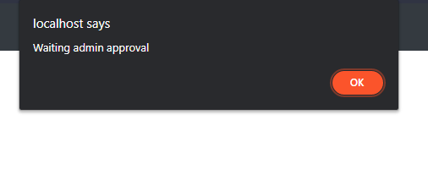

Remarks:Pass

### 4.2.2. Test Cases for System Testing

System Testing is a type of software testing that is performed on a complete integrated system to evaluate the compliance of the system with the corresponding requirements.SystemTesting is carried out on the whole system in the context of either system requirement specifications or functional requirement specifications or in the context of both.

**Test case for creating Auction:**

Input: Auction information

Expected Outcome: Auction is started

Obtained Outcome:

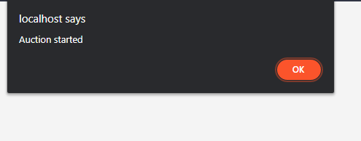

Remarks:Pass

**Test case for bidding in an auction:**

Input: Bid Amount

Expected Outcome: Bid placed successfully

Obtained Outcome: 

Remarks:Pass

**Test case for editing profile:**

Input: Users’ new information

Expected Outcome: Edit successful

Obtained Outcome: 

Remarks:Pass

**Test case for searching auctions:**

Input: Auction title

Expected Outcome: Searched entered auction

Obtained Outcome:

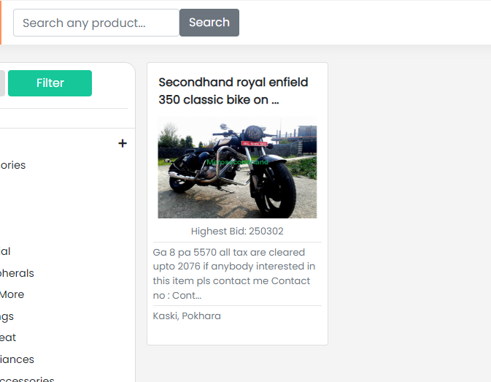

Remarks:Pass

**Test case for deleting auction:**

Input: clicked on ‘delete’ button

Expected Outcome: Auction removed from list

Obtained Outcome:

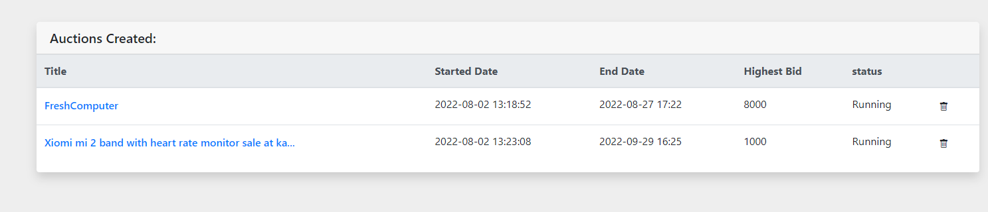

Remarks:Pass

**Test case for deleting user:**

Input: clicked on ‘delete’ button

Expected Outcome: User removed from users list

Obtained Outcome:

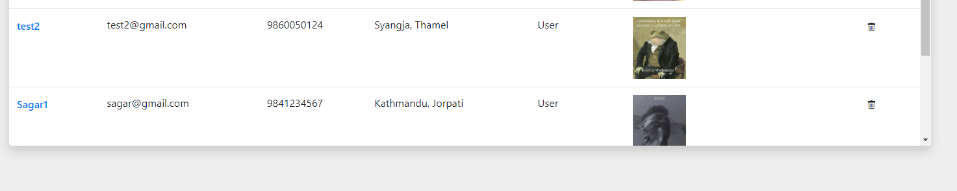

Remarks:Pass

# Chapter 5: Conclusion and Future Recommendations

## 5.1. Lesson Learnt / Outcome

While working on this project, we have learned a lot of things that are being implemented in real-world projects. Although this project was supposed to be an academic fulfilment, with the help of our teachers’ guides and time spent on this project, we have learned many more about software engineering, testing, and database management, rules to create software, time management, and better audience targeting.

Although the project has turned out to be exactly what we had imagined it to be, there are some functions that we would like to add in the forthcoming days and make it more user-friendly and competitive.

## 5.2. Conclusion

We created our system to be fully interactive, reliable, and efficient. Now system users register themselves, create an auction and place bids on them. The admin can edit users, auctions and get overall basic report.

## 5.3. Future Recommendations

Although this project is fully usable and can be used in the real world, it can be polished more with new features and great improvements. However, here are some features that we would love to add start working on:

1. Provide email facility for confirmation.
2. Provide OTP for changing password via email.
3. Add inbuilt payment facility for secure transaction.

# References:

[1]"Waterfall Model | Different Phases With Advantages & Disadvantages", *EDUCBA*, 2022. [Online]. Available: https://www.educba.com/waterfall-model/. [Accessed: 04- Aug- 2022].

[2]"Chothani, Rashesh & Patel, Nainesh & Dekavadiya, Asagarali & Patel, Punit. (2015). A Review of Online Auction and It's Pros and Cons. International Journal of Advance Engineering and Research Development. 2. 3-134.

[3]"Trevathan, Jarrod. (2007). Privacy and security in online auctions.

[4]"Networks, Crowds, and Markets: A Book by David Easley and Jon Kleinberg",

Cs.cornell.edu, 2022. [Online]. Available: http://www.cs.cornell.edu/home/kleinber/networks-book/. [Accessed: 09- Feb- 2022].

[5]"Milgrom, Paul. (1989). Auctions and Bidding: A Primer. Journal of Economic Perspectives. 3. 3-22. 10.1257/jep.3.3.3.

[6]"Ravi Bapna, Alo k Gupta, Paulo Goes, "Rep licat ing Online Yan kee Auctions to Analyse Auctioneer's and Bidder's Strategies",april 2001

[7]"Pinker, Edieal & Seidmann, Abraham & Vakrat, Yaniv. (2003). Managing Online Auctions: Current Business and Research Issues. Management Science. 49. 14571484. 10.1287/mnsc.49.11.1457.20584.

[8]"SDLC - Waterfall Model", Tutorialspoint.com, 2021. [Online]. Available: https://www.tutorialspoint.com/sdlc/sdlc_waterfall_model.htm. [Accessed: 10- Sep- 2021].

[9]"K. Kendall and J. Kendall, *Systems analysis and design*. .

[10]"L. Welling and L. Thomson, *PHP and MySQL web development*. Hoboken, NJ:

Addison-Wesley, 2017.

[11] "L. Ullman, *MySQL*. Berkeley, Calif.: Peachpit Press, 2006.

# Appendices

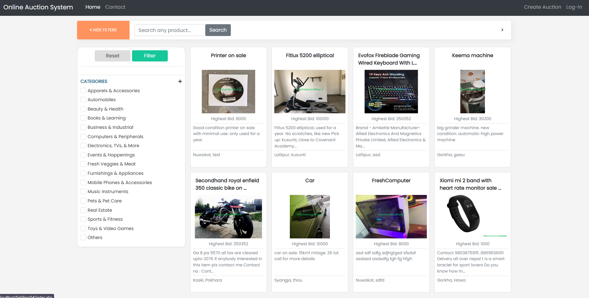

**Index Page**

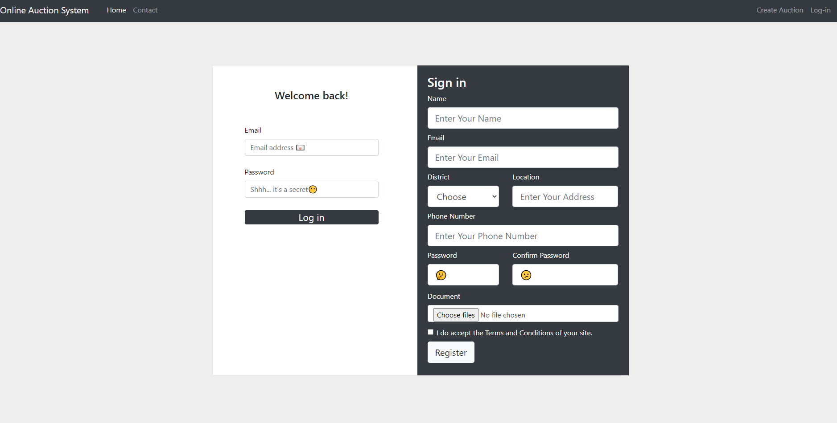

**Login/Register Page**

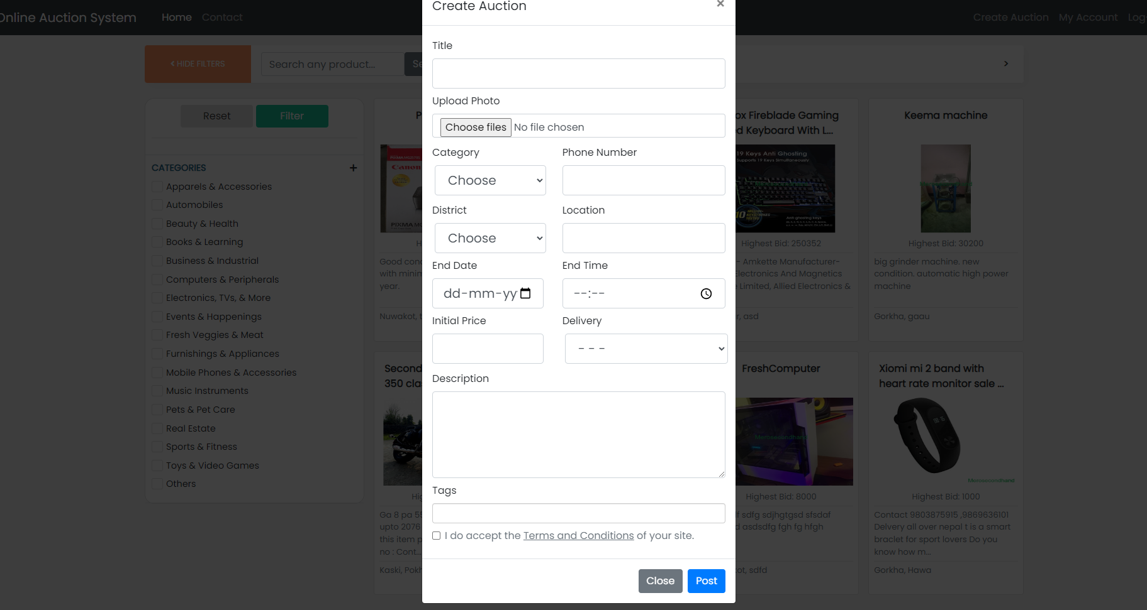

**Create Auction Page**

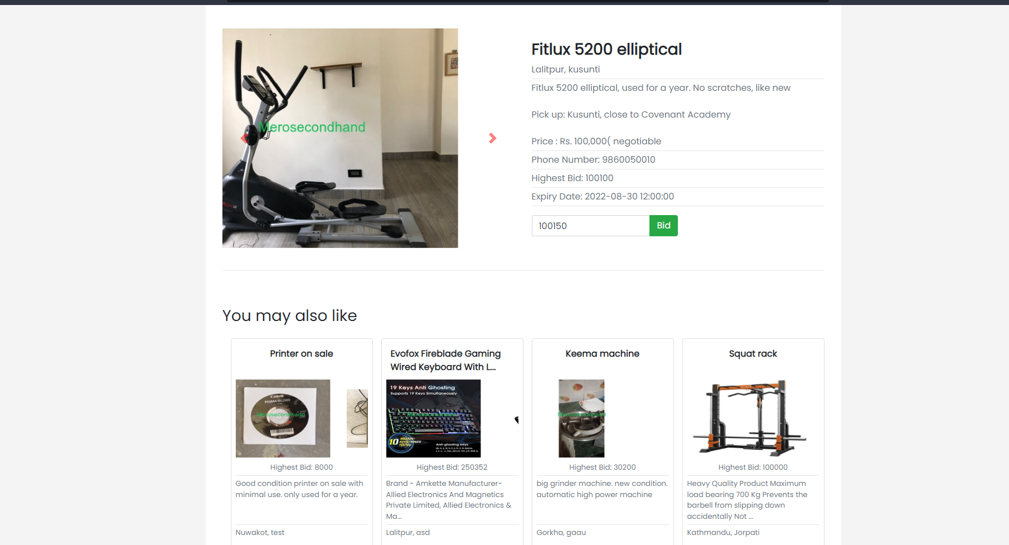

**Product Page**

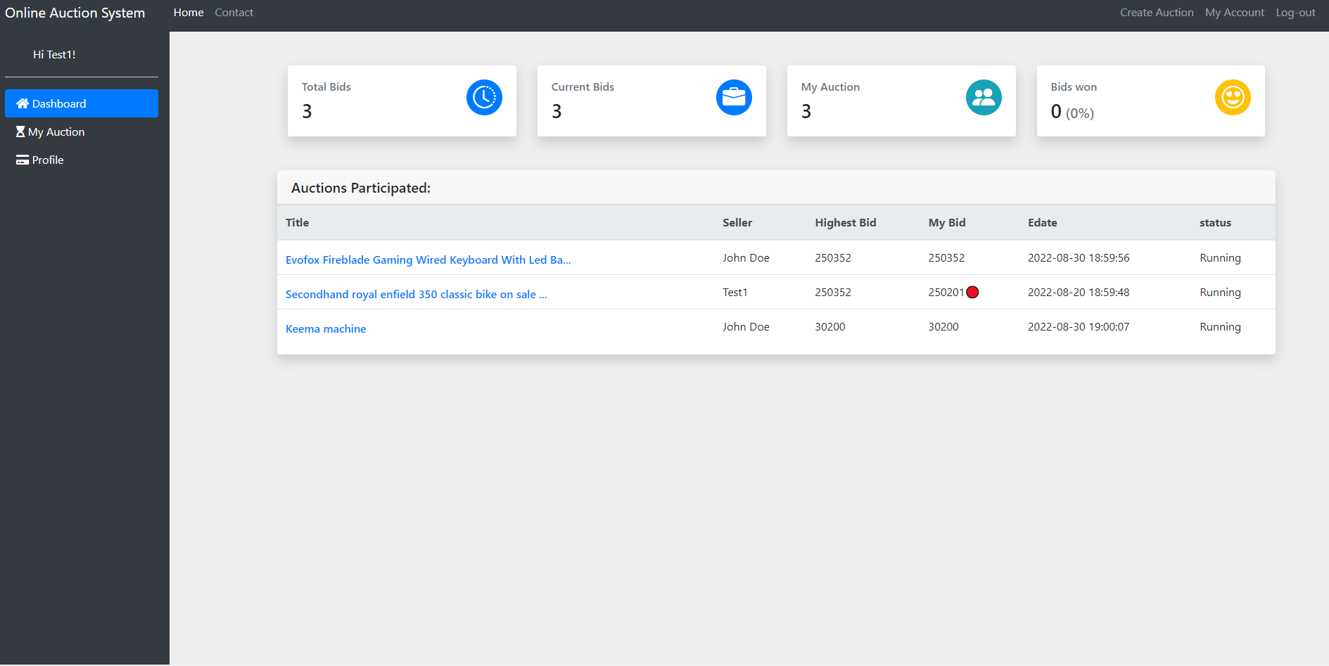

**User Dashboard Page**

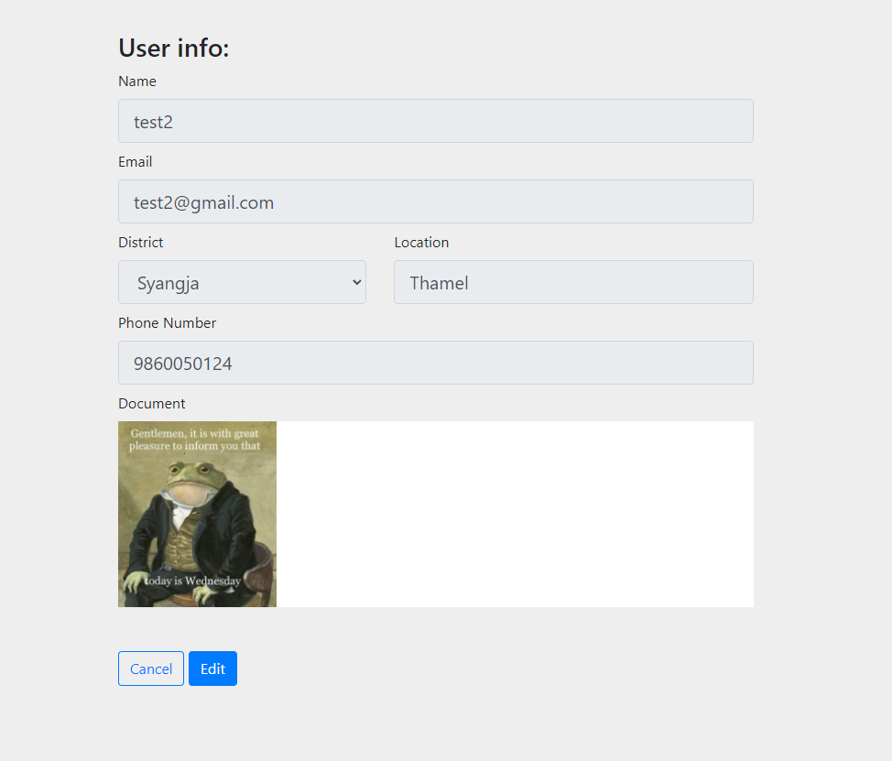

**User Edit Page**

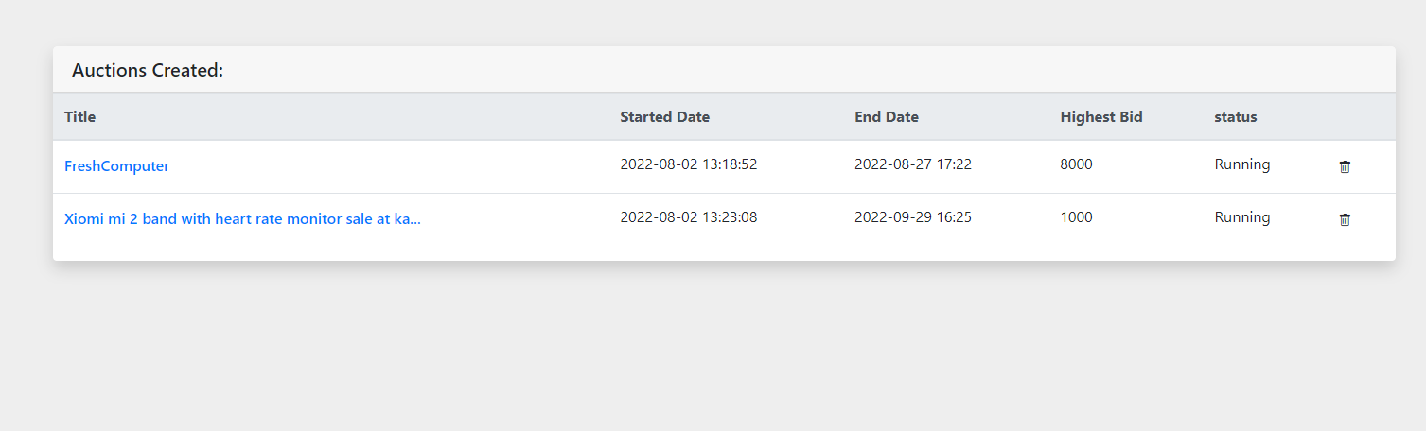 **User Auction Page**

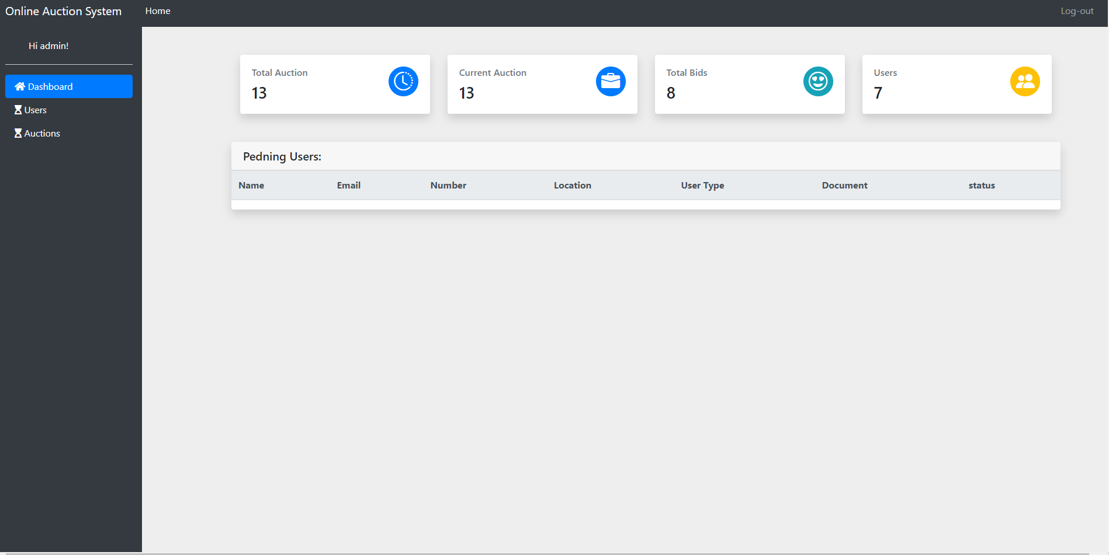

**Admin Dashboard Page**

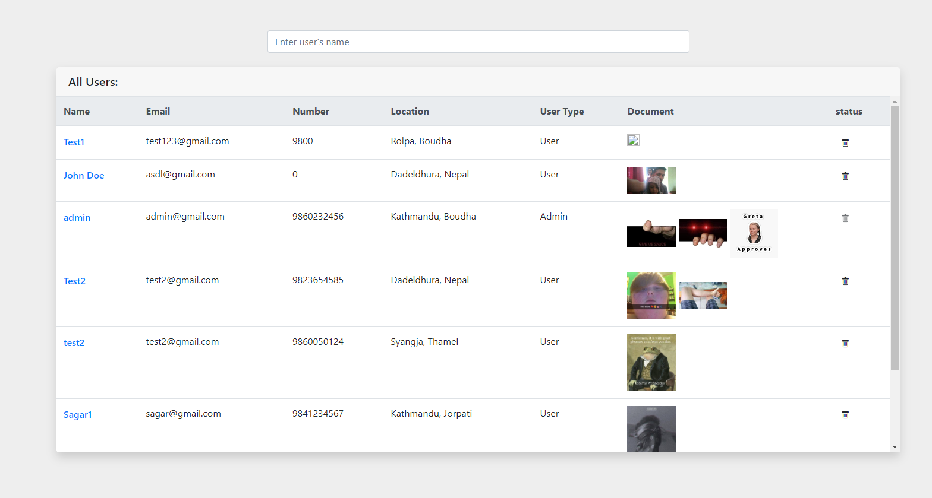

**Users Edit Page**

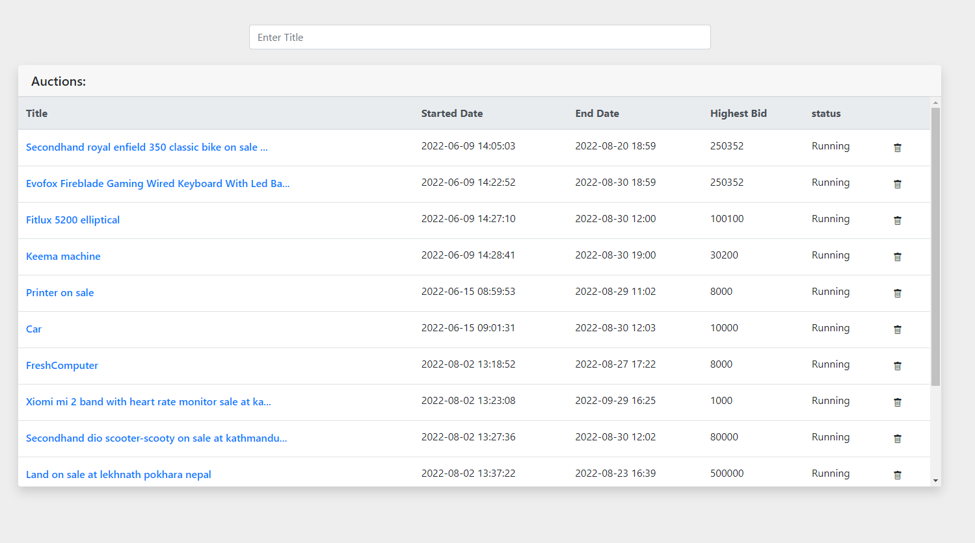

**Auctions Edit Page**