Slanje podataka iz React-a preko php scripta u Json fail

Package.json file
{
"name": "fetch-test",
"version": "0.1.0",
"private": true,
"dependencies": {
"react": "^16.4.2",
"react-dom": "^16.4.2",
"react-scripts": "1.1.4",
"whatwg-fetch": "^2.0.4"
},
"scripts": {
"start": "react-scripts start",
"build": "react-scripts build",
"test": "react-scripts test --env=jsdom",
"eject": "react-scripts eject"
},
"proxy": "http://localhost:80"
}

Slanje.js file
import React from 'react';
import 'whatwg-fetch';
class DemoComponent extends React.Component {
constructor() {
super();
this.state = {
users: {},
errors: {},
};
this.handleChange = this.handleChange.bind(this);
this.handleSubmit = this.handleSubmit.bind(this);
}
handleChange(event) {
let users = this.state.users;
let field = event.target.name;
users[field] = event.target.value;
this.setState({ users });
}
handleSubmit(event) {
event.preventDefault();
let dataURL = "http://localhost/fetchReact/server/test.php";
let h = new Headers();
let req = new Request( dataURL,{
headers: h,
method: 'POST',
body: JSON.stringify({users: this.state.users})
});
console.log(this.state.users,"users");
fetch(req)
.then((response)=>{
if(response.ok){
return response.json();
}else{
throw new Error("losa konekcija");
}
})
.then((users) =>{
alert("forma je poslata");
})
.catch( (err) =>{
console.log('Error', err.message);
});
}
render() {
return (
<div>
<form onSubmit={this.handleSubmit.bind(this)}>
<label htmlFor="name">Username </label>
<input name="name" type="text" onChange={this.handleChange} value={this.state.users["name"]} />
<br/>
<label htmlFor="password">Password</label>
<input name="password" type="password" onChange={this.handleChange} value={this.state.users["password"]} />
<br/>
<label htmlFor="age"> Age </label>
<input name="age" type="text" onChange={this.handleChange} value={this.state.users["age"]} />
<br/>
<label htmlFor="email">Email </label>
<input name="email" type="text" onChange={this.handleChange} value={this.state.users["email"]} />
<br/>
<label htmlFor="website">Website</label>
<input name="website" type="text" onChange={this.handleChange} value={this.state.users["website"]} />
<br/>
<input type="submit" value="Slanje" />
</form>
</div>
);
}
}
export default DemoComponent;

test.php file
<?php
header('Accept: application/json');
header('Access-Control-Allow-Methods: POST,GET,PUT,DELETE,OPTIONS');
header("Access-Control-Allow-Headers: eToken,X-Requested-With,Content-Type");
header('Content-type: text/json; charset=utf-8; application/json; application/x-www-form-urlencoded');
header ( 'Access-Control-Allow-Origin: *');
// ako zelimo procitati sadrzaj failaposts.json mozemo upotrebiti php kod
// readfile('./posts.json');
$podaci = json_decode(file_get_contents('php://input'), true);
$podaci['primmnjeno'] = true;
// vrati resultat da se snimnjeno
echo json_encode($podaci);
// upos rezultata u json fail
$primljeno= json_encode($podaci);
file_put_contents('posts.json', $primljeno);

Organizacija failova

Project folder
React-app folder
Public folder
Index.html

Src folder
App.js
Index.js

Package.json

Server folder
Test.php
Posts.json

Princip rada

Pripreme
Postaviti kompletnu aplikaciju (Project folder ) sa svim delovima u www folder Wamp-a u windowsu ili u httpdocs u slucaju Xamp-a I sl. Pokrenuti konzolu ili ako imate neki bolji editor( InteliJ idea ili storm) da bi se uradilo sledece:
Preci iz Project foldera u folder React-app( cd react-app)
U konzoli ili editoru uneti
Npm I
Da bi se izvrsila instalacija nepohodnih modula koje mozete videti u failu package.json.
U medju vremenu pokrenuti WAMP il ista vec imate, jer je za rad php-a porteban Apche server
Po izvrsenoj instalaciji u konzoli ili editoru startovati aplikaciju sa
Npm start

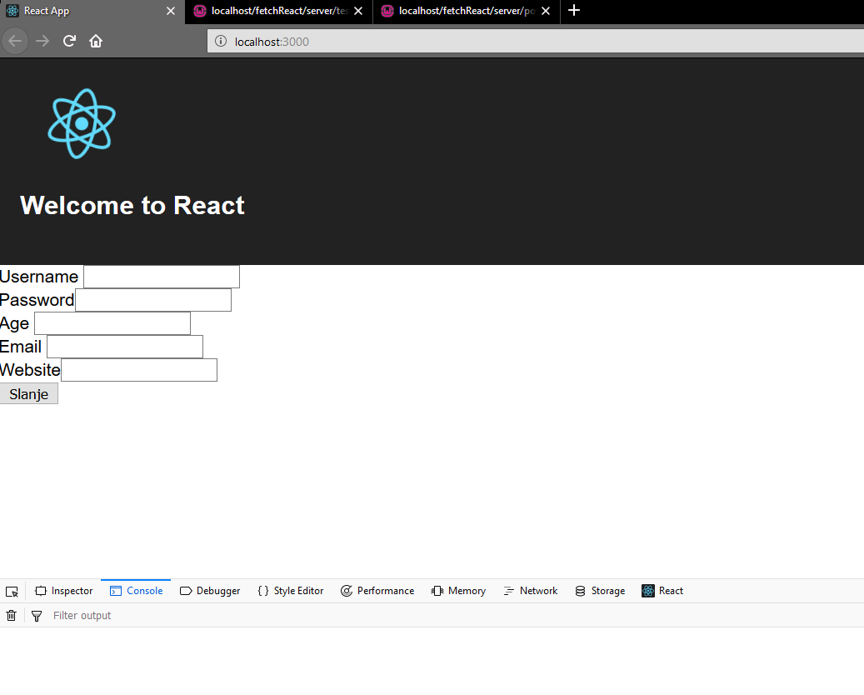
Izgled koji dobijaete na ekranu brozvsera gde unosite sve ili ono sto zelite jer nije dodata validacija

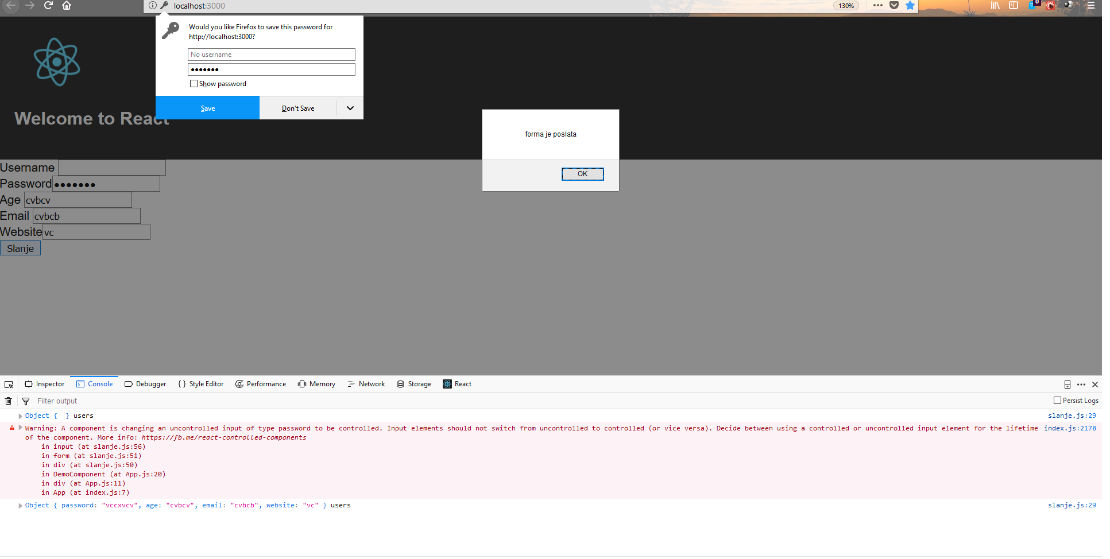

Upisano u donjem redu
Object { password: "vccxvcv", age: "cvbcv", email: "cvbcb", website: "vc" }users
Moze se videti u ciljnom posts.json failu

