Raise and Shine

I was standing on one of the biggest dance platforms, the applause of the audience encouraging in my ears when I heard a voice called my name loudly from the audience, I saw a group of people on the ground of the stage, with a smile they ask can you tell me your story? How did you get here? I took a deep breath knowing that sharing my journey might inspire others to follow their dreams as well. I closed my eyes and began to speak...

My love of dance began in 5th grade during the Dasara and Navaratri Festivals. My mother and I attended a local dance performance where the stage was lit up with twinkling lights and traditional music filled in the air. The classical dancers were mesmerising, they look beautiful in vibrant costumes with jewellery and elaborate makeup, their every movement a blend of grease and precision. I captured a video of the dance. When we returned home, with zero knowledge, I tried to practice what I had seen. My mother, noticing my enthusiasm, encouraged me to purse this passion. Despite being a middle-class family with financial concerns she enrolled me in a local dance class. That was the beginning of a journey that would define my life.

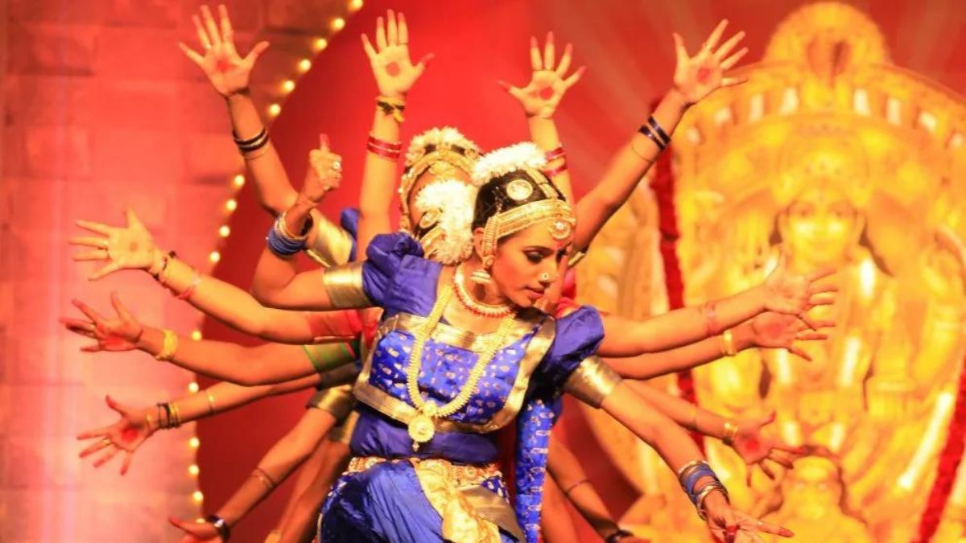

On the first day at the classical dance institute, I felt a mix of excitement and nervousness. The anticipation of learning a new art form filled me with enthusiasm. The dance institutes ambience with its mirrors and traditional decor highlighted my sense of seriousness and dedication. After completion of my first song, I felt a sense of achievement and relief. Making new friends at the institute added to my joy. Eventually my body had grown more accustomed to the demands of classical dance.

The D-Day came , I entered the stage for my debut performance (Ranga Pravesham). As I stepped onto the stage the bright lights and silent anticipation of the crowd amplified my adrenaline. Once the music started I focus on my training cluttering the rhythm guide me. Every successful moment brought me a mix of relief and joy. By the end of performance the applause from the audience was incredibly rewarding, leaving me a proposed sense of accomplishment and stronger passion for dance.

As I grow older, the path became steeper. The initial excitement of dancing turned into a strict routine that demanded discipline and dedication. I faced major challenges from my 10th grade when school and dance class schedules clashed, forcing me to balance academics and my passion of dance. This struggle continued into my higher education, where the academic workload intensified. College days were filled with back-to-back classes and hours of dance practice, requiring a master of art of time management. Despite the pressure, my unwavering determination and family’s encouragement helped me to push through. Each challenge, from the late night in library to early morning in dance studio strengthened my resolution to succeed.

The competitive world of dance was fearful and Self doubt began to creep in. I faced numerous rejections in auditions and had performances that did not go as planned. Each failure felt like a heavy blow, making me question my abilities. However, I learn many valuable lessons. Every time I feel low my mother’s words anchored in my mind **“Success isn’t about never falling, but about raising every time** **you fall”**. Gradually I learn to embrace my failures as stepping stones to success.

I started practicing as much I can. My hard work began to pay off. I started winning competitions and gaining recognition in the dance community. After graduating from the academy, I faced a daunting task of building a career. I joined in a renowned dance company and toured internationally, learning and growing with every performance.

I also decided to carry forward the art to our future generations, so I started teaching dance to underprivileged children hoping to inspire them as I had once been inspired. Seeing their eyes light up with the same passion I felt was one of the most rewarding experiences of my life.

Lastly, In this performance, I was supposed to dance while holding fire pots in my hands and on my head but while practicing for it, I got seriously injured. The doctors said I shouldn’t use the bi firepots in the performance because of it might be dangerous for me. However, I really wanted to do the dance as planned, even without the bi fire pots. So, I decided to go ahead with the performance, but without the properties. It was a big challenge because I had to rely only on my dancing skills. But I faced my fear and doubts and performed anyway. This experience showed me how strong and determined I could be when faced with difficulties. This will be my one of the most special and memorable performances.

Finally reflecting on my journey I realized every challenge and triumph has shaped who I am from balancing school and dance to overcoming injuries my part was filled with obstructers at each hurdle strengthen my resolve.

**Conclusion:**

Everybody have a hidden talent and you also have a unique talent waiting to be discovered. Financial challenges, time constraint, self doubt are all part of the process, but with dedication and creativity, you can overcome them. Surround yourself with supportive people, seeks mentors, and never lose sight of your passion.“**If I could dance my way through hurdles and find success, you can surely find your rhythm in whatever you love. Pursue your dreams with all your heart, and let your passion lead the way”.**

**By, S. Bala Sai Gayathri**