Development Environment Setup

# Applications

* GIT
* NPM, Nodejs
* MySQL 8.0 (Community)
* Visual Studio 2022 (Community)
* Visual Studio Code

# Installation

## GIT

1. Go to <https://git-scm.com/downloads> and download the latest version.
2. After downloading, start the installation.
3. Select the desired location for Git and click Next. 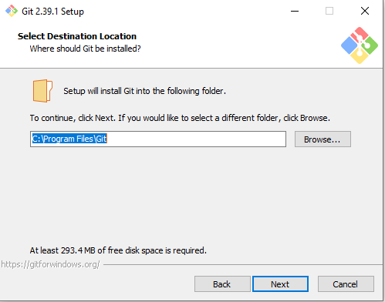
4. Leave the default selection for each page and just click Next until the app starts its installation.
5. Click Finish once it was successfully installed.

## NPM

1. Go to <https://nodejs.org/en/download/> and download the latest LTS version.
2. After downloading, start the installation process.
3. Accept the terms and agreement and select the desired location to install the app and click Next. Leave all the default values as is until you finish the installation.
4. Click Finish.

## MySQL Workbench

1. Go to <https://dev.mysql.com/downloads/workbench/> and download version 8 of MySQL Installer and start the installation after.
2. Select Developer Default as a Setup Type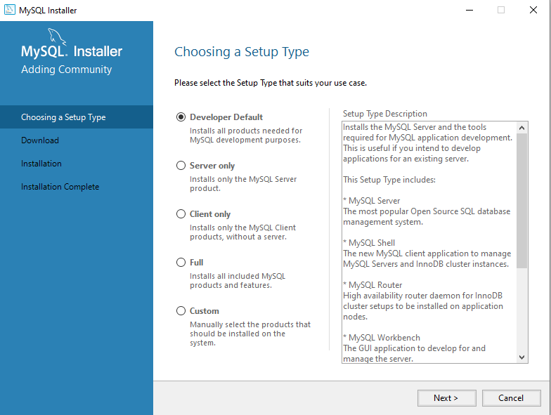
3. Proceed into the next steps of the installation until you are prompted to add a password. For the root account use **p@ssw0rd** as the root password

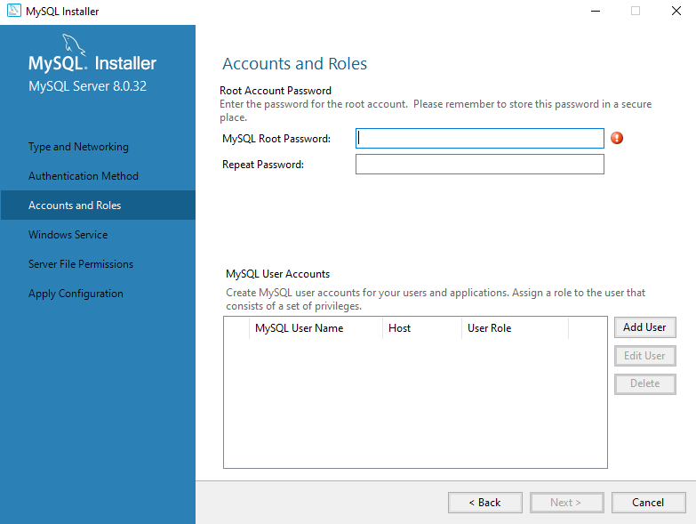

1. Leave the default values as is for the other configuration until you reach this step. Input the password you added from Step 3 and click Check. 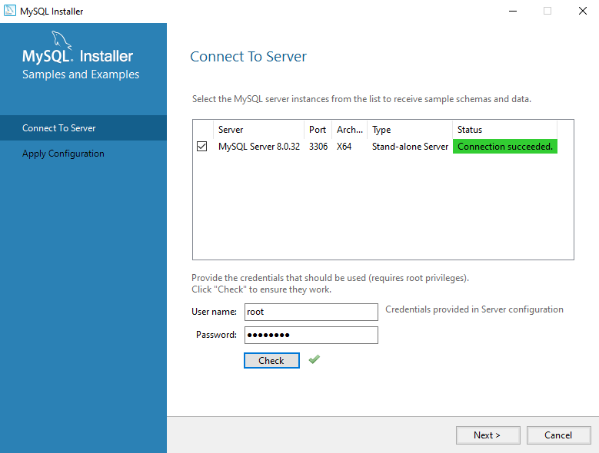
2. Proceed to the next steps by clicking Next after until you reach the Installation Complete and click Finish.

## Visual Studio & Visual Studio Code

1. Go to <https://visualstudio.microsoft.com/downloads/> and download Visual Studio 2022 Community edition.
2. Select ASP.NET and web development and click Install.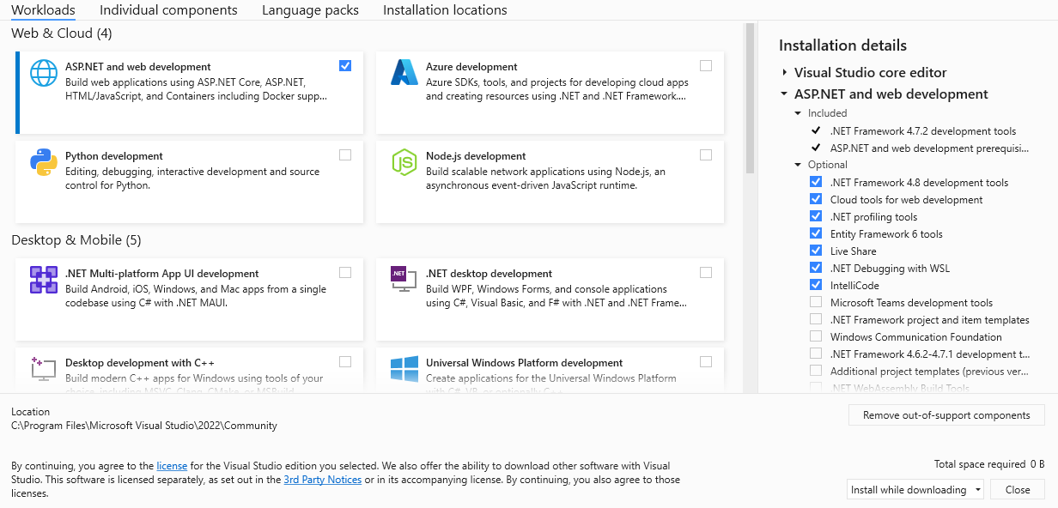
3. Once installation is done, the application will launch itself and you can select to log-in, create an account or skip it for now and proceed to starting the visual studio.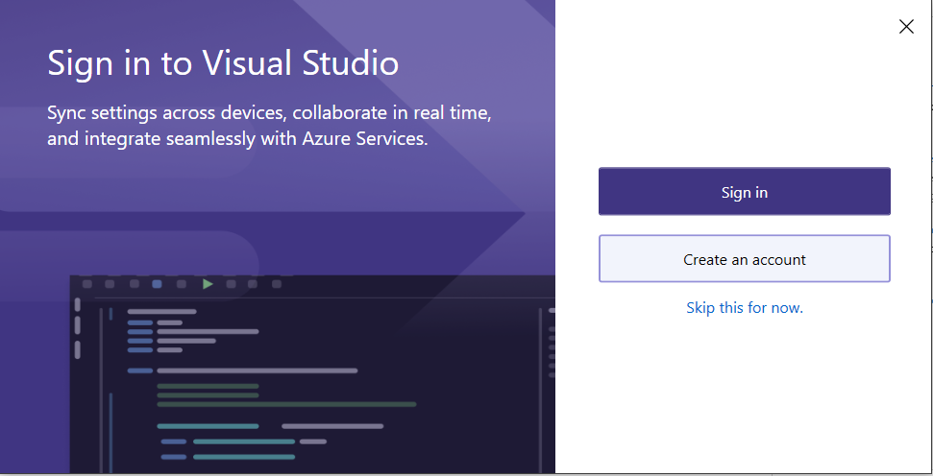
4. Using the same url from Step 1, download Visual Studio Code.
5. Select your desired location and just leave the other selection as default and proceed to installation.
6. After the installation, launch Visual Studio Code.

# Running the local environment

1. To clone the repository, open the Visual Studio and select Clone a repository. Using the given github link for the repository, input it in the Repository Location then select your desired location and click Clone.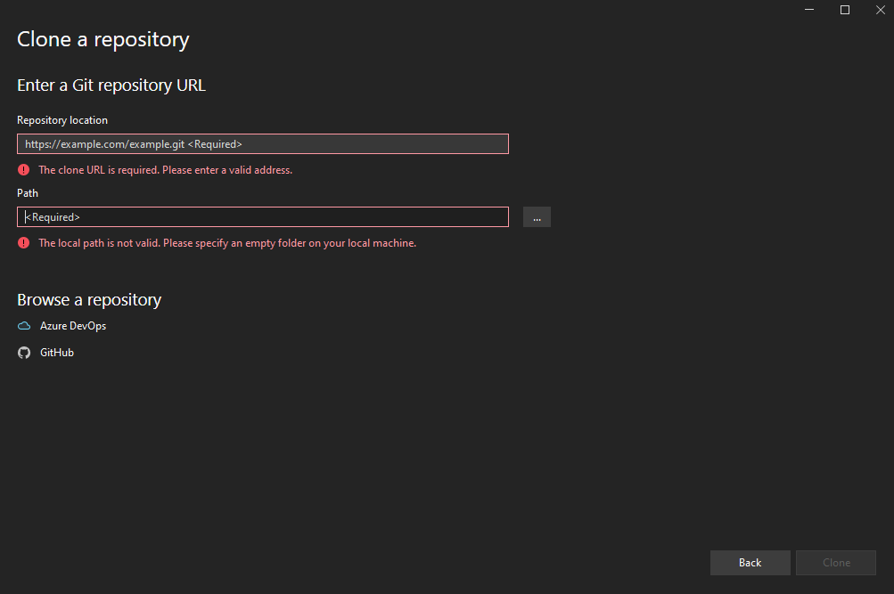
2. After cloning, make sure the solution is opened in Visual Studio.
3. To create the database, click View, Other Windows and look for the Package Manager Console.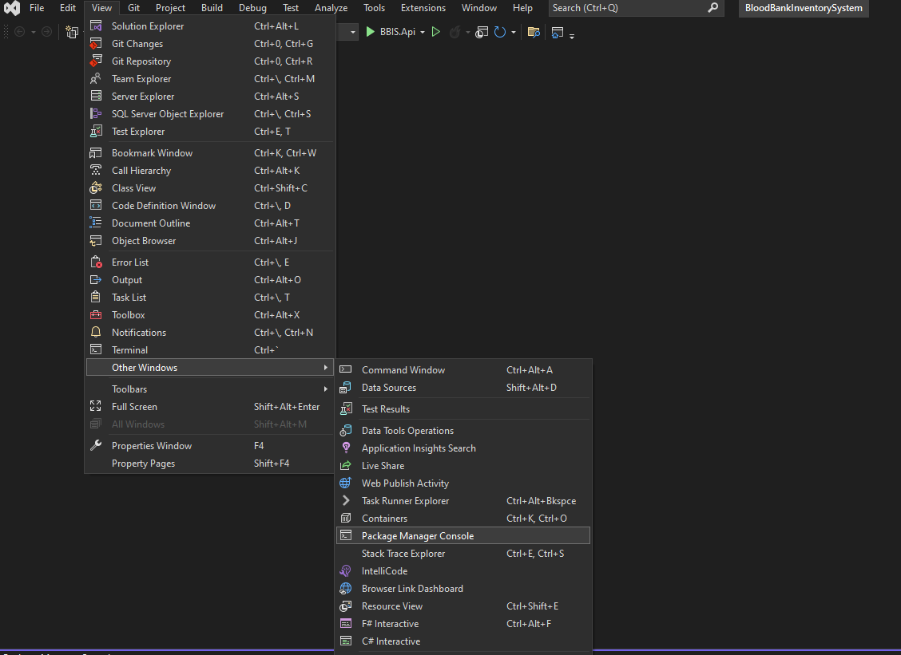
4. Select BBIS.Database in the Package Manager Console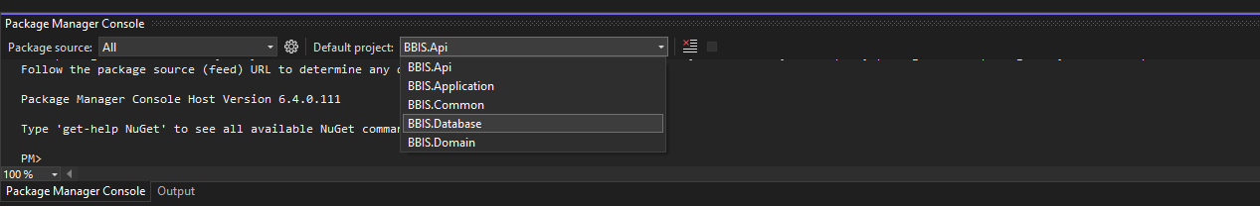
5. Type in **update-database -context BBDbContext**. 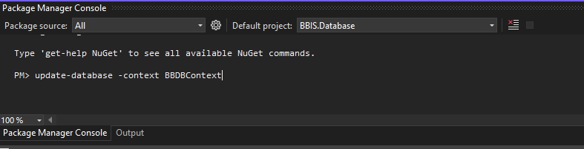
6. Once the syntax is done executing without any errors, the database **bbis** will be created automatically and can be seen in your MySQL Workbench.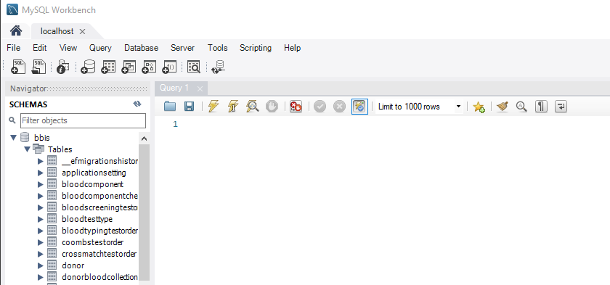
7. In your Visual Studio Code, open the vue files by clicking File in the menu, then Open Folder and look for the repository you just cloned from Step 1 and select the folder …\BloodBankInventorySystem\BBIS.Api\ClientApp.
8. Open a terminal in your Visual Studio Code by clicking Terminal in the Menu and then New Terminal.
9. Type in **npm run build** in the terminal to build the application.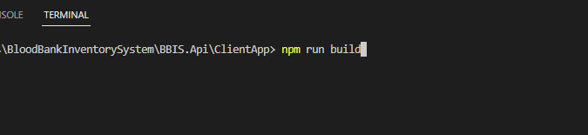
10. Go back to your Visual Studio and make sure BBIS.Api is the Startup Project. If not, do this by right clicking on it and click Set as Startup Project.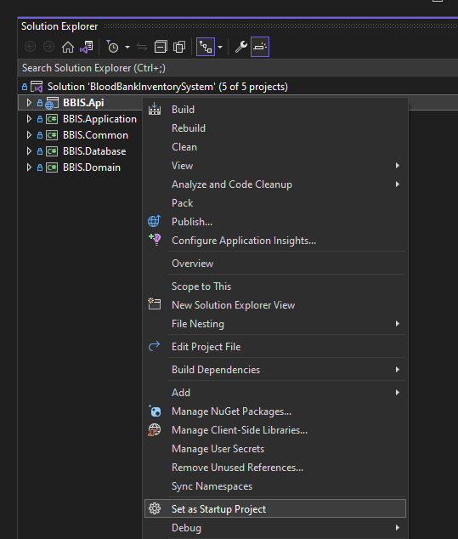
11. Press F5 or click the play button in the menu to start the application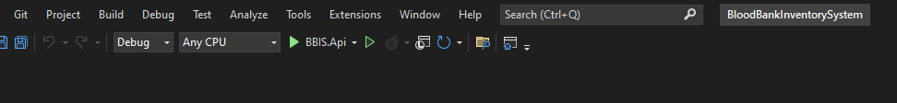
12. You will be redirect to <https://localhost:7194> and can start using the application. Credentials to use:

Username: admin

Password: @dm!n

