Help Validate Chronoacupuncture for Jet Lag
© 2026 Steven Schram PhD, DC, LAc

Introduction
Jet lag is a problem for many international travelers. Traditional interventions like sunrise viewing, strategic melatonin use, sleep strategy and meal scheduling show variable efficacy.¹ But acupuncturists propose a different approach.

Over 40 years ago, Khoe² and then Amaro³ postulated that stimulating horary points based on destination time zones during travel could help pre-synchronize organ systems to the destination time zone, targeting jet lag's circadian misalignment. Theory and anecdotal evidence say this works. Unfortunately, no studies have validated it. We aim to address that lack of evidence with an app that provides a destination based 24-hour schedule of acupuncture points for travelers to stimulate as they travel.

We invite readers planning international travel to participate.

Circadian Biology and the Western Understanding of our Internal Clocks
The scientific literature describes how circadian rhythms synchronize physiological processes to a 24-26 hour cycle through the suprachiasmatic nucleus (SCN), a cluster of neurons entrained by light.^{4,5} The SCN coordinates peripheral clocks in organs like the liver and heart and tissue-specific functions such as vascular and blood pressure regulation.^{6,7} Then, clock genes drive a molecular feedback loop, producing rhythmic gene expression.⁸ This synchronization is maintained by zeitgebers, external signals such as light, temperature, activity, and meals. ⁹

We end up with jet lag when rapid time zone changes desynchronize these internal clocks.

A 2024 comprehensive review shows that acupuncture significantly affects circadian biology, demonstrating measurable impacts on circadian clock genes, neurotransmitter regulation, and sleep-wake cycles.¹⁰. While these studies employed acupuncture points known to assist with sleep, they establish the neurobiological plausibility of acupuncture serving as a non-photic zeitgeber for circadian rhythm modulation.

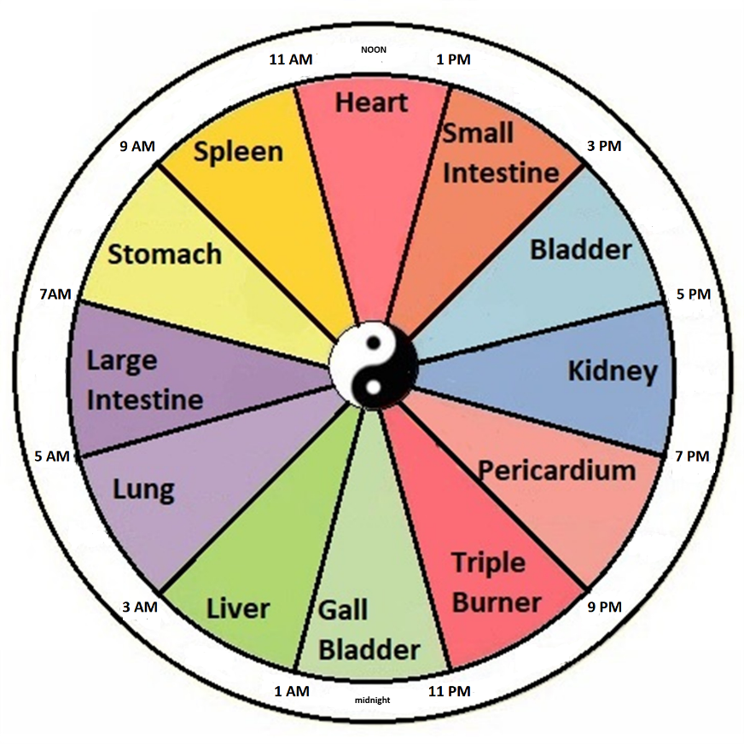
Figure 1: 24-hour Organ Clock

Table 1: 24-hour Schedule
Time Range | Meridian / Organ System | Horary -> Suggested Point
3:00 AM – 5:00 AM | Lung | LU-8
5:00 AM – 7:00 AM | Large Intestine | LI-1
7:00 AM – 9:00 AM | Stomach | ST-36
9:00 AM – 11:00 AM | Spleen | SP-3 -> SP-10*
11:00 AM – 1:00 PM | Heart | HT-8
1:00 PM – 3:00 PM | Small Intestine | SI-5
3:00 PM – 5:00 PM | Bladder | BL-66 -> BL-2*
5:00 PM – 7:00 PM | Kidney | KI-10 -> KI-27*
7:00 PM – 9:00 PM | Pericardium | PC-8
9:00 PM – 11:00 PM | San Jiao (Triple Warmer) | SJ-6
11:00 PM – 1:00 AM | Gallbladder | GB-41 -> GB-20*
1:00 AM – 3:00 AM | Liver | LIV-1 -> LIV-8*
Table 1
The * suggested points are modifications implemented for practical accessibility.

Point Changes for Practical Accessibility
While Amaro recommended stimulating the horary points on each meridian, initial testers of the app who were flying economy class were hesitant to remove shoes to stimulate ankle and foot points. Our solution was to use alternative channel points to replace “inaccessible” points understanding that it would be better to stimulate channel with a “non-ideal” yet accessible point rather than skip the channel altogether.

For practicality and ease of location, we chose to use SP-10 (above the knee) for SP-3, BL-2 (inner eyebrow) for BL-66, GB-20 (back of head) for GB-41, LIV-8 (medial knee) for LIV-1, and KI-27 (upper chest) for KI-10. In TCM theory, any point on a meridian can affect the entire pathway and this substitution maintains meridian specificity.

How to participate

On your iPhone, go here https://jetlagpro.com/#download to get the app. Detailed instructions are provided on the website. This research app is entirely free with no add-ons, upgrades or advertisements. As an incentive, participants who use the app for a valid journey and complete the survey will enjoy free lifetime access.

Once you have the app installed, follow the simple directions to receive timing and instructions. If you have questions, email info@jetlagpro.com.

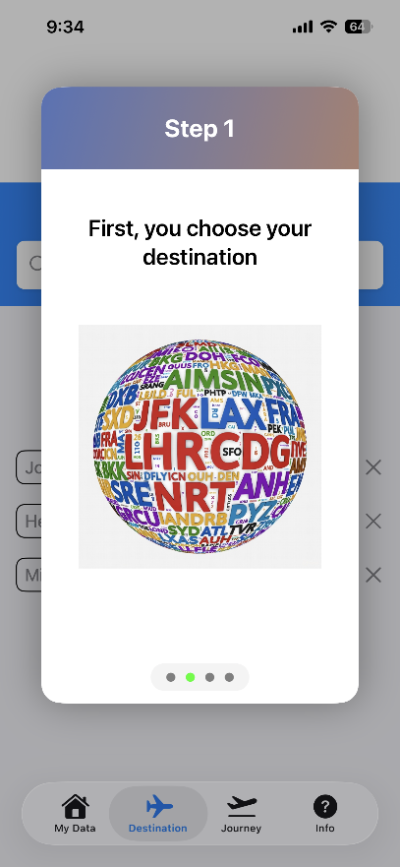 | 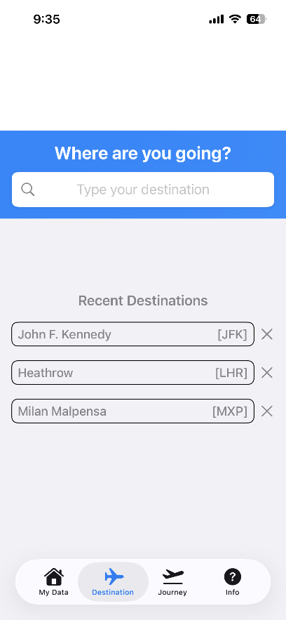 | 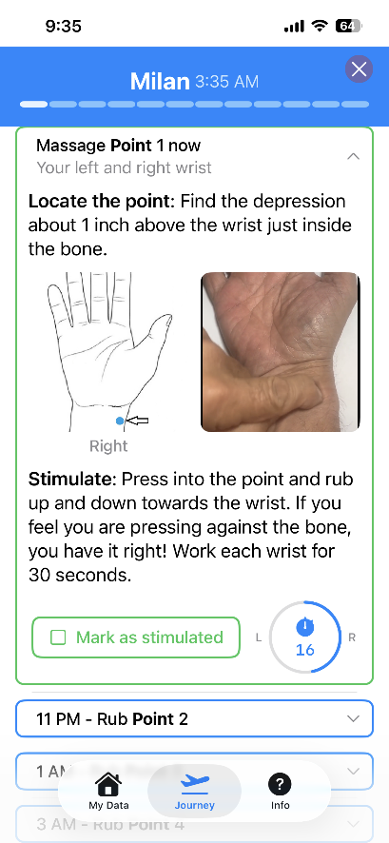

Figure 2 – The Three Steps

Scheduled reminders pop up over the next 24 hours to prompt the traveler to do the next point. The reminders are persistent and remain on the user's phone (or iWatch) until clicked. When clicked, the traveler is shown the correct point image beside a looping video showing how to stimulate the point.

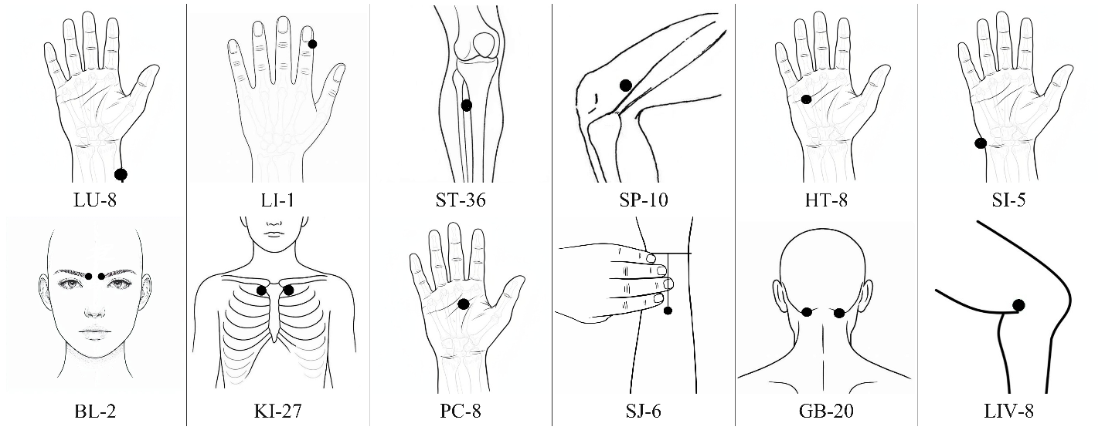

Figure 3 – Point Images

After the trip ends, the app saves point stimulation data along with origin and arrival time zones to a central database. Then a survey reminder is the scheduled for 2 days later. This survey is a streamlined assessment based on the Liverpool Jet Lag Questionnaire's core symptom domains.

Data Analysis
Our primary question is “Does chronoacupuncture (as provided by the app) reduce jet lag symptoms as compared to no intervention?” We will compare survey results to baseline severity data from Waterhouse et al.'s 2007 comprehensive quantitative assessment¹. Participants will be grouped by the number of acupressure points along with time zones crossed.

Discussion
Traditional clinical trials face significant challenges in jet lag research because they cannot control countless travel variables, including demographics and environmental factors. In this study, these uncontrolled variables do not undermine validity because the expected sample size of point usage data and survey results will provide sufficient statistical power to detect meaningful effects.

References
- Waterhouse, J., Reilly, T., Atkinson, G., & Edwards, B. (2007). Jet lag: Trends and coping strategies. The Lancet, 369(9567), 1117–1129. https://doi.org/10.1016/S0140-6736(07)60529-7
- Khoe, W.H. (1978). Treatment of jet lag syndrome by acupuncture. American Journal of Acupuncture, 6(2), 135–139.
- Amaro, J. (2001). Time Travel: Contemporary Applications for Jet Lag from Ancient Principles. Acupuncture Today, October 2001. https://acupuncturetoday.com/article/27861-time-travel-contemporary-applications-for-jet-lag-from-ancient-principles
- Panda, S. (2022). Foundations of circadian medicine. PLoS Biology, 20(3), e3001567. https://doi.org/10.1371/journal.pbio.3001567
- Honma, S., & Honma, K.I. (2019). The mammalian circadian timing system and the suprachiasmatic nucleus as its pacemaker. Biology, 8(1), 13. https://doi.org/10.3390/biology8010013
- Paschos, G.K., & FitzGerald, G.A. (2010). Circadian clocks and vascular function. Circulation Research, 106(5), 833-841. https://doi.org/10.1161/CIRCRESAHA.109.211706
- Hastings, M. H., et al. (2003). A clockwork web: circadian timing in brain and periphery. Nature Reviews Neuroscience, 4(8), 649–661. https://doi.org/10.1038/nrn1177
- Nangle, S. N., Rosensweig, C., Koike, N., Tei, H., Takahashi, J. S., Green, C. B., & Zheng, N. (2014). Molecular assembly of the period-cryptochrome circadian transcriptional repressor complex. eLife, 3, e03674. https://doi.org/10.7554/eLife.03674
- Heyde, I., & Oster, H. (2019). Differentiating external zeitgeber impact on peripheral circadian clock resetting. Scientific Reports, 9, 20114. https://doi.org/10.1038/s41598-019-56323-z
- Wu, J., & Zhao, Z. (2024). Acupuncture in circadian rhythm sleep–wake disorders and its potential neurochemical mechanisms. Frontiers in Neuroscience, 18, 1346635. https://doi.org/10.3389/fnins.2024.1346635

