Chronoacupuncture for Jet Lag: A Pilot Study Seeking Participants

The Jet Lag Problem
Jet lag affects over 90 percent of long-haul travelers, creating a significant public health challenge with substantial economic implications. The condition disrupts sleep-wake cycles, impairs cognitive function, reduces productivity and compromises overall well-being. Symptoms typically include fatigue, insomnia, gastrointestinal disturbances, difficulty concentrating and mood alterations that can persist for days or weeks after travel.
Current management strategies include light therapy, melatonin supplementation, strategic sleep scheduling and dietary modifications. However, these approaches show variable efficacy and individual responses differ widely. Some travelers adapt quickly while others experience prolonged disruption, particularly when crossing multiple time zones or traveling eastward. The lack of consistently effective interventions underscores the need for alternative approaches.

Circadian Biology: The Science of Internal Clocks
Modern science has revealed that virtually every cell in the human body operates on a 24-hour circadian rhythm. The suprachiasmatic nucleus (SCN), a cluster of approximately 20,000 neurons in the hypothalamus, serves as the master circadian pacemaker, coordinating physiological processes throughout the body.² The SCN receives direct input from specialized retinal cells containing melanopsin, a light-sensitive protein that synchronizes the master clock with external day-night cycles.
Beyond the central SCN, peripheral clocks exist in organs throughout the body – the liver, heart, lungs, kidneys and gastrointestinal tract each maintain their own molecular timepieces. These peripheral clocks coordinate tissue-specific functions including metabolism, hormone secretion, immune responses and cellular repair. Core clock genes – Clock, Bmal1, Period (Per1, Per2, Per3) and Cryptochrome (Cry1, Cry2) – drive a molecular feedback loop that creates approximately 24-hour oscillations in gene expression and cellular function.³
Jet lag occurs when rapid time zone transitions create a mismatch between the body's internal circadian clocks and the external environment. The SCN continues operating on departure time while the destination operates on a different schedule. This desynchronization affects multiple systems: sleep-wake cycles misalign with local day-night patterns, hormonal rhythms (cortisol, melatonin) remain on departure time, digestive processes continue on the original schedule, and cognitive performance patterns become disrupted.
The body naturally adapts to new time zones, but this process typically requires one to two days per time zone crossed. During this adaptation period, travelers experience the constellation of symptoms we recognize as jet lag. The scientific understanding of circadian biology provides a framework for understanding how timing-based interventions might facilitate faster adaptation.

Traditional Chinese Medicine: A Temporal Understanding
Traditional Chinese Medicine has incorporated temporal organization into its theoretical framework for thousands of years. The Chinese Organ Clock, documented in classical texts such as the Huangdi Neijing (Yellow Emperor's Inner Canon), describes a 24-hour cycle where vital energy (Qi) flows through 12 primary meridians in a predictable sequence.¹ Each meridian and its associated organ system reaches peak activity during a specific two-hour window.
Within each meridian, specific acupuncture points are classified according to the Five Element theory. Points are designated as Wood, Fire, Earth, Metal or Water points based on their position and function within the meridian system. On Yin channels, the elemental progression runs from distal to proximal as: Wood → Fire → Earth → Metal → Water. On Yang channels, the progression is: Metal → Water → Wood → Fire → Earth.
This systematic distribution creates horary points – where the elemental nature of the point matches the elemental nature of its associated meridian. When elemental matching occurs, the point demonstrates heightened potency for influencing the meridian's function. During the meridian's peak activity period according to the Chinese Organ Clock, these horary points become particularly exalted in their therapeutic potential.

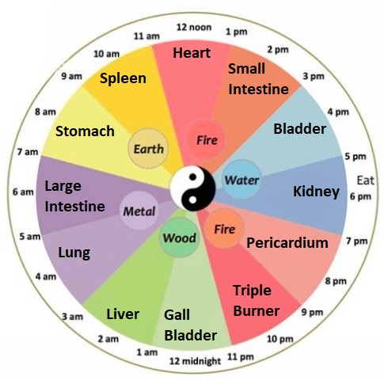
Figure 1: Chinese Organ Clock

Table 1: Horary Points and Chinese Organ Clock Schedule
Time Range | Meridian / Organ | Horary Point
3:00 AM – 5:00 AM | Lung | LU-8
5:00 AM – 7:00 AM | Large Intestine | LI-1
7:00 AM – 9:00 AM | Stomach | ST-36
9:00 AM – 11:00 AM | Spleen | SP-3
11:00 AM – 1:00 PM | Heart | HT-8
1:00 PM – 3:00 PM | Small Intestine | SI-5
3:00 PM – 5:00 PM | Bladder | BL-66
5:00 PM – 7:00 PM | Kidney | KI-3*
7:00 PM – 9:00 PM | Pericardium | PC-8
9:00 PM – 11:00 PM | San Jiao (Triple Warmer) | SJ-6
11:00 PM – 1:00 AM | Gallbladder | GB-41
1:00 AM – 3:00 AM | Liver | LIV-1
*KI-3 (Kidney Source point) substituted for KI-10 (Kidney horary point) for practical accessibility during travel.

The integration of elemental matching with temporal organization creates the foundation for chronoacupuncture. Horary points represent the most potent acupuncture points on each meridian during its peak activity period. When stimulated at the optimal time according to the Chinese Organ Clock, these points demonstrate maximum efficacy for influencing the meridian's function and the associated organ system.
For practical accessibility during travel, we substituted KI-3 (Kidney Source point) for KI-10 (Kidney horary point). While horary points excel due to elemental correspondence with their meridian, Source points are ideal for tonifying or sedating the corresponding organ. Since KI-10's location behind the knee is difficult to find and stimulate effectively, especially in confined aircraft seating, KI-3 at the medial ankle serves as an essentially equivalent point that maintains meridian specificity while optimizing real-world usability.

The Evidence Gap
Over 40 years ago, practitioners Khoe and Amaro postulated that stimulating horary points sequentially during travel, aligned with destination time zones, could help pre-synchronize organ systems to new time zones, targeting jet lag's circadian misalignment. While jet lag was unknown in ancient times, the time theory of acupuncture meridians was documented and understood in terms of the cyclical nature of all body functions including digestion, activity and rest.
Many acupuncturists report using horary points for jet lag management for decades, and the approach has been advocated in professional publications. However, despite widespread anecdotal use and theoretical support, no systematic studies have validated the efficacy of chronoacupuncture for jet lag. This represents a significant gap between traditional practice and evidence-based medicine.
Recent research demonstrates that acupuncture significantly affects circadian biology through measurable impacts on circadian clock genes, neurotransmitter regulation and sleep-wake cycles.⁷ While these studies employed general acupuncture points known to assist with sleep issues rather than the horary point methodology, they establish the neurobiological plausibility of acupuncture serving as a non-photic zeitgeber for circadian rhythm modulation.
The absence of systematic evaluation means that practitioners cannot confidently recommend chronoacupuncture based on evidence, and the broader medical community remains unaware of this potential intervention. This pilot study aims to address this evidence gap through systematic data collection and analysis.

The Pilot Study: Methodology and Mobile Application
This pilot study represents the first systematic investigation of chronoacupuncture for jet lag management. The research uses a mobile application as a research instrument that guides participants through timed acupressure stimulation of horary points based on destination time zones. The study design prioritizes external validity by evaluating the intervention under real-world travel conditions rather than controlled laboratory settings.
The study protocol involves travelers using the research application to receive prompts for self-administered acupressure stimulation. Starting at the airport or anytime during travel, participants select their destination. The research application identifies the active horary point matching the destination's current time and provides visual guidance for point location and stimulation technique. Scheduled reminders appear at appropriate times, prompting participants to complete a full 24-hour cycle of point stimulation.

Figure 2: Mobile Application Interface
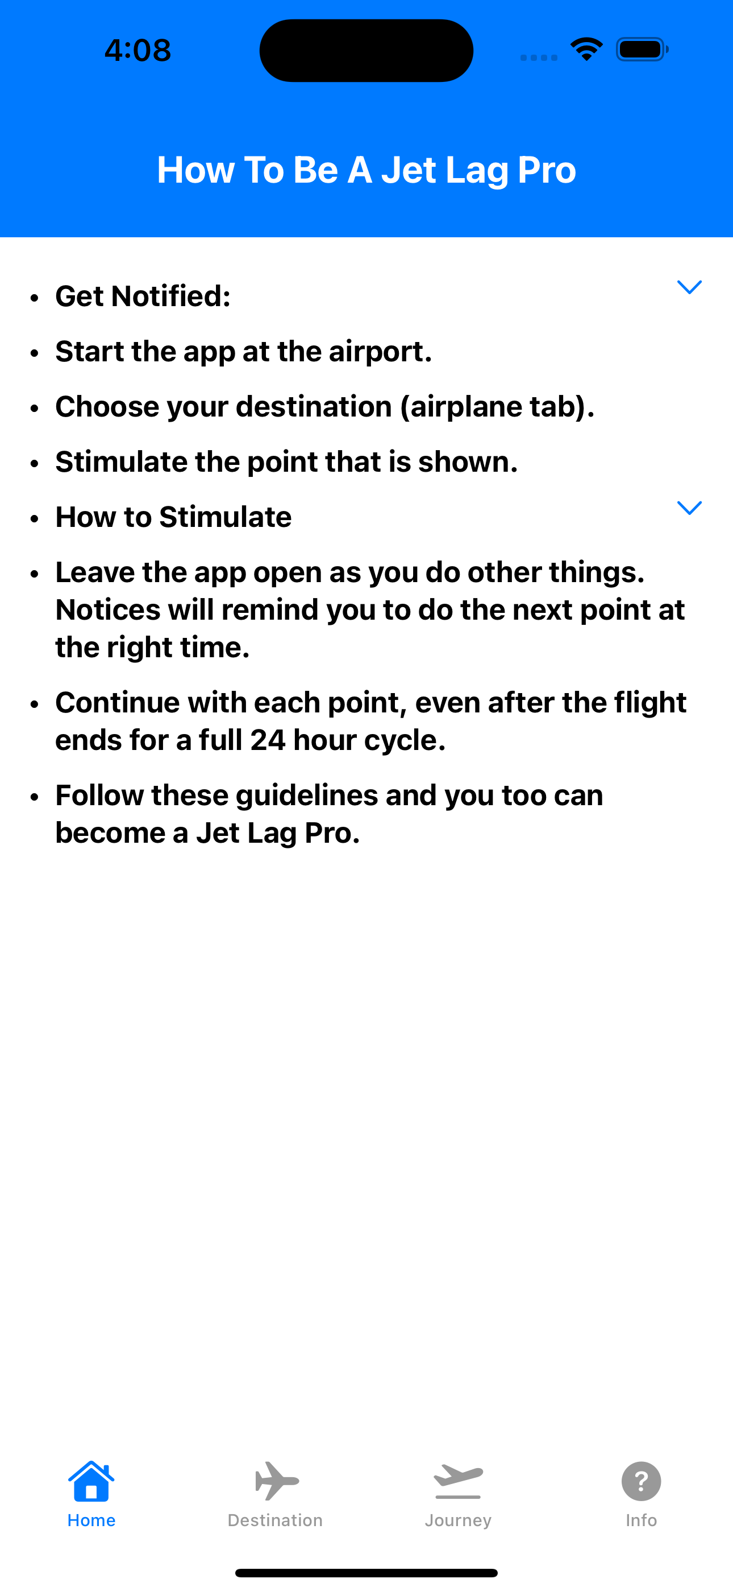 | 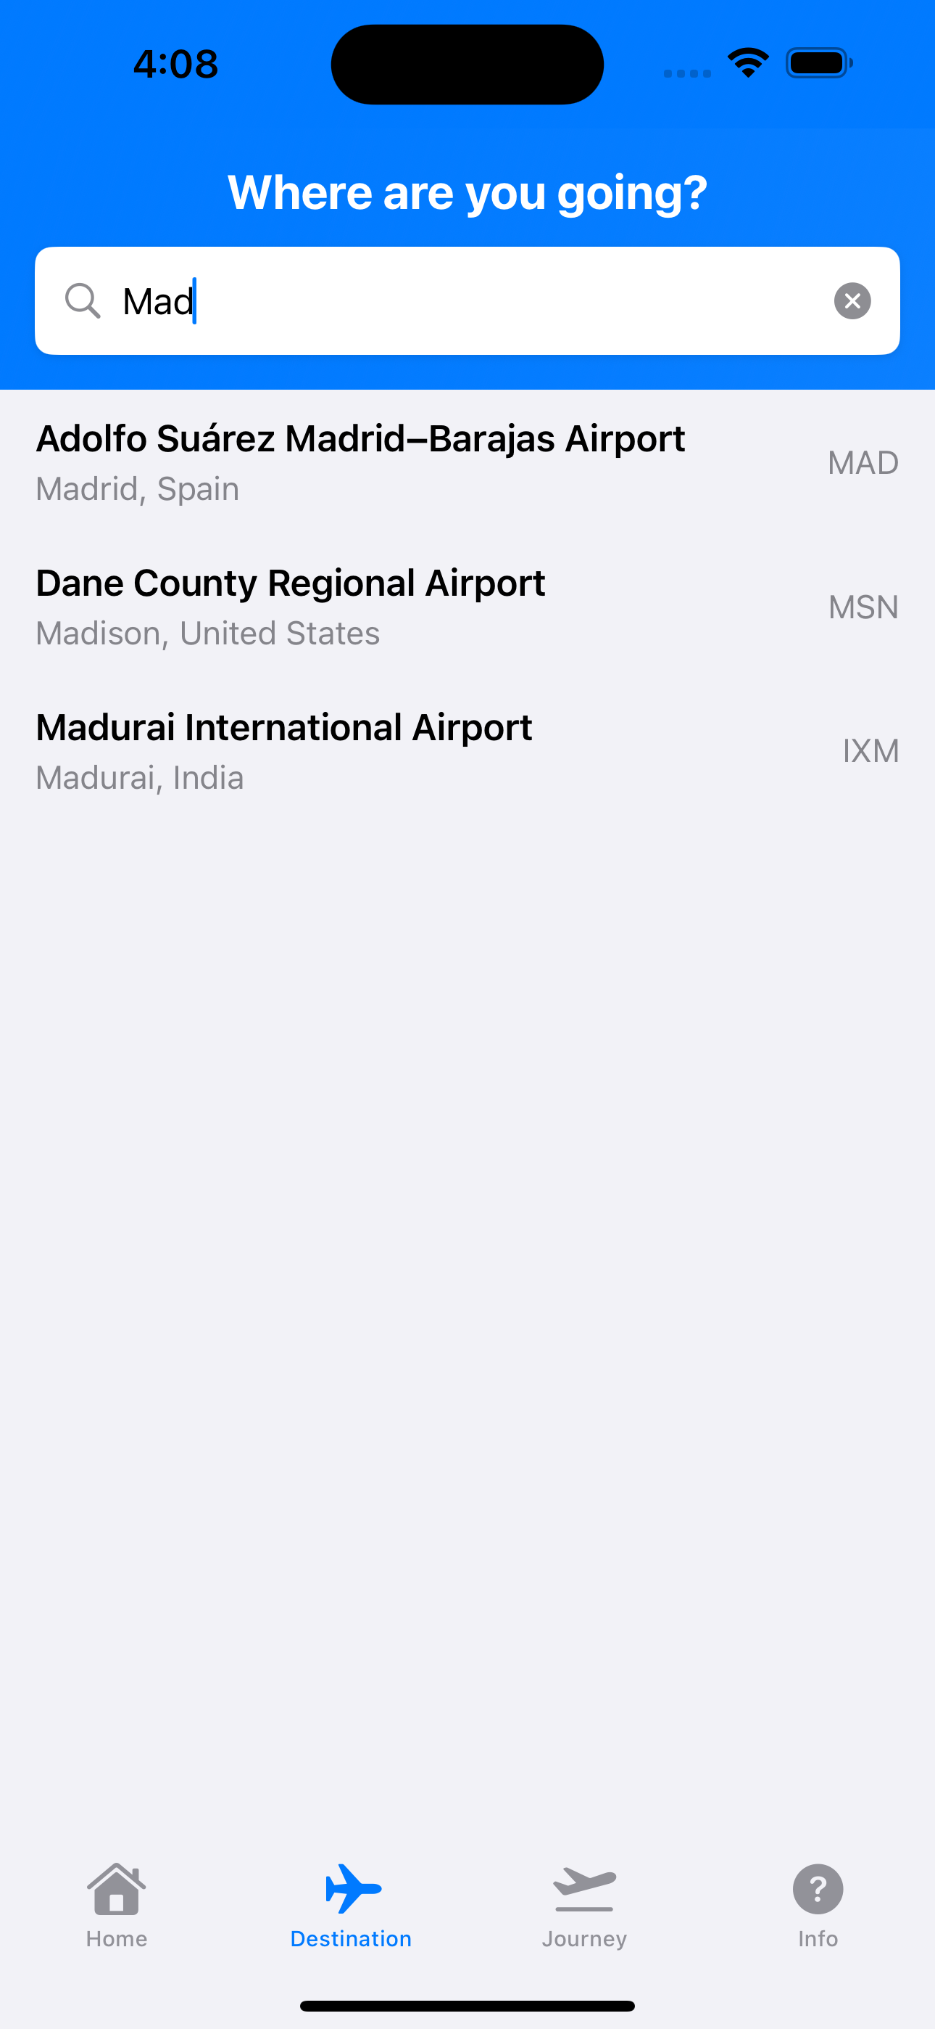 | 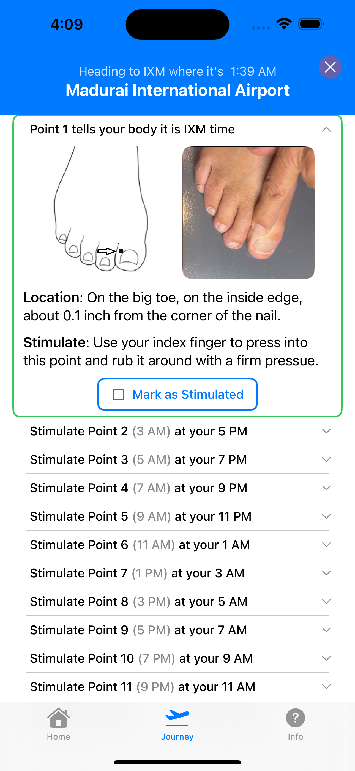
Screen 1: Basic Instructions | Screen 2: Destination Selection | Screen 3: Point Stimulation

The app displays point images alongside looping video demonstrations showing how to stimulate each point. Written instructions are provided above and below the images. The reminders are persistent and remain on the user's device until acknowledged, ensuring users can access guidance even during flight when internet connectivity may be limited.

Figure 3: Horary Point Locations
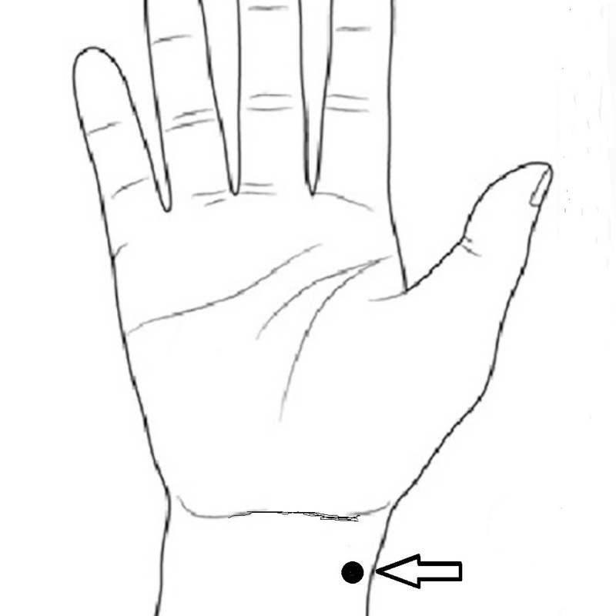 | 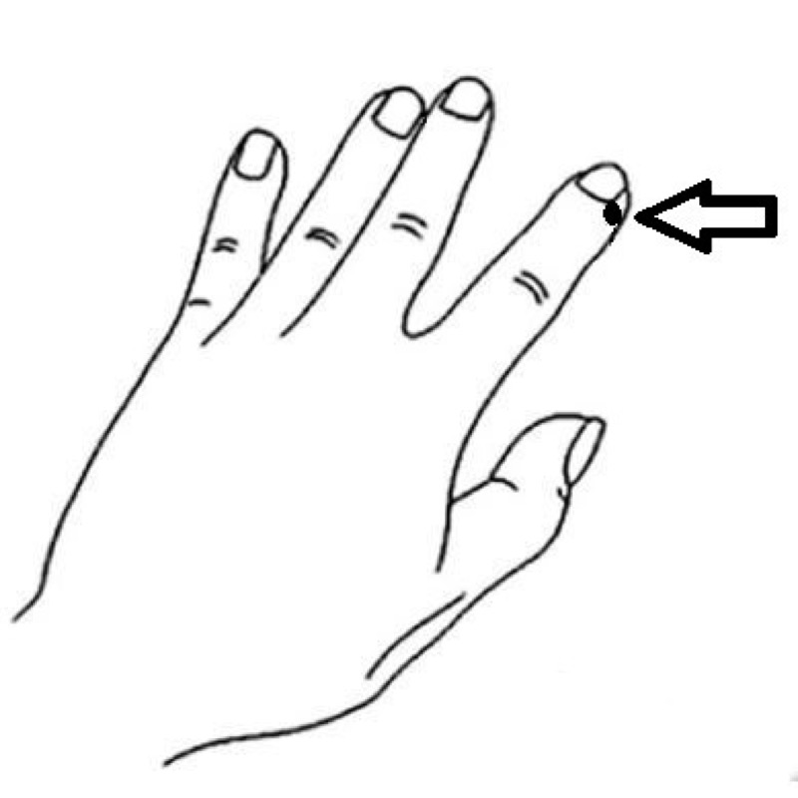 | 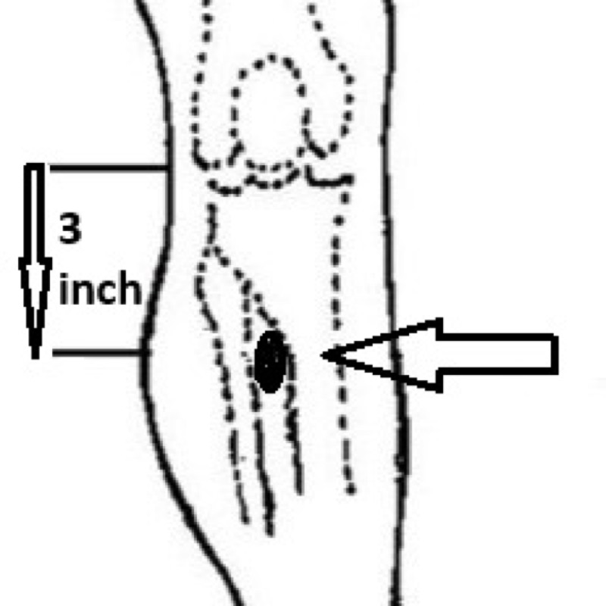 | 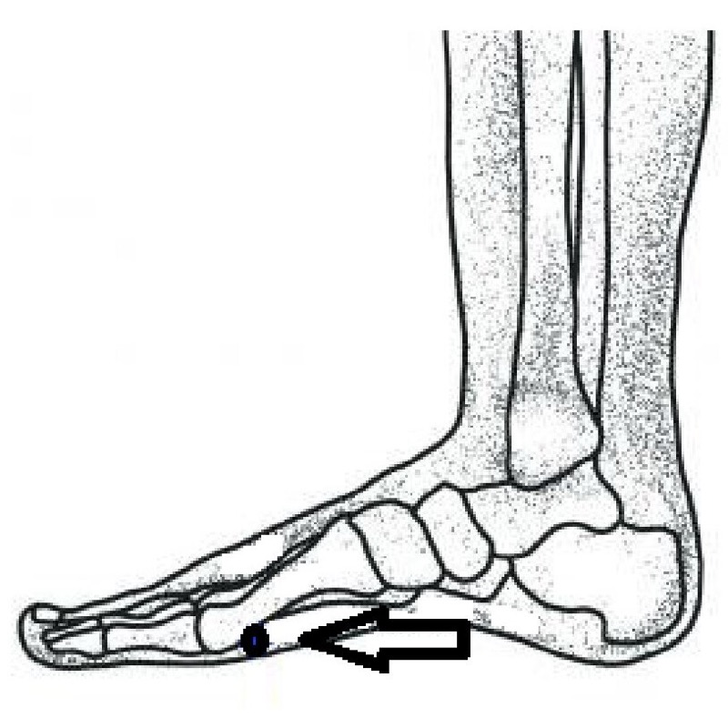 | 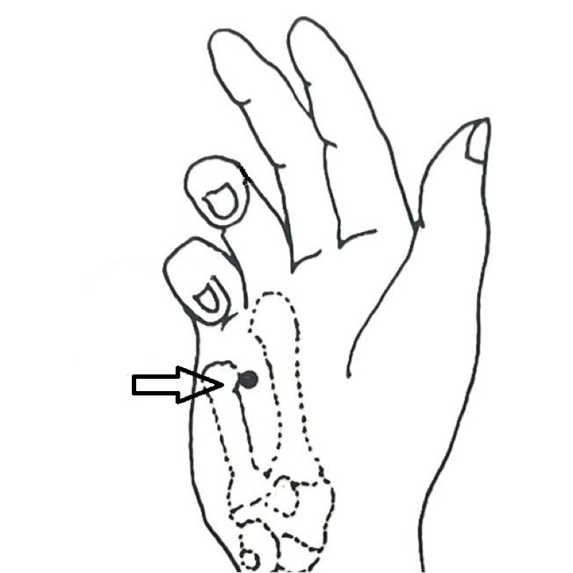 | 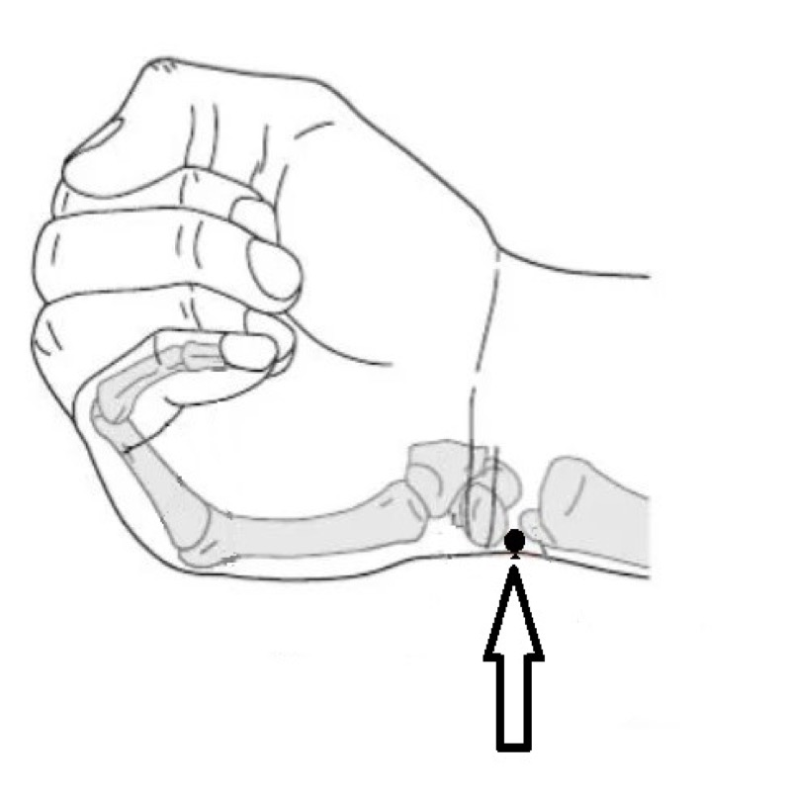
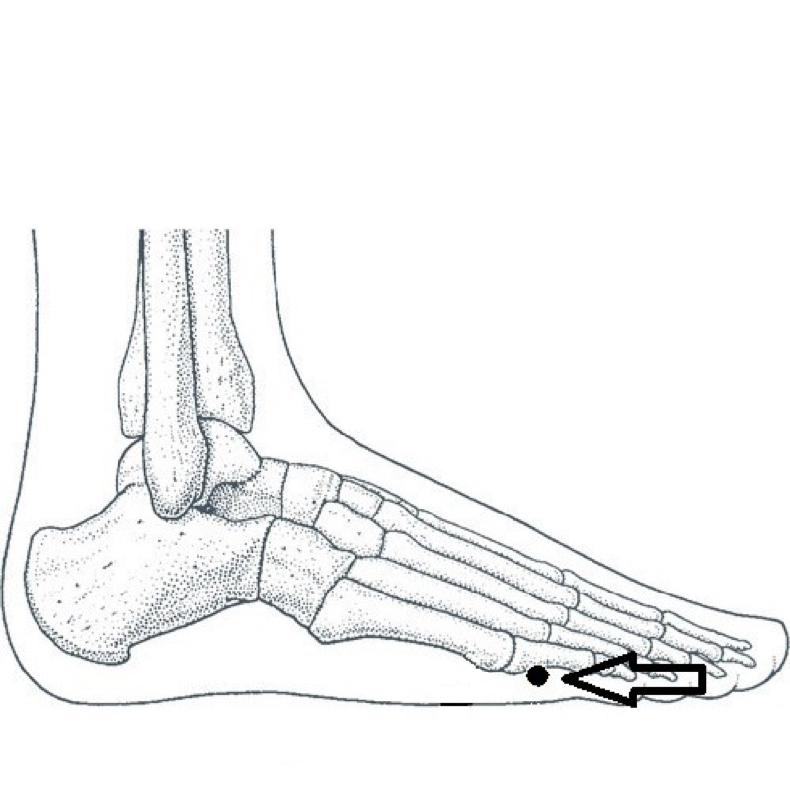 | 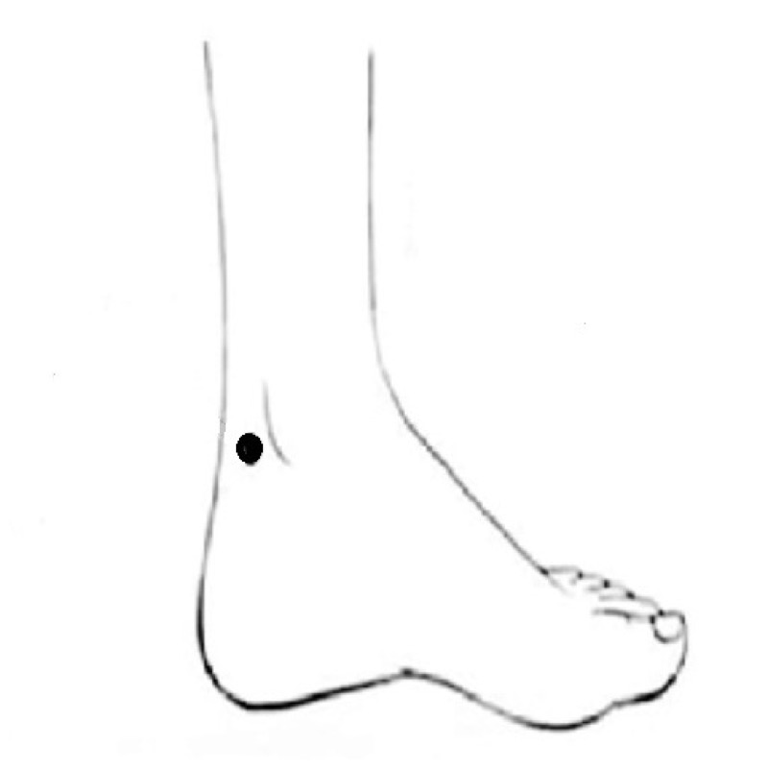 | 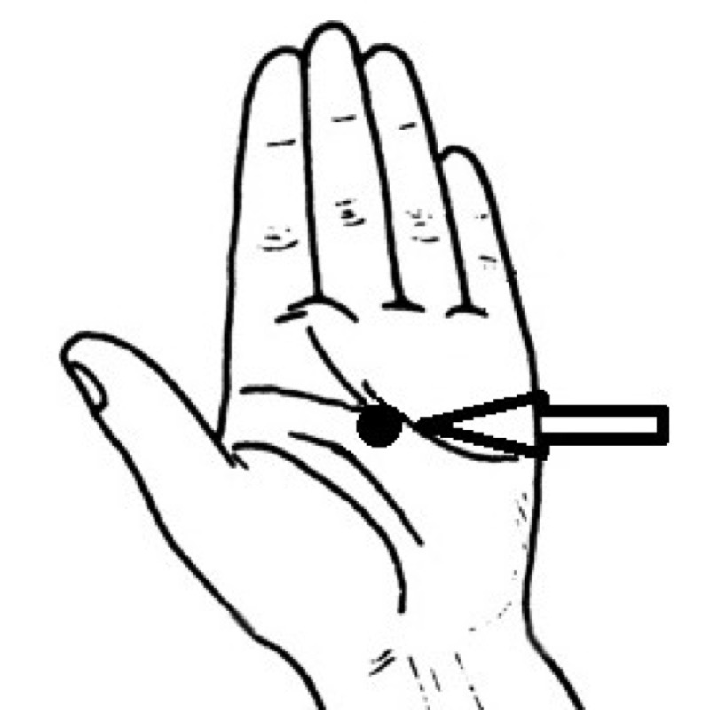 | 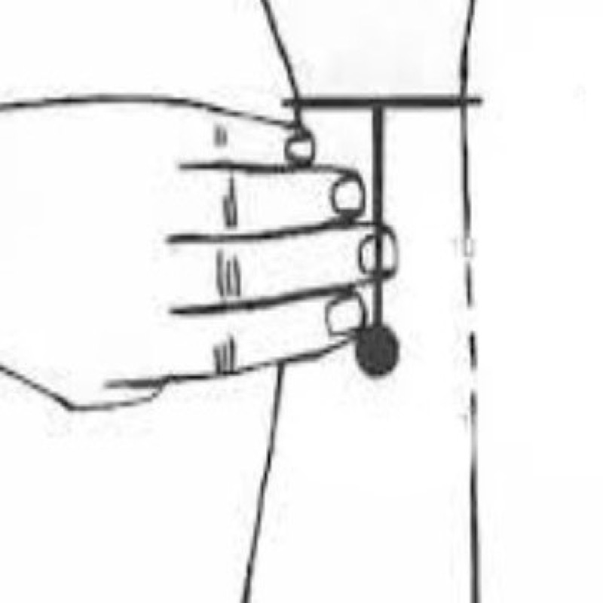 | 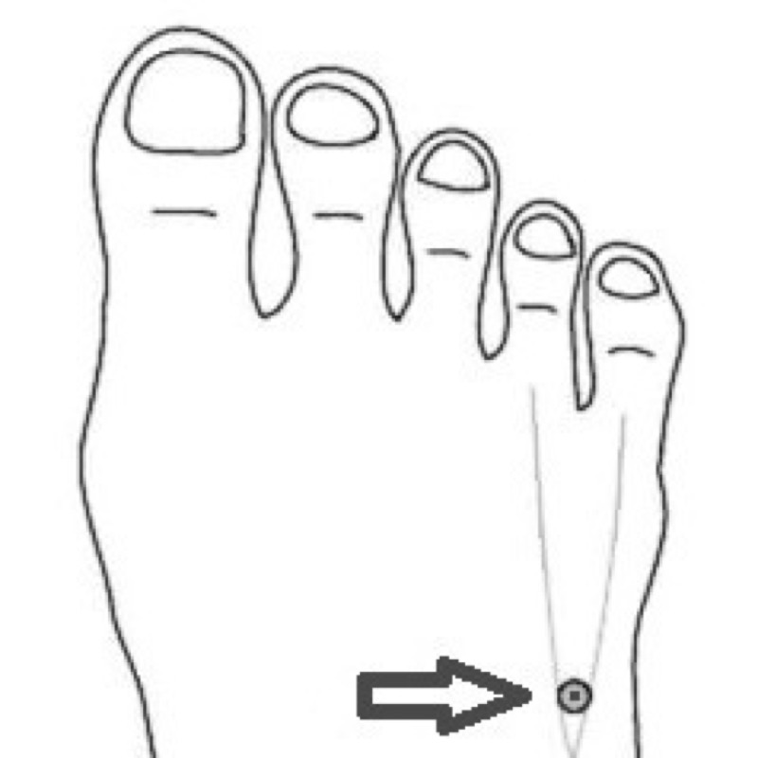 | 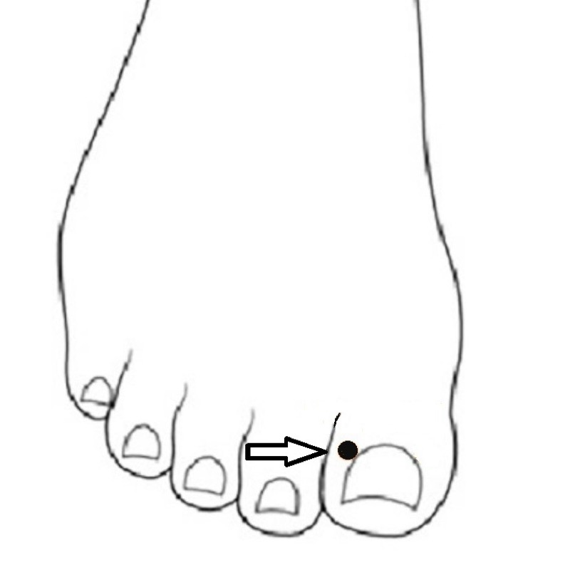
Following travel, participants complete an online survey assessing jet lag symptom severity using a modified Liverpool Jet Lag Questionnaire.⁸ The survey evaluates sleep disturbance, daytime fatigue, difficulty concentrating, irritability, lack of motivation and gastrointestinal issues. The research application automatically logs trip data including time zones crossed, points stimulated and arrival timezone to validate actual travel.
The study design uses a within-subject approach where each participant serves as their own control. Participants report anticipated symptom severity based on prior travel experience, which is then compared with post-travel symptom severity. Results will be compared to baseline severity data from Waterhouse et al.'s 2007 comprehensive quantitative assessment of jet lag severity stratified by time zones crossed.⁹

Research Participation Opportunity
We are actively seeking participants for this pilot study. The mobile application serves as a research instrument designed to collect data on chronoacupuncture effectiveness while providing participants with the timing guidance and point location information necessary to apply the intervention during travel. The application functions as both a data collection platform and an intervention delivery mechanism, enabling real-world evaluation of chronoacupuncture principles across diverse travel scenarios.
Acupuncturists are encouraged to share this research opportunity with patients who travel internationally. Practitioners who travel themselves are also welcome to participate. Participation involves using the research application during travel to receive timed prompts for horary point stimulation, and completing brief post-travel surveys that assess symptom severity. All data collected contributes to the systematic evaluation of chronoacupuncture as a potential intervention for jet lag.
This research design enables large-scale data collection from diverse travel scenarios that would be impractical to study in traditional clinical trial settings. The mobile platform allows for real-world evaluation where participants apply chronoacupuncture during actual travel, providing ecological validity that laboratory studies cannot achieve. Data collected through this platform will contribute to evidence-based understanding of whether chronoacupuncture can serve as an effective non-photic synchronizer of circadian rhythms.
Participation contributes to bridging the gap between traditional practice and evidence-based medicine. If chronoacupuncture proves effective, this research will provide the validation needed for practitioners to confidently recommend this approach. If it proves ineffective, the study will provide definitive answers and redirect research efforts appropriately. Either outcome advances the profession's understanding of chronoacupuncture applications.
For more information about the study protocol, research methodology, or to participate in data collection, visit the research website at jetlagpro.com. The website provides detailed information about the theoretical framework, study design, data collection procedures, and how to participate in the research.

How to Participate in the Research Study
The research application is available for iPhone devices through Apple's TestFlight platform, which is required for distributing research applications prior to formal publication. The iPhone platform was selected for this study because it enables verification of app usage and secure linking to post-travel surveys, ensuring data integrity for research purposes. To participate in the study:
1. Install TestFlight from the App Store (required for research application distribution)
2. Visit jetlagpro.com or scan the QR code below to access the research application
3. Join the research study using this link: https://testflight.apple.com/join/YZc7jzJT
Participation is voluntary and all data collection follows research ethics guidelines. The iPhone platform's verification capabilities ensure that research data can be accurately linked between app usage and survey responses, maintaining the integrity of the study design.

Research Participation: QR Code

Figure 4: Scan QR code to access research platform at jetlagpro.com
Once the research application is accessed, participants select their travel destination, and the application provides timed prompts for horary point stimulation based on the destination's local time. Following travel, participants complete post-travel surveys that assess symptom severity, contributing data to the research evaluation of chronoacupuncture effectiveness.

References
1. Huangdi Neijing (Yellow Emperor's Inner Canon). Classical Chinese medical text.
2. Panda, S., & Hogenesch, J. B. (2022). Foundations of circadian medicine. PLoS Biology, 20(3), e3001567.
3. Hastings, M. H., et al. (2019). The mammalian circadian timing system and the suprachiasmatic nucleus as its pacemaker. Biology, 8(1), 13.
4. Khoe, W. H. (1978). Treatment of jet lag syndrome by acupuncture. American Journal of Acupuncture, 6(2), 135-139.
5. Amaro, J. (1989). An ancient approach to beating 20th century jet lag. Dynamic Chiropractic, March 1, 12-17.
6. Amaro, J. (1989). Cheating time - an ancient approach to beating 20th century jet lag. Dynamic Chiropractic, April 1, 14-16.
7. Wu, J., & Zhao, Z. (2024). Acupuncture in circadian rhythm sleep-wake disorders and its potential neurochemical mechanisms. Frontiers in Neuroscience, 18, 1346635.
8. Waterhouse, J., Reilly, T., Atkinson, G., & Edwards, B. (2007). Liverpool Jet Lag Questionnaire: validation and baseline data from athletes and travelers. Chronobiology International, 24(6), 1065-1084.
9. Waterhouse, J., Reilly, T., Atkinson, G., & Edwards, B. (2007). Jet lag: trends and coping strategies. The Lancet, 369(9567), 1117-1129.

