Technical Description of the NScale Library
Operations and Pipeline

\

1 Introduction 3
2 Nuclear Segmentation and Feature Extraction 3
3 C++ and CUDA based Implementation 5
3.1 Nuclear Segmentation Operations Ported to C++ and CUDA 6
3.1.1 Watershed Segmentation 8
3.1.2 Morphological Reconstruction 9
3.1.3 Distance Transform 10
3.2 Feature Extraction 12
4 Bibliography 13

Introduction

This document describes the GPU-enabled implementation of the nuclear segmentation and feature extraction pipeline that has been employed for in silico experiments in our center. The segmentation pipeline identifies and outlines nuclei in microscopy images obtained from whole slide tissue specimens stained with hematoxylin and eosin. The feature extraction, on the other hand, computes a set of features for each of the micro-anatomic objects (nucleus and surrounding cytoplasm area) identified during the segmentation. Both phases were originally developed using Matlab . This implementation ports the original pipeline to GPU equipped machines using C++ and CUDA in order to reduce the execution times when it is applied to large image datasets.

Nuclear Segmentation and Feature Extraction

The nuclear segmentation stage in image analysis performs the following set of computations on image tiles. The computations can be applied on whole images, but images are usually partitioned into tiles so that images that do not fit in memory can be processed. In addition, multiple tiles can be processed concurrently on a parallel machine, enabling further reduction in processing times.

- Image tiles containing more than 90% background pixels are excluded from the further analysis. Background pixels are identified by a transformation of the color space and then by performing thresholding.

- Pixels representing red blood cells are marked and excluded from analysis by thresholding the color channels.

- Morphological reconstruction operations are applied to a gray scale transform of the image tiles to remove noises in the tiles that are due to nonspecific hematoxylin staining and out-of-plane nuclei.

- Pixels within nuclei are identified by thresholding the reconstruction result, and the resulting objects are cleaned up using morphological operations and filtered based on size.

- Overlapped nuclei are separated using watershed segmentation based on shape (distance of foreground pixel to background).
The original segmentation implementation has been tuned experimentally for Hematoxylin and Eosin stained histology images. More specifically, the choices of thresholds and the structuring element shape and sizes for the morphological operations have been chosen for accuracy of the segmentation compared to human segmentation.
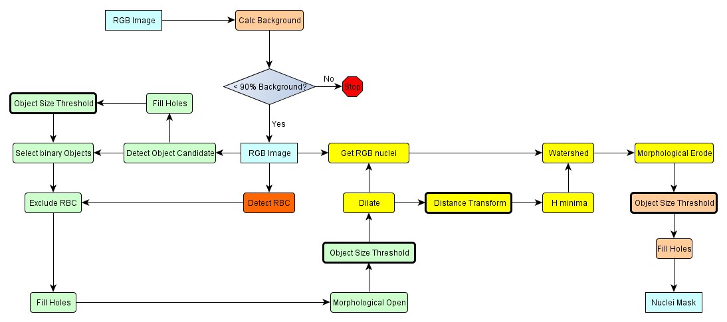
Figure 1. Nuclei segmentation stage contains multiple dependent tasks.
A closer inspection of the segmentation stage shows that the segmentation function consists of over 20 orchestrated tasks, which can be organized into a workflow. These tasks are show in Figure 1 as a directed acyclic graph of processing components. In this figure, the green boxes select initial candidate nuclei, the yellow boxes separate overlapping nuclei using watershed segmentation, and the light orange boxes perform cleanup operations.

The feature extraction phase calculates informative, quantitative descriptors from individual segmented objects. A list of classes of features computed in our current implementation is shown in Table 1 along with the core operations involved in the computation of those features. The feature classes include pixel statistics, gradient statistics, Haralick, edge, and morphometry features. The computation of most of the features can be carried out independently. Some features require the same intermediate results, such as histograms or co-occurrence matrices, before the final feature values are calculated. The Morphometry features are computed only once, because they depend only on the shape of the objects segmented. The other features (Pixel, Gradient, Haralick, and Edge) are calculated for the nuclei and for the cytoplasm. The grayscale representation is used in the calculate of the former three classes of features for nuclei, while they are calculated three times for the cytoplasm using different image channel: grayscale, eosin, and hematoxylin channels derived from the original image (using color to grayscale and color deconvolution transforms that we have also implemented for CPUs and GPUs).
Namely, the 74 features we calculate for each of the segmented object are: (Features calculated based on nucleus and grayscale channel as input) 1)Area; 2)Perimeter; 3)Eccentricity; 4)Circularity; 5)MajorAxis; 6)MinorAxis; 7)ExtentRatio; 8)MeanPixelIntensity; 9)MaxPixelIntensity; 10)MinPixelIntensity; 11)StdPixelIntensity; 12)EntropyPixelIntensity; 13)EnergyPixelIntensity; 14)SkewnessPixelIntensity; 15)KurtosisPixelIntensity; 16)MeanGradient; 17)StdGradient; 18)EntropyGradient; 19)EnergyGradient; 20)SkewnessGradient; 21)KurtosisGradient; 22)CannyArea; 23)MeanCanny; (Features calculated for cytoplasm, using grayscale channel as input) 24)MeanPixelIntensity; 25)MedianPixelIntensity-MeanPixelIntensity; 26)MaxPixelIntensity; 27)MinPixelIntensity; 28)StdPixelIntensity; 29)EntropyPixelIntensity; 30)EnergyPixelIntensity; 31)SkewnessPixelIntensity; 32)KurtosisPixelIntensity; 33)MeanGradient; 34)StdGradient; 35)EntropyGradient; 36)EnergyGradient; 37)SkewnessGradient; 38)KurtosisGradient; 39)CannyArea; 40)MeanCanny; (Features calculated for cytoplasm, using Eosin channel as input) 41)MeanPixelIntensity; 42)MedianPixelIntensity-MeanPixelIntensity; 43)MaxPixelIntensity; 44)MinPixelIntensity; 45)StdPixelIntensity; 46)EntropyPixelIntensity; 47)EnergyPixelIntensity; 48)SkewnessPixelIntensity; 49)KurtosisPixelIntensity; 50)MeanGradient; 51)StdGradient; 52)EntropyGradient; 53)EnergyGradient; 54)SkewnessGradient; 55)KurtosisGradient; 56)CannyArea; 57)MeanCanny; (Features calculated for cytoplasm, using Hematoxylin channel as input) 58)MeanPixelIntensity; 59)MedianPixelIntensity-MeanPixelIntensity; 60)MaxPixelIntensity; 61)MinPixelIntensity; 62)StdPixelIntensity; 63)EntropyPixelIntensity; 64)EnergyPixelIntensity; 65)SkewnessPixelIntensity; 66)KurtosisPixelIntensity; 67)MeanGradient; 68)StdGradient; 69)EntropyGradient; 70)EnergyGradient; 71)SkewnessGradient; 72)KurtosisGradient; 73)CannyArea; 74)MeanCanny;
Table 1. Classes of features computed in the feature extraction phase.
Class | Core operations | Features
Pixel Statistics | Histogram calculation | Mean, Median, Max, Min, Std
Gradient Statistics | Gradient and Histogram calculation | Mean, Median, Max, Min, Std
Haralick | Normalization of pixel values and Co-occurrence matrix | Entropy, Energy, Skewness, Kurtosis
Edge | Canny | Area, mean
Morphometry | Pixel counting, Ellipse fitting, Bounding blox, convex hull | Area, Perimeter, Eccentricity, Circularity, MajorAxis, MinorAxis, ExtentRatio

C++ and CUDA based Implementation

The CPU and GPU implementations of the nuclear segmentation and feature computation methods leverage the OpenCV library . OpenCV provides a large number of image processing routines. Some of these routines have GPU implementations as well. We have extended the existing functions or implemented new functions when there were no comparable functions in OpenCV or existing functions did not produce correct or comparable results to the corresponding MATLAB function(s) from the original implementation.

Throughout the development cycle, unit tests were performed using synthetic and/or real data to evaluate the correctness of the component operations. Correctness is evaluated by comparing the output of the CPU and GPU implementations against the corresponding MATLAB functions. With the exception of Watershed segmentation, we were able to match the MATLAB output accurately for all component operations in the nuclear segmentation method. The challenges with and impact of differences in watershed segmentation algorithm implementations is described Section 3.1.1.

Nuclear Segmentation Operations Ported to C++ and CUDA

One of the goals of this effort was to provide a GPU-enabled version of the nuclear segmentation method. This objective includes providing a single API with both CPU and GPU variants of the functions. With this goal in mind, we have mirrored our CPU API with a GPU equivalent in all the segmentation operations. The GPU versions of the operations were obtained from OpenCV, or from public implementations, or developed by us. In developing these operations, especially with new function development, we used the CUDA toolkit. Table 2 lists the operations implemented for CPU and GPU using C++ and CUDA which are used in the segmentation stage.

Table 2. Segmentation operations implemented using C++ and CUDA.
Operation | Description | Implementation
Pixel-wise inversion | Produces the complement of an image. The inversion operation is performed for each pixel independently. For a binary image, if a pixel is 1, it becomes 0 and vice-versa. For floating point image, the output is an inversion on the pixel’s signal value. | OpenCV does not provide a consistent invert function for all data types. We have implemented version in CUDA and C++ for floating point types, signed and unsigned integer types.
Pixel-wise threshold (>, <) | Performs a threshold operation on each pixel in an image independently. In the output image, the pixels with value in the threshold interval will be set to 255 and others to 0. | We use OpenCV for the CPU based version of the operation, and we have implemented the GPU version using CUDA.
Pixel–wise modulus | Performs a mod operation for each pixel in the input image. | OpenCV does not provide a modulus function for all image data types used. We have implemented it using CUDA and C++.
Morphological Reconstruction in gray scale and binary images | Performs morphological reconstruction and is used in several operations in segmentation. This function is explained in more detail in Section 3.1.2. | OpenCV does not provide a morphologic reconstruction function. We have implemented it using CUDA and C++.
Distance Transform | Computes the distance to the closest zero (background) pixel for each foreground pixel in the input image. This function is described in more detail in Section 3.1.3. | OpenCV provides the CPU based implemented. We have implemented it for GPU using CUDA.
Fill in holes in all regions | This operation is used to fill holes in objects identified in an image. It performs a flood-fill in the background pixels of the input binary image, starting from points selected from the inverse of the input image. | OpenCV does not provide this function. This function uses Morphological Reconstruction, and pixel-wise inverse described above. We have implemented it for C++ and CUDA.
Select a component in a binary image | This operation selects objects from an input image, which contain at least one pixel from a marker image. | OpenCV does not provide this function. This function uses Morphological Reconstruction. We have implemented it for C++ and CUDA.
Connected components labeling | This operation receives a binary image as input, and returns a labeled image. Pixels in the same connected components of the input image will have the same value. | OpenCV does not provide this function. The connected component labeling operation (BWLabel) was implemented using the union-find pattern. We have implemented it for C++ and used the framework of to implement the CUDA version.
Selecting component in binary image based on size threshold | This operation removes all connected components in a binary image that have fewer pixels than a given threshold value. | OpenCV does not provide this function. This operation uses the connected component labeling, and counts the number of pixels in each component. We have implemented it using C++ and CUDA.
Computing the h-minima | This operation suppresses all minima in an input image, with depth less than a given value h. The regional minima components of an image are regions with pixels whose values are smaller than boundary pixels. | OpenCV does not provide this function. This function uses Morphological Reconstruction. We have implemented it using C++ and CUDA.
Watershed Segmentation | It is used to separate overlapping nuclei. Watershed segmentation algorithm is based on the simple idea that an image can be viewed as a height map . If water were to flow down this height map, it would follow the steepest slope to the valleys and basins. Based on this idea, the watershed algorithm segments an image into regions such as those at the mountainous divides between the “geological” watersheds. A detailed discussing of the operation is presented in Section 3.1.1. | OpenCV’s implementation does not use the same inputs, and the output has slight differences. This function transforms the input and output, and is described in more detail below. For CPU we used OpenCV and for GPU we used the CUDA code from .
Regional extrema: regionalmax and regionalmin | These functions are used to compute the regional maxima and minima of an image. The regional minima, for instance, are connected components in an image with the same pixel values and with boundary pixels with higher values. | OpenCV does not provide this function. The implementation uses Morphological Reconstruction. We have implemented it using C++ and CUDA.
Morphological Open | This operation will apply an opening on an input image using a given structuring element. It is basically a concatenation of an open operation followed by a dilation operation. | OpenCV provided implementation does not generate the same result as Matlab (used to verify the results). Specifically, pixels near the edges of the tile are calculated incorrectly. This was then implemented by use using operations available in the OpenCV’s interface: erode followed by dilate, with appropriate border padding.
Morphological Erode | This operation erodes an input binary image by a structuring element. | The CPU implementation uses OpenCV. The GPU implementation of the operation in OpenCV does not generate the same result as Matlab. To assert that results are correct we have added a border to the image before GPU implementation in OpenCV is called.
Morphological Dilate | This operation dilates an input binary image by a structuring element. | The CPU implementation uses OpenCV. The GPU implementation of the operation in OpenCV does not generate the same result as Matlab. To assert that results are correct we have added a border to the image before GPU implementation in OpenCV is called.

Watershed Segmentation

Watershed segmentation is a critical component in the segmentation method. It is used to separate overlapping nuclei. The watershed segmentation algorithm is based on the idea that an image can be viewed as a height map . If water were to flow down this height map, it would follow the steepest slope to the valleys and basins. Based on this idea, the watershed algorithm segments an image into regions, as if they were regions at the mountainous divides between the “geological” watersheds.

In our implementation, watershed is used to separate overlapping nuclei as follows:

Given a binary (i.e., black-and-white) image
Compute distance transform (Euclidean distance of foreground pixel from nearest background pixel)
Compute the h-minima for the distance transform
Call watershed

The output of this process is a set of labeled components that are surrounded by a border. There are variations of the basic algorithm. Hence, the MATLAB, OpenCV, and the CUDA based watershed implementations all have different behaviors and require different input data and produce different output transformations.

The MATLAB implementation calculates the regional minima from the h-minima of the distance transform (h-minima = I – imreconstruct(I-h, I, 8), where I is the input image and h is a scalar value). The connected components labeling of the regional minima and the h-minima are used as the input to the actual watershed implementation.

The OpenCV implementation of the watershed algorithm follows the same process to compute the connected components of the regional minima, which is in turn computed from the h-minima of the distance map. However, the OpenCV version requires that the second input to the method be the original color image with the pixels that are not within the boundaries of a nucleus masked to 0. The output of the watershed algorithm differs from the MATLAB version in that the borders around the watershed regions are 8 connected, i.e., two border pixels are connected if they share a corner. The output from the MATLAB version, on the other hand, is 4 connected. The consequence of this difference between the two implementations is that the subsequent operation in the segmentation pipeline requires 4 connected borders, and the 8 connected border pixels appear as holes to be filled, thus negating the effect of the watershed segmentation. To circumvent this problem the foreground components in the watershed output is eroded by 1 pixel. The foreground regions from the OpenCV watershed operation are therefore slightly smaller than the corresponding MATLAB regions.

We used the implementation by Korbes for the GPU implementation of the watershed operation. This implementation uses a variation of the union-find approach. It takes as input the h-minima directly without explicit connected component labeling. The output has borders between the background pixels and the foreground components, circumscribing each set of overlapping nuclei. The borders are also generated for “holes” in the regions. However, two overlapping nuclei that have been labeled as separate will not have a border between the regions. To work around this issue, our extensions detect border pixels (defined as pixels with background neighbors) and set their values to be the same as background. Then we detect all pixels that have non-background neighbors and neighbor labels that are not the same as the pixel’s own label. These pixels are marked as border as well. This approach reduces the size of the labeled regions more aggressively compared to the OpenCV and MATLAB implementations.

Morphological Reconstruction

The morphological reconstruction operation is commonly used in the segmentation, filtering, and object selection operations. As shown by the tables in the Error: Reference source not found and Error: Reference source not found sections, Morphological reconstruction is also used as component operations in several other operations in the segmentation method. We refer the reader to the paper by Vincent for a detailed description of the morphological reconstruction method.

The basic idea of morphological reconstruction is that by repeated dilation of a marker image, while constrained by the pixel values of the mask image, one can obtain a new image that contains the desired, seeded structure. Figure 2 illustrates the process of morphological reconstruction for gray scale values. The red represents the intensity profile of the marker image, the blue curve the intensity profile of the mask image, the green curve represents result image, and the arrow show the direction of pixel value propagation in the marker image.

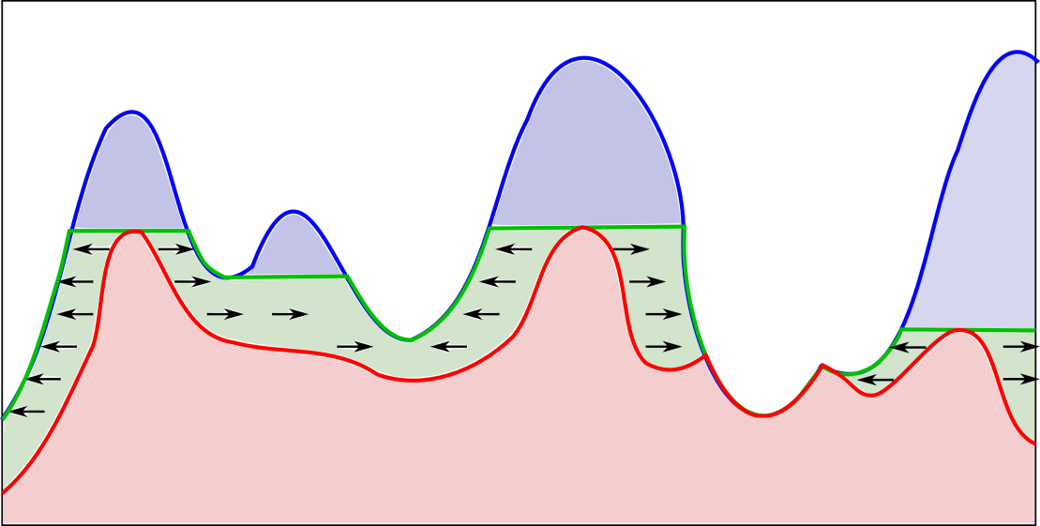
Figure 2. Grayscale morphological reconstruction in 1-dimension.
Vincent has developed and evaluated several morphological reconstruction algorithms to process gray scale images . The fastest proposed algorithm is called the hybrid method, and it consists of a composition of two other algorithms. The hybrid method first makes a pass on the image using the Sequential Reconstruction algorithm. It then carries out computation using the Queue Based algorithm. These two algorithms are briefly explained bellow.

Sequential Reconstruction Algorithm (SR): Pixel value propagation in the marker image is computed by alternating raster and anti-raster scans. A raster scan starts from the pixel at (0, 0) and proceeds to the pixel at (N-1, M-1) in a row-wise manner, while an anti-raster starts from the pixel at (N-1, M-1) and moves to the pixel at (0, 0) in a row-wise manner. Here, N and M are the resolutions of the image in x and y dimensions, respectively. In each scan, values from pixels in the upper left or the lower right half neighborhood are propagated to the current pixel in raster or anti-raster fashion, respectively. The raster and anti-raster scans allow for changes in a pixel to be propagated in the current iteration. The SR method iterates until stability is reached, i.e., no more changes in pixels are computed.

Queue Based Algorithm: A first-in first-out (FIFO) queue is initialized with pixels in the regional maxima. The computation then proceeds by removing a pixel from the queue, scanning the pixel's neighborhood, and queuing the neighbor pixels whose values change based on a propagation function. The overall process continues until the queue is empty. The regional maxima needed to initialize the queue require significant computational cost to generate.

For the GPU version of morphological reconstruction, we have implemented the hybrid fast algorithm by extending a GPU-enabled implementation by Pavel Karas of the Sequential Reconstruction algorithm. We also have implemented a GPU-enabled parallel scalable queue that supports the queue-based phase of the hybrid morphological reconstruction algorithm.

Distance Transform

The distances transform (DT) operation computes a distance map M from a binary input image I, where for each pixel p in I, the pixel's value in M, M(p), is the smallest distance from p to a background pixel. DT is a fundamental operator in a number of image computations, including shape analysis, morphological operations, and the computation of Voronoi diagrams and Delaunay triangulation.

Our implementation uses an algorithm proposed by Danielsson to compute Euclidean DT that propagates information of the nearest background pixel using neighborhood operators. Intrinsically, the algorithm builds Voronoi diagrams where regions are formed by pixels with the same nearest background pixel. Danielsson's algorithm is not an exact algorithm. Nevertheless, the approximation errors introduced by the algorithm are small and bound by a mathematical framework. They have been found to be sufficiently small in practice for several applications. Moreover, some of the exact Euclidean distance transform algorithms are implemented as a post-processing phase to Danielsson's algorithm, in which approximation errors are resolved.

Our implementation, shown in Figure 3, computes the single neighborhood approximation of DT. In the initialization phase a pass on the input is performed to identify and queue pixels forming the initial wavefront. In Lines 2 and 3, the Voronoi diagram (VR) that holds the current nearest background pixel for each image pixel is initialized. Each background pixel will itself be its nearest pixel, while the foreground pixels will initially point to a pixel virtually at inﬁnite distance (inf). The inf pixel is such that for each pixel p, p is closer to any other pixel in the image domain than it is to the inf pixel. At the end of the initialization phase, background pixels with a foreground neighbor (contour pixels) are inserted into a queue for propagation (Lines 4 and 5).

The wavefront propagation phase of the EDT is carried out in Lines 7 to 12. In each iteration, a pixel p is removed from the queue. The pixel’s nearest background pixel is propagated to the neighbors through a neighborhood operator. For each neighbor pixel q, if the distance of q to the current assigned nearest background pixel (DIST(q,V R(q))) is greater than the distance of q to the nearest background pixel of p (DIST(q,V R(p))), the propagation occurs. In that case, the nearest background pixel of q is updated with that of p (Line 11), and q is added to the queue for propagation. After the propagation phase is completed, the distance map is computed from the Voronoi diagram.
Input: I, mask image
Output: M, distance map image

FG: Foreground
BG: Background
N_{G}(p): set of neighbors of pixel p
D_{I}: domain of input mask image

1: {Initialization Phase}
2: for all p ∈ D_{I} do
3: VR(p)=(p == BG)? p : inf
4: if I(p) == BG and ∃q ∈ N_{G}(p) | I(q) == FG then
5: queue.enqueue(p)
6: {Wavefront Propagation Phase}
7: while queue.empty() = false do
8: p ← queue.dequeue()
9: for all q ∈ N_{G}(p) do
10: if DIST(q, VR(p)) < DIST(q, VR(q)) then
11: VR(q)= VR(p)
12: queue.enqueue(q)
13: for all p ∈ D_{I} do
14: M(p) = DIST(p, VR(p)))

Figure 3. Distance transform algorithm.

Feature Extraction

This section describes the implementation of the features extraction step for CPUs and GPUs, using C++ and CUDA. Some of the operations also used OpenCV, but must of the feature computation operations were developed by us as presented in Table 3. Unlike nuclear segmentation, most of the operations in the feature extraction stage involve computations that are executed only in sub-regions of the input data in which there are objects (e.g., nuclei), resulting in uneven computing costs across image pixels. For feature computations on objects, we restructured the computation into a set of smaller regions of interest: a set of minimum bounding boxes, each of which containing a nucleus. Since each bounding box can be processed independently, a large set of fine-grained tasks will be created in this strategy. By restructuring the computations in this way, we avoid unnecessary computation in areas that are not of interest (i.e., that do not have objects) and create a more compact representation of the data.
Table 3. Features extraction operations implemented using C++ and CUDA.
Class of Features | Description | Implementations
Pixel Statistics | A set of pixel statistics (See Table 1) is calculated for each of the objects received as input. It calculates a histogram using the raw value of the input data for each object received, and then derives the feature values. | OpenCV does not support any of these operations. We have implemented them using C++ and CUDA.
Gradient Statistics | A gradient channel is calculated using the input image channel, and a set of features is derived from that resulting gradient image channel for each of the segmented objects. Similarly to the Pixel Statistics case, a histogram is built for each object and features are derived from that histogram. | OpenCV does not support any of these operations. We have implemented them using C++ and CUDA.
Haralick | This class of features involves a normalization of the input image and calculation of a co-occurrence matrix for each segmented object, before the final features values can be calculated. | OpenCV does not support any of these operations. We have implemented them using C++ and CUDA.
Edge | These features involve the calculation of the Canny values for the input image, before simple statistics are calculated for each segmented object using the Canny results. | OpenCV was used to calculate Canny values, and we have implemented additional C++ and CUDA code to derive the features from the Canny data.
Morphometry | This set of features calculates shape characteristics of the objects identified in the segmentation phase. Among other computations, it involves the fitting of an ellipse to each of the objects in order to calculate shape attributes such as axis sizes. | OpenCV does not support any of these operations. We have implemented them using C++ and CUDA.

The parallel computation of object features using a GPU is organized in 2 steps. First we assign one GPU block of threads to each bounding box, and those threads in a block collectively compute the intermediate results, i.e., histograms and co-occurrence matrices of the corresponding nuclei. By structuring the computation in this way, we take advantage of a GPU’s ability to dynamically assign thread blocks to GPU multiprocessors, in order to reduce load imbalance that may arise due to differences in sizes and, consequently, computation costs of different nuclei. In the second step, the nuclear feature values are calculated from intermediate results, which are now fixed sized per nucleus, and one GPU thread is executed per nucleus. A single step computation of intermediate results and features is in contrast less efficient because: (i) the number of threads needed for intermediate results computation is much higher than the number of features to compute, resulting in idle threads; and (ii) the computation of different features by threads in same block creates divergent branches. Both inefficiencies are resolved with the two-step approach.

Bibliography

Bradski, G. (2000). The OpenCV Library. Dr. Dobb's Journal of Software Tools.
Cooper, L. A. D., Kong, J., Gutman, D. A., Wang, F., Cholleti, S. R., Pan, T. C., Saltz, J. H. (2010). An Integrative Approach for In Silico Glioma Research. Biomedical Engineering, IEEE Transactions on, 57(10), 2617 -2621.
Korbes, A. a., Vitor, G. B., de Alencar Lotufo, R., & Ferreira, J. V. (2011). Advances on watershed processing on GPU architecture Proceedings of the 10th International Conference on Mathematical Morphology (pp. 260-271). Verbania-Intra, Italy.
Karas, P. (2010). Efficient Computation of Morphological Greyscale Reconstruction MEMICS (pp. 54-61).
Teodoro, G., Kurc, T. M., Pan, T., Cooper, L. A. D., Kong, J., Widener, P., & Saltz, J. H. (2012(to appear)). Accelerating Large Scale Image Analyses on Parallel, CPU-GPU Equipped Systems International Parallel and Distributed Processing Symposium (IPDPS). Shangai, China.
Vincent, L., & Soille, P. (1991). Watersheds in Digital Spaces: An Efficient Algorithm Based on Immersion Simulations. IEEE Trans. Pattern Anal. Mach. Intell., 13, 583-598.

