Contents

**Overall SEER JSON Structure** 2

**Prediction Output Structure Explained** 3

**Color -WSI-MultiRes explained** 3

**Prediction -WSI-MultiRes explained** 4

**Prediction -WSI-MultiRes for low resolution images explained** 5

**Cluster Output Structure Explained** 6

**Overall cluster statistics output** 6

**Overall cluster summary information** 7

**Cluster Indices output (AP algorithm)** 8

# **Overall SEER JSON Structure**

The complete JSON file is available here in Github. [SEER.json](https://github.com/SBU-BMI/prismTil/blob/master/data_management/json_structure/SEER/SEER.json)

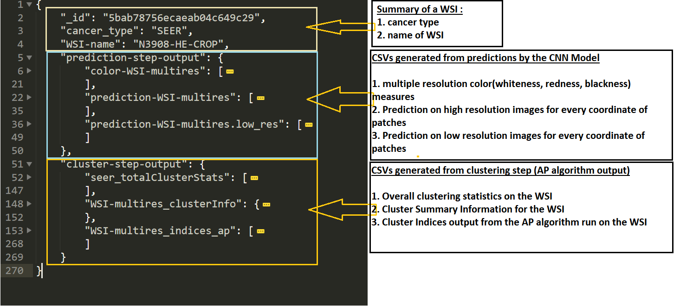

# **Prediction Output Structure Explained**

## **Color -WSI-MultiRes explained**

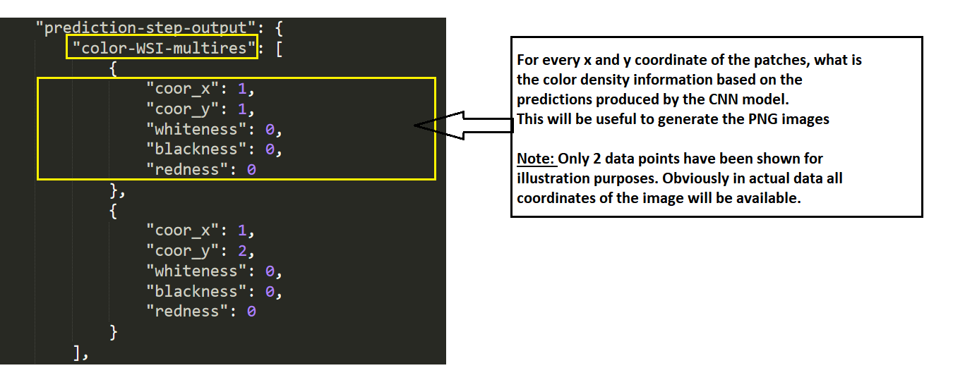

## **Prediction -WSI-MultiRes explained**

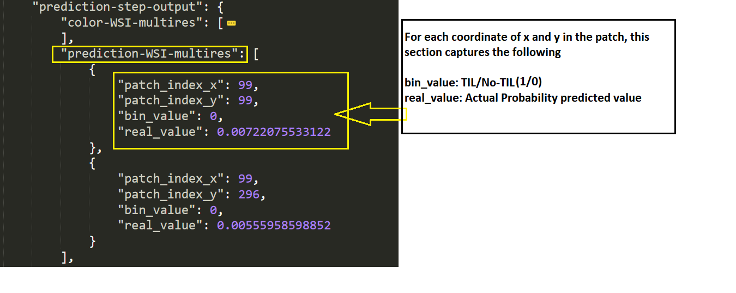

## **Prediction -WSI-MultiRes for low resolution images explained**

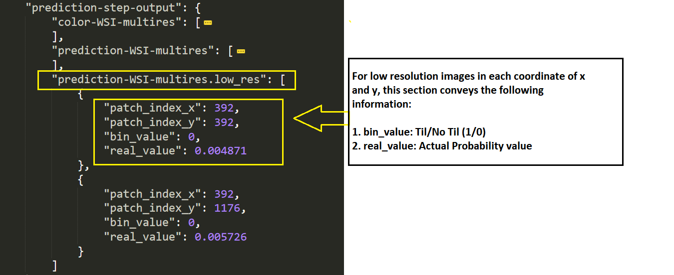

# **Cluster Output Structure Explained**

## **Overall cluster statistics output**

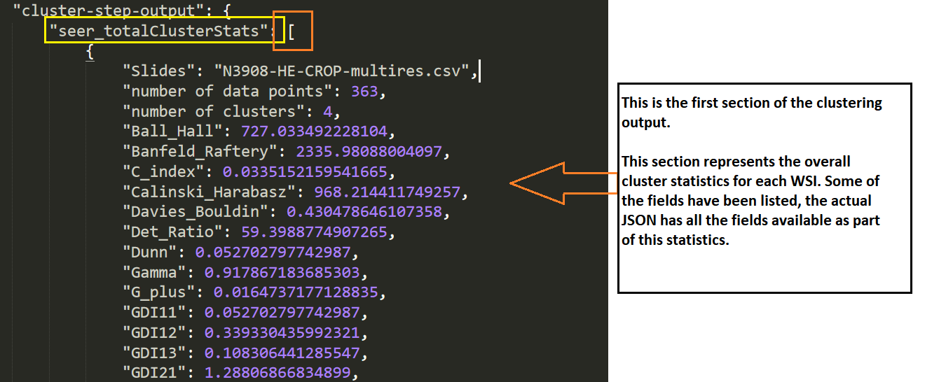

## **Overall cluster summary information**

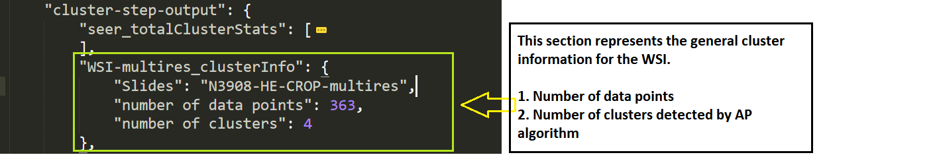

## **Cluster Indices output (AP algorithm)**

