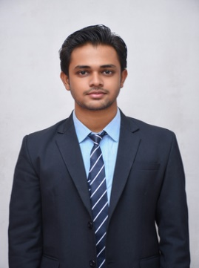Subhrajit Bagchi

Temple Street, Jalpaiguri, India| 7001941108 |subhrajitbagchi0202@gmail.com| linkedin.com/in/subhrajitbagchi|

Seeking a role within an innovative organization that highly regards my analytical and technical proﬁciencies while oﬀering opportunities for continuous learning and skill enhancement. I am eager to contribute to the company's advancement and simultaneously foster my own professional development journey.

|  |  |
| --- | --- |
| EducationB.Tech Computer Science Engineering | Siliguri Institute of Technology| 09/2021 - Present  * CGPA – 7.5   **Higher Secondary Education |Indian School Certiﬁcate| Saint Paul's School | 05/2006 - 05/2021**   * Percentage – 86.32 %   **Secondary Examination |Indian Certiﬁcate of Secondary Education| Saint Paul's School | 05/2006 - 05/2019**   * Percentage -79.3 % | |
| projectsJava Password Generator |*March 2024 - April 2024* • Developed a password generator with customizable parameters and robust encryption • Implemented password strength visualization and credential management Skills: Java, encryption, UI/UX design, GitHub, IntelliJ IDEA, GitHub, and Notepad++CASS AI - Digital Assistant| *January 2024 – February 2024* • Developed CASS AI, a digital assistant with dynamic responses and customizable settings • Focused on Python development and project documentation with PowerPoint • Managed the project using GitHub Skills: Python, AI, user experience design, GitHubAccessible Job Portal for People with Disabilities (Team Project) |February *2025 - Present* • Collaborating with a team to develop a web portal connecting people with disabilities to job opportunities • Focus on implementing accessibility features like text-to-speech, easy navigation, and screen reader compatibility • Ensuring the portal meets WCAG (Web Content Accessibility Guidelines) for an inclusive user experience • Contributing to front-end development (HTML, CSS, JavaScript) and accessibility testing Skills: Team collaboration, web development, accessibility standards (WCAG), front-end technologies (HTML, CSS, JavaScript) | |
| Skills | |
| * HTML * CSS * JavaScript * Python * Troubleshooting | * JAVA * GITHUB * TEAMWORK * SQL Basics * Operating Systems |