  - Sasha Barrilleaux

Project Documentation – Picky Pigeon


Executive Summary
This summary can be taken directly from the project design document. Proofread and edit the section so that it is appropriate for the final project documentation.
Picky Pigeon is a match-3 style game. It is about matching/collecting nibbles for a pigeon, who is setting the objectives for the level based on what he wants. This means a game that is similar to games such as Candy Crush, where you are matching pieces on a board in lines. Each level of Picky Pigeon has at least one objective to complete, such as clearing 20 blueberries from the board within the number of turns the level has. Successfully completing all objectives results in winning the level with a 3-star rating and provides coins based on amount that clear rating, which can be used for items. There are currently four purchasable items with the following abilities:
- clear a horizontal line
- clear a vertical line
- clear all of a specific type/color of nibble from the board
- remove a singular nibble from the board.
Items can also be made on the board by matching more than three in a row or column, as is common in this type of game. For instance, a line of four spawns a row or column clear item depending on the direction of the 4-match. The project consists of 6 levels currently. Picky Pigeon is a game suited for anyone looking for a simple game to play.

Scenario | Main Menu | Program Usage Description
This is the main menu for the game, the main purpose of it is to select levels. Each level shows up in the scrollable list with its current highest saved rating on a scale of 0 – 3. The top right displays how many coins the user has, and the bottom left button will pull up a menu to adjust volume or exit the game.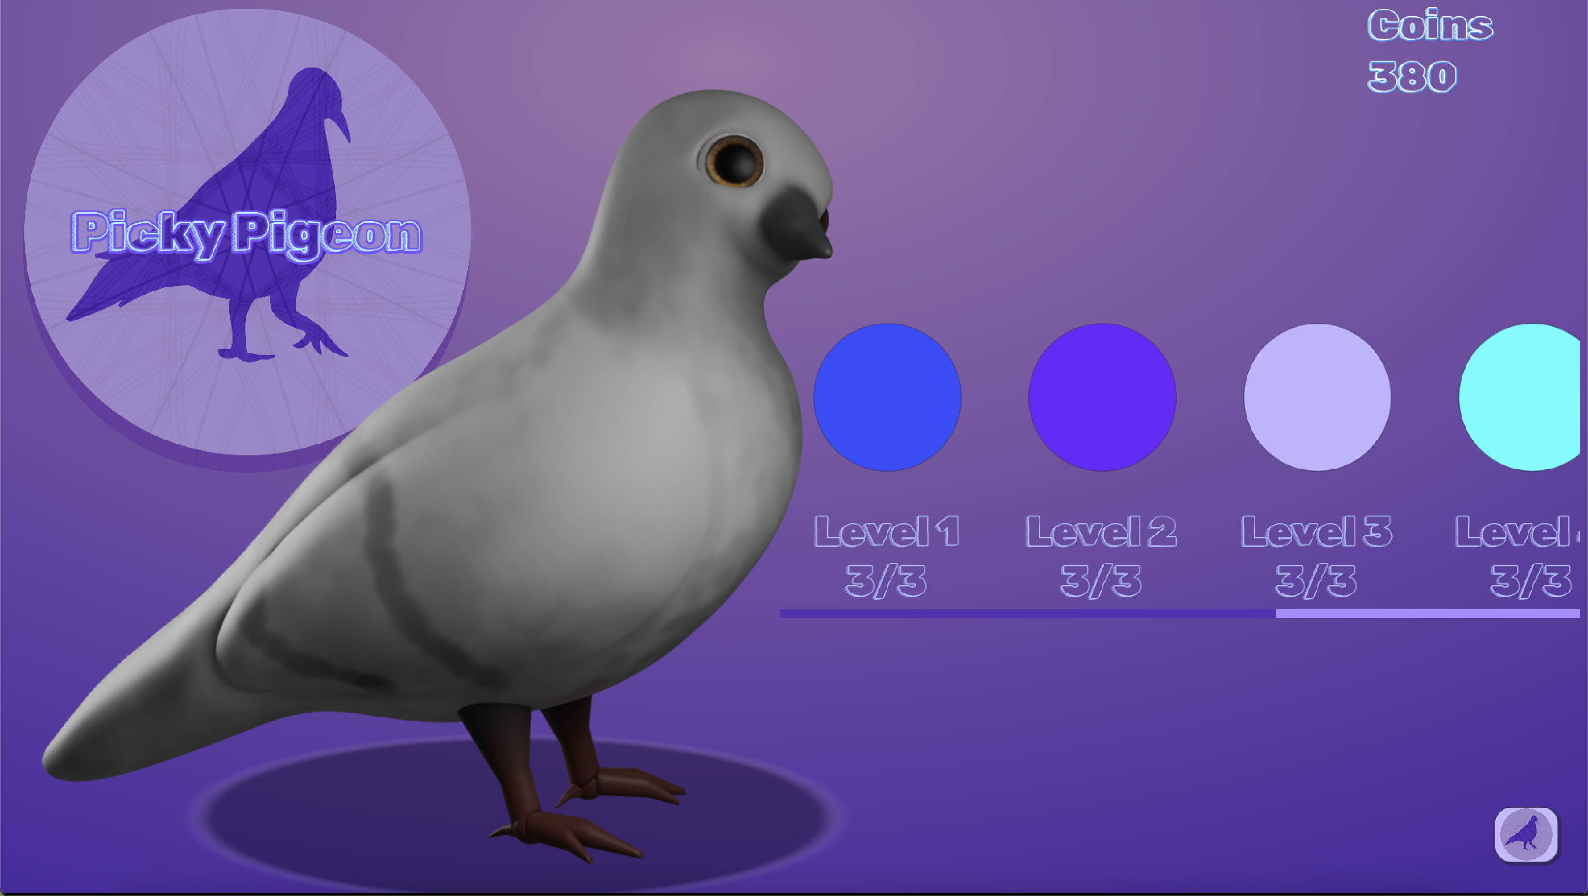

Scenario | Level | Program Use Description
This screenshot of one of the levels for the game. The left-hand side includes how many turns are remaining in the level, and items which can be used and purchased. The Picky Pigeon is there to observe as you collect the snacks he wants. In the middle of the screen is the game board, filled with nibbles to match and collect for the Picky Pigeon. The right-hand side has the objectives, which is what needs to be matched to get a good rating and more coins from the level. It also has the coin total and volume/ exit button in the bottom left.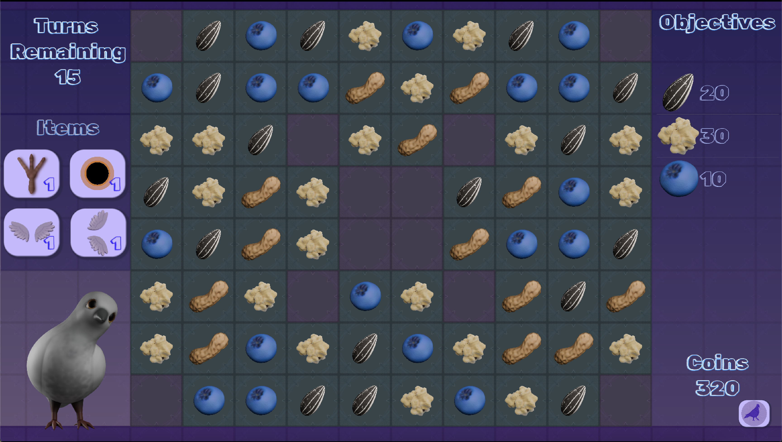

System Architecture
Describe and diagram the system architecture. This section is set aside to document where code lives and runs. A graphical map of a live system works nicely here. Additionally, if it was necessary to employ any type of record-locking scheme, this is the place to discuss that.
Everything for the game is entirely local to the device, no connections to any databases or servers are used.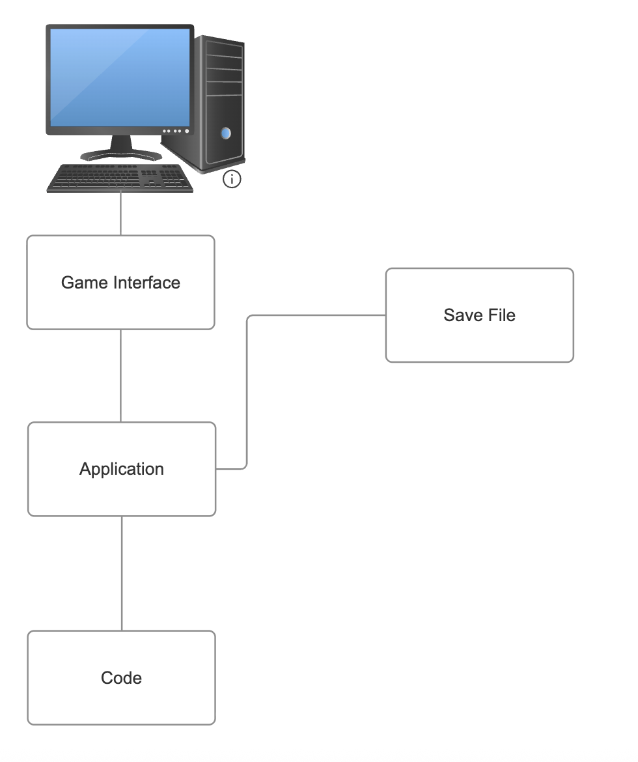

Source Code Structure
Source code structure introduction. The following is a summary of the source code directories and their contents: *Only one directory contains code files, the rest are for visuals, sounds and scenes. *It is also worth mentioning that all assets for the project were created by me.
Code Directory
Directory | Usage
scripts | This directory holds all the scripts for the project
Levels | Contains all game level scenes, levels should be inheriting instances of BaseLevel.tscn, which is stored in otherScenes.
MenuItems | Contains scenes meant to be used for buttons that allow buying and using an item from left menu. MenuItem.tscn is the base scene these buttons all inherit from.
otherScenes | Misc scenes, such as menus that can be put in levels, like pause and game over, the main screen.
Nibbles | Has two subfolders, one for nibble art, which is the icons for board nibbles, and another for nibble scenes, which are the different kinds of nibbles that can be spawned. Nibbles all inherit from Nibble.tscn.
BoardItems&Obstacles | Contains the art for obstacles and scenes for them. Currently only has bramble as an obstacle and a base scene for obstacles.
sounds | All the mp3 files for background music and sound effects go here
BackoundAndUI | Contains subfolders with icons for menus and items, also contains font and tileset, as well as theme for the game.
pickyPigeon | Contains animations for the Picky Pigeon
Highlighted rows indicate directories containing source code.

Executables
Describe the executables that are a part of this project. If there are multiple executables break out each one into its own heading and give its name and a description of what function it plays in the system.
*The executable files were around 100 mb each so they are downloadable from Google Drive instead of being in the GitHub repository

PickyPigeonProject_macOS (PickyPigeonProject_macOS.dmg)
A playable build of the game that is executable on MacOS

PickyPigeonProject_Windows (PickyPigeonProject_Windows.exe)
A playable build of the game that is executable on Windows

Code Architecture
Explain how the system is put together. Provide an introduction and then dig into the database or data store design and then explore the internals of the code.
There are nine scripts for the project. In Godot, these scripts are attached to objects in a scene and use the hierarchy established in them. For instance, each level of my game inherits from a base level scene which has everything setup in it, which is then customized per level. Multiple objects in this scene have scripts attached, and most objects that don’t have their own script are controlled by objects that do have scripts.

Database or Data Store
Introduction to the database or data store.
The project does not use a database, but here is the format of data saved to a file, and an example save file: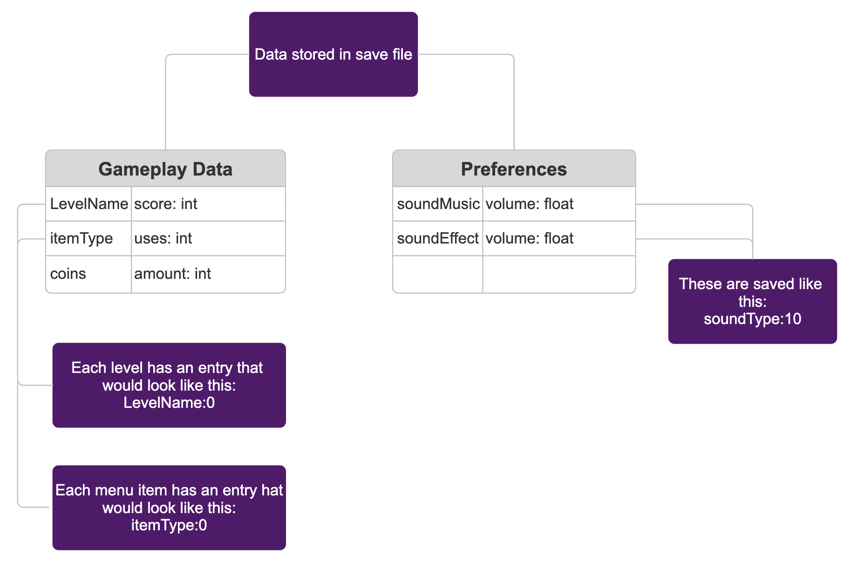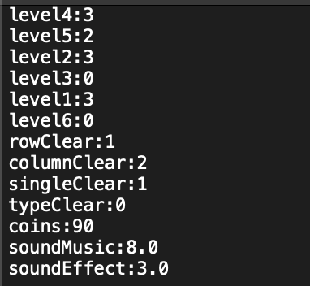

Programming Language | C#.NET
Provide details about what language the project is written in. – Be sure to identify any components, references and/or external DLLS.
This project is written in GDScript, which is a Godot specific language, which is a free game engine I’ve used to make the project. Godot provides many useful tools for making games, such as the tools that allow making the game window and setting up the GUI. It also provides several base classes to be used that can be used for projects, such as buttons, tileMapLayers, sprites, and particle systems. Scripts can then be written to utilize or customize the built in functions of these objects, or create new functionalities entirely.
The project has not used any external DLLS, just functionality that is already built into the Godot engine.

Project Classes
Classes within the project are used to abstract re-usable pieces of code. Classes are also used to group related values, known as properties. The project utilizes these classes:
* By the definition above, I’m only counting some of the scripts as full classes and am mostly highlighting the scripts that adapt the most between scenes.

The center piece of all level functionality| board_manager.gd
This class creates the game board and controls the majority of gameplay. It has several re-usable methods within it. It meant to be attached a node in a game scene to control the rest of the game, such as timers and playing sound effects, on top of its own base functionality. The script has several exported values which are set in the editor, the most frequently changed per level of these fields being two arrays for objective items and objective goals, which establish goals for the level, and an int field for the max number of turns in the level. There are a lot of things that this script does, such as handling mouse inputs, input checks, matching, destroying, collapsing, and refilling the board, controlling how items work, etc. The board is also made of two 2D arrays, one for nibbles and items, another which obstacles are placed on.

Handles saving and loading data, and sharing that data| playerData.gd
PlayerData is a script attached to a general node which should exist in each scene. It manages saving and loading primarily. It also has a few methods to allow other scripts to adjust or retrieve those values, such as useCoins and getLevelScore.

The logic for board nibbles| nibble.gd
While the board_manager controls most of the behavior in game for nibbles, this script establishes what a nibble is, and allows creating different types of nibbles. A base nibble scene uses this script, which is inherited by other nibble scenes to create different types. The script establishes a few variables, such as matched which is set to true of false during gameplay. It has a few exported variables, most of which are to create references to textures, but the major one for code is ‘nibbleType’ which is a string that establishes what kind of nibble it is. This is extremely important, since it dictates how it should interact with the rest of the game. The script also contains methods for making a nibble into a board item, as rather than spawning new objects, a nibble in the matched set is converted into the new item. It also has methods for match animations.

A base logic for obstacles | obstacle
A simple function with a few methods for the base logic of obstacles. Has a method to takeDamage and getHealth, and exported variables for setting maxHealth, its type, and different stateSprites for full health and damaged visuals.
Program Start and End Flow
Describe and then diagram the program flow.

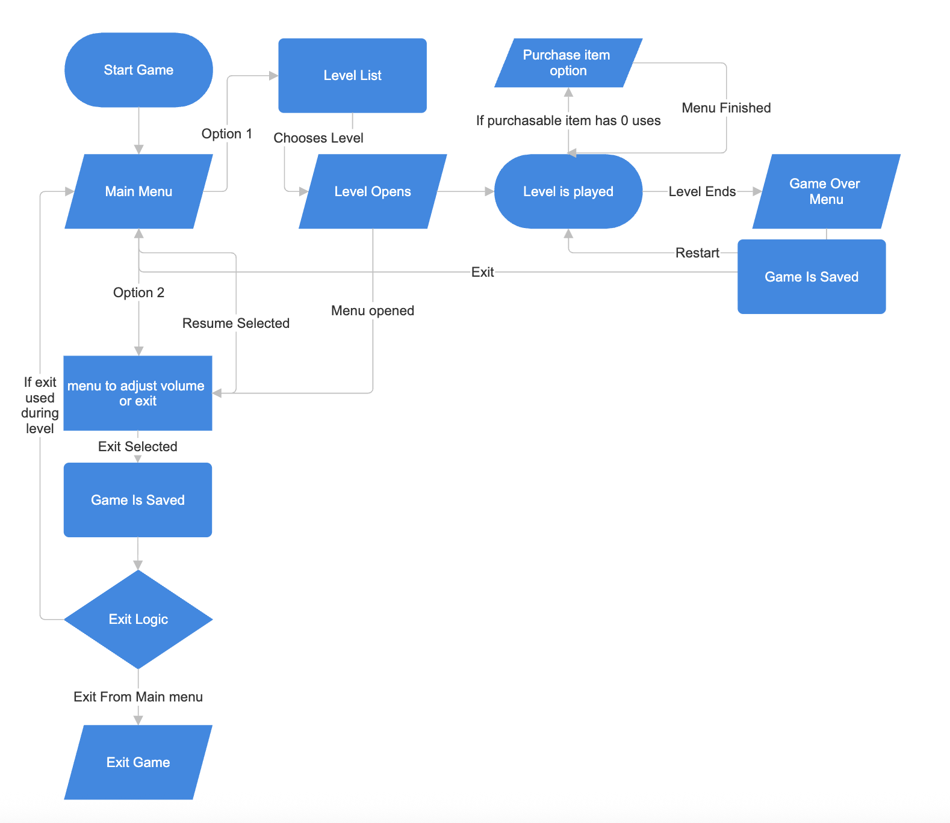

Testing
The game was tested throughout development by playtesting. I play tested features as they were implemented, and as more things were put together, have had a handful of other people test the gameplay. I also had people test that the game worked on export for both platforms and that it worked outside of my own system. Testers were asked to play levels and see if they noticed any unusual behavior, as well give their opinion on design choices and features. Testing between systems was important, and several issues were caught during this phase, as file handling had issues from editor playtesting to build and between platforms.

Maintenance
Future maintenance would involve patching out bugs that were discovered from users. Maintenance would also involve updating documentation as the program changed.
Summary
Briefly summarize the system documentation here. This section should be no longer than 1/3-1/2 of the page.
Picky Pigeon is a match-3 style game that has been successfully created in the 15-week project timeline, from project proposal, design, to a V1.0 project. All assets in the project from the code to art and sound, were made by me during this timeline. The project has been made using Godot, a free game engine, and uses GDscript. Currently is has been exported to be played on either MacOS or Windows.
Save data, input validation, re-usable code, and in-code documentation were project requirements, and all of those areas have been fulfilled. The code is made to be re-usable and expandable for potential future upgrades and updates. It would be straightforward to add more nibble types, items, and obstacles in future.
Project GitHub:
https://github.com/SBarrilleaux/Picky-Pigeon

APPENDIX B (BUILD AND RELEASE PROCESS)

Describe the build & release process required to implement an update.

After a version is ready to be built and released, assuming it has been fully tested, the build and release process for the game would involve re-exporting a new executable or .pck file for the version for each supported platform. The game created for this project or V1.0, involved building the project for each platform (MacOS and Windows), testing those builds, correcting and re-exporting, and then making those files accessible in google drive. If I were intending to release this game, I would need to also see how updates should be rolled out for say the App Store or Steam, however that isn’t necessary for the scope of this project.

APPENDIX C (CLIENT INSTALLATION INSTRUCTIONS)

Detail how a client machine or device is prepared to utilize the project. –

To install and play the game, all that is needed is download the executable files for the correct operating system.
Notes for installation on each supported operating system:
MacOS: Trying to open the .dmg will cause Apple to give a warning about opening the program from an unidentified source. To get around this, after trying to use the .dmg file, go to system settings, privacy and security, scroll down and there should be a button to open anyway. After this the device will ask for the password to make sure, and then the program will be opened without issue.
Windows: The executable files contain both an .exe file and an .pck file. The .exe file needs the .pck file, there may be some warnings or recommendations that Windows give during this, doing what the system advises should allow proper installation.

APPENDIX D (DEVELOPER SETUP INSTRUCTIONS)

Detail how a developer must setup their environment in order to work on the code.

For opening the project in Godot, you would need to download the Github repository and import the project. When importing those files into Godot, select the project.godot file.

