1. Error:

First calculate installed services on perticulor node, you can find these details in host Resource tab, then memory section. Now calculate allocated memory, if its maching your total installed memory, you won't get any **"Memory Overcommit Validation Threshold"** warnings, if its coming morethat what you have memory, then you will get this type of warnings.

<https://aws.amazon.com/premiumsupport/knowledge-center/resize-instance/>

1. Cloudera recommends setting /proc/sys/vm/swappiness to a maximum of 10. Current setting is 30. Use the sysctl command to change this setting at run time and edit /etc/sysctl.conf for this setting to be saved after a reboot. You can continue with installation, but Cloudera Manager might report that your hosts are unhealthy because they are swapping. The following hosts are affected:  
   [View Details](http://ec2-3-210-215-20.compute-1.amazonaws.com:7180/cmf/express-wizard/wizard)3.

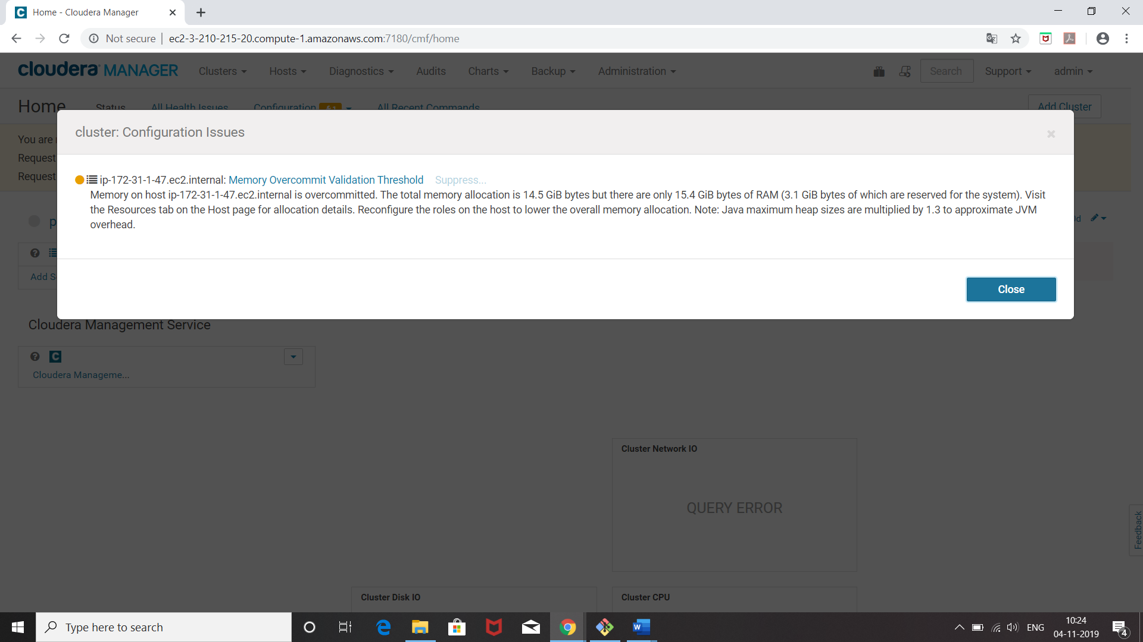

setfacl -R -m user:cloudera-scm:rwx /var/log

1. <https://community.cloudera.com/t5/Support-Questions/error-in-activation-of-zookeeper-failed/td-p/53560>
2. log4j:ERROR setFile(null,true) call failed.
3. java.io.FileNotFoundException: /var/log/cloudera-scm-firehose/mgmt-cmf-mgmt-SERVICEMONITOR