Setting up a Helpdesk

Contents
Introduction 3
Requirements 4
How to Setup a JIRA Cloud Instance 4
1. Create or sign in to an Atlassian Account 4
2. Create a Workspace 5
3. Service Management Template Setup 10
4. Verification 11
Summary 12
Appendix 13
Glossary 13

Introduction
This document serves as a step-by-step guide for setting up a JIRA Cloud helpdesk instance. By following this guide, a technical worker will be able to create a functional helpdesk environment, suitable for tracking issues, managing support requests, and organizing client interactions.
This guide assumes no prior experience with JIRA and is designed to help technicians deploy a basic helpdesk system from scratch.

Requirements
Before beginning, ensure you have the following:
- A stable internet connection
- An active Atlassian account (free to create)
- A computer with a modern browser

How to Setup a JIRA Cloud Instance

Create or sign in to an Atlassian Account
- Navigate to Sign up - Try Atlassian Cloud | Atlassian.

- Sign up for an Atlassian account with your email, then click “Sign up”. If you already have an Atlassian account, click “Login” and sign in with your email.

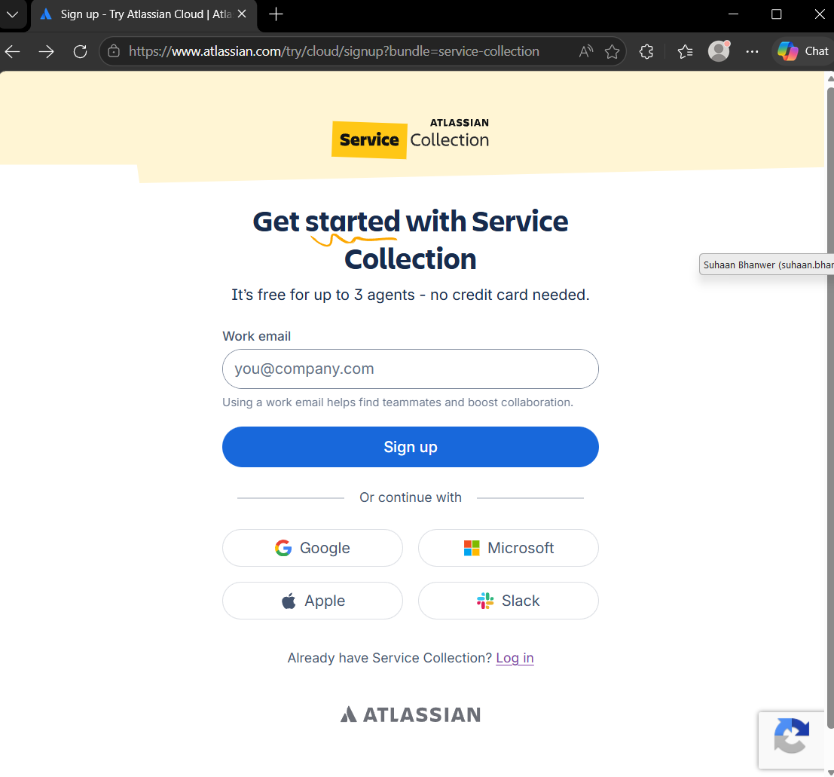
Click here if you already have an Atlassian account.
Sign up for an Atlassian account here

- If you already have an Atlassian account, disregard these next steps, and continue to the next section. You will need to verify your account. Log into the email you used to sign up and enter the six-character verification code.

- Next, you will need to enter your full name and create a password. After you are done, click “continue”.

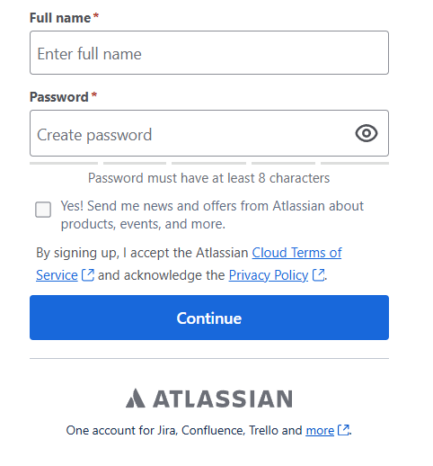

Your account is now setup, and you are ready to begin setting up a JIRA helpdesk.

Create a Workspace
- Now that you are signed in, you need to create a name for your workspace. The name should be unique, then click “continue”.

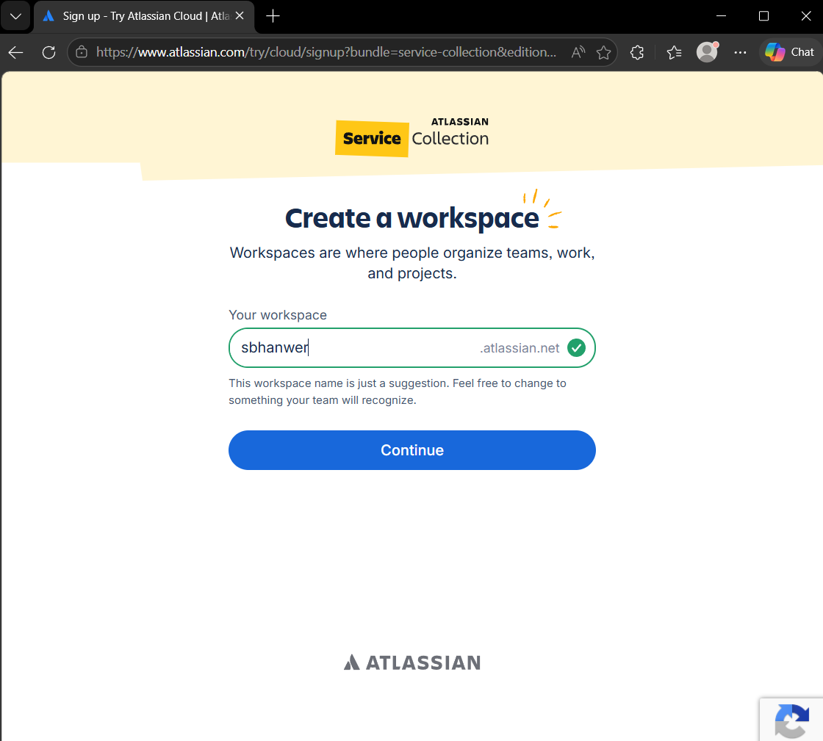
2. Click here
- Enter a name here

- When asked what time of work you do, select “IT Support”.

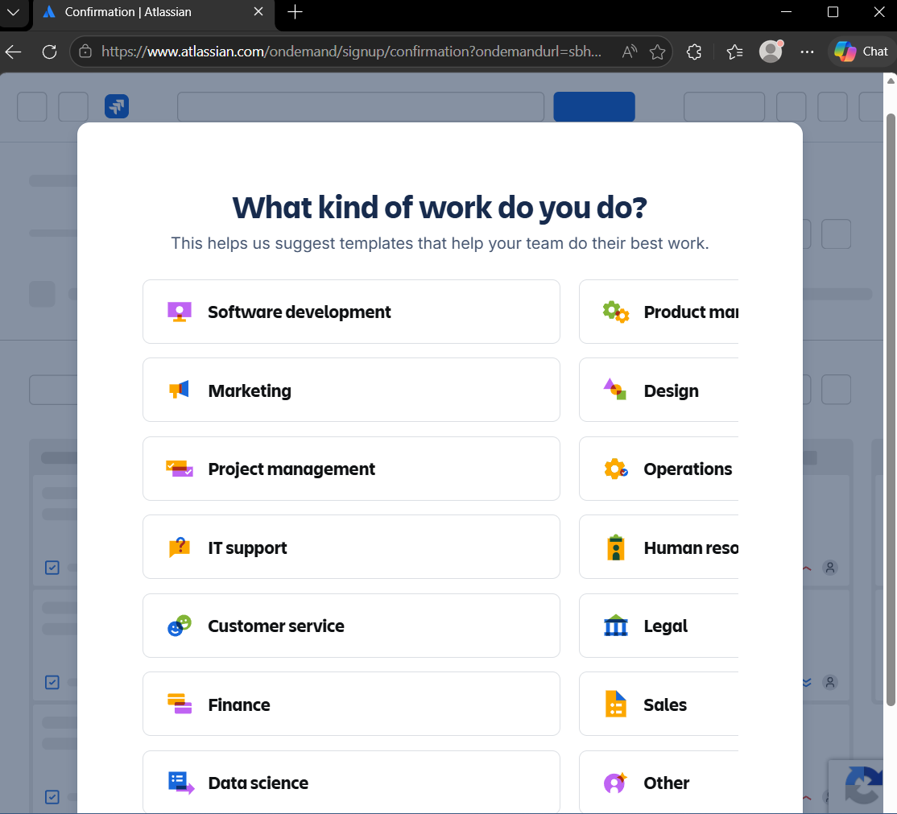

- When asked what your service management will be used for, select “Manage service requests.

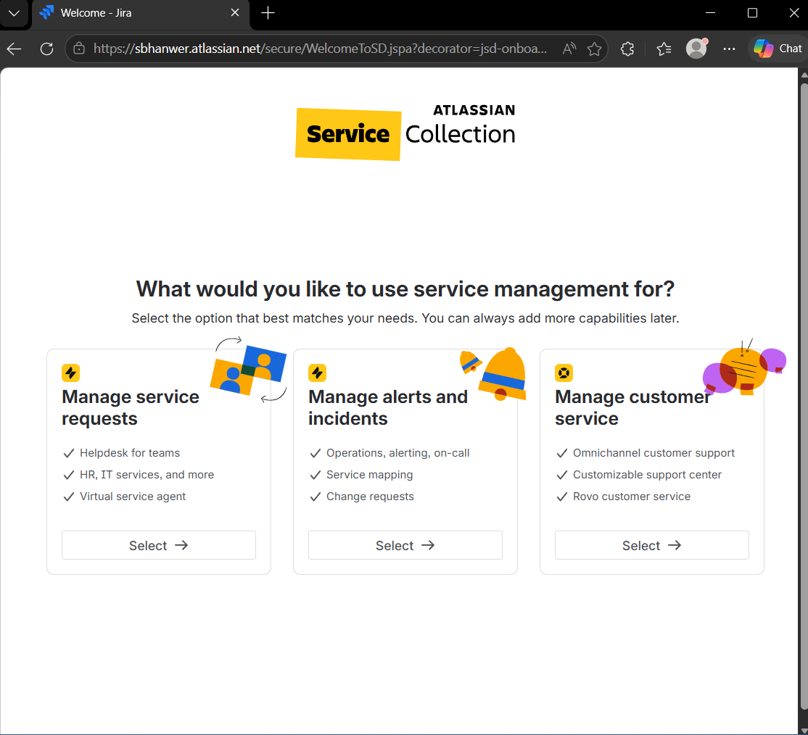

- For service management templates, select “Basic IT service management”.

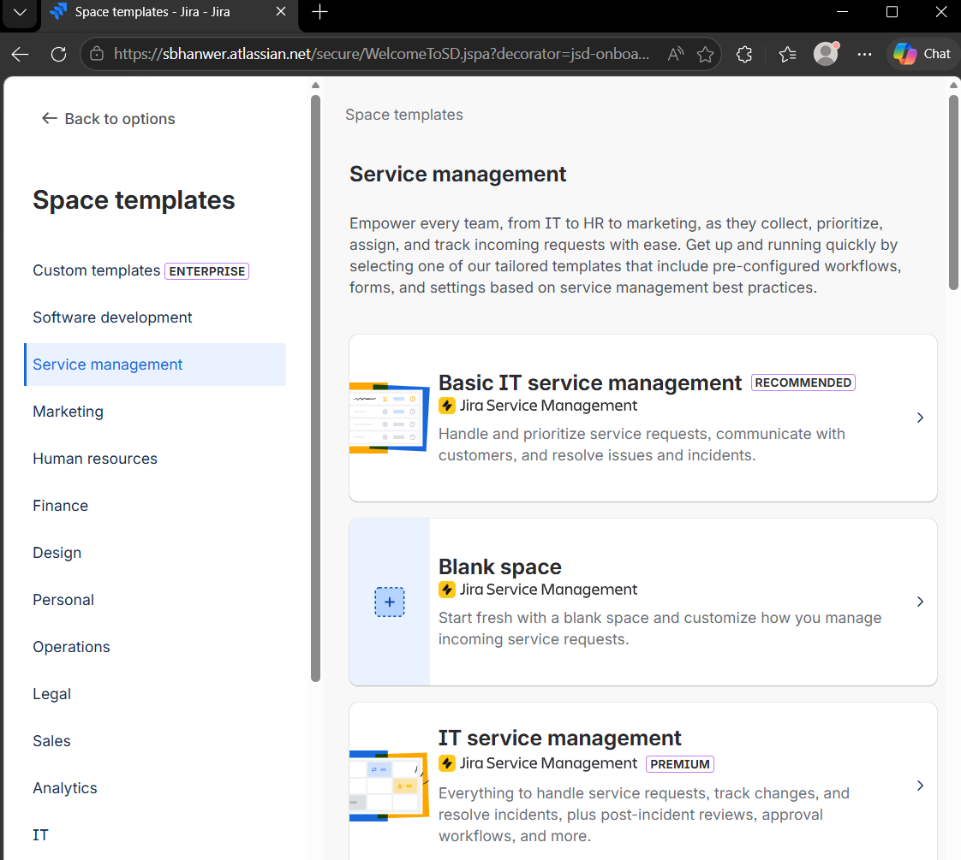

- Select “Use template” to proceed.

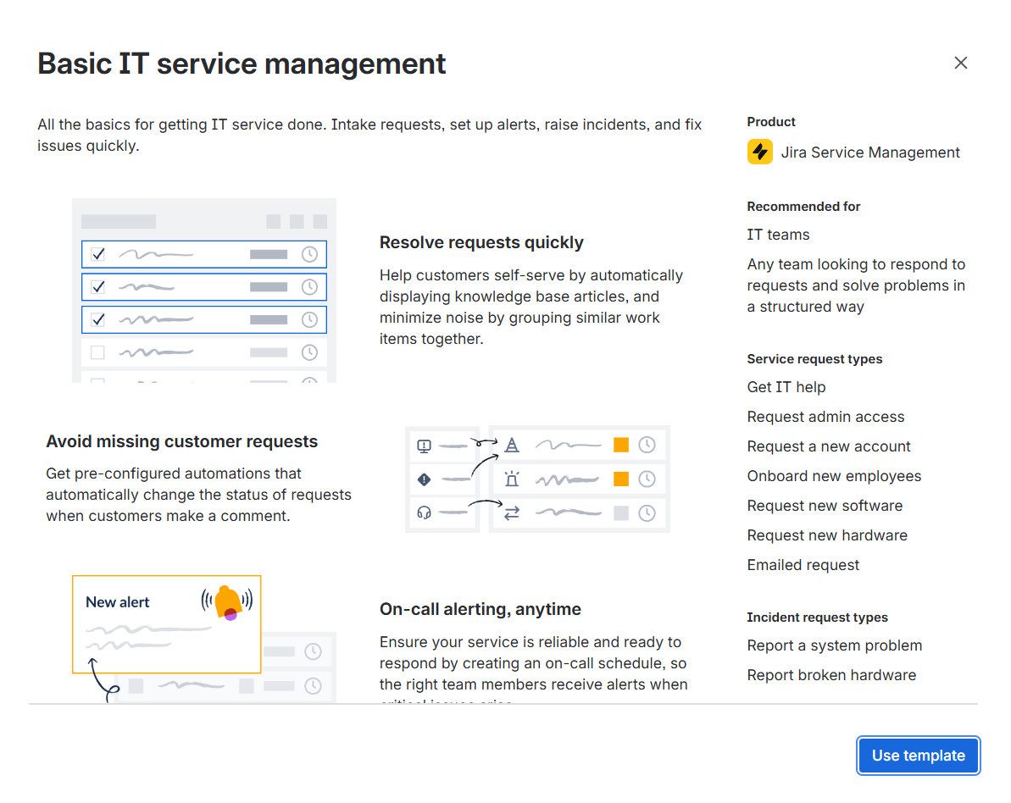

Service Management Template Setup
- To set up the service management template, choose a project name, a team type, and the channel access configuration, and click “Create project”.

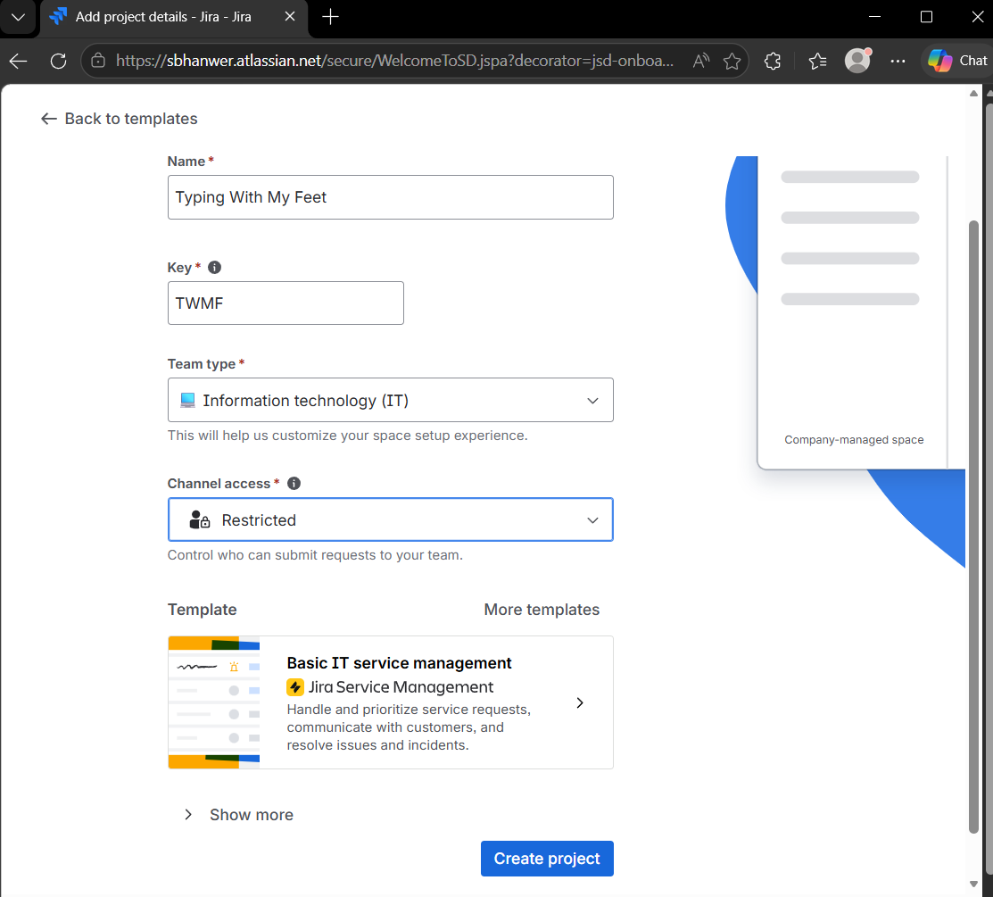
Click
Drop down menus
Enter name here

Verification
You have successfully created a basic JIRA service helpdesk. You should see the name of your project in the tab.
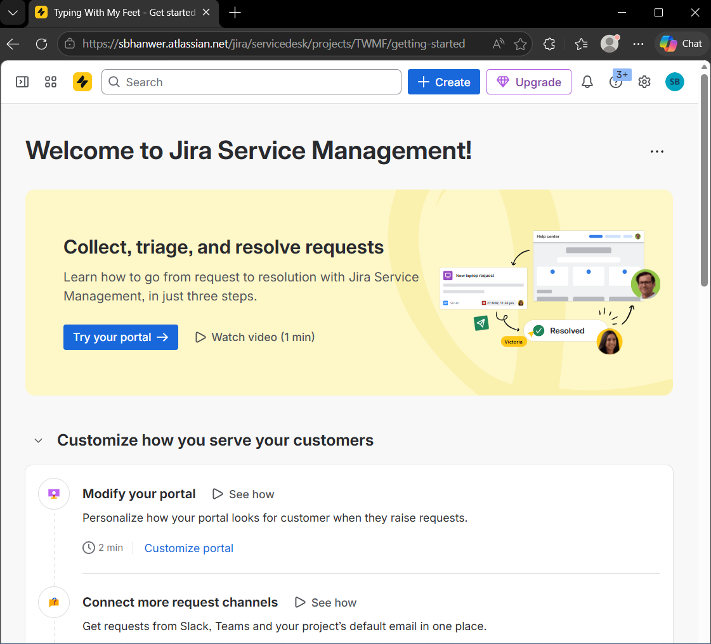

Summary
By completing this guide, you can successfully create a functional JIRA Cloud instance, which serves as an environment for tracking issues, managing support requests, and organizing client interactions. This setup helps create a basic JIRA service helpdesk, which can be further configured.

Appendix

Glossary
Channel access: Permission setting on JIRA, controlling who is allowed to submit requests to your service desk.
Jira Cloud: Atlassian’s cloud-based service management platform, used for helpdesk operations.
Project: A workspace on JIRA where issues and requests are grouped and managed.
Request: A ticket submitted by a user to the helpdesk. They can be either an issue, a question, or a service need.

