Report Contents

For the better result, use your word processor’s own Table of Contents generator!

# 1 Structure

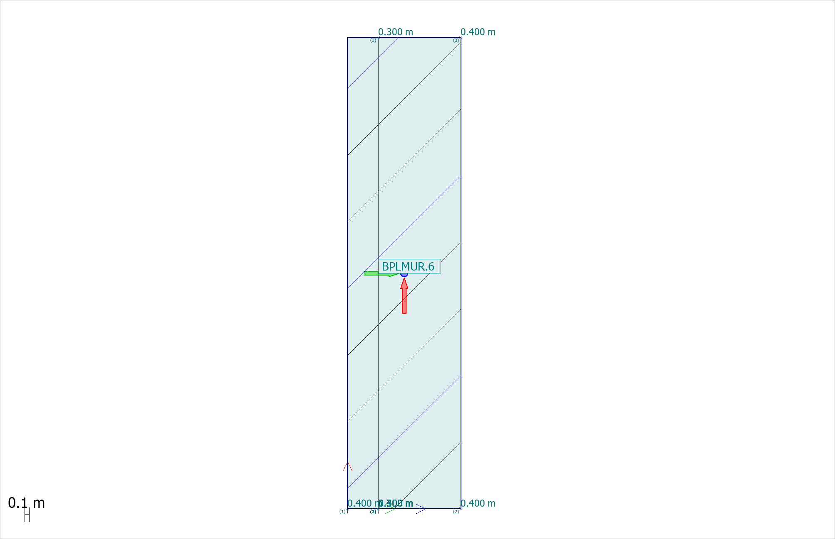 Figure 1.1: BPL / - Plane view

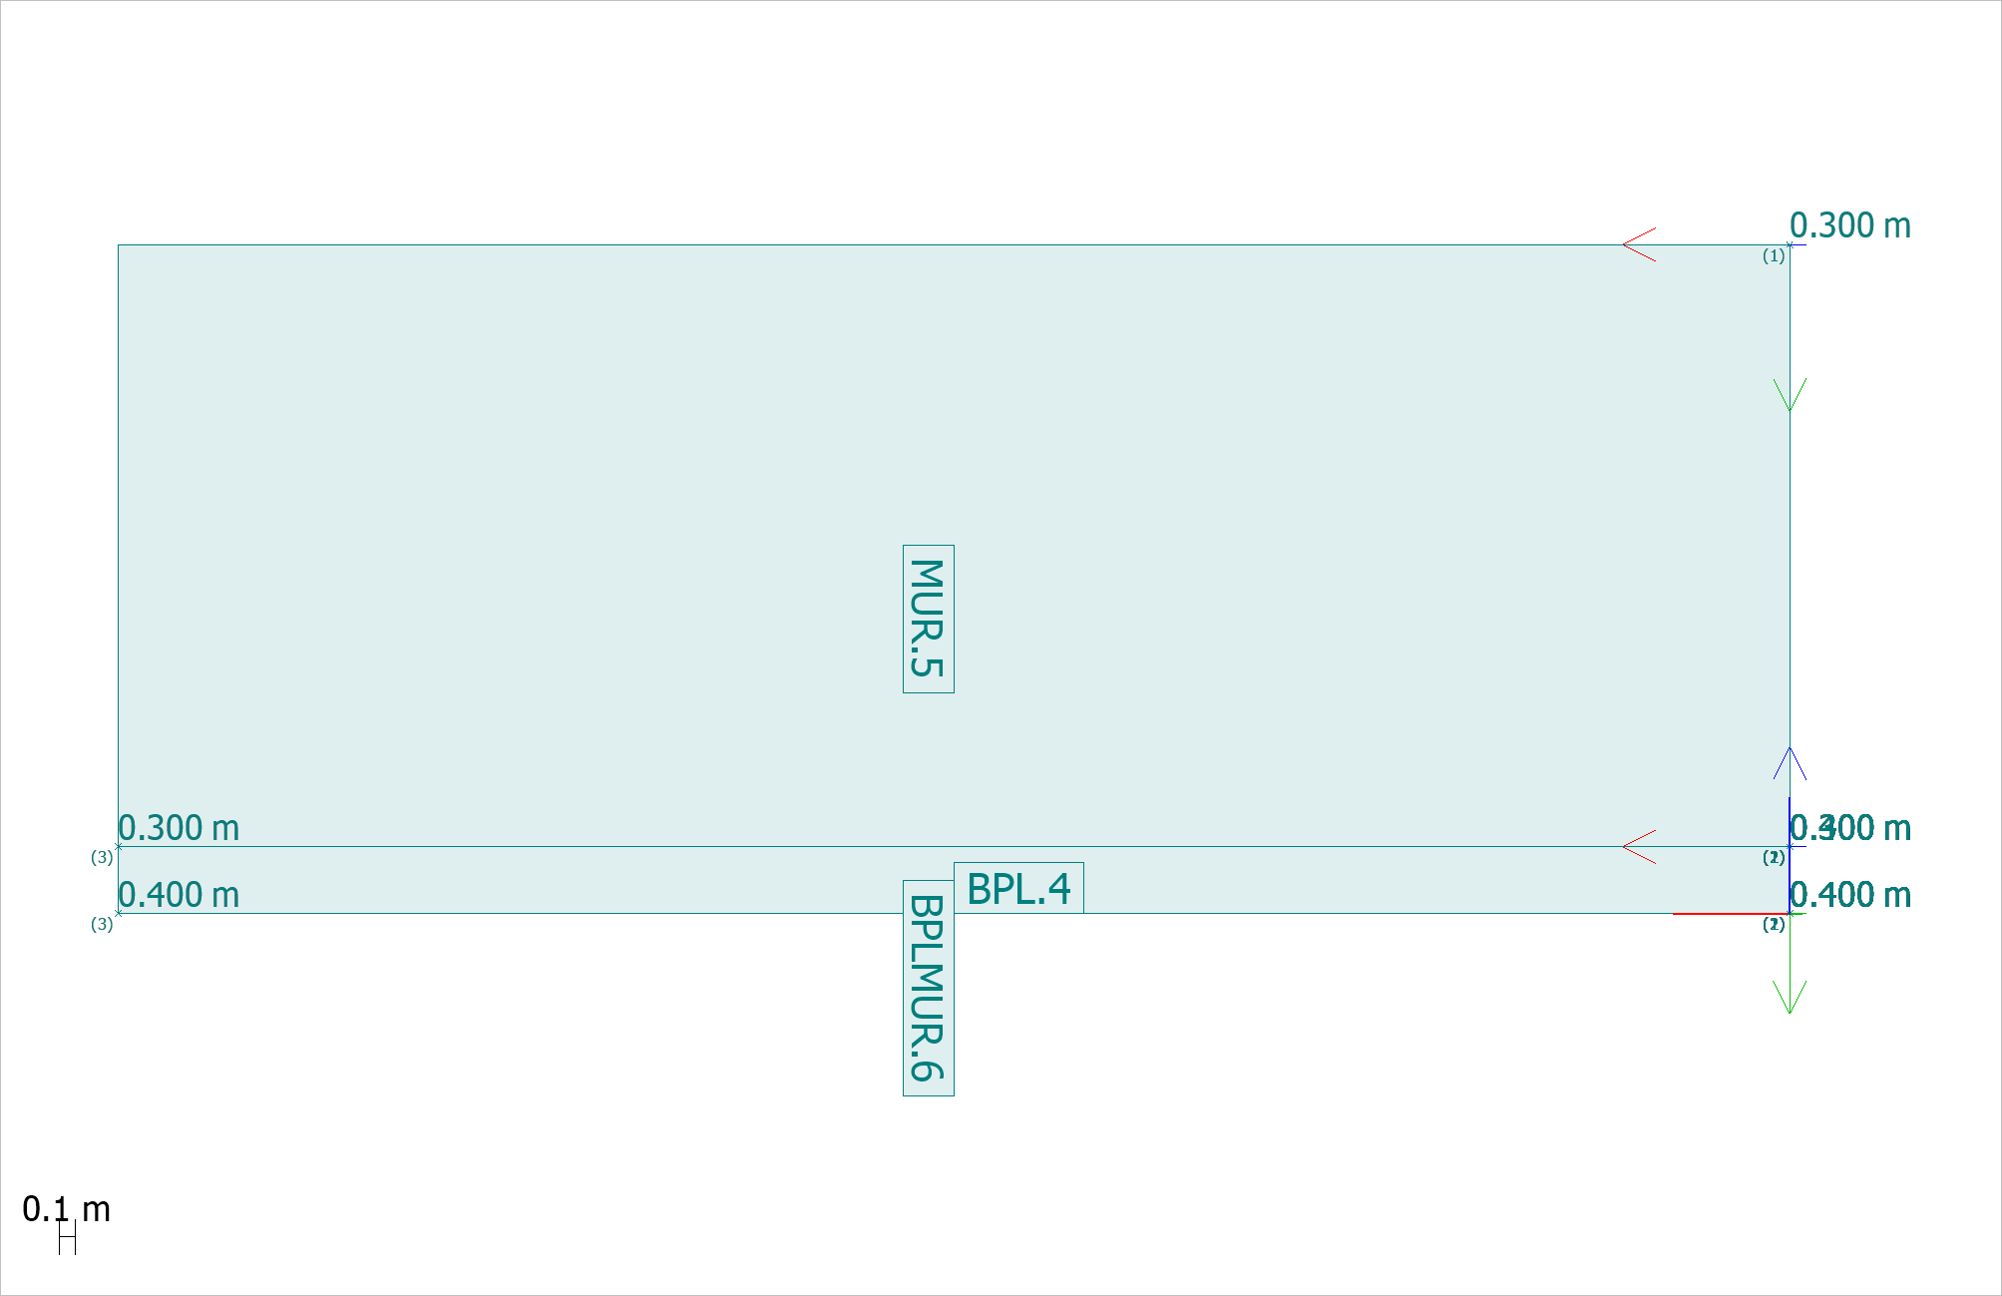 Figure 1.2: MUR / Shell - West view

**Concrete materials (3 items)**

|  |  |  |  |  |  |  |  |  |  |
| --- | --- | --- | --- | --- | --- | --- | --- | --- | --- |
| **No.** | **Name** | **Fck**  N/mm2 | **Fctm**  N/mm2 | **Fctk**  N/mm2 | **Ecm**  N/mm2 | **Yield strain** | **Ultimate strain** | **Density**  t/m3 | **Creep c.(U,Ua,Us)** |
| 1 | C35/45 | 35.0 | 3.2 | 2.2 | 34000 | 0.0020 | 0.0035 | 2.548 | 0.000 |
| 2 | C35/45_1 | 35.0 | 3.2 | 2.2 | 34000 | 0.0020 | 0.0035 | 2.548 | 0.000 |
| 3 | C35/45NoMass | 35.0 | 3.2 | 2.2 | 34000 | 0.0020 | 0.0035 | 0.000 | 0.000 |

|  |  |  |  |
| --- | --- | --- | --- |
| **Creep c.(Sq)** | **Creep c.(Sf)** | **Creep c.(Sc)** | **Plastic**  **data** |
| 1.643 | 1.643 | 1.643 | No |
| 2.118 | 2.118 | 2.118 | No |
| 0.000 | 0.000 | 0.000 | No |

**Plates (3 items)**

|  |  |  |  |
| --- | --- | --- | --- |
| **ID** | **Material** | **t1**  m | **t2**  m |
| BPL.4.1 | C35/45 | 0.400 | 0.400 |
| BPLMUR.6.1 | C35/45NoMass | 0.400 | 0.400 |
| MUR.5.1 | C35/45_1 | 0.300 | 0.300 |

**Surface support groups**

|  |  |  |  |  |  |  |  |  |  |
| --- | --- | --- | --- | --- | --- | --- | --- | --- | --- |
| **ID** | **Calculation type** | **Kx' comp.**  kN/m/m2 | **Kx' tens.**  kN/m/m2 | **Ky' comp.**  kN/m/m2 | **Ky' tens.**  kN/m/m2 | **Kz' comp.**  kN/m/m2 | **Kz' tens.**  kN/m/m2 | **Type** | **Disconn.** |
| BMBPL.2 | All | 6.09e+03 | 6.09e+03 | 6.09e+03 | 6.09e+03 | 1.00e+04 | 0.00e+00 | - | No |

# 2 Load

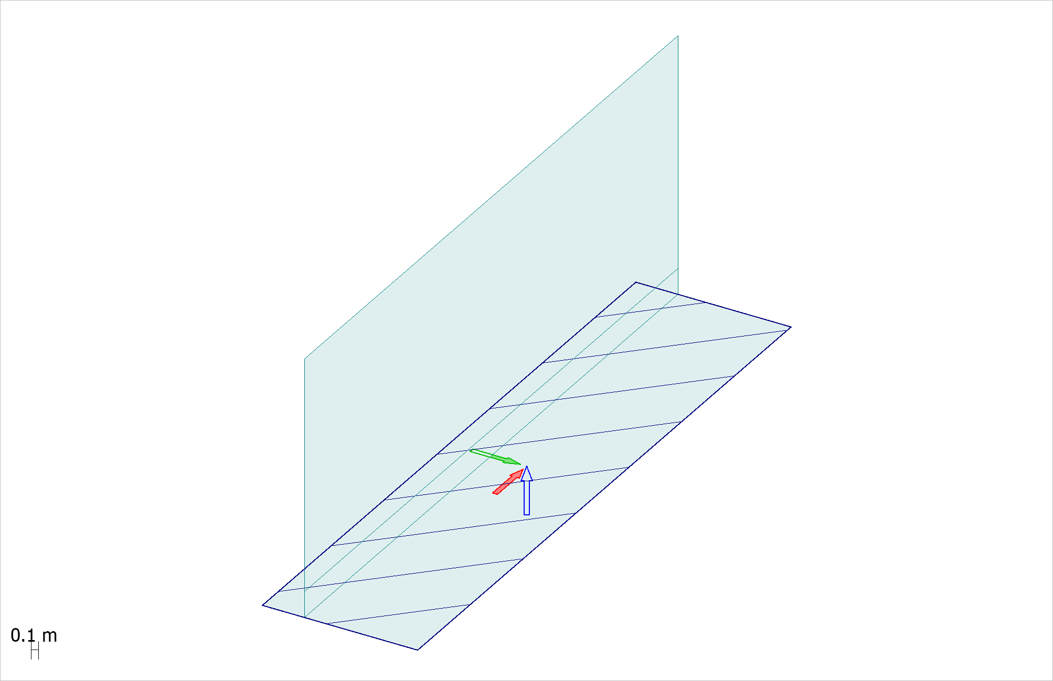 Figure 2.1: DL

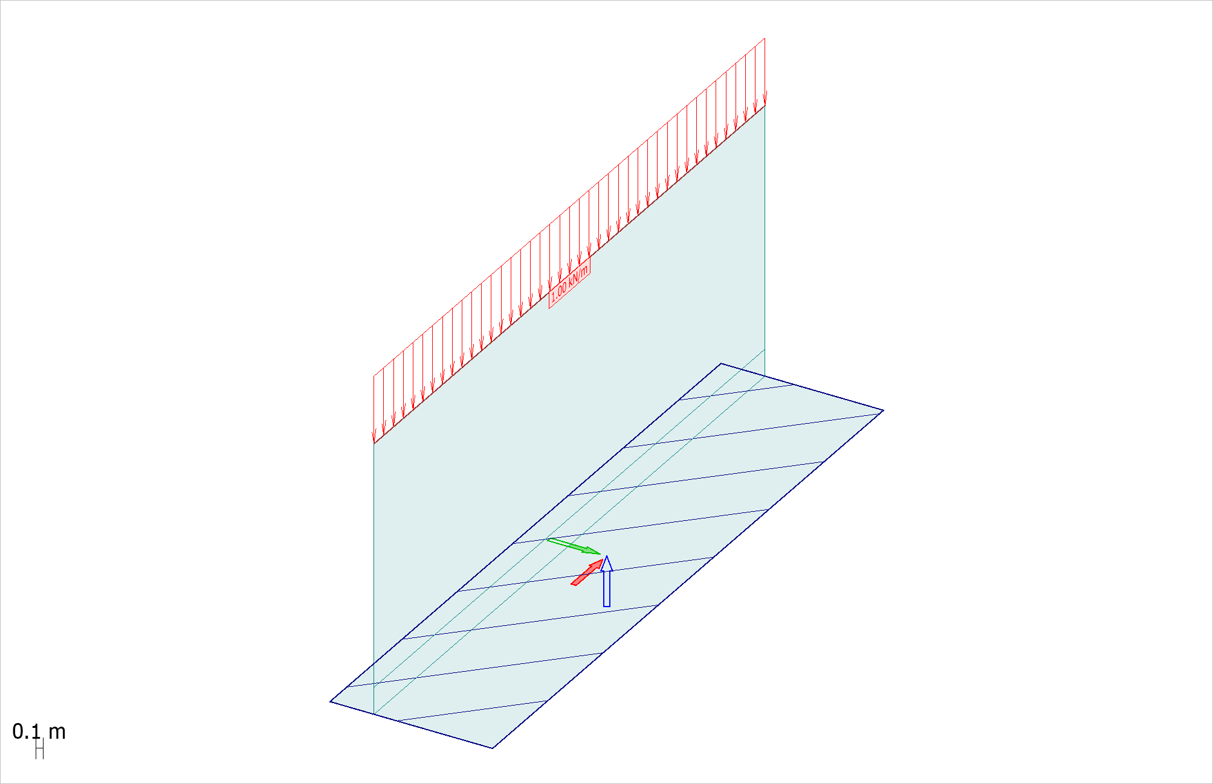 Figure 2.2: Räcke

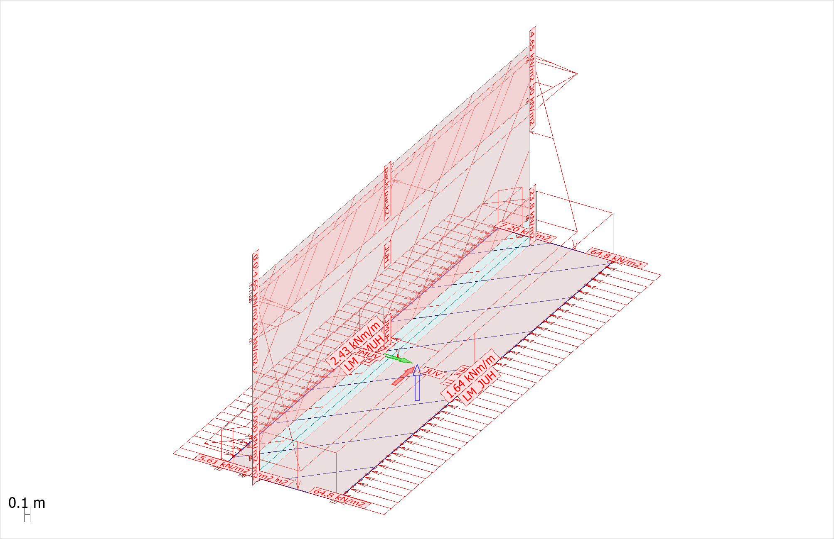 Figure 2.3: JordU

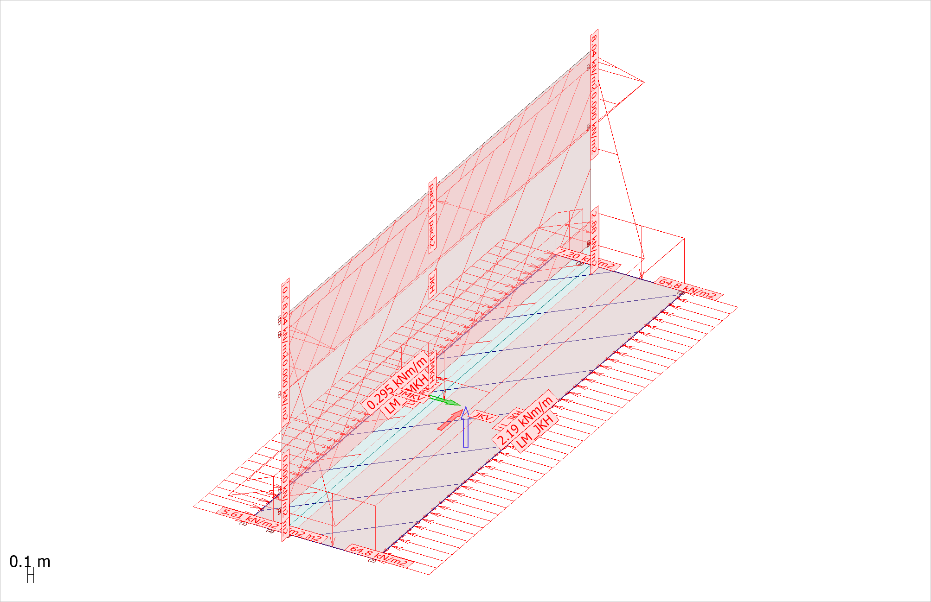 Figure 2.4: JordK

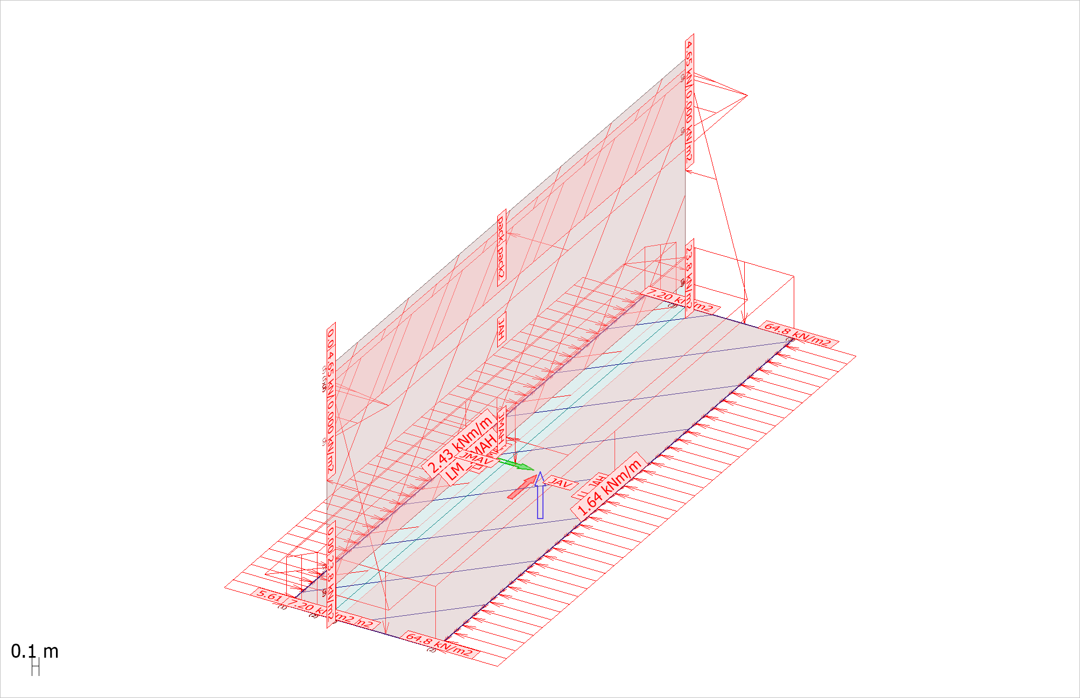 Figure 2.5: JordA

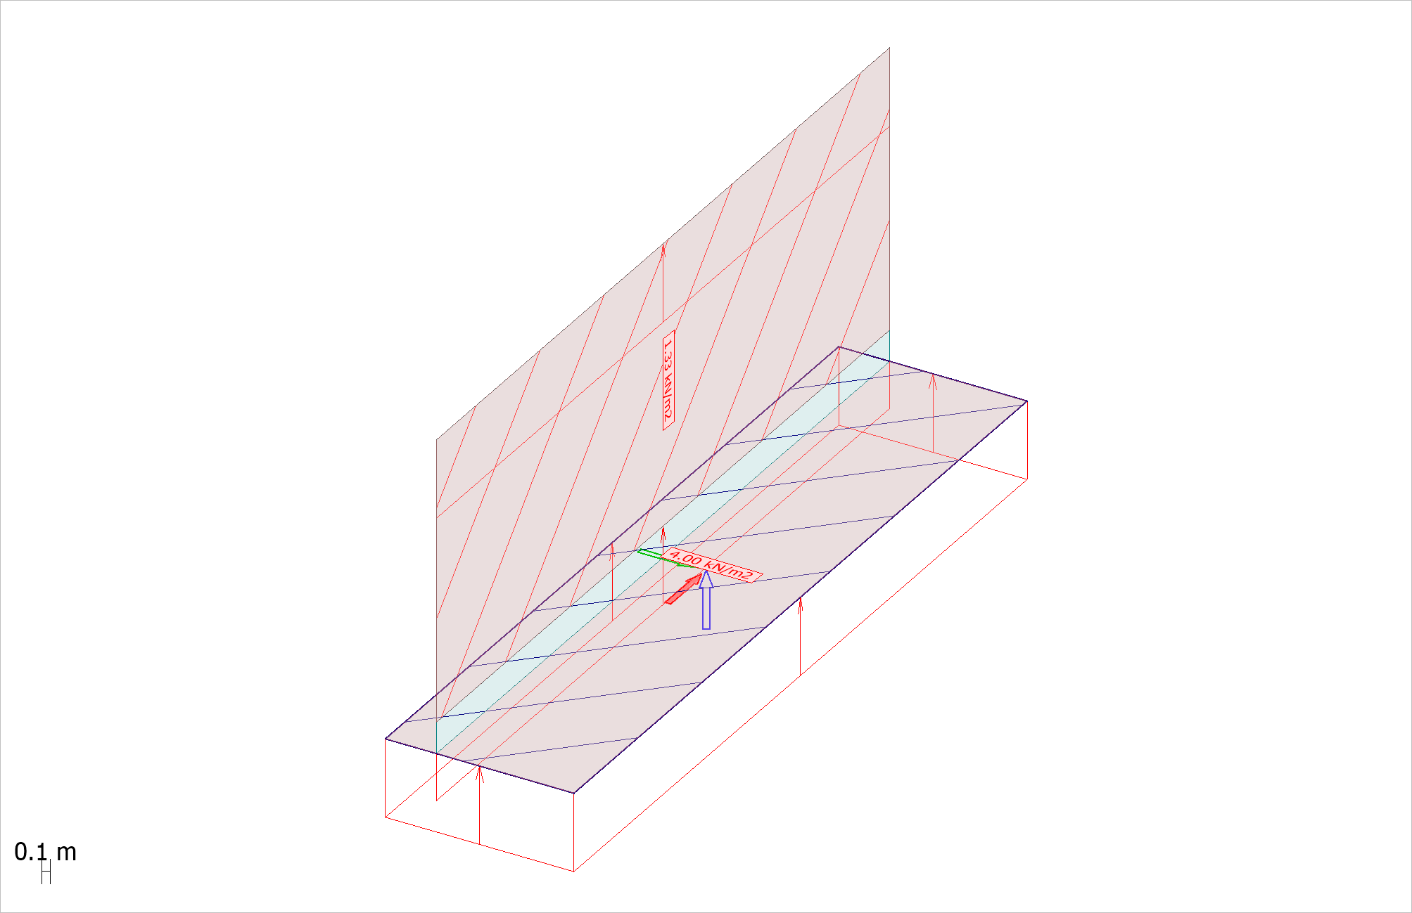 Figure 2.6: HHW

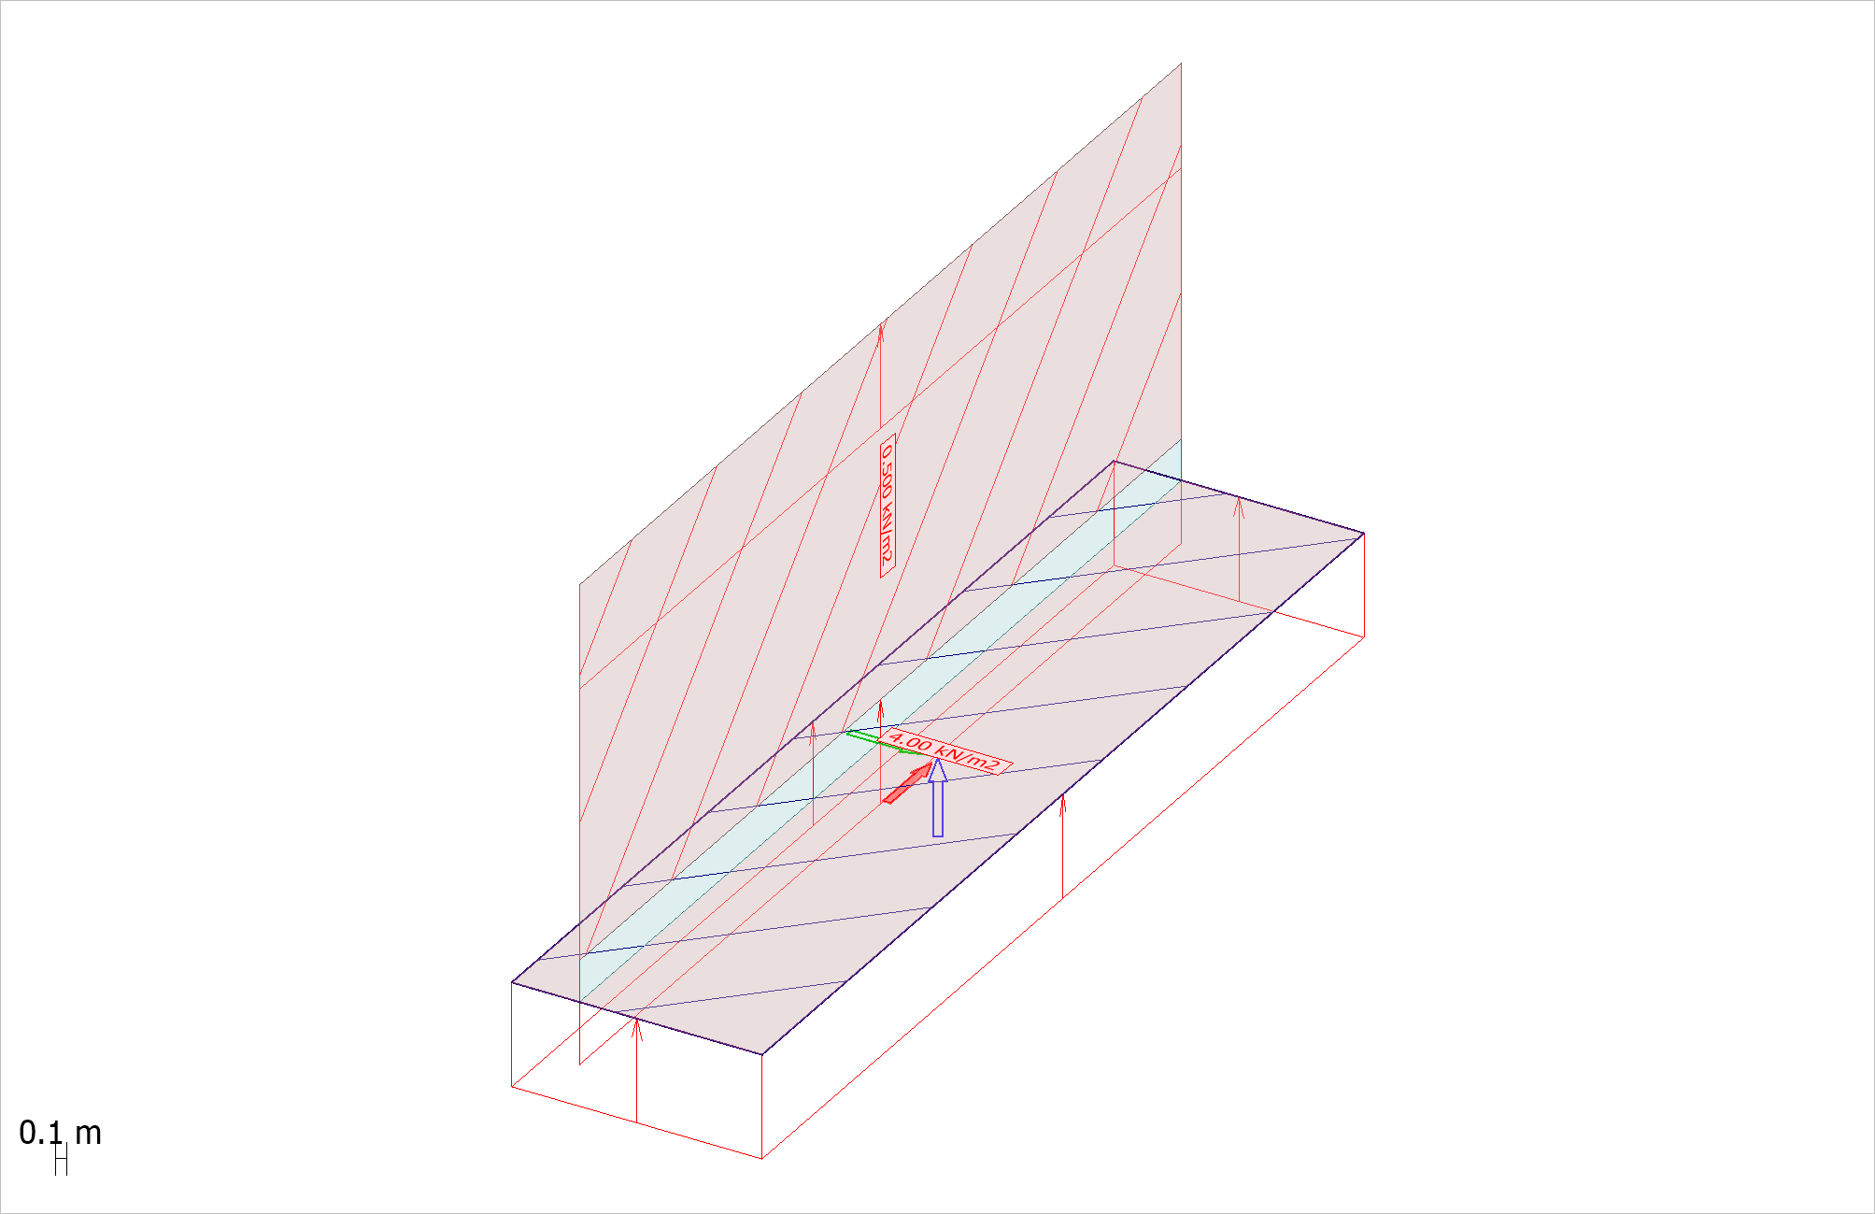 Figure 2.7: MW

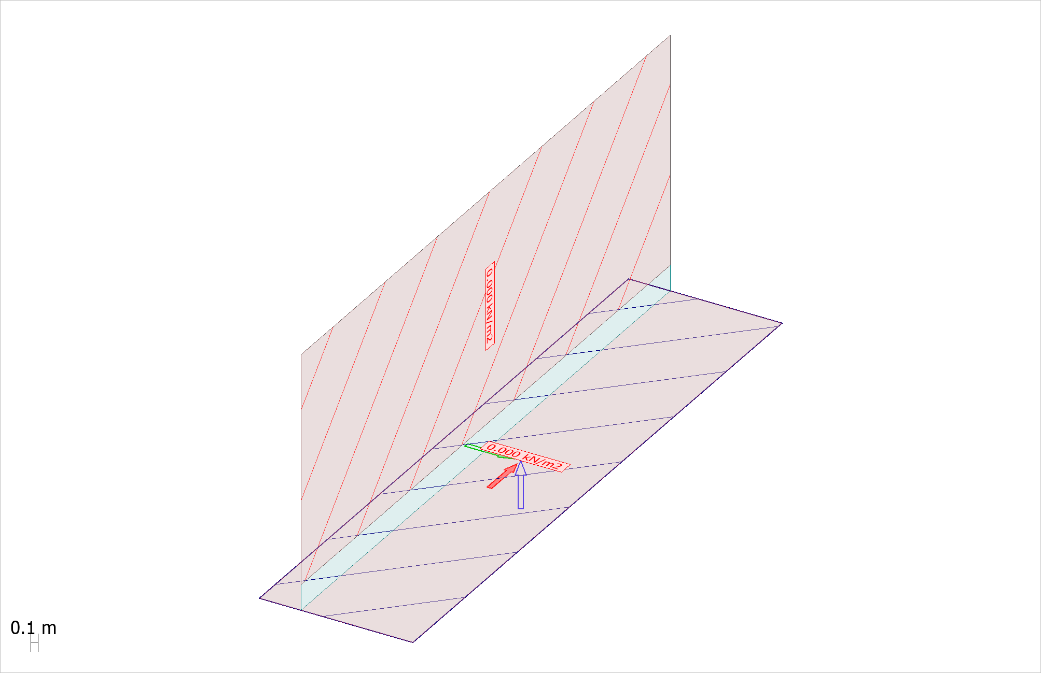 Figure 2.8: LLW

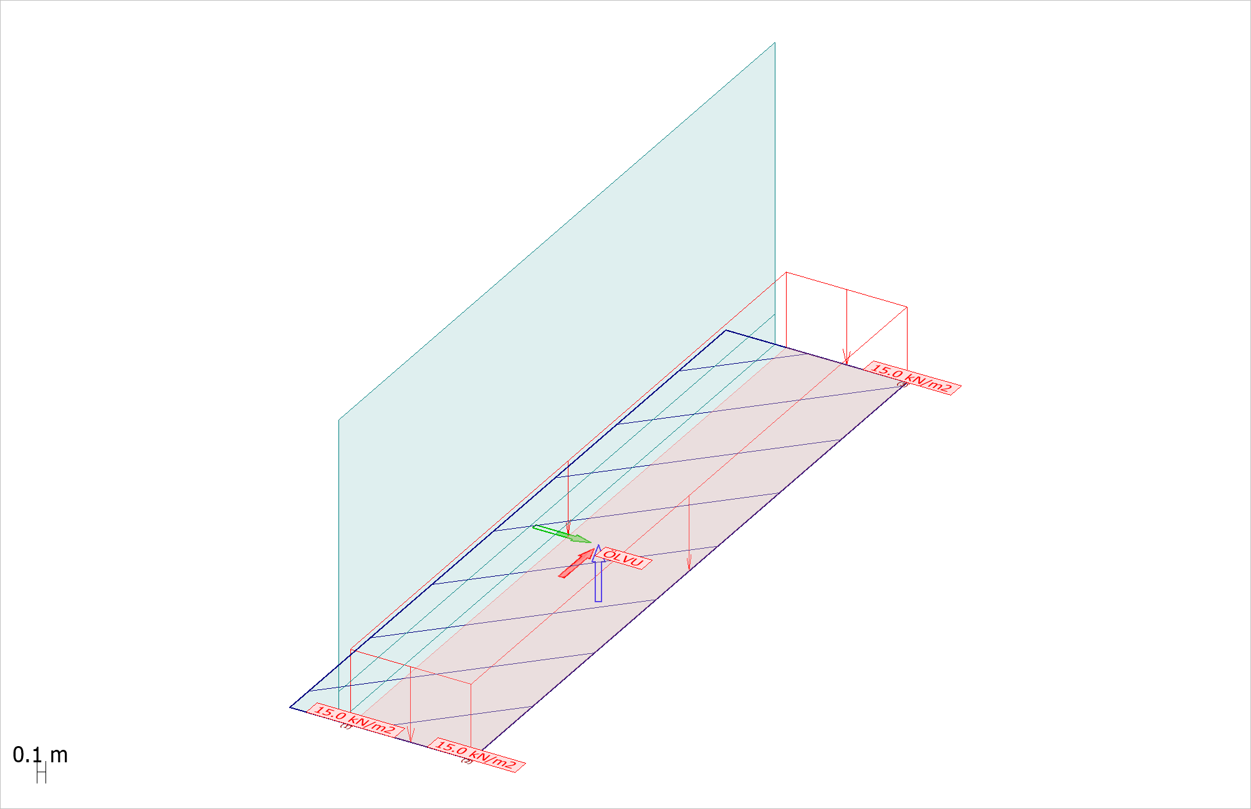 Figure 2.9: ÖLVU

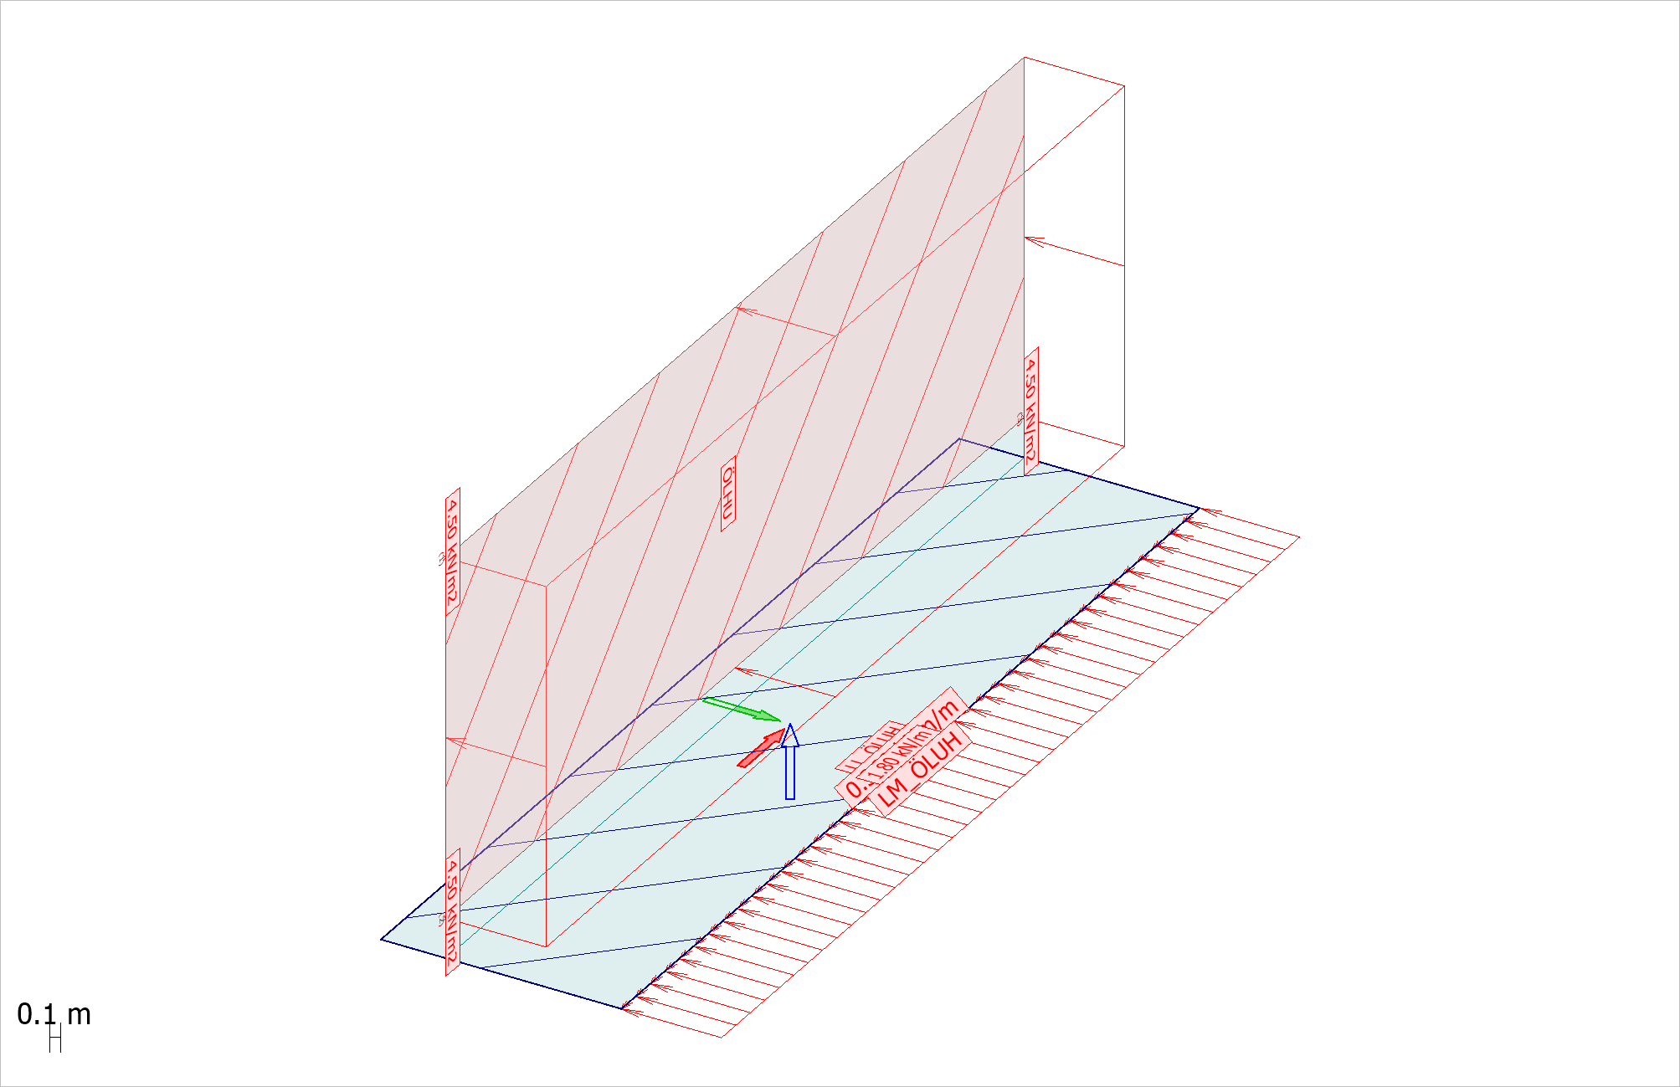 Figure 2.10: ÖLHU

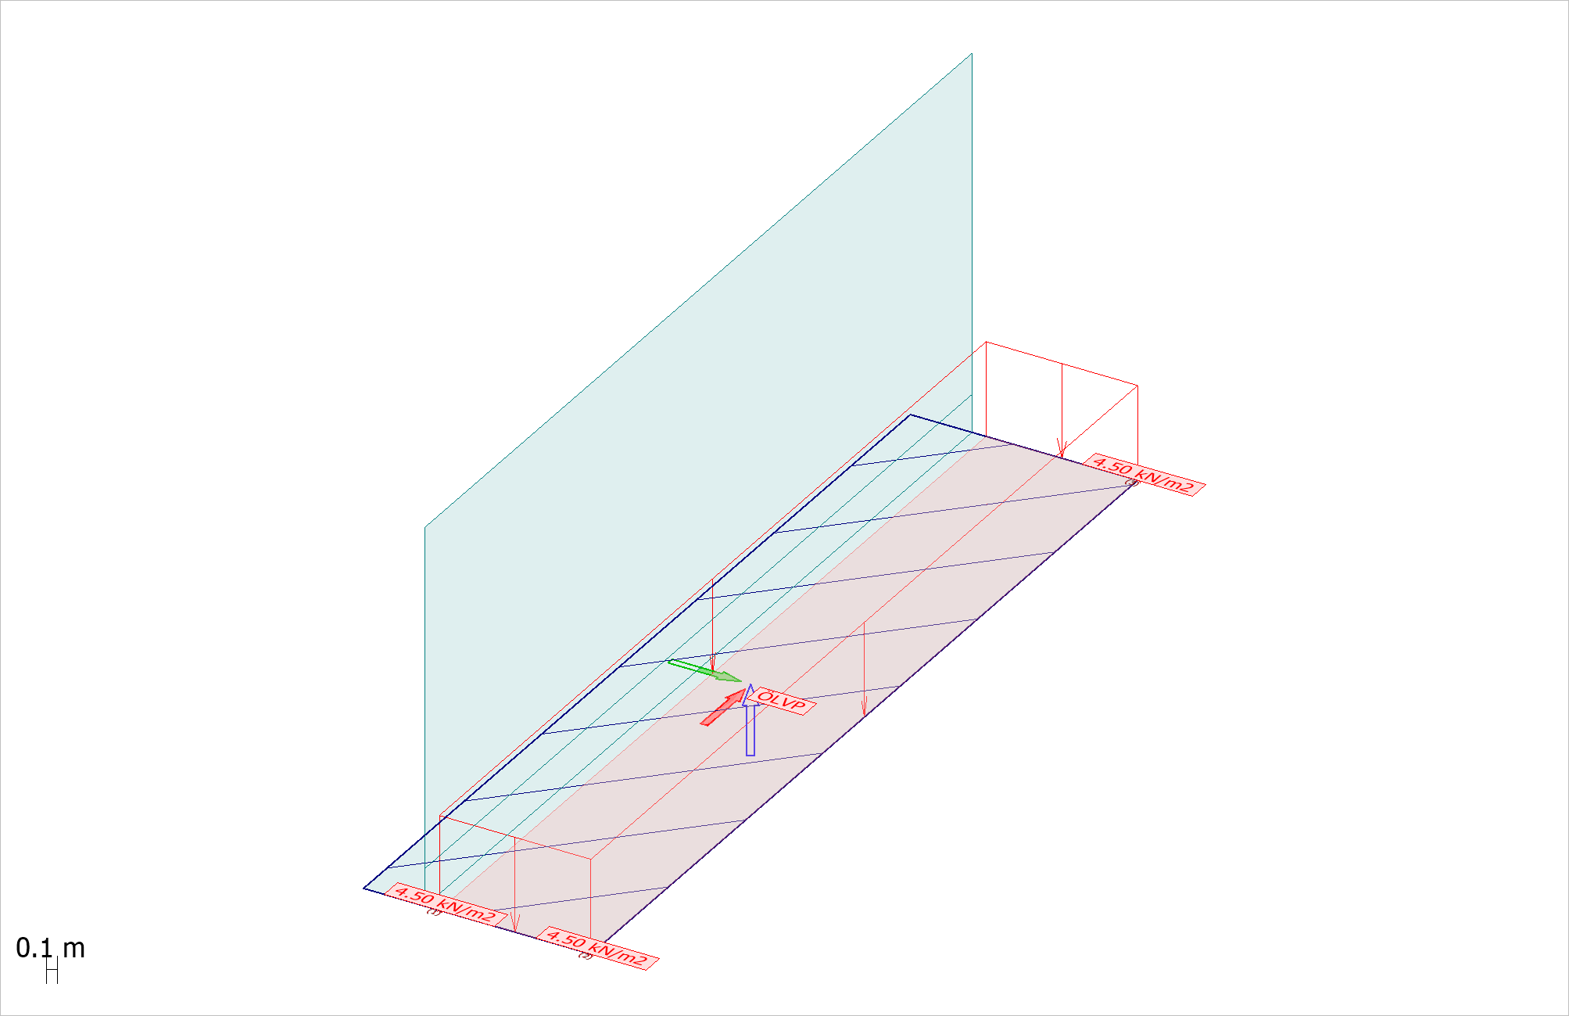 Figure 2.11: ÖLVP

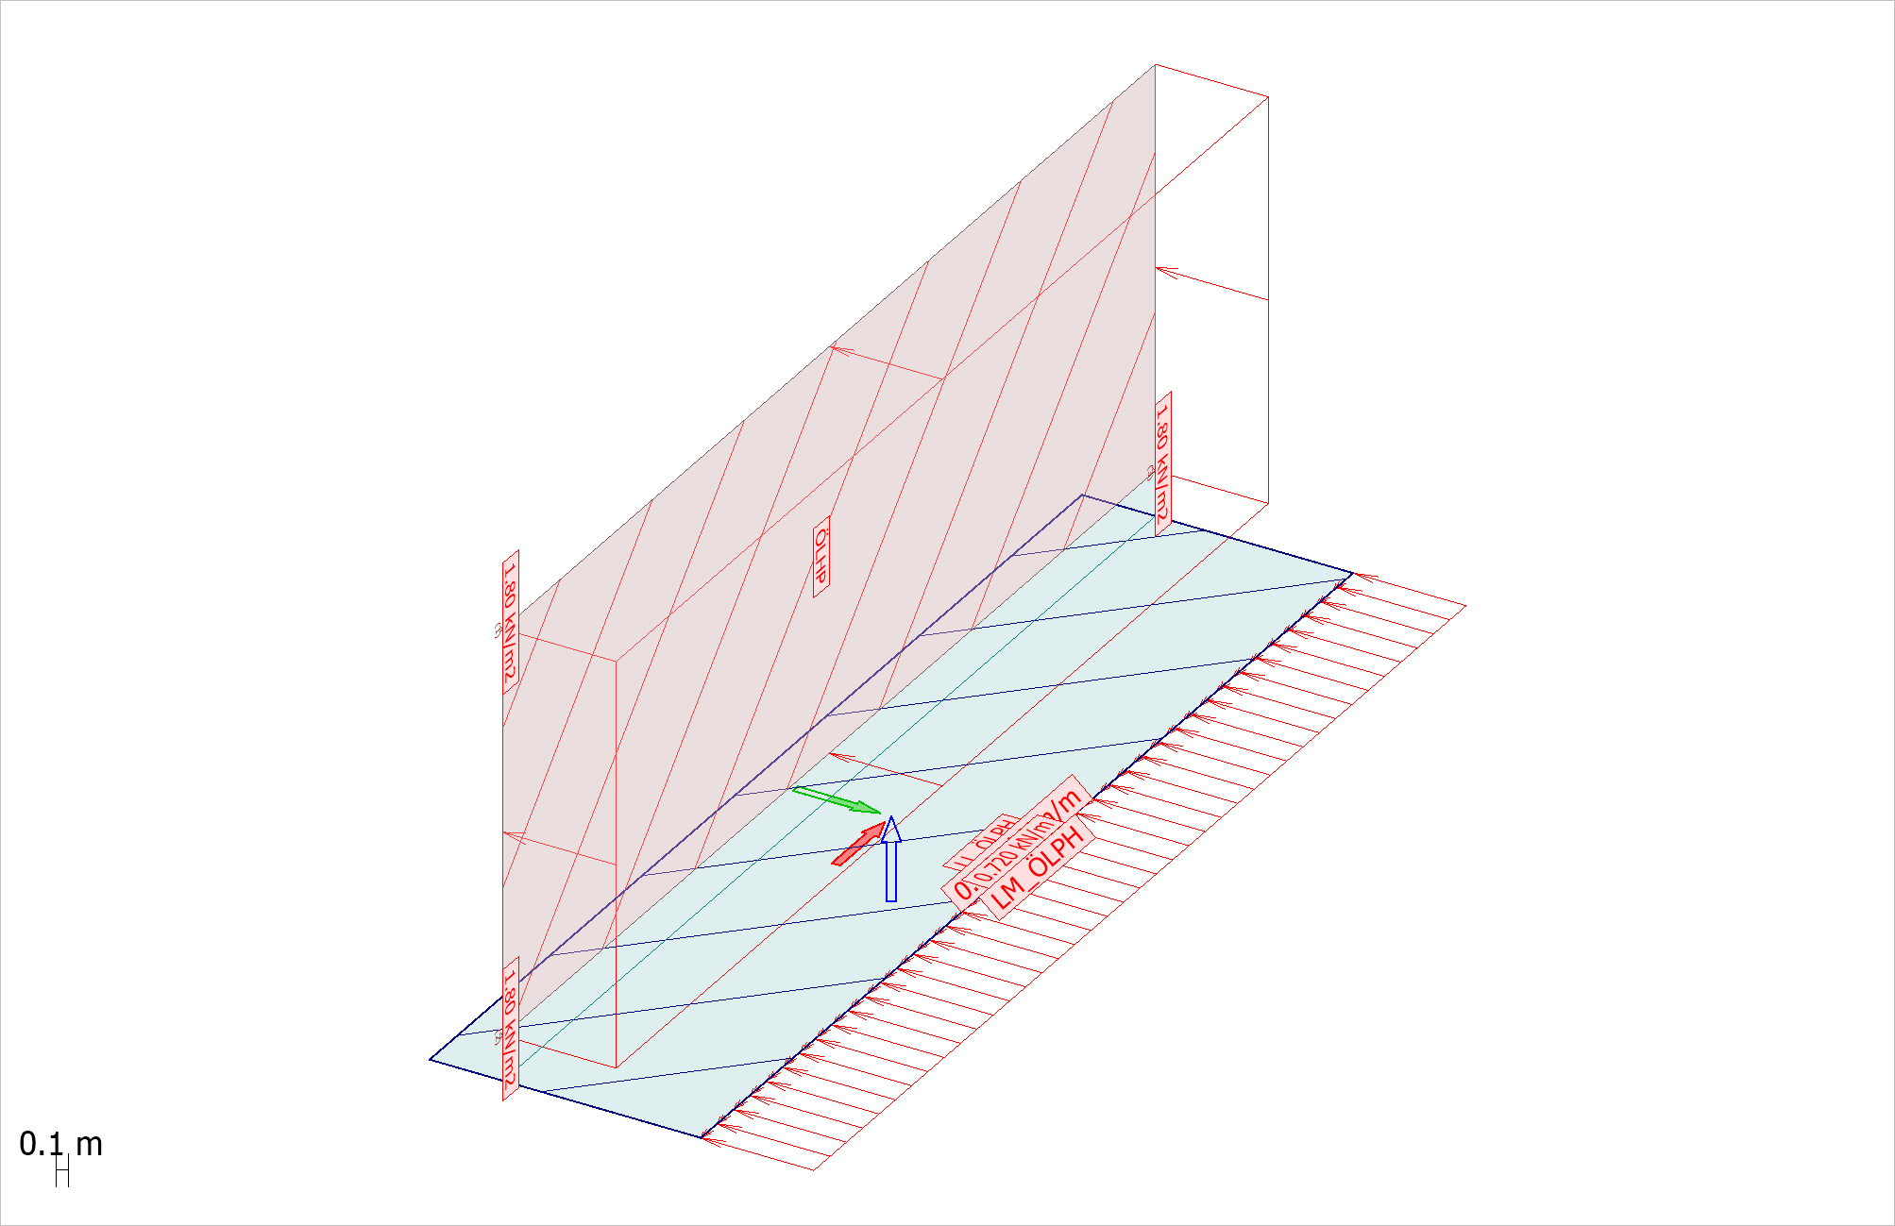 Figure 2.12: ÖLHP

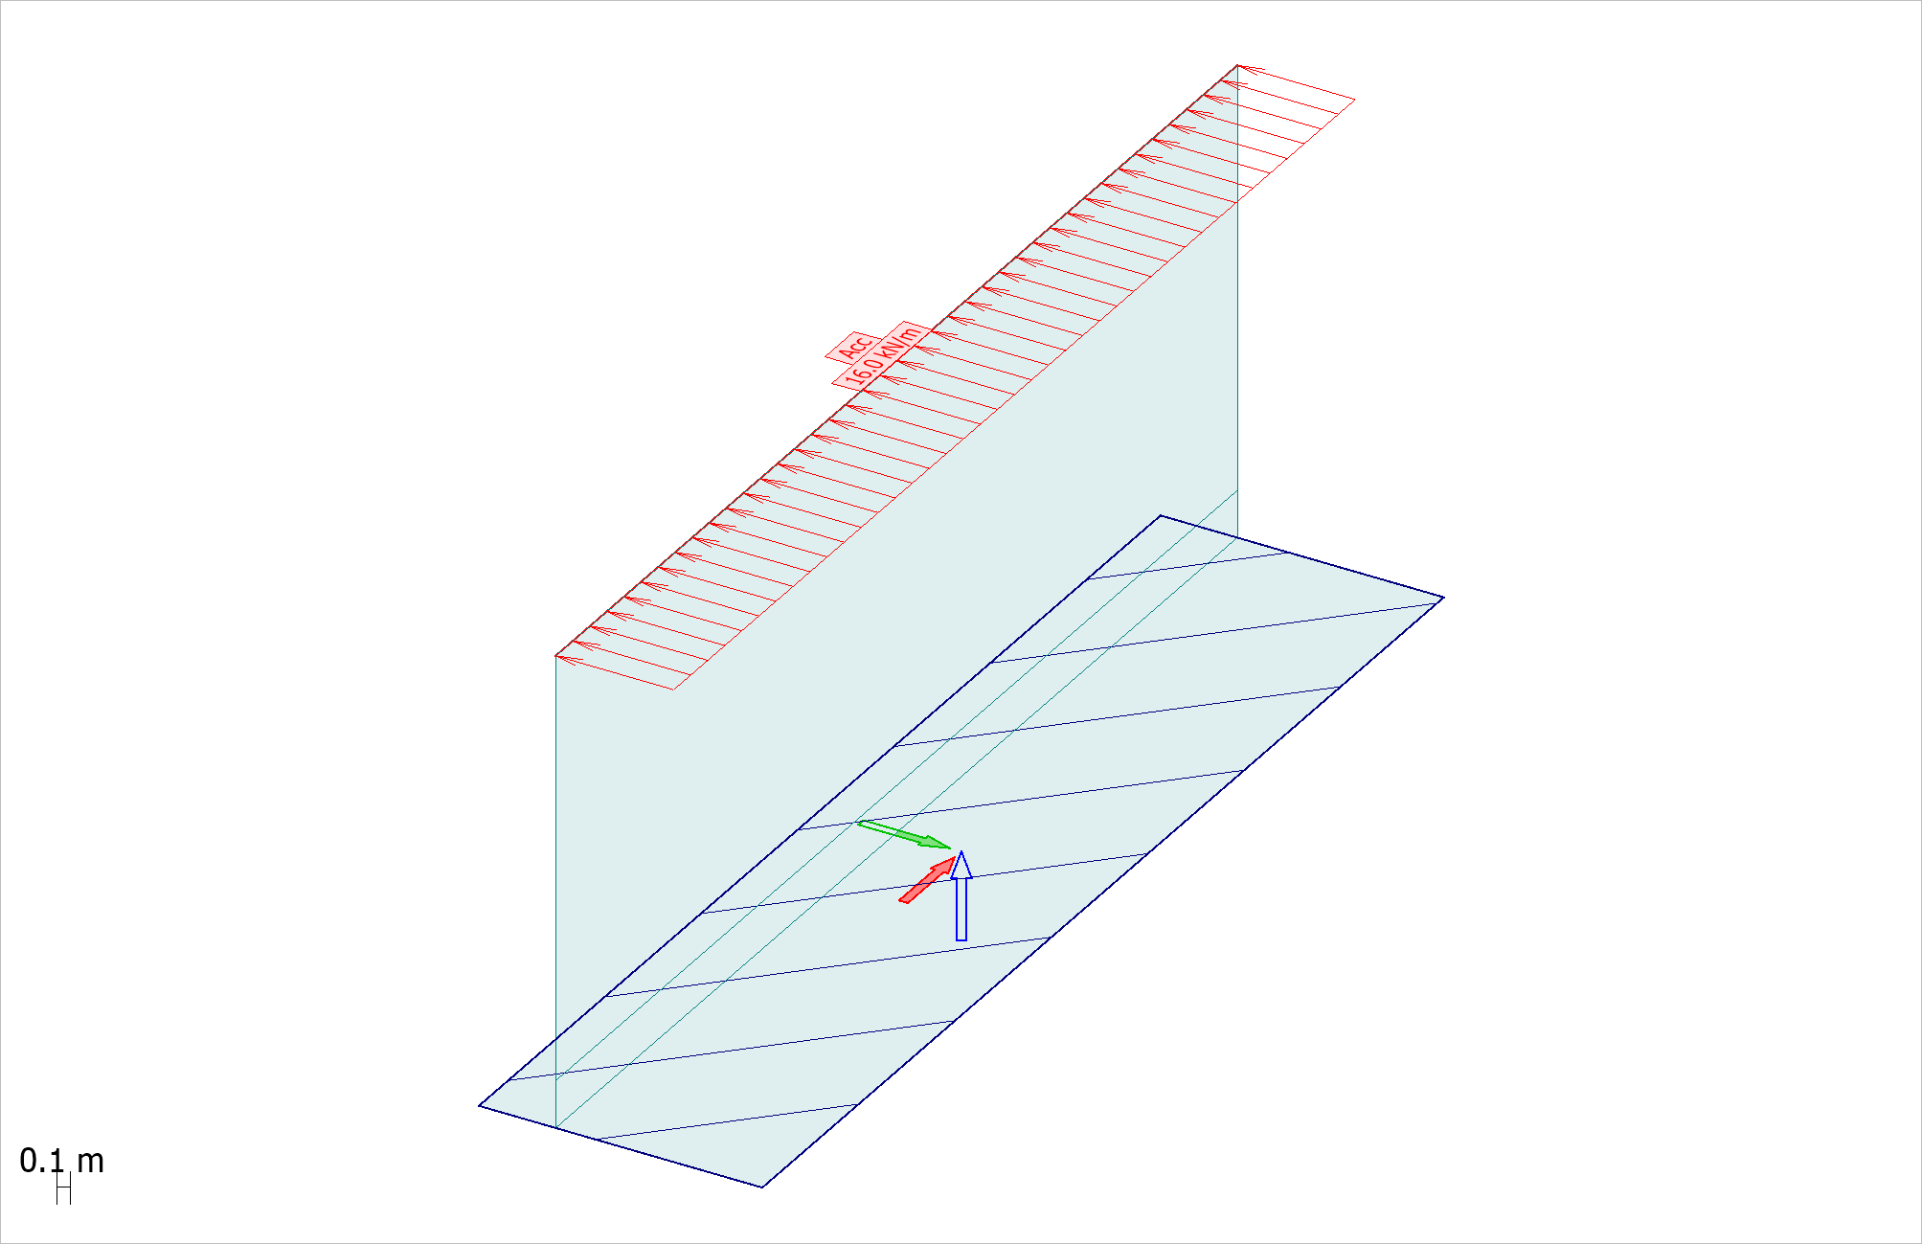 Figure 2.13: Olycka

**Load cases (13 items)**

|  |  |  |  |
| --- | --- | --- | --- |
| **No.** | **Name** | **Type** | **Duration class** |
| 1 | DL | +Struc. dead load | Permanent |
| 2 | Räcke | Ordinary | Permanent |
| 3 | JordU | Ordinary | Permanent |
| 4 | JordK | Ordinary | Permanent |
| 5 | JordA | Ordinary | Permanent |
| 6 | HHW | Ordinary | Long-term |
| 7 | MW | Ordinary | Permanent |
| 8 | LLW | Ordinary | Long-term |
| 9 | ÖLVU | Ordinary | Short-term |
| 10 | ÖLHU | Ordinary | Short-term |
| 11 | ÖLVP | Ordinary | Permanent |
| 12 | ÖLHP | Ordinary | Permanent |
| 13 | Olycka | Ordinary | Instantaneous |

**Load combinations (16 items)**

|  |  |  |  |  |
| --- | --- | --- | --- | --- |
| **No.** | **Name** | **Type** | **Factor** | **Load cases** |
| 1 | LC1 B, Bruk-frek, 6.15 Vogyn_Hogyn_Mogyn | Frequent | 1.000 | DL (+Struc. dead load) |
|  |  |  | 1.000 | JordK |
|  |  |  | 0.750 | ÖLVU |
|  |  |  | 0.750 | ÖLHU |
| 2 | LC2 B, Bruk-kvasi, 6.16 Vogyn_Hogyn_Mogyn | UG_SLS | Quasi-permanent | 1.000 | DL (+Struc. dead load) |
|  |  |  | 1.000 | JordK |
|  |  |  | 1.000 | ÖLVP |
|  |  |  | 1.000 | ÖLHP |
| 3 | LC3 B, Bruk-kvasi, 6.16 Vgyn_Hgyn_Mgyn | UG_SLS | Quasi-permanent | 1.000 | DL (+Struc. dead load) |
|  |  |  | 1.000 | JordK |
| 4 | LC4 B, 6.10a Vogyn_Hogyn_Mogyn | UG_B UG_G UG_S | Ultimate | 1.229 | DL (+Struc. dead load) |
|  |  |  | 1.001 | JordU |
|  |  |  | 1.274 | ÖLVU |
|  |  |  | 1.274 | ÖLHU |
| 5 | LC5 B, 6.10a Vgyn_Hgyn_Mgyn | UG_B UG_G UG_S | Ultimate | 1.000 | DL (+Struc. dead load) |
|  |  |  | 1.000 | JordU |

**Load combinations analysis setup (5 items)**

|  |  |  |  |  |  |  |  |  |
| --- | --- | --- | --- | --- | --- | --- | --- | --- |
| **No.** | **Type** | **Load combination** | **Calculate** | **Construction**  **stages** | **Non-linear**  **elements** | **Plastic**  **elements** | **Cracked**  **section** | **2nd**  **order** |
| 1 | Sf | LC1 B, Bruk-frek, 6.15 Vogyn_Hogyn_Mogyn | Yes | No | Yes | Yes | No | No |
| 2 | Sq | LC2 B, Bruk-kvasi, 6.16 Vogyn_Hogyn_Mogyn | UG_SLS | Yes | No | Yes | Yes | No | No |
| 3 | Sq | LC3 B, Bruk-kvasi, 6.16 Vgyn_Hgyn_Mgyn | UG_SLS | Yes | No | Yes | Yes | No | No |
| 4 | U | LC4 B, 6.10a Vogyn_Hogyn_Mogyn | UG_B UG_G UG_S | Yes | No | Yes | Yes | No | No |
| 5 | U | LC5 B, 6.10a Vgyn_Hgyn_Mgyn | UG_B UG_G UG_S | Yes | No | Yes | Yes | No | No |

|  |  |
| --- | --- |
| **Imperfection**  **shape** | **Amplitud**  m |
| - | - |
| - | - |
| - | - |
| - | - |
| - | - |

# 3 Reinforcement in model

**Reinforcing steel materials (2 items)**

|  |  |  |  |  |  |
| --- | --- | --- | --- | --- | --- |
| **Name** | **fyk**  N/mm2 | **Es**  N/mm2 | **ε uk** | **ε ud** | **k** |
| K500C | 500 | 200000 | 0.0750 | 0.0675 | 1.15 |
| B500B | 500 | 200000 | 0.0500 | 0.0450 | 1.08 |

## 3.1 Result objects

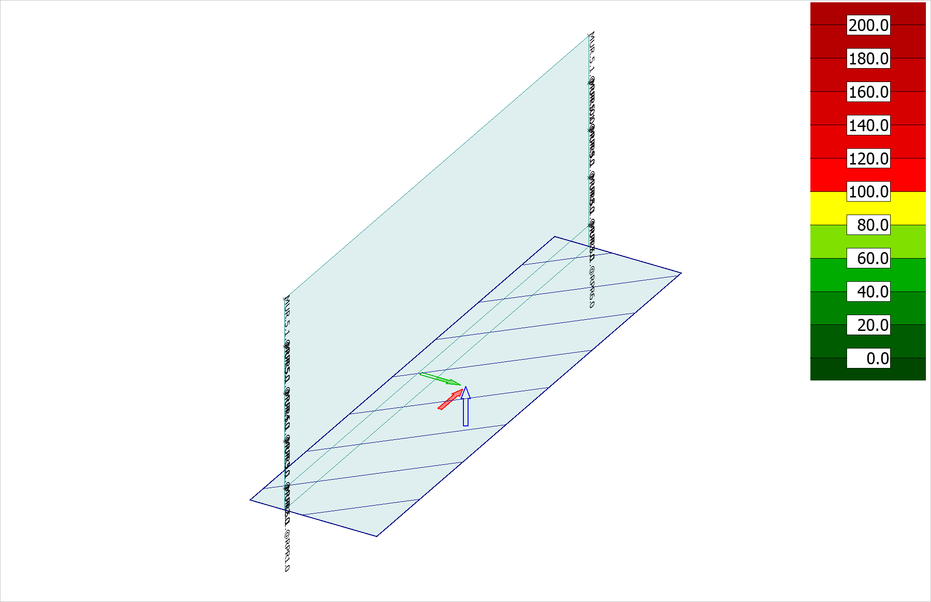 Figure 3.1.1: RC concealed bar - Utilization - Load combinations - Maximum - [%]

## 3.2 BPL

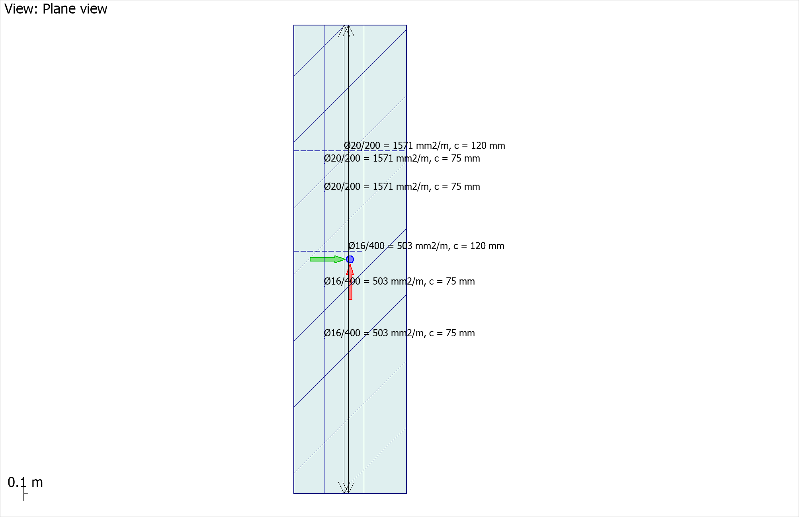 Figure 3.2.1: RC Design X Bottom

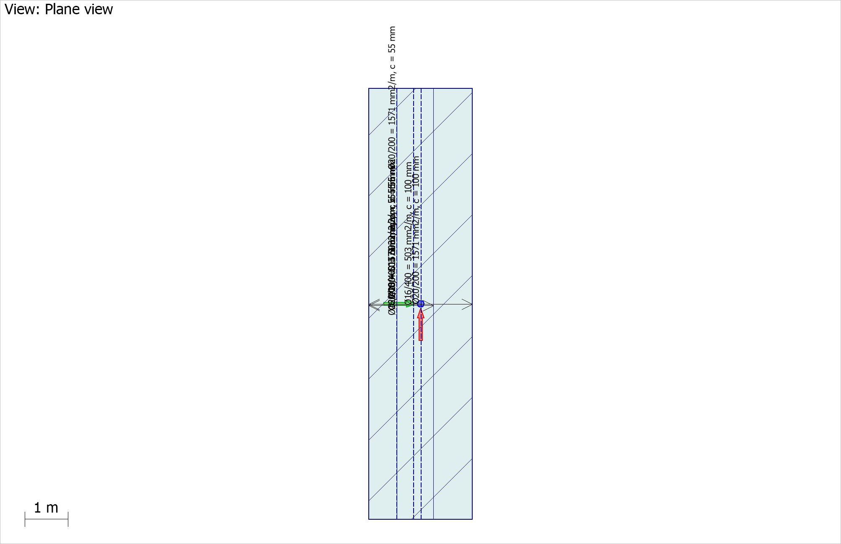 Figure 3.2.2: RC Design Y Bottom

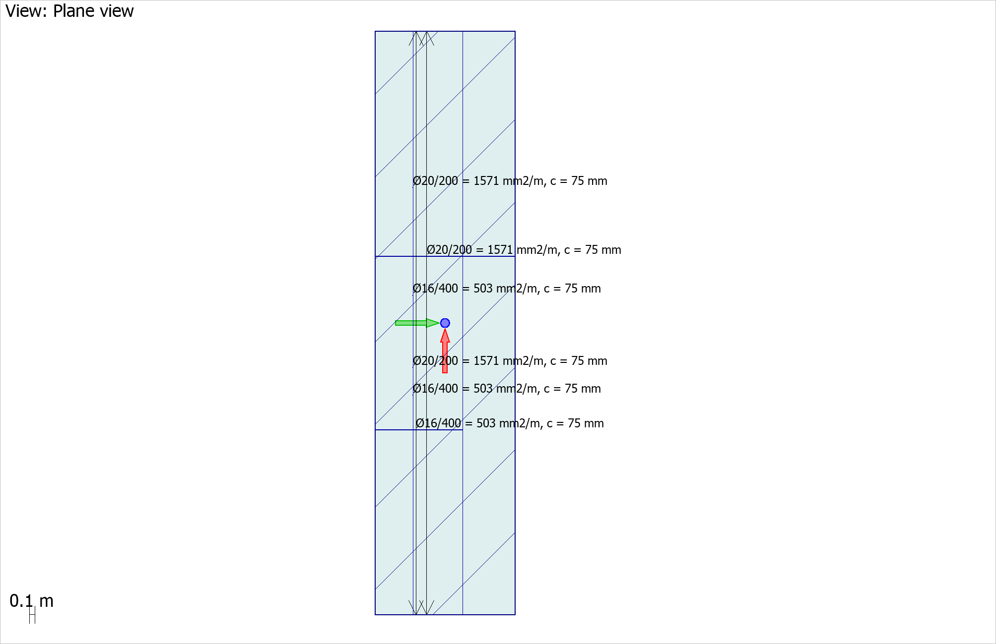 Figure 3.2.3: RC Design X Top

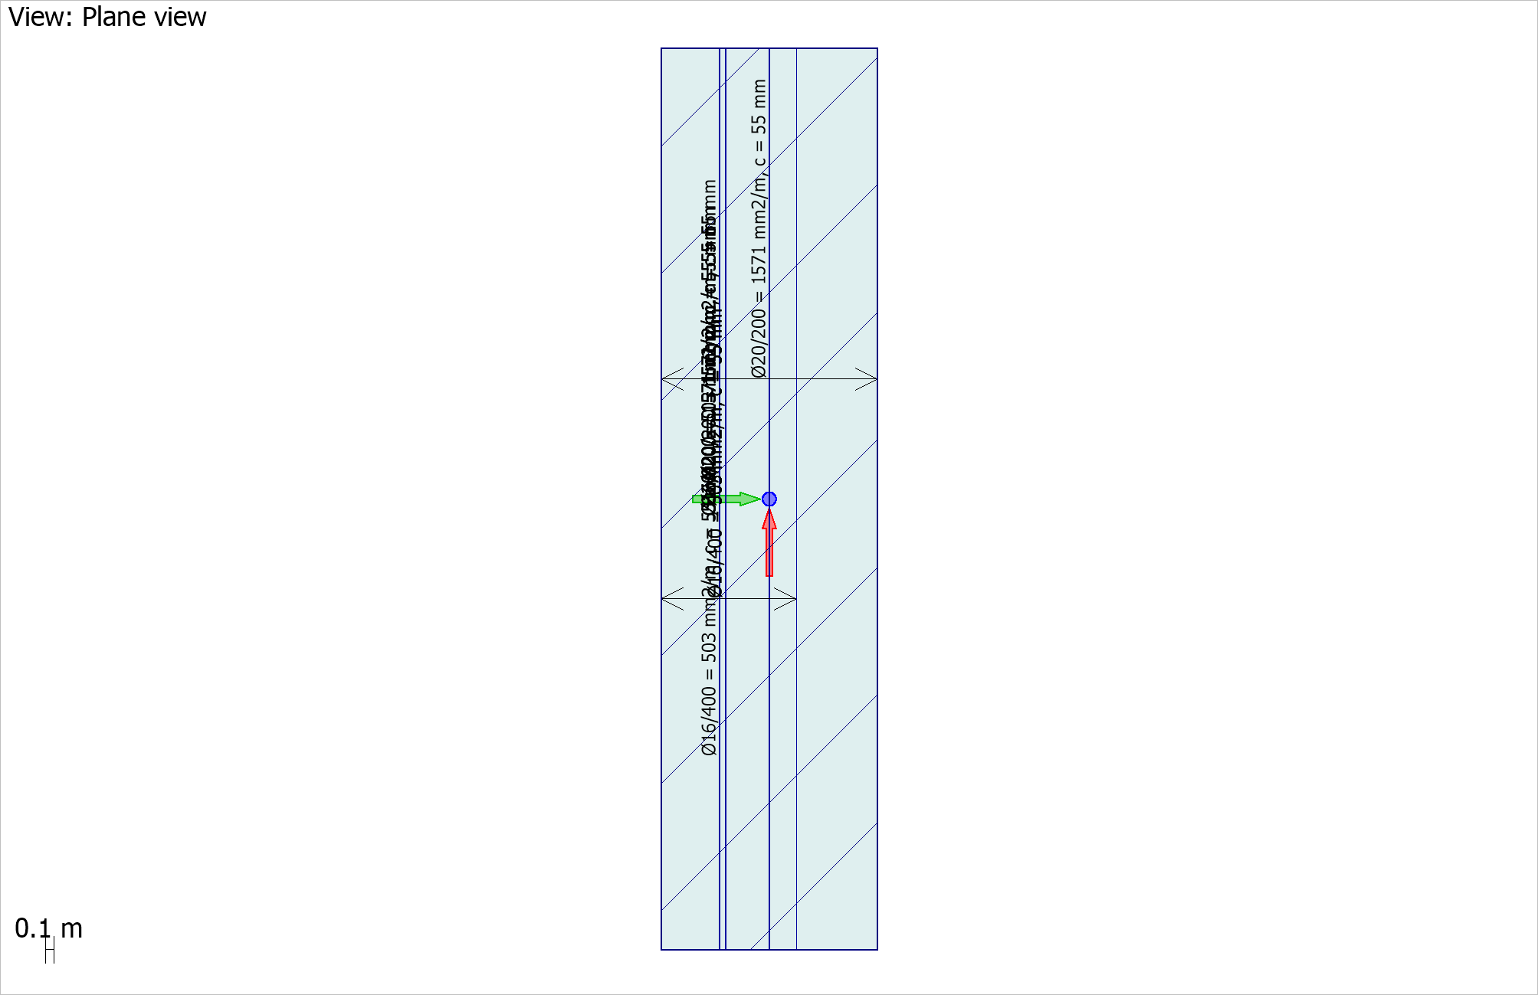 Figure 3.2.4: RC Design Y Top

## 3.3 MUR

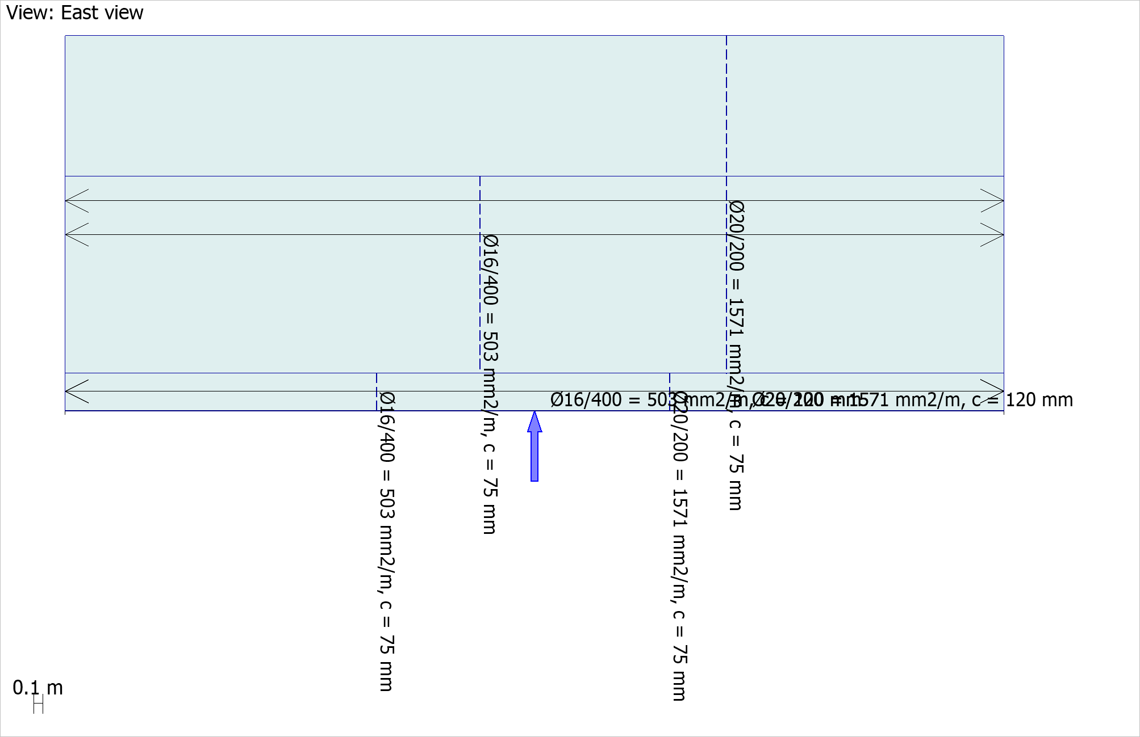 Figure 3.3.1: RC Design X Bottom

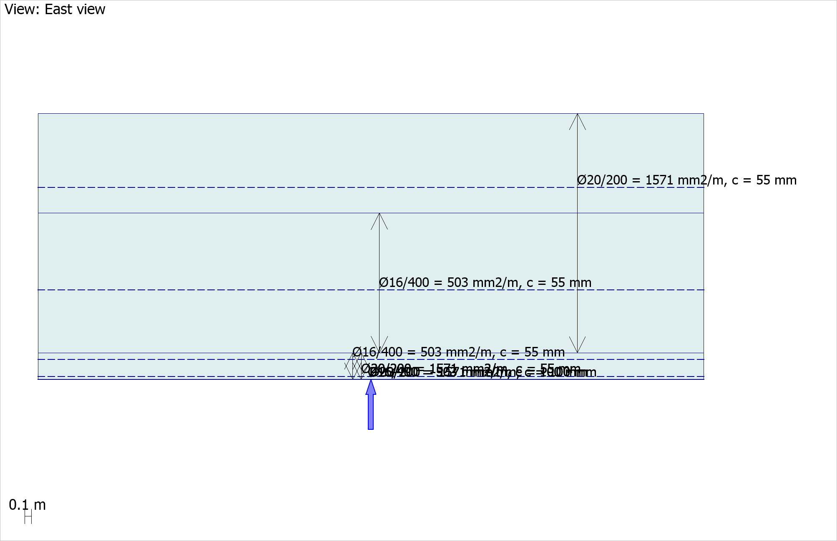 Figure 3.3.2: RC Design Y Bottom

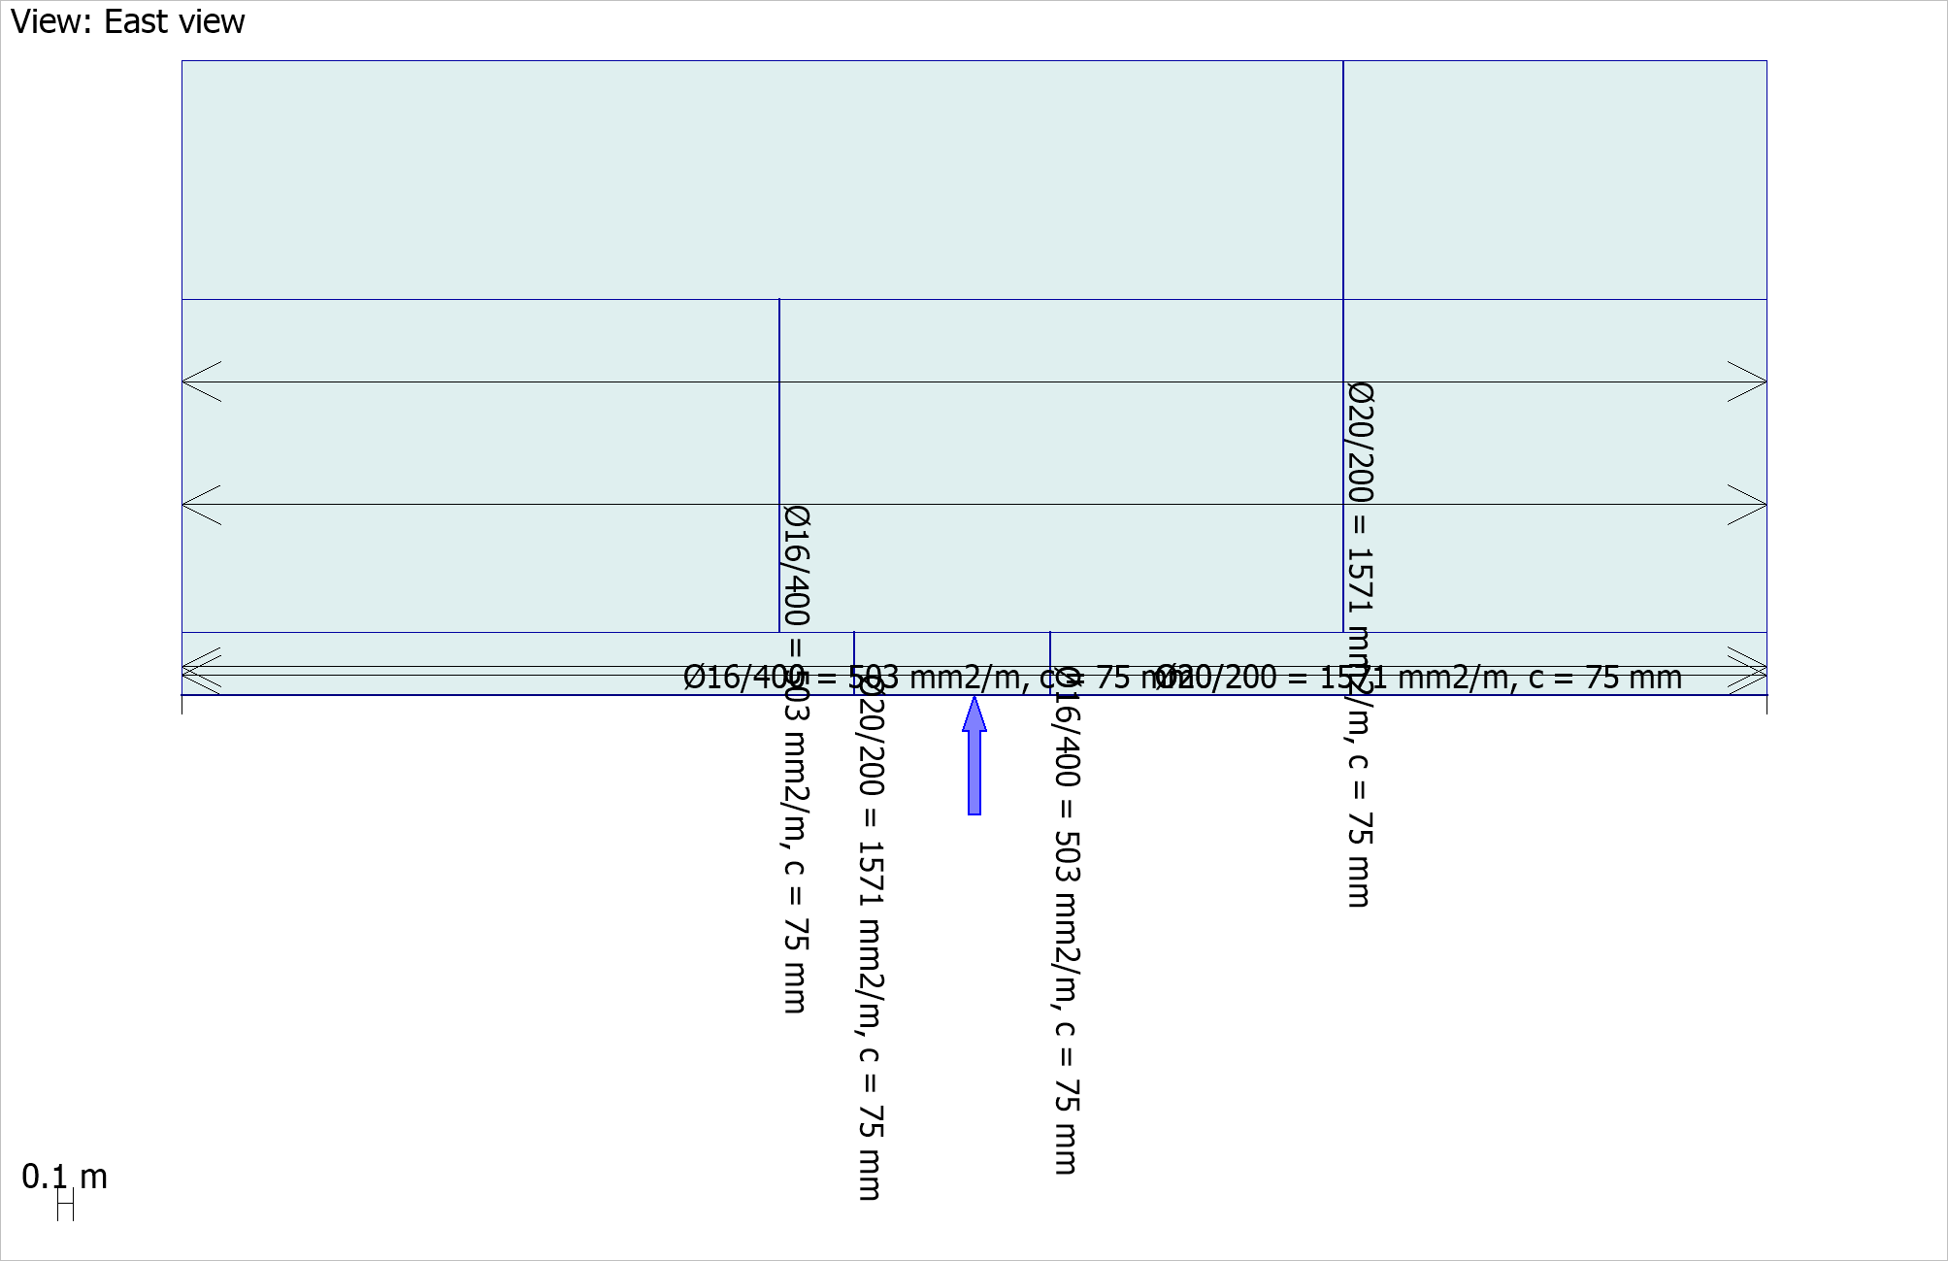 Figure 3.3.3: RC Design X Top

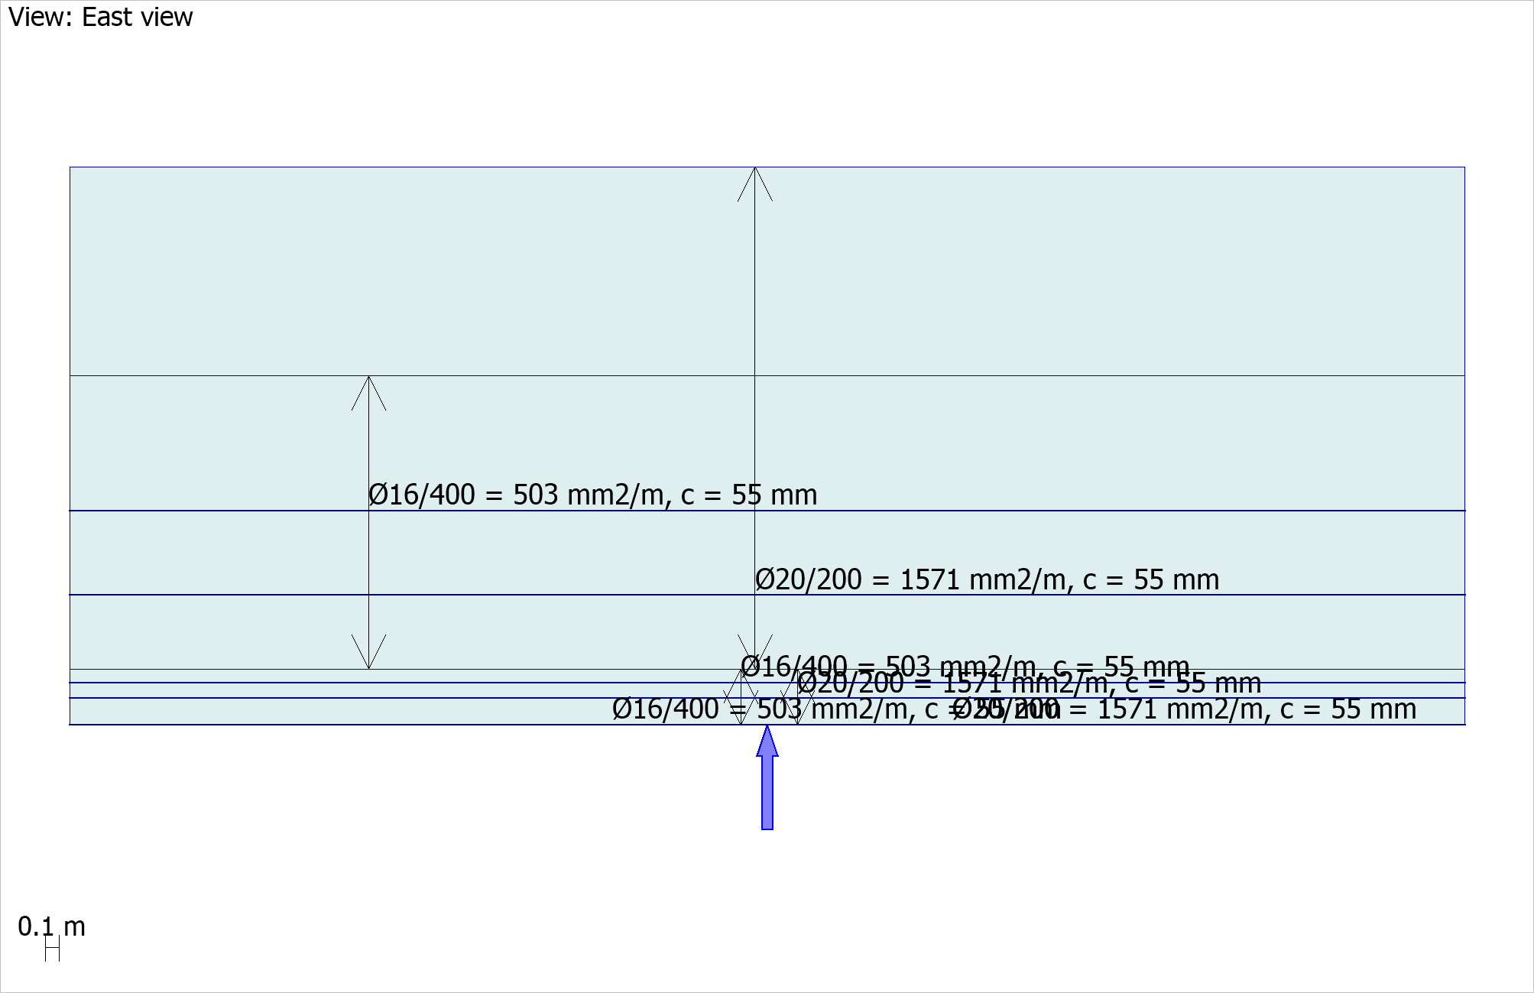 Figure 3.3.4: RC Design Y Top

# 4 Combination result

## 4.1 BPL

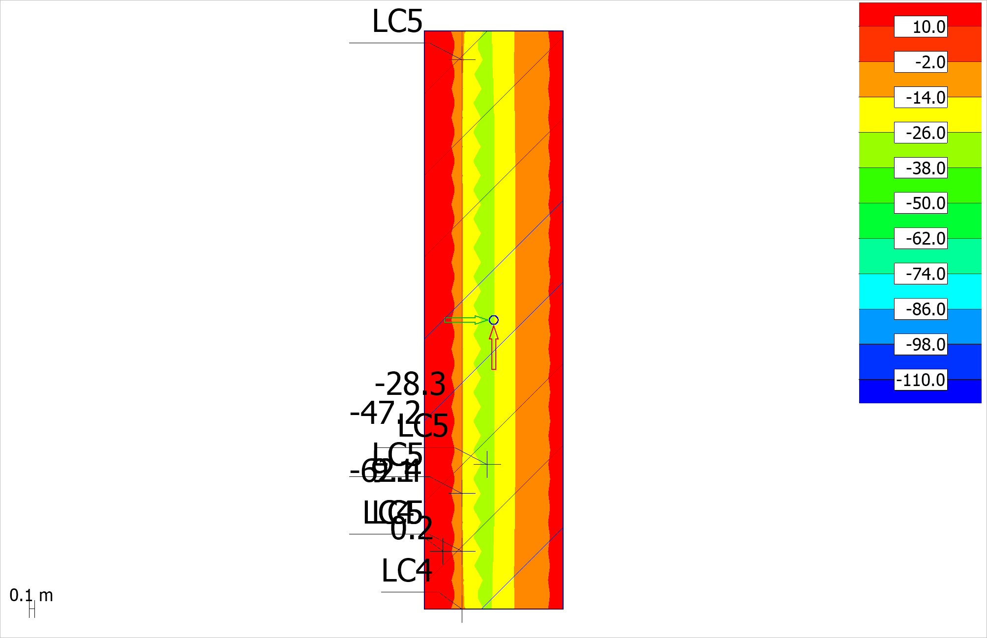 Figure 4.1.1: Cmax, U - Shell internal forces - Mx' (Mx'+) - [kNm/m] - Plane view

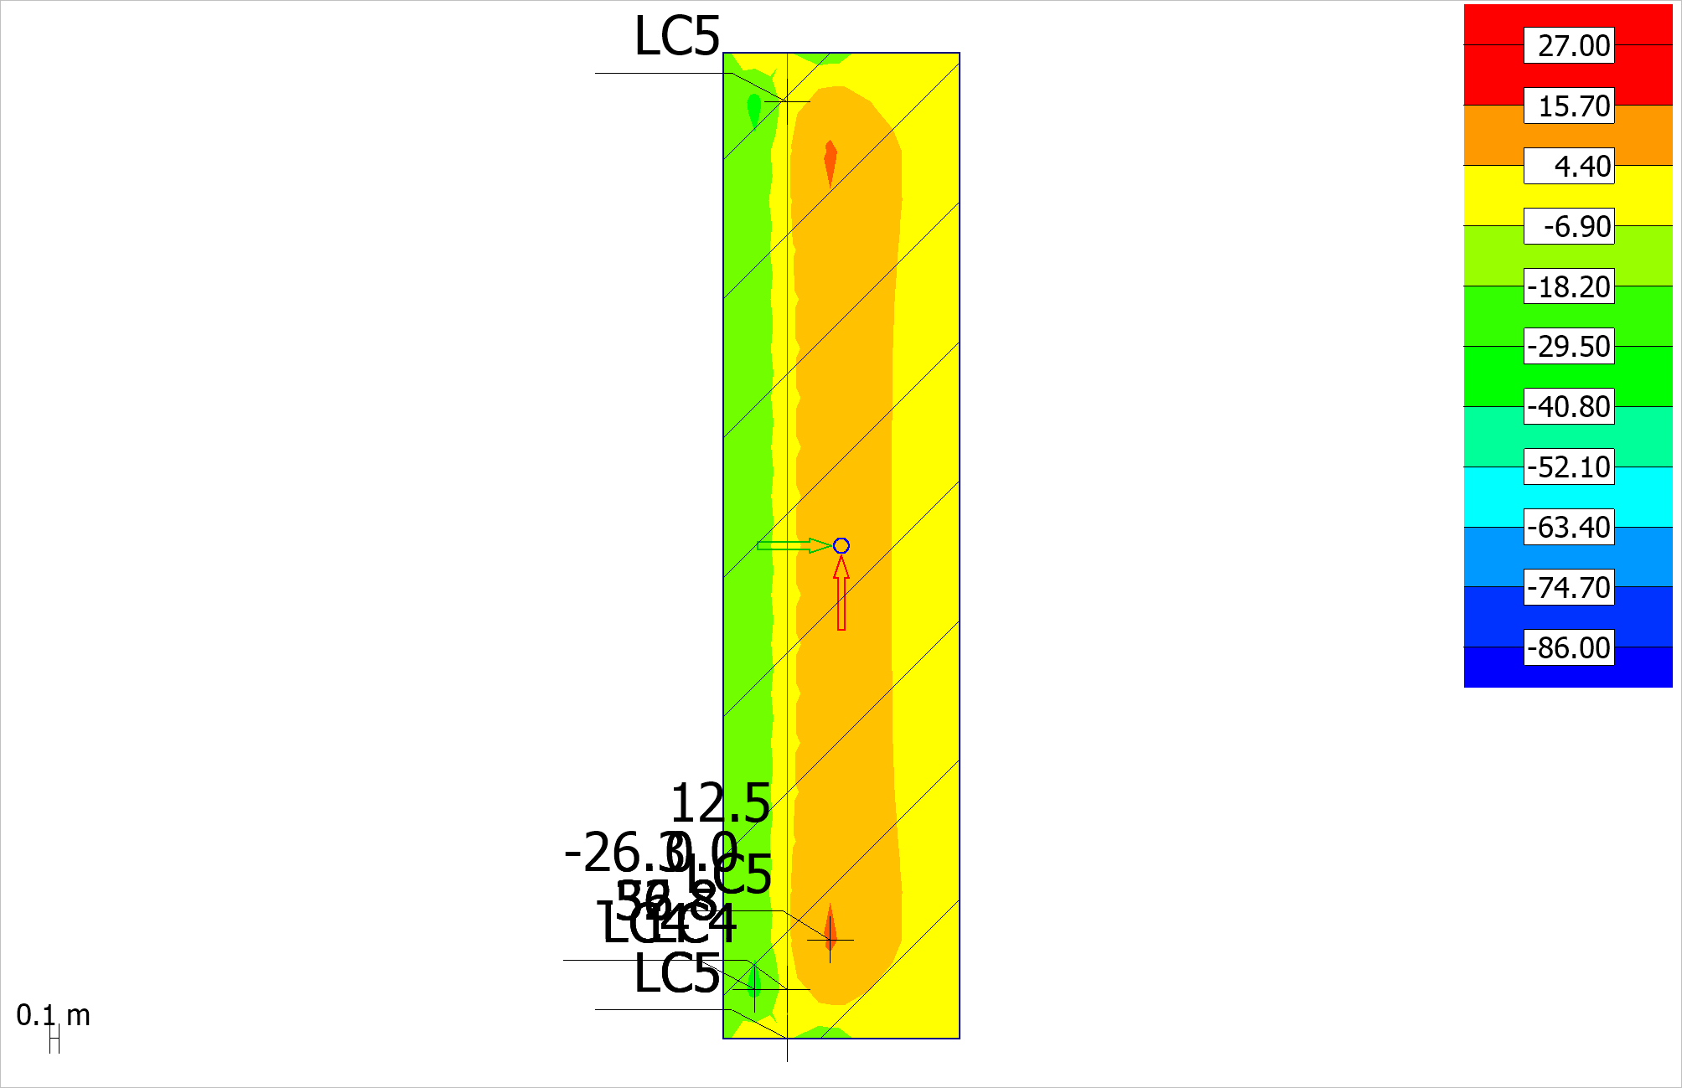 Figure 4.1.2: Cmax, U - Shell internal forces - Nx' (Mx'+) - [kN/m] - Plane view

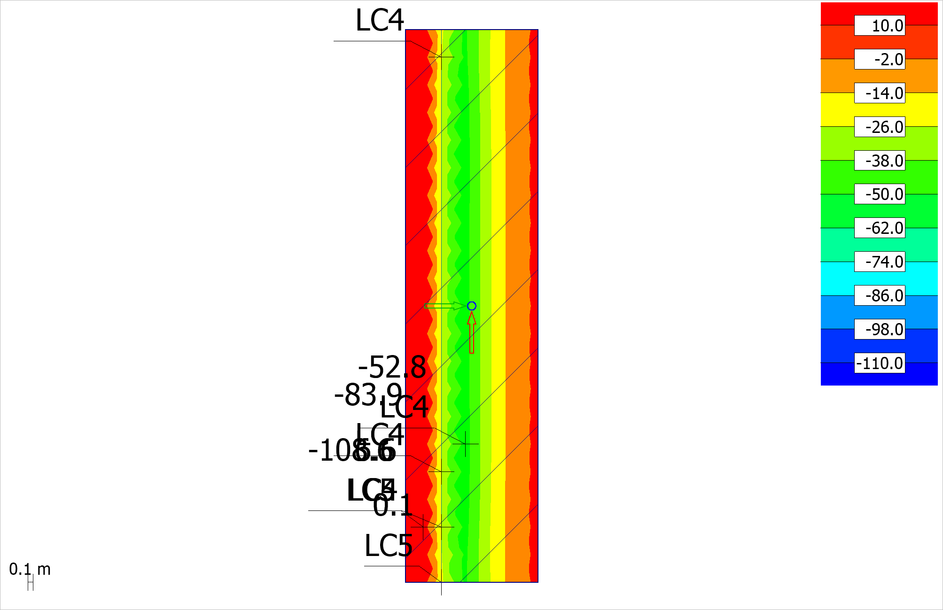 Figure 4.1.3: Cmax, U - Shell internal forces - Mx' (Mx'-) - [kNm/m] - Plane view

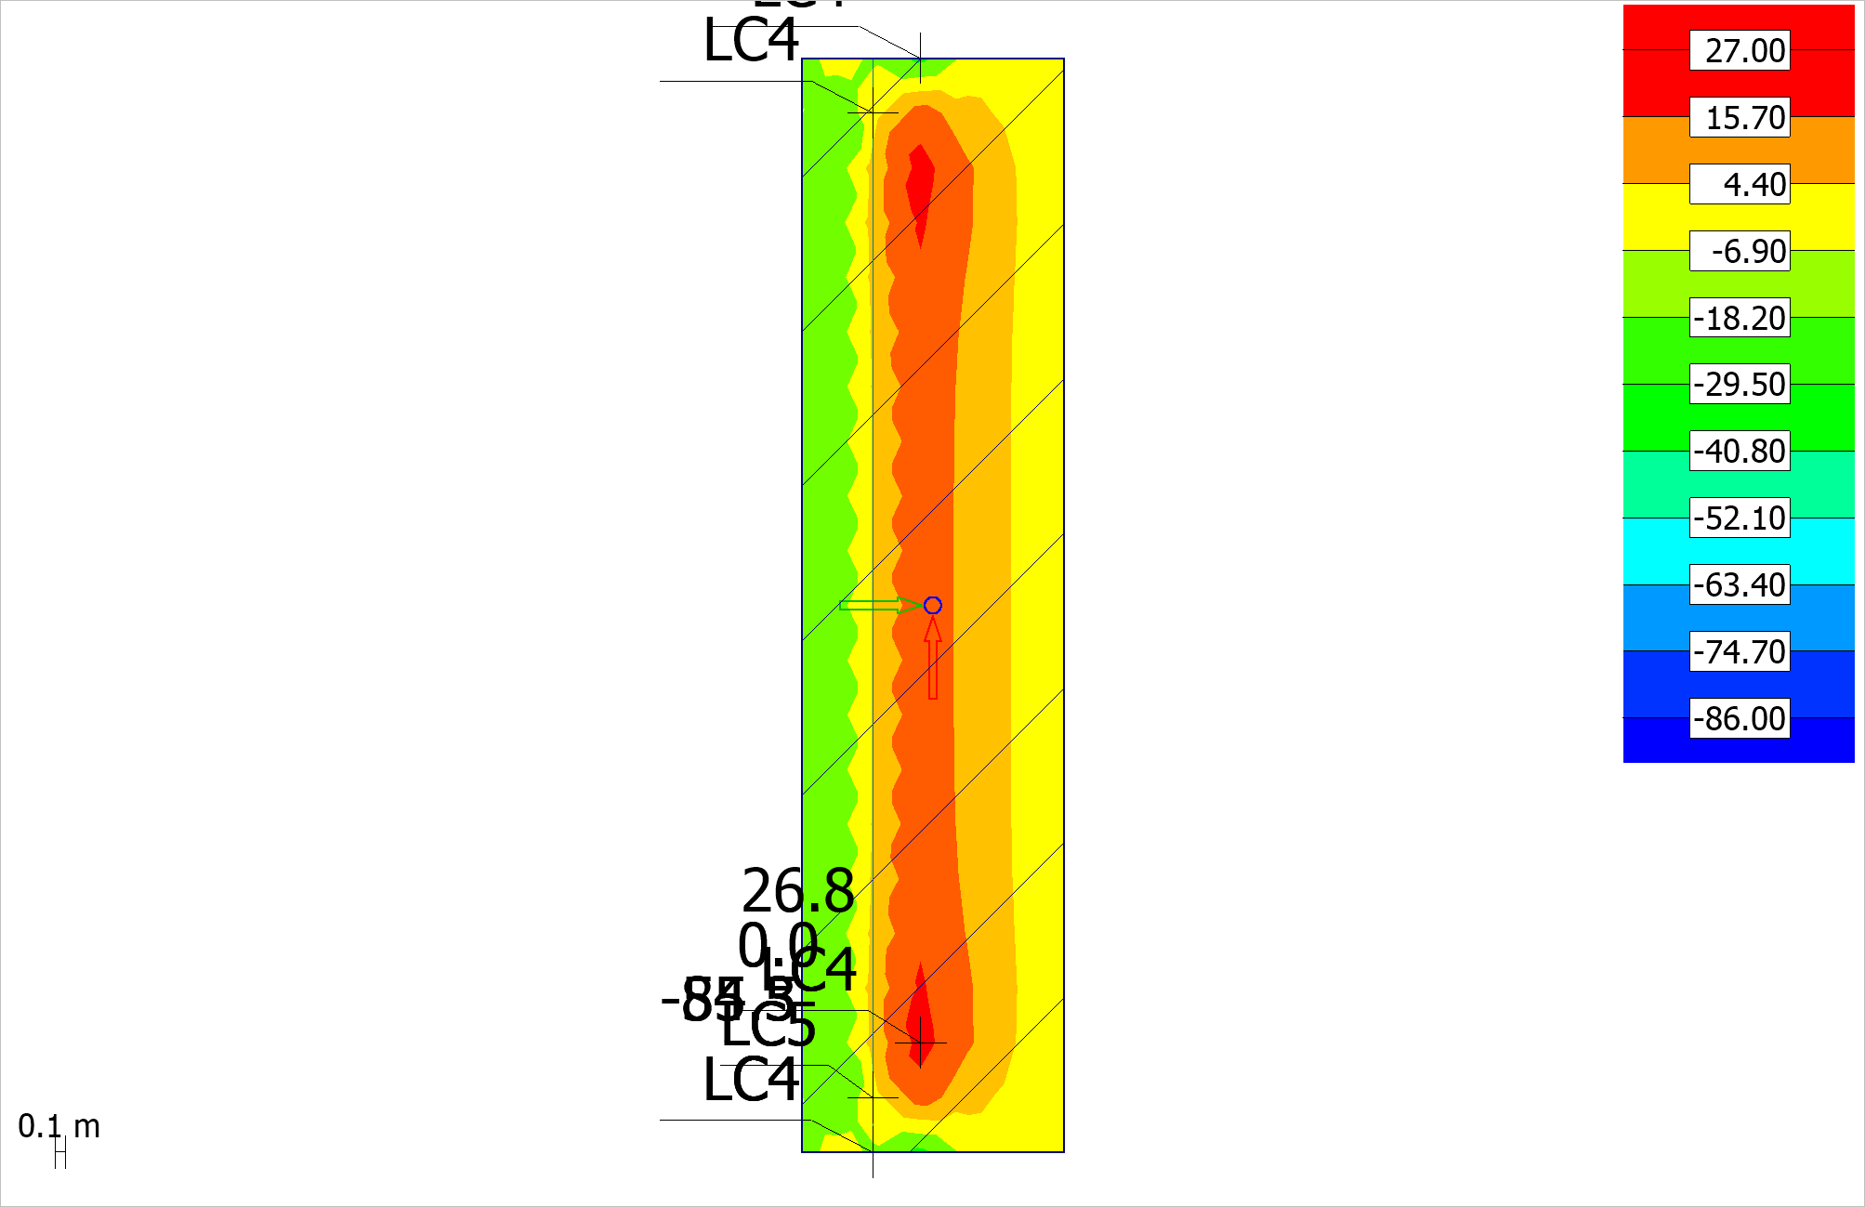 Figure 4.1.4: Cmax, U - Shell internal forces - Nx' (Mx'-) - [kN/m] - Plane view

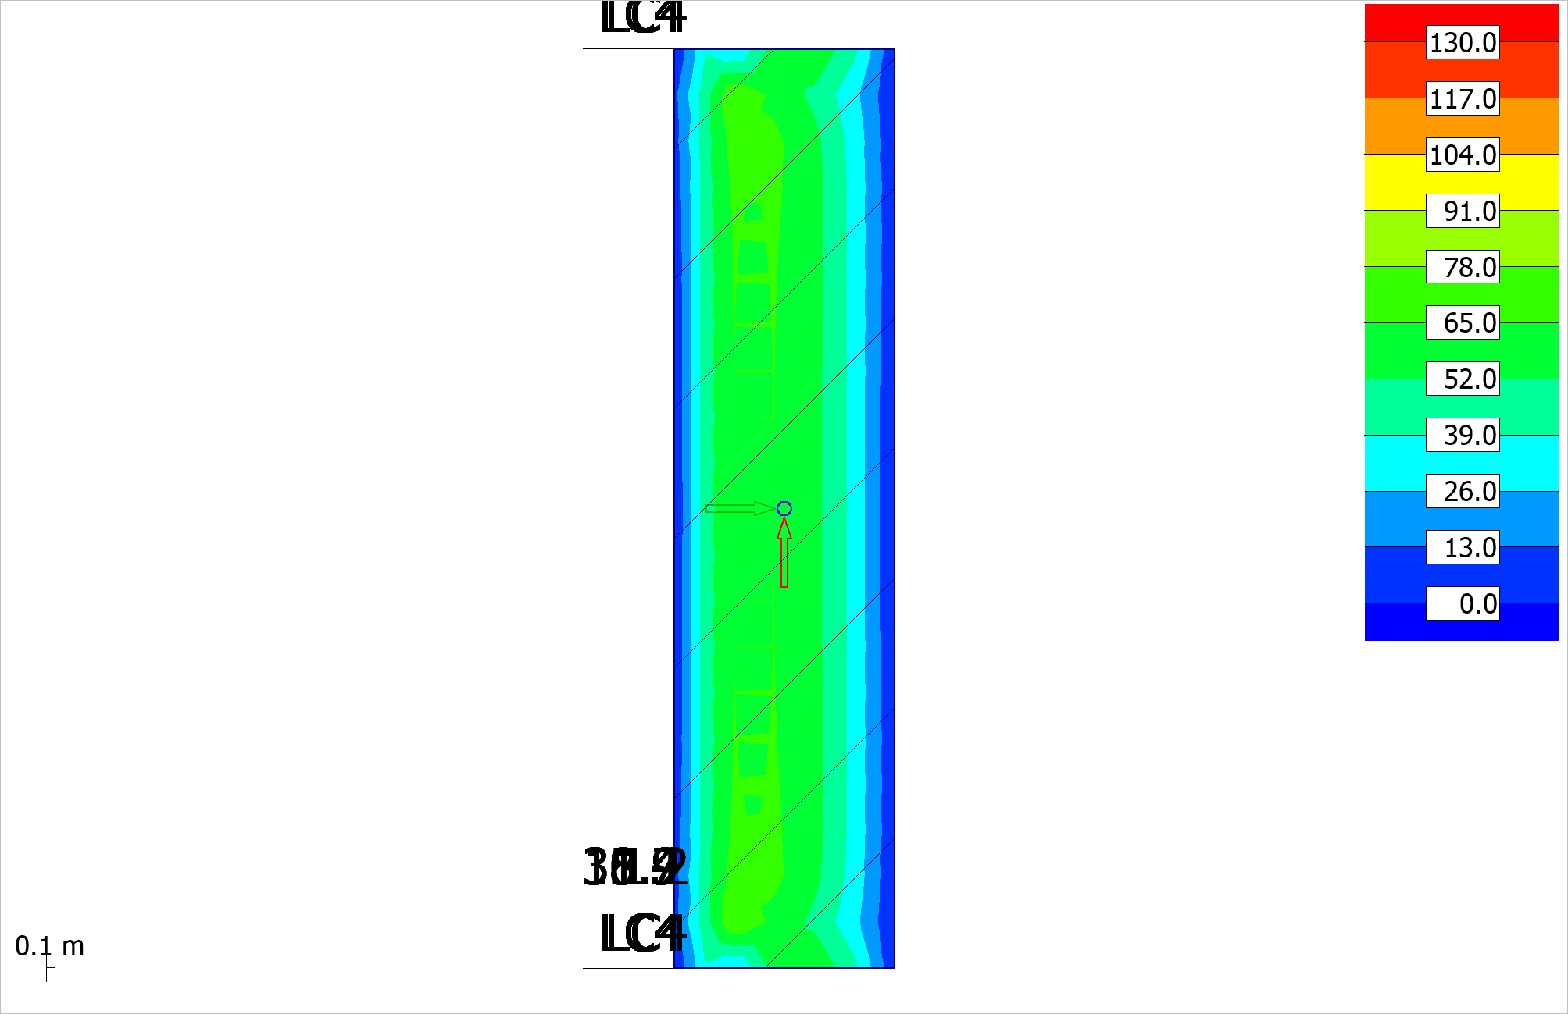 Figure 4.1.5: (|T|) - Cmax, U - Shell internal forces - |T|+ - [kN/m] - Plane view

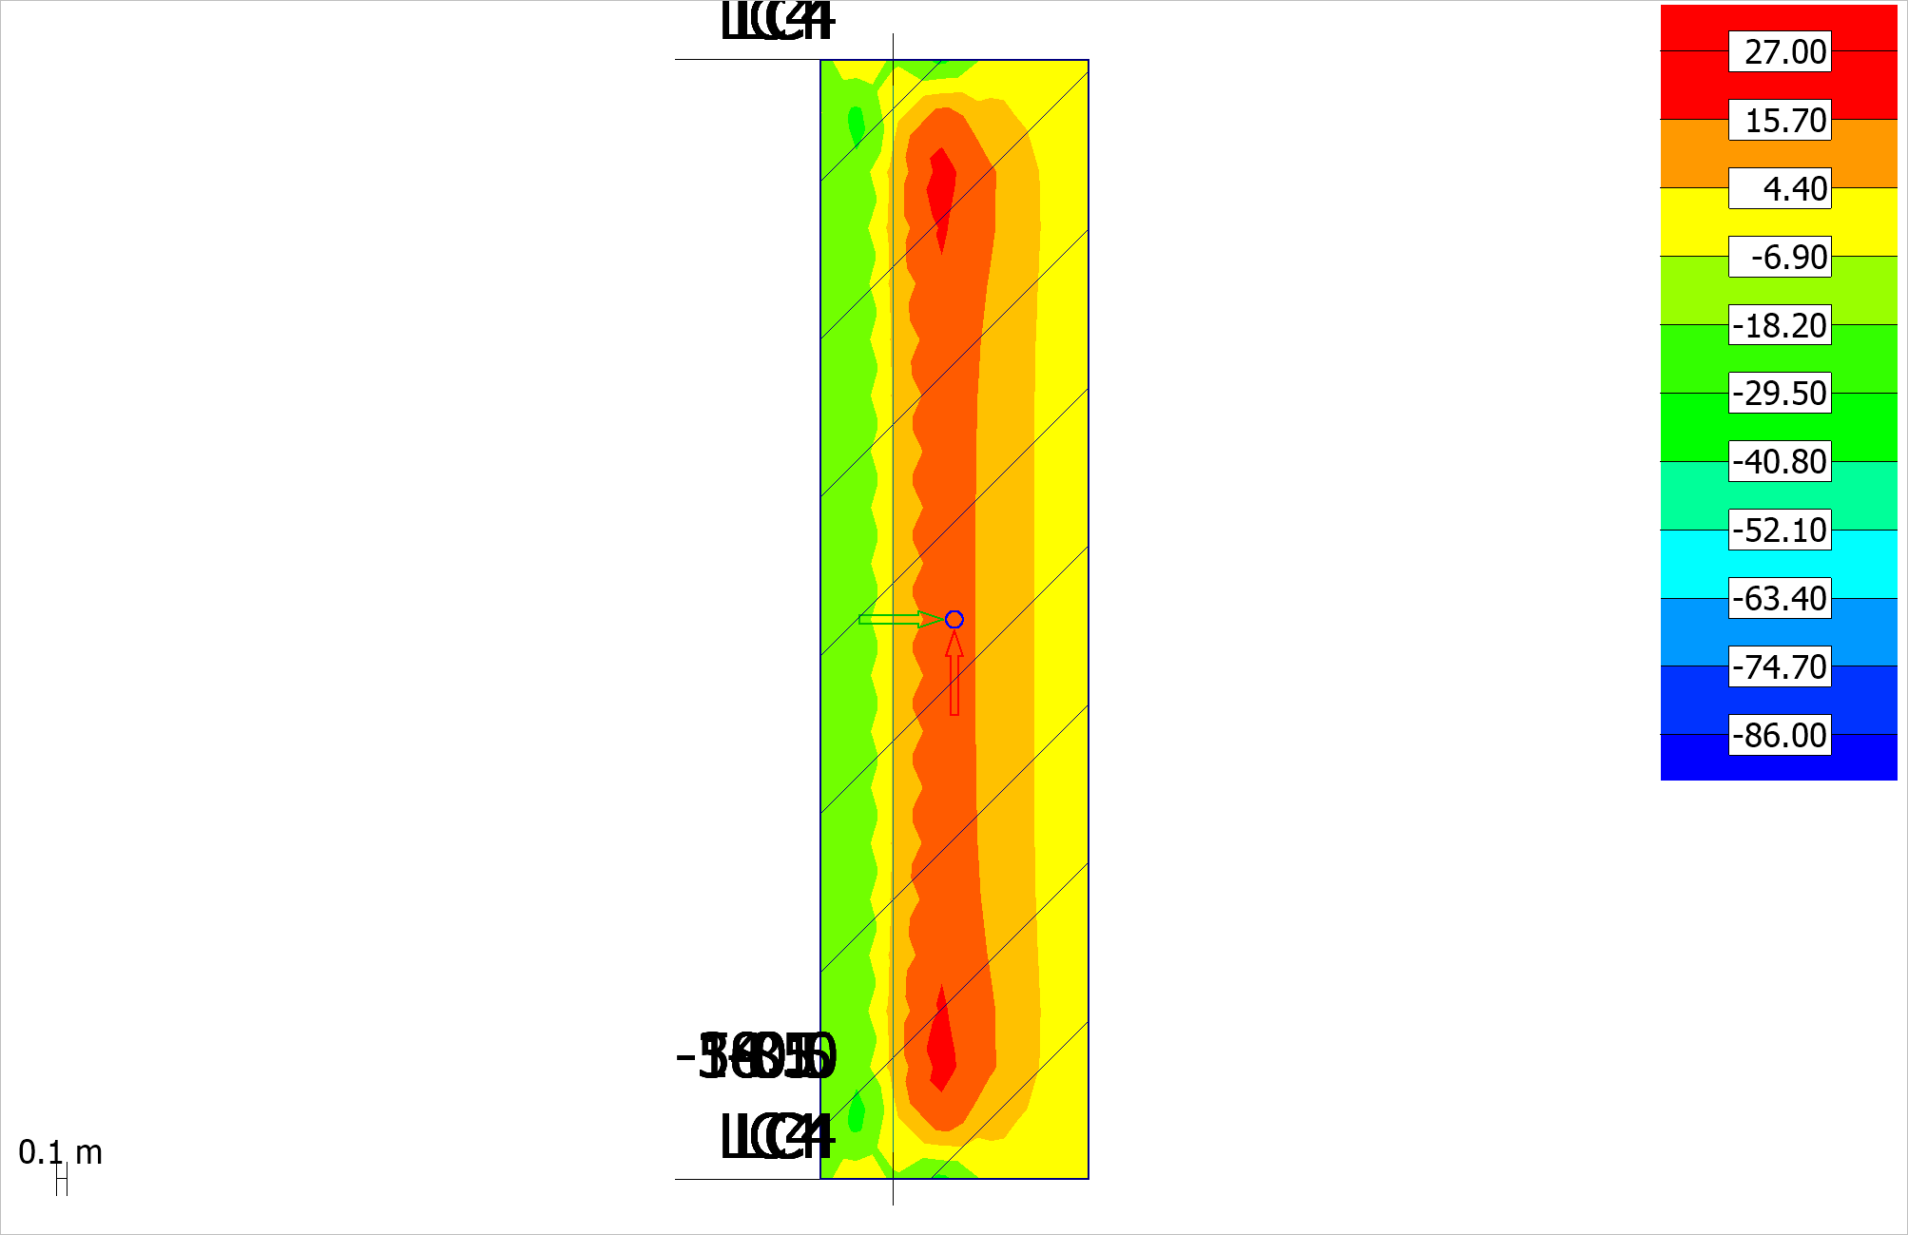 Figure 4.1.6: (Nx') - Cmax, U - Shell internal forces - |T|+ - [kN/m] - Plane view

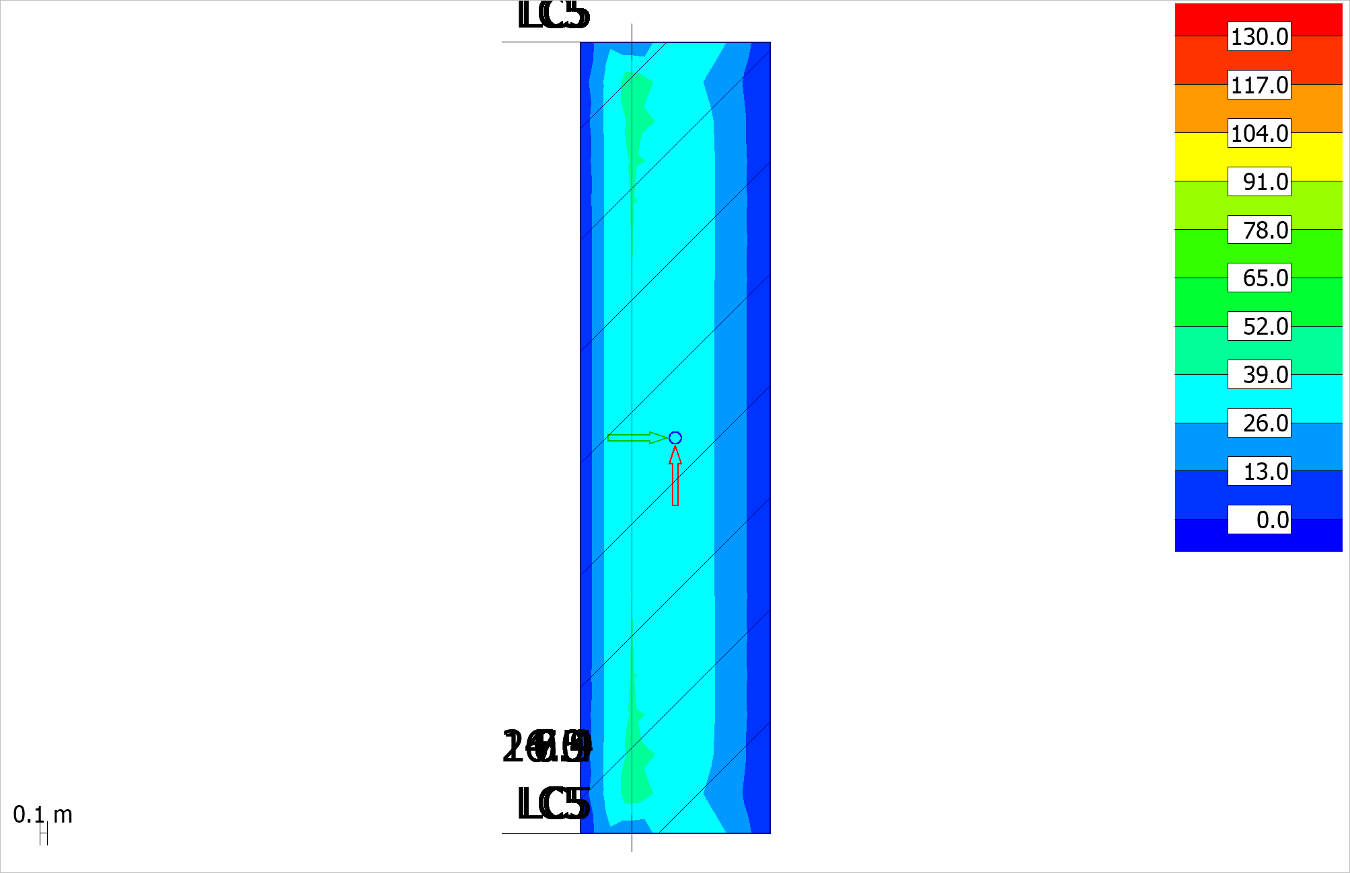 Figure 4.1.7: (|T|) - Cmax, U - Shell internal forces - |T|- - [kN/m] - Plane view

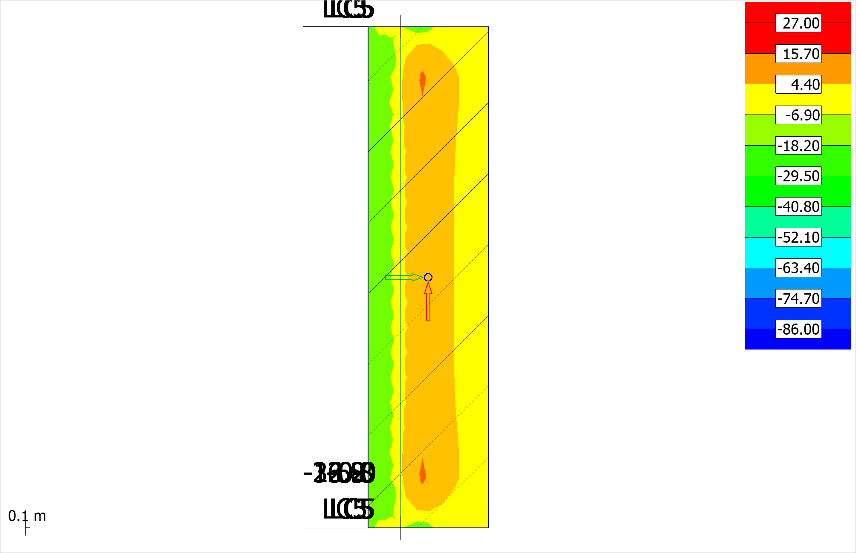 Figure 4.1.8: (Nx') - Cmax, U - Shell internal forces - |T|- - [kN/m] - Plane view

## 4.2 MUR

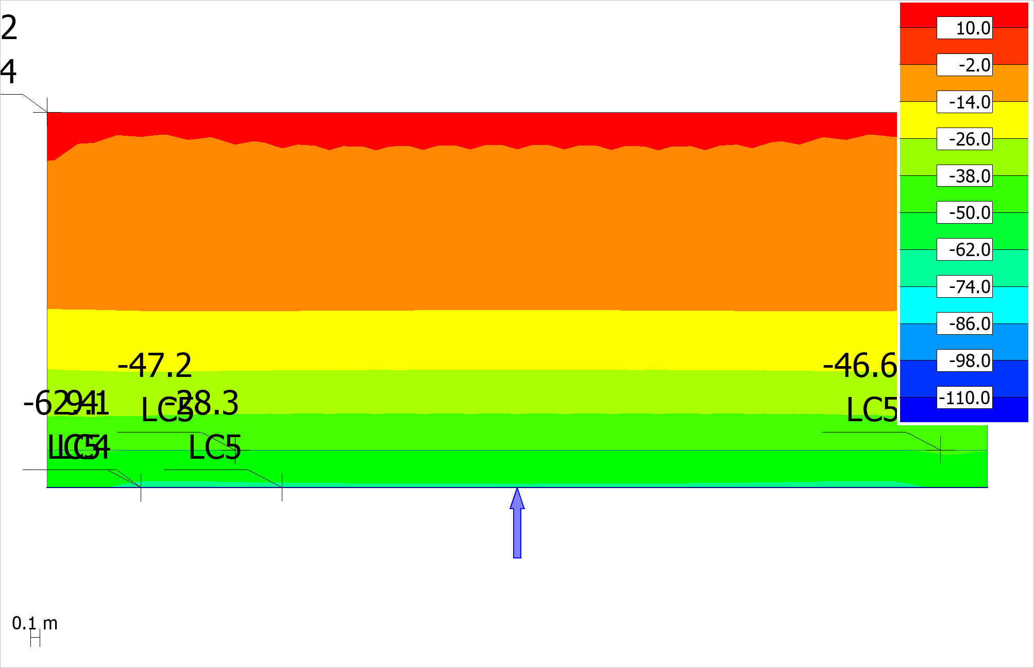 Figure 4.2.1: Cmax, U - Shell internal forces - Mx' (Mx'+) - [kNm/m] - East view

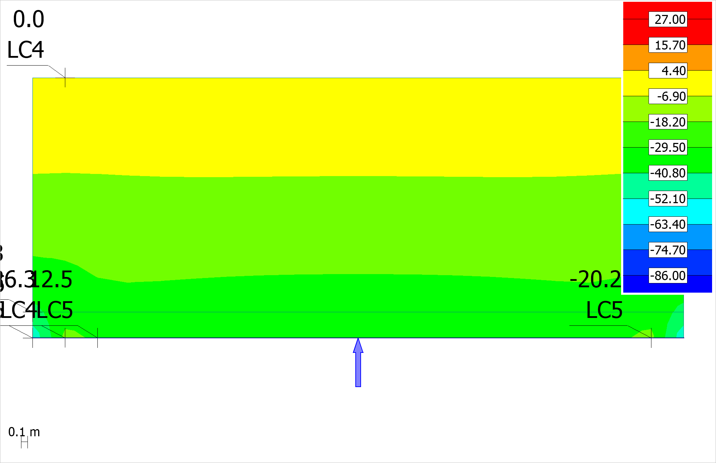 Figure 4.2.2: Cmax, U - Shell internal forces - Nx' (Mx'+) - [kN/m] - East view

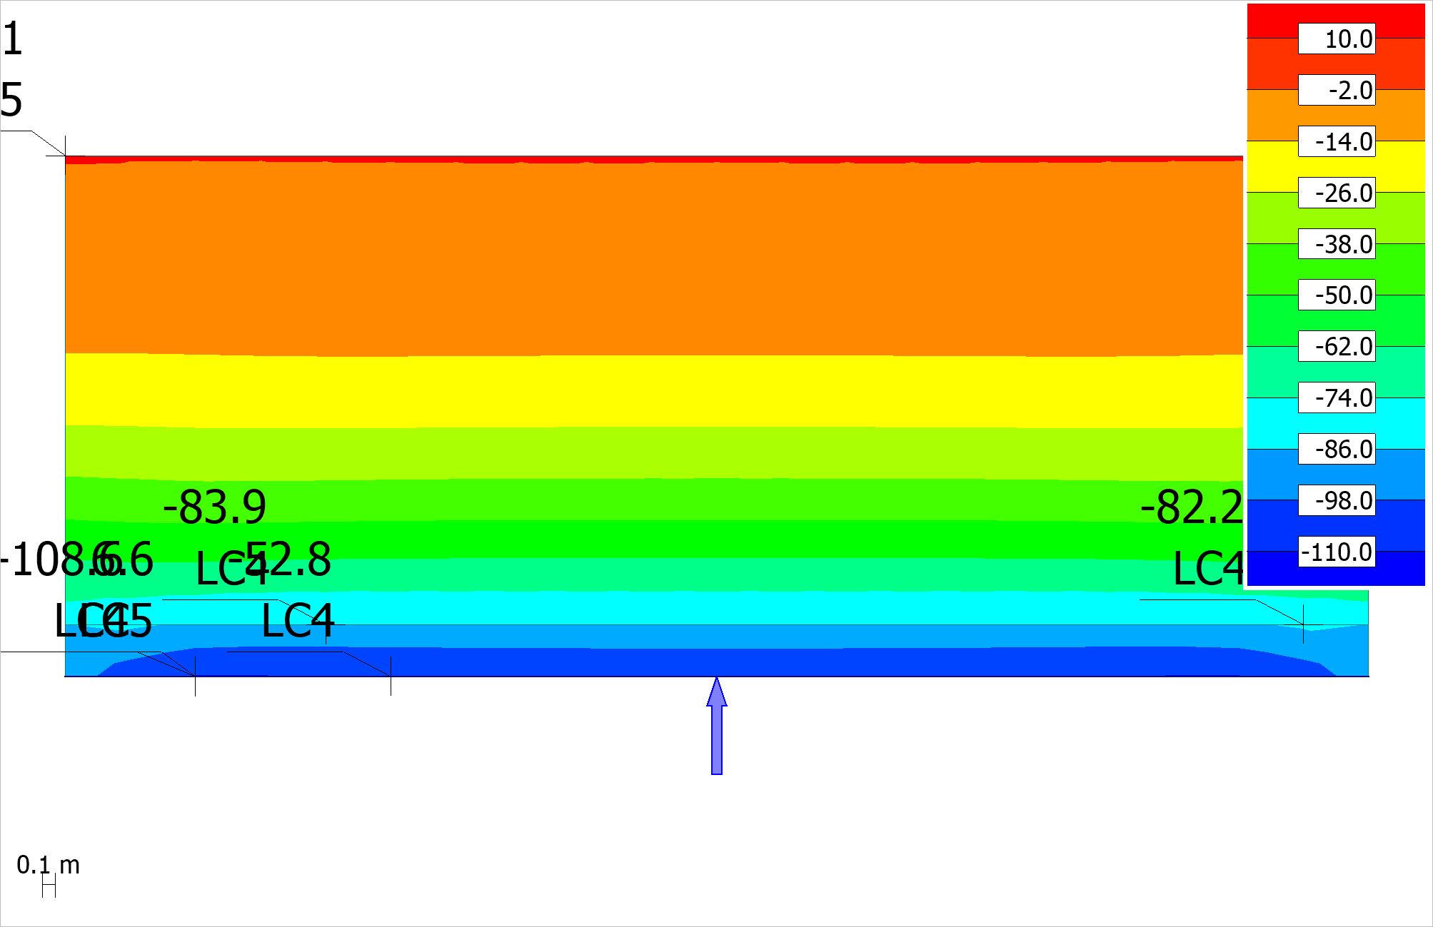 Figure 4.2.3: Cmax, U - Shell internal forces - Mx' (Mx'-) - [kNm/m] - East view

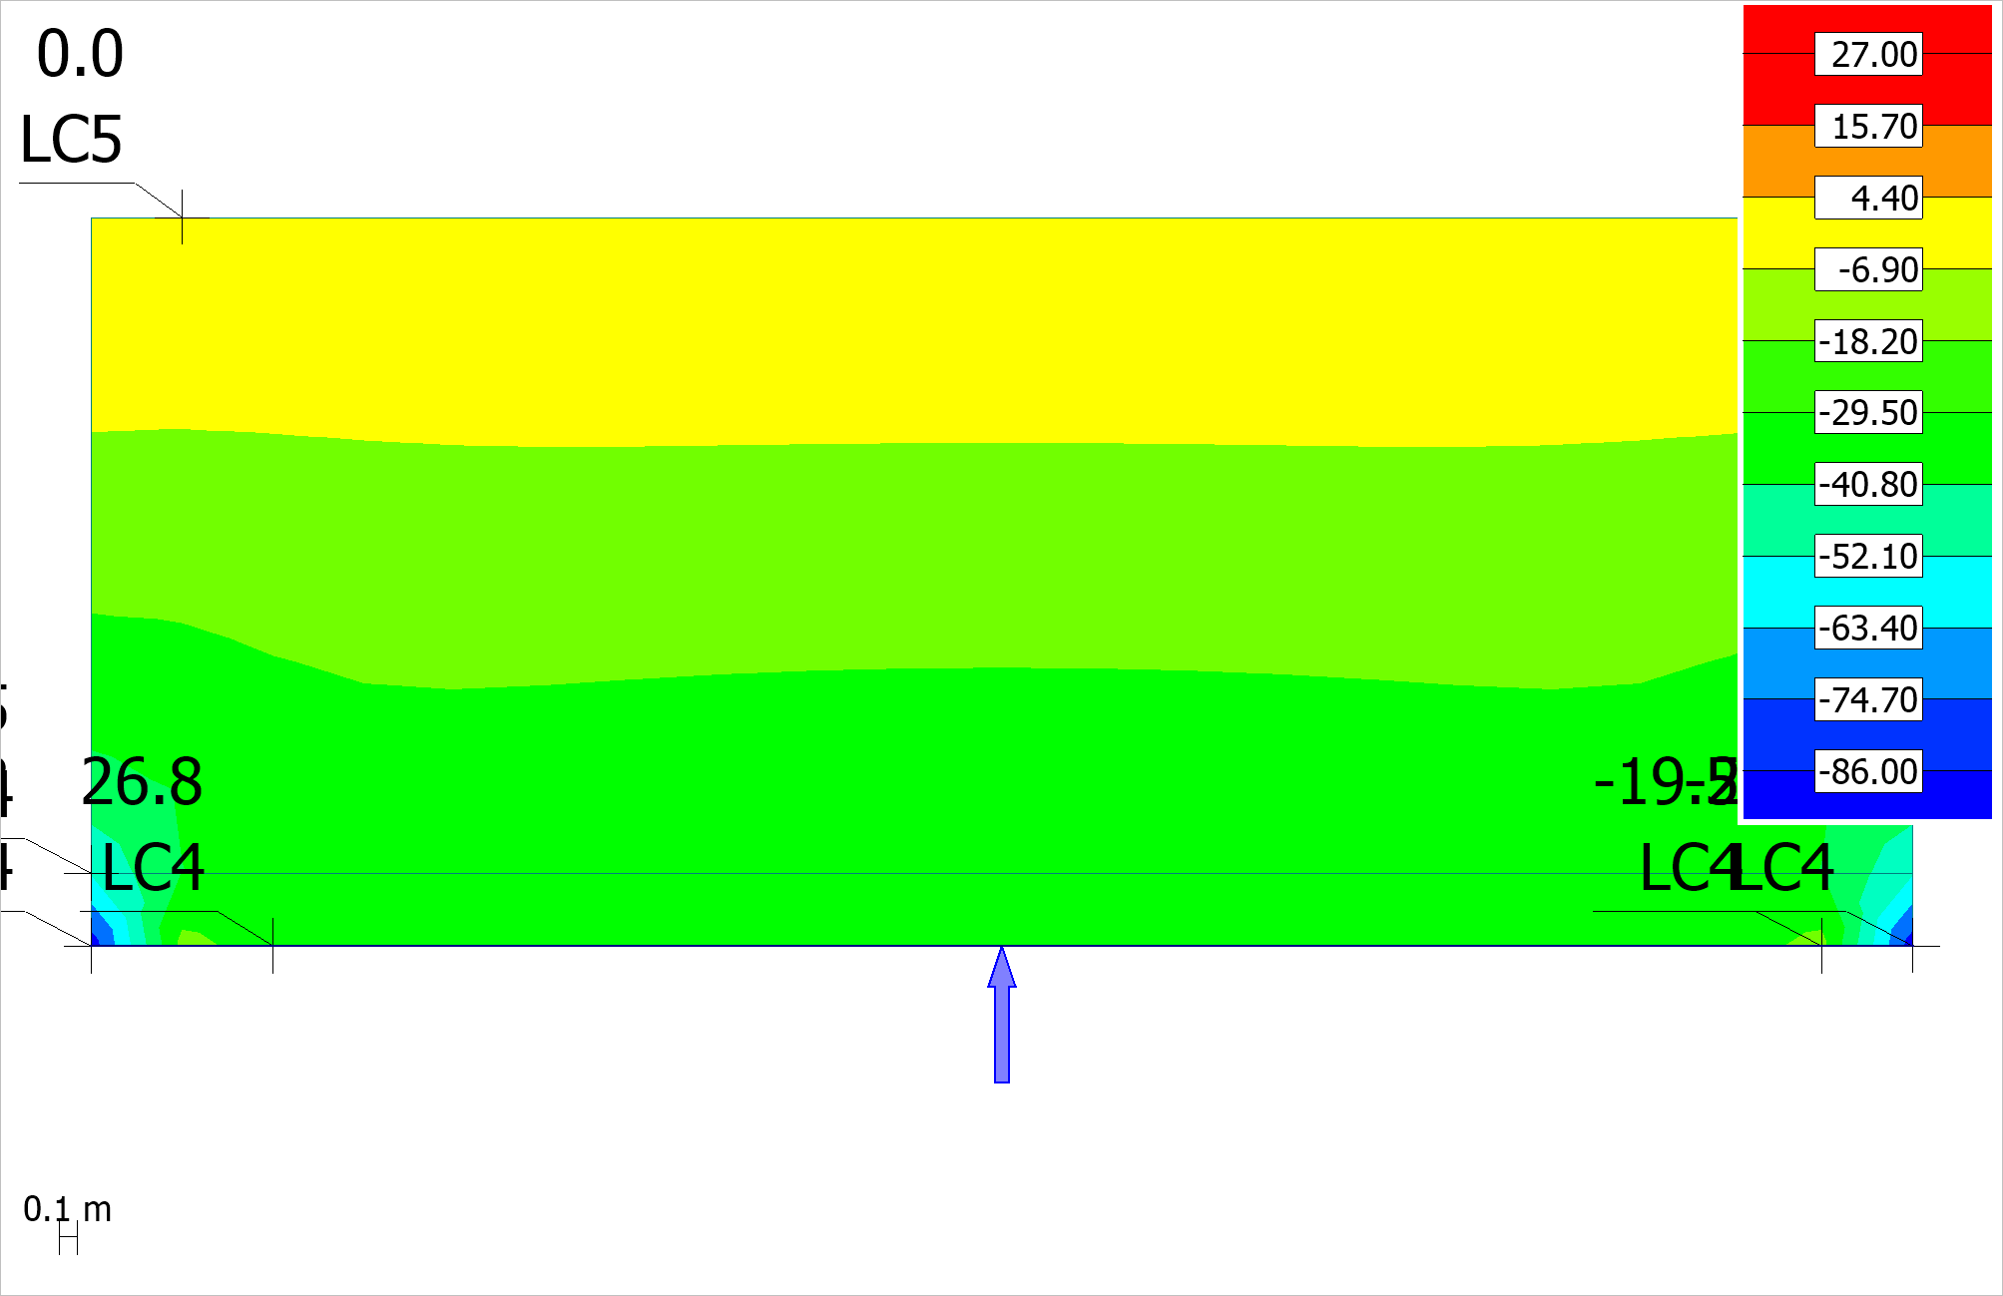 Figure 4.2.4: Cmax, U - Shell internal forces - Nx' (Mx'-) - [kN/m] - East view

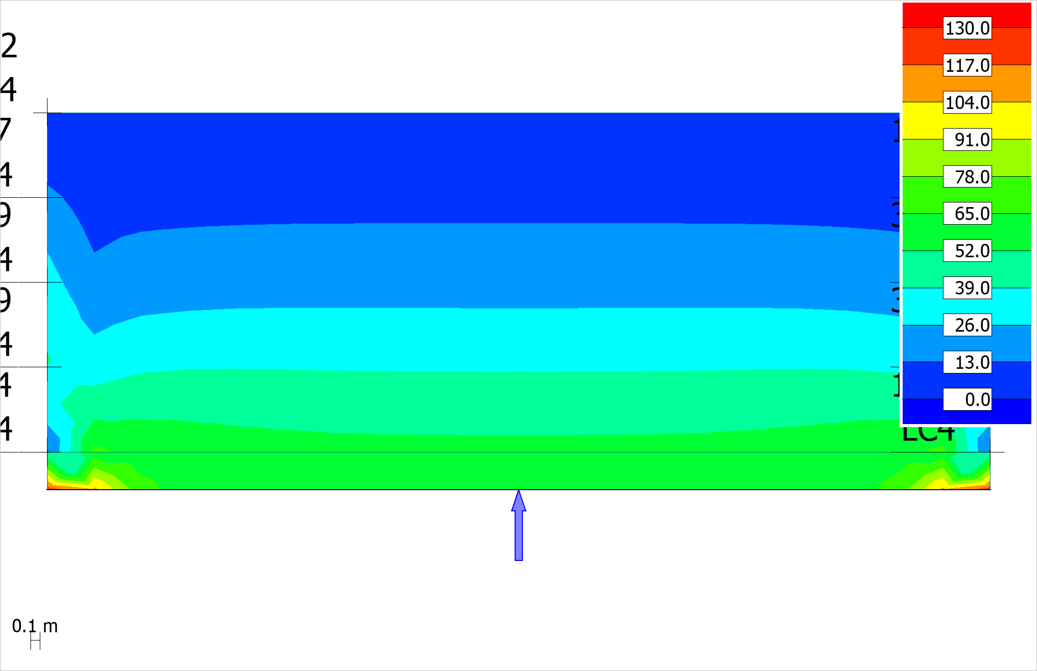 Figure 4.2.5: (|T|) - Cmax, U - Shell internal forces - |T|+ - [kN/m] - East view

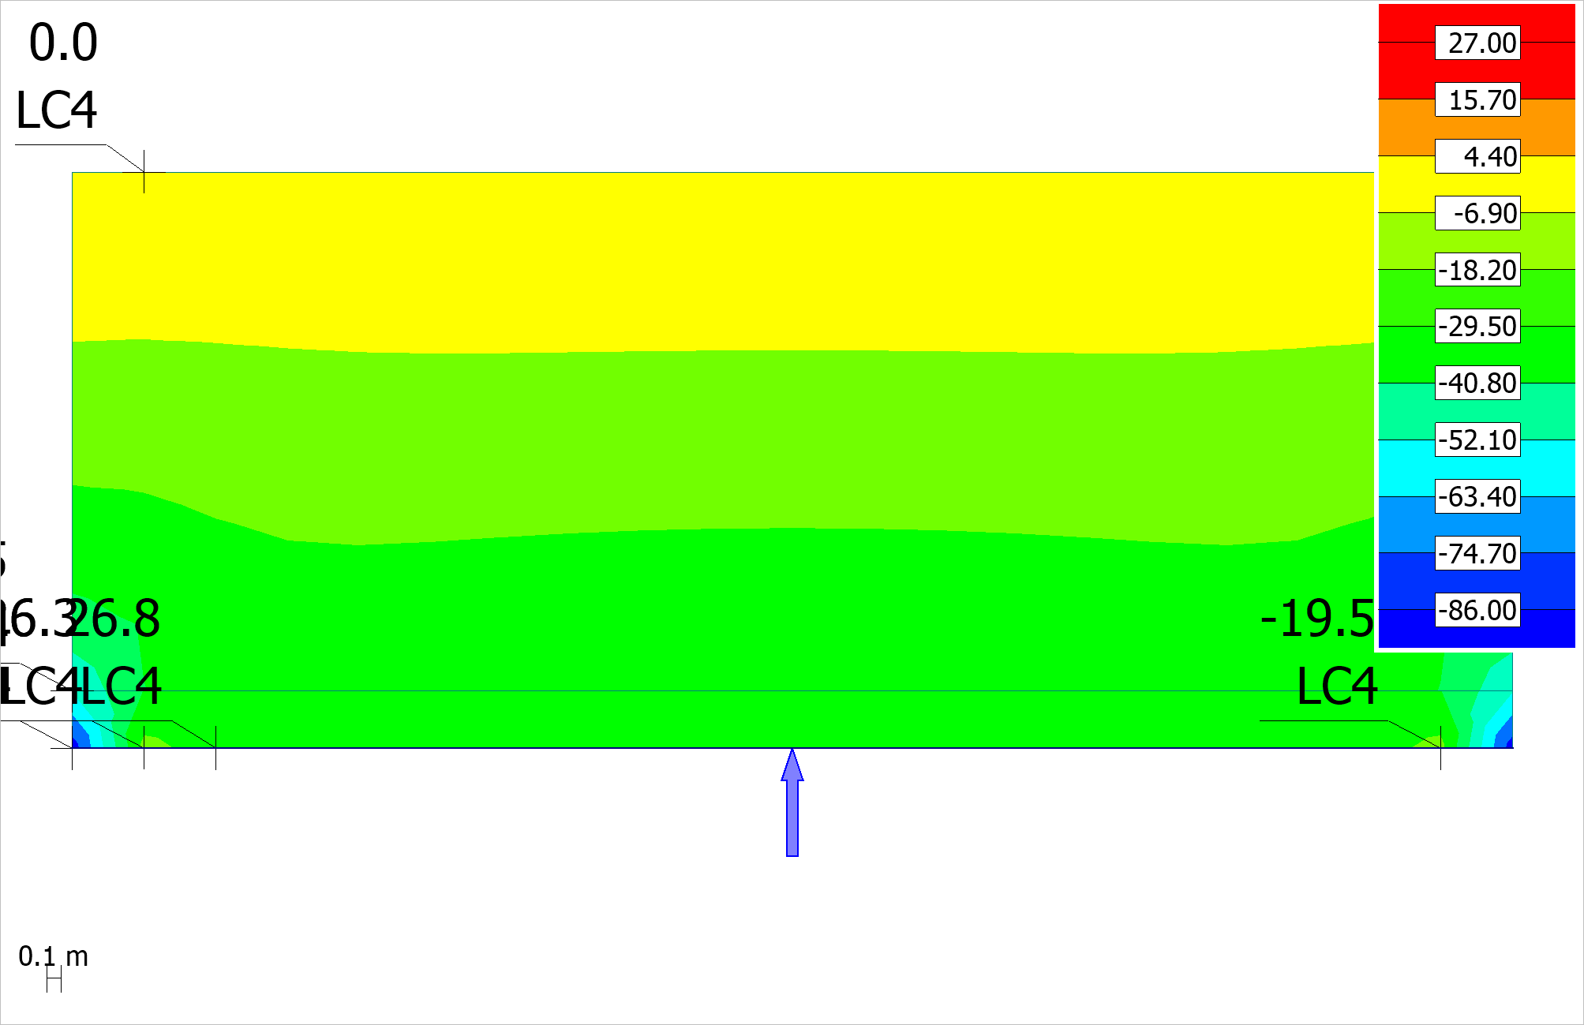 Figure 4.2.6: (Nx') - Cmax, U - Shell internal forces - |T|+ - [kN/m] - East view

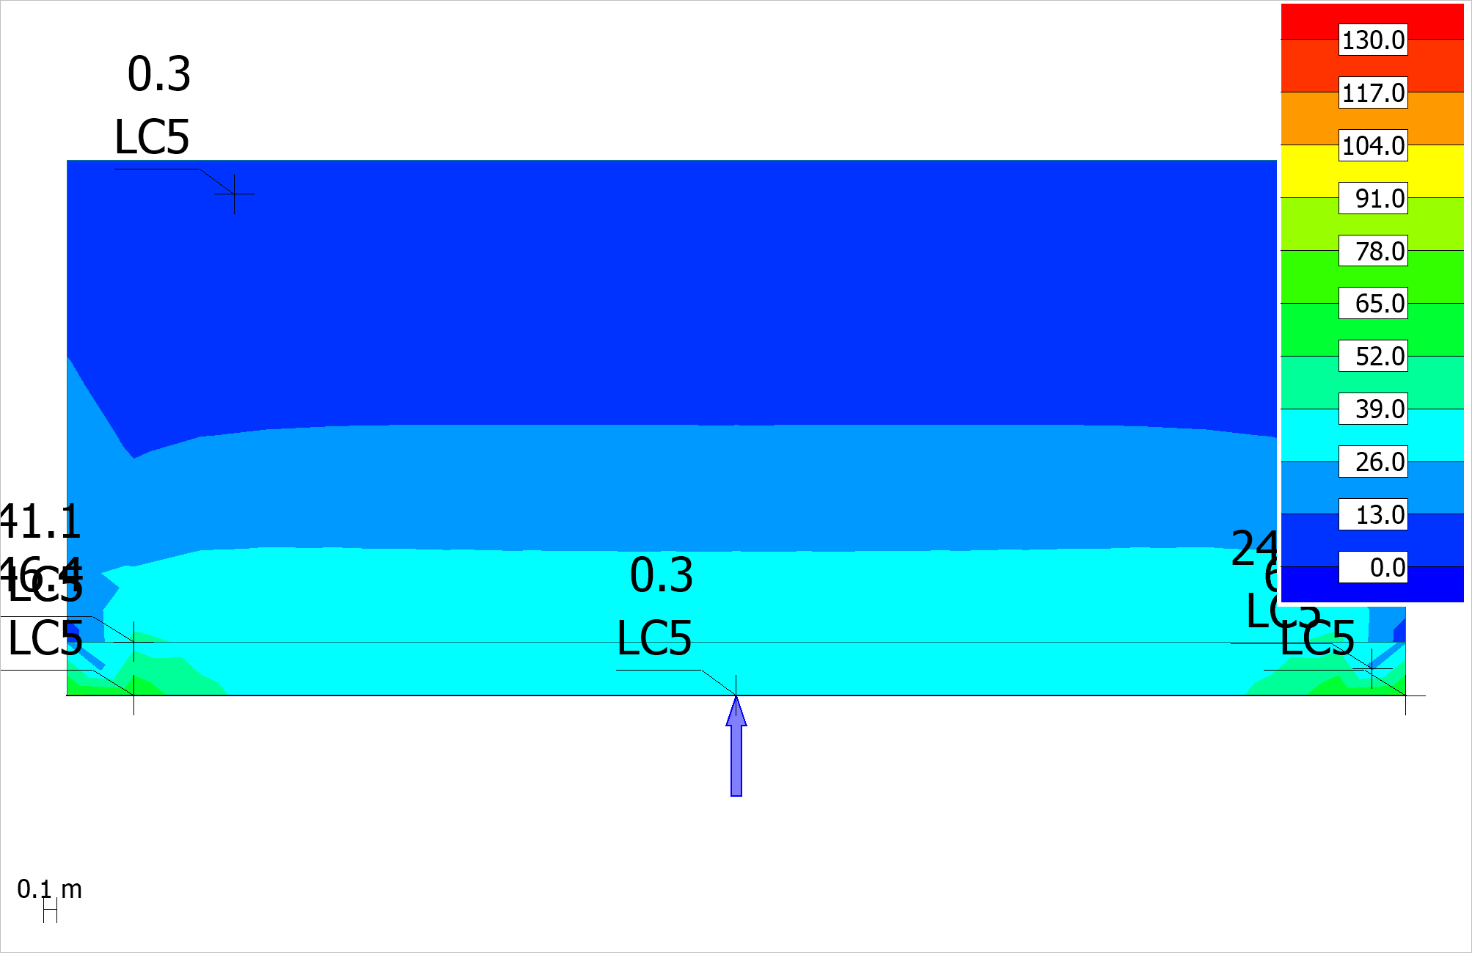 Figure 4.2.7: (|T|) - Cmax, U - Shell internal forces - |T|- - [kN/m] - East view

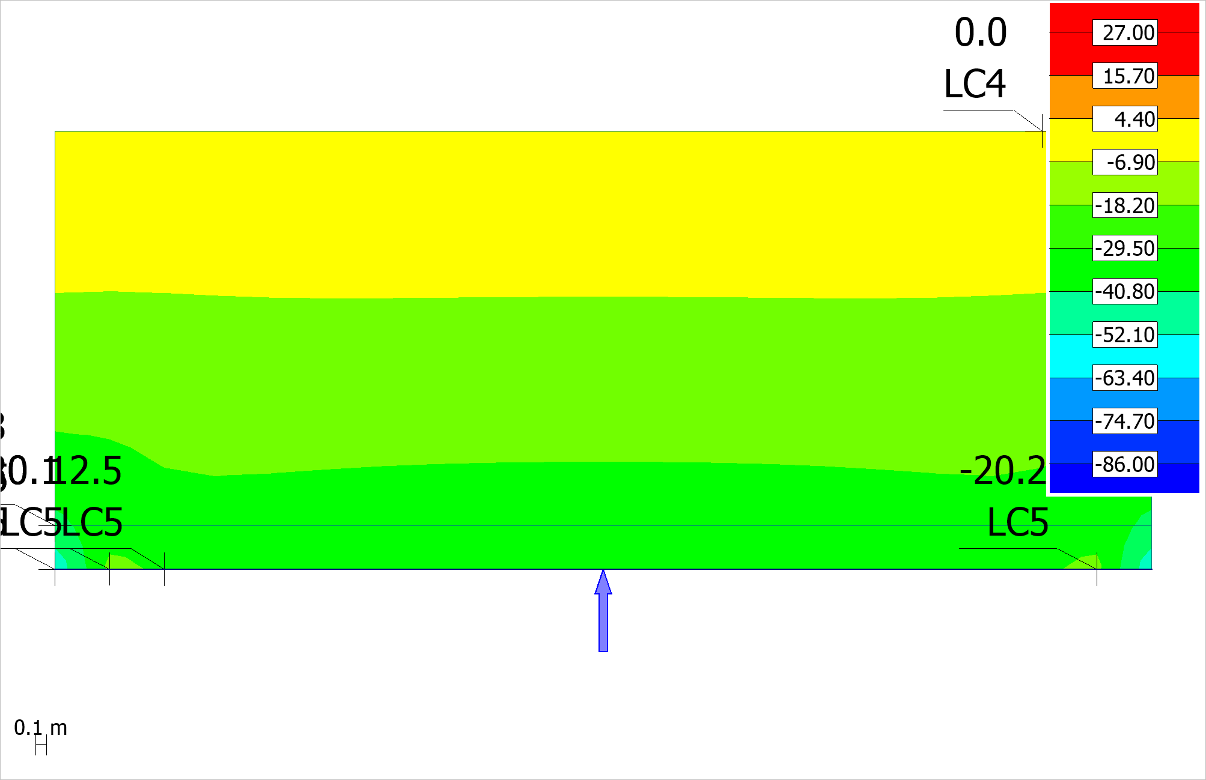 Figure 4.2.8: (Nx') - Cmax, U - Shell internal forces - |T|- - [kN/m] - East view

# 5 Reinforement utilization

## 5.1 BPL

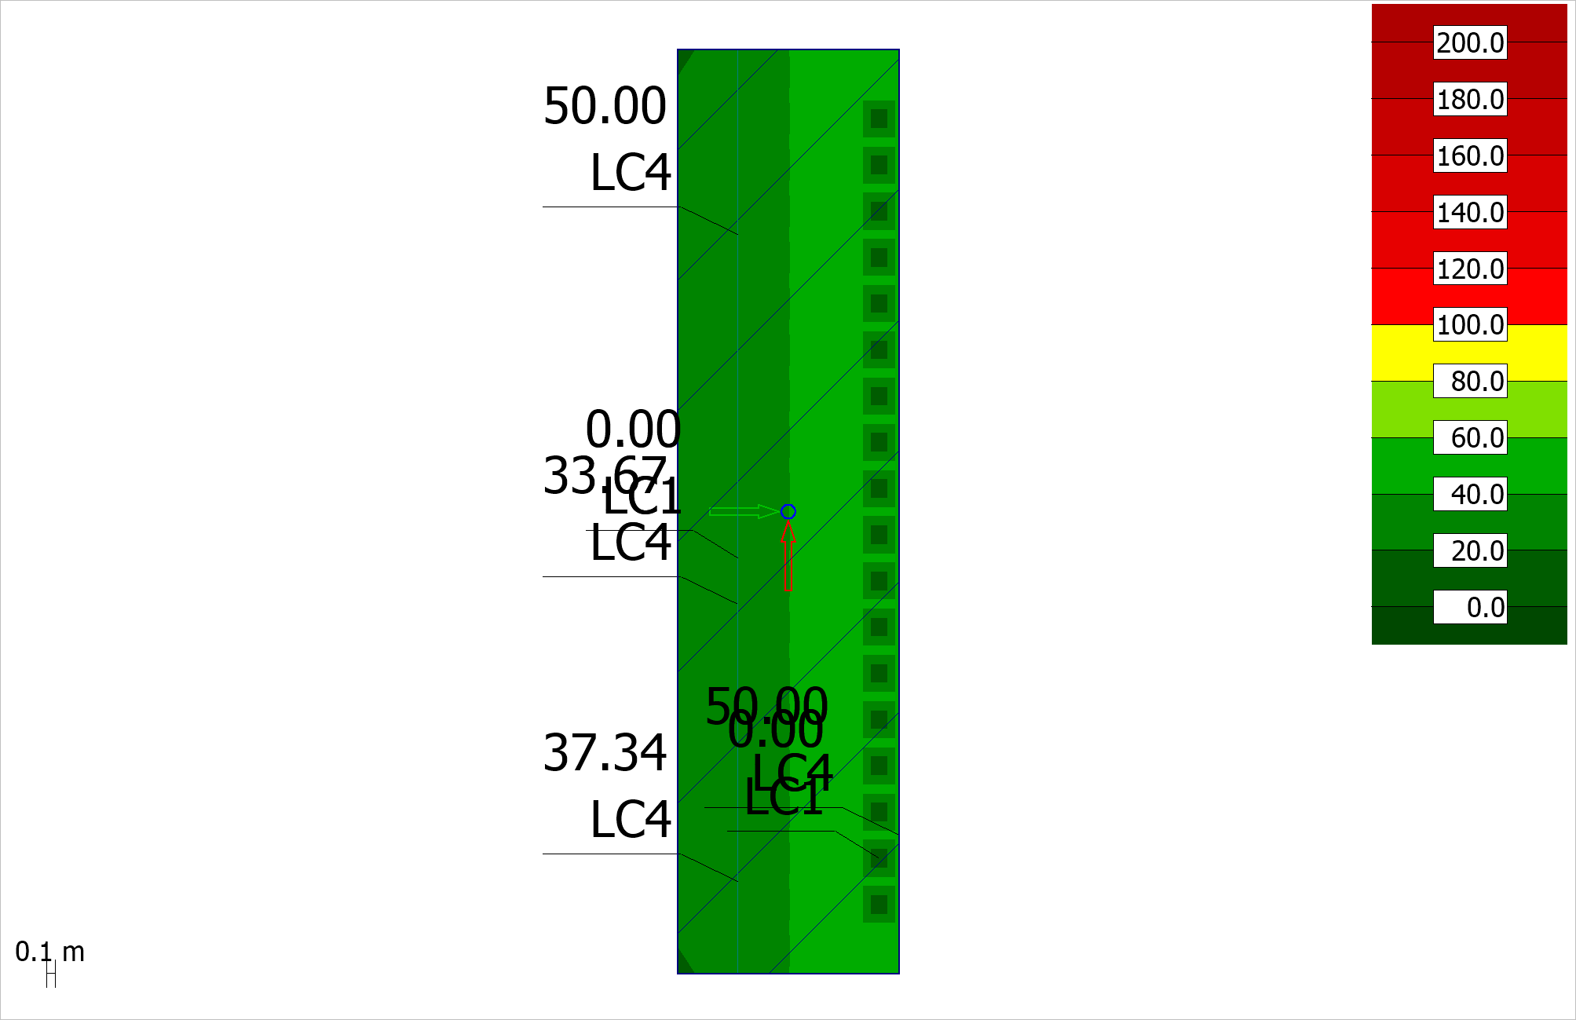 Figure 5.1.1: BPL - RC shell - Utilization - Load combinations - Maximum - [%] - Plane view

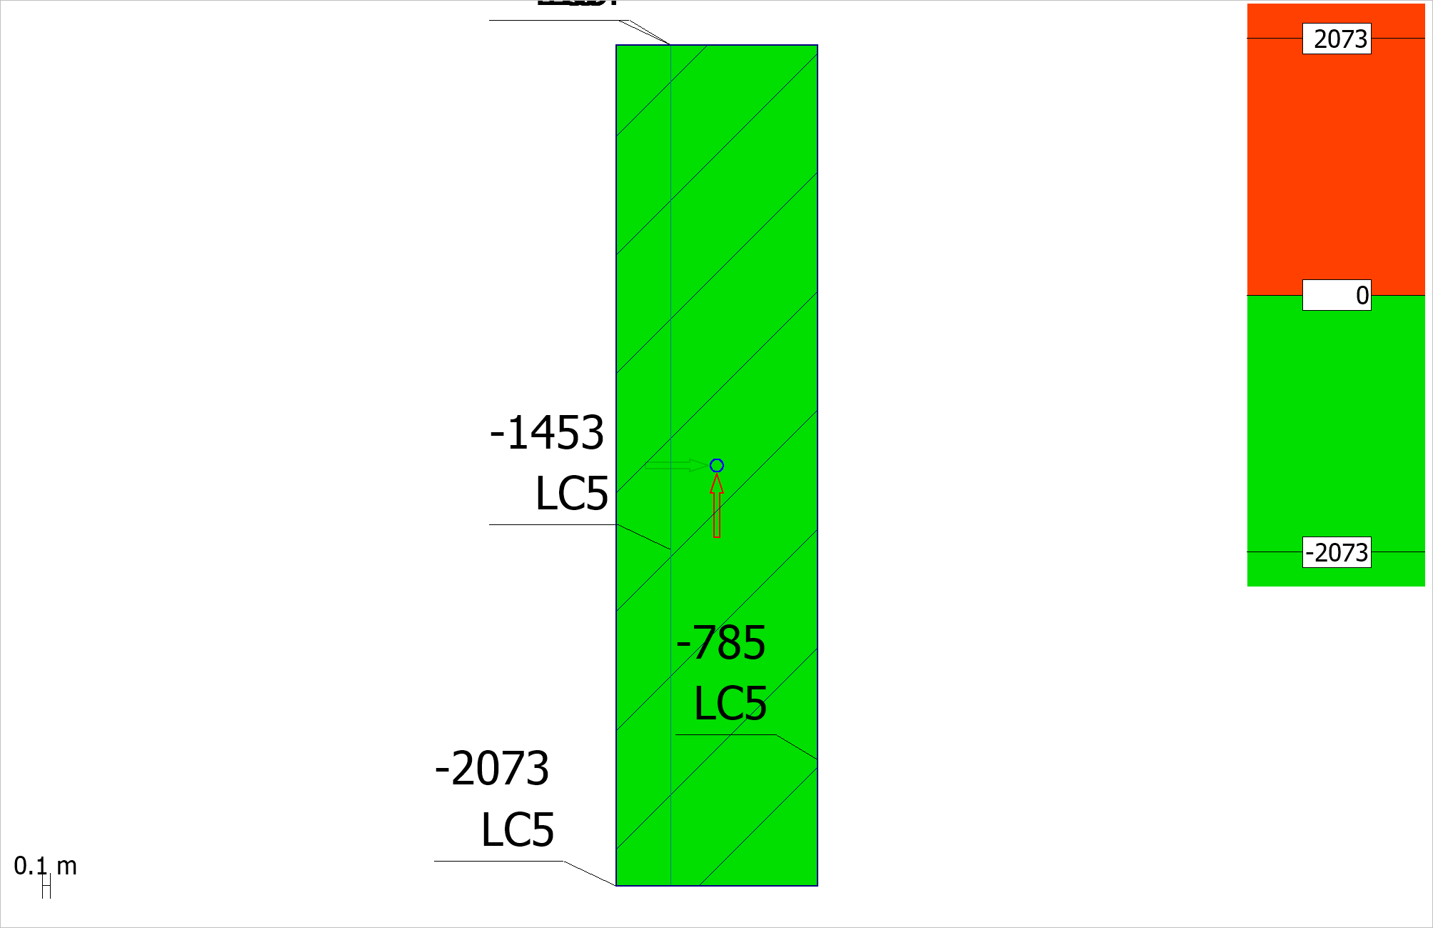 Figure 5.1.2: BPL - RC shell - Missing reinforcement - x' or r, bottom - Load combinations - Maximum - [mm2/m] - Plane view

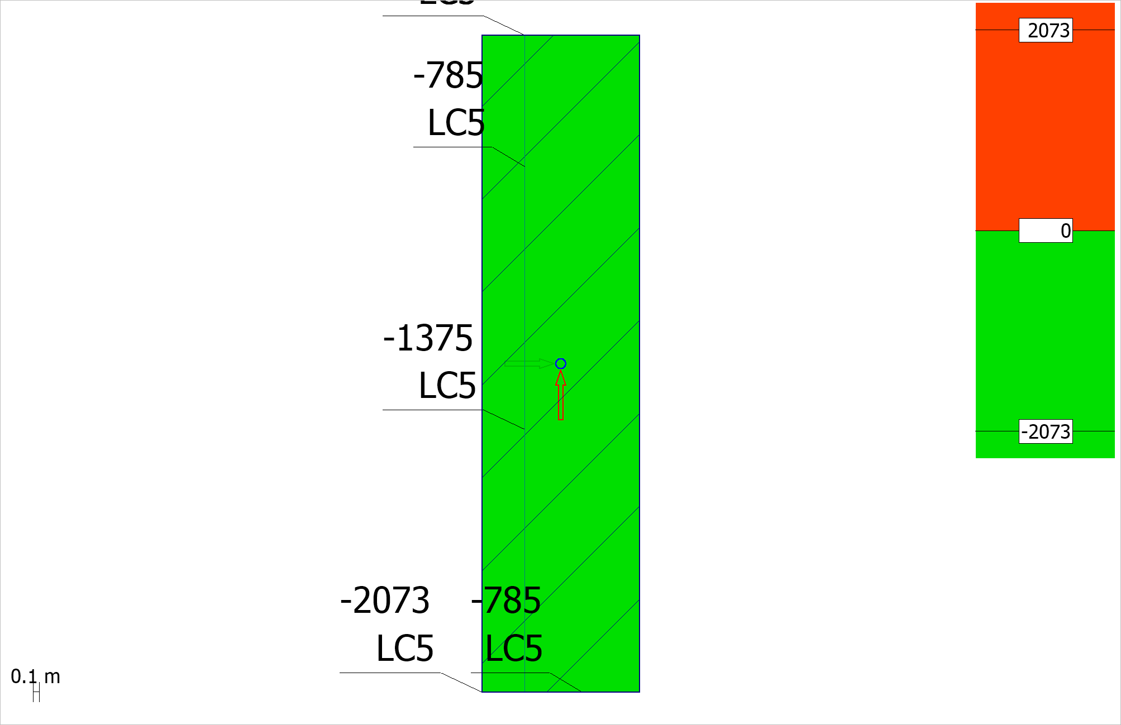 Figure 5.1.3: BPL - RC shell - Missing reinforcement - y' or t, bottom - Load combinations - Maximum - [mm2/m] - Plane view

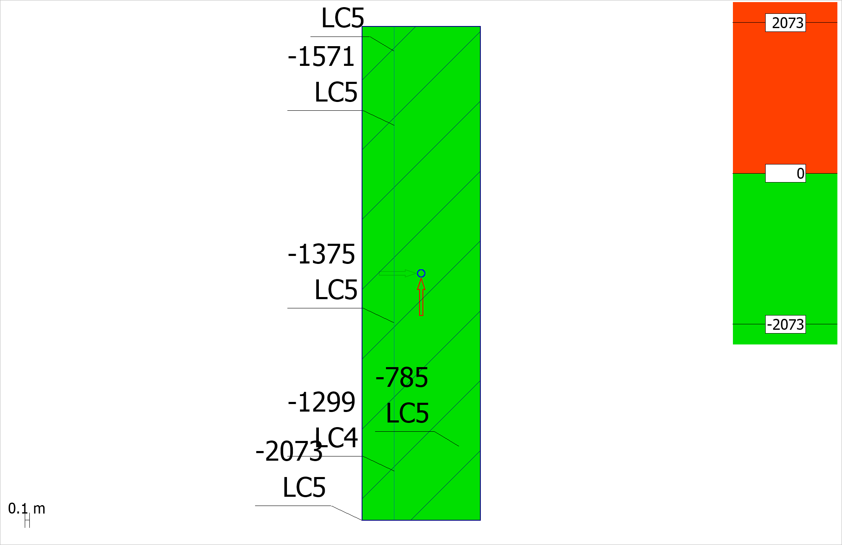 Figure 5.1.4: BPL - RC shell - Missing reinforcement - x' or r, top - Load combinations - Maximum - [mm2/m] - Plane view

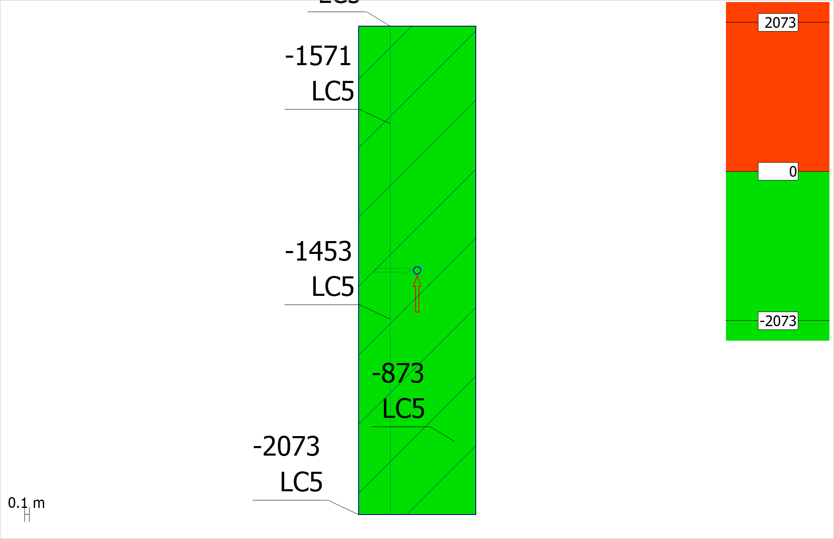 Figure 5.1.5: BPL - RC shell - Missing reinforcement - y' or t, top - Load combinations - Maximum - [mm2/m] - Plane view

## 5.2 MUR

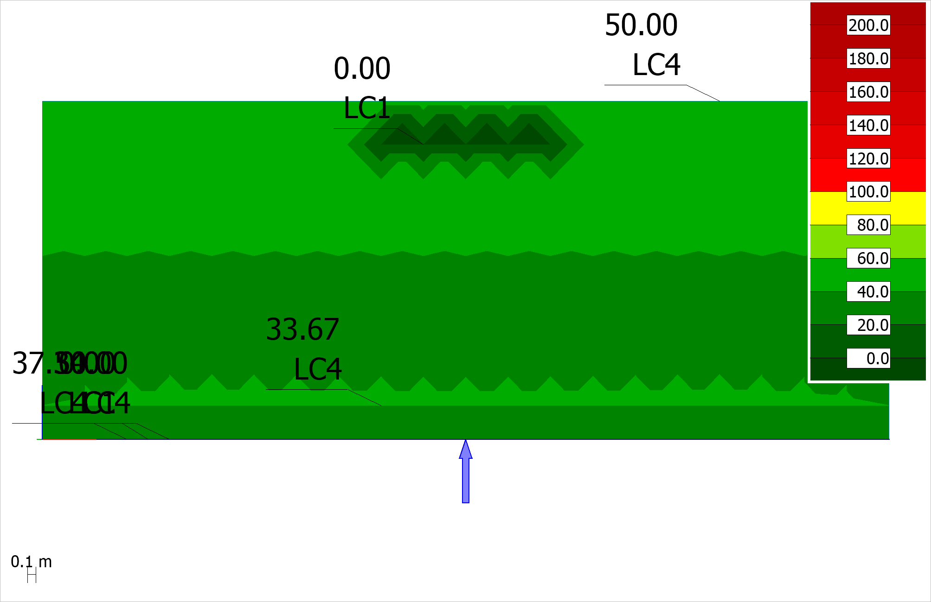 Figure 5.2.1: MUR - RC shell - Utilization - Load combinations - Maximum - [%] - East view

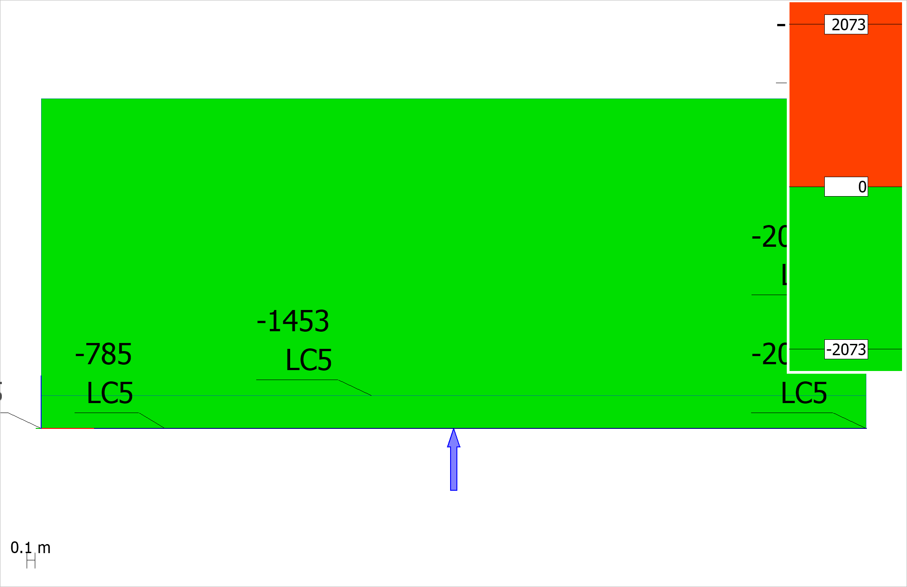 Figure 5.2.2: MUR - RC shell - Missing reinforcement - x' or r, bottom - Load combinations - Maximum - [mm2/m] - East view

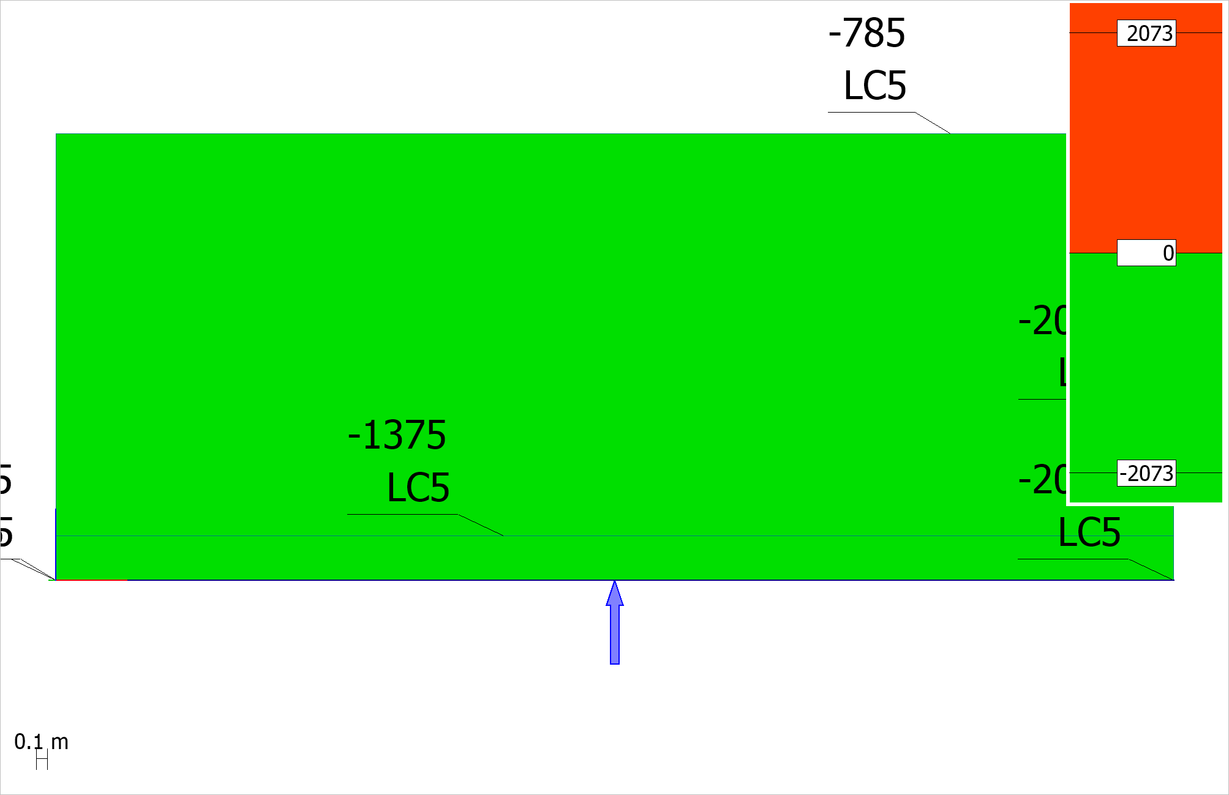 Figure 5.2.3: MUR - RC shell - Missing reinforcement - y' or t, bottom - Load combinations - Maximum - [mm2/m] - East view

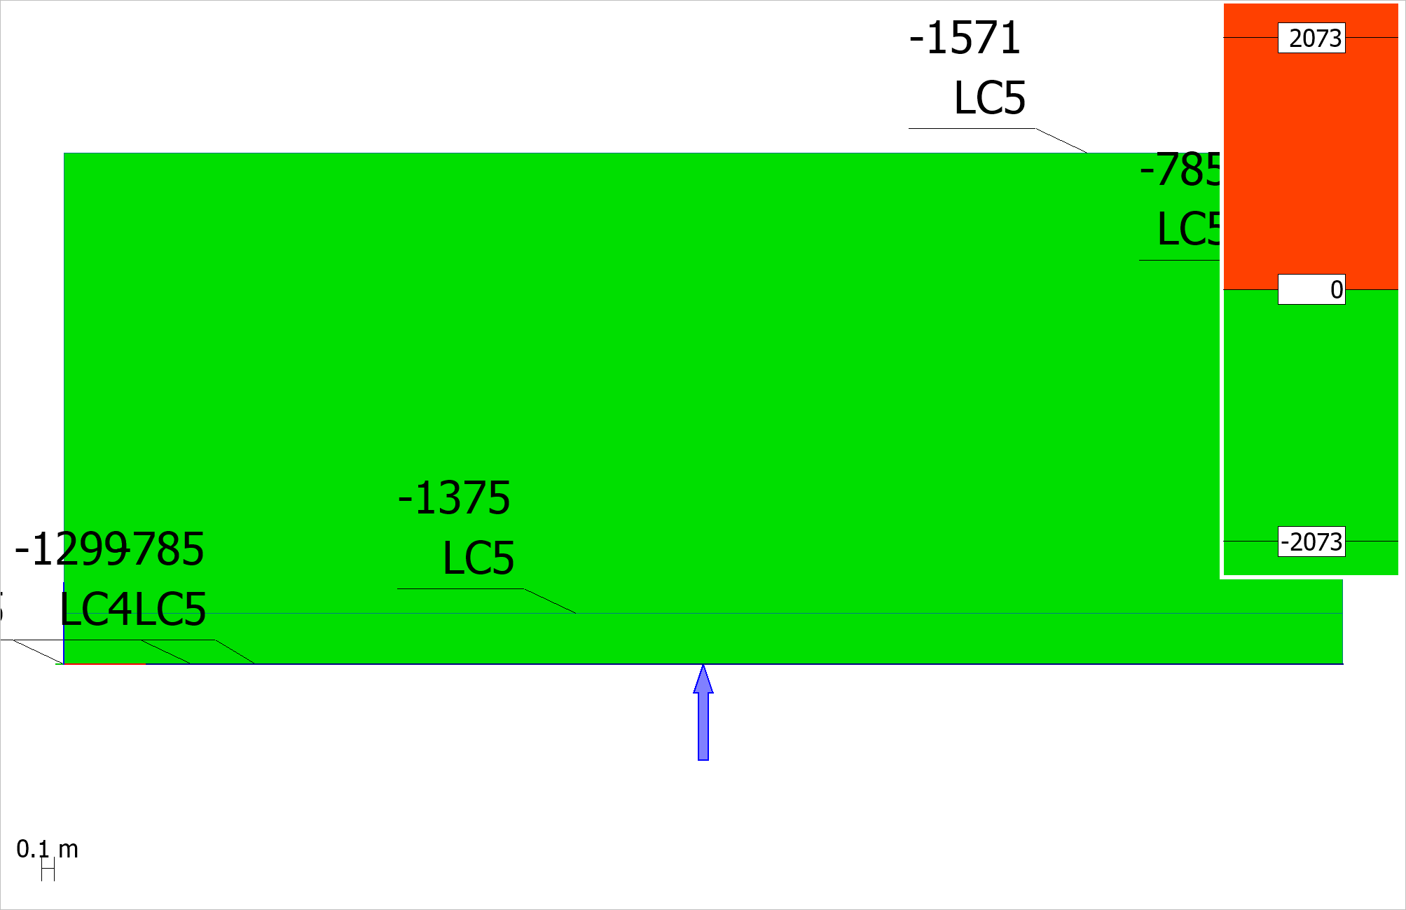 Figure 5.2.4: MUR - RC shell - Missing reinforcement - x' or r, top - Load combinations - Maximum - [mm2/m] - East view

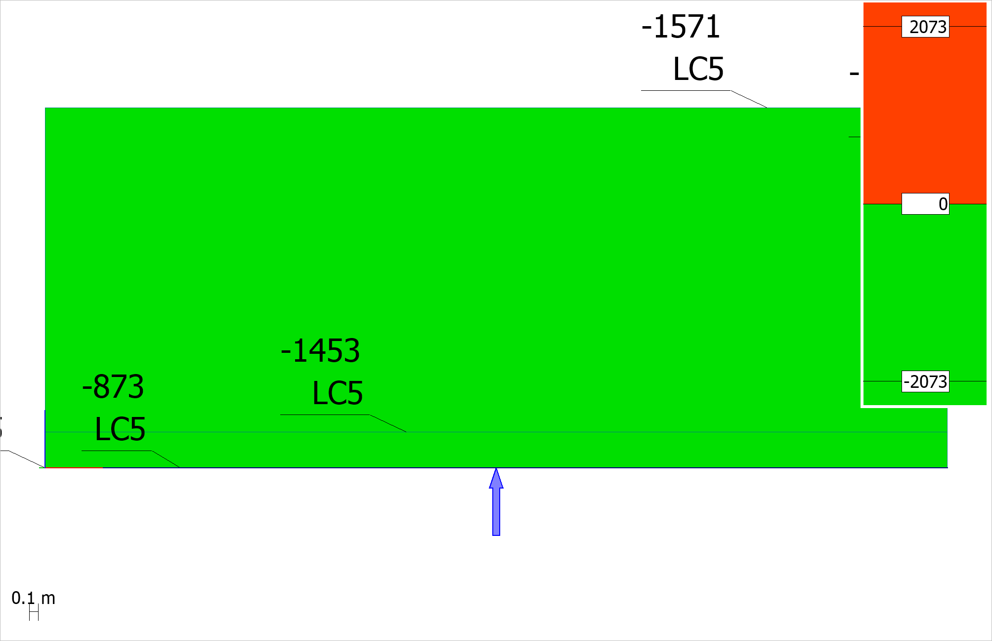 Figure 5.2.5: MUR - RC shell - Missing reinforcement - y' or t, top - Load combinations - Maximum - [mm2/m] - East view

# 6 Crack width

## 6.1 BPL

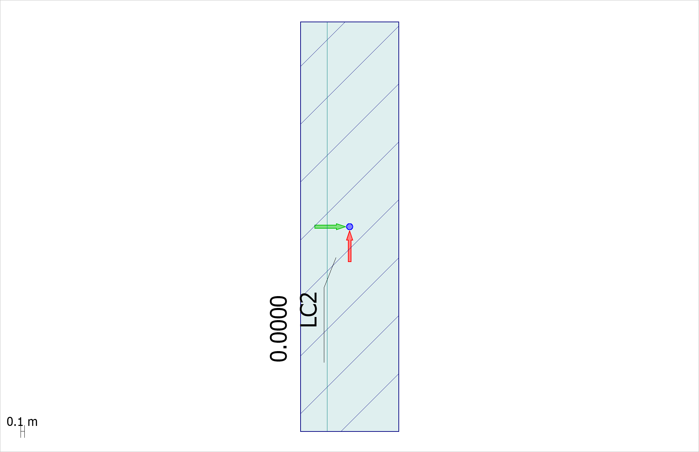 Figure 6.1.1: BPL - RC shell - Crack width - bottom - Load combinations - Maximum - [mm] - Plane view

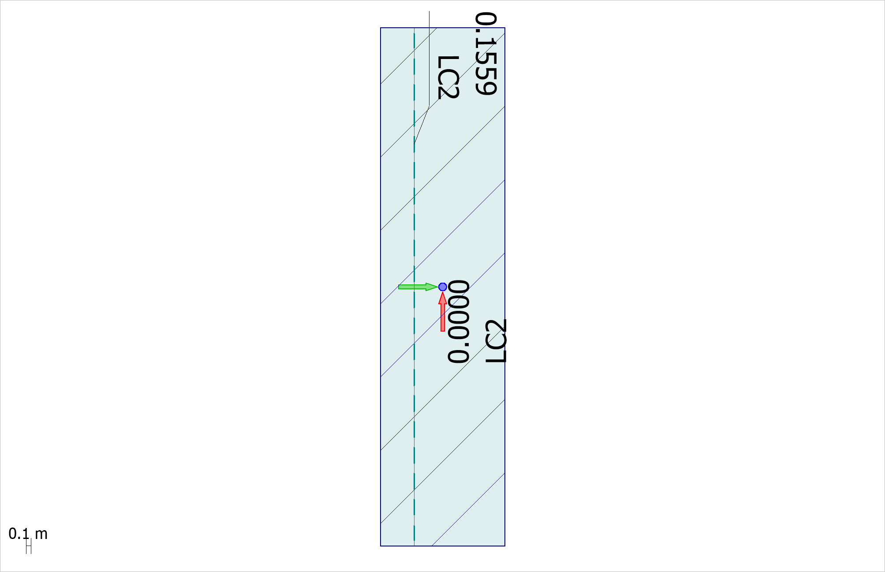 Figure 6.1.2: BPL - RC shell - Crack width - top - Load combinations - Maximum - [mm] - Plane view

## 6.2 MUR

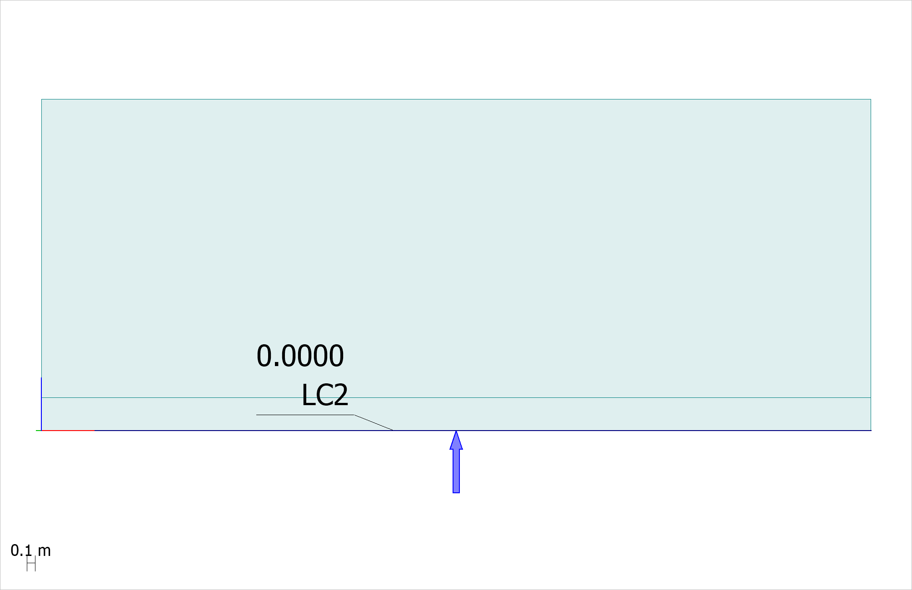 Figure 6.2.1: MUR - RC shell - Crack width - bottom - Load combinations - Maximum - [mm] - East view

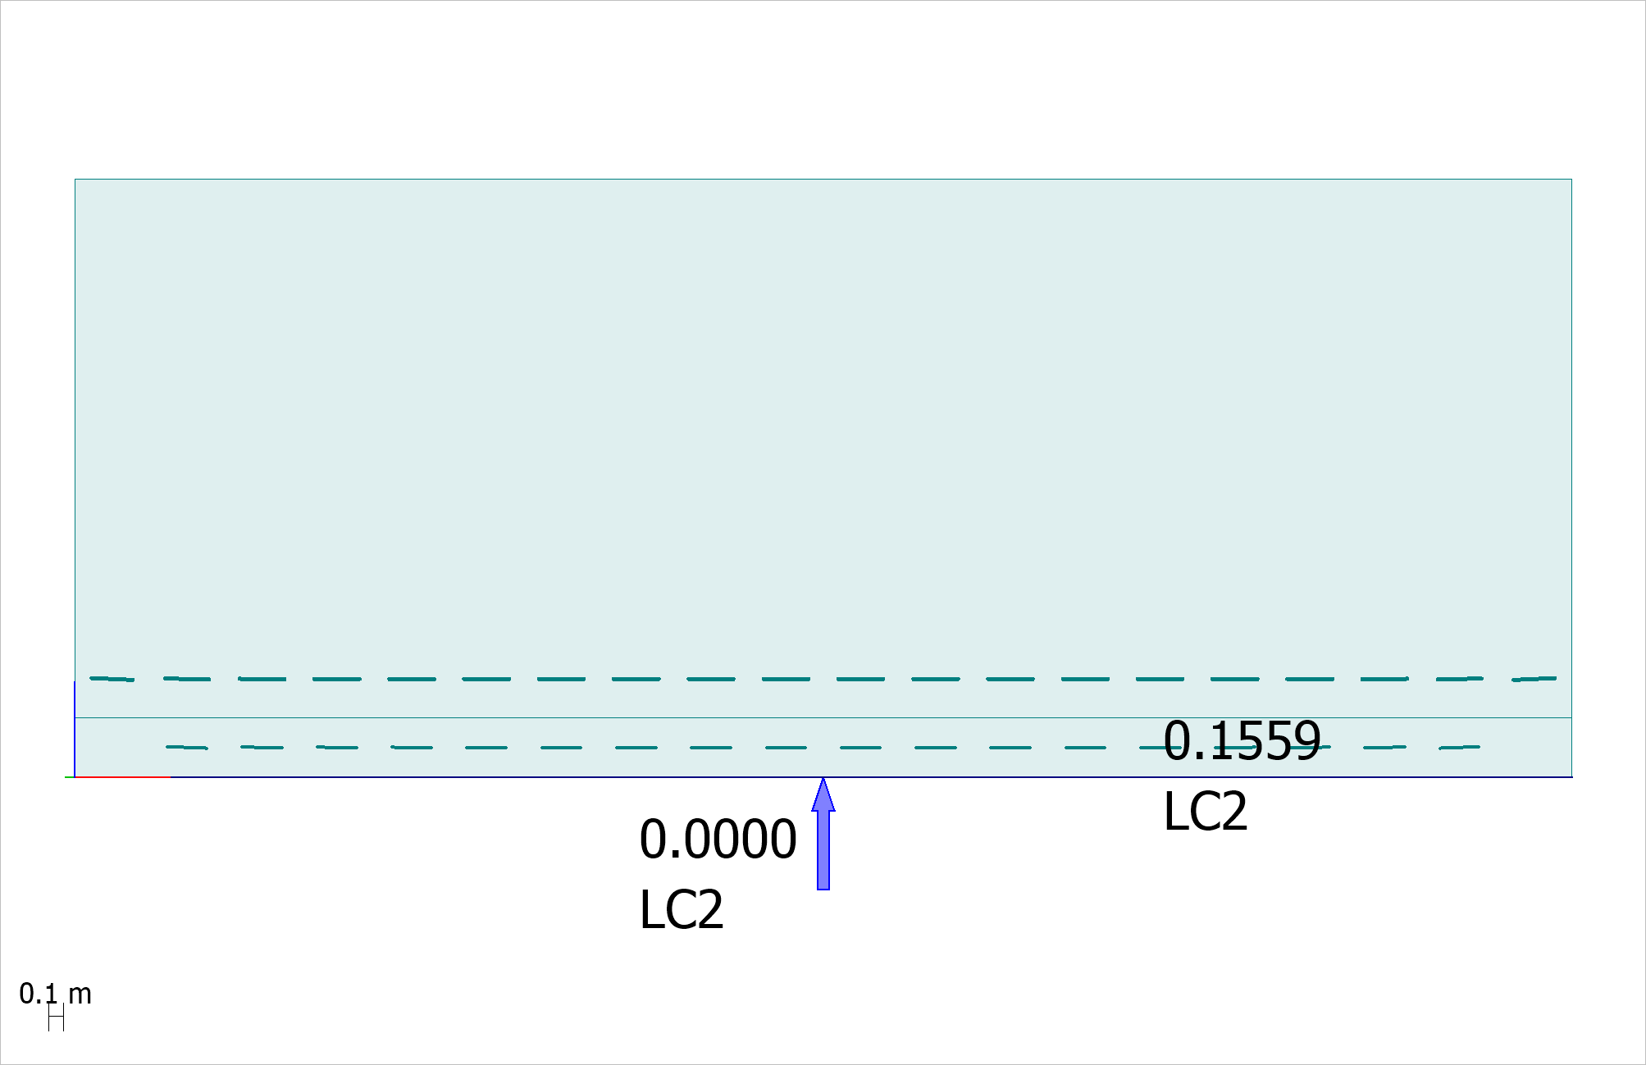 Figure 6.2.2: MUR - RC shell - Crack width - top - Load combinations - Maximum - [mm] - East view

# 7 Deformation

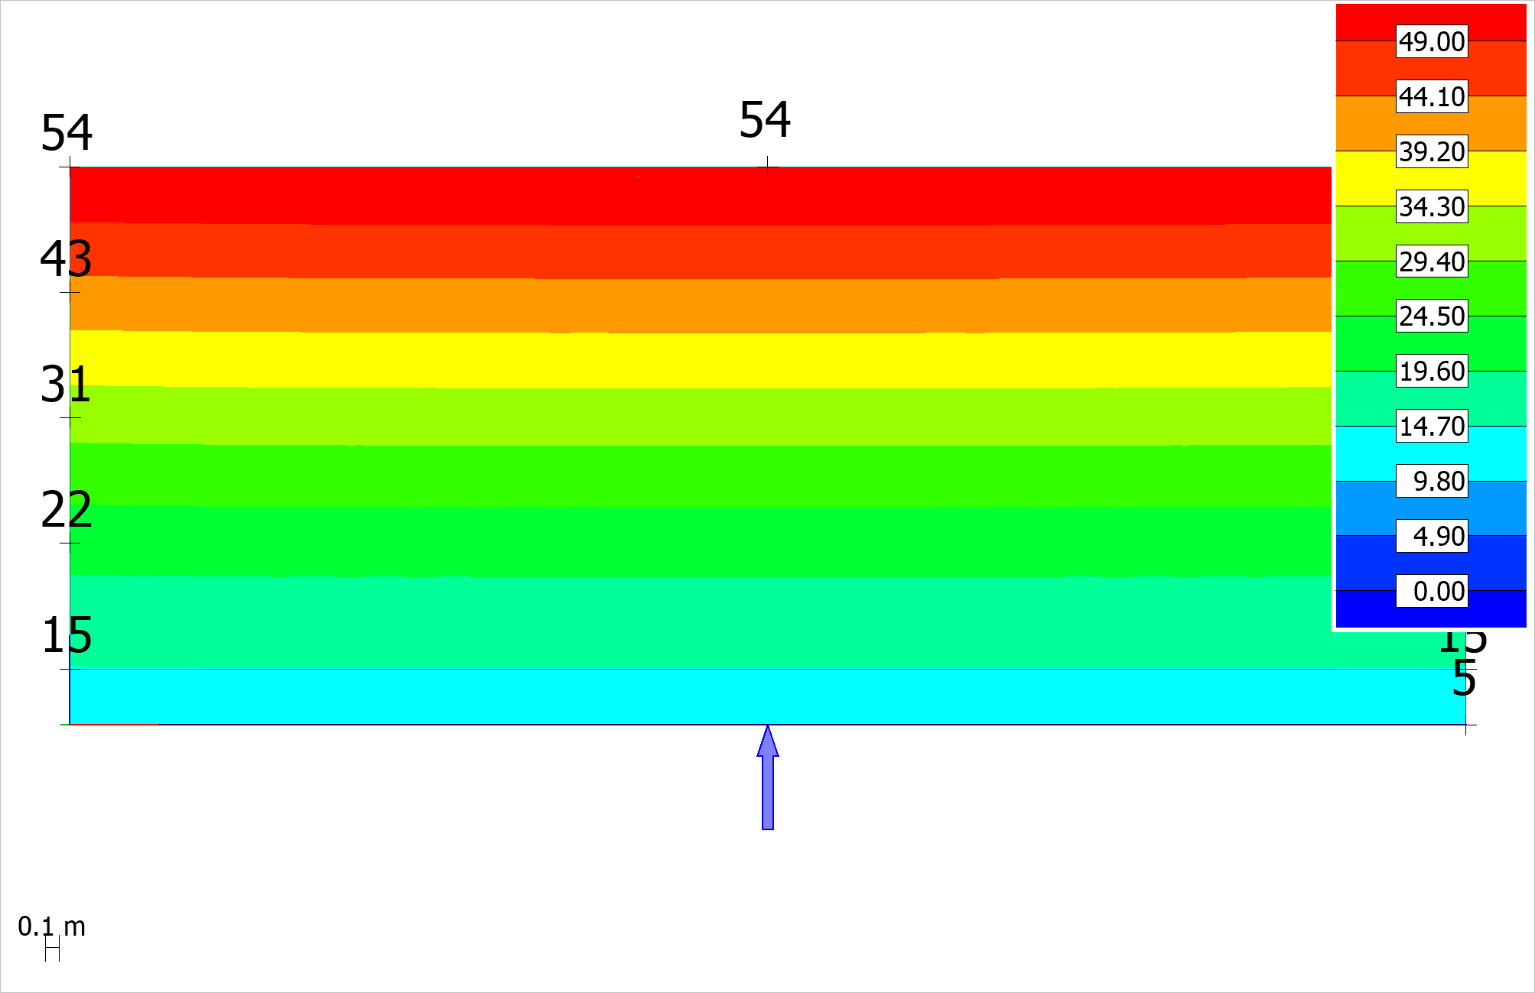 Figure 7.1: MUR - Load comb.: LC1 B, Bruk-frek, 6.15 Vogyn_Hogyn_Mogyn - Translational displacements - Abs - [mm] - East view

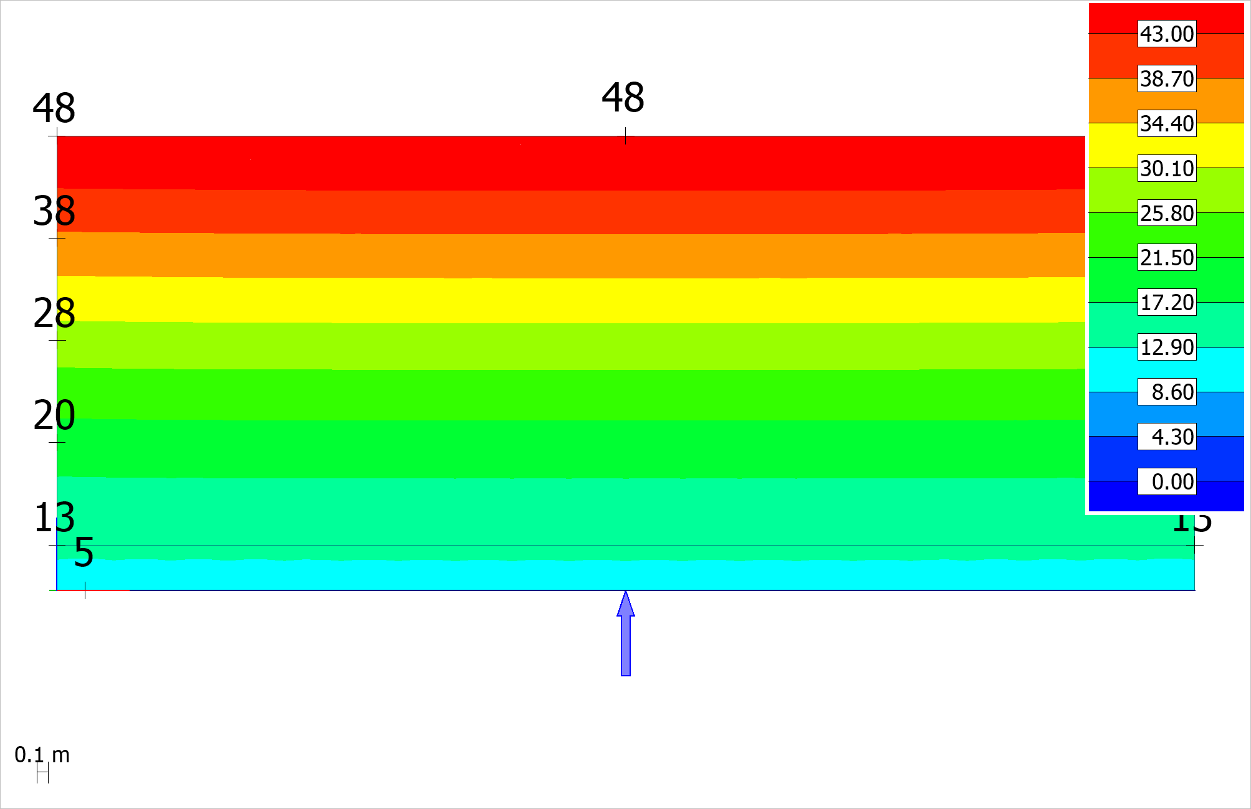 Figure 7.2: MUR - Load comb.: LC2 B, Bruk-kvasi, 6.16 Vogyn_Hogyn_Mogyn | UG_SLS - Translational displacements - Abs - [mm] - East view