[2.2.2] Should be able to write Logout, on site display Log off

Severity: Major  
Priority-Major

Steps To Reproduce:

1. Navigate to home page: <http://qaf2017demo1-001-site1.dtempurl.com/>

Expected Behavior: Should be write Logout.

Actual Behavior: Write Log off

Environment-Mozilla Firefox-57.0, Windows-10.

Assigning to: The junior developer is Franz Fischbach.

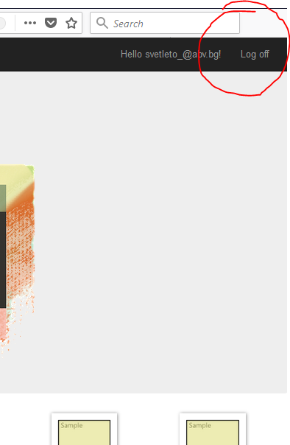

[2.2.4] Remove button is missing.

Severity: Major  
Priority-Major

Steps To Reproduce:

1. Navigate to home page: <http://qaf2017demo1-001-site1.dtempurl.com/>

Expected Behavior: Should be write Logout.

Actual Behavior: Write Log off

Environment-Mozilla Firefox-57.0, Windows-10.

Assigning to: The junior developer is Franz Fischbach.

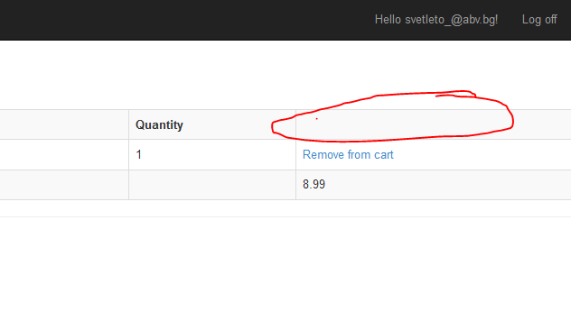

[2.2.5]The fields’ country and phone are not repeat

Severity:Major  
Priority-Major

Steps To Reproduce:

1. Navigate to home page: <http://qaf2017demo1-001-site1.dtempurl.com/Checkout/AddressAndPayment>

Expected Behavior: Should be to repeat twice.

Actual Behavior: Only ones.

Environment-Mozilla Firefox-57.0, Windows-10.

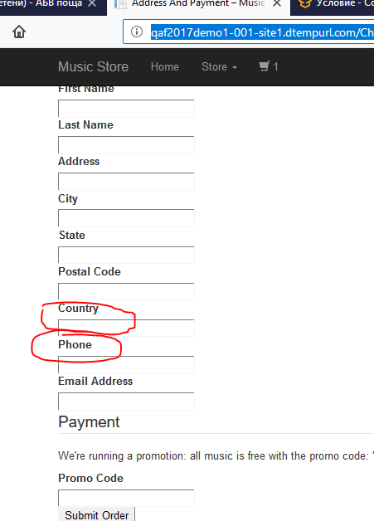

Assigning to: The junior developer is Franz Fischbach.

[2.2.5] The field under Paymant Method is not active.

Severity: Major  
Priority-Major

Steps To Reproduce:

1. Navigate to home page: <http://qaf2017demo1-001-site1.dtempurl.com/Checkout/AddressAndPayment>

Expected Behavior: Should be active.

Actual Behavior: Paymant field is not active..

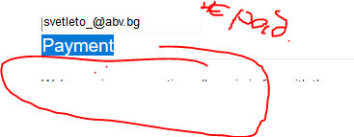

Environment-Mozilla Firefox-57.0, Windows-10.

Assigning to: The junior developer is Franz Fischbach.

[2.2.5] User can not successful order without promo code “FREE”

Severity: Major  
Priority-Major

Steps To Reproduce:

Navigate to home page: <http://qaf2017demo1-001-site1.dtempurl.com/Checkout/AddressAndPayment>

Expected Behavior: Users should be able successful order without promo code “FREE”

Actual Behavior: Unsuccessful order.

Environment-Mozilla Firefox-57.0, Windows-10.7

Assigning to: The Development lead is Petar Kirov

[2.2.5] format accepts invalid data

Severity: Major  
Priority-Major

Steps To Reproduce:

Navigate to home page: <http://qaf2017demo1-001-site1.dtempurl.com/Checkout/AddressAndPayment>

Expected Behavior: Should be able accepts invalid data.

Actual Behavior: format accepts invalid data.

Environment-Mozilla Firefox-57.0, Windows-10.

Assigning to: The junior developer is Franz Fischbach.

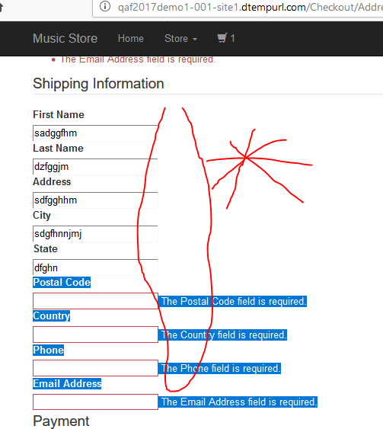

Assigning to: The junior developer is Franz Fischbach.

[2.2.5] No mandatory fields are marked.

Severity: Major  
Priority-Major

Steps To Reproduce:

Navigate to home page: <http://qaf2017demo1-001-site1.dtempurl.com/Checkout/AddressAndPayment>

Expected Behavior: Should be able mandatory fields.

Actual Behavior: No mandatory fields are marked.

Environment-Mozilla Firefox-57.0, Windows-10.

Assigning to: The junior developer is Franz Fischbach.

[2.2.7.1]Field Genre Name on the site is only Name.

Severity: Major  
Priority-Major

Steps To Reproduce:

Navigate to home page: <http://qaf2017demo1-001-site1.dtempurl.com/Admin/StoreManager>

Expected Behavior: Should be able field Genre name.

Actual Behavior: On the site have only Name.

Environment-Mozilla Firefox-57.0, Windows-10.

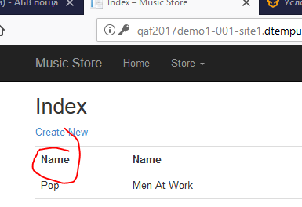

Assigning to:the lead of design and art is Nattaly Cantdravo

[2.2.7.1]Field Artist Name on the site is only Name.

Severity: Major   
Priority-Major

Steps To Reproduce:

Navigate to home page: <http://qaf2017demo1-001-site1.dtempurl.com/Admin/StoreManager>

Expected Behavior: Should be able field Artist Name.

Actual Behavior: On the site have only Name.

Environment-Mozilla Firefox-57.0, Windows-10.

Assigning to:the lead of design and art is Nattaly Cantdravo

[2.2.7.1]Field Album Title on the site is only Name.

Severity: Major   
Priority-Major

Steps To Reproduce:

Navigate to home page: <http://qaf2017demo1-001-site1.dtempurl.com/Admin/StoreManager>

Expected Behavior: Should be able field Album Title.

Actual Behavior: On the site have only Name.

Environment-Mozilla Firefox-57.0, Windows-10.

Assigning to:he lead of design and art is Nattaly Cantdravo

[2.2.7.1]Field Album Title on the site is only Name.

Severity: Major   
Priority-Major

Steps To Reproduce:

Navigate to home page: <http://qaf2017demo1-001-site1.dtempurl.com/Admin/StoreManager>

Expected Behavior: Should be able field Album Title.

Actual Behavior: On the site have only Name.

Environment-Mozilla Firefox-57.0, Windows-10.

Assigning to:the lead of design and art is Nattaly Cantdravo

[2.2.7.1]Field Edit Button on the site is missing.

Severity:Major   
Priority-Major

Steps To Reproduce:

Navigate to home page: <http://qaf2017demo1-001-site1.dtempurl.com/Admin/StoreManager>

Expected Behavior: Should be able available.

Actual Behavior: Field Edit Button on the site is missing.

Environment-Mozilla Firefox-57.0, Windows-10.

Assigning to: The junior developer is Franz Fischbach.

[2.2.7.1]Field Details Button on the site is missing.

Severity: Major   
Priority-Major

Steps To Reproduce:

Navigate to home page: <http://qaf2017demo1-001-site1.dtempurl.com/Admin/StoreManager>

Expected Behavior: Should be able available.

Actual Behavior: Field Details Button on the site is missing.

Environment-Mozilla Firefox-57.0, Windows-10.

Assigning to: The junior developer is Franz Fischbach.

[2.2.7.1]Field Delete Button on the site is missing.

Severity: Major   
Priority-Major

Steps To Reproduce:

Navigate to home page: <http://qaf2017demo1-001-site1.dtempurl.com/Admin/StoreManager>

Expected Behavior: Should be able available.

Actual Behavior: Field Delete Button on the site is missing.

Environment-Mozilla Firefox-57.0, Windows-10.

Assigning to: The junior developer is Franz Fischbach.

Has an album in a foreign language.

Severity: Major   
Priority-Major

Steps To Reproduce:

Navigate to home page: http://qaf2017demo1-001-site1.dtempurl.com/

Expected Behavior: Should be able available in English..

Actual Behavior Has an album in a foreign language.

Environment-Mozilla Firefox-57.0, Windows-10

Assigning to: the lead of design and art is Nattaly Cantdravo

On albums missing photos

Severity: Major   
Priority-Major

Steps To Reproduce:

Navigate to home page: http://qaf2017demo1-001-site1.dtempurl.com/

Expected Behavior: Should be able available photos on the albums..

Actual Behavior On albums missing photos.

Environment-Mozilla Firefox-57.0, Windows-10

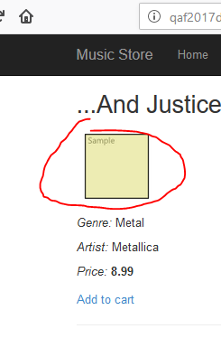

Assigning to: Assigning to: The junior developer is Franz Fischbach.

On albums missing photos

Severity: Major   
Priority-Major

Steps To Reproduce:

Navigate to home page: http://qaf2017demo1-001-site1.dtempurl.com/

Expected Behavior: Should be able available photos on the albums..

Actual Behavior On albums missing photos.

Environment-Mozilla Firefox-57.0, Windows-10

Assigning to: the lead of design and art is Nattaly Cantdravo

**The field Artist is not configured**

Severity:Major   
Priority-Major

Steps To Reproduce:

Navigate to home page: http://qaf2017demo1-001-site1.dtempurl.com/

Expected Behavior: Should be able write name on Artist..

Actual Behavior: The place on Artist write Tool.

Environment-Mozilla Firefox-57.0, Windows-10

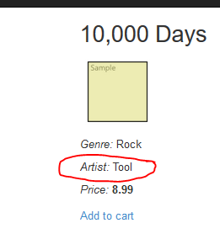

Assigning to: the lead of design and art is Nattaly Cantdravo

Have a missing albums.

Severity: Major   
Priority-Major

Steps To Reproduce:

Navigate to home page: http://qaf2017demo1-001-site1.dtempurl.com/

Expected Behavior: Have a missing albums.

Actual Behavior: The place on Artist write Tool.

Environment-Mozilla Firefox-57.0, Windows-10

Assigning to: the lead of design and art is Nattaly Cantdravo

Missing button Search.

Severity: Major   
Priority-Major

Steps To Reproduce:

Navigate to home page: http://qaf2017demo1-001-site1.dtempurl.com/

Expected Behavior: User can not uses button Search.

Actual Behavior: Missing button Search.

Environment-Mozilla Firefox-57.0, Windows-10

Assigning to:the project manager is Anastas Satanasov

Buttons for another service to log is not **configured.**

Severity:Major   
Priority-Major

Steps To Reproduce:

Navigate to home page: http://qaf2017demo1-001-site1.dtempurl.com/Account/Login

Expected Behavior: Buttons for another service to log is **configured**

Actual Behavior: Buttons for another service to log is not **configured**

Environment-Mozilla Firefox-57.0, Windows-10

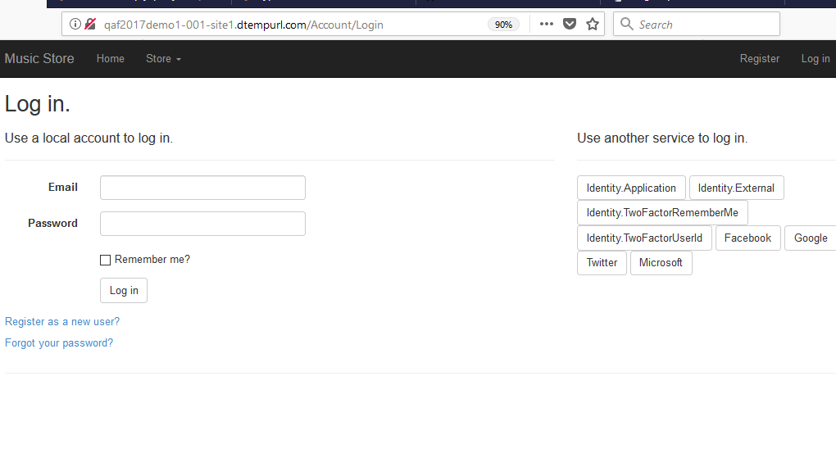

Assigning to: The junior developer is Franz Fischbach.

## **The field Manage your account is not configured.**

Severity:Major   
Priority-Major

Steps To Reproduce:

Navigate to home page: <http://qaf2017demo1-001-site1.dtempurl.com/Manage>

Expected Behavior: **The field Manage your account is configured**

Actual Behavior: **The field Manage your account is not configured**

Environment-Mozilla Firefox-57.0, Windows-10

Assigning to: The junior developer is Franz Fischbach.

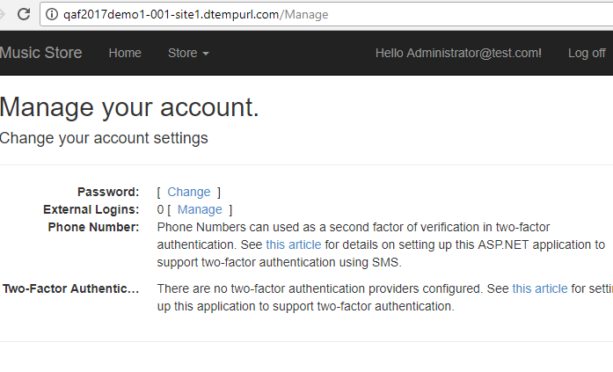

Incorrect logos and texts in HomePage

**Priority:** Medium  
**Severity**: Minor

**Description**: Incorrect logos and text in HomePage

**Expected Result**: You should see the correct logos and texts.

**Actual Result**: no logos images in HomePage

**Steps:**  
1. open <http://qaf2017demo1-001-site1.dtempurl.com/>   
2. go down to the page  
3. You should see the incorrect logos images

**Assigned to**: Petar Kirov

No currency of the price

**Priority:** Medium  
**Severity**: Minor

**Expected Result**: Latest  
products section

**Actual Result**: No currency of the price

**Steps:**  
1. open <http://qaf2017demo1-001-site1.dtempurl.com/>   
2. go to Navigation Bar  
3. Click the button on the Store

4.Select Store

5. Click to choosen one Store

6. Select an Album

7. Click on the choosen one Album

8. You shouldn`t see currency of the price

**Assigned to**: Franz Fischbach

**Description**:No currency of the price

**Title:** No currency of the price

**Priority:** Medium  
**Severity**: Minor

**Description**: No currency of the price

**Expected Result**: Latest  
products section

**Actual Result**: No currency of the price

**Steps:**  
1. open <http://qaf2017demo1-001-site1.dtempurl.com/>   
2. go to Navigation Bar  
3. Click the button on the Store

4.Select Store

5. Click to choosen one Store

6. Select an Album

7. Click on the choosen one Album

8. You shouldn`t see currency of the price

**Assigned to**: Franz Fischbach