[2.2.1] User can not remove product rating

Steps To Reproduce:

1. Navigate to page: http://store.demoqa.com/products-page/product-category/iphones/apple-iphone-4s-16gb-sim-free-black/, as registered user.
2. Click on vote button by adding and removing starts

Severity:Major

Priority-Major

Assing to: The Development lead is Franz Fishbach.

Expected Behavior:Registered users can remove vote.

Actual Behavior: Registered users can not remove vote.

Environment-Mozilla Firefox-57.0, Windows-10.

**[2.1] Unregistered users can give vote**

Steps To Reproduce:

1. Navigate to page: <http://store.demoqa.com/products-page/product-category/>, as unregistered user.
2. Click on vote button by adding/removing starts.

Severity:Major

Priority-Major

Assing to: The Development lead is Franz Fishbach.

Expected Behavior:Unregistered users can not give vote.

Actual Behavior:Unregistered users can vote

Environment-Mozilla Firefox-57.0, Windows-10.

## [2.2.1] The section “People who bought this item also bought”-some of them are missing photos.

Steps To Reproduce:

1. Navigate to page: <http://store.demoqa.com/products-page/product-category/>.

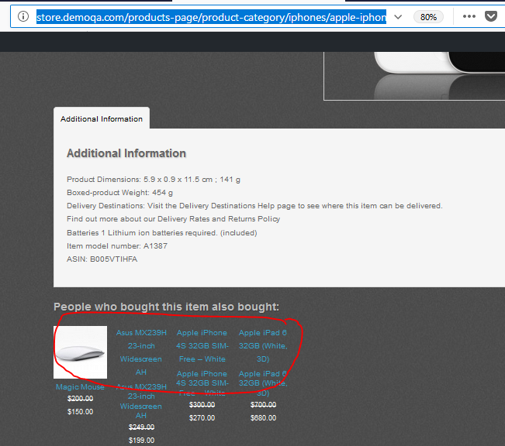

Severity:Major

Priority-Major

## Assaing to: the lead of Design and Art is Kevin Lynch

## Expected Behavior: The section “People who bought this item also bought” should be able to photos.

Actual Behavior: In the section “ People who bought this item also bought” missing photos on products.

Environment-Mozilla Firefox-57.0, Windows-10.

[2.2.2] The picture should be able to the right side on the site.

Steps To Reproduce:

1.Navigate to home page: store.demoqa.com/.

2. Select “Product Category”

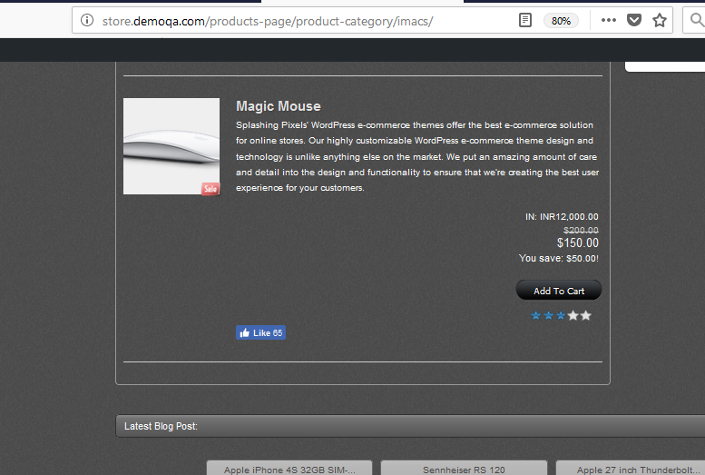

## Assaing to: The Development lead is Franz Fishbach.

## Expected Behavior: The picture at the right

Actual Behavior: The picture at the left side on the site.

Environment-Mozilla Firefox-57.0, Windows-10.

[2.2.2] The product price should be able in USA.

Steps To Reproduce:

1.Navigate to page: http://store.demoqa.com/products-page/product-category/

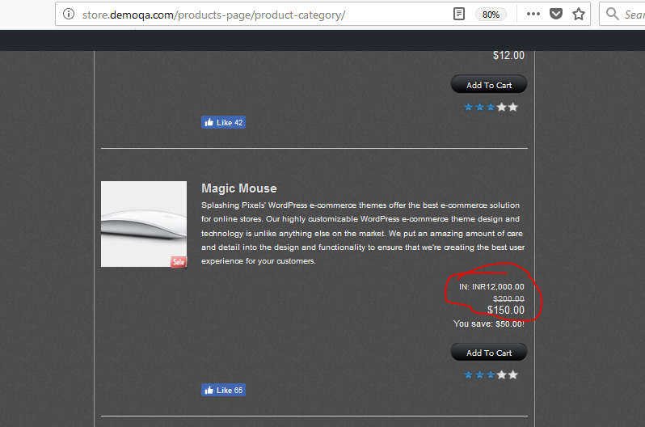

## Assaing to: the lead of Design and Art is Kevin Lynch

## Expected Behavior: Product price must in USD.

Actual Behavior: Product price contain IN: INR

Environment-Mozilla Firefox-57.0, Windows-10.

[2.2.3] The section ” Latest products view” on the side is “ Latest Blog Post”

Steps To Reproduce:

1.Navigate to page: <http://store.demoqa.com/products-page/product-category/>

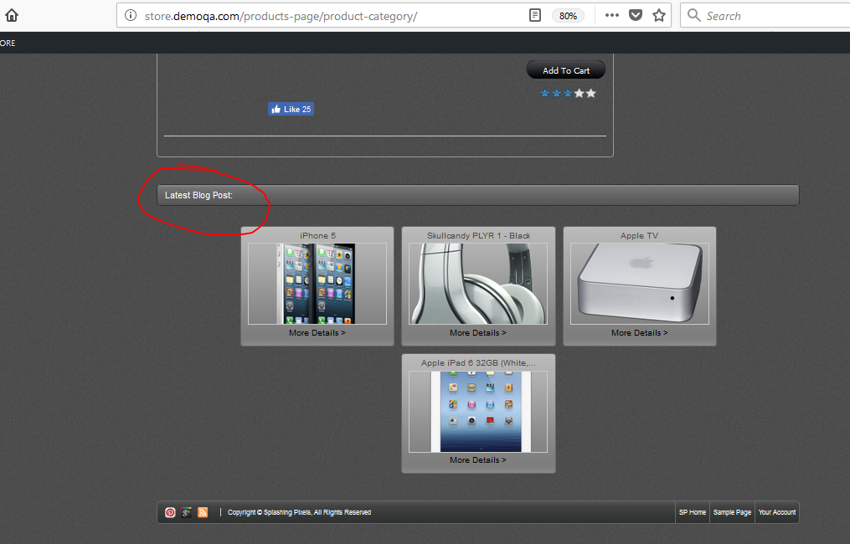

## Assaing to: The Development lead is Franz Fishbach.

## Expected Behavior: To write ”Latest products view” on the site.

Actual Behavior: The section ”Latest products view” on the side is “ Latest Blog Post”

Environment-Mozilla Firefox-57.0, Windows-10.

[2.2.3] The Photos on product are not arranged.

Steps To Reproduce:

1.Navigate to page: <http://store.demoqa.com/products-page/product-category/>

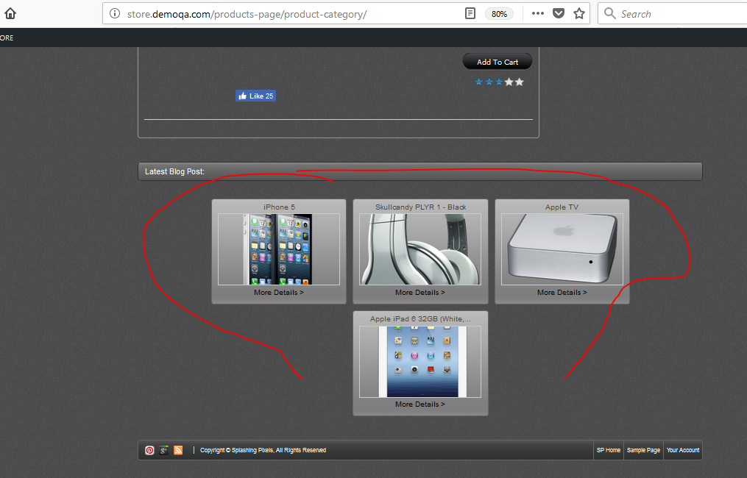

## Assaing to: the lead of Design and Art is Kevin Lynch

## Expected Behavior: The Photos on product should arranged.

Actual Behavior: The Photos on product are not arranged.

Environment-Mozilla Firefox-57.0, Windows-10.

[2.3.2] The navigation bar has not navigational hyperlink Services & Support.

Steps To Reproduce:

1.Navigate to home page: <http://store.demoqa.com/>

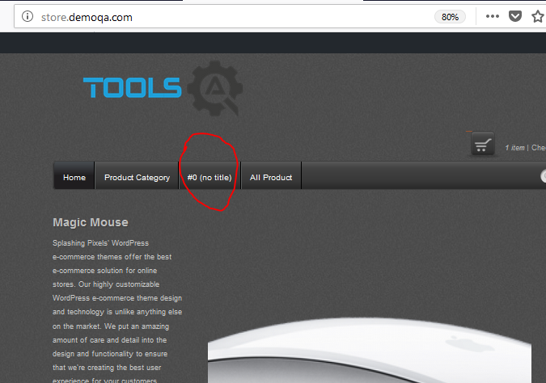

## Assaing to: The Development lead is Franz Fishbach.

## Expected Behavior: The navigation bar should be able navigational hyperlink Services & Support

Actual Behavior: The navigation bar has not navigational hyperlink Services & Support

Environment-Mozilla Firefox-57.0, Windows-10.

[2.3.4] The filter on Products Category Page is missing.

Steps To Reproduce:

1.Navigate to page: http://store.demoqa.com/products-page/product-category/

2. Click on Product Category.

## Assaing to: The Development lead is Franz Fishbach.

## Expected Behavior: The filter should be available on Products Category Page.

Actual Behavior: The filter on Products Category Page is missing.

Environment-Mozilla Firefox-57.0, Windows-10.

[2.3.5] = [2.3.2]

[2.3.6] Unregister user can order to add product to cart.

Steps To Reproduce:

1.Navigate to home page: http://store.demoqa.com/

2. Click on Product Category.

3. Click on Add to cart .

4. Select Checkout

## Assaing to: The Development lead is Franz Fishbach.

## Expected Behavior:Only users as login on the site

Actual Behavior: Unregister user can order to add product to cart.

Environment-Mozilla Firefox-57.0, Windows-10.

[2.3.6]Button “Quantity” on the site have button “Update”.

Steps To Reproduce:

1.Navigate to home page: http://store.demoqa.com/

2. Click on Product Category.

3. Click on Add to cart .

4. Select Checkout

## Assaing to: Project Manager is Rob High.

## Expected Behavior: There are have a buttons for up and down on Quantity.

Actual Behavior: There are have a button “Quantity”

Environment-Mozilla Firefox-57.0, Windows-10.

[2.3.6] Total price should contain product, shipping and tax.

Steps To Reproduce:

1.Navigate to home page: http://store.demoqa.com/

2. Click on Product Category.

3. Click on Add to cart .

4. Select Checkout.

## Assaing to: the lead of Design and Art is Kevin Lynch

## Expected Behavior: Total price should contain product, shipping and tax.

Actual Behavior: Total price contain Product, Quantity, Price and Total.

Environment-Mozilla Firefox-57.0, Windows-10.

[2.3.6] The places on Country and City are exchanged.

Steps To Reproduce:

1.Navigate to home page: http://store.demoqa.com/

2. Click on Product Category.

3. Click on Add to cart .

4. Select Checkout.

5. Click on Continue.

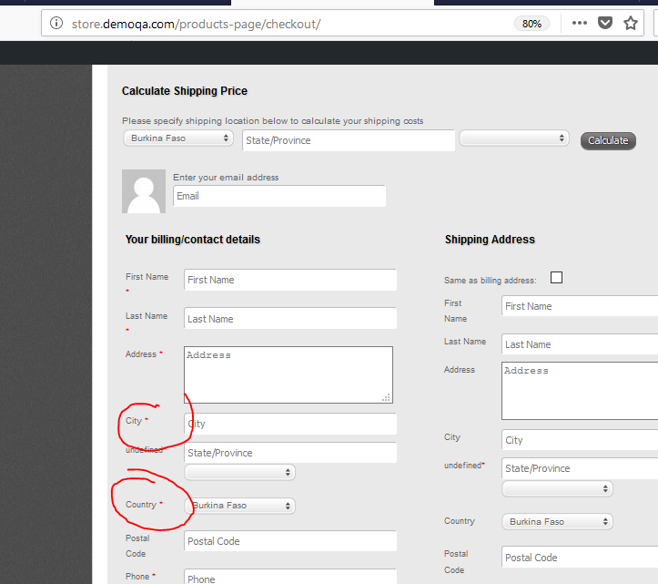

## Assaing to: the lead of Design and Art is Kevin Lynch

## Expected Behavior: The place on Country should be able on 5 position and City is 7 position.

## Actual Behavior: The place on Country should be able on 7 position and City is 5 position.

Environment-Mozilla Firefox-57.0, Windows-10.

[2.3.6] In the section All Products have only 3 products.

Steps To Reproduce:

1.Navigate to home page: http://store.demoqa.com/

2. Click on All Products.

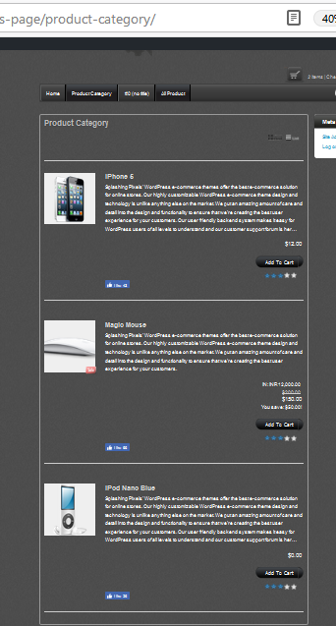

## Assaing to: The Development lead is Franz Fishbach.

## Expected Behavior: In the section All Products should be able all products on the site.

## Actual Behavior: In the section All Products have only 3 products.

Environment-Mozilla Firefox-57.0, Windows-10.

[2.3.6] In the section All Products write All Product.

Steps To Reproduce:

1.Navigate to home page: <http://store.demoqa.com/>

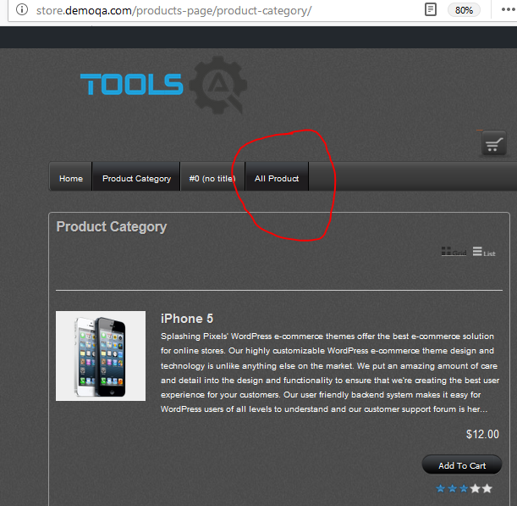

## Assaing to: the lead of Design and Art is Kevin Lynch.

## Expected Behavior: On the site should write “All Products”

## Actual Behavior: There is write “All Product”

Environment-Mozilla Firefox-57.0, Windows-10.

[2.3.8.1] My account – Purchase History is not working.

Steps To Reproduce:

1.Navigate to home page: store.demoqa.com

2 Bay something successful

3 Select “My Account”

4 Click on “Purchase History”.

## Assaing to: The Development lead is Franz Fishbach.

## Expected Behavior: My account – Purchase History have to show History .

## Actual Behavior: The section Purchase History is not working.

[2.3.9] When user using Search button, Meta field is moving.

Steps To Reproduce:

1.Navigate to home page: store.demoqa.com

2. Select Search button.

## Assaing to: the lead of Design and Art is Kevin Lynch.

## Expected Behavior: Meta field is not moving.

## Actual Behavior: Meta field is moving.

Environment-Mozilla Firefox-57.0, Windows-10.

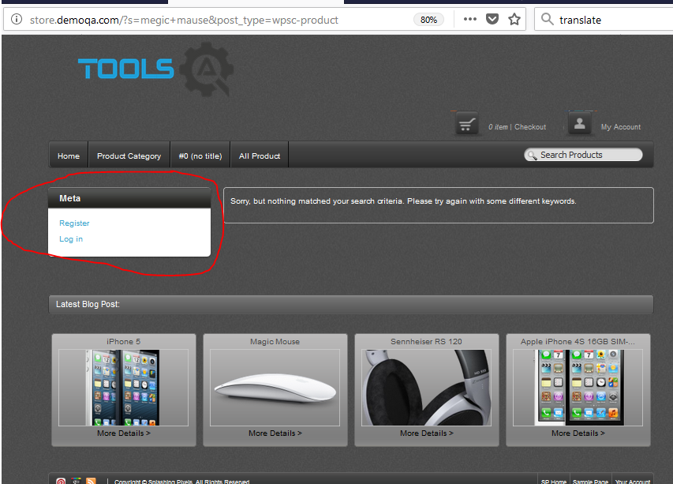

The users can register as an admin.

Steps To Reproduce:

1.Navigate to home page: store.demoqa.com

2. Select “My Account”.

3. Click on “Register”.

## Assaing to: The Development lead is Franz Fishbach.

Expected Behavior: The users can not register as an admin.

Actual Behavior: The users can register as an admin.

Environment-Mozilla Firefox-57.0, Windows-10.

Confirm Password is missing on the register page.

Steps To Reproduce:

1.Navigate to home page: store.demoqa.com

2 Select Register

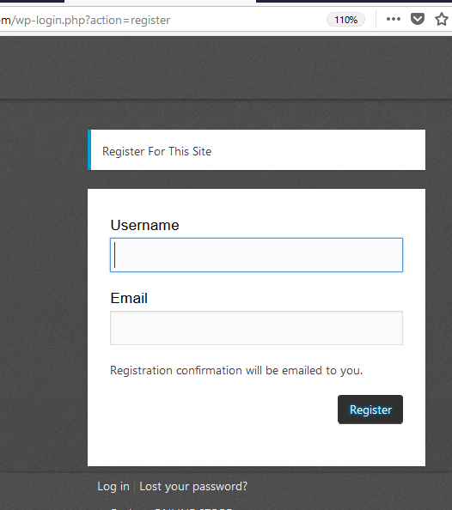

## Assaing to: The Development lead is Franz Fishbach.

Expected Behavior: Register form must contain Confirm Password .

Actual Behavior: The users can register as an admin.

Environment-Mozilla Firefox-57.0, Windows-10.

On some of page missing description on products.

Steps To Reproduce:

1.Navigate to home page: store.demoqa.com

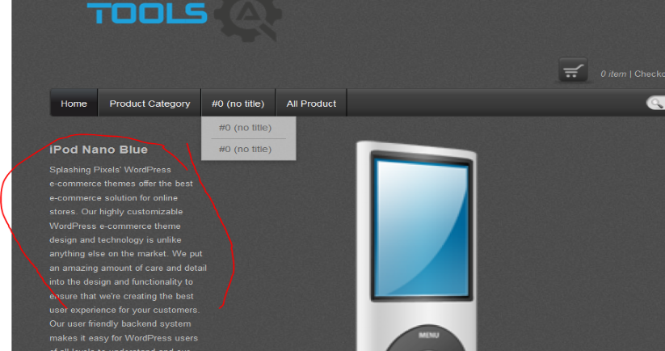

## Assaing to: the lead of Design and Art is Kevin Lynch.

## Expected Behavior: Products should be able description.

## Actual Behavior: Products have not description .

Environment-Mozilla Firefox-57.0, Windows-10.

Field Your comment have not limit of words.

Steps To Reproduce:

1.Navigate to page: http://store.demoqa.com/sample-page/#comment-110

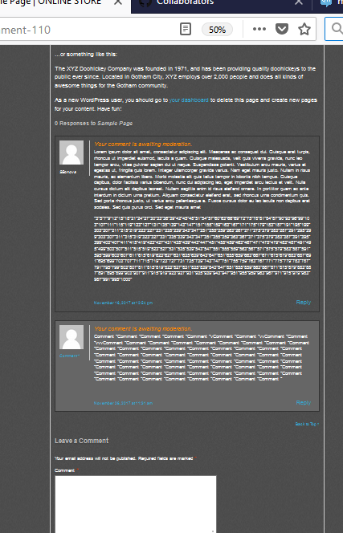

## Assaing to: the lead of Design and Art is Kevin Lynch.

Expected Behavior: Field Your comment have limit of words.

Actual Behavior: Field Your comment have not limit of words.

Environment-Mozilla Firefox-57.0, Windows-10.

## Field “Calculate Shipping Price” is not active.

Steps To Reproduce:

## 1.Navigate to page: http://store.demoqa.com/products-page/checkout/

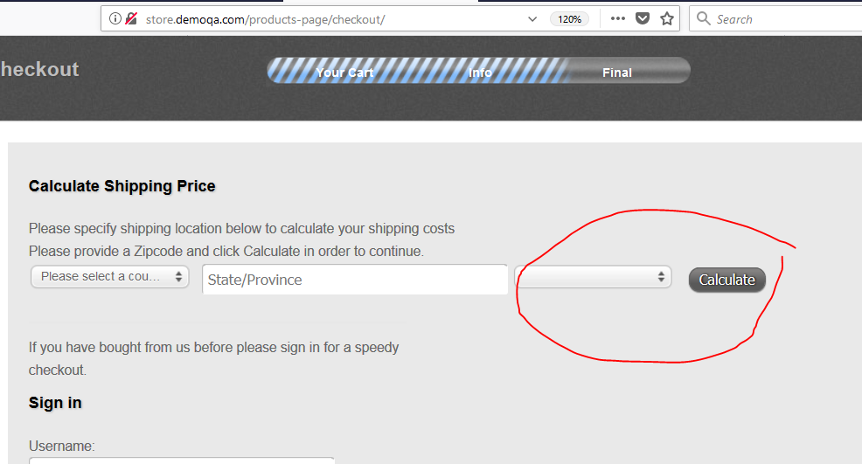

## Assaing to: The Development lead is Franz Fishbach.

Expected Behavior: Field “Calculate Shipping Price” is active.

Actual Behavior: Field “Calculate Shipping Price” is not active.

Environment-Mozilla Firefox-57.0, Windows-10.

The mandatory field State/Province is not undefined.

Steps To Reproduce:

## 1.Navigate to page: http://store.demoqa.com/products-page/checkout/

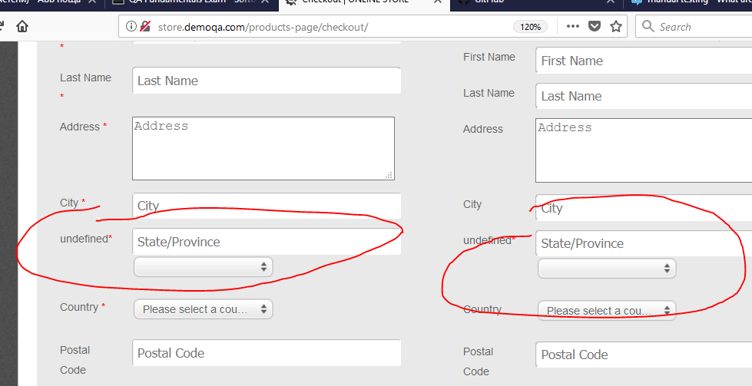

## Assaing to: The Development lead is Franz Fishbach.

Expected Behavior: The mandatory field State/Province is defined.

Actual Behavior: The mandatory field State/Province is not undefined.

Environment-Mozilla Firefox-57.0, Windows-10.

Button under State/Province is not active.

Steps To Reproduce:

## 1.Navigate to page: http://store.demoqa.com/products-page/checkout/



## Assaing to: The Development lead is Franz Fishbach.

Expected Behavior: Button under State/Province is active.

Actual Behavior: The mandatory field State/Province is not undefined.

Environment-Mozilla Firefox-57.0, Windows-10.

Buttons Pins, Google Plus Profile and Feeds are not working.

Steps To Reproduce:

1.Navigate to home page: <http://store.demoqa.com/>

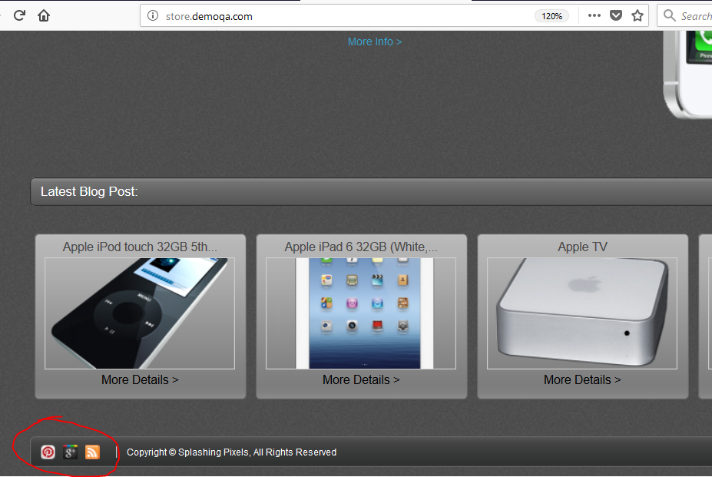

## Assaing to: The Development lead is Franz Fishbach.

Expected Behavior: Buttons Pins, Google Plus Profile and Feeds should be able to working.

Actual Behavior: Buttons Pins, Google Plus Profile and Feeds are not working.

Environment-Mozilla Firefox-57.0, Windows-10.