Lab 2

1. Accuracy – “0.948”
2. MLP architectures

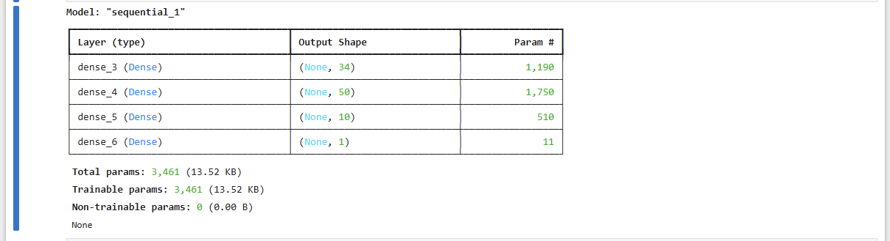

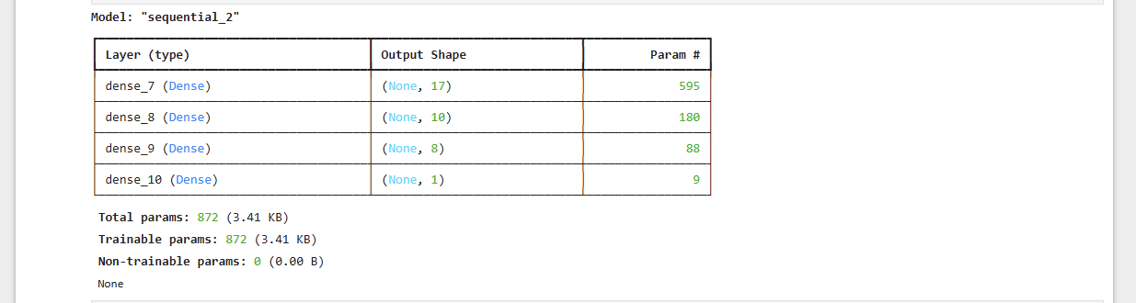3.The output of the neural network as provided in Task 2 is – “0.733”