Game Design Document

Fill up the following document

1. Write the title of your project.

**The Intergalactic Warlords**

1. What is the goal of the game?

It is an Infinite runner game; the player will have to make his own high scores.

1. Write a brief story of your game.

Two Brothers Xander and Quinshi are at war with each other.

Xander (NPC) is the bad guy and wants to destroy his brother, as he is the only person coming in his way of conquering the universe.

Xander has a much larger army than Quinshi. But the spaceship Quinshi has is capable to defeating more than 100 enemies at once.

Quinshi, favoured by almost the whole of multiverse will get frequent powerups that will make him super over powered.

1. Which are the playing characters of this game?

* Playing characters are the ones who respond to the user based on the input from the user.
* Cars, monkeys, dinos, wizards, etc., are the playing characters in the game.

|  |  |  |
| --- | --- | --- |
| Number | Character Name | What can this character do? |
| 1 | Spaceship Thunder (You) | This is the main spaceship |
| 2 |  |  |
| 3 |  |  |
| 4 |  |  |
| 5 |  |  |
| 6 |  |  |
| 7 |  |  |
| 8 |  |  |

1. Which are the Non-Playing Characters of this game?

* Non-Playing characters are the ones that don't have an action or behavior when the user interacts with the game.
* Hurdles, stones, bananas, coins, etc., are non-playing characters in the game.

|  |  |  |
| --- | --- | --- |
| Number | Character Name | What can this character do? |
| 1 | Boss (NPC) | Xander The Boss will always spawn every 2minutes and sometimes 1minute. Shoots Out planets.  It is a massive spaceship that looks like two ends of the blood reaper glued together. |
| 2 | Boss’s Minions (NPC) | Xander’s Army The Boss’s Minions will spawn every 30secs and then to 20 and then finally in 10secs. Shoots out Bazookas!  These are small UFO like. |
| 3 | Powerups | The Powerups will spawn randomly between 5 to 10 seconds.  The Powerups can range from multi shot to extra health  Some of the effects are permanent and some are temporary, such as multi shot is for one minute and is temporary and extra health is permanent. |
| 4 | The Droids (NPC) | Xander’s Droids The Boss’s Droids will spawn every 5secs and then every 3secs and then finally 2secs.  They shoot out laser beams and are small eye like structures that only attack from the right side. |
| 5 | Reinforcements (For the PC) | These are the small spaceships that will spawn from any position (x) and then will demolish everthing in its way until it reached destination position. They help the Player. And are 5 to 6 in number. |
| 6 |  |  |
| 7 |  |  |
| 8 |  |  |

Draw your imagination of this game. What does this game look like?

* Draw the game either on your computer or on paper.
* Add images of the game scenes to show each of the playing and non-playing characters at least once.

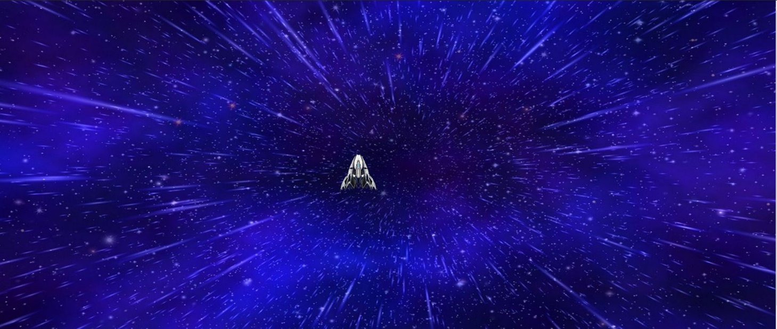 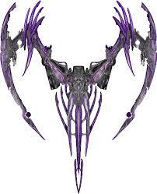 Xander’s Ship(BOSS) 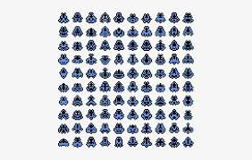 The Boss’s Minions Sprite sheet

The Droids

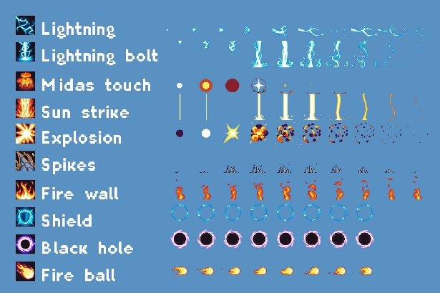 The Powerups(Just a Picture , not going to implement all)

How do you plan to make your game engaging?

The Spaceship is yours to command. The Droids will spawn every 5secs and then every 3secs and then finally 2secs.

The Boss’s Minions will spawn every 30secs and then to 20 and then finally in 10secs.

The Boss will always spawn every 2minutes and sometimes 1minute.

The Powerups will spawn randomly between 5 to 10 seconds.

The Powerups can range from multi shot to extra health

Some of the effects are permanent and some are temporary, such as multis hot is for one minute and is temporary and extra health is permanent.