**Mental Binary Math Game User Manual**

**Stefan Bucur**

**ECE5440**

The Mental Binary Math Game is a way for you and a friend to practice binary/hex conversions in your head. Take turns inputting numbers with the switches and calculating which number you need to add to your friend’s number to make 15 in hexadecimal.

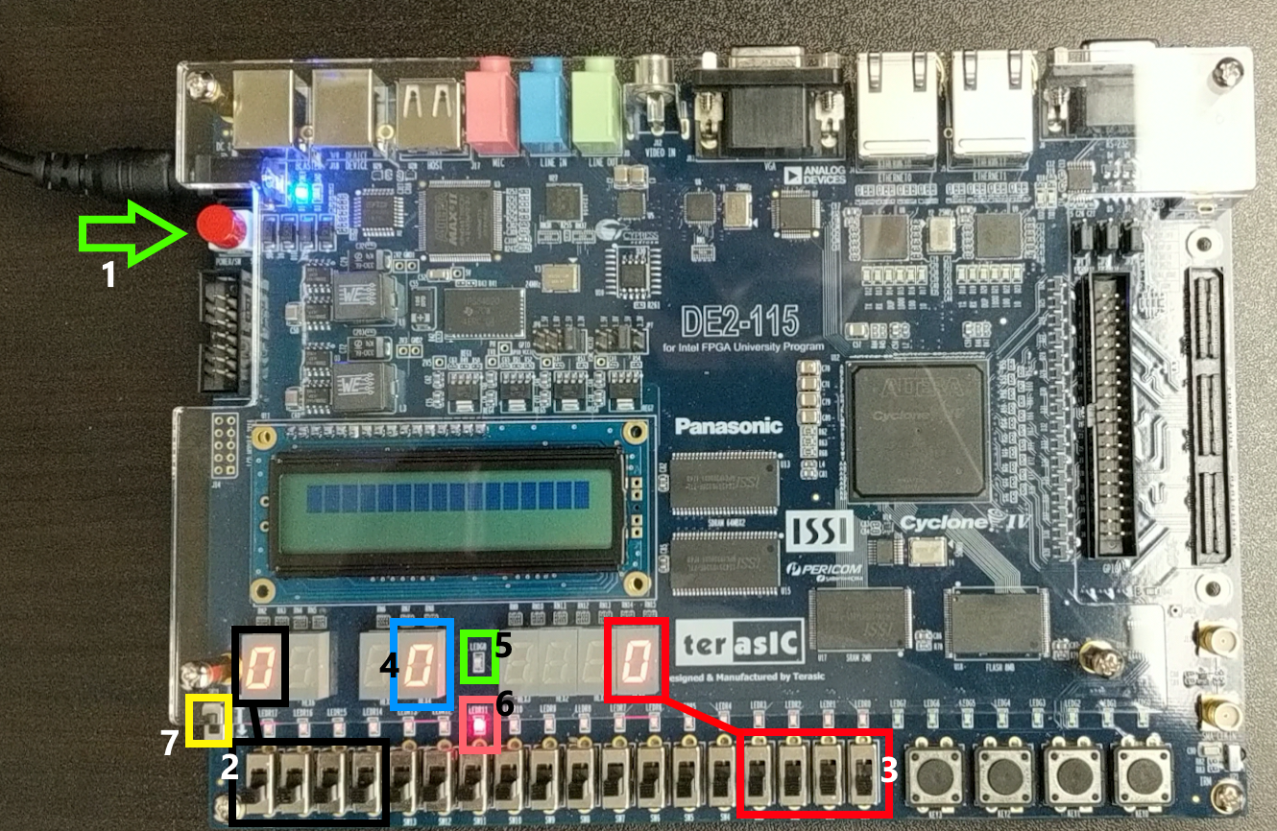

|  |  |
| --- | --- |
| Item # | Description |
| 1 | Power button. Make sure the power cable is connected. |
| 2 | Set of input switches/hex display for a player. Most significant bit is on the left. |
| 3 | Set of input switches/hex display for a player. Most significant bit is on the left. |
| 4 | Hex display for the sum of the two players’ numbers. |
| 5 | Green LED. Only on if both player inputs add to the winning number. |
| 6 | Red LED. On whenever both player inputs do not add to a winning number. |
| 7 | Run/Prog switch. Make sure it is set to RUN BEFORE turning on the power! |

**Game Steps:**

1. Assign a player to each of the two sets of switches. It does not matter which player is first.
2. Have the first player begin entering a binary number through the 4 switches available to them. The display will update as you change each switch. Make sure the other player cannot see your switches.
3. Have the second player enter their matching number with the other set of input switches. The second player should avoid looking at the sum display or either of the LEDs until they are finished with their attempt.
4. Look at the sum display and LEDs and see if both the numbers add to 15. If done correctly, there should be an F displayed and the green LED should be on.
   1. Winning attempt:
      1. Player 1 enters 1100 = 12
      2. Player 2 enters 0011 = 3
      3. Sum = 15 -> green LED ON, red LED OFF
   2. Losing attempt:
      1. Player 1 enters 0110 = 6
      2. Player 2 enters 0011 = 3
      3. Sum = 9 -> green LED OFF, red LED ON
5. Players can keep score on a sheet of paper, electronically, etc. and play multiple rounds by returning to step 1.
6. Once you are finished playing, please return all switches to their zero state and press the power button off.