**Mental Binary Math Game User Manual**

**Stefan Bucur**

**ECE5440**

**Passcode: 3 1 5 3**

The Mental Binary Math Game is a way for you and a friend to practice binary/hex conversions in your head. Take turns inputting numbers with the switches and calculating which number you need to add to your friend’s number to make 15 in hexadecimal.

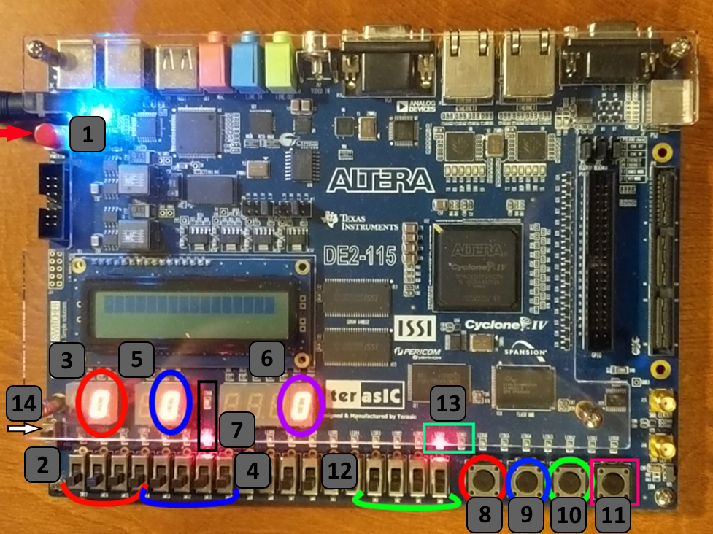

On the next page is a table and step-by-step tutorial on how to play the game.

|  |  |
| --- | --- |
| Item # | Description |
| 1 | Power button. Press once to start the game. |
| 2 | One set of player switches, four in total. |
| 3 | Number display for switch set #2. |
| 4 | One set of player switches, four in total. |
| 5 | Number display for switch set #4. |
| 6 | Sum of the two numbers shown in #3 and #5. |
| 7 | Sum indicator LEDs. Red LED turns on for wrong answers, green for correct ones. |
| 8 | Player input button for switch set #2. |
| 9 | Player input button for switch set #4. |
| 10 | Input button for login system. |
| 11 | Reset button. Logs out and erases any saved numbers in the system. |
| 12 | Input switches for the login system. |
| 13 | Indicator LEDs for the login system. Red if logged off, green if logged in. |
| 14 | Run/Prog switch. Make sure it is set to Run BEFORE powering on the device. |

**Game Steps:**

1. Assign a player to each of the two sets of switches (#2 or #4). It does not matter which player is first.
2. Log in to the system, entering the passcode digit by digit using the switches (#12) and pressing the button for each digit (#10).
3. Once you are logged in, have the first player begin entering a binary number through the 4 switches available to them and their corresponding button (#8 for #2 switches, #9 for #4 switches). The display will update as you enter each number. Make sure the other player cannot see your switches.
4. Have the second player enter their matching number with the other set of input switches. The second player should avoid looking at the sum display or either of the LEDs until they are finished with their attempt.
5. Look at the sum display and LEDs and see if both the numbers add to 15. If done correctly, there should be an F displayed and the green LED should be on.
   1. Winning attempt:
      1. Player 1 enters 1100 = 12
      2. Player 2 enters 0011 = 3
      3. Sum = 15 -> green LED ON, red LED OFF
   2. Losing attempt:
      1. Player 1 enters 0110 = 6
      2. Player 2 enters 0011 = 3
      3. Sum = 9 -> green LED OFF, red LED ON
6. Players can keep score on a sheet of paper, electronically, etc. and play multiple rounds by returning to step 3.

* If you want to lock the board to prevent others from changing things while you are away, press the #10 button again to log out of the system. Enter the passcode again to log in.
* Pressing the reset switch logs you out of the board and erases all numbers to 0.

Once you are finished playing, please return all switches to their zero state and press the power button off.