**Mental Binary Math Game User Manual**

**Stefan Bucur**

**ECE5440**

**Passcode: 3 1 5 3**

The Mental Binary Math Game is a way for you and a friend to practice binary/hex conversions in your head. Take turns inputting numbers with the switches and calculating which number you need to add to your friend’s number to make 15 in hexadecimal.

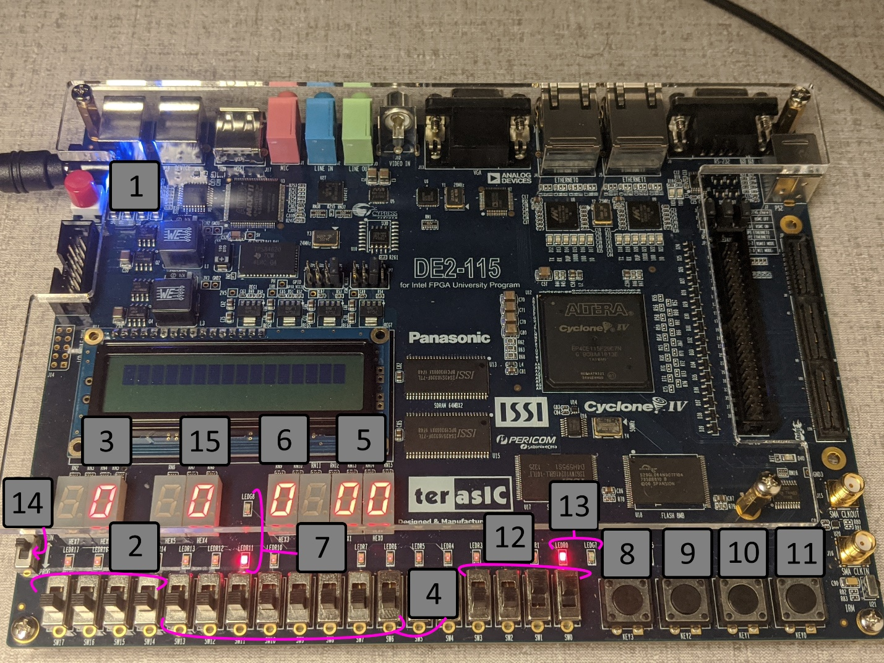

On the next page is a table and step-by-step tutorial on how to play the game.

|  |  |
| --- | --- |
| Item # | Description |
| 1 | Power button. Press once to start the game. |
| 2 | One set of player switches, four in total. |
| 3 | Number display for the player number. |
| 4 | Set of switches to set the time limit. 8 in total. |
| 5 | Number display for the two-digit timer. |
| 6 | Sum of the two numbers shown in #3 and #5. |
| 7 | Sum indicator LEDs. Red LED turns on for wrong answers, green for correct ones. |
| 8 | Player input button. |
| 9 | Random number generator button. |
| 10 | Input button for login system. |
| 11 | Reset button. Logs out and erases any saved numbers in the system. |
| 12 | Input switches for the login system. |
| 13 | Indicator LEDs for the login system. Red if logged off, green if logged in. |
| 14 | Run/Prog switch. Make sure it is set to Run BEFORE powering on the device. |
| 15 | Number display for the random number generator. |

**Game Steps:**

1. Log in to the system, entering the passcode digit by digit using the switches (#12) and pressing the button for each digit (#10).
2. Once you are logged in, button #10 becomes the game control button. Press it again and use the #4 switches to set the time limit on the digit timer (#5). Example: 25 seconds = 0010 0101 (2 and 5)
3. Press the button again to start the timer countdown. Now you can change the player number using switch set #2. Press button 9 to generate a new number and try to find the matching number that adds to 15.
4. Look at the sum display and LEDs and see if both the numbers add to 15. If done correctly, there should be an F displayed and the green LED should be on.
   1. Winning attempt:
      1. Player 1 enters 1100 = 12
      2. Player 2 enters 0011 = 3
      3. Sum = 15 -> green LED ON, red LED OFF
   2. Losing attempt:
      1. Player 1 enters 0110 = 6
      2. Player 2 enters 0011 = 3
      3. Sum = 9 -> green LED OFF, red LED ON
5. The player can keep score on a sheet of paper, electronically, etc. and play multiple rounds by returning to step 3.

* If you want to lock the board to prevent others from changing things while you are away, press the #11 button again to log out and reset the system. Enter the passcode again to log in.
* Pressing the reset switch logs you out of the board and erases all numbers to 0.
* When the timer reaches zero, you cannot change any of the numbers again. Press button #10 again to return to step 3 or #11 to reset the system.

Once you are finished playing, please return all switches to their zero state and press the power button off.