David Trail

CS383

Dr. BC

Copywrite Infringement

The Copyrighted Item  
Ancient Knife Sprite

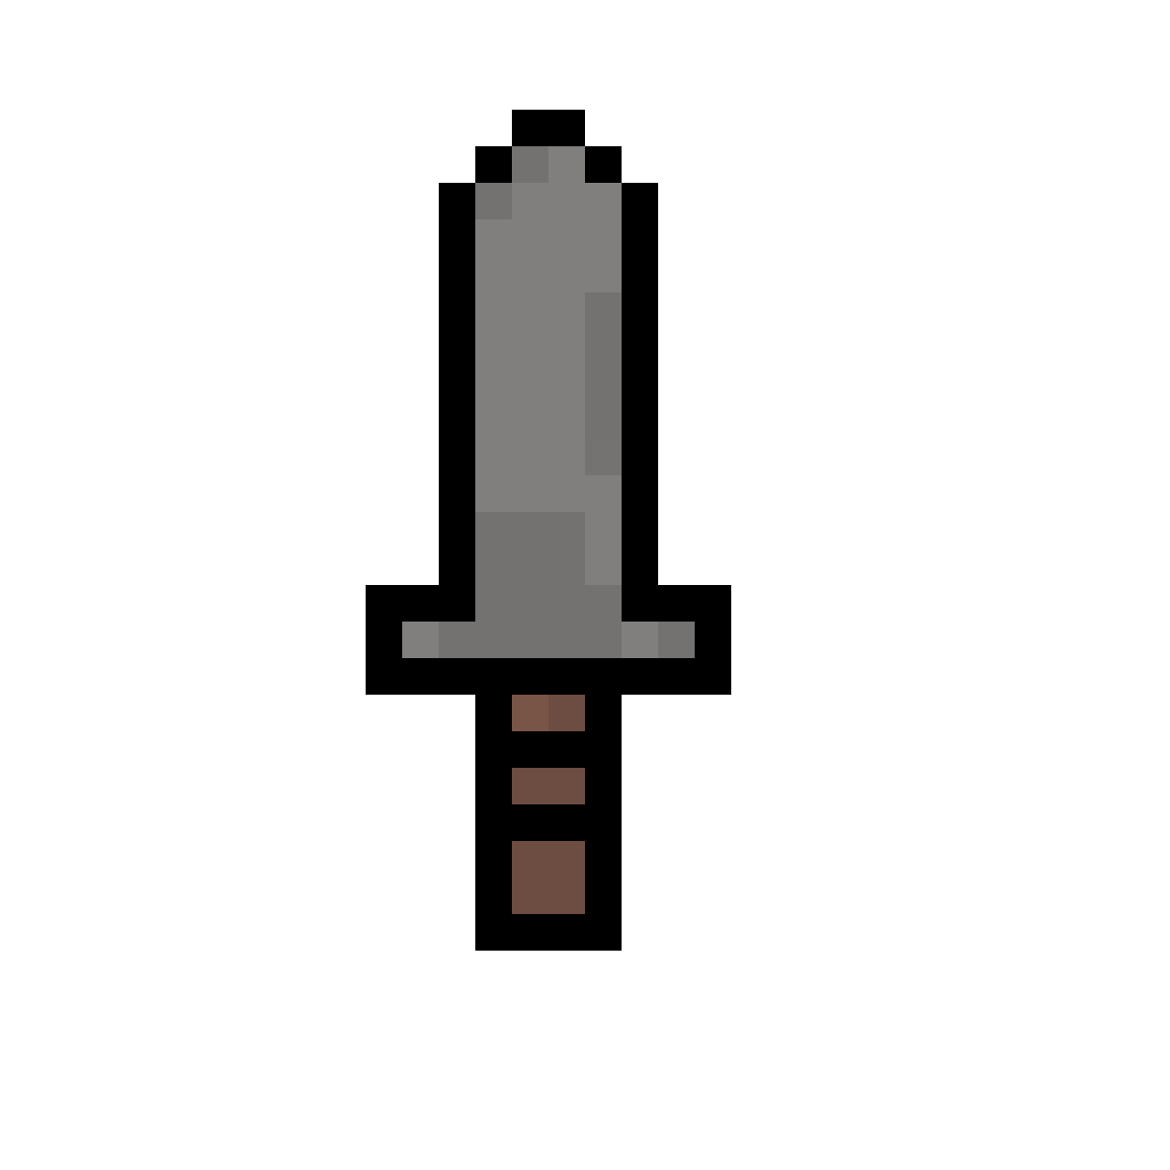

Overview:

I needed a weapon for my enemies, so I went on google and looked up “Knife Sprite”. This was the first thing to show up, and it matched the style of our game, so I used it. It ended up being a sprite created by user “Bluesanta” from the website “pixilart.com”.

Claim:

I could receive a complaint from user “Bluesanta” of the website “pixilart.com” who would claim copywrite infringement if they believed that my use of their sprite was unauthorized use of their material. “Bluesanta” would most likely claim that their sprite is a unique and creative expression protected under copywrite.

My Argument:

Transformative: I would argue that my use of the sprite would be protected by fair use. I would say that the use is transformative because I changed the color scheme of the sprite making it differ from the original sprite. Pictured below.



Educational Purposes: The work of Hotdog Jones: The Video Game I ultimately an educational venture. We include many core game design and programming principles within our game to accomplish this goal of education. The knife sprite has been added as a vessel for these educational ventures with the actual “product” being the code that contains the aforementioned core game design and programming principles.