**Assignment — Mobile Android application**

**Hardware and Software Requirements:**

Microsoft Windows 7/8/10 (32-bit or 64-bit)

2 GB RAM minimum, 8 GB RAM recommended.

2 GB of available disk space minimum, 4 GB Recommended (500 MB for IDE + 1.5 GB for Android SDK and emulator system image)

1280 x 800 minimum screen resolution.

JDK 7 | 8

**Minimum SDK: Android 14 (IceCreamSandwich)**

**Implemented Features:**

The implemented features are indicated by following screens taken by running on Emulator.

1. Start up screen

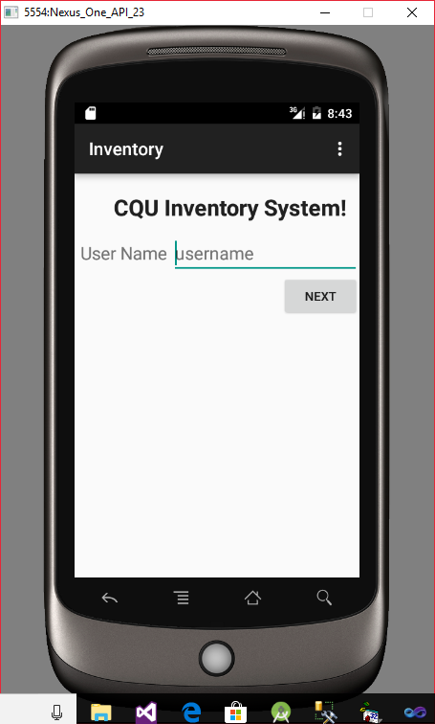

1. If Next is clicked without specifying name, A Toast message is displayed as follows.

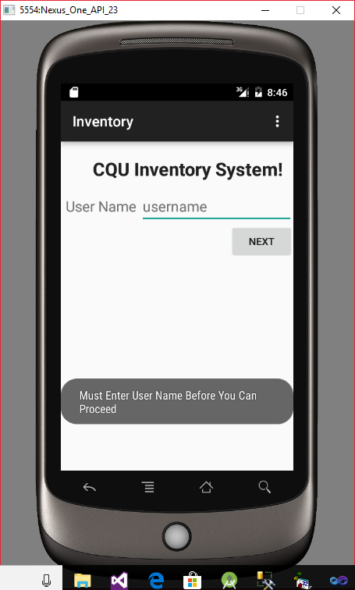

1. On specifying name and then clicking Next button m the following screen is displayed.

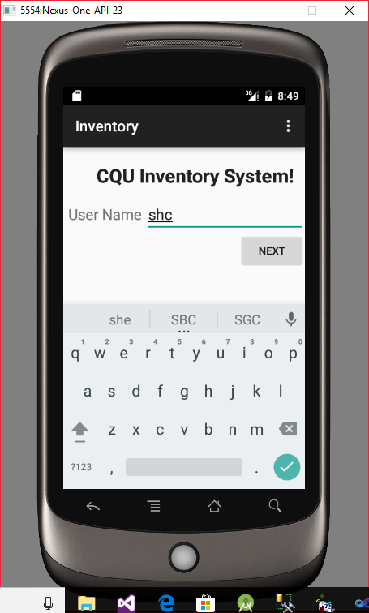

1. Clicking on Next button

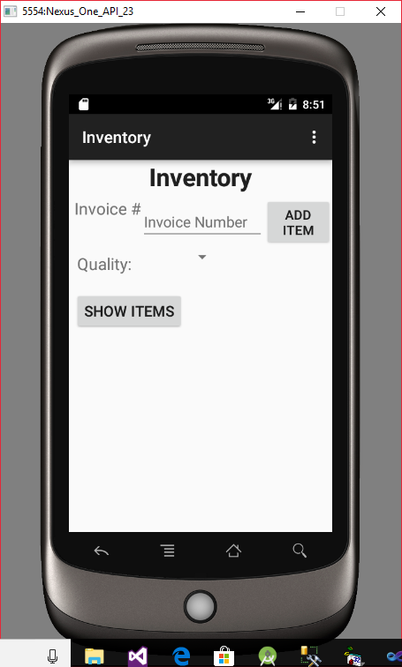

1. Without specifying values, clicking on Add Item button

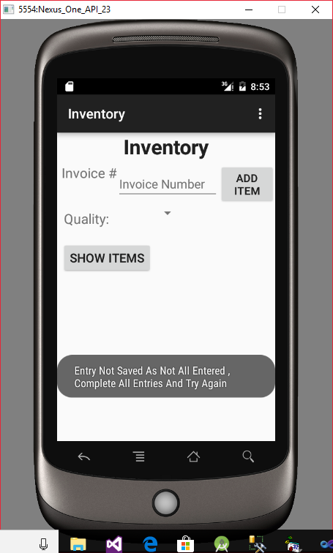

1. Clicking on Show Items, if List is Empty

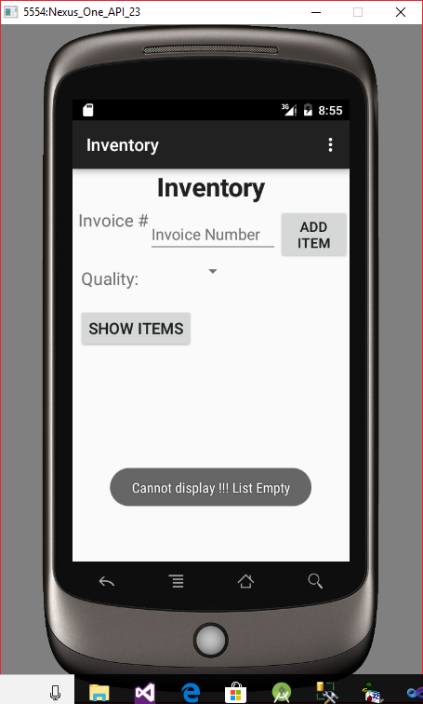

1. Specifying values

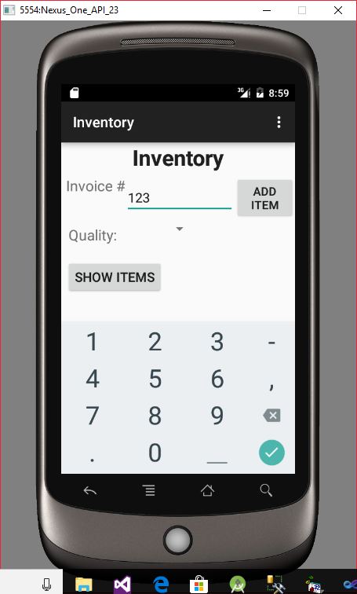

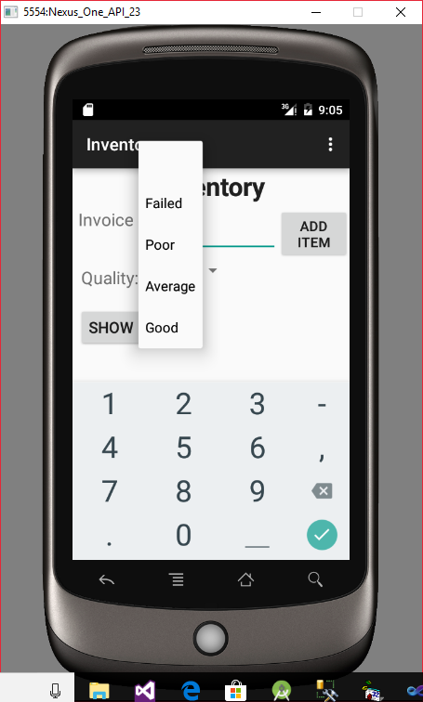

1. On clicking Add Button , Data saved to ArrayList and following message is displayed

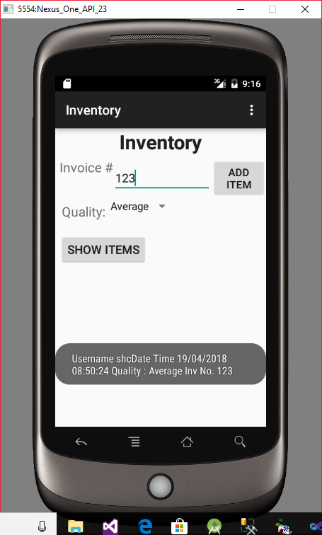

1. Similarly more records can be added

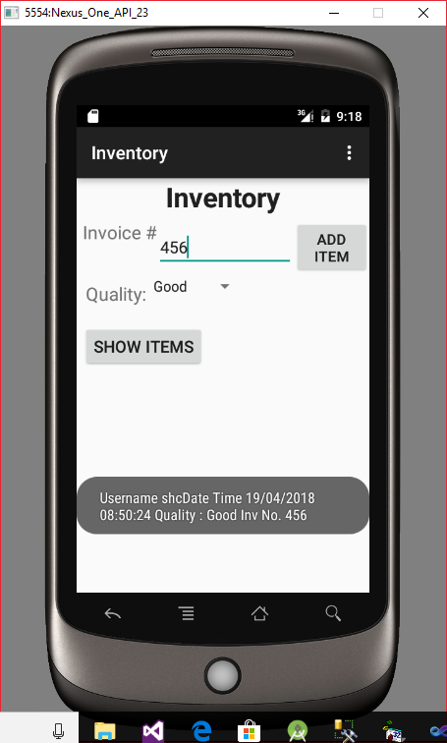

1. Now Clicking on Show Items will display List

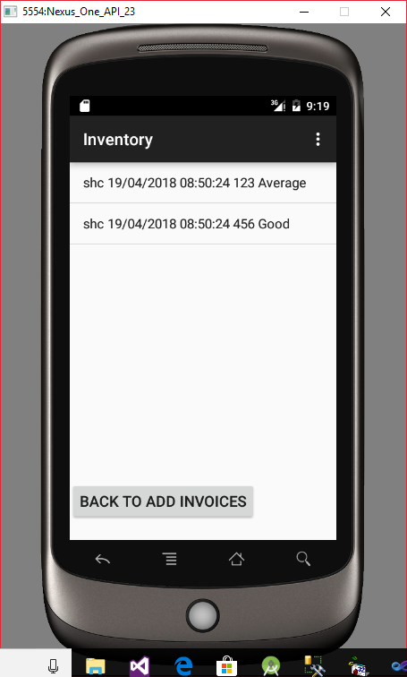

1. Clicking on Back To Add Invoices, will bring following screen

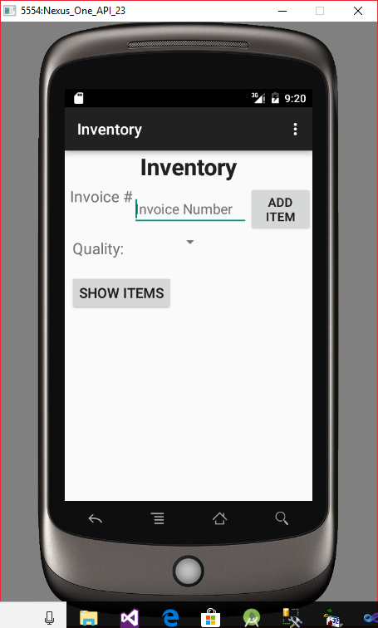

1. Click To see Option Menu

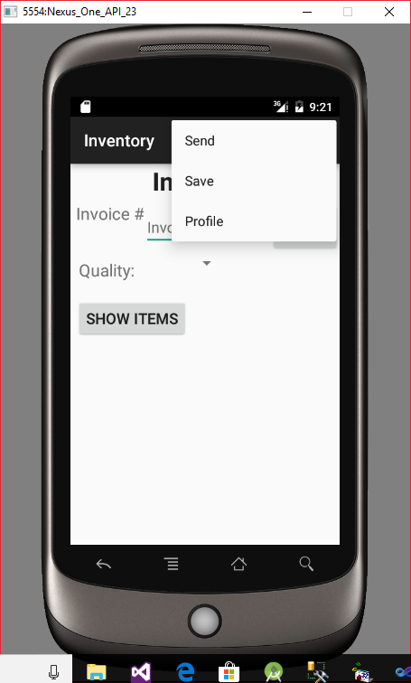

1. Clicking on Save will save entered entries To SQLLite Database

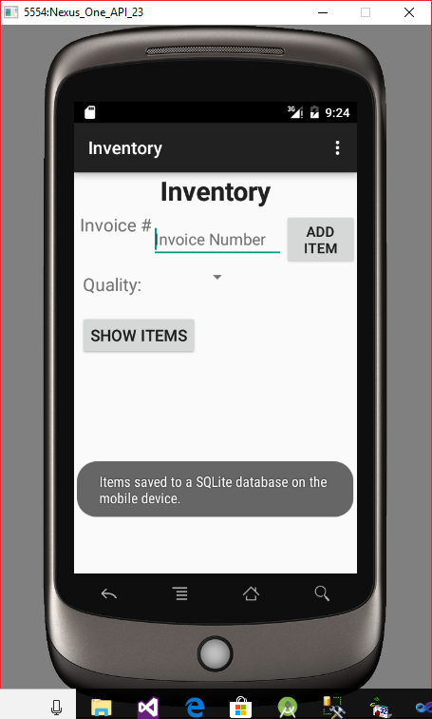

1. Clicking on Profile button

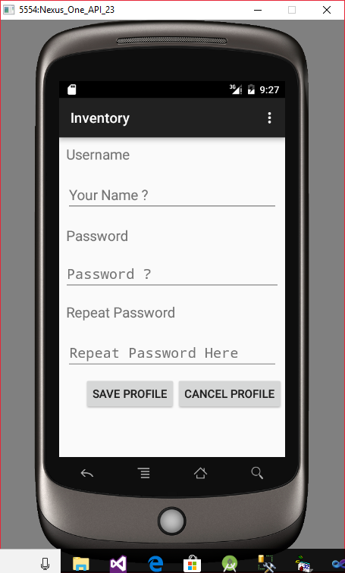

1. Validations on this form

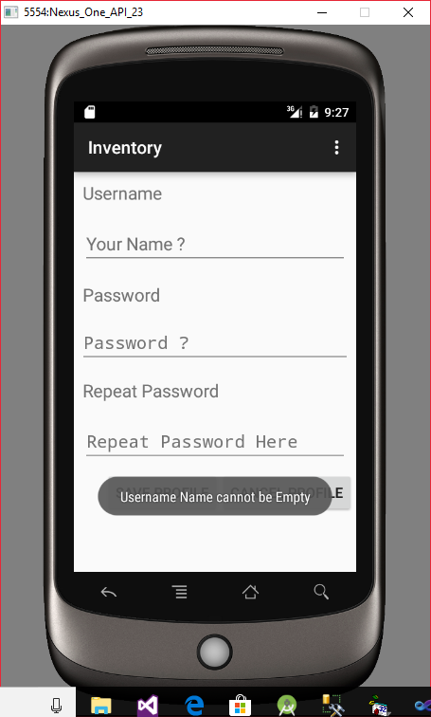

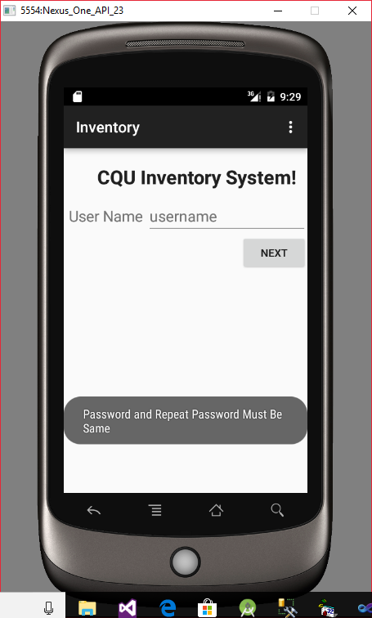

1. Clicking on back button

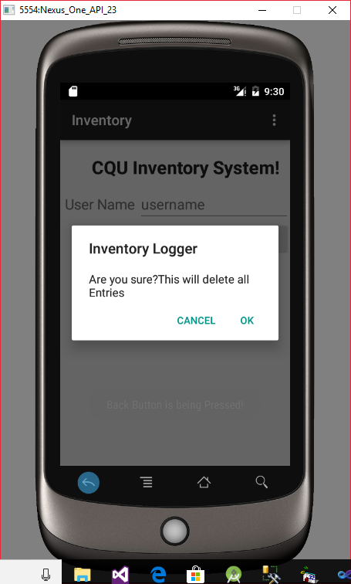

1. Clicking on Cancel button

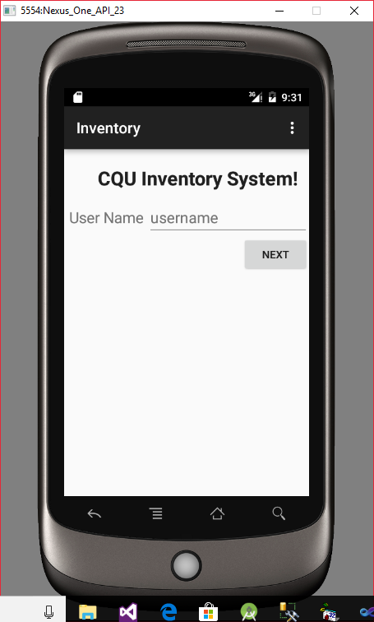

1. Clicking on OK button ends the application

**Conclusion:** Here all the required functionalities are implemented as per the requirements given in the problem statement. The same can be tested on Android device.