STUDENT COUNCIL MANAGEMENT SYSTEM
PANEL DEFENSE EVALUATION FORM
Group Members: Sophia Corsiga | Princess Lhea Cominador | Evanlloyd Bandolin
Adviser: Richie A. Cabangon, MSc IT
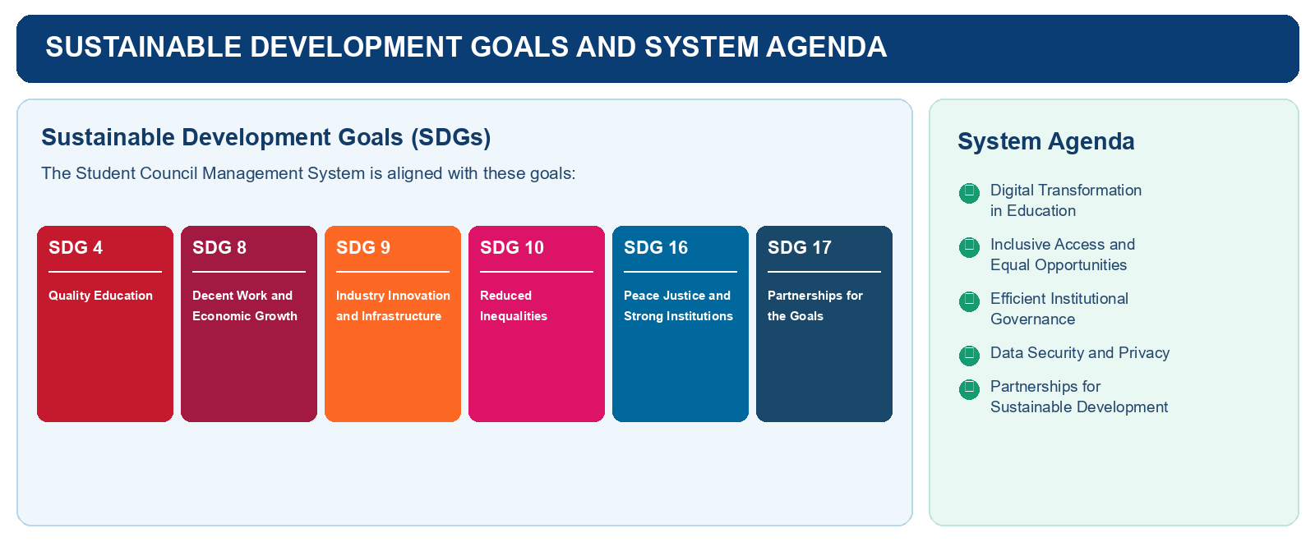
Name of Panelist: ____________________________________ | Date: __________________________________________
Project Group: Sophia Corsiga, Princess Lhea Cominador, Evanlloyd Bandolin | Defense Schedule: ________________________________
Instructions: Evaluate the system by placing a check mark (✓) in the column that best represents your rating. Use the comments section for recommendations or required revisions.
5 - Excellent | 4 - Very Good | 3 - Good | 2 - Fair | 1 - Needs Improvement

A. Functional Suitability | 5 | 4 | 3 | 2 | 1
The system provides the essential functions for managing student organizations, members, events, documents, and concerns.
Authorized users can create, update, view, and manage student council records and activities correctly.
The voting and election features accurately record eligible votes while protecting ballot confidentiality.
Event planning, attendance monitoring, and related announcements display accurate and timely information.
The system generates useful dashboards, reports, and activity records based on stored data.

B. Performance Efficiency | 5 | 4 | 3 | 2 | 1
Pages, dashboards, lists, and reports load within an acceptable time during normal use.
Search, filtering, voting, attendance, and document functions respond smoothly without noticeable delay.
The system remains stable when several users access its features at the same time.

C. Usability | 5 | 4 | 3 | 2 | 1
Menus, labels, and navigation make the system easy to understand for students, officers, and administrators.
Users can complete common tasks with minimal guidance and without confusion.
Forms provide clear instructions and validation that help prevent incorrect or incomplete entries.
The visual design is clean, readable, consistent, and appropriate for a student council system.

D. Reliability | 5 | 4 | 3 | 2 | 1
The system performs consistently during normal operations and maintains accurate records.
The system handles common errors appropriately and provides understandable feedback to users.
Submitted information, such as votes, attendance, tasks, and concerns, is saved correctly.
Links, uploaded documents, and system features work as expected without broken content.

E. Security | 5 | 4 | 3 | 2 | 1
The system properly authenticates users and limits features according to their assigned roles.
Only authorized users can access, modify, approve, or delete protected information.
Personal information, confidential concerns, and voting records are protected from unauthorized access.
The system prevents invalid or unauthorized actions through appropriate validation and access controls.

F. Maintainability | 5 | 4 | 3 | 2 | 1
Administrators can manage user accounts, membership records, and basic system settings with ease.
Officers can update announcements, events, tasks, and documents without extensive technical assistance.
The structure of the system supports future updates and additional student council features.
The system maintains activity records that help administrators monitor changes and resolve issues.

PANEL COMMENTS AND RECOMMENDATIONS
Strengths observed:
Required revisions or recommendations:
Overall assessment:
Panelist signature: ______________________________________

INDIVIDUAL ORAL DEFENSE EVALUATION
Score each member using the weighted criteria. Compute the final score out of 100.
Group Member | Ability to Answer  50% | Technical Knowledge  30% | Correctness of Answer  20% | Total  100%
Sophia Corsiga
Princess Lhea Cominador
Evanlloyd Bandolin

PANEL RECOMMENDATION
☐ Approved ☐ Approved with Revisions ☐ For Re-defense
Panelist Name and Signature: _________________________________________________

