Steven Counterman, Owen Hoffman, Pedro Medina
DeSales University | 2755 Station Ave, Center Valley, PA 18034
Software Design Specification
Project Workflow Manager

Software Design Document Specification Template

The Software Design Specification (SDS) sections provide you with guidelines related to the structure and the contents of SDS document. The Software Design Specification document includes at least these sections.

For the project, your team may have good reasons for wanting to deviate from this proposed outline. If a section is not applicable in your case, do not delete it; instead, give the topic heading and write "Not applicable".

You will note that there is some overlap in the content between different documents (i.e. the User Requirements Specification Document and the Software Design Specification Document.) This redundancy allows each document to stand on its own.

ONLY THE SECTION TITLES COLORED IN ORANGE ARE REQUIRED TO BE COMPLETED.
DO NOT DELETE THE SECTIONS YOU ARE NOT COMPLETING AS THEY ARE A PART OF THE DOCUMENT

Contents
1 Introduction 3
1.1 Purpose of this document 3
1.2 Scope of the development project 3
1.3 Definitions, acronyms, and abbreviations 3
1.4 References 3
1.5 Overview of document 3
2 System architecture description 3
2.1 Overview of modules / components 3
2.2 Structure and relationships 4
2.3 User interface 5
2.4 User interface issues 5
3 Detailed description of components 5
3.1 Authentication Component 5
3.2 User Account Management Component 7
3.3 Dashboard Component 9
3.4 Project Management Component 10
4 Reuse and relationships to other products 13
5 Design decisions and tradeoffs 13
6 Pseudocode for components 14
7 Appendices (if any) 14
Software component template for section 3 14

Introduction

Purpose of this document
Full description of the main objectives of the SDS document.

Scope of the development project
This will be similar to what was written in the SRS.

Definitions, acronyms, and abbreviations
Be sure to alphabetize!

References
This section will include technical books and documents related to design issues. Be certain that the references you give are complete and in the appropriate format.

Overview of document
A short description of how the rest of the SDS is organized and what can be found in the rest of the document. This is not simply a table of contents. Motivate and briefly describe the various parts!

System architecture description

Overview of modules / components
The Project Workflow Manager is created using a modular design. Functionality is split into separate components that interact through associated interfaces. Each component has a set of specified responsibilities, so the system can remain organized, maintainable, and extensible for future development.

The Authentication component is responsible for verifying user credentials and access control for protected system areas and functionality. It processes login and functionality requests to determine whether a user has access to the application or restricted action. The User Account Management component manages the creation and storage of user account records. It processes registration requests, validates account information, and stores user account data in the database. This information is later used for authentication purposes and access control. The Project Management component handles the creation, modification, and archiving of project records. It permits project information validation, storage, and updating according to requirements and permissions. The Dashboard component is the primary user interface used to interact with project and assignment information. It displays project data, workflow dependencies, and a calendar view in a centralized interface. This allows users to monitor and manage their work in a localized environment.

Structure and relationships

Domain concept for the account creation process
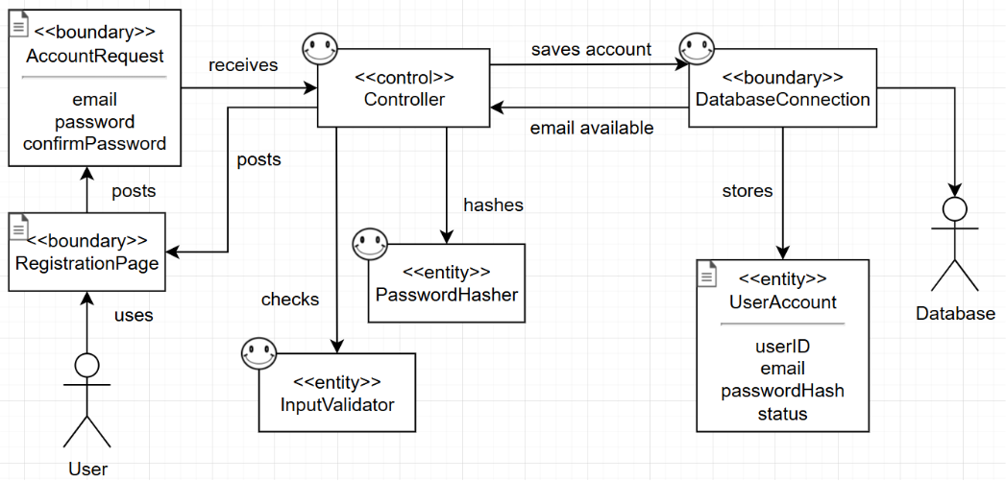
This chart demonstrates the interdependencies of components utilized in the account creation process. The user uses the registration page to submit an account creation request. They provide the preferred email, password, and password confirmation field values. The controller receives the account creation request and utilizes the input validator to verify these values. If valid, the controller then checks the database connection to verify if the email is in use. If available, the controller hashes the password for secure storage and saves the account using the database connection and a user account record in the database.

Domain concept for the project creation process.
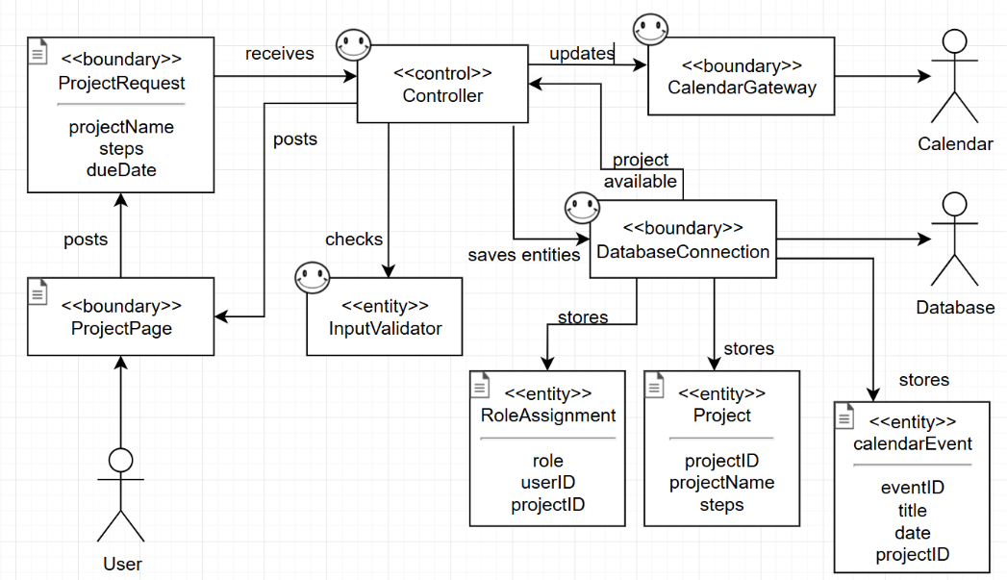
This chart demonstrates the interdependencies during the project creation process. The user accesses the project page and submits project information via a project request. The controller receives this project request and validates user input. If determined valid, the controller prompts the database connection to determine if the project name is unique and fields are compatible. If these criteria are met, the controller saves entities in the database to include the assignment of the creator to the project manager role, the project and relative information, and a calendar event to add the project to the calendar. The controller then updates the calendar through the calendar gateway to add the project to the project manager’s dashboard.

User interface
Complete design with user interactive windows, error messages, etc. Include all windows and messages that will be viewed by the user and also the ones that the user will be interacting with.

User interface issues
This section will present the main principles of the product's user interface. Use the personas/use cases defined in the SRS to make specific examples. This section should not touch on technical details. You may want to include sketches and specific text messages.

Detailed description of components

Authentication Component
Identification | Authenticator, located on the server-side application layer.
Type | Module
Purpose | Responsible for verifying user credentials and access control within the Project Workflow Manager. This component processes verification requests submitted through the client interface against records stored in the system database. This component satisfies the requirement that registered users are authenticated before accessing their dashboard or restricted application functionality. Upon successful validation, the component grants access to the dashboard or functionality the user was requesting. If authentication fails, access is denied.
Function | Processes user verification requests and determines whether access is granted or denied. This component receives user-provided login credentials from the client interface, including the email and password, and compares that information against account records in the system database. The transformation performed by this component is the conversion of login input into an authentication determination. If credentials match a valid existing user account record, the component produces a successful authentication result and permits the user access to the requested functionality. Otherwise, a failed authentication result is produced and access is denied.
Subordinates | - Credential Verification Module  - Compares submitted credentials against stored user account records in the database to determine whether authentication is granted or denied.  - Session Authorization Handler  - Establishes an authenticated session for users whose credentials are successfully verified.  These satisfy the requirements that system access is granted to validated users and prevent unauthorized users from restricted system functionality.
Dependencies | The Client Interface component provides the login form and submits the user’s credentials for processing. This component relies on this information to receive the input necessary for verification.  The Database component stores user account records and provides authentication data for credential verification. During authentication, the authorization component retrieves the stored information from the database but does not create, duplicate, or modify this data in any way.  The Dashboard component is passed control once authorization is approved. This provides the main interface for authenticated users. This interaction happens only once information has been submitted and approved.
Interfaces | The Authentication component provides both external and internal interfaces required to process user login requests. The primary external interface is the login interface. This contains fields for email and password, and control for login submission. When the user submits valid input through this interface, the entered credentials are passed to the Authentication component for verification.  The component interfaces with the Database component to retrieve the stored account record associated with the submitted username. The Authentication component compares the provided email and password with the stored data to determine authentication success. The Credential Verification Module passes verification results to the Session Authorization Handler to determine whether access should be granted.  If authentication succeeds, the component initiates a user session and transfers control to the dashboard interface associated with the user. If authentication fails, the system remains on the login page and displays an error notification. The messages include invalid email or password, or authentication required when attempting to access a protected function without valid credentials. These interfaces support the login and authentication behavior defined in the SRS.
Resources | This component relies on the database system to retrieve stored user account records for authentication. This database provides persistent storage for emails, passwords, and related account information. The component also requires server processing resources, including CPU execution time and system memory, to perform authentication decision processing. Memory resources are used temporarily to store submitted login credentials and retrieved account records during verification. The Authentication component also depends on network communication services to receive credential input from the client interface and return authentication results to the user interface. No specialized hardware devices or external libraries beyond the standard operating environment are required.
Processing | INPUT email, password  IF email is empty OR password is empty  DISPLAY “Required login fields are missing”  RETURN authentication_failed  QUERY database for email: Return accountRecord  IF accountRecord does not exist  DISPLAY “Username not found”  RETURN authentication_failed  IF password matches stored credential  CREATE authenticated session  REDIRECT user to dashboard  RETURN authentication_success  ELSE  DISPLAY “Invalid username or password”  RETURN authentication_failed
Data | The primary data elements processed by this component include the submitted credentials and the corresponding account record retrieved from the database.  The email is a unique identifier provided by the user at the login interface. It is used to query the database for the associated account record. The password is submitted by the user and compared against the stored credentials.  The component also maintains a temporary indicator to store if authentication failed or succeeded. If it succeeds, an authenticated session is created. If it fails, it remains invalid and the user is denied access.  These data elements support the authentication behavior defined in the system login requirements and ensure only valid user credentials are granted access.

User Account Management Component
Identification | AccountManager, located on the server-side application layer.
Type | Module
Purpose | This component is responsible for creating and maintaining user account records within the Project Workflow Manager. It processes account creation requests submitted through the client interface and stores new user account information in the database. It satisfies the requirement that users must be able to create a personal account that can be used for authentication and project association. Upon successful creation, the component stores the new account, initializes default permissions, and redirects the user to the login interface. If creation fails, it denies the request and returns an error notification.
Function | The User Account Management component processes user registration requests and determines if a new account can be created. It receives user-provided registration information from the client interface, including the email, password, and company role. It validates these values against formatting rules, checks the email for uniqueness in the database, and creates a new user account record in the database.  The transformation performed is registration input into a stored user account record. If the submitted values meet formatting requirements and the email is unique, it produces a successful account creation, initializes it with default permissions, and redirects the user to the login interface. If validation fails, the component produces a failed registration result and returns an error notification.
Subordinates | - Input Validation Module  - Validates submitted email, password, and company role values against formatting requirements before account creation.  - Username Uniqueness Verification Module  - Checks the database to verify whether the email is already in use.  - Account Record Creation Handler  - Creates and stores the new account record in the database once deemed valid.  - Permissions Allocator  - Assigns the new account its default permissions after successful creation.  These satisfy the requirements that account input must be validated and unique, new user records are stored, and new account must be initialized for later use.
Dependencies | The Client Interface component provides the account creation form and submits the user’s entered registration data for processing. The User Account Management component relies on this interface to receive the email, password, and role needed for account creation.  This component also depends on the Database component to check whether the email exists and to store the completed record. The database is responsible for persistent storage of user account data.  This component supports the Authentication component, since accounts created using this module are later used for login and verification. After successful account creation, control is transferred back to the login interface, so the Authentication component can process login requests.
Interfaces | The primary external interface is the account creation interface, which contains input fields for email, password, and company role, along with submission control for registration. The user submits registration data through this interface, where the values are sent to the User Account Management component for validation and storage.  This component interfaces with the Database component to check for email uniqueness and to store the validated account record. Communication occurs between the validation, uniqueness verification, record creation, and permission initialization subordinates as the registration process moves from input checks to record creation.  If the account creation succeeds, the component returns a successful creation results, displays confirmation, and redirects the user to the login interface. If it fails, the system remains on the registration interface and displays an error notification. These error messages include “Invalid registration input”, “Email already in use”, and “Required fields are missing.” These interfaces support account creation as defined in the SRS.
Resources | This component relies on the database system to verify username uniqueness and store new user account records. It also requires server processing resources, to include CPU execution time and memory, to validate registration data, perform uniqueness checks, and prepare account records. Network communication services are necessary to receive account creation requests from the client interface and return either confirmation or error notifications. No specialized hardware devies are required.
Processing | The User Account Management Component processes user registration requests by validating submitted account information, checking the email for uniqueness, creating an account record, and intializing default permissions.  INPUT email, password, role  IF email is empty OR password is empty OR role is empty  DISPLAY “Required fields are missing”  RETURN account_creation_failed  IF input format invalid  DISPLAY “Invalid registration input”  RETURN account_creation_failed  QUERY database for email  IF account exists  DISPLAY “Email already in use”  RETURN account_creation_failed  CREATE new account record  STORE new account record in database  ASSIGN default permissions  DISPLAY “Account created successfully”  REDIRECT user to login interface  RETURN account_creation_success
Data | The primary data elements include the registration information and the account records. The email is used as a unique identifier entered through the registration interface. It is used for uniqueness verification and authentication. The password is provided by the user during registration and stored alongside the email in the account record. The company role identifies the role for permission allocation for the account record.  This component creates an account record in the database after successful validation. This contains account information utilized in future login and project association. It also assigns initial default permissions for system interaction.  These data elements support the account creation requirements so that user records can be stored for authentication and functionality access approval.

Dashboard Component
Identification | DashboardDisplay, located on the client-side presentation layer.
Type | Module
Purpose | This component is responsible for allowing the user to access and use the Project Workflow manager. It allows the user to navigate between the log in page, the user’s calendar, and the project creation interface. It satisfies the requirement that users can travers the application and view their project details. Upon interacting with any of the designated elements of the dashboard, the user will either be provided with the relevant information or moved to the relevant section of the application.
Function | The Dashboard Display component acts as the main hub which the user will use to interact with and travers the Project Workflow Manager. After successfully logging in, the user will be directed to their Dashboard. The user will be able to access different sections and features of the application from the Dashboard Display by selecting specific interface components. Once an interface component is activated, the user will be directed to a different section of the application where they can choose to stay and perform a task or return to the Dashboard. The user will also be able to view specific information, such as approaching deadlines and newly assigned projects.
Subordinates | - User Account Element  - An interface element allowing the user to access and modify information regarding their user account.  - Calendar Element  - An interface element which will redirect the user to the calendar interface, allowing them to see currently assigned projects in more detail.  - Project Creation Element  - An interface element which redirects the user to the project creation interface, where they are able to create and assign new projects.  - Log Out Element  - An interface element which allows the user to log out of and exit the application.  These satisfy the requirements that users should be able to freely travers the application and access all of its relevant sections and functions.
Dependencies | The Dashboard Display Interface will be comprised of a single main page for the user to view. Display elements such as buttons will allow the user to navigate to other sections of the applications. The Dashboard will also include several information outputs related to the user. These outputs, such as deadline dates, will be populated with data taken from the database depending on the account of the user currently logged in to the application.  This component will support access for the Project Management component, Project Creation Interface component, Calendar component, and any future components the user must be able to be directed to.
Interfaces | The primary external interface is the Main Dashboard Display, which contains the interactable interface elements and displays which allow the user to use and navigate the application. The user can choose to view different sections of the application via selecting display elements or view important information via Dashboard displays.  This component interfaces with the Database component to display relevant information for the user, but does not return any data to it.  If the user selects one of the interface elements, they will be directed to the associated section of the application. The user may return to the Dashboard at any time from any section of the application.
Resources | This component relies on the database system to associate and display pertinent information for the user. It also requires server processing resources, to include CPU execution time and memory, to perform the methods which transfer users from the Dashboard to other application sections, as. Network communication services are necessary to receive account specific user data for display on the Dashboard. No specialized hardware devices are required.
Processing | The Dashboard Display Component pulls user data from the database for display on the Dashboard.  On PageOpen()  {  def getData (Select Data From Database Where Email = UserEmail);  String displayDataText = getData;  };  The Dashboard Display Component redirects users to different section of the  On buttonPress(buttonID)  {  Case(ID 1) – Move user to page A  Case(ID 2) – Move user to page B  Ext.  }
Data | The primary data elements are user specific data taken from the Database Component for display in the Dashboard. Data is pulled based on the email provided by the user in order to only display account specific information.  This component does not create data for storage in the database. It instead only displays information and directs users to other applications sections which do allow the user to generate new information for storage in the database.

Project Management Component
Identification | ProjectManagementHandler, located on the server-side application layer.
Type | Module
Purpose | The Project Management component is responsible for creating, maintaining, modifying, and archiving project records within the Project Workflow Manager. This component processes project-related requests submitted by users with appropriate permissions. It then validates, stores, updates, and manages the project information according to system requirements. It satisfies the requirements that authorized users can create projects, assign a project manager, modify project details, and archive projects. This component updates the database and returns a system response. If it fails, it denies the request and provides an error notification.
Function | This component processes project creation, modification, and archive requests. It receives input from the client interface, including project name, due date, steps, and modifications. It validates these values against formatting and permissions, checks the database for uniqueness, and then performs the requested functionality for the desired project record.  The transformation performed is the conversion of user input into project records and updates within the database. For project creation, it validates input, verifies uniqueness, stores the record, and assigns the Project Manager role. For project modification, it validates updated information and applies those changes to an existing record. For archiving a project, it updates the status and prevents further modification and retains the record. Outputs include successful creation, modification, or archive confirmation, and updated visibility reflected in the system.
Subordinates | - Input Validation Module  - Validates submitted project names, due dates, steps, and modification input against formatting and completeness requirements  - Project Retrieval Module  - Retrieves existing project records for modification and archiving  - Role Assignment Handler  - Assigns the creator of the project to the Project Manager role for that project  - Project Archive Handler  - Updates the project status to archived, removes the project from interfaces that display them, and prevents further modification  These parts satisfy the requirement that projects must be validated, unique, assigned to a manager, able to be updated, and archived without loss of the project.
Dependencies | The Client Interface Component provides the project creation, project modification, and project archive interfaces that users utilize for project-related requests. This component relies on these interfaces to receive data needed for the desired operations.  It also depends on the Authentication component to ensure that only permitted users can create, modify, or archive projects. Role-based permissions ensure that only authorized users can perform restricted actions.  The Database component is required to store project records, retrieve existing records, enforce uniqueness constraints, and preserve archived records. The Project Management component reads and modifies database data through this component.  Finally, it interacts with the Dashboard component which reflects stored and associated projects, their information, and archive status in user-facing views. After completion of these operations, control is returned to the relative interface.
Interfaces | The primary external interfaces are the project creation interface, the project modification interface, and the project archive interface. These allow authorized users to submit project names, due dates, steps, and updated project information through the client application.  It interfaces with the Database component to verify uniqueness, retrieve existing project records for modification or archival, and store new or updated project information. Internal communication occurs as the request passes through this component.  If creation succeeds, it stores the project record, assigns the creator the Project Manager role, displays a confirmation message, and returns control to the dashboard. If modification succeeds, the component updates the project information, displays confirmation of the update, and returns the user to the previous interface. If archiving succeeds, it updates the project status to archived, removes it from active displays, and returns the user to the previous interface. If any of these fails, the system displays an error notification. These include “Invalid project input”, “Project name already exists”, “Unauthorized action”, and “Project update failed.” These interfaces correspond to project functionality requirements defined in the SRS.
Resources | This component relies on the database system to verify uniqueness, retrieve project records, store new projects, update existing project information, and retain archived project information. It also requires server processing resources, including CPU execution time and memory, to validate input, process project changes, assign roles, and data storage and retrieval. As with the other components, this one also depends on network communication services for project requests from the client interface and to return success or error messages to the user-facing application. It relies on the standard operating environment of the Project Workflow Manager and does not require specialized external hardware.
Processing | This component processes project requests by validating data, confirming authorization, and checking storage conditions. It then creates, modifies, or archives the desired project record.  INPUT requestType, projectData, authenticatedUser  IF authenticatedUser not valid  DISPLAY “Authentication required”  RETURN project_request_failed  IF requestType = “CreateProject”  VALIDATE projectData  IF projectData invalid  DISPLAY “Invalid project input”  RETURN project_request_failed  QUERY database for existing project name  IF projectName exists  DISPLAY “Project name already exists in database”  RETURN project_request_failed  CREATE new project record  STORE project record in database  ASSIGN authenticatedUser Project Manager role  DISPLAY “Project created successfully”  RETURN project_creation_success  IF requestType = “ModifyProject”  VERIFY user has permission to modify  IF not permission  DISPLAY “Unauthorized project action”  RETURN project_request_failed  VALIDATE updated project data  IF invalid  DISPLAY “Invalid project input”  RETURN project_request_failed  UPDATE project record in database  DISPLAY “Project updated successfully”  RETURN project_modification_success  IF requestType = “ArchiveProject”  VERIFY user has permission for action  IF not permission  DISPLAY “Unauthorized project action”  RETURN project_request_failed  UPDATE project status to Archived  DENY further modifications  DISPLAY “Project archived successfully”  RETURN project_archive_success
Data | The primary data elements processed by this component are project information, stored project records, role assignment, and project statuses. The project name is a user-defined identifier used for uniqueness control in the database. The due date identifies the expected completion date for the project or phase. Project steps represent tasks associated with the project and may be modified with project management operations.  It maintains a project record in the database containing project-specific data. It also creates a project manager association in the database. Project status is used to indicate prevention of modification and inactive projects. These support the creation, maintenance, security, and retention requirements noted in the SRS.

Reuse and relationships to other products
For teams doing enhancement work, reuse is an important issue. Most enhancement work should focus on extending, rather than replacing, the design and product development from earlier semesters. For teams doing new development, reuse can also be an important strategy. In some cases, there is freeware that could be incorporated. In other cases, there are existing modules or classes that could be adapted. Another possibility is the use of special tools that produce open source results and thus permissible under the terms of this course.
This section should include the following subsections as appropriate:
- How reuse is playing a role in your product design
- How reuse is playing a role in your product implementation (and the motivation for changes)
- If you are not reusing material that is available, then give motivation for why it is being thrown out.

Design decisions and tradeoffs
The Project Workflow Manager is conceived using a modular framework. This categorizes the system based on responsibilities and separates components. Core functionality requirements like authentication, account management, and project management are individual modules that communicate through separate interfaces. This helps with maintainability and expansion without large overhauls to the remainder of the system.

One key design choice was application of user authentication before accessing critical system functionality. This ensures that project information and data are associated with only assigned users and prevents unauthorized access to both the project and modification features. This allows for the utilization of role-based permissions.

Another design choice was to store user accounts on a server-based database. This ensures that project information is accessible and up-to-date across multiple user sessions. This allows the system to maintain records in long-term storage, to include archived projects for reference.

We also considered implementing client-side input validation for a faster response and reducing server processing requirements. Although this could improve user experience, this could potentially lead to vulnerabilities with manipulated requests. We then decided that the security provided by performing validation within a sandboxed server environment before data processing would be ideal for system and data integrity.

Finally, this system presents project and assignment information through a centralized dashboard interface. This provides users with a clear overview of their projects and workflow while minimizing excess navigation.

Pseudocode for components
Utilize the use cases to create pseudocode for components.

Appendices (if any)

Software component template for section 3
The template given below suggests a reasonable structure for giving a thorough description of each component described in Part 3 of the SDS. The specific information depends in part on the design approach. Your team must adapt this template to your needs and describe it in section 3.1 of your SDS.

Identification | The unique name for the component and the location of the component in the system.
Type | A module, a subprogram, a data file, a control procedure, a class, etc.
Purpose | Function and performance requirements implemented by the design component, including derived requirements. Derived requirements are not explicitly stated in the SRS, but are implied or adjunct to formally stated SDS requirements.
Function | What the component does, the transformation process, the specific inputs that are processed, the algorithms that are used, the outputs that are produced, where the data items are stored, and which data items are modified.
Subordinates | The internal structure of the component, the constituents of the component, and the functional requirements satisfied by each part.
Dependencies | How the component's function and performance relate to other components. How this component is used by other components. The other components that use this component. Interaction details such as timing, interaction conditions (such as order of execution and data sharing), and responsibility for creation, duplication, use, storage, and elimination of components.
Interfaces | Detailed descriptions of all external and internal interfaces as well as of any mechanisms for communicating through messages, parameters, or common data areas. All error messages and error codes should be identified. All screen formats, interactive messages, and other user interface components (originally defined in the SRS) should be given here.
Resources | A complete description of all resources (hardware or software) external to the component but required to carry out its functions. Some examples are CPU execution time, memory (primary, secondary, or archival), buffers, I/O channels, plotters, printers, math libraries, hardware registers, interrupt structures, and system services.
Processing | The full description of the functions presented in the Function subsection. Pseudocode can be used to document algorithms, equations, and logic.
Data | For the data internal to the component, describes the representation method, initial values, use, semantics, and format. This information will probably be recorded in the data dictionary.

