Web Based Solution for Trading Agricultural Products

**Software Requirements Specification**

**Document**

Team Members

PGIS/SC/MSc/CSC/19/30 - H.A.D.D.N.Hathurusinghe

PGIS/SC/MSc/CSC/19/10 - E.M.S.D.Jayawardane

PGIS/SC/MSc/CSC/19/27 - D.R.C.G.K.Dampalessa

PGIS/SC/MSc/CSC/19/03 - H.M.Iresha Bandaranayake

Contents

1 Introduction 3

1.1 Purpose 3

1.2 Scope 3

1.3 References 5

2 Overview 6

2.1 Overall Description: 6

2.2 User Characteristics 6

2.2.1 Principle Actors 6

2.3 General Constraints 6

3 Specific Requirements 7

3.1 Functional Requirements 7

3.1.1 Product Description 7

3.1.2 Browse Product Catalog 7

3.1.3 Add New Products for Trading 7

3.1.4 Registration 7

3.1.5 Login 7

3.1.6 Changes to Cart 7

3.1.7 Payment 7

3.1.8 Logout 7

3.1.9 Report Generation 8

3.2 Non-Functional Requirements: 8

3.3 Performance Requirements 8

3.4 Technical Requirements 8

3.5 Interface Requirement 8

3.6 Server Requirements 9

3.7 Hardware Interface Requirements 9

3.8 Communication Interfaces: 9

4 System Design Specification: 10

4.1 Use Case Diagram 10

4.2 Class Diagram 11

4.3 Deployment Diagram 12

# Introduction

## Purpose

There are numerous platforms available for farmers to trade their products online. But, none of them are been used country wide, by farmers. We have identified these reasons as the main causes for this issue.

* Inconvenient User Interface
* Not available 24/7
* No proper description about the policy when it comes to user data
* Users are reluctant to use online payment methods.

So our objective is to come up with a trading platform which will address all above mentioned issues.

## Scope

The objective of the project proposal is to develop a web-based solution for trading agricultural food/crop products. This business will be developed in two phases. The first phase will contain up to the checkout of products and will take six weeks to complete from the start to finish.

The advantage would be a simple and user-friendly user interface that is easy to understand by all types of users and responsive for mobile, tablets and desktops.

**The platform will have following functionalities**

**Admin Panel**

* Login
* Dashboard
* Administrator
* User Management
* Product Management
* Order Manager

**Registration**

This section allows new users to create new registration account on the site

* Fill the registration form with all required fields
* Enter Profile details like name, email id, password
* Enter address details like Country, State and Zip Code
* Submit Form

**User Login**

This section allows user to enter the website by adding login details created during registration Enter authenticated Email Address and Password to login

* Forgot Password Link
* Recover password through mail
* New User? Sign up link available

**Registered Member/Seller Panel**

* Login to site
* Manage Account
* My Profile
* My products
* Manage products
* Logout

**My Account**

* Personal Information
* Change Name, Login, E-mail Address or Password
* Manage Address Information

**My Products**

* View all own available products

**My Selling Bucket**

* All current received orders
* View receiving order details

**History/Receipts**

* View all the completed orders
* View order id, status, date ordered

**Delete Account**

**Sign out**

**Registered Member - Buyer Panel**

* Login to site
* Manage Account
* My Profile
* Checkout
* Logout

**My Account**

* Personal Information
* Edit Name, Address, Login, E-mail Address, Password, etc.

**My Orders**

* View Details of all the orders made
* View order no/ order date/ amount/ quantity
* View order id, status, date ordered

**Last Order**

* Displays the last order made

**Delete Account**

**Sign Out**

**View Shopping Cart**

* Displays products added to the shopping cart with a small product image, subtotal, shipping amount link to “Update‟ and “checkout‟ and link to “See entire shopping Cart”.
* Remove Product from the Cart
* Update Quantity and Recalculate Subtotal.

**Checkout**

* Review Order
* View Total Order Summary

**Visitor/Viewers Features**

* View Home page
* Browse Products
* View Product Details
* View Static Pages (Contact Us, AboutUs, Terms& Conditions etc.)

## References

# Overview

This product aimed toward farmers and buyers. Farmers can sell their export agricultural products directly to the buyers without going through intermediaries.

Buyers can easily browse through the product catalogue and buy products which suits their needs without any hassle

## Overall Description:

The Web Based Solution for Trading Agricultural Products application, enables farmers (vendors) to set up online shops, customers to browse through the shops, and a system administrator to approve and reject requests for new shops and maintain lists of shop categories. The system will use the internet as the sole method for selling goods to its consumers.

## User Characteristics

User should be familiar with the terms like login, register, order system etc.

### Principle Actors

3 Principle Actors are Customer, Seller and Administrator.

## General Constraints

A stable internet connection require.

# Specific Requirements

## Functional Requirements

This section provides requirement overview of the system. Various functional modules that will be implemented by the system will be described in the section 1.2 of this document

### Product Description

Each products will have descriptions and selectable properties (quantity)

### Browse Product Catalog

Buyers will be able to browse through product catalog and choose from different products

### Add New Products for Trading

Farmers (Sellers) will be able to add new products to their online stores

### Registration

If customer wants to buy the product then he/she must be registered, unregistered user can’t go to the shopping cart.

### Login

Customer logins to the system by entering valid user id and password for the shopping.

### Changes to Cart

A customer can make order or cancel order of the product from the shopping cart, after login.

### Payment

In this system we are dealing the mode of payment by Cash. We will extend this to online payments in the phase II of the project.

### Logout

After ordering or surfing for the product customer has to logout, or will be logged out automatically after a specific time period.

### Report Generation

After ordering for the product, the system will sent one copy of the bill to the customer’s Email-address and another one for the system data base.

## Non-Functional Requirements:

Following Non-Functional Requirements will be there,

* User friendly user interfaces for both mobile and PCs
* Secure access to consumer’s confidential data.
* 24X7 availability**.**
* Better component design to get better performance at peak time.
* Various other Non-Functional Requirements are:
  + Security
  + Reliability
  + Maintainability
  + Portability
  + Extensibility
  + Reusability
  + Compatibility
  + Resource Utilization

## Performance Requirements

In order to maintain the server at a optimum state, captcha will be implemented in the 2nd phase of the development of the system to mitigate denial of service attacks.

Connection speeds will depend on the attributes of the user like his location, and bandwidth.

## Technical Requirements

This system will work on client-server architecture. It will require a server which will run an instance of Apache Tomcat Server. The system should support some commonly used browser such as IE, Mozilla Firefox, Chrome etc.

## Interface Requirement

* Main interfaces of the system will be,
* Login Page
* Registration Form
* Product Page
* Product Catalog
* Shopping Cart

## Server Requirements

* Operating System: Linux/Windows
* JDK

## Hardware Interface Requirements

Hardware requirements for insurance on internet will be same for both parties which are as follows.

* Processor: Dual Core
* RAM: 2 GB
* Hard Disk: 320 GB

## Communication Interfaces:

All users should have a stable internet connection in order to use the system

# System Design Specification:

## Use Case Diagram

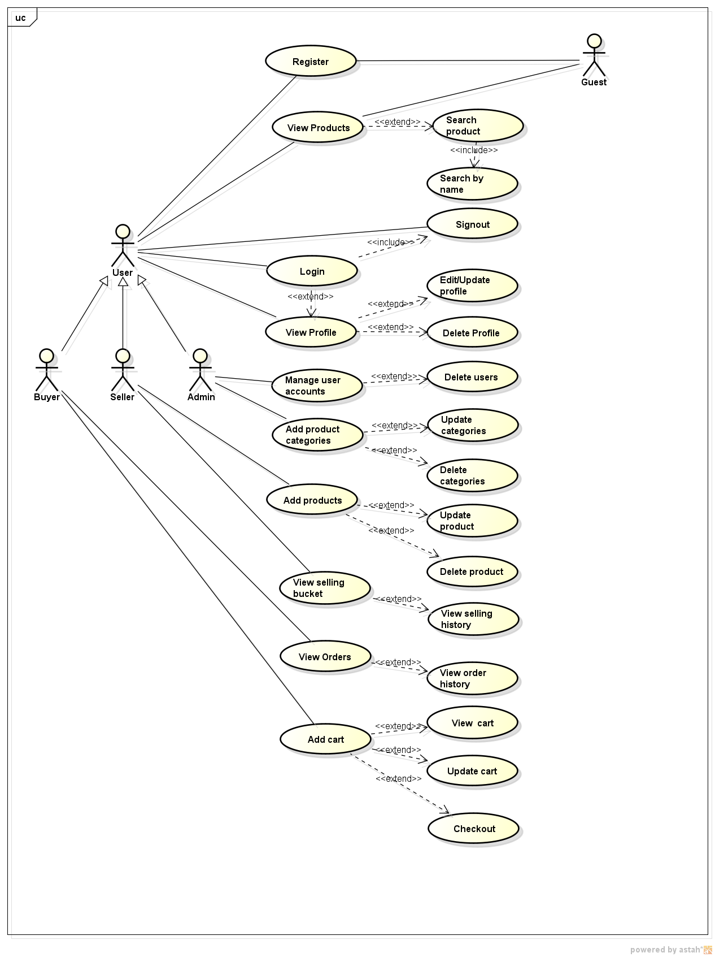

## Class Diagram

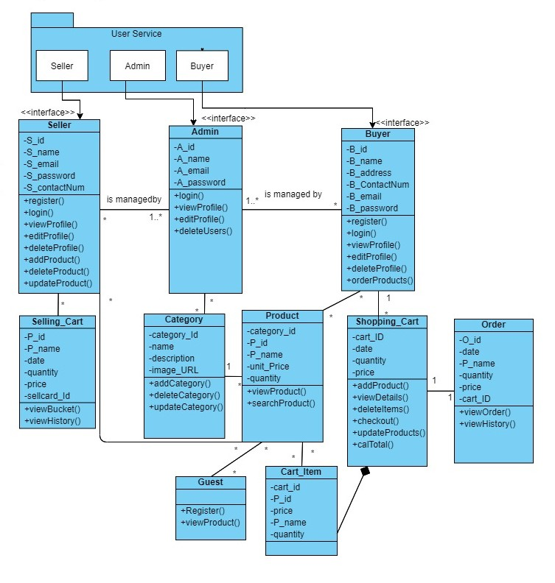

## Deployment Diagram

