Area 24: Summary of observations and preliminary escapement estimates

South Coast StA

Last Update: 2024-02-20

# **Overview**

There are almost 60 streams and major tributaries that have records of spawning salmon in Area 24. The priorities for escapement enumeration are the Chinook indicator stocks in the Bedwell River, Tranquil Creek, and Megin River. There is no Coho indicator in Area 24. The Moyeha River was historically a Chinook indicator but was dropped due to logistical difficulties. Additional systems are surveyed when funding allows and typically less frequently than the indicator systems. Most surveys are conducted using the snorkel method described in the DFO snorkel survey manual, or by stream or bank-walk. Surveys are typically conducted by DFO contractors, First Nations and local enhancement groups.

Enhancement in Area 24 has been primarily done by the Tofino Salmon Enhancement Society, Thornton Creek Enhancement Society, and Kennedy Lake Hatchery operated by Tla-o-qui-aht. The Kennedy River has been enhanced in most years since the mid-1980s, Tranquil Creek since the early 1990s, Cypre River since the late 1990s and Bedwell River since 2008. Enhancement efforts have focused primarily on Chinook.

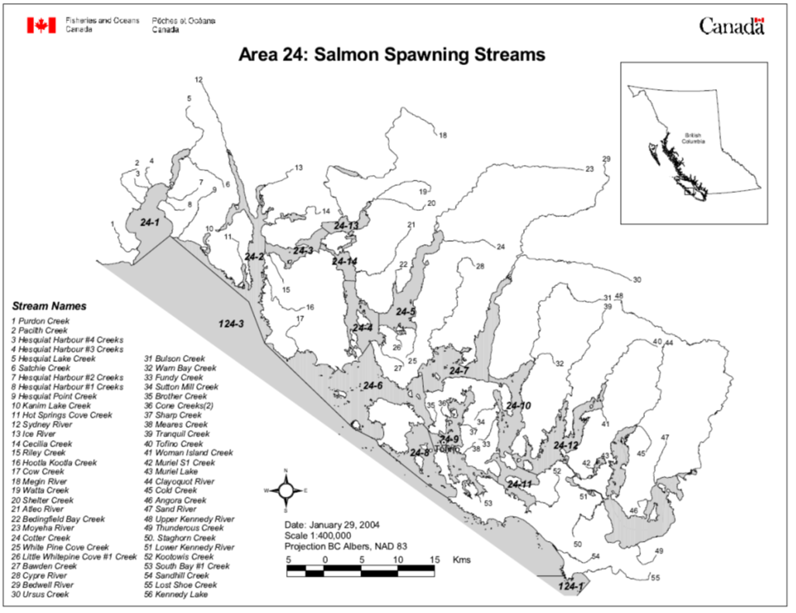

Figure 1-1. Area 24 Survey Streams

## 2023 Operational summary

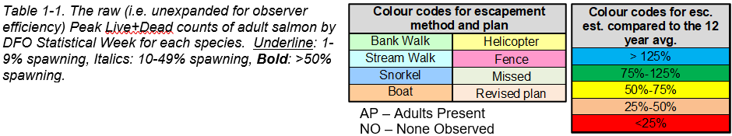

Sockeye

Coho

Chum

Chinook

## Escapement survey review meeting

## Other data and activities

# **Bedwell System (Bedwell & Ursus)**

## Stream summary

The Bedwell River and Ursus Creek make up the Bedwell System, which flows southwest into the Bedwell Sound. The area is remote with the exception of the Clayoquot Wilderness Resort which operates at the mouth of the River. The Bedwell River is fed by glacier snowmelt from many steep tributaries and by Bedwell Lake located almost 30 km upstream from the mouth.

The lower 6 km of the Bedwell River has been divided into 12-500 m survey sections for salmon enumeration (Figure 2-1). At the top of the survey section on the Bedwell River there is a canyon that is impassible to fish. The largest tributary to the Bedwell is Ursus Creek which historically entered the Bedwell River at survey marker 5. In the past several years there have been major changes in the stream channel around the confluence with the Ursus. The location of marker 6 in Figure 2-1 is now dry river bed. The channel cut in 2013/14 is also now dry, and in 2016, a new channel formed that goes from the bottom of the riffle above marker 6 straight to marker 5. The lower 3 km, markers 0 to 6, is the area usually surveyed on the Ursus.

The system is dynamic, with few or no log jams and no beaver dams. The mainstem channels are generally shallow and wide, and erosion is a problem. Most large woody debris gets washed out. On a high tide, salt water reaches marker 1. There are several deep pools on the Bedwell between markers 2 and 3, 9 and 10 and below the canyon (marker 12) on the Bedwell. The pool between markers 4 and 5 has been filling-in in recent years and is now only 3-4 feet deep. On Ursus Creek, there are several pools between markers 3 and 6.

The system is described as ‘great indicator stream’ with generally clear water and pools that have excellent visibility. After heavy rainfall the system will become murky and take up to three days to clear. The water clarity and retainment characteristics are similar to nearby systems Cypre, Tranquil and Moyeha. Typical flow for the Bedwell system is 1.8 m3/s, compared to 0.4 for Tranquil and 0.8 for Megin. The Bedwell is considered a relatively cool system, with temperatures slightly cooler than Tranquil. The Environment Canada Water Survey Station at Tofino Creek (08HB086) has a long record of discharge measurements and can be used as an indicator for discharge at Bedwell. DFO installed a hydrometric station on the Bedwell in 2015 at marker 8. Seals are occasionally seen in the estuary but also not considered to be a problem.

Historical spawner survey reports note considerable silt and erosion. The upper reaches of the Ursus, above marker 13, are unlogged, relatively flat, but have experienced a lot of change since the early 2000s. There was a side channel installed in the lower Bedwell River.

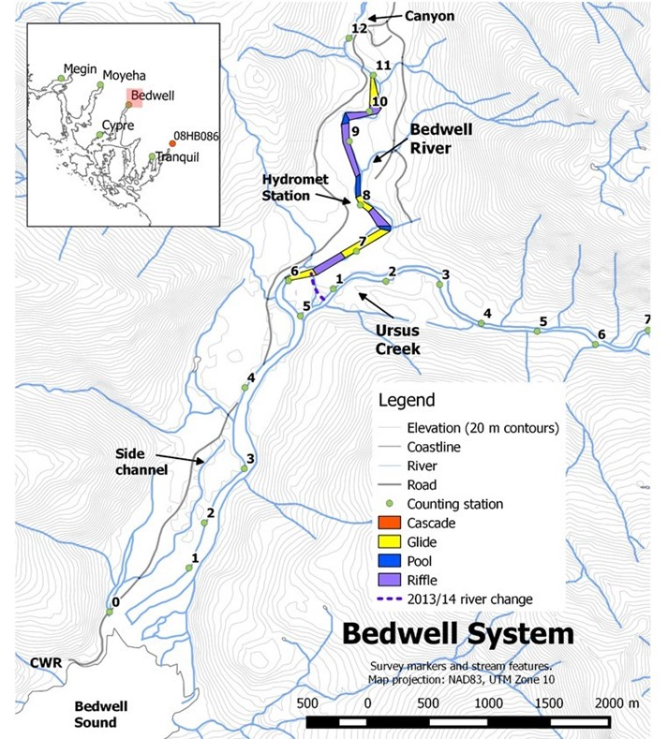

Figure 2-1. The Bedwell/Ursus system habitat units and counting stations. Map inset shows locations of other systems that are regularly surveyed in Area 24 as well as the location of the Environment Canada hydrometric station at Tofino Creek (08HB086). Roads, rivers, coastline and elevations are based on the Terrain Resource Information Management (TRIM) digital base maps of British Columbia. The 2013/14 river change (purple dashed line) shows the approximate location of the Ursus channel as of 2014. This channel changed in 2016 to join up at marker 5.. Habitat data were mapped in the field and / or digitized from recent high resolution orthophotographs by M.C. Wright and Associates Ltd.

## Survey results and escapement estimates

**Survey crew:**

**Stock Assessment technician:**

## Environmental conditions

## Update to stream survey protocols

## Enhancement

## Biosamples

## Concerns and comments

# **Cypre River**

## Stream summary

The Cypre River flows south into Cypress Bay, west of Bedwell Sound in Clayoquot Sound (Figure 3 1). It is a clean, clear fast flowing system fed by many small tributaries from the surrounding mountains. The mainstem length is about 21 km and there are many small tributaries.

Compared to other streams in the area, Cypre flow is moderate; slightly less than the Moyeha and more than Tranquil. The system has a large floodplain and the lower 4 km has a low gradient (i.e. below marker 8). About 8 km upstream from the mouth (i.e. above marker 16) the stream becomes steeper, has two sets of cascades, more boulders and not as much spawning habitat. There is a canyon between survey markers 8 and 9 which is swimmable under most conditions. There are falls about 13 km upstream from the mouth (marker 26). The closest station where discharge is monitored is at Tofino Creek (Environment Canada Water Survey Station 08HB086). Low water can be a problem for fish entering the system. In 2012, fish were unable to access the system prior to late September because of low water level (the Tofino gauge was below 0.1 m at the time).

The lower 13 km of the system is considered suitable and accessible spawning habitat and has been divided into 26 - 500 m sections for salmon enumeration (Figure 3-1). There are many deep pools on the system including Oscar’s Pool (between markers 6 to 7; Named for Oscar Hanson who was one of the early surveyors), the Oxbow Pool (above marker 12), Bouncing Spruce Pool (100 m below marker 15) and the Boulder Pool (above marker 15), Lucky Pool (between markers 20 and 21), and Ice Pool (near marker 25). There is a cave in the Ice Pool. There were three side channels made in the late-90s: at survey marker 12, in the tidal area between markers 0 and 1 and near marker 20.

The historical survey reports tell of frequent erosion, silting and landslides. Spawner survey reports also frequently note significant amounts of mobile large woody debris causing large areas of scouring in the spawning riffles. The watershed consists of steep terrain and old growth forests. It was subject to extensive damage from poor logging practices in the 1970s and 80s. Logging mostly stopped in the 1980s and since then the Cypre habitat has returned to a stable state with excellent fish habitat with spawning stocks that have rebuilt.

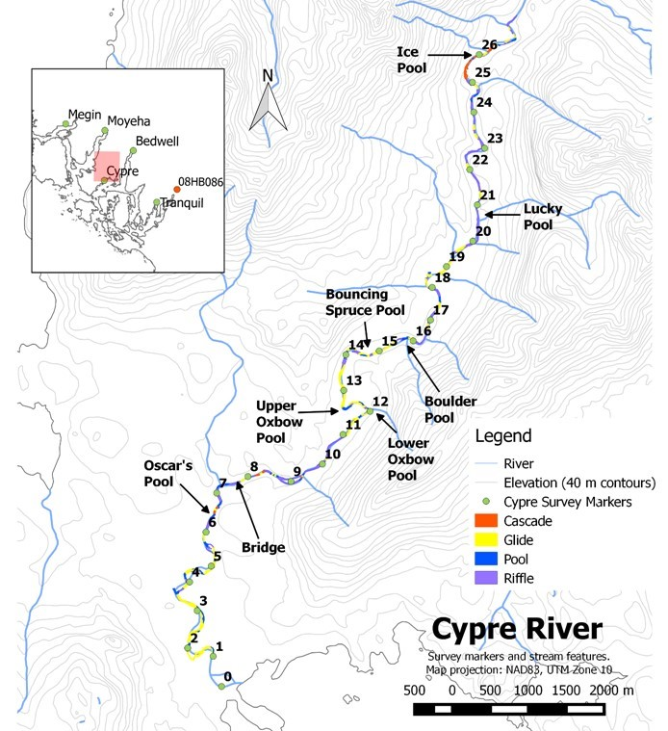

Figure 3-1. Cypre River counting stations and habitat units. Map inset shows locations of other systems that are regularly surveyed in Area 24 as well as the location of the Environment Canada hydrometric station at Tofino Creek (08HB086). Rivers, coastline and elevations are based on the Terrain Resource Information Management (TRIM) digital base maps of British Columbia. Habitat data were mapped in the field and / or digitized from recent high resolution orthophotographs by M.C. Wright and Associates Ltd. The positions of survey markers 15 to 26 are approximate.

## Survey results and escapement estimates

**Survey crew:**

**Stock Assessment technician:**

## Environmental conditions

## Update to stream survey protocols

## Enhancement

## Biosamples

## Concerns and comments

# **Kennedy River (Upper)**

## Stream summary

Upper Kennedy River flows into Kennedy Lake from the northwest (Figure 4-1). The system has many big, deep pools. The Upper Kennedy River survey markers were originally set-up by an external contractor conducting a detailed assessment of the Kennedy. Marker 0 is located at upstream location where the survey begins and markers space approximately 100 m apart downstream to marker 93 near the mouth. Many of these 100m markers are missing in recent years. Despite the differences from the standard marker system (500 m spacing and 0 marker farthest downstream), surveyors continue to use the historical survey marker locations for observations on the Upper Kennedy.

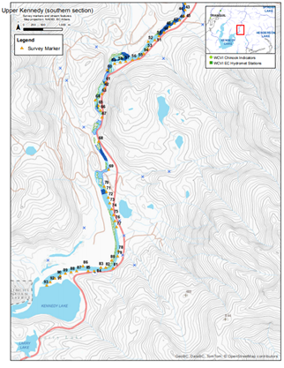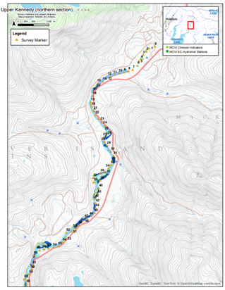

## Survey results and escapement estimates

**Survey crew:**

**Stock Assessment technician:**

## Environmental conditions

## Update to stream survey protocols

## Enhancement

## Biosamples

## Concerns and comments

# **Megin River**

## Stream summary

The lower Megin River flows out of the western end of Megin Lake and southward into Shelter Inlet in Clayoquot Sound (Figure 5-1). The system is remote and access is only available via boat or plane. Fog is often a problem for accessing the system. The Megin is located in Strathcona Provincial Park and near the mouth is the Megin River Ecological Reserved which was established in 1981. The area is unlogged with pristine habitat in the park. As of the early 2000s there have been no survey markers on this system. Survey sections are estimated using habitat and reference to survey markers is based on historical positions of 19 survey markers, each about 500 m apart.

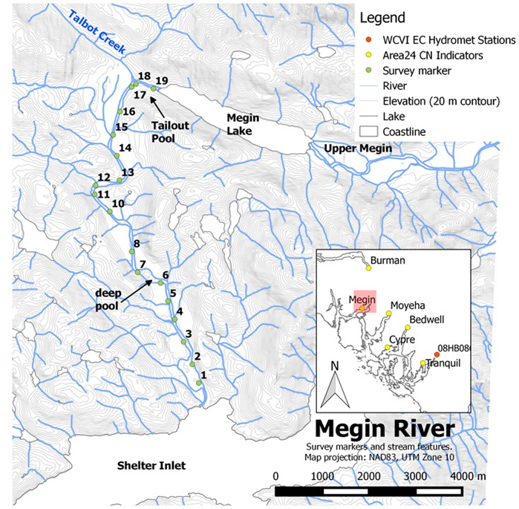

Figure 4-1. The approximate location of Megin River counting stations. Roads, rivers, coastline and elevations are based on the Terrain Resource Information Management (TRIM) digital base maps of British Columbia. Reference to survey markers are based on historical positions and should be updated if new markers are installed. Map inset shows locations of other well-sampled systems in the area and also the location of the Environment Canada monitoring station at Tofino Creek (08HB086).

The lower Megin River is fed by Megin Lake, located about 9.5 km upstream from the mouth, as well as by many small tributaries. The largest tributary is Talbot Creek which joins the lower Megin about 9 km upstream from the mouth (near marker 18). Megin Lake is fed by the upper Megin River and many small tributaries. The lower Megin has water clarity and retainment characteristics that are quite different from other streams in Area 24. The system has heavy suspended silt after rains and can take up to 6 days to clear. Some pools never clear. The Upper Megin, above the lake, is clearer and takes less time to clear after rain.

The Megin River is described as a slow system with many areas of little or no water movement. Typical flow for the Megin is 0.8 m3/s compared to 1.8 m3/s for the Bedwell River and 0.4 m3/s for Tranquil Creek. The lower Megin has a low gradient (<2%) and mostly consists of wide cobble/gravel bars. There are several deep pools, including the Tailout Pool (marker 18), a deep pool near marker 7 (~10 m depth), and another pool near marker 3. The habitat is generally described as stable. However, in 2014, erosion was noted near marker 1.

The lower Megin (from the lake to the tidal zone) is surveyed primarily for Chinook and Chum. The upper Megin (above the lake) is surveyed to provide Coho and Sockeye numbers.

## Survey results and escapement estimates

**Survey crew:**

**Stock Assessment technician:**

## Environmental conditions

## Update to stream survey protocols

## Enhancement

## Biosamples

## Concerns and comments

# **Moyeha River**

## Stream summary

The Moyeha River flows southwest into Moyeha Bay at the head of Herbert Inlet in Clayoquot Sound. The system is located in the traditional territory of the Ahousaht First Nation and in Strathcona Provincial Park. Access is available only by boat or float plane and the town of Tofino is about 30 km to the south.

The mainstem is almost 30 km in length and is fed by many short, steep tributaries originating in the surrounding mountains. The lower Moyeha has a low gradient with wide sand and gravel banks. The gradient becomes slightly steeper above about 6 km from the mouth, and about 14 km from the mouth there is a canyon that is considered a migration barrier (above survey marker 27).

Compared to other streams in the area, Moyeha has generally moderate flow; slightly more flow than the Cypre River and less than Bedwell System. The water clarity and retainment characteristics are similar to Bedwell, Cypre and Tranquil; it is generally clear but will become murky after heavy rain and take up to three days to clear.

The watershed is mostly old growth forest which has been largely untouched by logging. Despite this, the Moyeha changes a lot physically and is subject to erosion. Historically, the habitat included pools but in recent years the pools have mostly been filled in. Past surveyor reports often note erosion and scouring.

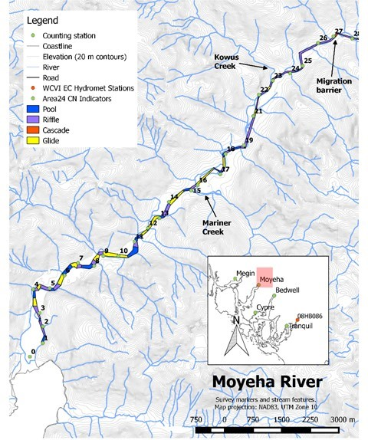

Figure 6-1. Moyeha River counting stations and habitat units. Map inset shows locations of other systems that are regularly surveyed in Area 24 as well as the location of the Environment Canada hydrometric station at Tofino Creek (08HB086). Rivers, coastline and elevations are based on the Terrain Resource Information Management (TRIM) digital base maps of British Columbia. Habitat data were mapped in the field and / or digitized from recent high resolution orthophotographs by M.C. Wright and Associates Ltd.

## Survey results and escapement estimates

**Survey crew:**

**Stock Assessment technician:**

## Environmental conditions

## Update to stream survey protocols

## Enhancement

## Biosamples

## Concerns and comments

# **Tranquil Creek**

## Stream summary

Tranquil Creek flows south into the head of Tranquil Inlet in Clayoquot Sound. Tranquil is a small, clear system fed mainly by run-off and small surrounding streams (lakes at headwater). The lower 3.5 km of the system have been divided into seven 500 m sections for salmon enumeration (Figure 7 1). There are falls located about 3.5 km upstream which are considered impassable to fish. The system has several deep (~6 m), clear pools including pool just below the falls, a small pool just below marker 6, the Mossy Rock Pool below marker 5, the Road Pool between markers 3 and 2, and Dougie’s Pool at marker 2.

The system is generally clear with good visibility except after heavy rainfall when it becomes murky and takes up to three days to clear. The water clarity and retainment characteristics are similar to Cypre, Bedwell and Moyeha. Typical flow for the Tranquil Creek is 0.4 m3/s, compared to 1.8 for Bedwell, and 0.8 for Megin. Tranquil is warmer than Bedwell, but temperature is never an issue for spawning salmon or surveys. The closest station where discharge is monitored is at Tofino Creek (Environment Canada Water Survey Station 08HB086) or on the Bedwell River since 2015.

Surveyors report frequent erosion events including large slides in 2006 and 2009 which degraded water quality for several weeks during the fall. In late-2011, there was a major flow event which cut a new channel between markers 3 and 2. The event deposited sand downstream to marker 2 and partially filled in Dougie’s Pool. Ongoing erosion is reported above marker 3 where the system is eating away at alders on the bank. There is a small alder log-jam below marker 3. Most of area around the stream has been logged, although near survey maker 6 there are a few very old cedars.

Salmon enhancement started on the Tranquil in 1990 by Tofino Salmon Enhancement Society and the Thornton Creek Hatchery. Chinook and Coho Salmon continue to be enhanced.

## Survey results and escapement estimates

**Survey crew:**

**Stock Assessment technician:**

## Environmental conditions

## Update to stream survey protocols

## Enhancement

## Biosamples

## Concerns and comments

# **Cone Creek (2)**

## Stream summary

## Survey results and escapement estimates

**Survey crew:**

**Stock Assessment technician:**

## Environmental conditions

## Update to stream survey protocols

## Enhancement

## Biosamples

## Concerns and comments

# **Kennedy Lake and Feeder Streams**

## Stream summary

Kennedy Lake is a large watershed that is made up of several areas that are assessed independently. The lake is 6542 ha and has a perimeter of 133.5 km. It is fed by several rivers and many small streams, and drains into the Lower Kennedy River in a westerly direction.

The Kennedy Lake and Clayoquot Arm shores are surveyed by boat for Sockeye Lake spawners. The Upper Kennedy River (northeast end of lake) is surveyed via swim survey (next section). In addition, some small tributaries are surveyed by CWFS, often in relation to habitat work. In 2017, these included the Conference Creek Watershed Creeks 9 and 13 (southern shore of Kennedy Lake), and Hydro Hill West (near the mouth of the upper Kennedy River).

## Survey results and escapement estimates

**Survey crew:**

**Stock Assessment technician:**

## Environmental conditions

## Update to stream survey protocols

## Enhancement

## Biosamples

## Concerns and comments

# **Upper Clayoquot River**

## Stream summary

## Survey results and escapement estimates

**Survey crew:**

**Stock Assessment technician:**

## Environmental conditions

## Update to stream survey protocols

## Enhancement

## Biosamples

## Concerns and comments

# **Sharp Creek**

## Stream summary

## Survey results and escapement estimates

**Survey crew:**

**Stock Assessment technician:**

## Environmental conditions

## Update to stream survey protocols

## Enhancement

## Biosamples

## Concerns and comments

# **Sutton Mill Creeks**

## Stream summary

## Survey results and escapement estimates

**Survey crew:**

**Stock Assessment technician:**

## Environmental conditions

## Update to stream survey protocols

## Enhancement

## Biosamples

## Concerns and comments

# **Warn Bay Creek**

## Stream summary

## Survey results and escapement estimates

**Survey crew:**

**Stock Assessment technician:**

## Environmental conditions

## Update to stream survey protocols

## Enhancement

## Biosamples

## Concerns and comments

# **Wood Islets Creek (Fundy)**

## Stream summary

## Survey results and escapement estimates

**Survey crew:**

**Stock Assessment technician:**

## Environmental conditions

## Update to stream survey protocols

## Enhancement

## Biosamples

## Concerns and comments

# **Sand River**

## Stream summary

## Survey results and escapement estimates

**Survey crew:**

**Stock Assessment technician:**

## Environmental conditions

## Update to stream survey protocols

## Enhancement

## Biosamples

## Concerns and comments

# **Muriel Lake Creek**

## Stream summary

## Survey results and escapement estimates

**Survey crew:**

**Stock Assessment technician:**

## Environmental conditions

## Update to stream survey protocols

## Enhancement

## Biosamples

## Concerns and comments

# **Escalante River**

## Stream summary

## Survey results and escapement estimates

**Survey crew:**

**Stock Assessment technician:**

## Environmental conditions

## Update to stream survey protocols

## Enhancement

## Biosamples

## Concerns and comments