Based on classic American preamp designs of the late ‘60s and early ‘70s, the A12 delivers the sound of rock. A simple, single stage, transformer-coupled preamp, the A12 produces an aggressive midrange with pronounced transformer coloration. The A12 sounds fantastic with rock drums and electric guitars, but is versatile enough to be used with just about any source.

Who Should Build This Kit?
The A12 is not difficult to build, but it is not intended for absolute beginners. You should have built at least one project on a printed circuit board (PCB) before trying the A12. Sorry, but soldering cables doesn’t count. If you’ve never built an electronic project of any kind, this is probably not the one to start with. To guarantee success make sure you have:

- The ability to make basic voltage and resistance measurements using a digital multi-meter (DMM).
- At least a rudimentary understanding of Ohm’s Law and the relationship between voltage, current, and resistance.
- Some experience soldering on printed circuit boards.
- The patience to follow instructions precisely and work carefully.

Essential Tools
Fine tipped 20-30 watt soldering iron w/ cleaning sponge (Hakko 936 or similar)
Eutectic (63/37) rosin core or “no clean” solder (.025” diameter is usually best)
Good-quality DMM
Small needle nose pliers
Small diagonal cutters
Wire stripper
Phillips screwdriver (#1)
Precision straight blade screwdriver (for adjusting potentiometers)

Highly Recommended Tools
Lead bender (Mouser 5166-801)
T-Handle wrench and 4-40 tap (Hanson 12001 and 8012)
MOLEX crimp tool (Waldom W-HT-1919 or equivalent)
Magnifying glass
Optional Tools
Panavise with circuit board head (PV-312, PV-300, and PV-315 or PV-366)
1/4" nut driver
Oscilloscope
Signal generator

Work Area
Find a clean, flat, stable, well-lit surface on which to work. An anti-static mat is recommended for this project. If you’re in a dry, static-prone environment, it’s highly recommended. The importance of good lighting can’t be overstated. Component markings are tiny, and you’ll be deciphering a lot of them.
Soldering Technique
Make sure your iron's tip is tinned properly, and keep it clean! The trick to making perfect solder joints is to heat the joint quickly and thoroughly before applying the solder, and a properly tinned and clean tip is essential for this. Apply enough solder to form a "fillet" between the lead and the pad, a little mound of solder that smoothly transitions from the plane of the board up to the lead, but don’t use too much. The finished joint should be smooth and shiny, not rough or gritty looking.

If you've never soldered a board with plated-through holes, you might be surprised to discover how difficult it can be to remove a component once you've soldered it in place. If you're using solder wick to correct a mistake, be very careful not to overheat the pads, since they will eventually delaminate and "lift". It's often better to sacrifice the component and remove its leads individually, and start over with a new part. If for some reason you need to unsolder a multipin component (like a rotary switch or integrated circuit), remove as much solder as you can with solder wick or a solder sucker, and then use a small heat gun to heat all the leads simultaneously. With care, you can remove the component without damaging the board.
Instruction Conventions
Text in orange indicates a step where extra care needs to be taken. Doing it wrong isn’t a disaster, but it’ll need to be corrected.
Text in red indicates a step that must be done correctly. Doing it wrong will guarantee improper operation, and probably damage components and/or the circuit board.
Assembly
- Before you begin, carefully unpack the kit and examine the parts. Check the contents of each small bag against the BOM to make sure all the parts have been included. If you think something’s missing, please e-mail the details to sales@seventhcircleaudio.com and we’ll ship replacement parts ASAP.
- Generally, the idea when "stuffing" or “populating” a circuit board by hand is to start with the lowest profile parts, such as the resistors, and work your way up to the taller components. In each step below, insert the components, flip the board onto your work surface component-side down, and carefully solder and trim the leads. Use a piece of stiff cardboard to hold the parts in place while you flip the board. First, orient the board as shown.
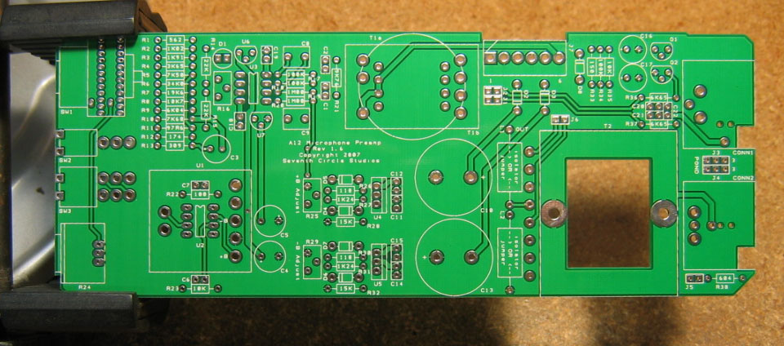

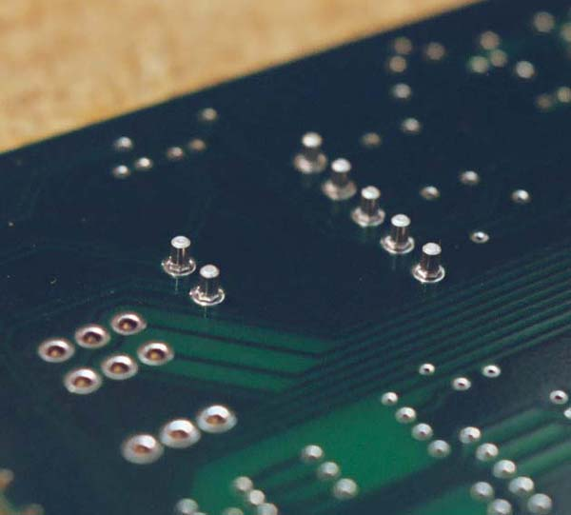
- The first components to place are the Mill-Max receptacles. Press them into the holes using the point of a Philips screwdriver or similar tool. Be sure to support the board from behind while applying pressure. Push the sockets in firmly until they're flush with the board, and solder them from the back.

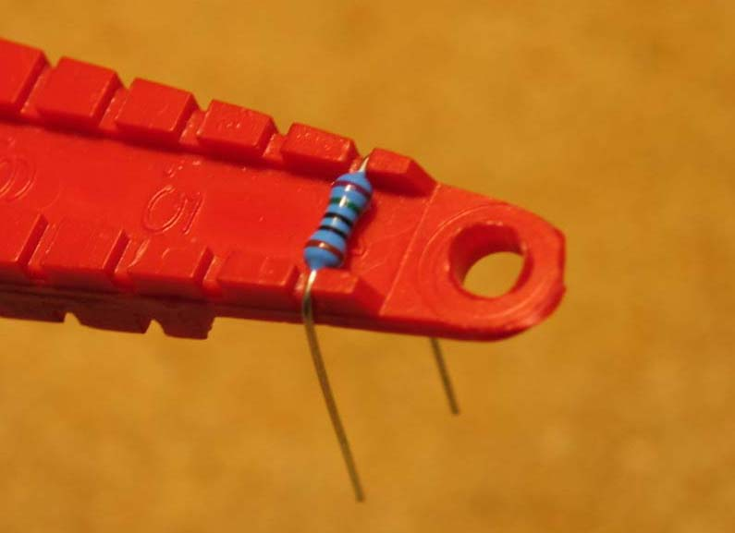
- Before installing the resistors, prepare the leads using small needle nose pliers or a lead-forming tool as shown below. Whatever you do, don’t bend the leads at the resistor body and force them into the board. This not only results in an ugly job, it can damage the parts. The resistors should be uniformly level and flush with the board.
- Install the 1/4-watt resistors. Check the Bill of Materials (BOM) for help in reading the resistor color bands. It's also a good idea to actually measure each resistor with your DMM as you place it on the board, just in case you've read it wrong. Don't rely on the photos for component placement. If the resistor value silk-screened on the board doesn't agree with the value on the schematic or parts list, follow the schematic. For the standard A12 with a discrete op-amp, don’t install anything at R20 or R22. If you are not using the optional load isolators at L1 and L2, install jumpers at L1 and L2 instead.
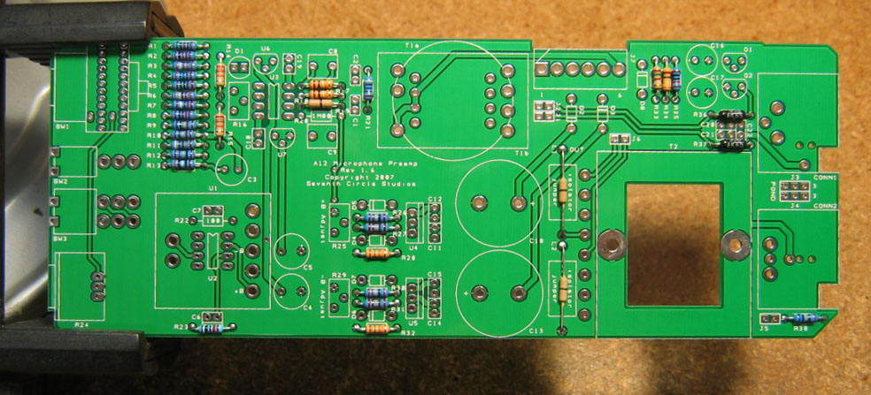
- Next, add the protection diodes D2 – D8. Diodes are polarized and must be installed the right way round! The colored band on the diode matches the white band on the silkscreen.
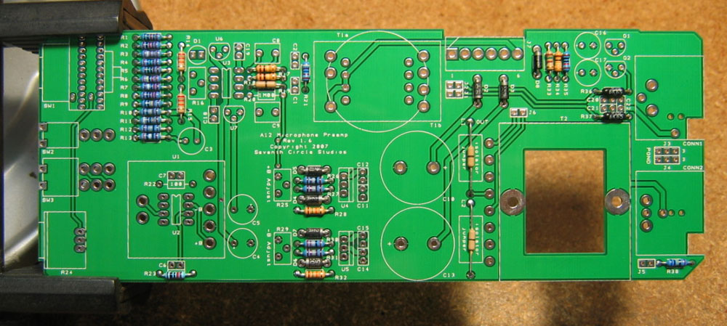
- Add the ceramic capacitors C1, C6, C11, C12, C14, C15, and C20 – C22. These capacitors are not polarized and can be installed in either direction, but pay close attention to the capacitor markings! These parts all look alike, but they are not interchangeable. Putting one in the wrong spot will not prevent the preamp from passing signal, but it can seriously impair its performance. For the standard A12 with a discrete op-amp, don’t install anything at C2, C7, C18, or C19.
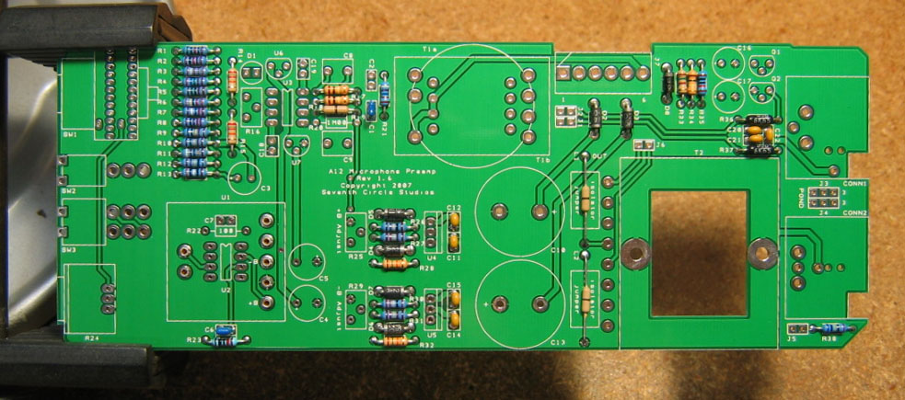
- Add film capacitor C8. This capacitor is not polarized and can be installed in either direction.
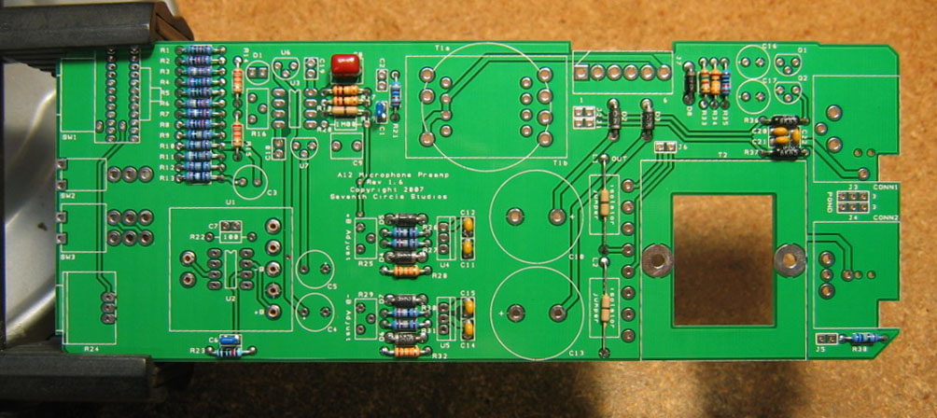
- Add the 0.1" headers. You may find it easier to handle the headers if you attach the shorting jumpers before soldering. Install the headers with the long pins up! The function of the headers is as follows:
J1 and J2 - When using an input transformer with split primaries, these headers select the input impedance by allowing the two halves of the primary to be connected either in series or in parallel. For the standard A12, J1 and J2 are not needed! Do not install headers at J1 and J2.
J5 connects a 604-ohm load resistor across the output. Unless you’ll be connecting the A12 to a piece of older gear with 600 ohm input impedance, connect a shorting jumper across J5
J6 - A separate, isolated output signal is available at this header. The amplitude at J6 is half the amplitude at CONN2.

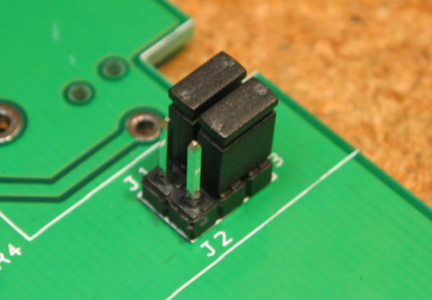
J3 and J4 connect pin 1 of CONN1 and CONN2 to ground as shown in the table. Unless you encounter issues with ground loop hum, jumper pins 2 and 3 on both headers as shown. A jumper must be installed at J3 to complete the phantom power circuit.
Jumper | Pins 1 and 2 | Pins 2 and 3 | No Jumper
J3 – CONN1 | PGND | CGND | Floating
J4 – CONN2 | PGND | CGND | Floating
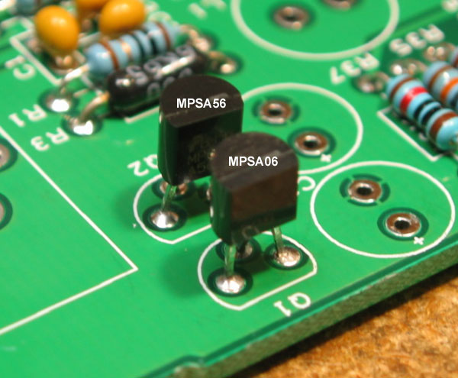
- Install Q1 and Q2. Be sure to orient the transistors correctly! These parts are not the same and are not interchangeable. Align the flat side of the transistor with the flat side of the silkscreen outline.

- Attach D1, the LED. LEDs are polarized and must be installed the right way round! Align the flat side of the LED with the flat side of the silkscreen outline. Wiggle the LED until it’s flush with the board. The LED provides a stable voltage reference for the offset correction circuit.
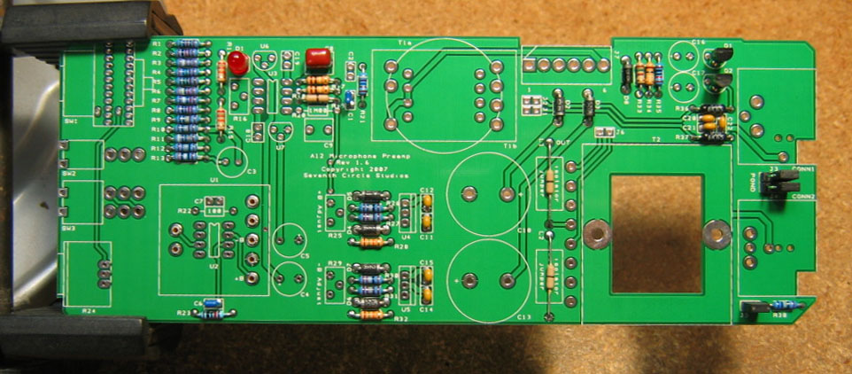
- Install trim pots R16, R25, and R29. These parts are not the same and are not interchangeable! Pay close attention to the component markings.
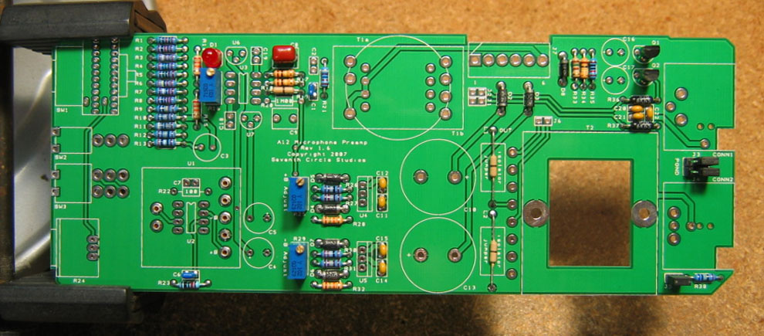
- Add aluminum electrolytic capacitor C3. Aluminum electrolytic capacitors are polarized and must be installed the right way round! Be absolutely sure to observe the correct polarity when installing this part. The negative lead of the capacitor is marked with a colored stripe. The positive pad on the circuit board is marked with a small "+" sign.
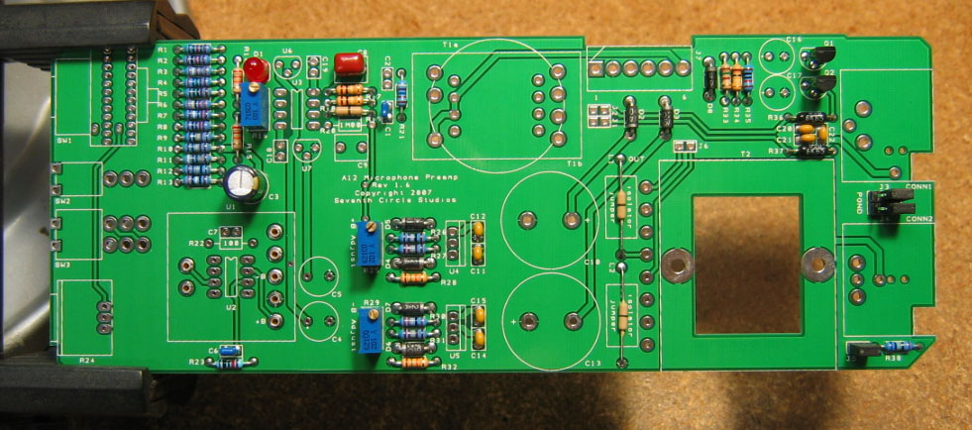
- Add tantalum bypass capacitors C4 and C5. Tantalum electrolytic capacitors are polarized and must be installed the right way round! Be absolutely sure to observe the correct polarity when installing these parts. The positive leads of the tantalum caps are marked with a small "+" sign. The positive pads on the circuit board are marked with a small "+" sign.
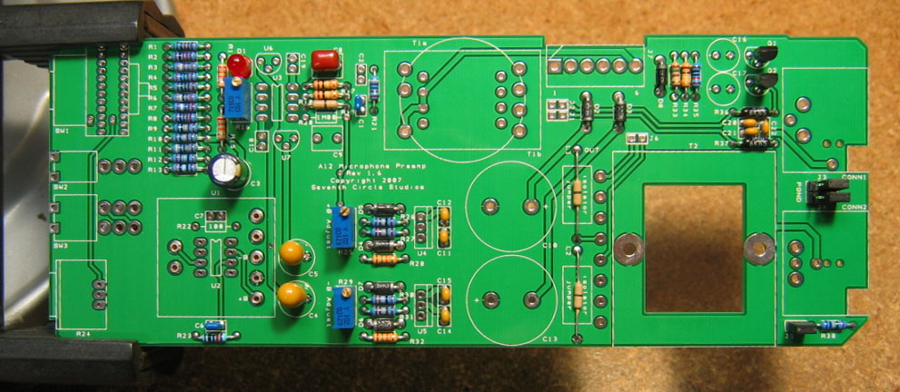
- Carefully mount the toggle switches. Be sure they're seated flat on the board before soldering all of the pins. You may find it easier to solder the first pin with the board component side up.
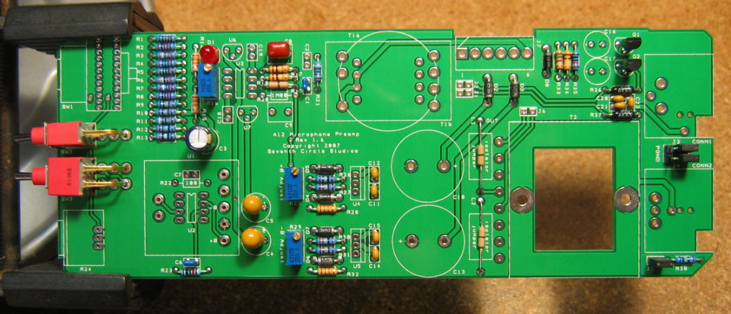
- Add J7, the MOLEX power connector. Be sure to orient it as shown, with the locking tab away from the edge of the board.
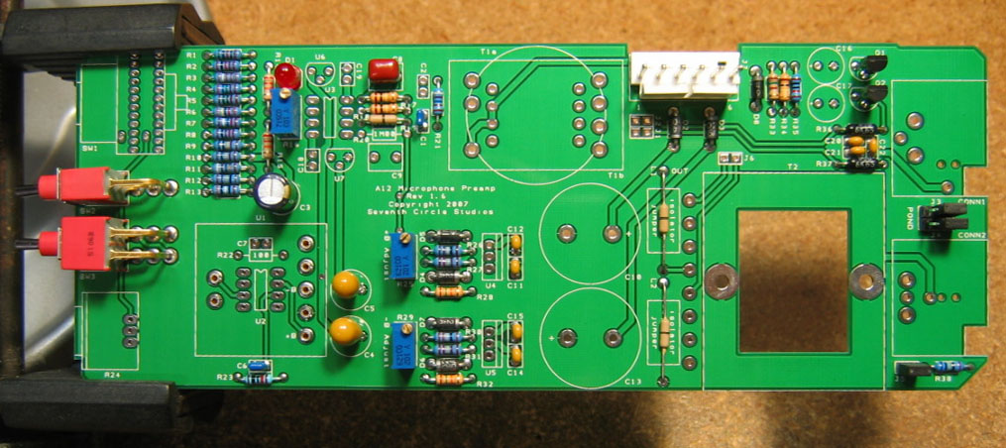
- Install C16 and C17, the phantom power filter caps. Aluminum electrolytic capacitors are polarized and must be installed the right way round! Again, be absolutely sure to observe the correct polarity when installing these parts. The negative leads of the electrolytic caps are marked with a colored stripe. The positive pads on the circuit board are marked with a small "+" sign.
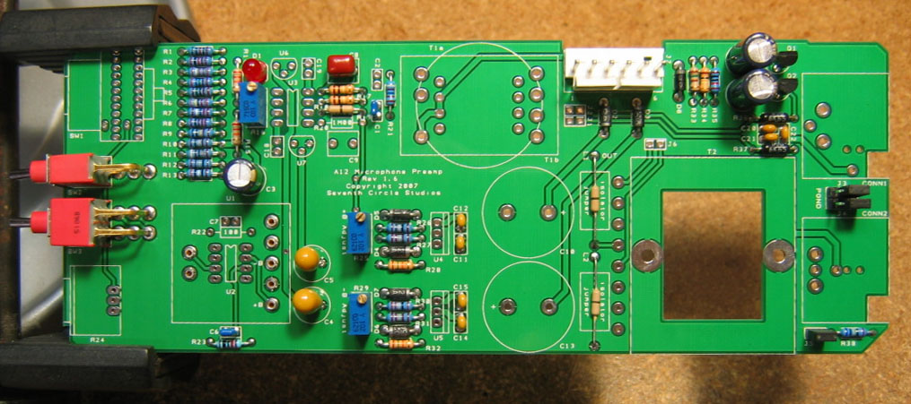
- Attach gain trim control R24. Make sure the control is seated flat to the board before soldering the leads. You may want to add a small dab of silicone adhesive to the bottom of the control to hold it more securely.
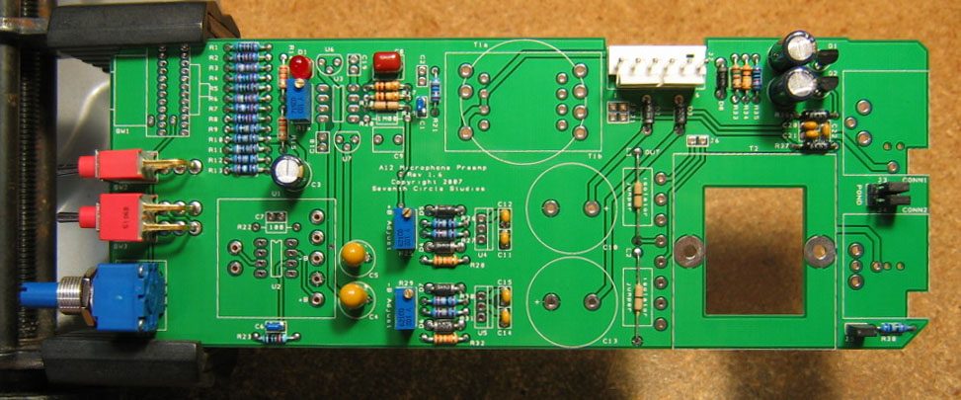
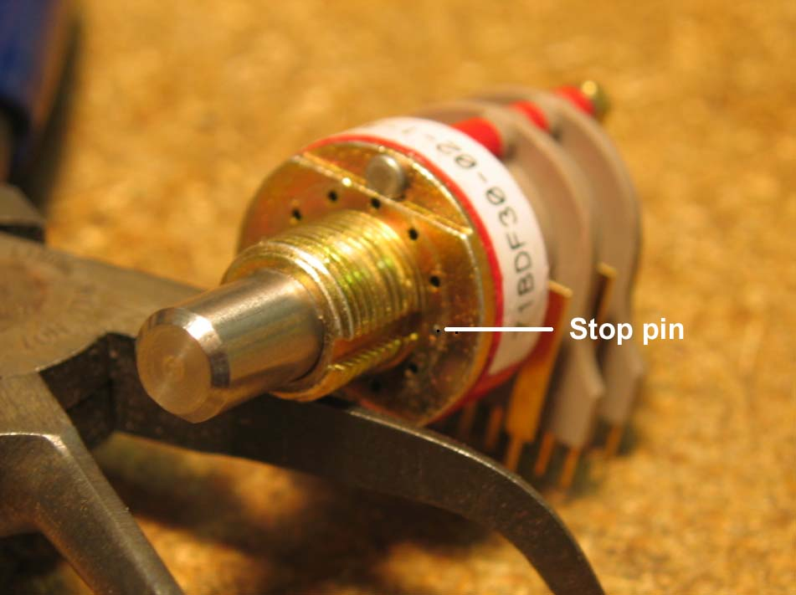
- Insert the stop pin in rotary switch SW1 at the position shown. Push the pin in completely.
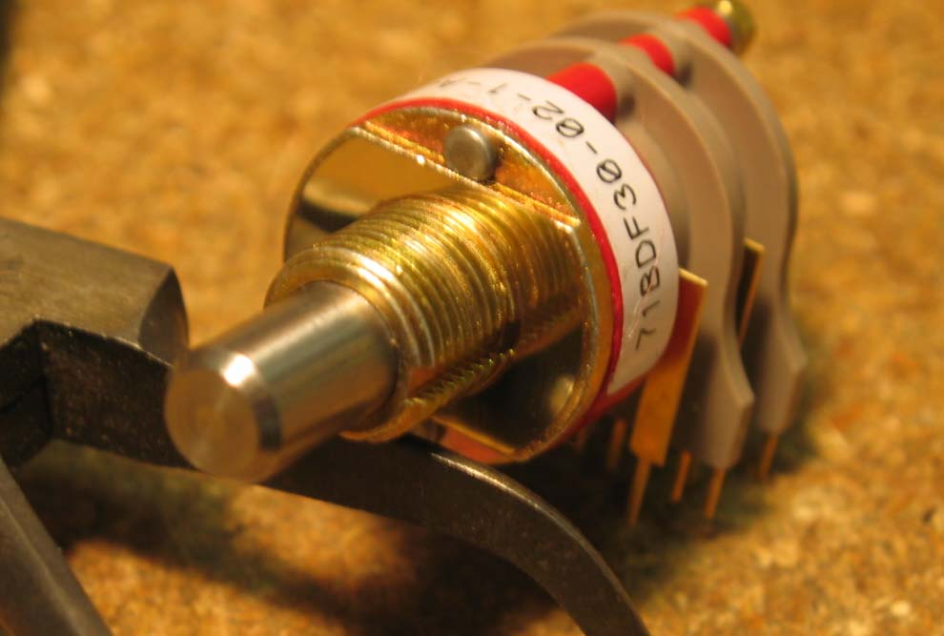
- Secure the pin with the adhesive foil supplied.
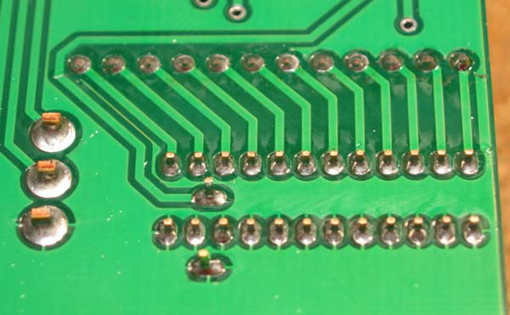
- Make sure the switch is fully seated and solder it to the board. Try to make your solder joints as neat as possible, and don’t use too much solder.
- Carefully thread the mounting holes of CONN1 and CONN2 using one of the included 4-40 screws or a tap as shown. This prevents any possibility of damage to the connectors during final assembly.
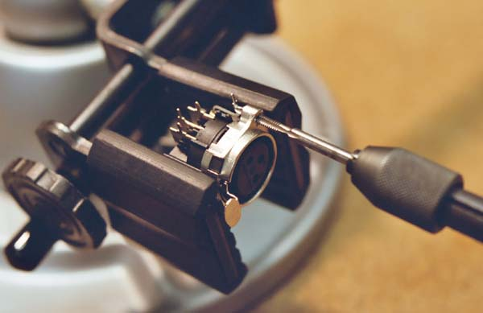

- Add CONN1 and CONN2 to the board. Make sure they’re fully seated before soldering.
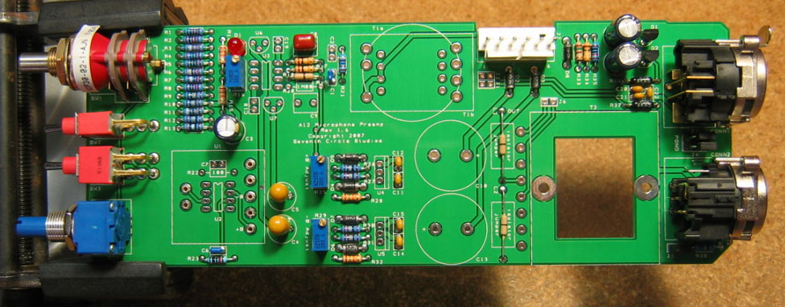
- Attach the input transformer T1. Don't forget to install the gray fish paper insulator under the transformer. Pin 1 on the transformer is clearly indicated with a red dot.
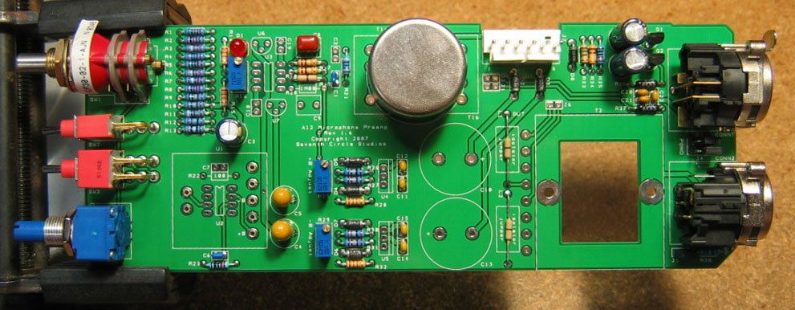
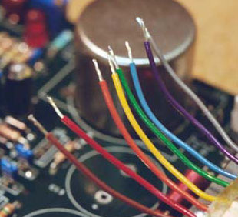
- Using two #4-40 x 1" screws, attach the output transformer to the board. Place a 1/8" spacer on each screw between the transformer and the circuit board. Secure each screw with a #4 keps nut. Trim the leads to length, then strip and tin them with solder as shown. Tinning the leads makes them easier to manage in the next step.

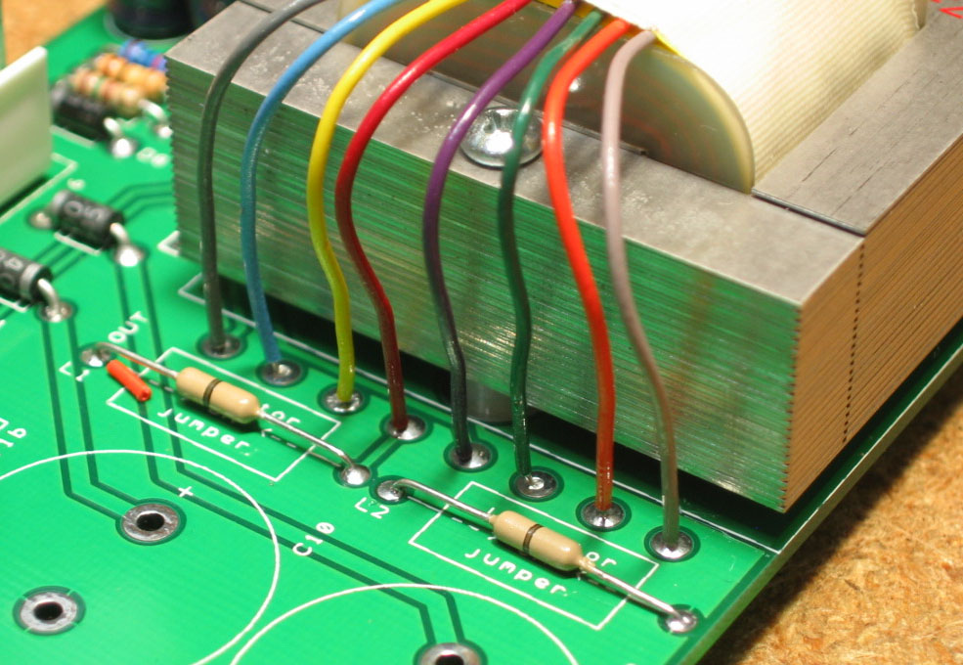
- Solder the transformer leads to the circuit board as shown. The wire color is silk-screened next to each pad. The leads should not cross over and should be trimmed to the length shown. Do not leave the leads un-trimmed.

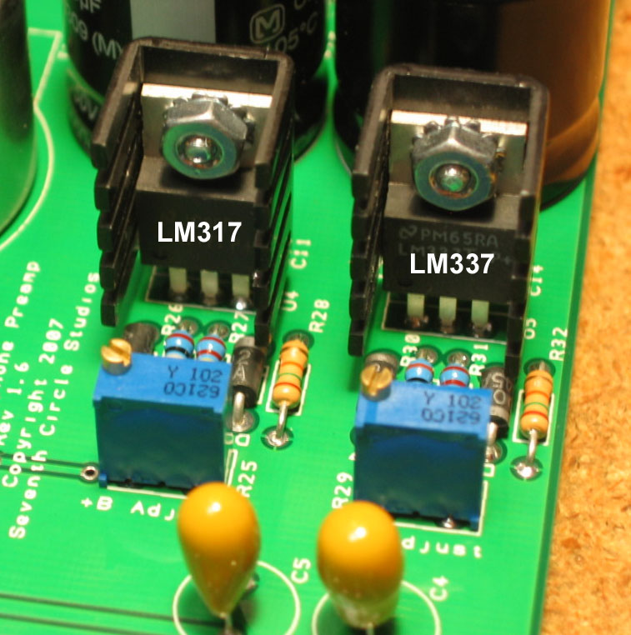
- Using the hardware supplied, attach heat sinks to U4 and U5 and solder them in place. Make sure to install the regulators correctly! These parts are not the same, and are not interchangeable. Align the regulator tab with the double line on the silkscreen outline. Don’t swap the positive and negative regulators, or mount them backwards!
- Install the bulk filter capacitors C10 and C13. Push them in firmly until they are fully seated against the board. Again, electrolytic capacitors are polarized and must be installed the right way round! Be absolutely sure to observe the correct polarity when installing these parts.
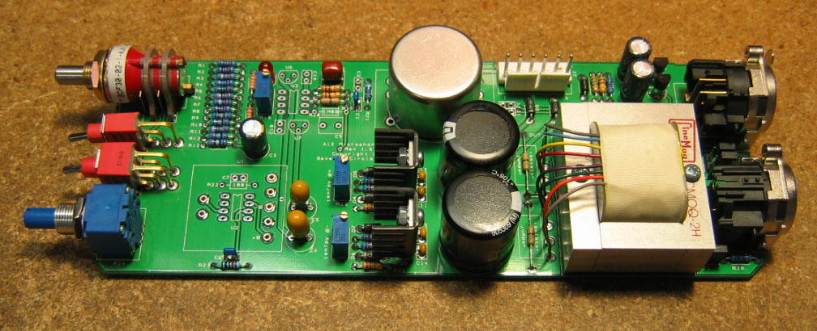
- That's it! Before going on to initial power-up, carefully check your work. Make sure you haven't created any solder bridges between pads, or between a pad and the ground plane.

Initial Power-Up and Testing.
- Again, carefully check your work. Make sure you've got the right resistors in the right locations. Make absolutely sure you've got all the diodes and electrolytic capacitors soldered in the right way round! Double check to make sure you haven’t inadvertently swapped the voltage regulators or trim pots. Check for poor solder joints and solder bridges, and make sure you fix any problems before continuing.
- Just to make sure you haven't created any blatant shorts, measure the resistance between pins 1 and 2 of J7. Do the same for pins 3 and 2. You should measure a very high resistance. If you measure a steady resistance under 100 ohms, don't apply power. Carefully check your work until you find that short.
- Turn R25 and R29 counter-clockwise 25 full turns or until you hear a soft click with every turn. This sets the regulators to their lowest voltage, about +/-14V.
- Connect the PS03 to J3. Simply wire the power supply connectors together in a 1:1 fashion. That is, PS03 J2, pin 1 to A12 J7 J3, pin 1, pin 2 to pin 2, etc. Set your DMM to measure DC voltages of 25V or greater, and turn on the power. Place the negative meter probe on U1, pin 4, and measure the voltage between U1, pin 4 and U1, pin 3. You should see about +14V. Keep the negative probe at pin 4, and measure the voltage at U1, pin 5. You should see about -14V. If these voltages are way off, you have problems. Possible things to check are incorrectly installed diodes D2 – D7, backwards caps C4, C5, C10 and C13, or shorts around U1, U2, and U3.
- With your DMM still set to read DC voltages of 24V or greater, adjust R25 and R29 for the proper working voltage for the op-amp you intend to use. The original API 2520 will be happiest with about +/-16V, though you can get away with a little more. If you’re using an SC25, +/-18V will provide a maximum output level of just about 30dBu.
- Remove power and allow the voltages at U1 to drop to 0V. Insert the op-amp in the socket and apply power. With your DMM set to the lowest voltage scale, measure the voltage between U1, pin 4 and the output at pin 6. Adjust R16 until this voltage drops to 0V. Wait for the op-amp to come up to working temperature, about 15 minutes or so, and adjust again. The offset voltage will drift slightly with temperature, but this will not be a problem with the great majority of op-amps.
- Congratulations! You've got a working A12 preamp.

Options
  - If you need to drive extremely long cables (greater than 50m) or know that you'll be connecting the preamp to capacitive loads (you probably won't), you may want to install Jensen "load isolators" at L1 and L2. Load isolators are optional and are not included in the kit.

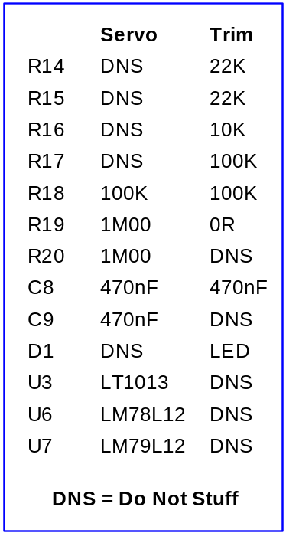
  - Rev 1.6 and higher of the A12 supports a DC servo that automatically corrects excessive DC offset produced by U1. To use the servo instead of the manual offset trim, install the components according to the table at right. The board should look like the photo below
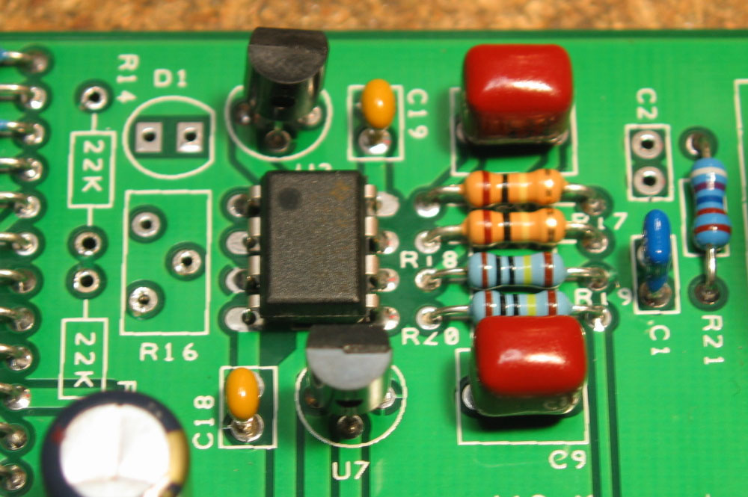

  - Rev 1.6 and higher of the A12 accepts IC op-amps as well as discrete op-amp modules. Depending on the type of IC, you may need to install a different compensation capacitor at C6 or an RC compensation network at R22 and C7. Consult the data sheets for the IC you’re using.
