Based on the innovative “Double Balanced Microphone Amplifier” circuit published by Graham John Cohen in 1984, the C84 microphone preamp offers exceptional performance in any application where extremely low distortion and neutral sonic characteristics are desired.

Who Should Build This Kit?
The C84 is not difficult to build, but it is not intended for beginners. If you’ve never built an electronic project before, this is definitely not the one to start with. To guarantee success, make sure you have:

- The ability to make basic voltage and resistance measurements using a digital multi-meter (DMM).
- At least a rudimentary understanding of voltage, current, and resistance.
- Some experience soldering on printed circuit boards.
- The patience to follow instructions precisely and work carefully.

Essential Tools
Fine tipped 20-30 watt soldering iron w/ cleaning sponge (Hakko 936 or similar)
Eutectic (63/37) rosin core or “no clean” solder (.025” diameter or smaller is best)
Good-quality DMM
Small needle nose pliers
Small diagonal cutters
Phillips screwdriver (#1)
Precision straight blade screwdriver (for adjusting potentiometers)

Highly Recommended Tools
Lead bender (Mouser 5166-801)
T-Handle wrench and 4-40 tap (Hanson 12001 and 8012)
MOLEX crimp tool (Waldom W-HT1919 or equivalent)
Magnifying glass
Optional Tools
Panavise w/ circuit board head
Oscilloscope
Signal generator
Work Area
Find a clean, flat, stable, well-lit surface on which to work. An anti-static mat is recommended for this project. If you’re in a dry, static-prone environment, it’s essential. The importance of good lighting can’t be overstated. Component markings are tiny, and you’ll be deciphering a lot of them.
Soldering Technique
Make sure your irons tip is tinned properly, and keep it clean! The trick to making perfect solder joints is to heat the joint quickly and thoroughly before applying the solder, and a properly tinned and clean tip is essential for this. Apply enough solder to form a "fillet" between the lead and the pad, a little mound of solder that smoothly transitions from the plane of the board up to the lead, but don’t use too much. The finished joint should be smooth and shiny, not rough or gritty looking.

If you've never soldered a board with plated-through holes, you might be surprised to discover how difficult it can be to remove a component once you've soldered it in place. If you're using solder wick to correct a mistake, be very careful not to overheat the pads, since they will eventually delaminate and "lift". It's often better to sacrifice the component and remove its leads individually, and start over with a new part. If for some reason you need to unsolder a multipin component (like a rotary switch or integrated circuit), remove as much solder as you can with solder wick or a solder sucker, and then use a small heat gun to heat all the leads simultaneously. With care, you can remove the component without damaging the board.
Instruction Conventions
Text in orange indicates a step where extra care needs to be taken. Doing it wrong isn’t a disaster, but it’ll need to be corrected.
Text in red indicates a step that must be done correctly. Doing it wrong will guarantee improper operation, and probably damage components and/or the circuit board.
Assembly
- Before you begin, carefully unpack the kit and examine the parts. Check the contents of each small bag against the BOM to make sure all the parts have been included. If you think something’s missing, please e-mail the details to sales@seventhcircleaudio.com and we’ll ship replacement parts ASAP.
- Generally, the idea when "stuffing" or “populating” a circuit board by hand is to start with the lowest profile parts, such as the resistors, and work your way up to the taller components. In each step below, insert the components, flip the board onto your work surface component-side down, and carefully solder and trim the leads. Use a piece of stiff cardboard to hold the parts in place while you flip the board. First, orient the board as shown.
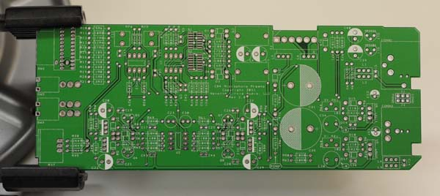
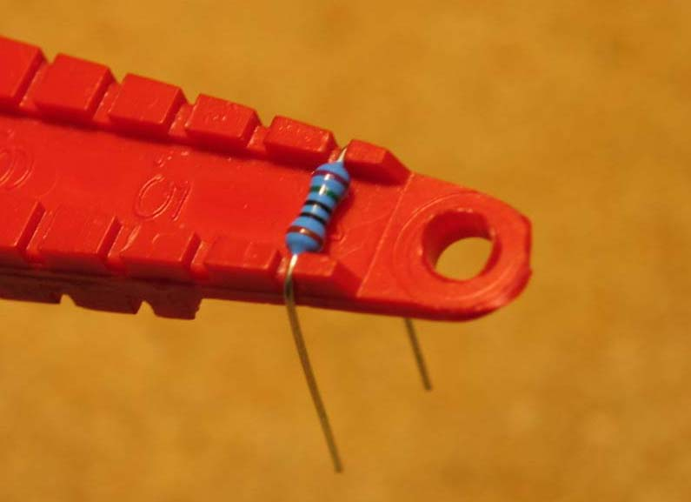
- Before installing the resistors, prepare the leads using small needle nose pliers or a lead-forming tool as shown below. Whatever you do, don’t bend the leads at the resistor body and force them into the board. This not only results in an ugly job, it can damage the parts.
- Insert the 1/4-watt resistors. Check the Bill of Materials (BOM) for help in reading the resistor color bands. It's also a good idea to actually measure each resistor with your DMM as you place it on the board, just in case you've decoded it incorrectly. Don't rely on the photos for component placement. If the resistor value silk-screened on the board doesn't agree with the value on the schematic or parts list, follow the schematic.
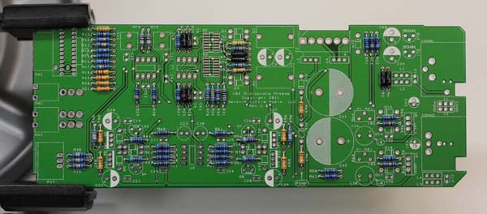

- Next, add the protection diodes D1 through D19. Diodes are polarized and must be installed the right way round! The colored band on the diode matches the white band on the silkscreen.
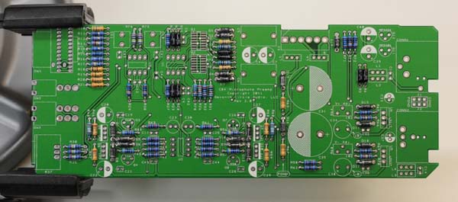
- Add the small ceramic capacitors. These capacitors are not polarized and can be installed in either direction, but pay close attention to the capacitor markings! These parts all look alike, but they are not interchangeable. Putting one in the wrong spot will not prevent the preamp from passing signal, but it can seriously impair its performance.
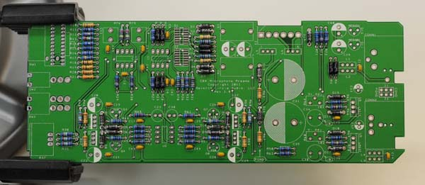

- Install Q1 and Q2 now. Start by flowing a small amount of solder on two pads only as shown.
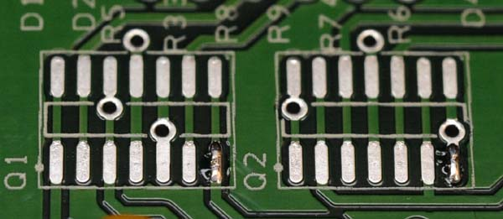
- Carefully position the part over the pads and re-flow the solder to tack it in place. Pay close attention to the IC markings. Align the dot on the IC with the dot on the silkscreen outline!
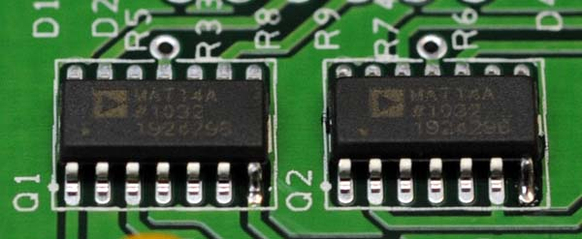

- Flow solder onto the rest of the pads. Use a flux pen or liquid flux for best results.
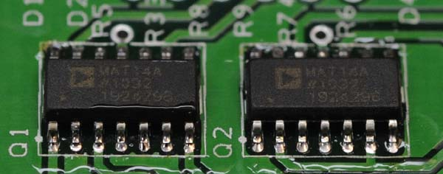
- Install U1, U2, and U3 now. Pay close attention to the IC markings. Align the notch on the IC with the notch on the silkscreen outline! IC sockets are not included in the kit and are not recommended. Socketing the ICs will interfere with the ability of the PC board to conduct heat away from the parts.
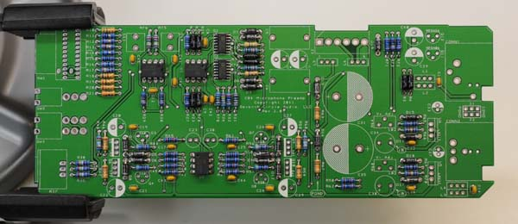
- Install the ferrite filters now. These parts are not polarized and can be installed in either direction.
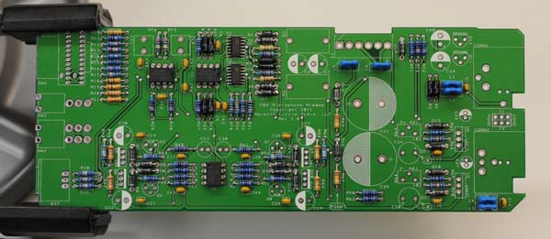

- Install the 1uF film caps at C10 and C11. These parts are not polarized and can be installed in either direction.
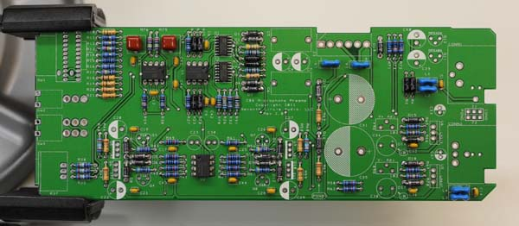

- Add small transistors Q3, Q4, Q7, and Q8. These parts are not the same, and are not interchangeable. Align the flat side of the transistors with the flat side of the silkscreen outline.
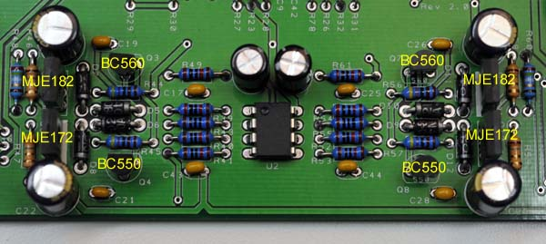

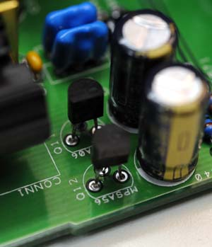
- Add Q11 and Q12. Again, these parts are not the same, and are not interchangeable. Align the flat side of the transistors with the flat side of the silkscreen outline.

- Add the 0.1” headers and shorting jumpers at J1 and J2. The jumpers connect the XLR cable shields as shown in the table below. Unless you encounter issues with ground loop hum, jumper pins 2 and 3 on both headers. A jumper must be installed at J1 to complete the phantom power circuit.
Jumper Location | Pins 1 and 2 | Pins 2 and 3 | No Jumper
J1 - Mic input | Power Ground | Chassis Ground | Floating
J2 - Line output | Power Ground | Chassis Ground | Floating
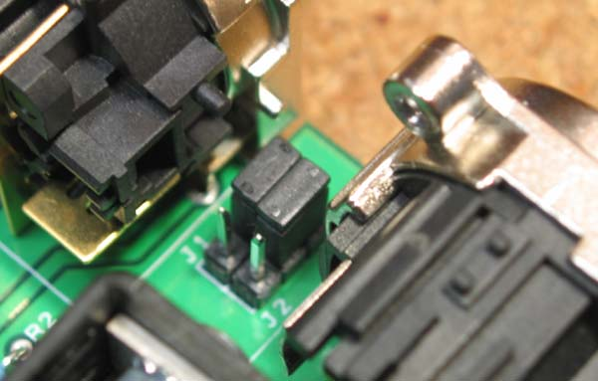

- Add the trim pots R64 and R68. R64 and R68 are used to adjust the on-board voltage regulators as described later.
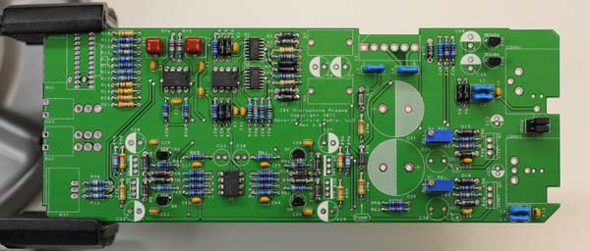

- Add tantalum capacitors C34 and C38. Tantalum electrolytic capacitors are polarized and must be installed the right way round! Be absolutely sure to observe the correct polarity when installing these parts. The positive leads of the tantalum caps are marked with a small "+" sign. The positive pads on the circuit board are marked with a small "+" sign.
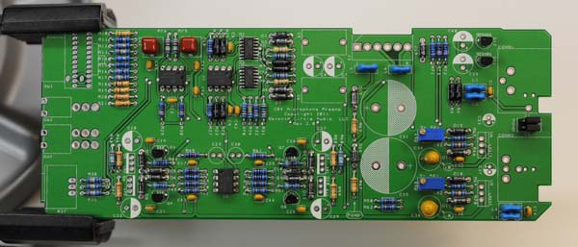
- Add the short electrolytic capacitors now. C23 and C30 are not polarized, but the rest are and must be installed the right way round! Be absolutely sure to observe the correct polarity when installing these parts. The negative leads of the electrolytic caps are marked with a colored stripe. The positive pads on the circuit board are marked with a small "+" sign.
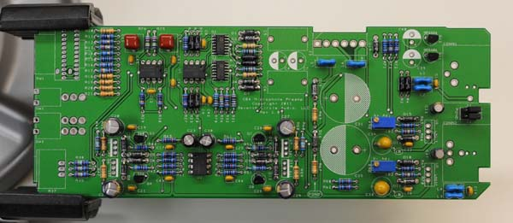

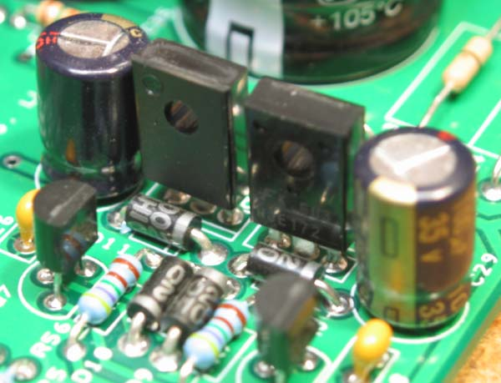
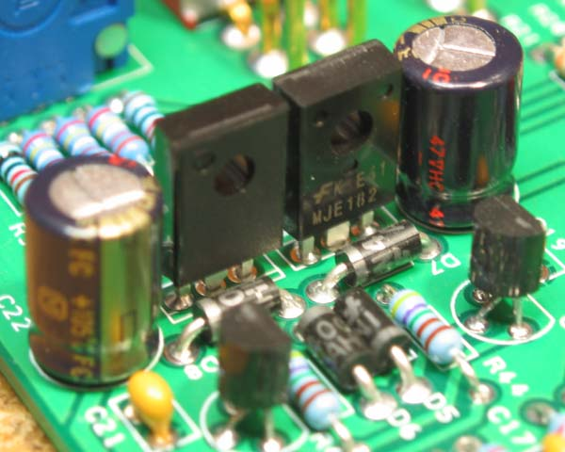
- Add transistors Q5, Q6, Q9, and Q10. Make sure to install the transistors correctly! These parts are not the same, and are not interchangeable. The heavy line on the silkscreen outline indicates the back of the transistor, the side without markings. Make absolutely sure you don’t insert them backwards.

- Carefully mount the toggle switches SW2 and SW3. Be sure they're seated flat on the board before soldering all the pins. You may find it easier to solder the first pin with the board component side up.
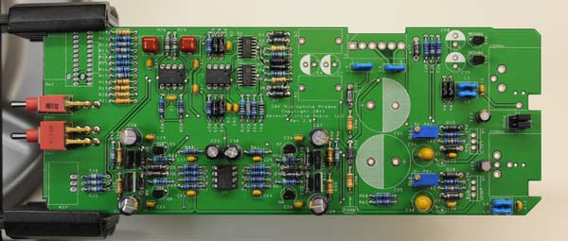

- Add J3, the MOLEX power connector. Be sure to orient it as shown, with the locking tab away from the edge of the board.
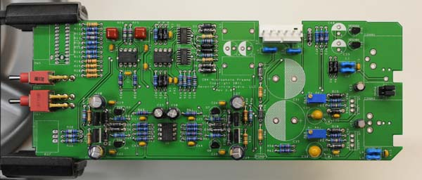
- Add electrolytic capacitors C4, C7, C39 and C40. Again, electrolytic capacitors are polarized and must be installed the right way round! Be absolutely sure to observe the correct polarity when installing these parts. Add polypropylene capacitors C5 and C6 as well.
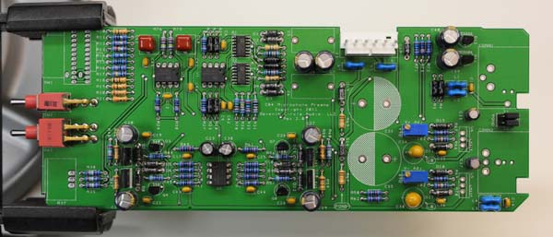

- Add polypropylene capacitors C5 and C6. Be sure to not overheat the leads, as these parts are susceptible to damage from excess soldering heat.
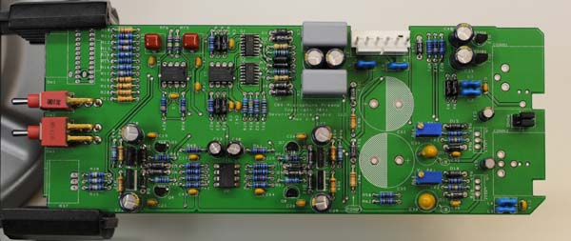
- Using the hardware supplied, attach heat sinks to U5 and U6 and solder them in place. Make sure to install the regulators correctly! These parts are not the same, and are not interchangeable.
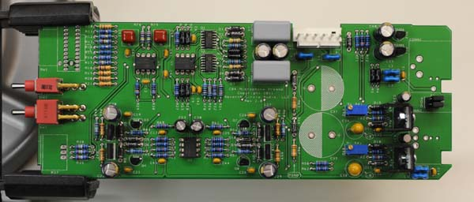

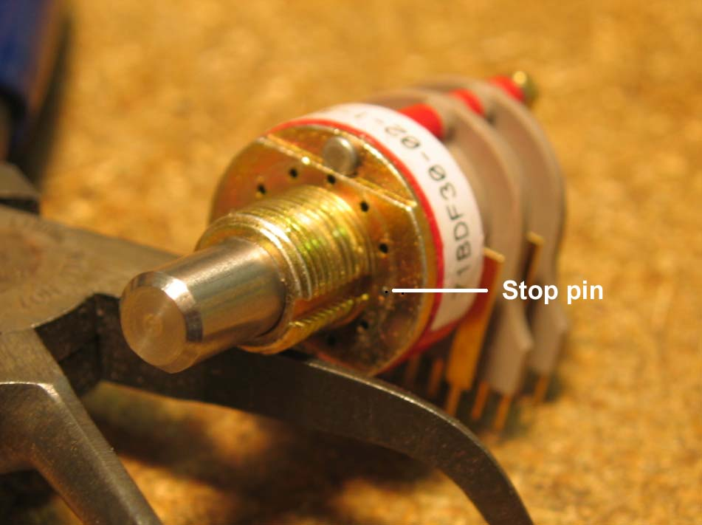
- Insert the stop pin in rotary switch SW1 at the position shown. Push the pin in completely.

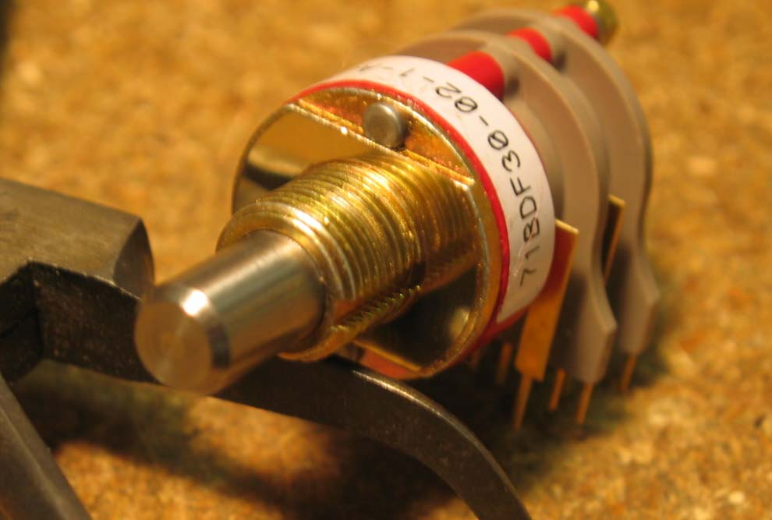
- Secure the pin with the adhesive foil supplied.

- Make sure the switch is fully seated and solder it to the board. Try to make your solder joints as neat as possible, and don’t use too much solder.
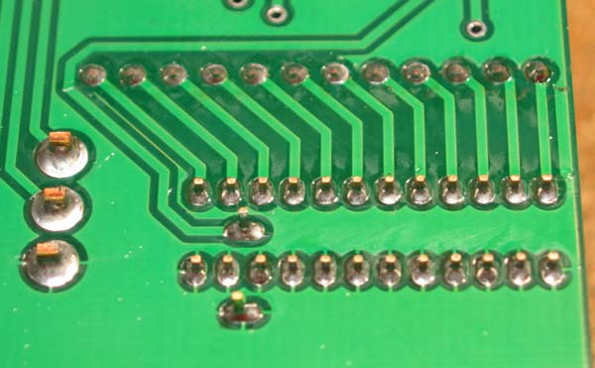

- Attach gain trim control R37. Make sure the control is seated flat to the board before soldering the leads. You may want to add a small dab of silicone adhesive to the bottom of the control to hold it more securely.
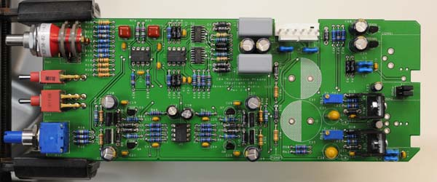

- Add CONN1 and CONN2 to the board. Make sure they’re fully seated before soldering.
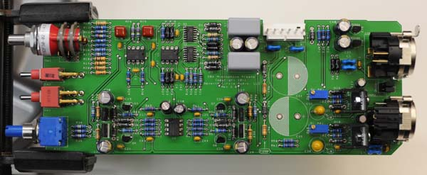

- Install the bulk filter capacitors C31 and C35. Push them in firmly until they are fully seated against the board. Again, electrolytic capacitors are polarized and must be installed the right way round! Be absolutely sure to observe the correct polarity when installing these parts.
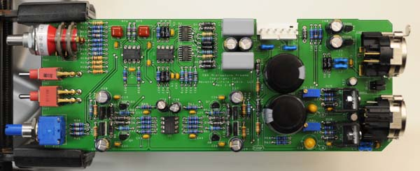

- Before going on to initial power-up, carefully check your work. Make sure you haven't created any solder bridges between pads, or between a pad and the ground plane.

Initial Power-Up and Testing.
- Again, carefully check your work. Make sure you've got the right resistors in the right locations. Make absolutely sure you've got all the transistors, diodes, and capacitors soldered in the right way round! Double check to make sure you haven’t inadvertently swapped a transistor or voltage regulator. Check for poor solder joints and solder bridges, and make sure you fix any problems before continuing.
- Just to make sure you haven't created any blatant shorts, measure the resistance between pins 1 and 2 of J3. Do the same for pins 3 and 2. If you measure a steady resistance of less than 100 ohms, don't apply power. Carefully check your work until you find that short.
- Turn R64 and R68 counter-clockwise 25 full turns, or until you hear a soft click with every turn. This sets the regulators to their lowest voltage, about +/-14V.
- Connect the PS03 to J3 on the C84 using a WH01 wire harness or similar. Verify that there are no crossed wires or loose crimps in the harness. Be sure the locking ramps engage.
- Set your DMM to measure DC voltages of 20V or greater, and turn on the power. Clip the negative meter probe to the PGND test point at the bottom of R67, and measure the voltage at the +B test point at C34. You should see about +14V.
- With the negative probe still connected to PGND, measure the –B test point at C38. You should see about -14V.
- If the voltages measured in the two previous steps are off by more than a volt or so, you have problems. Possible things to check are incorrectly installed diodes D13-D18, backwards caps C34, C38, C31, and C35, or shorts around U5, and U6.
- With your DMM still set to read DC voltages of 20V or greater, adjust R64 and R68 for +18V at +B and –18V at -B. If you need more headroom, the OPA2604s will withstand as much as +/-24V.
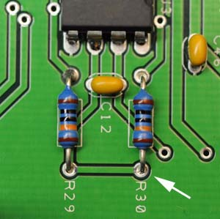
- Verify that the common mode servo is working by measuring the voltage at the junction of R29 and R30 as shown. You should see a voltage within a few millivolts of 0V.
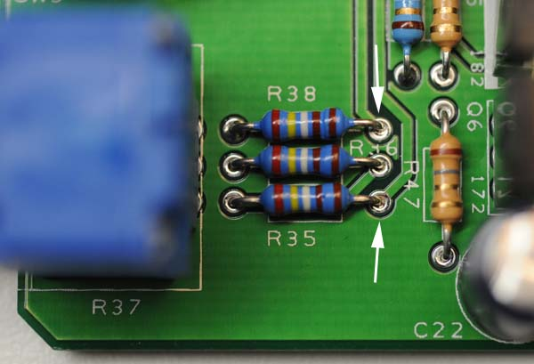
- Verify that the differential mode servo is working by measuring the voltage between R35 and R38 as shown. You should see a DC voltage below 50mV.

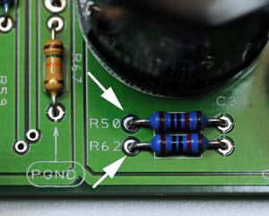
- Verify that the output buffer is working by measuring the voltage between R50 and R62 as shown. The voltage should be similar to that measured in the last step.
- Congratulations! You've got a working C84 preamp.

