The CH01 is a sturdy steel and aluminum chassis designed specifically to house SCA preamp modules.

Who Should Build This Kit?
The CH01 is not difficult to assemble, but it is not intended for absolute beginners. If you’ve never built an electronic project before, this is probably not the one to start with. To guarantee success, make sure you have:

- The ability to make basic voltage and resistance measurements using a digital multi-meter (DMM).
- At least a rudimentary understanding of voltage, current, and resistance.
- Some experience soldering on printed circuit boards.
- The patience to follow instructions precisely and work carefully.

Essential Tools
Fine tipped 20-30 watt soldering iron w/ cleaning sponge (Hakko 936 or similar)
Eutectic (63/37) rosin core or “no clean” solder (.025” diameter is usually best)
Small needle nose pliers
Small diagonal cutters
Wire stripper
Phillips screwdriver (#1)
Allen Wrench (4mm)

Highly Recommended Tools
T-Handle wrench and 4-40 tap (Hanson 12001 and 8012)
MOLEX crimp tool (Waldom W-HT1919 or equivalent)
Hole reamer
Countersink
Small heat gun
1/4" nut driver
Work Area
Find a clean, flat, stable, well-lit surface on which to work. An anti-static mat is recommended for this project. If you’re in a dry, static-prone environment, it’s highly recommended. The importance of good lighting can’t be overstated.
Soldering Technique
Make sure your iron's tip is tinned properly, and keep it clean! The trick to making perfect solder joints is to heat the joint quickly and thoroughly before applying the solder, and a properly tinned and clean tip is essential for this. Apply just enough solder to thoroughly encapsulate the joint, but don’t use too much. The finished joint should be smooth and shiny, not rough or gritty looking.

Instruction Conventions
Text in orange indicates a step where extra care needs to be taken. Doing it wrong isn’t a disaster, but it’ll need to be corrected.
Text in red indicates a step that must be done correctly. Doing it wrong will guarantee improper operation, and probably damage components and/or the circuit board.
Assembly
- Before you begin, carefully unpack the kit and examine the parts. Check the contents of each small bag against the BOM to make sure all the parts have been included. If you think something’s missing, please e-mail the details to sales@seventhcircleaudio.com and we’ll ship replacement parts ASAP.
- Arrange the chassis on the bench as shown.
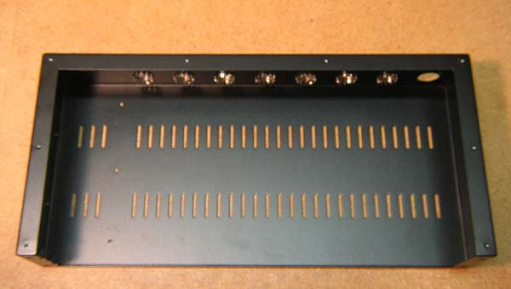

- Thread the mounting tabs at the left front of the chassis using a 4-40 tap or self-tapping screw.
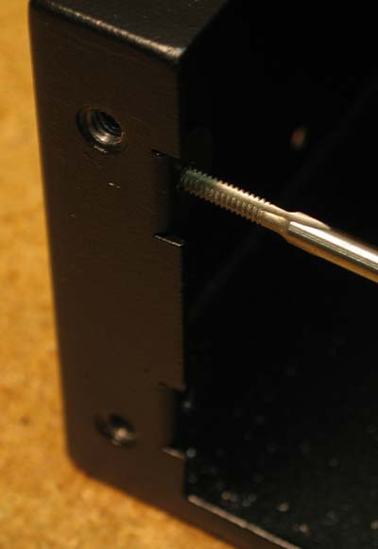

- Use a countersink to remove the paint from the countersunk screw holes in the chassis.
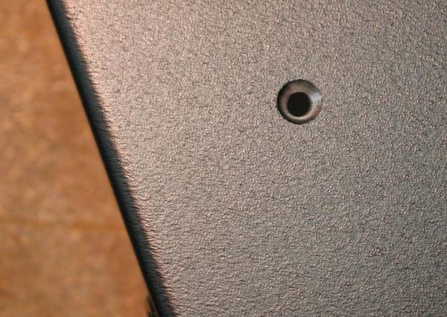

- Attach four 3/4” standoffs to the bottom of the PS03 using 6-32 x 3/8” screws. Carefully maneuver the supply into place.
- Use two 4-40 x 3/8” screws and Kepps nuts at the rear,
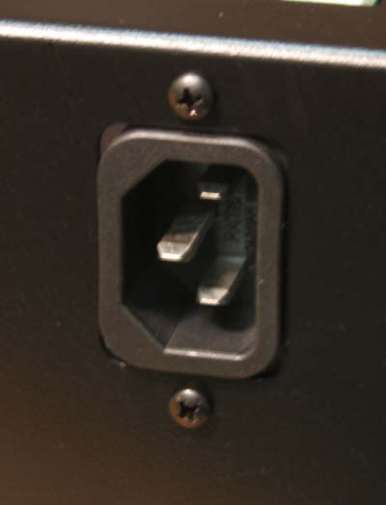

- four black 6-32 x 3/8” screws on the side,
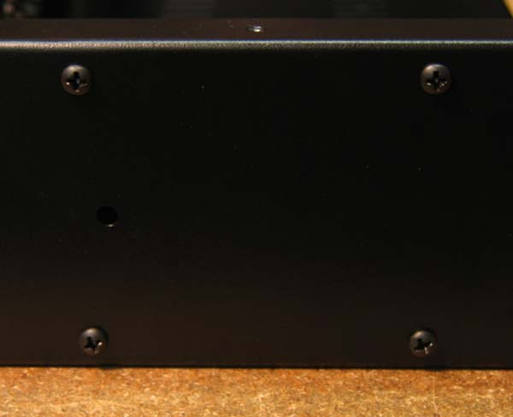

- and two 4-40 x 3/8” screws and nylon spacers at the front to secure the supply.
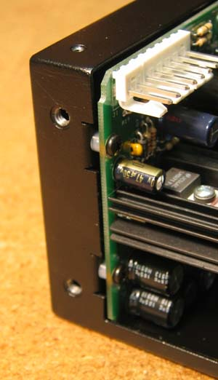

- Cut 4” of green wire. Strip ¼” of insulation from one end and ½” of insulation from the other.
- Firmly crimp the grounding lug to the ¼” end. If you don’t trust your crimp, solder the connection as well.
- Tin the ½” end with solder and bend as shown.
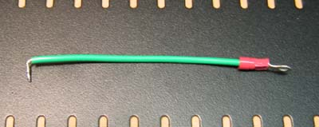

- Loop the ½” end through the power connector’s ground lug, solder, and trim the excess.
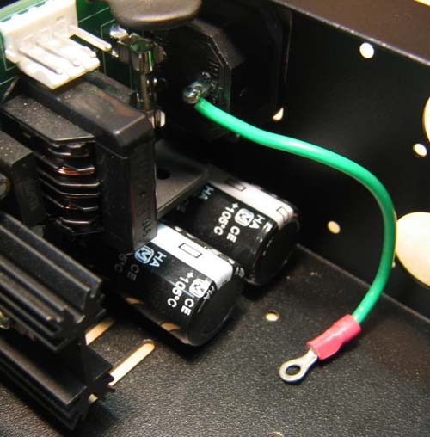

- Attach the mu metal shield to the divider using two pieces of double-sided tape, one on each side of the divider. Roughen the surface of the divider with sandpaper to insure good adhesion. Remove the backing from the flange side first. Carefully attach the shield, and then remove the backing from the other side of the divider. Press the shield into the tape firmly.
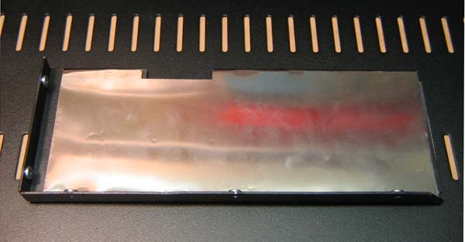

- Attach the divider using four 4-40 x ¼” screws and 1x 4-40 x 3/8” screw. Use the long screw at the bottom rear of the chassis.
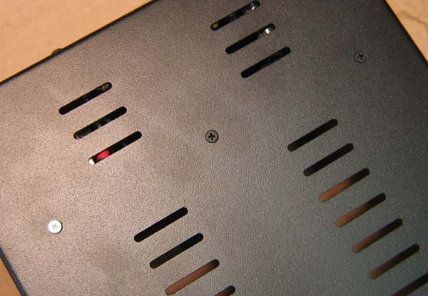
- Secure the ground lug to the long screw using a 4-40 Kepps nut.
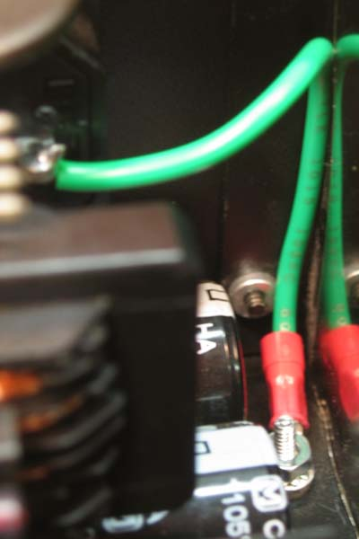

- Install the modules. Hook the connector release tabs through the top holes first, then gently but firmly wiggle each module into place until the boards rest on the bottom of the chassis.
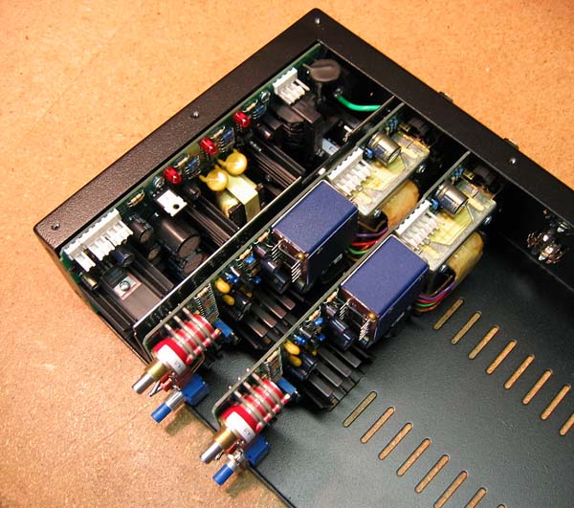
- Secure each module using 4x 4-40 x ¼” self-tapping screws.
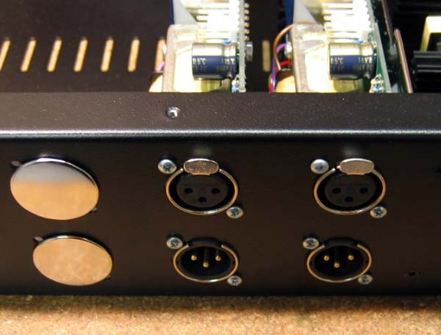

- Assemble the wiring harness. First, prepare the wires. Leave about 6” between module connectors, and about 14” between the PS03 and the first module. The exact measurement is not critical, but trim all the wires to the same length. Strip 1/8” of insulation from each end.
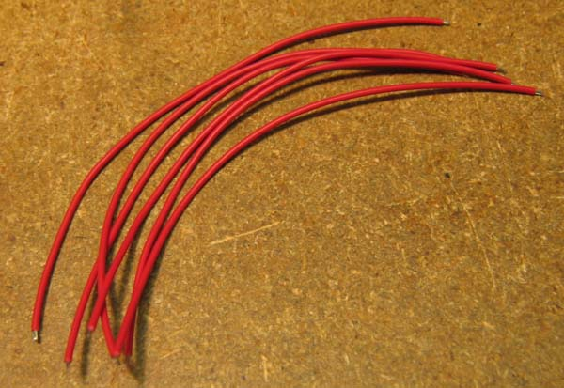

- Crimp the connectors to the wires in two stages. First, crimp the “inner” tangs around the bare wire. This crimp should be very tight.
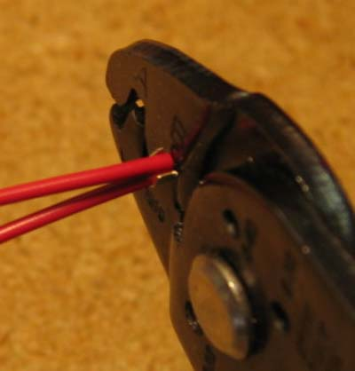

- Then, crimp the “outer” tangs around the insulation. This crimp only needs to be tight enough to secure the insulation. Don’t over crimp the insulation.
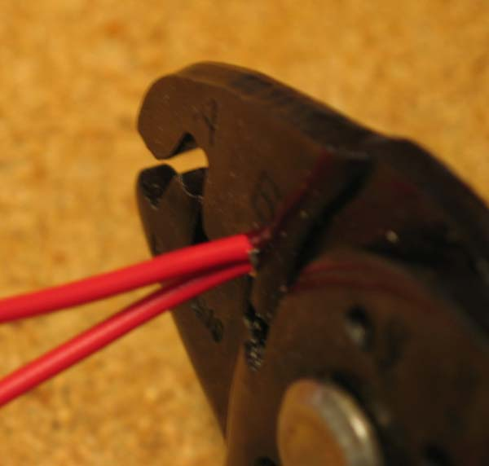

- The finished crimp should look at least as good as this. If you don’t trust your crimps, or for extra durability, solder the crimp connection.
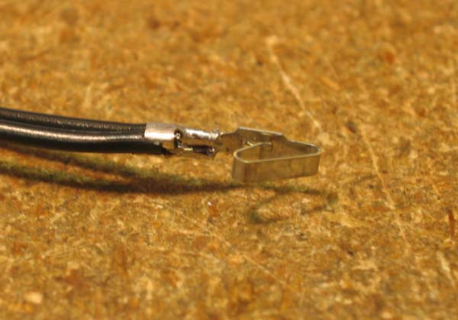

- Insert the crimp connectors into the 6-position housings until the locking tabs click into place. If you need to remove a crimp connector from the housing, simply depress the locking tab with a small screwdriver and push the connector out. Don’t install the power supply housing until later.
- Attach the ferrite core to one of the adhesive anchors using a wire tie and install as shown. Attach a second adhesive anchor about an inch away.
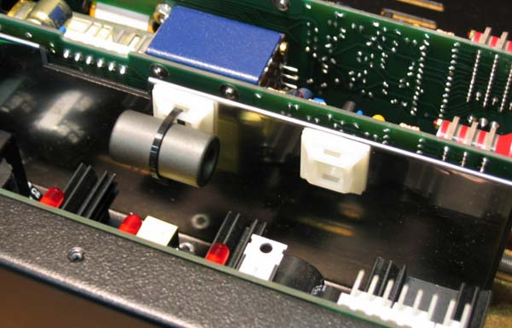

- Feed the wires through the ferrite core and attach the final 6-position housing. Plug in the rest of the power connectors and dress with wire ties as needed.
- Solder leads to the panel lamp, add crimp connectors, and insert into the 2-position housing as shown. The panel lamp is an LED and must be connected the right way round. The white paint dot indicates the positive terminal.
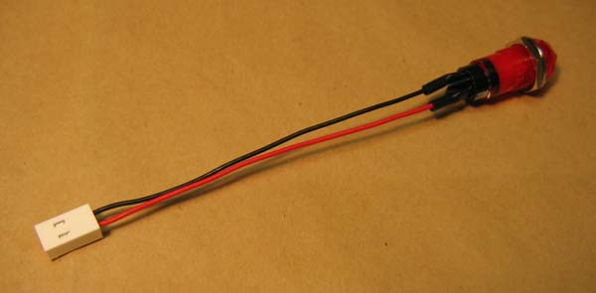

- Twist the leads and secure with wire ties as shown.
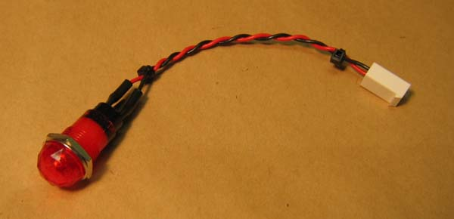

- Mount the toggle switch to the front panel with the keyway toward the bottom.
- Cut four 9” sections of wire, two brown and two blue, and solder to the switch as shown. Note the position of the keyed washer.
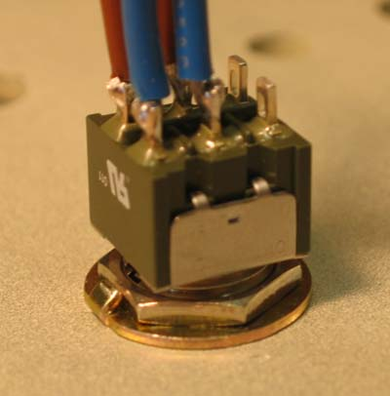
- Apply heat shrink to the connections.
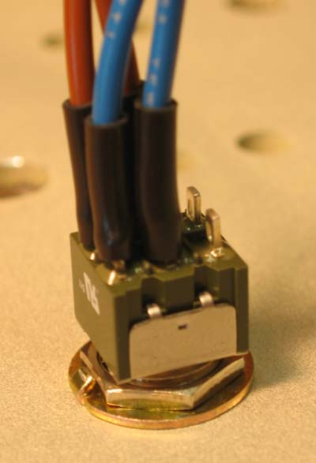

- Then apply heat shrink to the switch body.
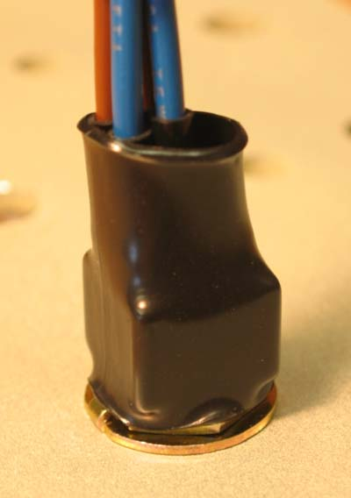

- Crimp terminals to the switch wires and insert into the 4-position housing as shown.
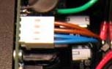

- Remove all nuts and washers from the module controls and tilt the chassis onto its back.
- Clean all paint from the panel holes using a reamer or similar tool. The gain switch and panel screw holes must be completely free of paint.
- Carefully maneuver the panel over the module shafts. Don’t force the panel over the bushings. The fit will be snug, but the panel will fit. Connect the switch and panel lamp as shown.
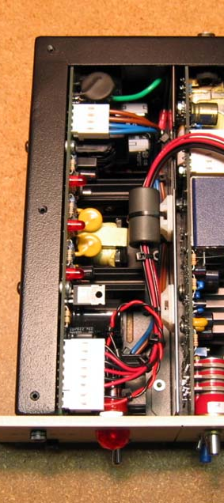

- Insert the front panel screws. Get them started, but don’t tighten them yet.
- Attach the top cover using eight 4-40 x ¼” flat head screws.
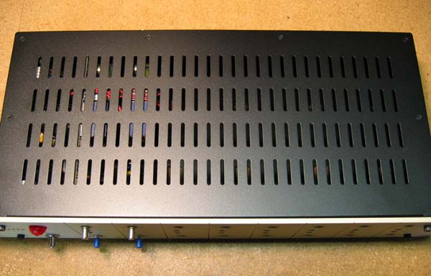

- Attach lock nuts to the controls. Use lock washers on the potentiometers, but not on the rotary switches. Tighten all the lock nuts until snug, but do not over-tighten them.
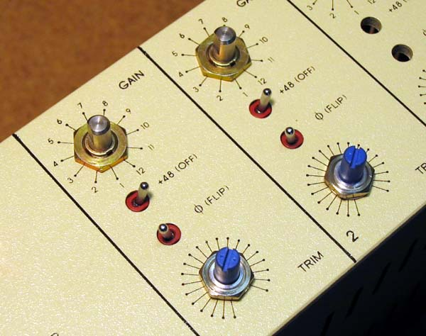

- Tighten the panel screws securely.
- Attach the knobs and securely tighten the setscrews. Insert plugs into any unused holes.
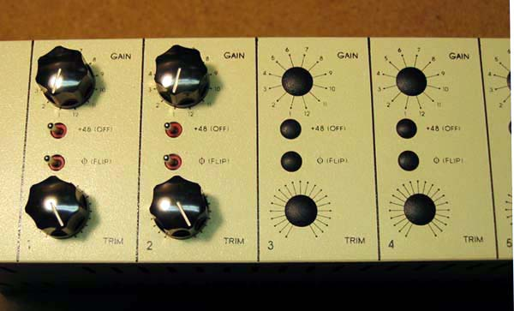

- Attach the clamp-on ferrite to the AC line cord as shown.
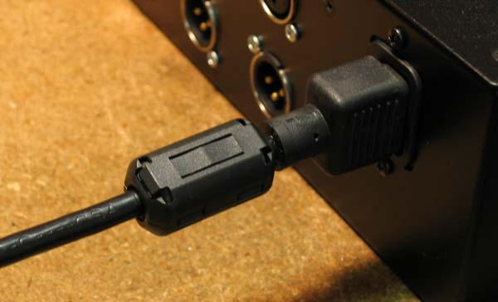

- Congratulations! You’ve got an assembled preamp.
