The J99 is a kit version of the Jensen Twin Servo circuit, the basis for some very well known and highly regarded microphone preamps. The J99 provides exceptional performance with high gain, extremely low noise and distortion, plus the benefits of transformer coupling at both input and output.

Who Should Build This Kit?

The J99 is not difficult to build, but it is not intended for absolute beginners. If you’ve never built an electronic project before, this is probably not the one to start with. To guarantee success, make sure you have:

- The ability to make basic voltage and resistance measurements using a digital multi-meter (DMM).
- At least a rudimentary understanding of voltage, current, and resistance.
- Some experience soldering on printed circuit boards.
- The patience to follow instructions precisely and work carefully.

Essential Tools

Fine tipped 20-30 watt soldering iron w/ cleaning sponge (Hakko 936 or similar)
Eutectic (63/37) rosin core or “no clean” solder (.025” diameter is usually best)
Good-quality DMM
Small needle nose pliers
Small diagonal cutters
Wire stripper
Phillips screwdriver (#1)
Precision straight blade screwdriver (for adjusting potentiometers)

Highly Recommended Tools

Lead bender (Mouser 5166-801)
T-Handle wrench and 4-40 tap (Hanson 12001 and 8012)
MOLEX crimp tool (Waldom W-HT1919 or equivalent)
Magnifying glass
Optional Tools
Panavise w/ circuit board head
1/4" nut driver
Oscilloscope
Signal generator
Work Area
Find a clean, flat, stable, well-lit surface on which to work. An anti-static mat is recommended for this project. If you’re in a dry, static-prone environment, it’s highly recommended. The importance of good lighting can’t be overstated. Component markings are tiny, and you’ll be deciphering a lot of them.
Soldering Technique
Make sure your iron's tip is tinned properly, and keep it clean! The trick to making perfect solder joints is to heat the joint quickly and thoroughly before applying the solder, and a properly tinned and clean tip is essential for this. Apply enough solder to form a "fillet" between the lead and the pad, a little mound of solder that smoothly transitions from the plane of the board up to the lead, but don’t use too much. The finished joint should be smooth and shiny, not rough or gritty looking.

If you've never soldered a board with plated-through holes, you might be surprised to discover how difficult it can be to remove a component once you've soldered it in place. If you're using solder wick to correct a mistake, be very careful not to overheat the pads, since they will eventually delaminate and "lift". It's often better to sacrifice the component and remove its leads individually, and start over with a new part. If for some reason you need to unsolder a multipin component (like a rotary switch or integrated circuit), remove as much solder as you can with solder wick or a solder sucker, and then use a small heat gun to heat all the leads simultaneously. With care, you can remove the component without damaging the board.

Instruction Conventions

Text in orange indicates a step where extra care needs to be taken. Doing it wrong isn’t a disaster, but it’ll need to be corrected.
Text in red indicates a step that must be done correctly. Doing it wrong will guarantee improper operation, and probably damage components and/or the circuit board.
Assembly
- Before you begin, carefully unpack the kit and examine the parts. Check the contents of each small bag against the BOM to make sure all the parts have been included. If you think something’s missing, please e-mail the details to sales@seventhcircleaudio.com and we’ll ship replacement parts ASAP.
- Generally, the idea when "stuffing" or “populating” a circuit board by hand is to start with the lowest profile parts, such as the resistors, and work your way up to the taller components. In each step below, insert the components, flip the board onto your work surface component-side down, and carefully solder and trim the leads. Use a piece of stiff cardboard to hold the parts in place while you flip the board. First, orient the board as shown
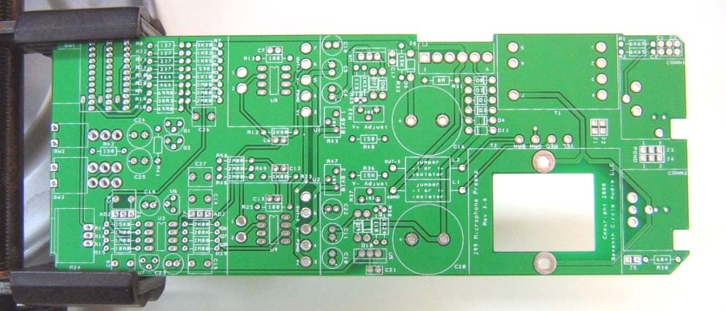
- The first components to place are the Mill-Max receptacles. Press them into the holes using the point of a Philips screwdriver or similar tool. Be sure to support the board from behind while applying pressure. Push the sockets in until they're flush with the board, and solder them from the back.
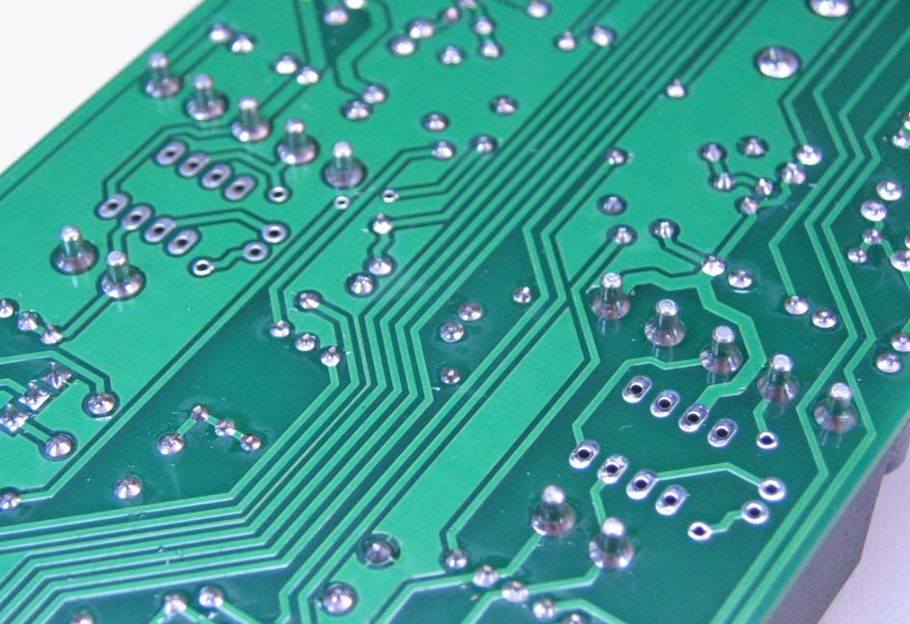
- Before installing the resistors, prepare the leads using small needle nose pliers or a lead-forming tool as shown below. Whatever you do, don’t bend the leads at the resistor body and force them into the board. This not only results in an ugly job, it can damage the parts.
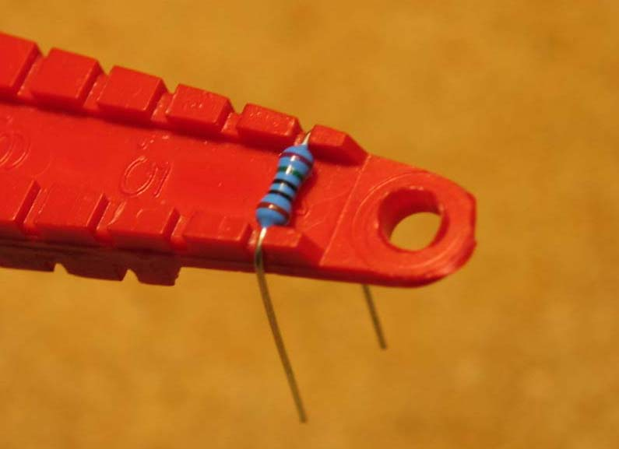
- Insert the 1/4-watt resistors. Check the Bill of Materials (BOM) for help in reading the resistor color bands. It's a good idea to actually measure each resistor with your DMM as you place it on the board, just in case you've read it incorrectly. Don't rely on the photos for component placement. If the resistor value silk-screened on the board doesn't agree with the value on the schematic or parts list, follow the schematic. Note that if you are using discrete op-amps like the SC99, do not install R13 and R25.
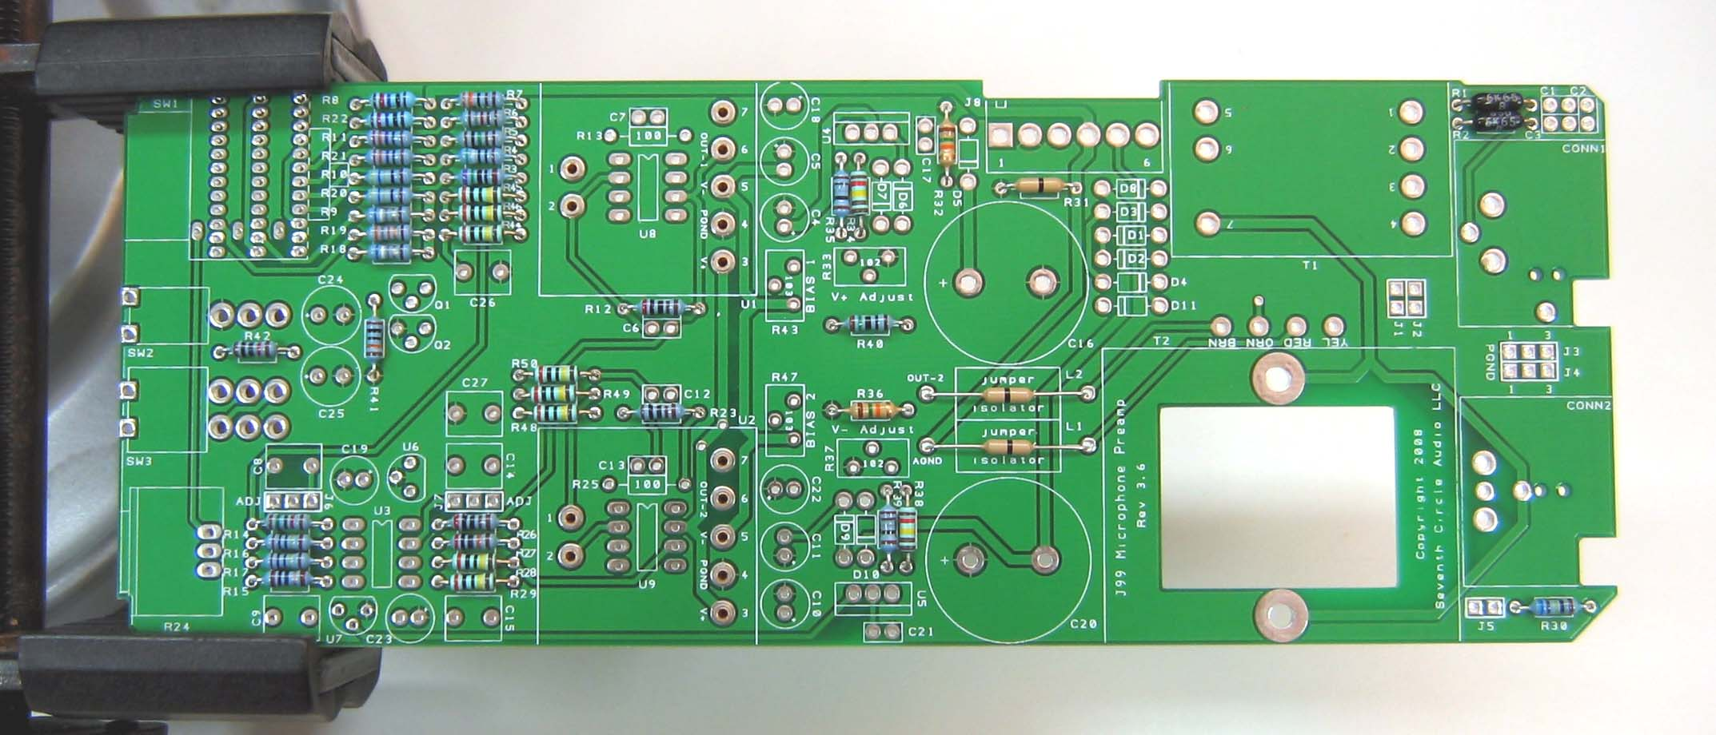
- Next, add the protection diodes D1 – D11. Diodes are polarized and must be installed the right way round! The colored band on the diode matches the white band on the silkscreen.
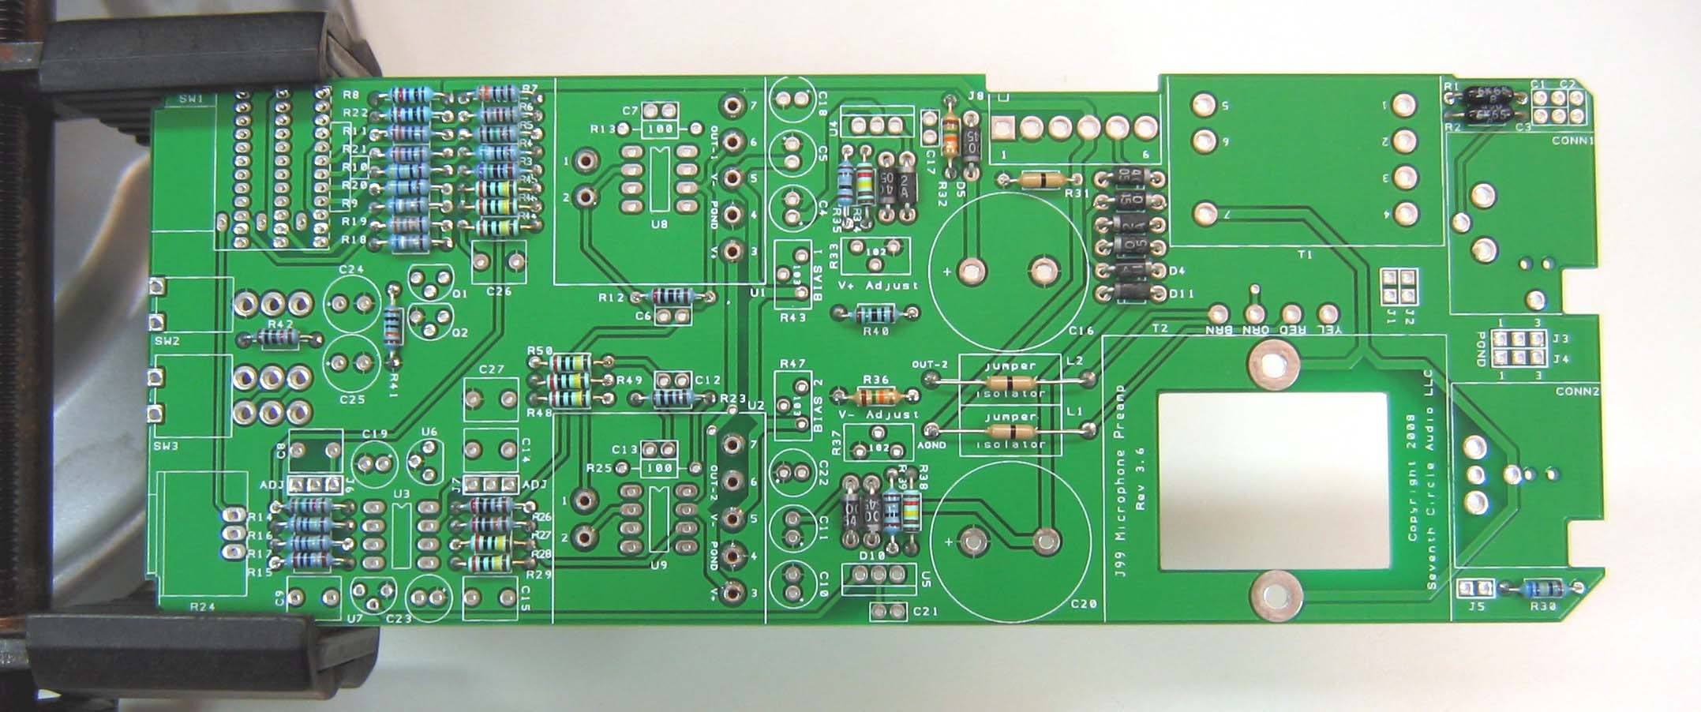
- Add ceramic capacitors C1, C2, C3, C6, C7, C12, C13, C17 and C21. These capacitors are not polarized and can be installed in either direction, but pay close attention to the capacitor markings! Note that if you are using AD797 IC op-amps, do not install C6 and C12. If you are using discrete op-amps like the SC99, do not install C7 and C13.
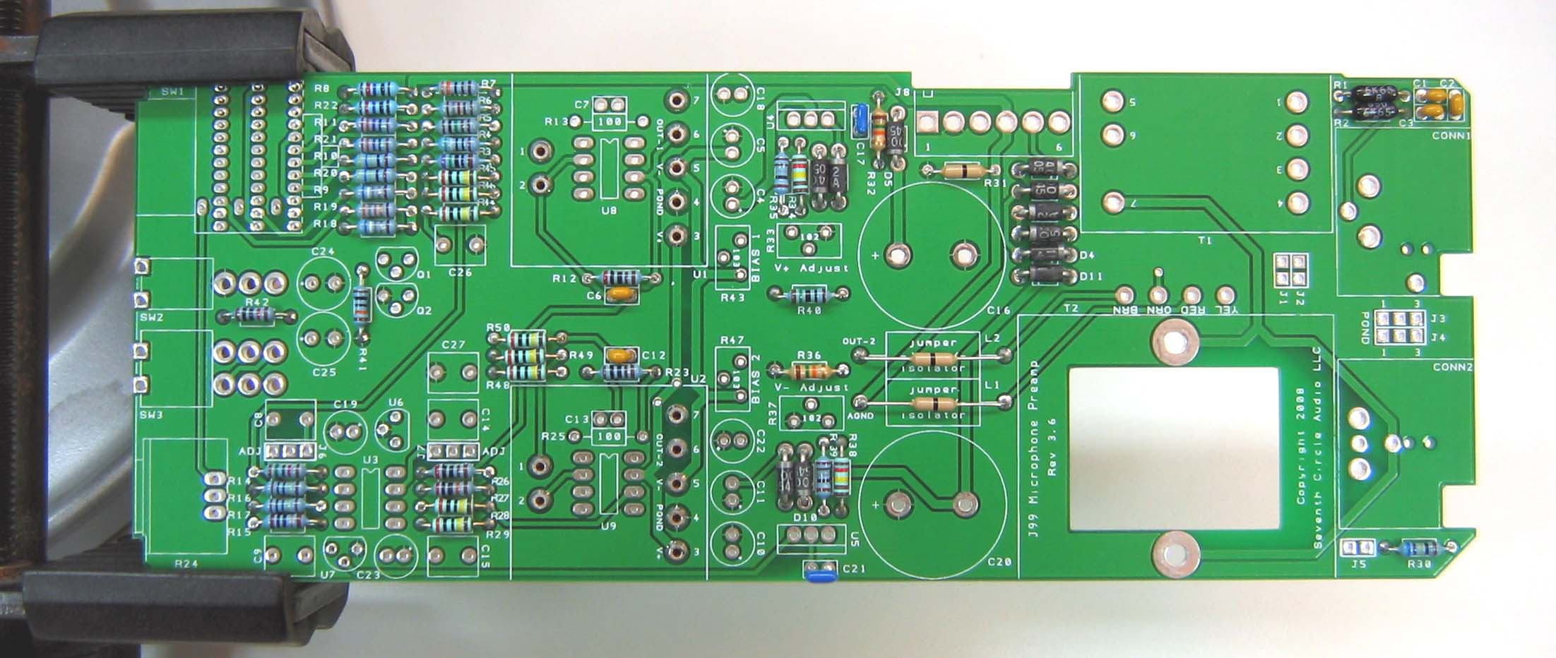
- Add film capacitors C8, C9, C14, C15, C26 and C27. These capacitors are not polarized and can be installed in either direction.
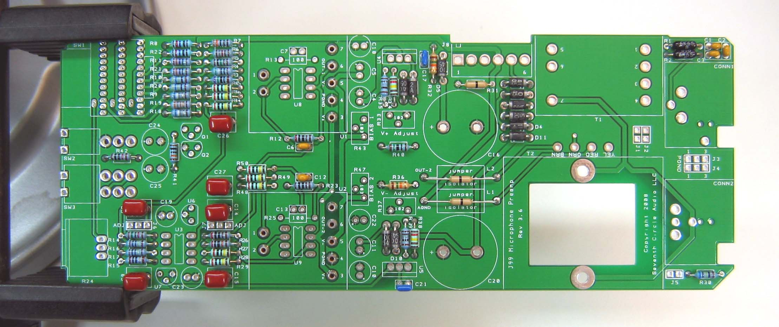
- Add the 0.1" headers now.
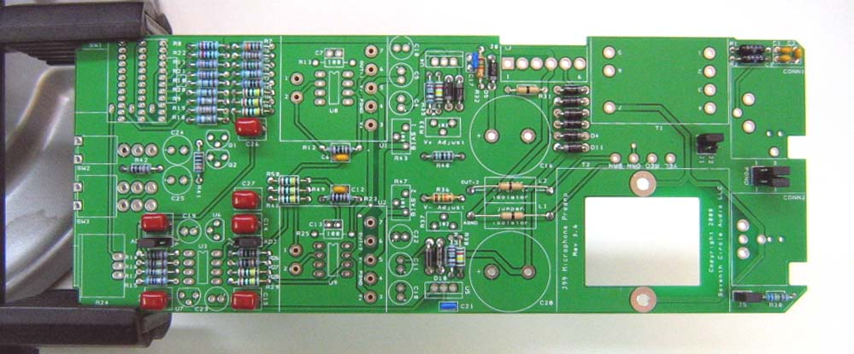
J1 and J2 – These headers access the input transformer primary windings. Jumpering across J1 and J2 as shown selects a 1200 ohm input impedance. Use this setting for most microphones. Jumpering both J1 and J2 selects a 300 ohm input impedance and gives an additional 6 dB of gain. Use this setting for very low output low impedance microphones, such as ribbon mics.
J3 and J4 – These headers allow the XLR cable shields to be connected to PGND or CGND, or to float. Unless you encounter issues with ground loop hum, jumper J3 and J4 as shown. A jumper must be installed at J3 to complete the phantom power circuit.
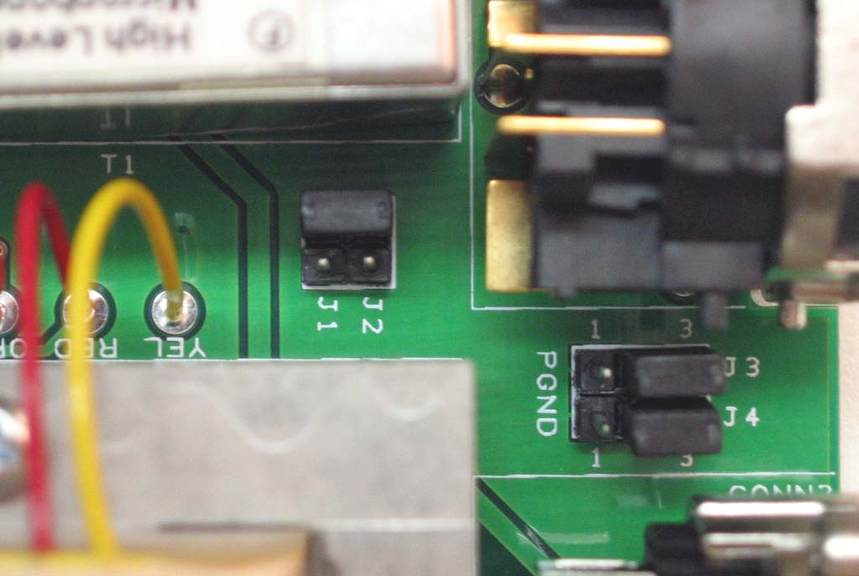
J5 connects a 604-ohm load resistor across the output. Unless you’ll be connecting the J99 to a piece of older gear with 600 ohm input impedance, connect a jumper at J5.
J6 and J7 – These headers allow the servos to be switched out of the circuit for adjustment as described in the testing section below.
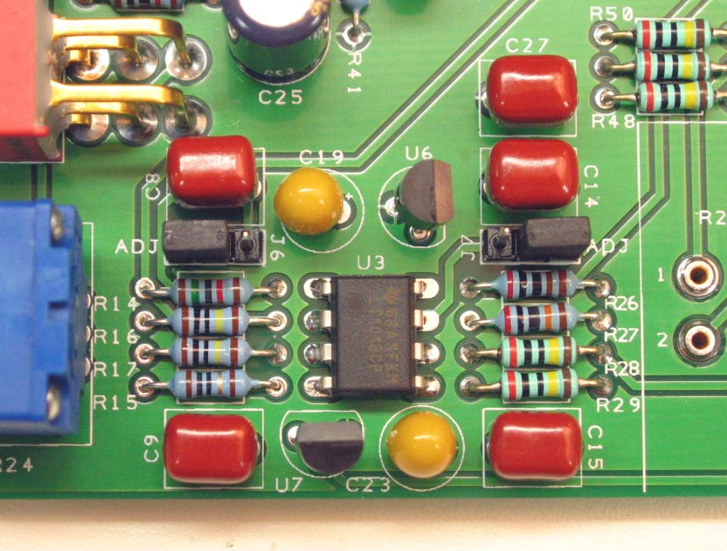

- Add tantalum bypass capacitors C4, C5, C10, C11, C19, and C23. Tantalum electrolytic capacitors are polarized and must be installed the right way round! These parts can be damaged by static discharge and must be handled with care. It’s a good idea to test them for shorts as you place them on the board. Be absolutely sure to observe the correct polarity when installing tantalum capacitors. The positive leads of the tantalum caps are marked with a small "+" sign. The positive pads on the circuit board are marked with a small "+" sign.
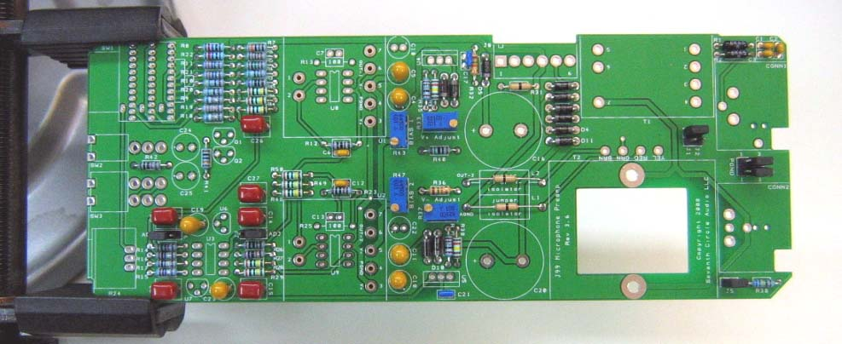
- If you need to drive extremely long cables (greater than 50m) or know that you'll be connecting the preamp to capacitive loads (you probably won't), add the "load isolator" inductors L1 and L2 now. Otherwise, solder jumpers in their place. The load isolators are optional and are not included in the kit.
- Add trim pots R33, R37, R43 and R47. R33 and R37 adjust the voltage for U1/U8 and U2/U9. R43 and R47 are used in the bias current compensation adjustment described below. Make sure you don’t mix up the 1K (102) and 10K (103) parts.
- Add electrolytic capacitors C18 and C22. Aluminum electrolytic capacitors are polarized and must be installed the right way round! Be absolutely sure to observe the correct polarity when installing these parts. The negative leads of the electrolytic caps are marked with a colored stripe. The positive pads on the circuit board are marked with a small "+" sign.
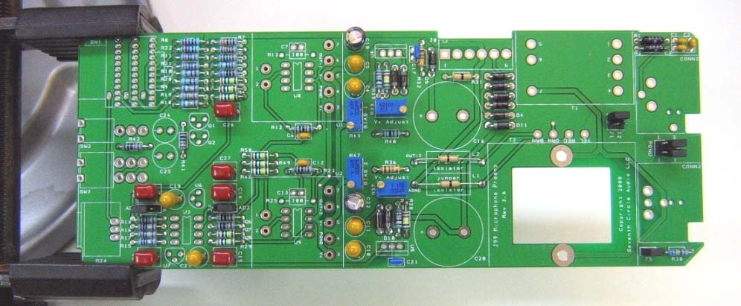
- Add Q1, Q2, U6 and U7. Be sure to install semiconductors correctly! These parts are not the same, and are not interchangeable. Read the markings carefully and orient the packages according to the silkscreen outlines. Don’t mix up the positive and negative regulators or the NPN and PNP transistors!
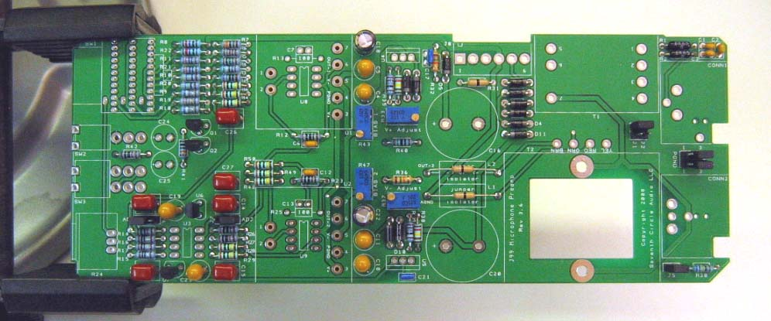
- Carefully mount the toggle switches SW2 and SW3. Be sure they're seated flat on the board before soldering all of the pins. You may find it easier to solder the first pin with the board component side up.
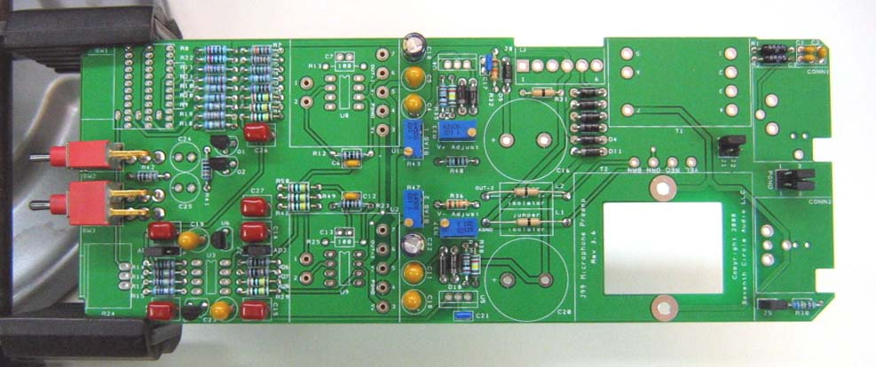
- Add J8, the MOLEX power connector. Be sure to orient it as shown, with the locking tab away from the edge of the board.
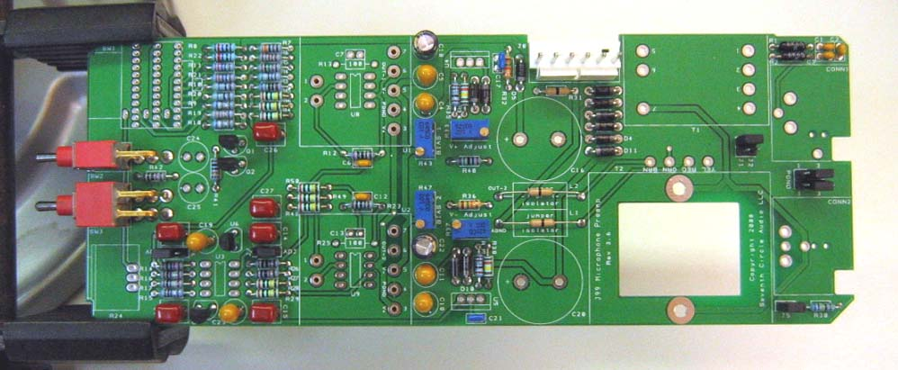
- Add electrolytic capacitors C24 and C25. Aluminum electrolytic capacitors are polarized and must be installed the right way round! Be absolutely sure to observe the correct polarity when installing these parts. The negative leads of the electrolytic caps are marked with a colored stripe. The positive pads on the circuit board are marked with a small "+" sign.
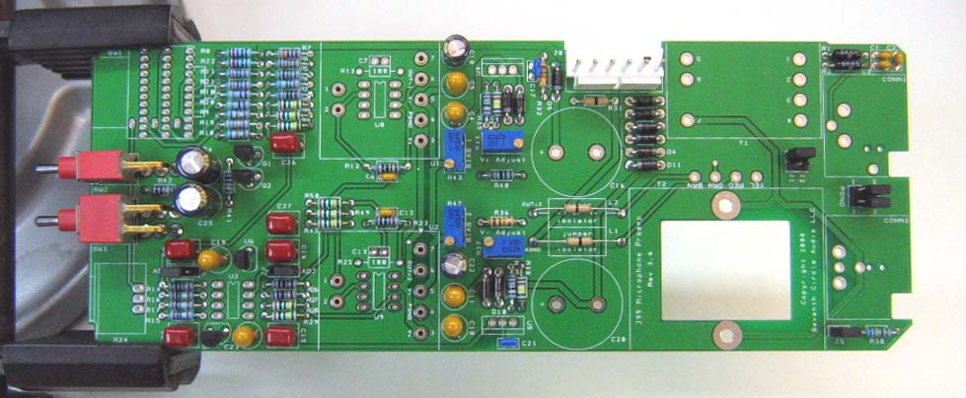
- Attach gain trim control R24. Make sure the control is seated flat to the board before soldering the leads. You may want to add a small dab of silicone adhesive to the bottom of the control to hold it more securely, but it isn’t necessary.
- Insert the stop pin in rotary switch SW2 at the position shown. Push the pin in completely. Note: You may want to skip steps 19 and 20 until after completing the bias current compensation adjustment.
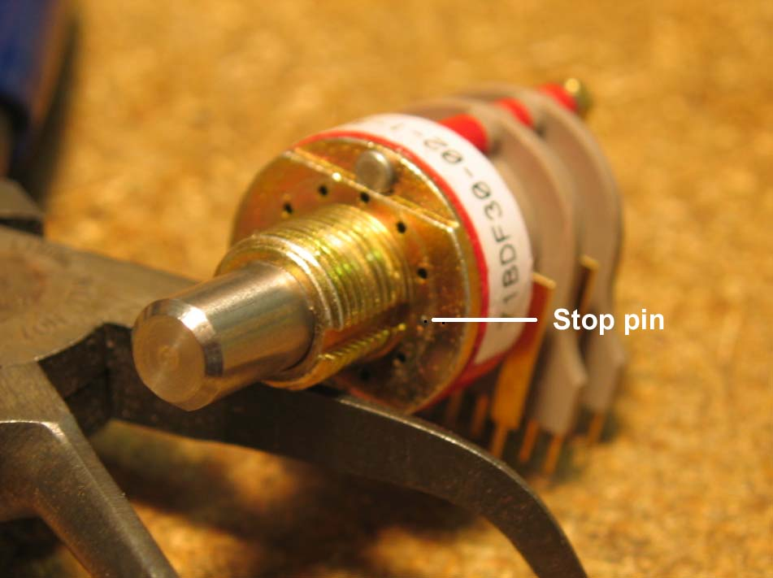

- Secure the pin with the adhesive foil supplied.
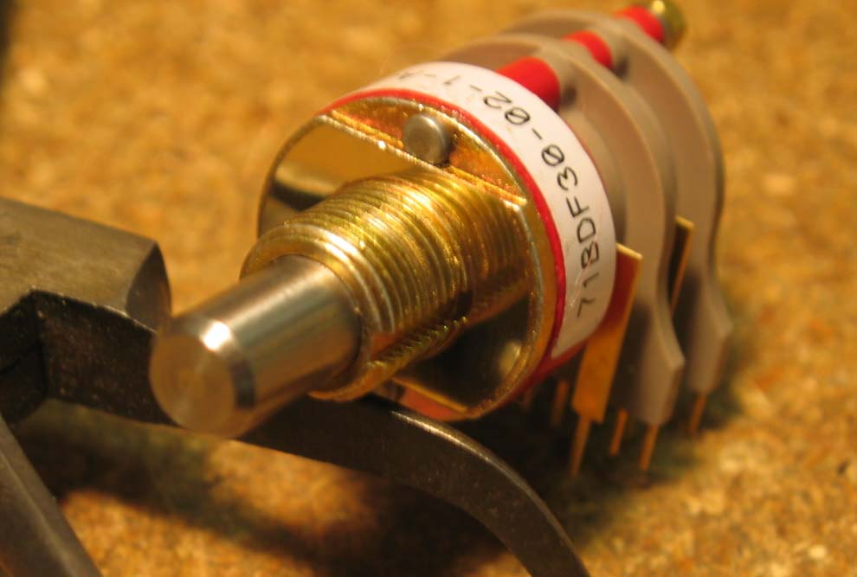
- Make sure the switch is fully seated and solder it to the board. Try to make your solder joints as neat as possible, and don’t use too much solder.
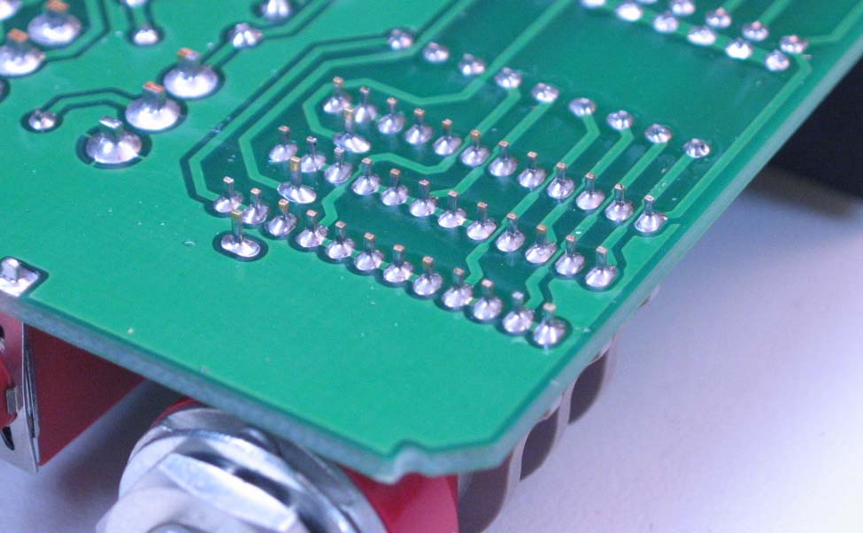
- Add the input transformer now.
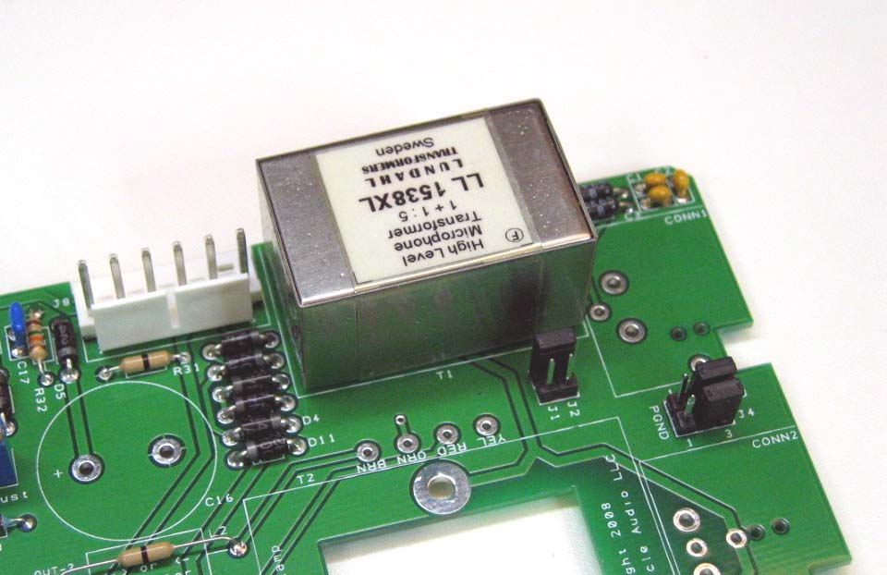
- Carefully thread the mounting holes of CONN1 and CONN2 using one of the included 4-40 screws or a tap as shown. This prevents any possibility of damage to the connectors during final assembly.
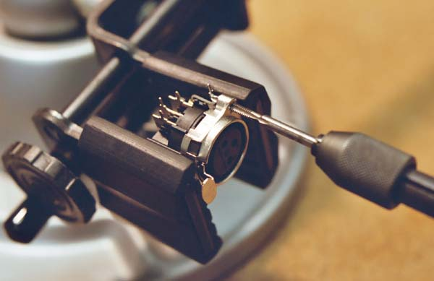

- Add CONN1 and CONN2 to the board. Make sure they’re fully seated before soldering.
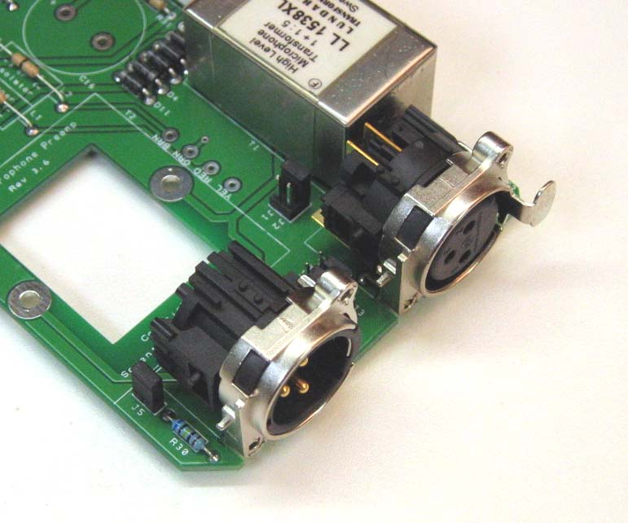

- Using the hardware supplied, attach heat sinks to U4 and U5 and solder them in place. Make sure to install the regulators correctly! These parts are not the same, and are not interchangeable. Align the regulator tab with the double line on the silkscreen outline. Don’t swap the positive and negative regulators, or mount them backwards!
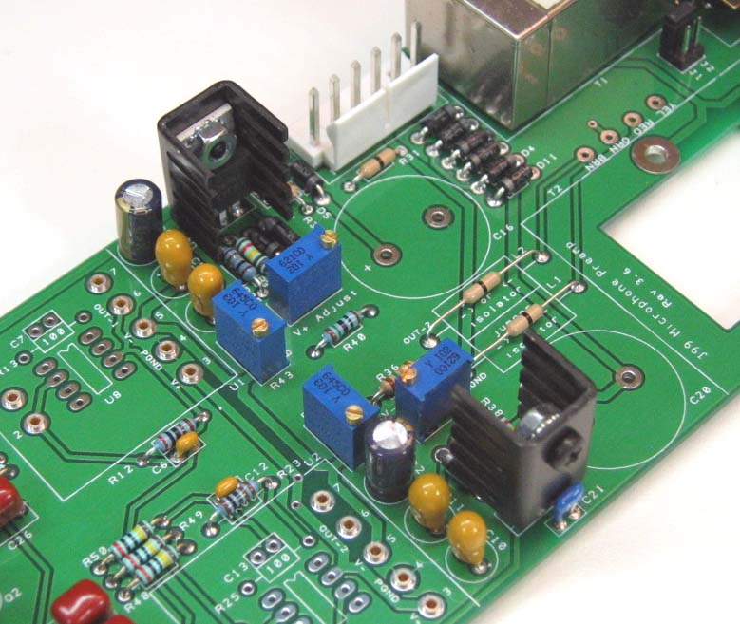
- Install the bulk filter capacitors C6 and C16. Push them in firmly until they are fully seated against the board. Again, electrolytic capacitors are polarized and must be installed the right way round! Be absolutely sure to observe the correct polarity when installing these parts.
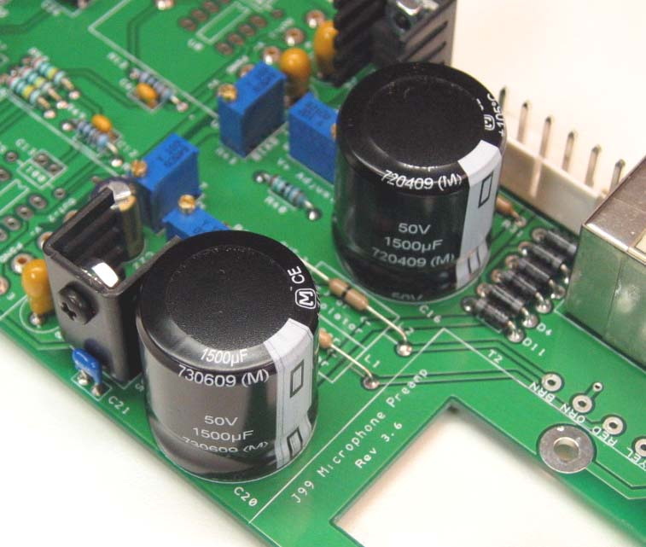
- Add U3 now. Orient the IC according to the silkscreen.
- Attach the output transformer to the board using two 1" 4-40 machine screws and nuts. Use the supplied spacers between the transformer and the circuit board. Trim the leads to length, and strip about 1/4" of insulation from the ends. Twist the strands together, and tin each lead with solder.
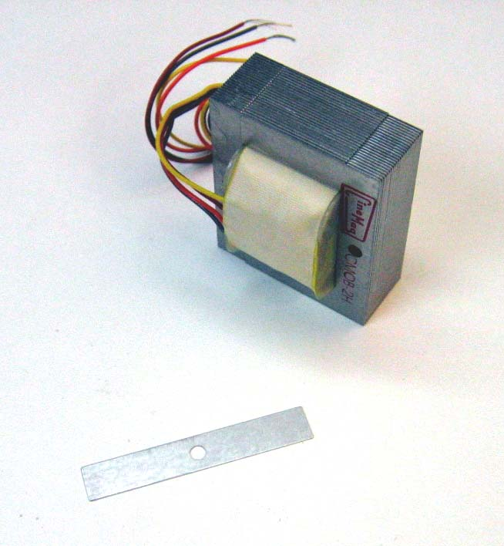
- Solder the leads as shown. The color code is screened onto the PC board.
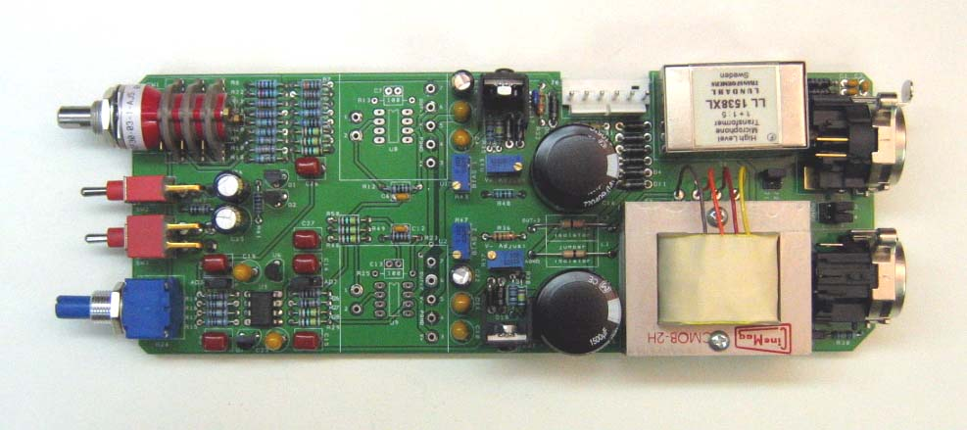
- That’s it! Before going on to initial power-up, carefully check your work. Make sure you haven't created any solder bridges between pads, or between a pad and the ground plane.
Initial Power-Up and Testing.
- Again, carefully check your work. Make sure you've got the right resistors in the right locations. Make absolutely sure you've got all the diodes and capacitors soldered in the right way round! Double check to make sure you haven’t inadvertently swapped a voltage regulator. Check for poor solder joints and solder bridges, and make sure you fix any problems before continuing.
- Just to make sure you haven't created any blatant shorts, measure the resistance between pins 1 and 2 of J8. Do the same for pins 3 and 2. You should measure a very high resistance. If you measure a steady resistance under 100 ohms, don't apply power. Carefully check your work until you find that short.
- Turn R33 and R37 counter-clockwise 25 full turns, or until you hear a soft click with every turn. This sets the regulators to their lowest voltage, about +/-14V.
- Connect the PS03 to J8 with a WH01 wire harness. Be sure to orient the connectors so the locking tabs are engaged. Be careful not to attach a connector backwards or to shift it sideways. If you’re making your own harness, please see the CH01KF assembly instructions for details. Set your DMM to measure DC voltages of 25V or greater, and turn on the power. Place the negative meter probe on U1, pin 4, and measure the voltage between U1, pin 4 and U1, pin 3. You should see about +14V. Keep the negative probe at pin 4, and measure the voltage at U1, pin 5. You should see about -14V. Do the same for U2. If these voltages are way off, you have problems. Possible things to look for are incorrectly installed diodes, backwards caps, or shorts around the voltage regulators. Do not proceed until you measure the proper voltages at U1 and U2.
- If the voltages at U1 and U2 are OK, check the voltages at U3. U3 pin 4 should be around -12V; U3 pin 8 should be around +12V. If the U1 and U2 voltages are OK but the U3 voltages are wrong, make sure you haven't inadvertently swapped U6 and U7.
- With your DMM still set to read DC voltages of 24V or greater, adjust R33 and R37 for the proper working voltage for the op-amps you intend to use. The SC99s and JH990Cs will run indefinitely at +/-24V, though if you don't need the headroom you can run them at lower voltages with no problem. The AD797s need +/-18V. If you’re using a different op-amp, follow the manufacturer's specifications to set the supply voltage. Measure the voltages as in the previous step; at U1 pins 3, 4, and 5.
- Set your DMM to measure DC voltages of 50V or greater. With the negative probe of your DMM connected to PGND, measure the voltage at CONN1 pin 2. Depending on the direction of SW2, you should measure a voltage quite close to either 0V or +48V. Flip SW2 and observe the meter. The voltage should transition from one state to the other in about 5 seconds, and then remain stable. Repeat the measurement at CONN1, pin 3.

Input Bias Current Adjustment

The J99 employs a servo around each op-amp to automatically minimize DC offset. Excessive offset can reduce available headroom and cause excessive heating of U2/U9 so it’s a good idea to minimize it, but it has virtually no effect on the audio performance of the amplifier. The servos do a good job of reducing the offset to nearly 0V within a few seconds even without bias current compensation, but the adjustment described below helps the servos do their job faster. Keep in mind that this adjustment is not critical and will have no impact on the audio performance of the J99.

- Install an op-amp at U1/U8 but not at U2/U9.
- Short CONN1 pin 2 and pin 3.
- Move the jumpers at J6 and J7 to the "ADJ" position, as indicated on the silk screen. This connects the center pin of the header to ground and disconnects the servos while you're making adjustments.
- Connect a DMM between U2, pin 1, and U2, pin 4. Set it to measure DC voltages of 2V or less.

- Apply power to the J99.
- Turn SW1 fully counter-clockwise (for minimum gain), and record the voltage at U2, pin 1.
- Turn SW1 fully clockwise (for maximum gain) and measure the voltage again. Adjust R43 to try to make the voltage the same as the first measurement.
- Repeat steps 42 and 43 until the voltage at each extreme of SW1 is as close as possible. Note that the exact voltage doesn't matter. What you're trying to do is minimize the difference between the voltages. You should be able to reduce the difference to a few millivolts.
- Turn off the power and remove the op-amp from U1/U8. Install the second op-amp at U2/U9. Don’t use the same op-amp you just used at U1/U8, since the input bias currents may be different. Connect the DMM between U1, pin 4 and U9, pin 6. You can also monitor this signal (out-2) at R28 and L2 as shown on the schematic.
- Repeat the process above, this time adjusting R47. Don’t worry if the voltage jumps around at the high gain settings, or if the voltage drifts a few millivolts.

- When the voltages are as close as you can get them, turn off the power and move the jumpers at J6 and J7 to the normal position.

- Reinstall the first op-amp at U1/U8 and apply power. With your DMM set to the lowest voltage scale, measure the voltage at U2, pin 6 while clicking through the gain steps. If the servo is working correctly, the voltage will fall very close to 0V within 30 seconds or so of each click.
- Congratulations! You've got a working J99 preamp.
