Designed around the excellent THAT 1512 preamp IC, the T15 microphone preamp offers superb performance in any application where extremely low distortion and neutral sonic characteristics are desired. Its low component count makes it the best choice for less-experienced kit builders.

Who Should Build This Kit?
The T15 is not difficult to build, but it is not intended for absolute beginners. You should have built at least one project on a printed circuit board (PCB) before trying the T15. Sorry, but soldering cables doesn’t count. If you’ve never built an electronic project of any kind, this is probably not the one to start with. To guarantee success make sure you have:

- The ability to make basic voltage and resistance measurements using a digital multi-meter (DMM).
- At least a rudimentary understanding of Ohm’s Law and the relationship between voltage, current, and resistance.
- Some experience soldering on printed circuit boards.
- The patience to follow instructions precisely and work carefully.

Essential Tools
Fine tipped 20-30 watt soldering iron w/ cleaning sponge (Hakko 936 or similar)
Eutectic (63/37) rosin core or “no clean” solder (.025” diameter is usually best)
Good-quality DMM
Small needle nose pliers
Small diagonal cutters
Phillips screwdriver (#1)

Highly Recommended Tools
Lead bender (Mouser 5166-801)
T-Handle wrench and 4-40 tap (Hanson 12001 and 8012)
MOLEX crimp tool (Waldom W-HT-1919 or equivalent)
Magnifying glass
Optional Tools
Panavise with circuit board head (PV-312, PV-300, and PV-315 or PV-366)
Oscilloscope
Signal generator
Work Area
Find a clean, flat, stable, well-lit surface on which to work. An anti-static mat is recommended for this project. If you’re in a dry, static-prone environment, it’s highly recommended. The importance of good lighting can’t be overstated. Component markings are tiny, and you’ll be deciphering a lot of them.
Soldering Technique
Make sure your iron's tip is tinned properly, and keep it clean! The trick to making perfect solder joints is to heat the joint quickly and thoroughly before applying the solder, and a properly tinned and clean tip is essential for this. Apply enough solder to form a "fillet" between the lead and the pad, a little mound of solder that smoothly transitions from the plane of the board up to the lead, but don’t use too much. The finished joint should be smooth and shiny, not rough or gritty looking.

If you've never soldered a board with plated-through holes, you might be surprised to discover how difficult it can be to remove a component once you've soldered it in place. If you're using solder wick to correct a mistake, be very careful not to overheat the pads, since they will eventually delaminate and "lift". It's often better to sacrifice the component and remove its leads individually, then start over with a new part. If for some reason you need to unsolder a multipin component (like a rotary switch or integrated circuit), remove as much solder as you can with solder wick or a solder sucker, and then use a small heat gun to heat all the leads simultaneously. With care, you can remove the component without damaging the board.
Instruction Conventions
Text in orange indicates a step where extra care needs to be taken. Doing it wrong isn’t a disaster, but it’ll need to be corrected.
Text in red indicates a step that must be done correctly. Doing it wrong will guarantee improper operation, and probably damage components and/or the circuit board.
Assembly
- Before you begin, carefully unpack the kit and examine the parts. Check the contents of each small bag against the BOM to make sure all the parts have been included. If you think something’s missing, please e-mail the details to sales@seventhcircleaudio.com and we’ll ship replacement parts ASAP.
- Generally, the idea when "stuffing" or “populating” a circuit board by hand is to start with the lowest profile parts, such as the resistors, and work your way up to the taller components. In each step below, insert the components, flip the board onto your work surface component-side down, and carefully solder and trim the leads. Use a piece of stiff cardboard to hold the parts in place while you flip the board. First, orient the board as shown.
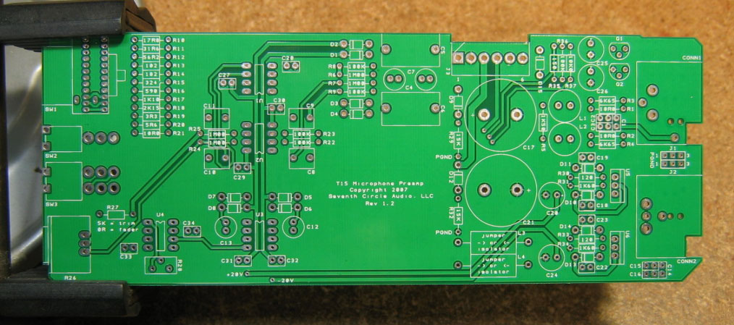
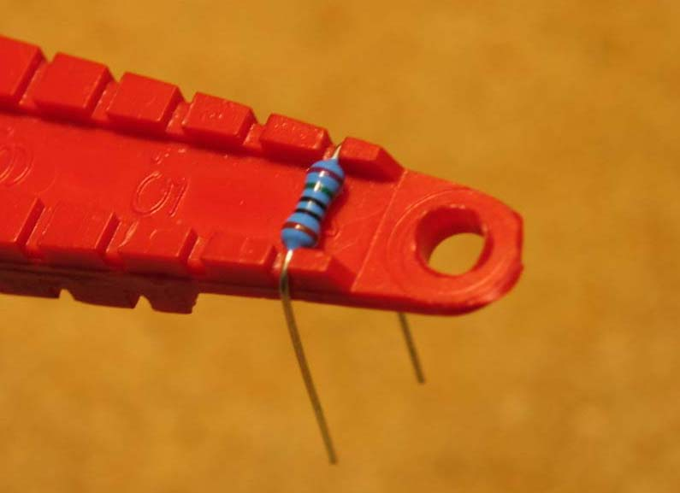
- Before installing the resistors, prepare the leads using small needle nose pliers or a lead-forming tool as shown below. Whatever you do, don’t bend the leads at the resistor body and force them into the board. This not only results in an ugly job, it can damage the parts.
- Insert the 1/4-watt resistors. Check the Bill of Materials (BOM) for help in reading the resistor color bands. It's also a good idea to actually measure each resistor with your DMM as you place it on the board, just in case you've read it incorrectly. Don't rely on the photos for component placement. If the resistor value silk-screened on the board doesn't agree with the value on the schematic or parts list, follow the schematic.
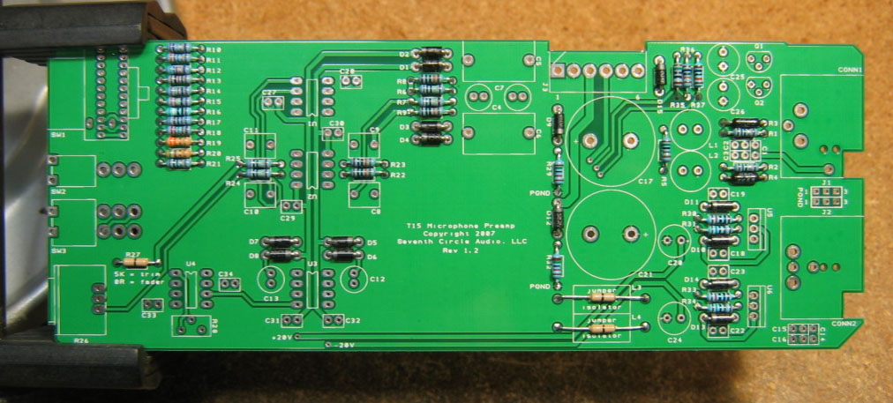
- Next, add the protection diodes D1 through D15. Diodes are polarized and must be installed the right way round! The colored band on the diode matches the white band on the silkscreen.
- Add the 470pF and 0.1uF ceramic capacitors. These capacitors are not polarized and can be installed in either direction, but pay close attention to the capacitor markings! These parts look alike, but they are not interchangeable. Putting one in the wrong spot will not prevent the preamp from passing signal, but it can seriously impair its performance.
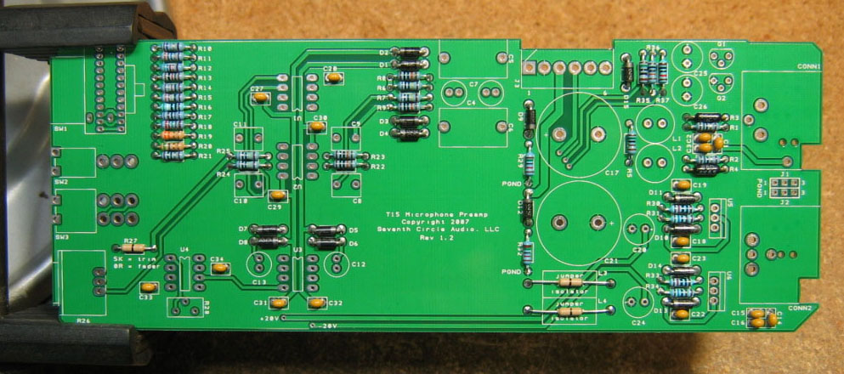
- Install U1 through U4 now. Pay close attention to the IC markings. Align the notch on the IC with the notch on the silkscreen outline! If you’d like the option of easily swapping or replacing the ICs, now is the time to add the sockets. Sockets are optional and are not included in the kit.
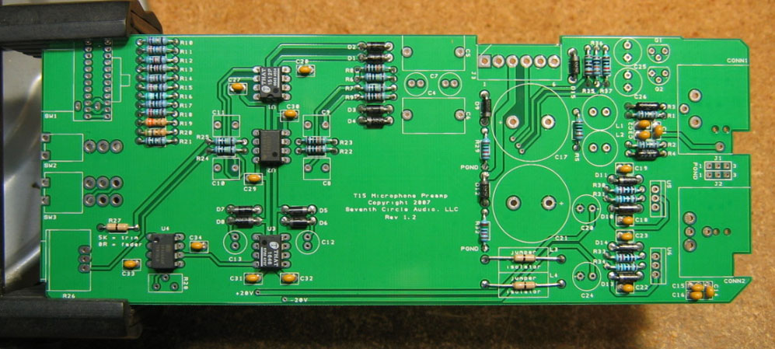
- If you need to drive extremely long cables (greater than 50m) or know that you'll be connecting the preamp to capacitive loads (you probably won't), add the "load isolator" inductors at L3 and L4. Otherwise, solder jumpers in their place as shown. You must install either the JT-OLI-3 inductors or jumpers at L3 and L4. Otherwise, the preamp will not pass a signal!
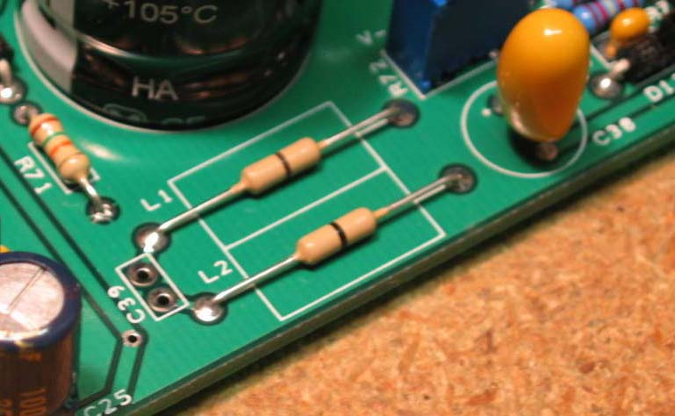

- Install the 470nF film caps at C8 through C11. These parts are not polarized and can be installed in either direction.
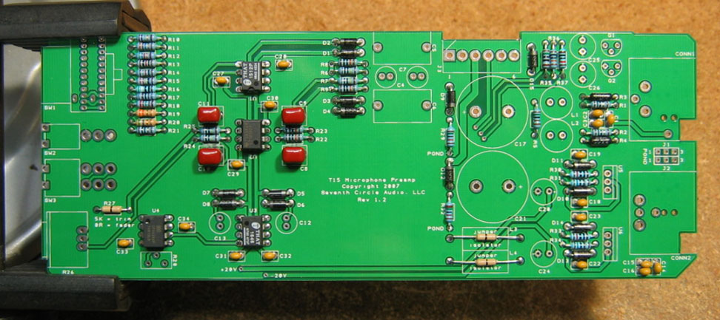

Jumper | Pins 1 and 2 | Pins 2 and 3 | No Jumper
J1 – CONN1 | PGND | CGND | Floating
J2 – CONN2 | PGND | CGND | Floating

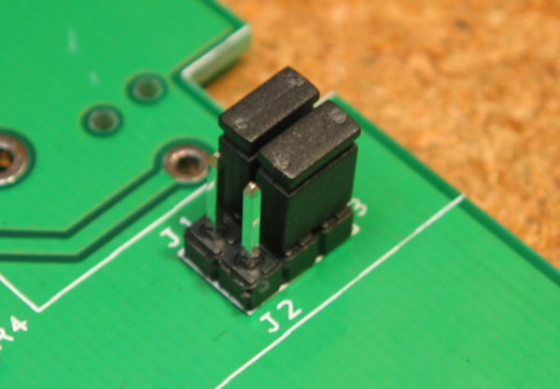
- Add the 0.1” headers and shorting jumpers at J1 and J2. Install the headers with the long pins up! The jumpers connect pin 1 of CONN1 and CONN2 to ground as shown in the table above. Unless you encounter issues with ground loop hum, jumper pins 2 and 3 on both headers as shown at right. A jumper must be installed at J1 to complete the phantom power circuit.
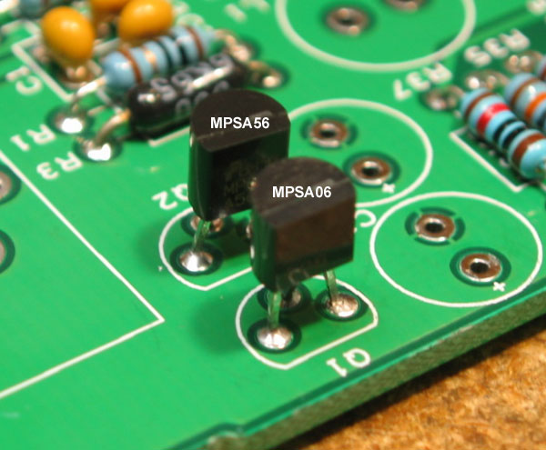
- Install Q1 and Q2. Be sure to orient the transistors correctly! These parts are not the same and are not interchangeable. Align the flat side of the transistor with the flat side of the silkscreen outline.
- Add electrolytic capacitors C4, C7, C12, and C13. These capacitors are not polarized and can be installed in either direction.
- Add electrolytic capacitors C20 and C24. Electrolytic capacitors are polarized and must be installed the right way round! Be absolutely sure to observe the correct polarity when installing these parts. The negative leads of the electrolytic caps are marked with a colored stripe. The positive pads on the circuit board are marked with a small "+" sign.
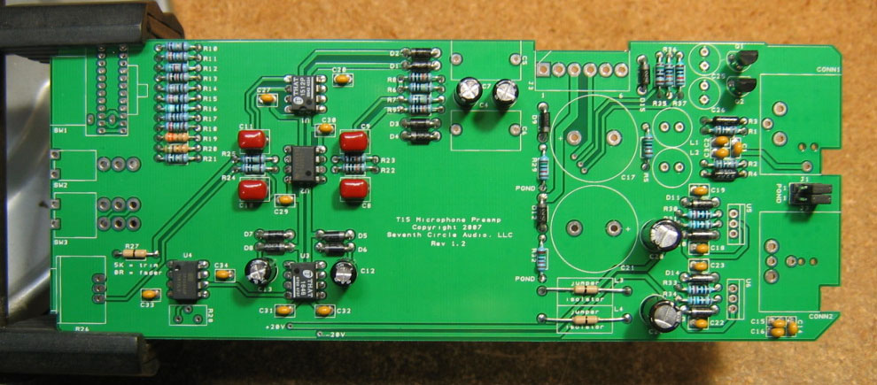
- Install L1 and L2. These parts may have markings that are hard to read or be completely unmarked. You can verify that they’re inductors by measuring their resistance, which should be very low. These parts are not polarized and may be installed in either direction.
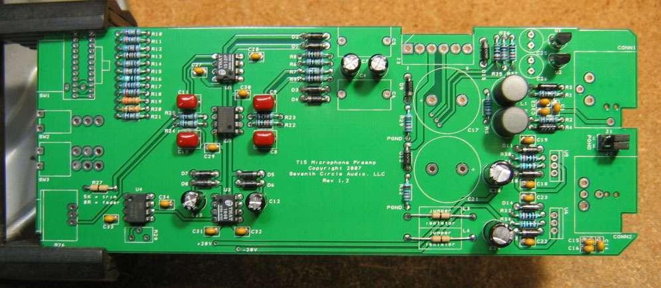
- Carefully mount the toggle switches SW2 and SW3. Be sure they're seated flat on the board before soldering the leads. You may find it easier to solder the first lead of each switch while the board is component side up.
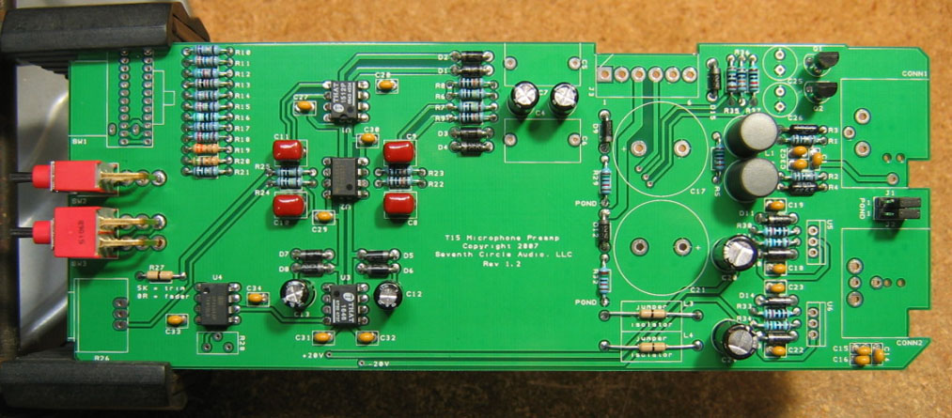

- Add J3, the MOLEX power connector. Be sure to orient it as shown, with the locking tab away from the edge of the board.
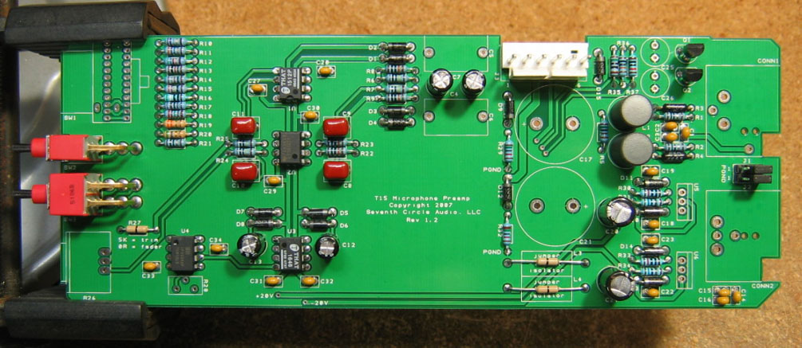
- Add electrolytic capacitors C25 and C26. Again, electrolytic capacitors are polarized and must be installed the right way round! Be absolutely sure to observe the correct polarity when installing these parts. Add polypropylene capacitors C5 and C6 as well.
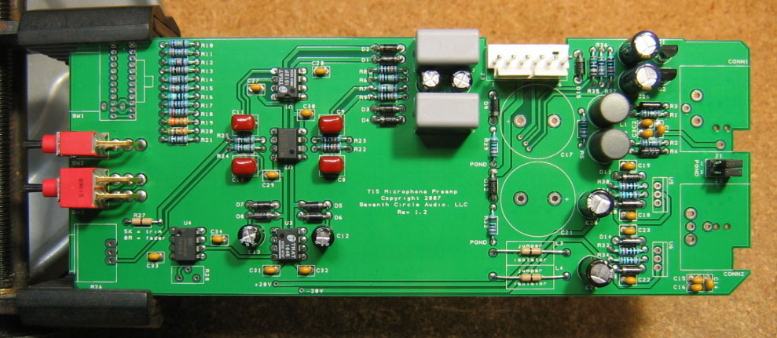

- Attach gain trim control R26. Make sure the control is seated flat to the board before soldering the leads. You may want to add a small dab of silicone adhesive to the bottom of the control to hold it more securely.
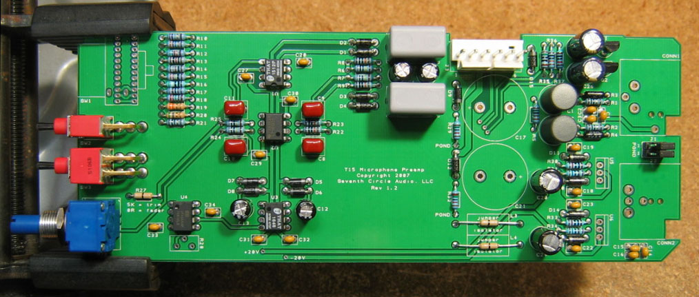
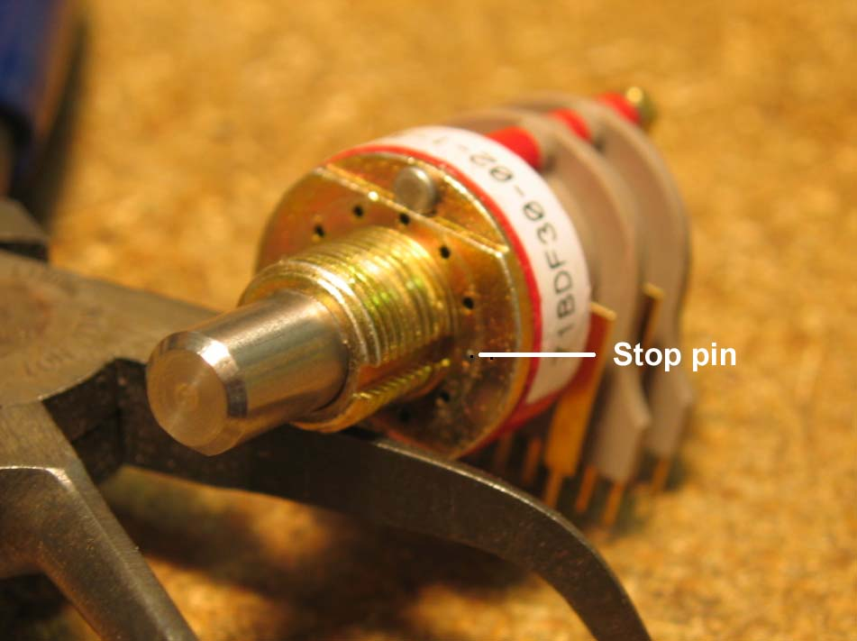
- Insert the stop pin in rotary switch SW1 at the position shown. Push the pin in completely.

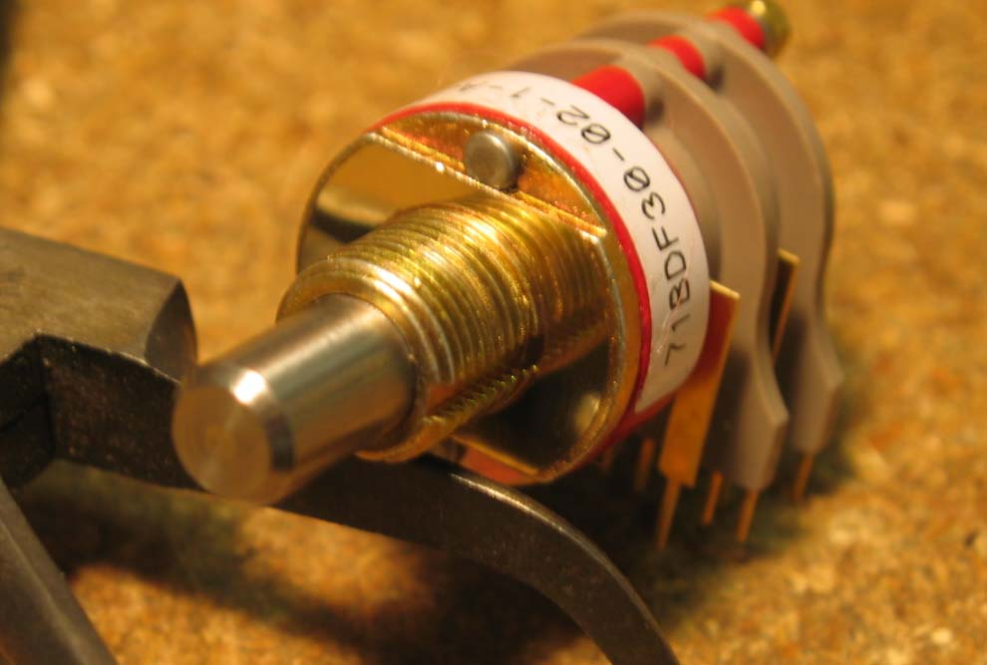
- Secure the pin with the adhesive foil supplied.

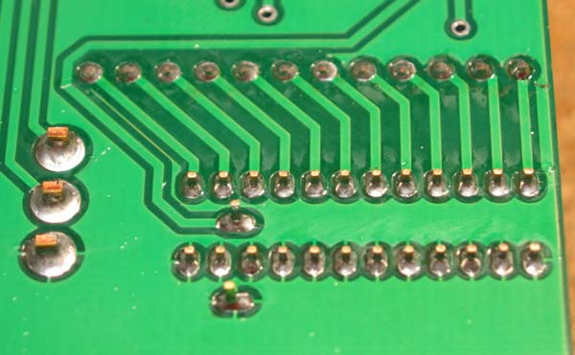
- Make sure the switch is fully seated and solder it to the board. Try to make your solder joints as neat as possible and don’t use too much solder.

- Carefully thread the mounting holes of CONN1 and CONN2 using one of the included 4-40 screws or a tap as shown. This makes installing the module in the chassis much easier. Adding a drop of light machine oil to the tap or screw makes tapping the holes much easier. Don’t drive the tap in all at once. Advance ¼ to ½ turn, then back the tap out to clear the hole of cuttings.
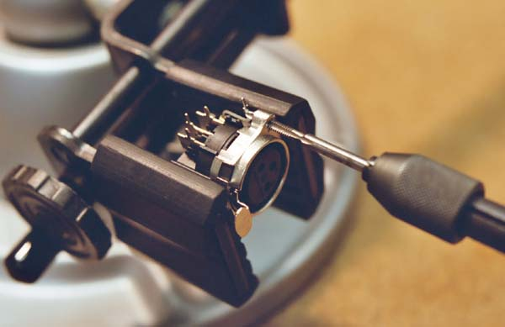

- Add CONN1 and CONN2 to the board. Make sure they’re fully seated before soldering.
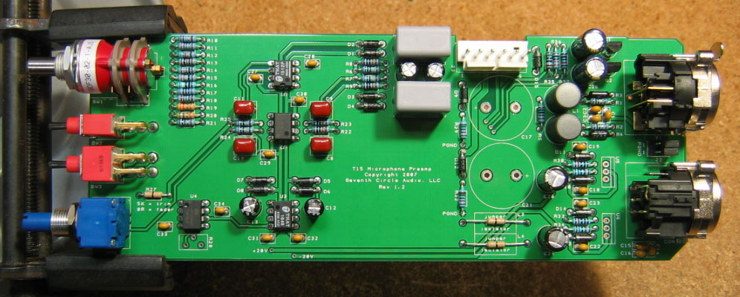
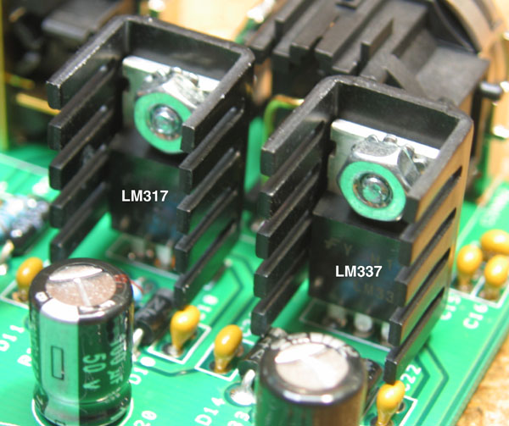
- Using the hardware supplied, attach heat sinks to U5 and U6 and solder them in place. Make sure to install the regulators correctly! These parts are not the same, and are not interchangeable.
- Install the bulk filter capacitors C17 and C21. Push them in firmly until they are fully seated against the board. Again, electrolytic capacitors are polarized and must be installed the right way round! Be absolutely sure to observe the correct polarity when installing these parts.
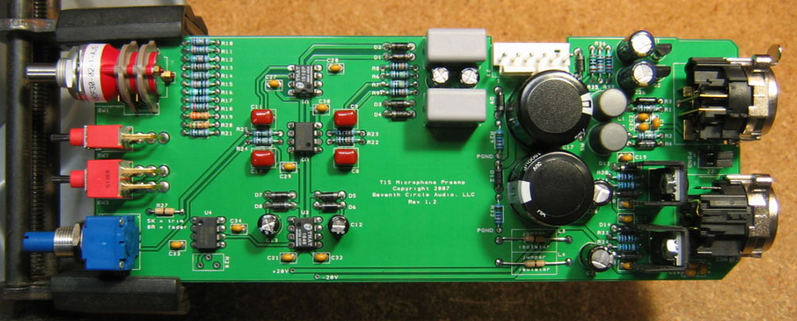

- Before going on to initial power-up, carefully check your work. Make sure you haven't created any solder bridges between pads, or between a pad and the ground plane.

Initial Power-Up and Testing.
- Again, carefully check your work. Make sure you've got the right resistors in the right locations. Make absolutely sure you've got all the transistors, diodes, and capacitors soldered in the right way round! Double check to make sure you haven’t inadvertently swapped a transistor or voltage regulator. Check for poor solder joints and solder bridges, and make sure you fix any problems before continuing.
- Just to make sure you haven't created any blatant shorts, measure the resistance between pins 1 and 2 of J3. Do the same for pins 3 and 2. If you measure a steady resistance of less than 100 ohms, don't apply power. Carefully check your work until you find that short.
- Connect the PS03 to J3. Simply wire the power supply connectors together in a 1:1 fashion. That is, PS03 J2, pin 1 to T15 J3, pin 1, pin 2 to pin 2, etc. Pin 1 is toward the front, pin 6 toward the rear. Set your DMM to measure DC voltages of 18V or greater and apply power. Connect the negative meter probe to J3, pin 2 or any connection labeled PGND. Connect the positive meter probe to U1, pin 7 or the +20V pad shown below. You should measure very close to +18V.

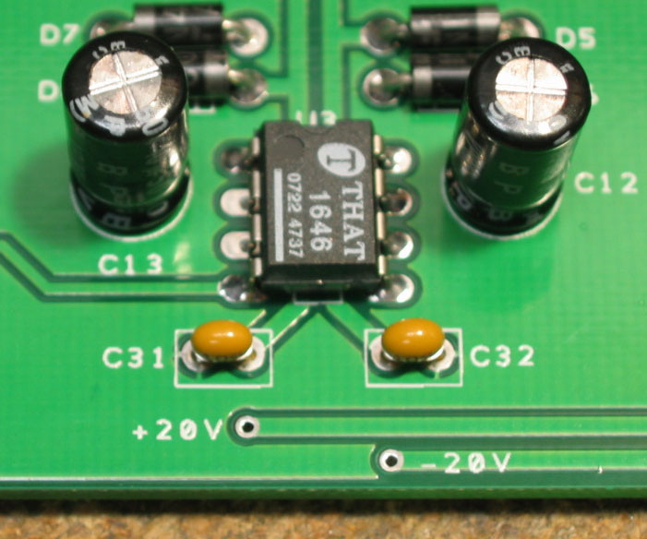
- With the negative probe still at PGND, measure the voltage at U1, pin 4 or the –20V pad shown above. You should measure very close to -18V.
- If the voltages measured in the two previous steps are off by more than 1V, you have problems. Don’t connect a microphone or attempt to pass a signal through the module. Possible things to check are incorrectly installed diodes, especially D9 through D14, backwards caps at C17, C20, C21, and C24, or shorts around U4 and U5.
- Set your DMM to measure DC voltages of 50V or greater. With the negative probe of your DMM connected to PGND, measure the voltage at CONN1 pin 2. Depending on the direction of SW2, you should measure a voltage quite close to either 0V or +48V. Flip SW2 and observe the meter. The voltage should transition from one state to the other in about 5 seconds, and then remain stable. Repeat the measurement at CONN1, pin 3.
- Congratulations! You've got a working T15 preamp.

Options.
- 8-pin DIP sockets may be used at U1 through U4 to allow for easy substitution of ICs. If you decide to install sockets, high quality, low-profile machined-pin types are recommended. Keep in mind that sockets may cause reliability issues in the very long term. IC Sockets are optional and not included with the kit.
- The T15KF ships with a 0R jumper that is to be installed at R27. This value produces infinite attenuation when R26 is fully counter-clockwise, causing it to act like a fader. However, resistor values greater than 0R can be used to produce different amounts of maximum attenuation as shown in the table below. The resistors listed in the table are optional and not included with the kit.
Maximum Attenuation | R27
5 dB | 8K87
6 dB | 4K99
10 dB | 1K58
20 dB | 499R

- The output of voltage regulators U5 and U6 is set by the ratio of R31/R30 and R34/R33, respectively. Substituting 1K8 resistors for R31 and R34 raises the supply voltage to +/-20V, giving a few dBs of additional headroom. The 1K8 resistors are optional and not included with the kit.
- For experienced builders only. Any DC offset produced by output buffer U4 can be trimmed by installing a 100K trim pot at R28 along with a resistor at R38 or R39 (not both). These components are optional and not included in the kit. Consult the manufacturer’s data sheet for details on trimming DC offset.
