EXERCISE 1
AIM: Create the following table.
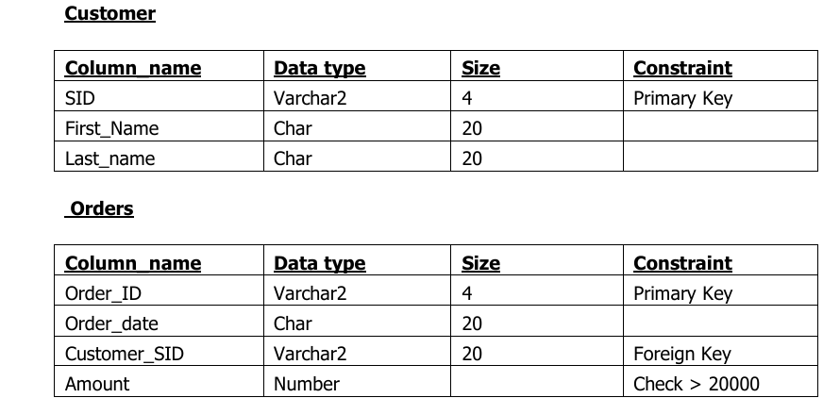

Output:

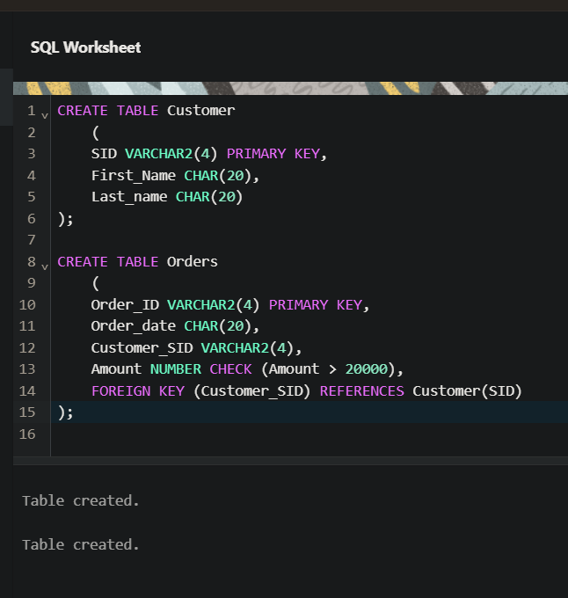
EXERCISE 2
AIM: Insert 5 records for each table.

Output:
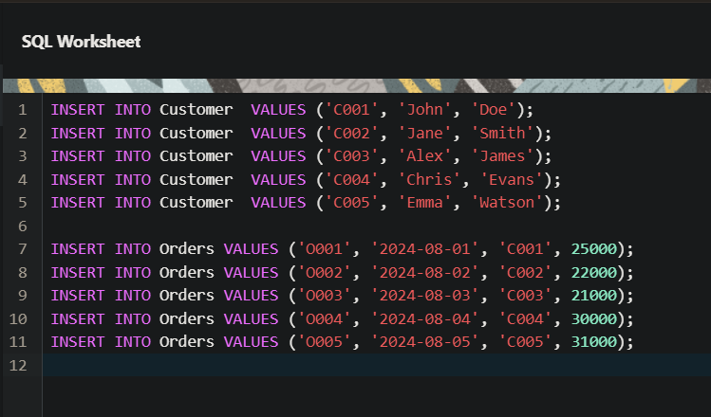
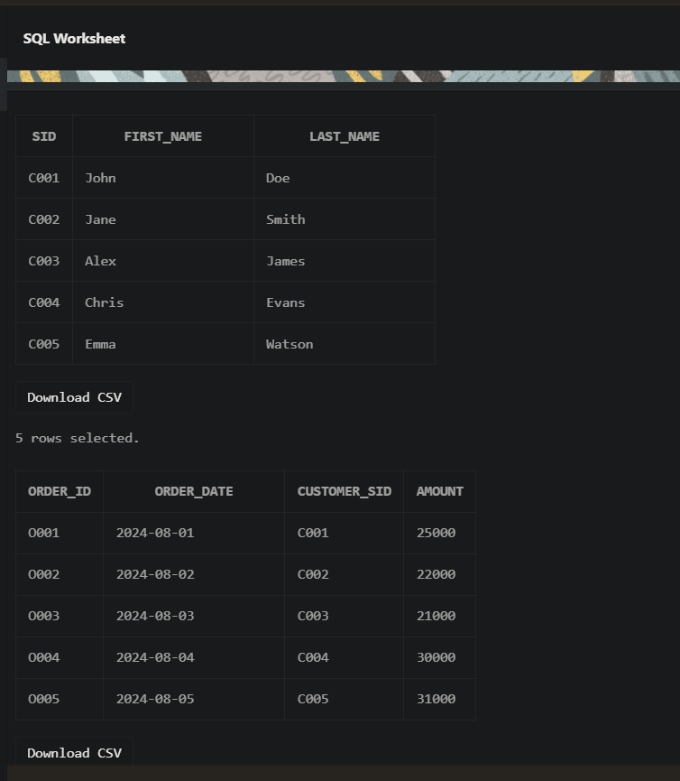
EXERCISE 3
AIM: Customer SID column in the ORDERS table is a foreign key pointing to the SID column in the CUSTOMER table.

Output:

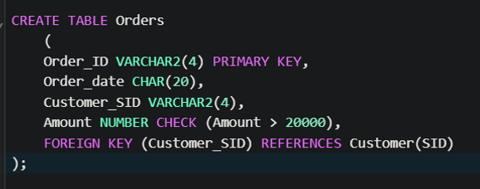

EXERCISE 4
AIM: List the details of the customers along with the amount.

Output:

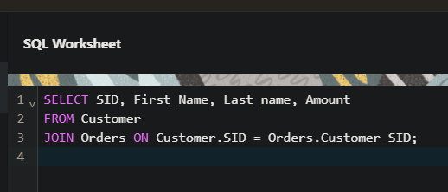

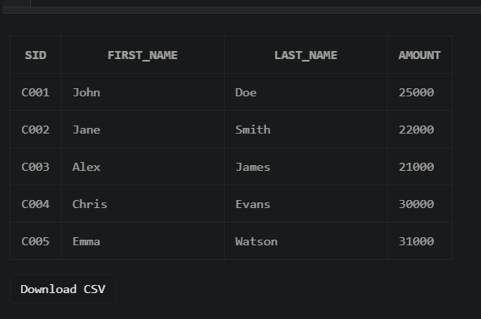
EXERCISE 5
AIM: List the customers whose names end with “s”.

Output:

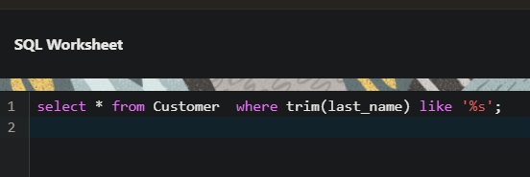

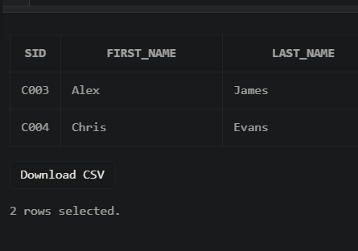

EXERCISE 6
AIM: List the orders where amount is between 21000 and 30000

Output:

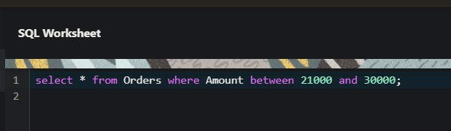

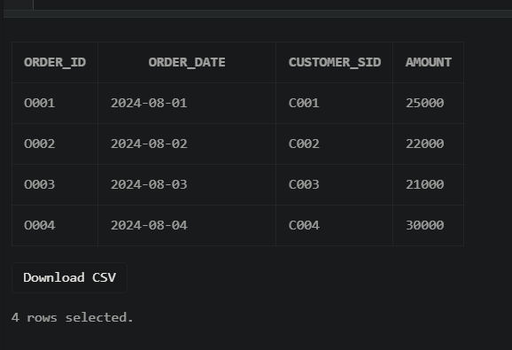

EXERCISE 7
AIM: List the orders where amount is increased by 500 and replace with name “new amount”.
Output:

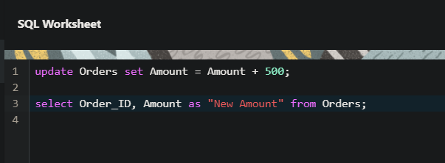

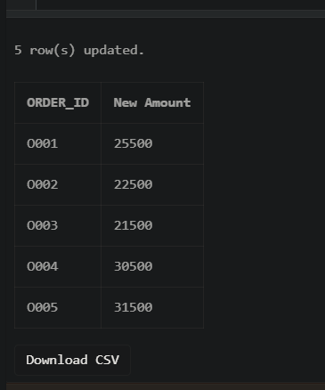

EXERCISE 8
AIM: Display the order_id and total amount of orders.
Output:

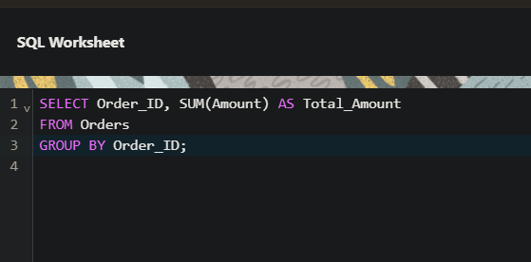

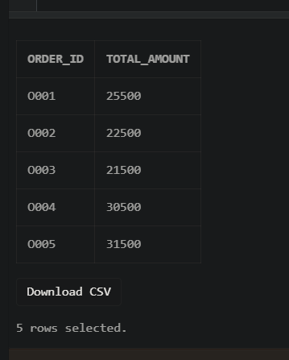

EXERCISE 9
AIM: Calculate the total amount of orders that has more than 15000.
Output:

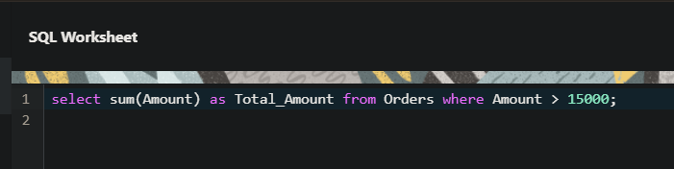

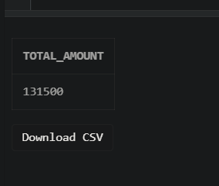

EXERCISE 10
AIM: Display all the string functions used in SQL.
Output:

SELECT
LOWER('ORACLE') AS "Lowercase", -- Converts string to lowercase
UPPER('oracle') AS "Uppercase", -- Converts string to uppercase
SUBSTR('ORACLE', 2, 3) AS "Substring", -- Extracts substring
LENGTH('ORACLE') AS "Length”, -- Returns length of string
INSTR('ORACLE', 'A') AS "Position", -- Returns position of a character
LPAD('123', 5, '0') AS "Left Padding", -- Pads a string on the left
RPAD('123', 5, '0') AS "Right Padding",-- Pads a string on the right
TRIM('O' FROM 'ORACLE') AS "Trimmed" -- Trims a specified character
FROM DUAL;

EXERCISE 11
AIM: Create the following tables.
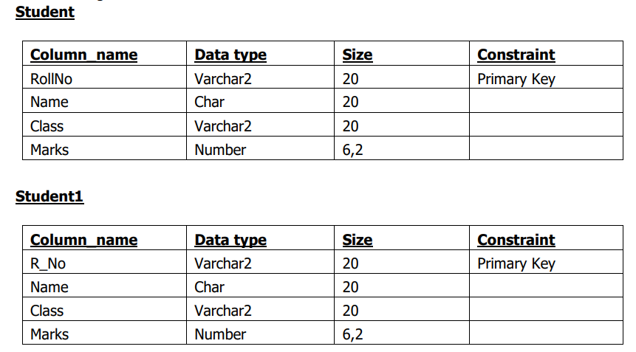
Output:
