Clarified steps for making & installing dendrobands

Master (word) version of this document currently lives at https://github.com/SCBI-ForestGEO/Dendrobands/tree/master/resources.

*The first couple pages contain only the step-by-step instructions for easy printing. Pictures accompanying the steps can be found on the following pages.

Notes
- The metal bands cut through skin easily. It is advised to wear gloves or have bandaids handy
- dendroband = dendrometer bands
- dcm = diameter cm. These are the cm measurements on the diameter side of the DBH tape. Creating a dendroband uses both dcm and normal cm (aka both sides of the DBH tape).
  - Remember: 1 dcm = 1 cm * pi
- Each roll of the dendroband material is ~ 205 dcm in length.
- Use the following measurements to determine what length dendroband can be applied to a certain tree given its dbh
For a dendroband of length…, | apply to tree of DBH...
<= 10 dcm | <= 8 cm
11-30 dcm | 6-25 cm
30+ dcm | 20+ cm

Instructions for office
- BEFORE starting to build, check stash of pre-made and pre-measured bands and use whatever you can of those first.
- Measure out the band to make sure it is the length you want (in dcm!).
- Take sleeve and put band through it, so that smooth side of sleeve is facing out (outside of curve).
  - To make sleeve, cut piece of metal that is 4-5 cm long, and fold in thirds (or close to thirds) such that a dendroband can slide through the space created.
- Slide it on enough such that you can fold over the end of the dendroband to match the length of the sleeve (folding with the curve of the band). Fold over again for Step 5 (so folded twice in total).
- Use marker and put 2 dots (eg NW and SE) on band next to sleeve – the dots should be within the length of where the sleeve was folded over the second time.
  - This second fold is optional, but it helps to give guidance for where to put the holes.
- Punch holes where the dots are.
- Using the other side of the DBH tape, measure 1.5-2 cm (normal cm!) from furthest hole from band edge, mark a line on the bottom of the band that goes vertically just under halfway up the band.
- Do the same thing 15 cm from that furthest hole.
- Connect the top of the two lines created in step 7 and 8. That should look like a ~13cm line, parallel to the long edge of the band, about half-way up the width of the band.
- Cut out a “window” on the bottom of that band from the drawn lines.
- Roll up the band, tape, label with tag number of desired tree for the band AND the length of band (in dcm), and store it. The reason for double labeling is in case the band needs to be reused, then you don’t need to re-measure it. Or, use right away (see “Instructions for field” section below).

Instructions for field
- First, prepare for the field:
  - Label the prepared bands with the tree’s tag number.
  - Gather appropriate springs based on band size.
  - Review the metadata so you know what data you’re collecting in the field.
    - The file is “bandreplace_metadata.csv”.
  - Bring materials necessary for dendroband installation:
    - Everything in the checklist (the datasheet is either the field_form_bandreplace.xlsx or field_form_treereplace.xlsx).
    - Prepared dendrobands + springs
    - Small hole puncher for field
    - DBH tape
    - Scissors to cut extra band material as needed

Note: For bigger trees, you will need someone to help put on the dendroband so it’s at breast height all the way around.
- Take dbh of the tree at 1.3m (standard) and the height of the old dendroband (dendDiam on datasheet).
- If replacing a band, use the old band’s height to be consistent.
- If installing a new band, the default measurement for dendrobands is 10cm above the main census point, as per Helene’s original protocol.
- Install a spring on the dendroband where you punched the holes (or two springs if tree bigger than about 90 cm dbh). Spring hook can be elongated to make installation easier (see pictures).
- Wrap band around the tree, and slide loose end of band inside the sleeve on the tree side.
- Important: Band should be wrapped such that the window is on the bottom and the smooth side of the sleeve is against the tree.
- Wrap the band tightly, holding two the overlapping part of the band tightly with one hand (if installing alone).
- With the other hand, pull the spring away from the edge of the band it is attached to (opposite direction of window).
- Use a sharpie to mark where the loose end of the spring is when you pull it ~10% of its stretch (moderate extension), then punch a hole at the mark (the band will need to be loosened a bit for that).
- Tighten the band again and attach the loose end of the spring to the new hole.
- Make sure the band is well positioned around the tree and that the spring has room to contract in case the tree bole shrinks.
- Cut the (not so loose anymore) end of the band about 1cm from the edge of the window that is the furthest from the spring. This is so that we can still measure the window in case the tree shrinks in diameter.
- Add another sleeve over the overlapping band/window to keep the free band in place.
- Take caliper measurement (in mm!!) and record necessary data.
- Add flagging tape ONLY IF adding a new tree to the intraannual survey, or if existing flagging needs to be replaced.
*These instructions are based off the updated CTFS-ForestGEO protocol for making dendrobands.

How to make dendrobands with pictures
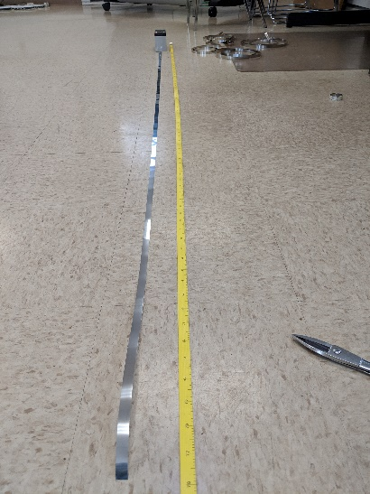
Instructions for office

Step 2: measure out band

Step 3: Put sleeve on band, smooth facing out
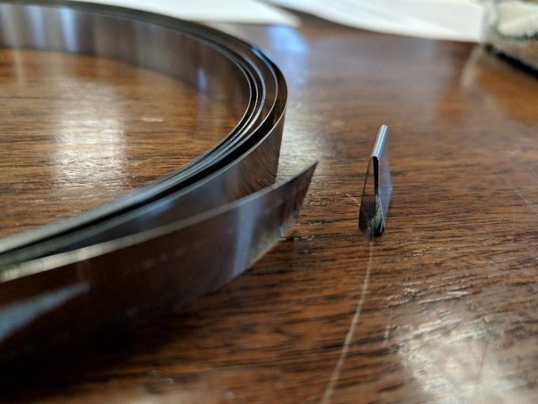

Step 3a: Making sleeves
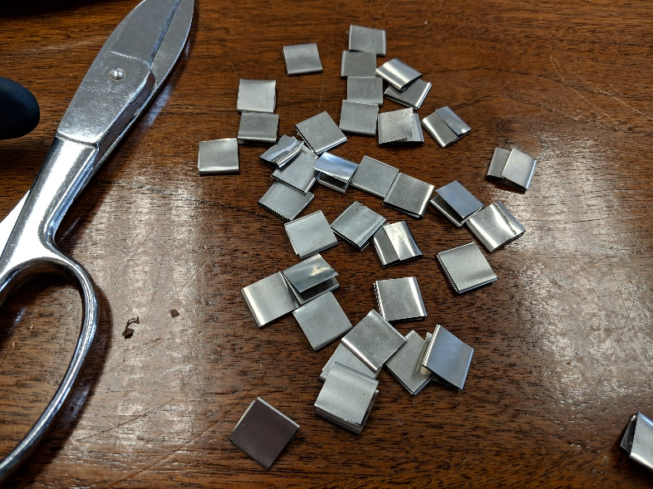
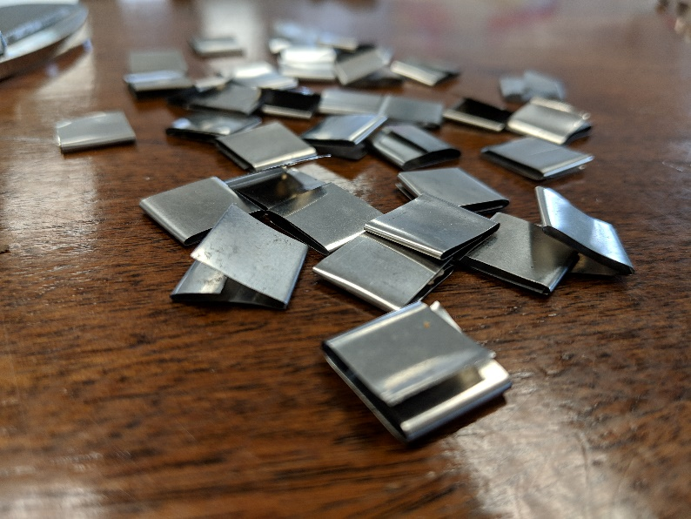

Step 4: Folding the band
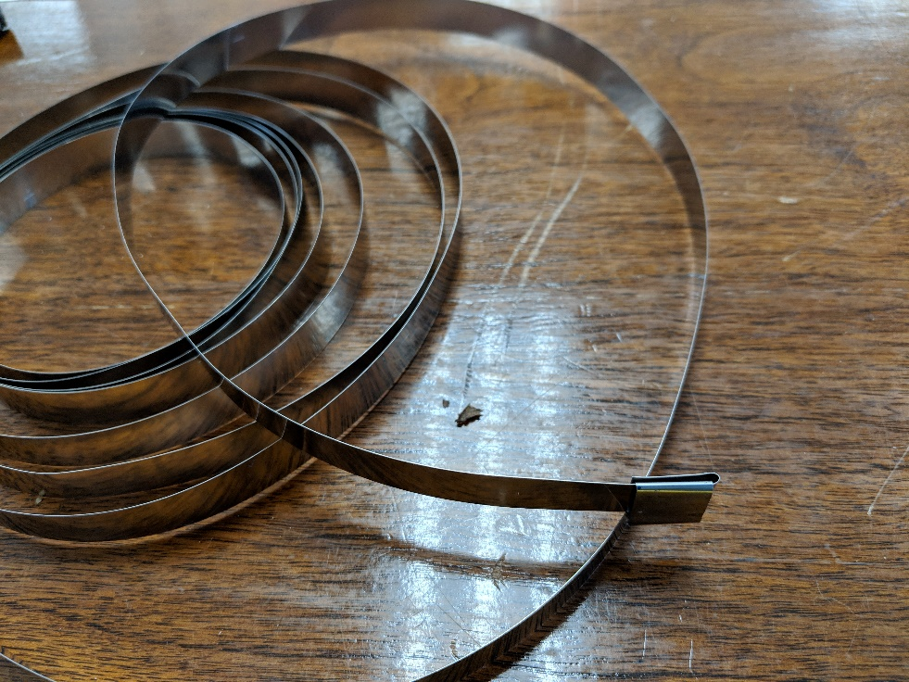

This picture represents the first of the two folds.
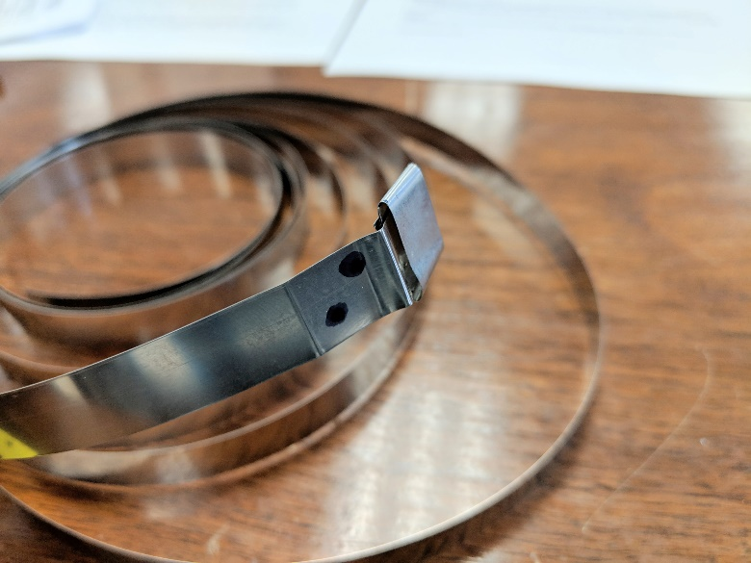
Step 5: Marking the holes

Step 6: Punch holes

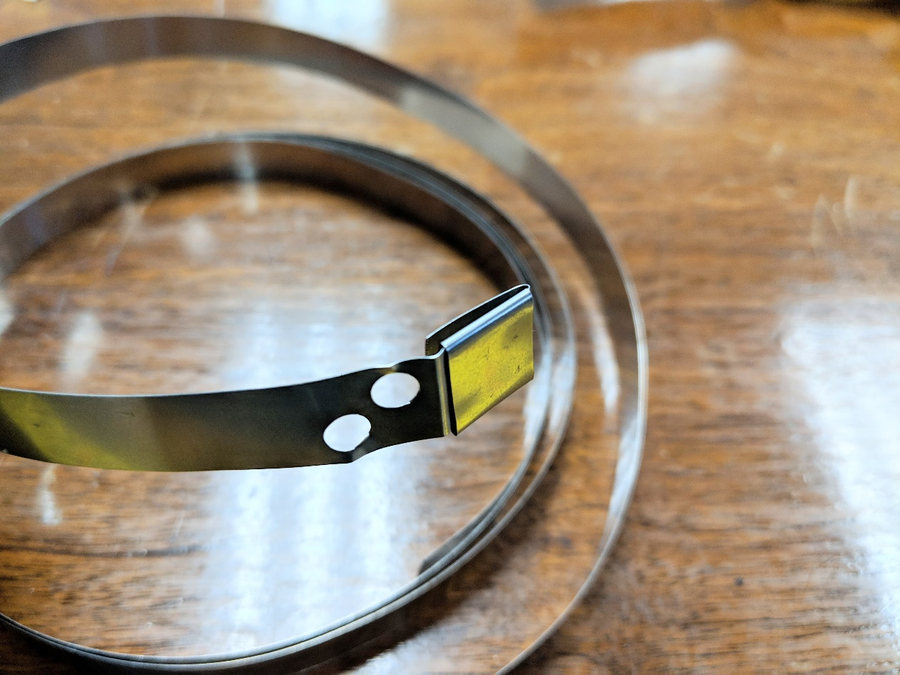

Steps 7-8: Mark window area
- 1.5-2 cm from furthest hole
- 15 cm from furthest hole
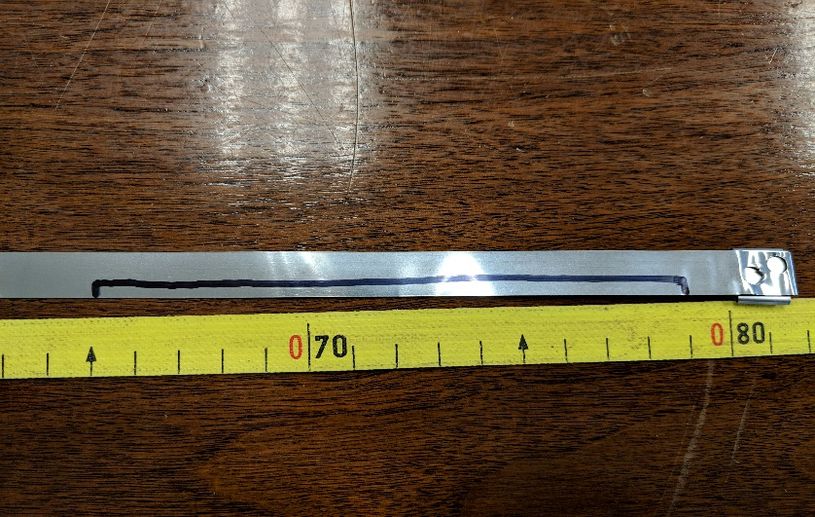

Step 9: Cut window
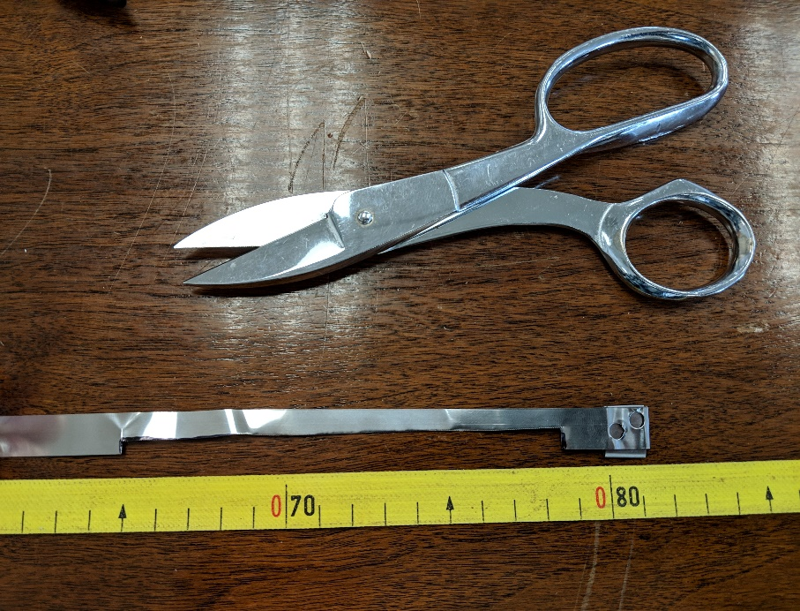

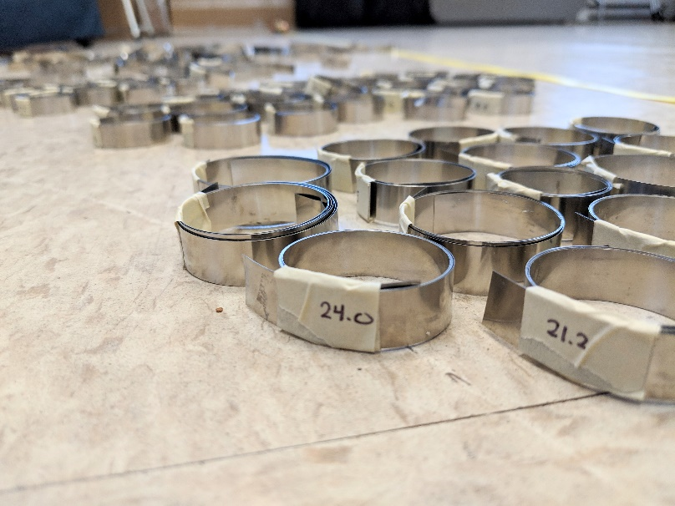
Step 10: Roll up band and label
- BOTH the tag number
- AND the measurement

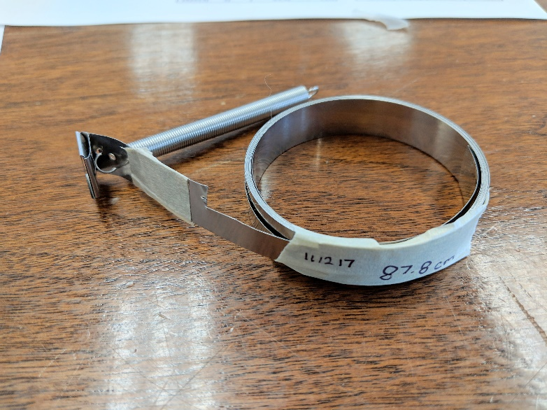
…or, use right away.
- Label as above
- See further steps below

Instructions for field
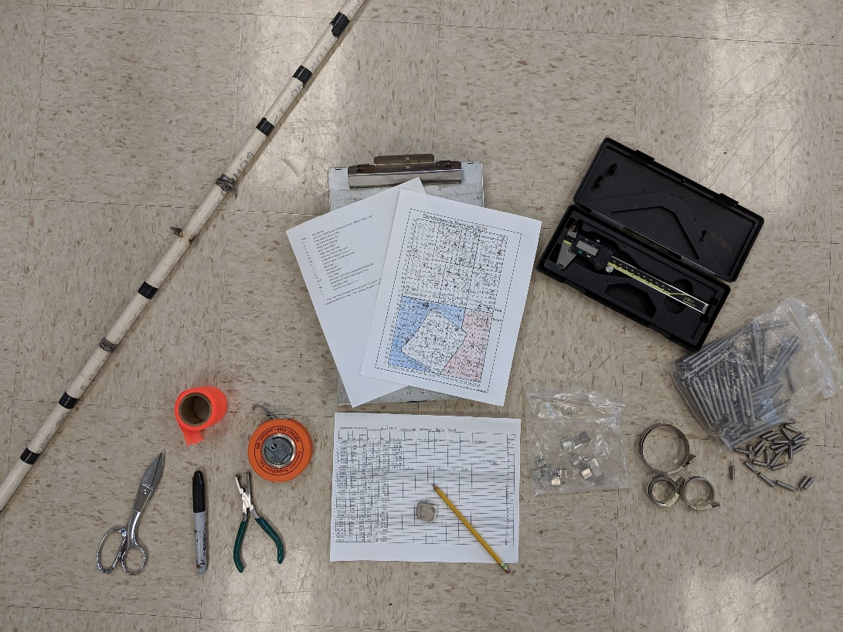
12. Prepare for field.

13. Take dbh in two places
- at 1.3m = “dbhnew” on datasheet
- at “dendHt” (the height of the dendroband) = “dendDiam” on datasheet

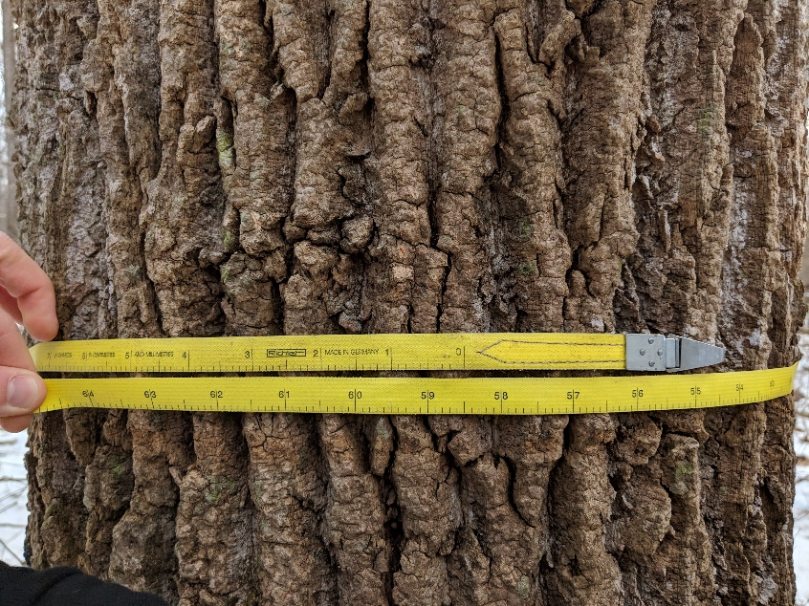

14. Install a spring.
- To make it easier to put the spring through the holes, it can help to elongate the hook. To do this, put the hook on the shears, and pull down a little on the spring.
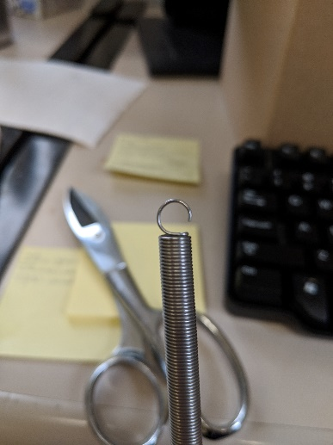
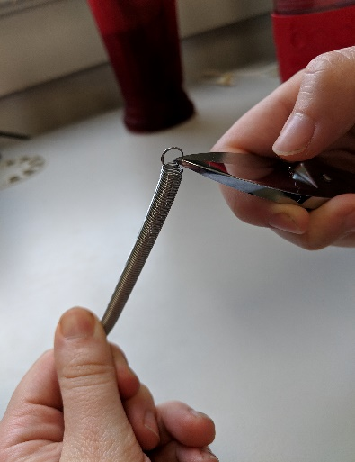
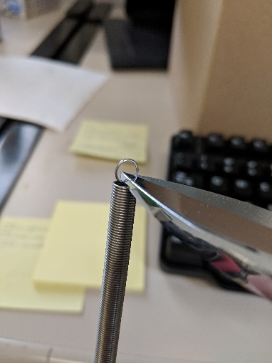
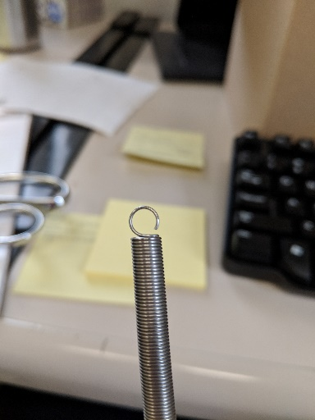

15. Wrap band such that the window is on the bottom and the smooth side of the sleeve is against the tree. Slide loose end of band into sleeve.
16. Wrap band tightly.
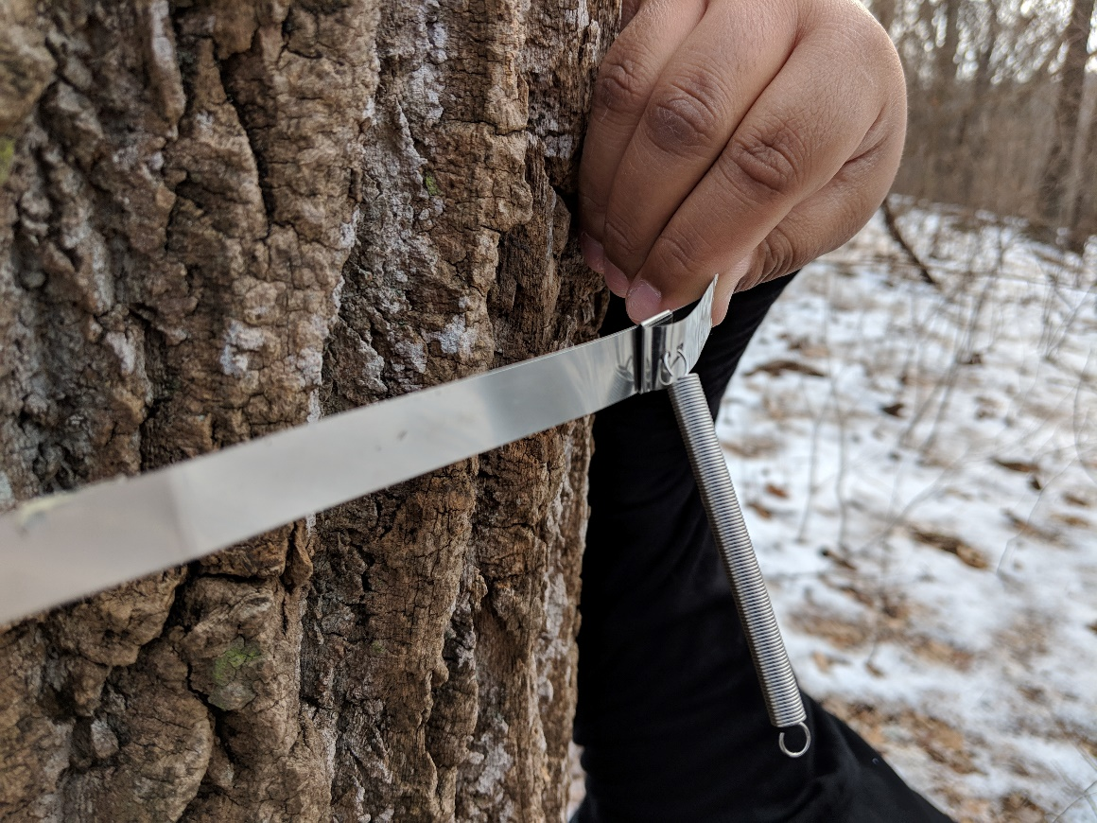

17. Pull spring opposite window.
18. At ~10% (moderate) stretch, mark hole and punch.
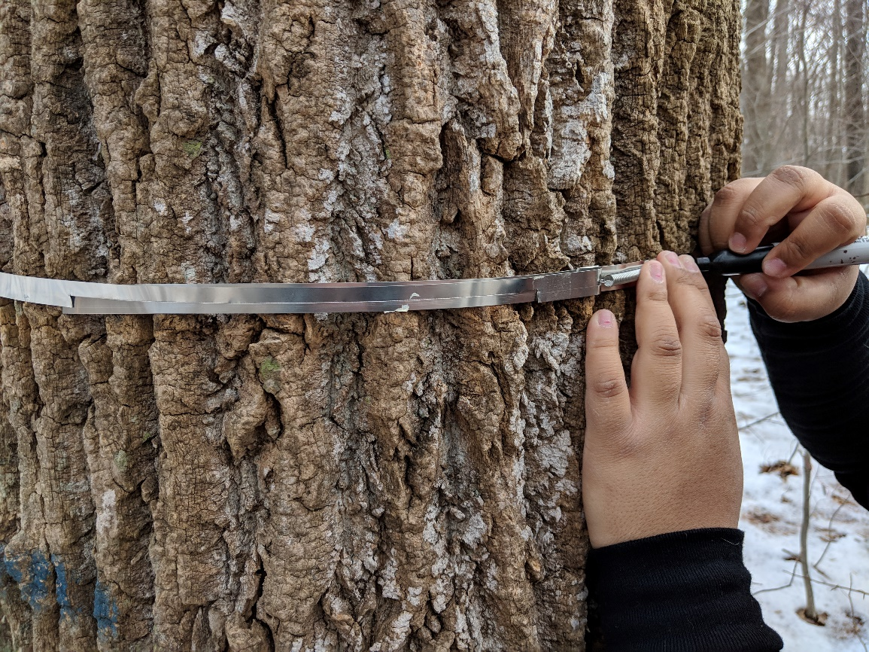

19. Tighten band and attach spring. Make sure the spring has room to contract in case the tree bole shrinks.
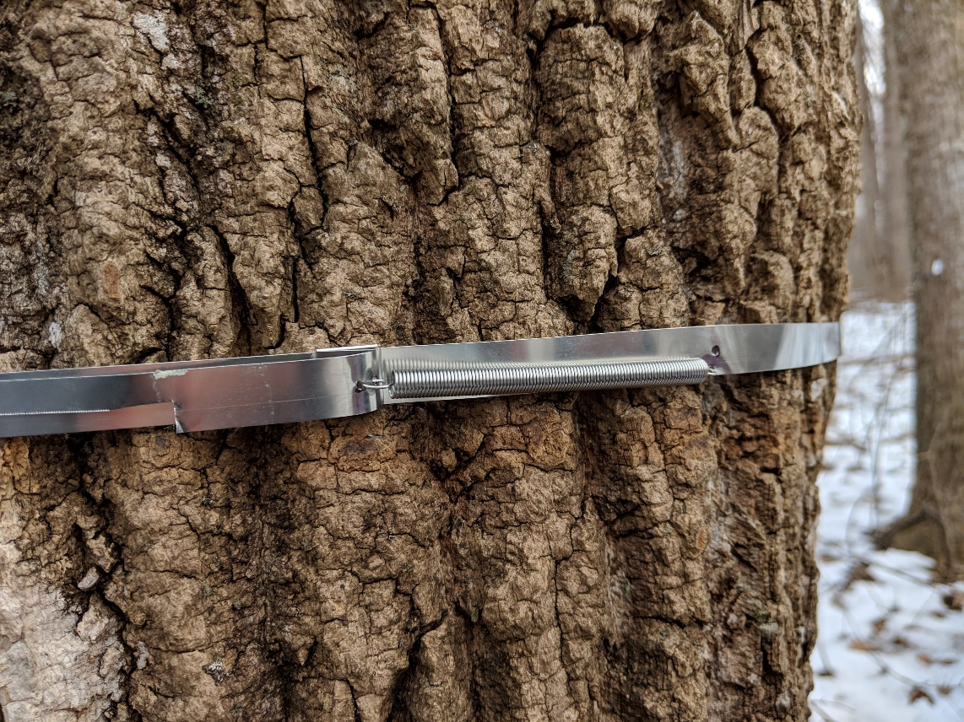

20. Cut extra loose band to roughly 1cm from window edge furthest from the spring.
21. Add another sleeve to keep free band in place.
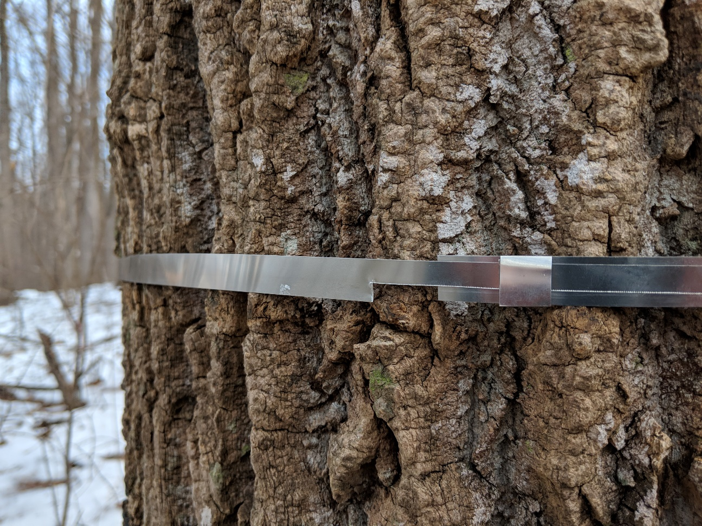

22. Take caliper measurement (in mm!!) and record necessary data.
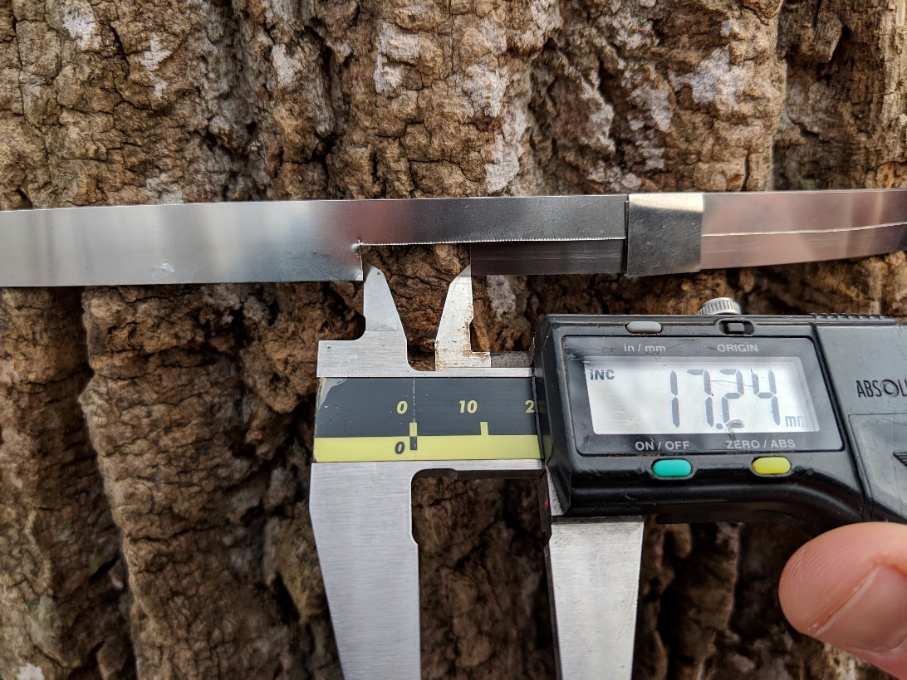
Add flagging tape ONLY
IF adding a new tree to
the intraannual survey,
or if existing flagging
needs to be replaced.

