**PROTOCOLS – DETERMINING CROWN ILLUMINATION, CONDITION, POSITION**

1. **Crown Illumination Index (“Crown.Illum”)**

Definition: Percentage of Illumination in reference to vertical and/or lateral light

5 = crown completely exposed (to vertical light and to lateral light within the 90-degree inverted cone encompassing the crown)

4 = full overhead light (>=90% of the vertical projection of the crown exposed to vertical light; later light blocked within some or all of the 90-degree inverted cone encompassing the crown)

3 = some overhead light (10-90% of the vertical project of the crown exposed to vertical light)

2 = lateral light (<10% of the vertical project of the crown exposed to vertical light; crown lit laterally)

1 = no direct light (crown not lit directly either vertically or laterally)

*Jennings 1999*

1. **Crown Condition (“crown.cond”)**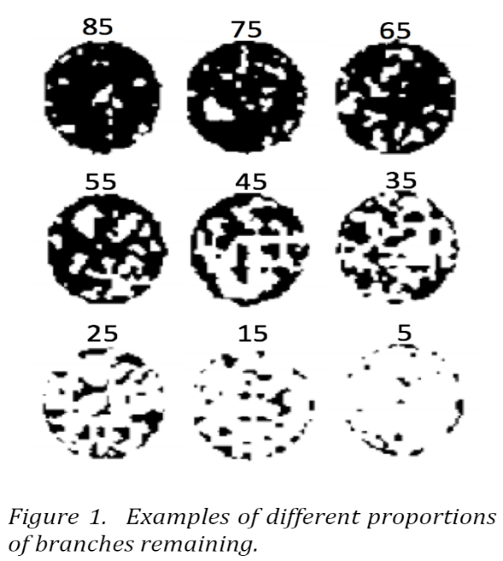Definition: refers to the amount of cover in regards to branches laterally connected to stem (this does not include dead branches).

The 4-point crown condition scale has the following categories:

4 = 75-100% of the crown is intact (no or few branches lost)

3 = 50-75% of the crown is intact

2 = 25-50% of the crown is intact

1 = 0-25% of the crown is intact (most of the crown is gone)

1. **Crown Position (“crown.pos”)**

Definition: The position of the crown of a specific tree compared to the primary portion of the canopy of designated forest, especially in relation to vertical light

Dominant (D) = Crown above the general level of the canopy  
 Codominant (C) = Crown within the general level of the canopy  
 Intermediate (I) = Shorter than general canopy level, but illuminated from above  
 Suppressed (S) = Shorter than the canopy level, receiving no illumination from above

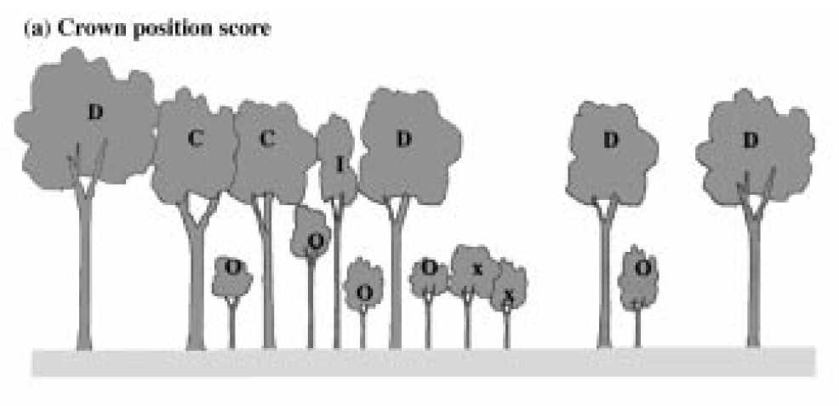*Jennings et al., 1999*