Clarified steps for making dendrobands

*\*The first couple pages contain only the step-by-step instructions for easy printing. Pictures accompanying the steps can be found on the following pages.*

**Notes**

* The metal bands cut through skin easily. It is advised to wear gloves or have bandaids handy
* dendroband = dendrometer bands
* dcm = diameter cm. These are the cm measurements on a DBH side of the DBH tape. Creating a dendroband uses both dcm and normal cm (aka both sides of the DBH tape).
  + **Remember:** 1 dcm > 1 cm
  + **Caution:** DBH measurements are by definition in dcm and dmm, but often they are written as just mm or cm. Be aware of this.
* Use the following measurements to determine what length dendroband can be applied to a certain tree given its dbh

|  |  |
| --- | --- |
| **For a dendroband of length…,** | **apply to tree of DBH...** |
| <= 10 dcm | <= 8 cm |
| 11-30 dcm | 6-25 cm |
| 30+ dcm | 20+ cm |

**Instructions for office**

1. Measure out the band to make sure it is the length you want (in dcm!).
2. Take clip and put band through it, so that smooth side of clip is facing out (outside of curve).
   * To make clips, cut piece of metal that is 4-5 cm long, and fold in thirds (or close to thirds) such that a dendroband can slide through the space created.
3. Slide it on enough such that you can fold over the end of the dendroband to match the length of the clip (folding with the curve of the band). Fold over again for Step 4 (so folded twice in total).
4. Use marker and put 2 dots (eg NW and SE) on band next to clip – the dots must be within the length of where the clip was folded over the second time.
   * This second fold is optional, but it helps to give guidance for where to put the holes.
5. Punch holes where the dots are, and fold as folded in step 3.
6. Using the other side of the DBH tape, measure 1.5-2 cm (normal cm!) from furthest hole from band edge, mark a line on the bottom of the band that goes vertically halfway up the band.
7. Do the same thing 15 cm from that furthest hole.
8. Connect the top of the two lines created in step 6 and 7. That should look like a ~13cm line, parallel to the long edge of the band, about half-way up the width of the band.
9. Cut out a “window” on the bottom of that band from the drawn lines.
10. Roll up the band, tape, label with the length of band (in dcm), and store it. Or, use right away (see “IN fIELD” section below).

IN FIELD

Note: For bigger trees, you will need someone to help put on the dendroband so it’s at breast hight all the way around.

1. Install a spring where you punched the holes
2. Wrap band around the tree
3. Slide the loose end of the band inside the clip, on the tree side.
4. Wrap the band tightly
5. Hold the two layers of the band tightly with one hand.
6. With the other hand, pull the spring away from the edge of the band it is attached too.
7. Mark where the loose end of the spring is when you pull it ~10% of it stretch.
8. Punch a hole in the band at the mark created in step 7. (you will have to losen up the band for that)
9. Thighten the band again and attach the loose end of the the spring to the new hole
10. After making sure the band is well positioned around the tree and that the spring has room to contract in case the tree bole shinks, cut the (not so loose anymore) end of the band about 1cm from the edge of the window that is the furthest from the spring. This is so that we can still measure the window in case the tree shrinks in diameter.

*These instructions are based off the updated [CTFS-ForestGEO protocol](https://docs.google.com/document/d/1kCG22EAEnOVxw9Z-cPPvrHIzvRFE-j0U7anTmhJbkqM/edit) for making dendrobands.

How to make dendrobands (with pictures)

**Notes**

* The metal bands cut through skin easily. It is advised to wear gloves or have bandaids handy
* dendroband = dendrometer bands
* dcm = diameter cm. These are the cm measurements on a DBH tape that measure the DBH. Creating a dendroband uses both dcm and normal cm (aka both sides of the DBH tape).
  + **Remember:** 1 dcm > 1 cm
  + **Caution:** DBH measurements are by definition in dcm and dmm, but often they are written as just mm or cm. Be aware of this.
* Use the following measurements to determine what length dendroband can be applied to a certain tree given its dbh

|  |  |
| --- | --- |
| **For a dendroband of length…,** | **apply to tree of DBH...** |
| <= 10 dcm | <= 8 dcm |
| 11-30 dcm | 6-25 dcm |
| 30+ dcm | 20+ dcm |

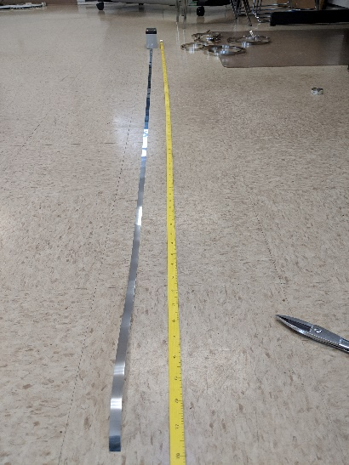**Instructions for office**

1. Measure out the band to make sure

it is the length you want (in dcm!).

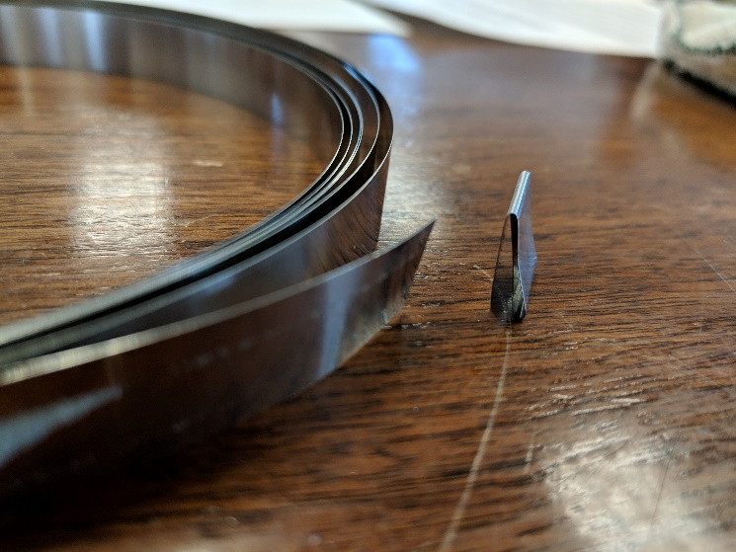

1. Take clip and put band through it,

so that smooth side of clip is facing out

(outside of curve).

* 1. To make clips, cut piece of metal that is 4-5 cm long, and fold in thirds (or close to thirds) such that a dendroband can slide through the space created.

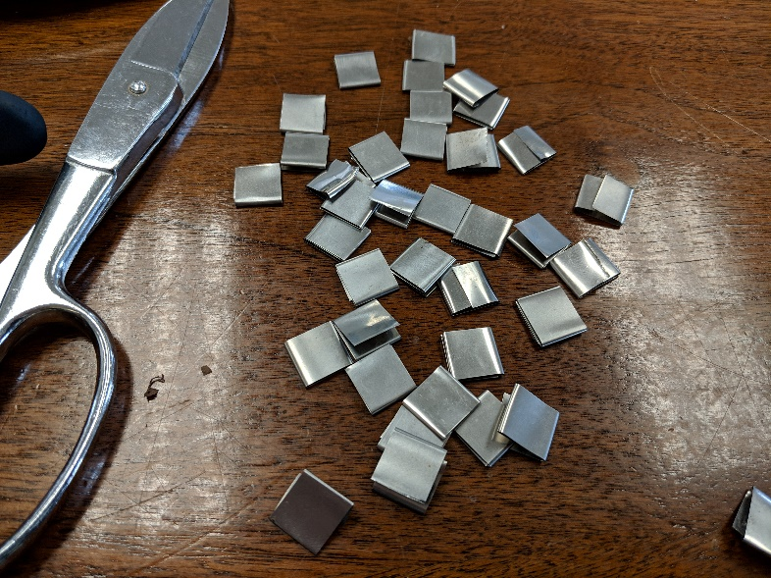

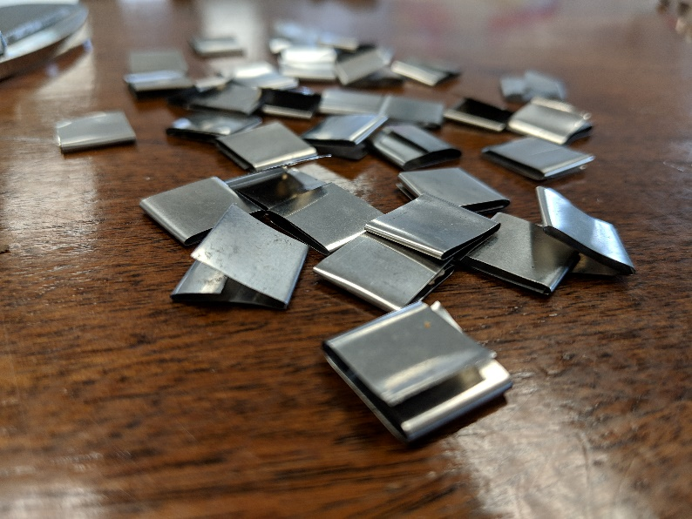

1. Slide it on enough such that you can fold over the end of the dendroband to match the length of the clip (folding with the curve of the band). Fold over again for Step 4 (so folded twice in total).

*\*This second fold is optional, but it helps to give guidance for where to put the holes in Step 4\**

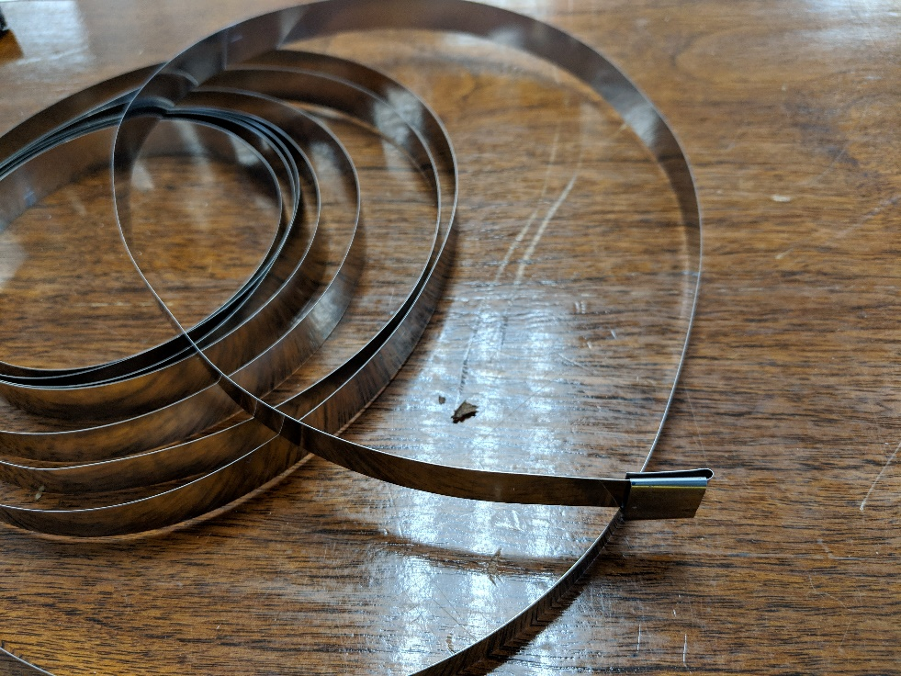

*This picture represents the first of the two folds.*

1. 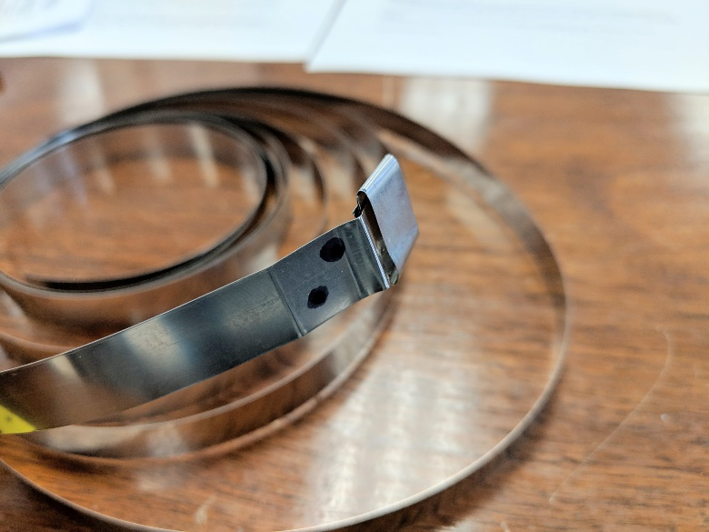Use marker and put 2 dots (eg NW and SE) on

band next to clip – the dots should be within

the length of where the clip was folded over

the second time.

1. Punch holes where the dots are, and fold as folded in step 3.

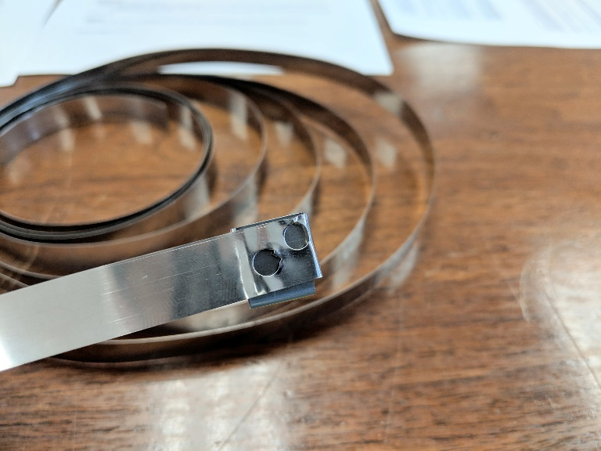

1. Using the other side of the DBH tape, measure 1.5-2 cm (normal cm!) from furthest hole from band edge, mark a line on the bottom of the band that goes vertically halfway up the band.

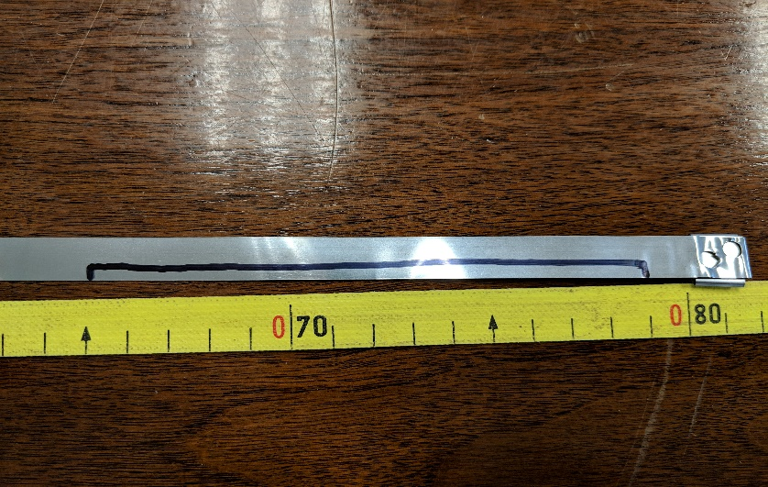

1. 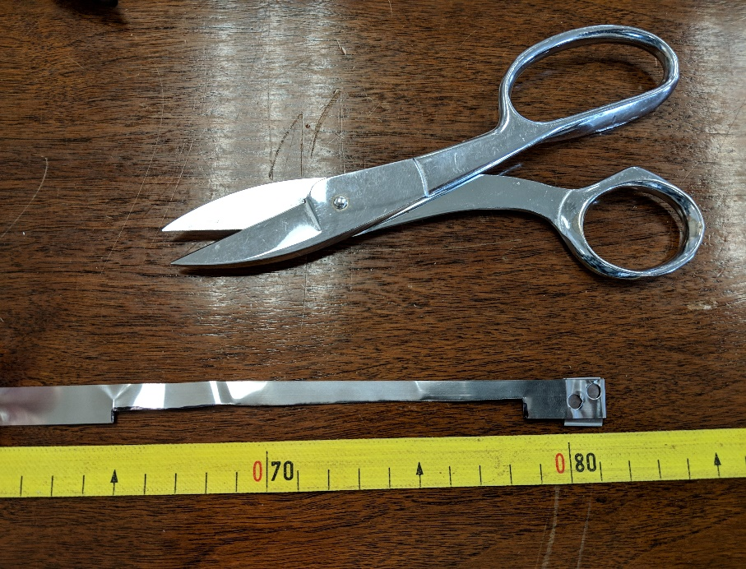Do the same thing 15 cm from that

furthest dot. Cut out a “window” on

the bottom of that band from the

drawn lines.

1. 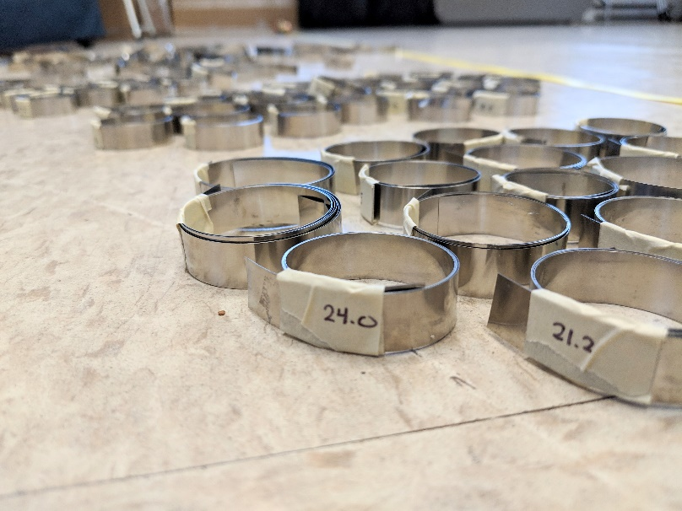Roll up the band, tape, label with the

length of band (in dcm), and store it.

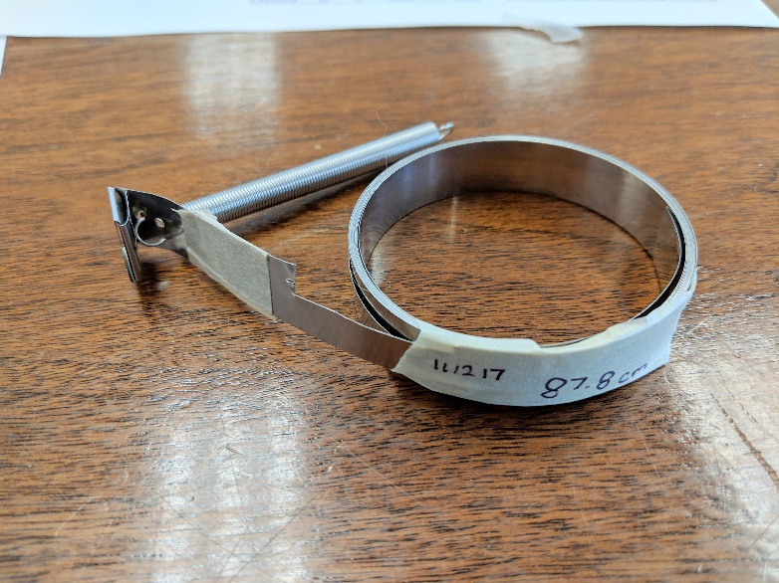

Or, use right away.

**Instructions for field**

1. First, prepare for the field:
   1. Label the prepared bands with the tree’s tag number.
   2. Gather appropriate springs based on band size.
   3. **Review the** [**metadata**](https://github.com/SCBI-ForestGEO/Dendrobands/tree/master/data/metadata) so you know what data you’re collecting in the field.
      1. The file is “bandreplace_metadata.csv”.
   4. Bring materials necessary for dendroband installation:
      1. Everything in the [checklist](https://github.com/SCBI-ForestGEO/Dendrobands/blob/master/resources/field_forms/README.md) (the [datasheet](https://github.com/SCBI-ForestGEO/Dendrobands/tree/master/resources/field_forms) is either the field_form_bandreplace.xlsx or field_form_treereplace.xlsx).
      2. Prepared dendrobands + springs
      3. Small hole puncher for field
      4. DBH tape

1. For bigger trees, need someone to help put on the dendroband so it’s at DBH all the way around.

2. Wrap band around tree and put such that the end is about 1cm from the edge of the window. This is so that if the tree shrinks in diameter we can still measure it.

**IMPORTANT:** After these steps are done, remember to finish going through the entire [workflow](https://github.com/SCBI-ForestGEO/Dendrobands/blob/master/resources/workflow_bandreplace.md).