How to core a tree – SCBI

*\*The first couple pages contain only the step-by-step instructions for easy printing. Pictures accompanying the steps can be found on the following pages.*

**Notes**

In general, coring is part of the annual mortality survey done in the ForestGEO plot. With that, it is assumed you will have the necessary data and are comfortable with navigating the plot, tree identification, and able to identify live/dead trees.

**Materials**

iPad and data

Plot map

Straws

Tape

Sharpie

2 increment borers (1 large – blue | 1 small – orange)

* “increment borer” is the name for the entire assemblage and contains 3 parts
  + Handle: the outside (what is blue or orange)
  + Auger: black tube that is used to bore into the tree
  + Extractor tray: silver tray with serrated edge, used to extract core
    - **** The auger and extractor trays are stored inside the handle
* Small increment borer should be used for trees <= 30cm dbh
* Large increment borer should be used for trees >30cm dbh

**Instructions for field**

1. Find the tree that needs to be cored, and determine which size increment borer you need to use.
2. Remove auger and extractor tray from handle.
3. Insert auger to middle hole of handle by unlatching top latch on opposite side, closing to secure. For the larger increment borer, this is done with a band of rubber.
4. Find a spot on the tree where bark is relatively flat at DBH.
   1. Remember, if on hill, DBH is taken on higher side.
5. Start turning handle (clockwise) while applying steady and constant pressure, in order to make the first incision.
   1. Ensure the auger is kept perpendicular to tree.
6. Once the auger is in the tree enough such that it can hold itself, use both hands to twist the handle.
7. The depth you want the auger is dependent on the middle of the tree. Line up the extractor tray next to the auger such that the serrated edge is a little more than halfway through the tree. The top of it is ultimately how far you want your handle to be.
8. When you get to within 2-3 turns of reaching that point, insert extractor tray through middle of the handle. Pull in and out while rotating to help detach core from inside of auger.
9. Do more large turns of the handle, with extractor tray inside.
10. Repeat step 8 (rotating and carving).
11. Turn the handle 3 times counter-clockwise to loosen from the tree, rotate and carve again.
12. **Slowly** pull out the extractor tray with the core.
13. Inspect core. You should be able to see the middle. If you can’t, return to step 4.
    1. If a tree is rotted before you reach the middle, you won’t be able to get the middle
    2. **ALYSSA PLEASE ELABORATE**
14. Once core is satisfactory, carefully remove it from the extractor tray and insert it into a straw, sometimes two are needed.
    1. Make sure you include any small or broken pieces if there are any.
15. Tape or staple ends of straw together to keep the core contained.
16. Label straw with tag number, species code, and date of coring.
17. Remove auger from tree by continuing to turn handle counter-clockwise. Reassemble the increment borer by putting the auger and extractor tray back inside the handle.

How to core a tree with pictures

1. 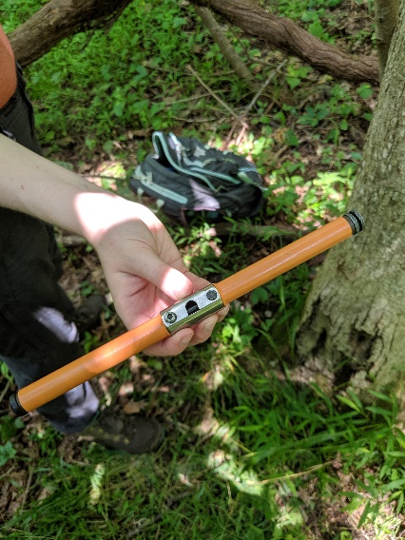Find the tree that needs to be cored, and determine

which size increment borer you need to use.

Increment borer ---->

1. Remove auger (right) and extractor tray (left) from handle.

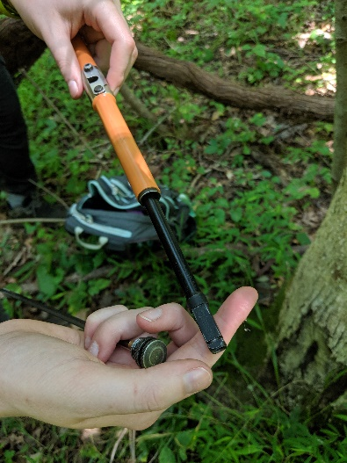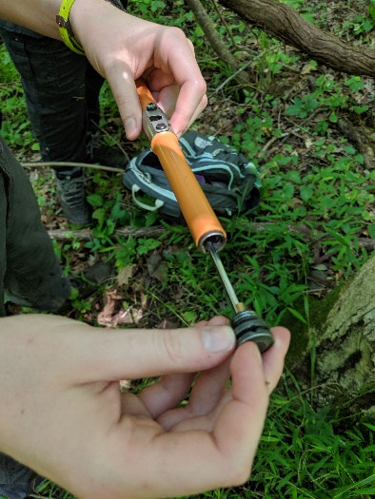

1. Insert auger to middle hole of handle by unlatching top latch on opposite side (left), closing to secure (right). For the larger increment borer, this is done with a band of rubber.

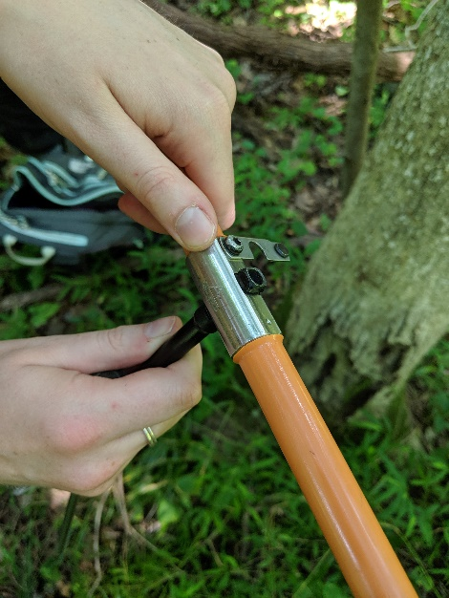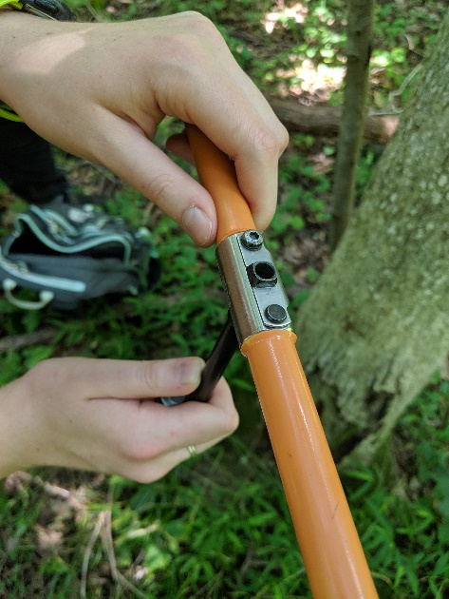

1. 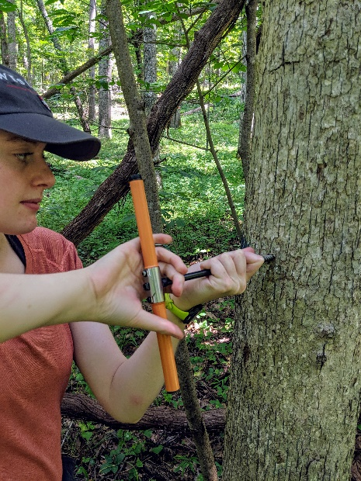Find a spot on the tree where bark is relatively

flat at DBH.

* 1. Remember, if on hill, DBH is taken on higher side.

1. Start turning handle (clockwise) while applying steady

and constant pressure, in order to make the first incision.

* 1. Ensure the auger is kept perpendicular to tree.

1. Once the auger is in the tree enough such that it can hold

itself, use both hands to twist the handle.

1. The depth you want the auger is dependent on the middle of the tree. Line up the extractor tray next to the auger such that the serrated edge is a little more than halfway through the tree. The top of it is ultimately how far you want your handle to be.

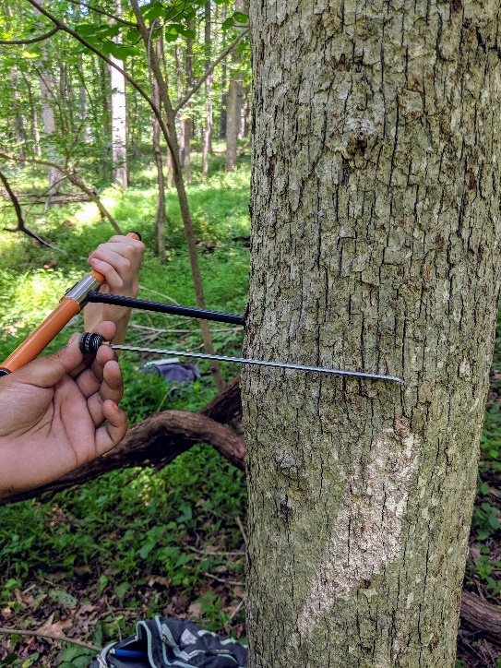

1. When you get to within 2-3 turns of reaching that point (left), insert extractor tray through middle of the handle. Pull in and out while rotating to help detach core from inside of auger.

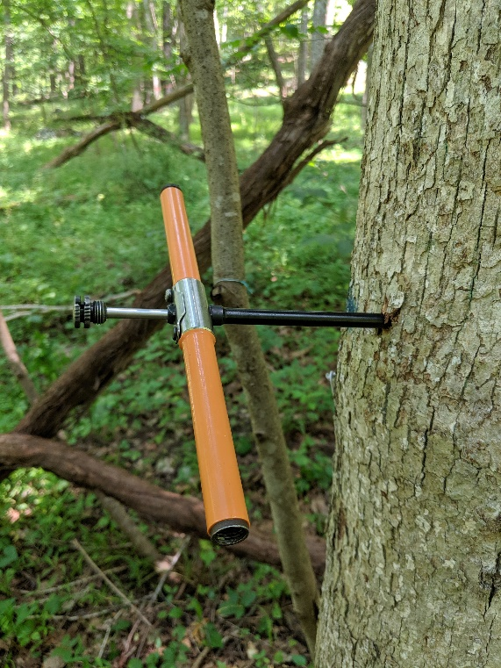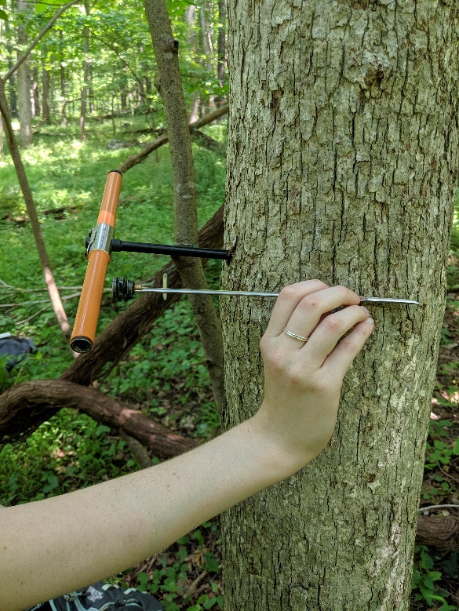

1. Do more large turns of the handle, with extractor tray inside.
2. Repeat step 8 (rotating and carving).
3. Turn the handle 3 times counter-clockwise to loosen from the tree, rotate and carve again.
4. **Slowly** pull out the extractor tray with the core.

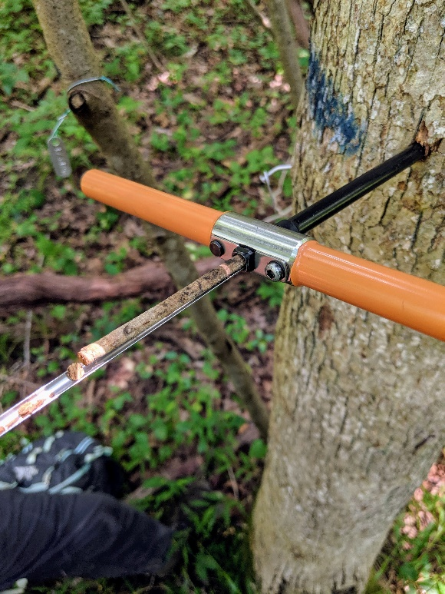

1. Inspect core. You should be able to see the middle. If you can’t, return to step 4.
   1. The middle of the tree shows itself in the core as where the rings start to be more fully rounded, like going in a semi-circle.
   2. If a tree is rotted before you reach the middle, you won’t be able to get the middle
   3. **ALYSSA PLEASE ELABORATE**

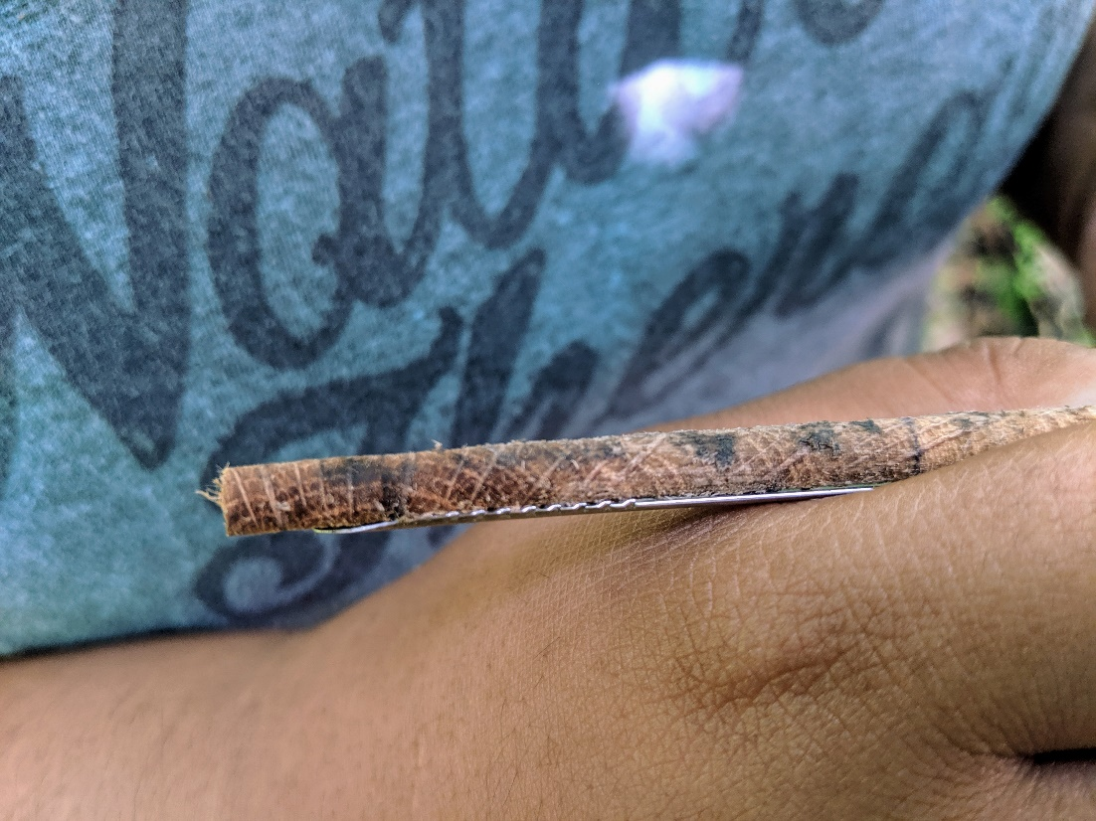

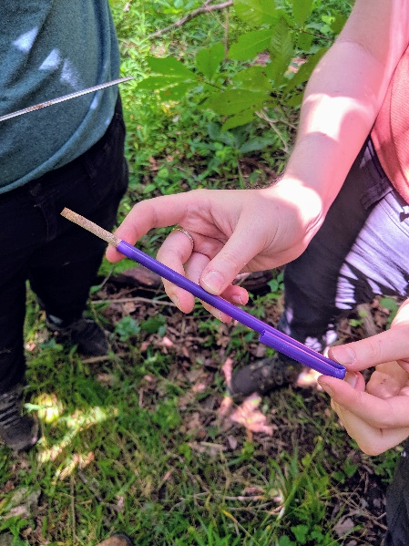

1. Once core is satisfactory, carefully remove it from the

extractor tray and insert it into a straw, sometimes two

are needed.

* 1. Make sure you include any small or broken

pieces if there are any.

1. Tape or staple ends of straw together to keep the core

contained (right).

1. Label straw with tag number, species code, and date of

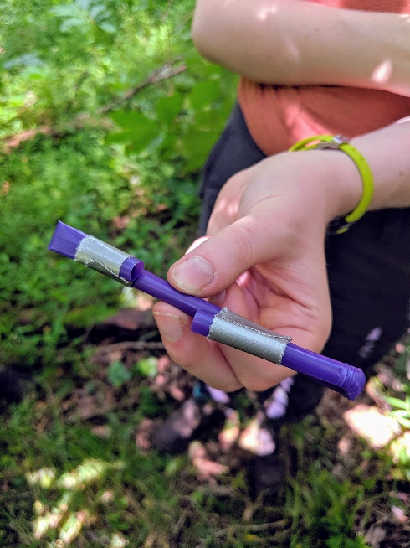Coring (bottom).

1. Remove auger from tree by continuing to turn handle

counter-clockwise. Reassemble the increment borer by putting

the auger and extractor tray back inside the handle.

