## *New Phytologist* Supporting Information

Article title: Tree height and leaf drought tolerance traits shape growth responses across droughts in a temperate broadleaf forest

Authors: Ian R. McGregor, Ryan Helcoski, Norbert Kunert, Alan J. Tepley, Erika B. Gonzalez-Akre, Valentine Herrmann, Joseph Zailaa, Atticus E.L. Stovall, Norman A. Bourg, William J. McShea, Neil Pederson, Lawren Sack, Kristina J. Anderson-Teixeira

Article acceptance date: 02 October 2020

The following Supporting Information is available for this article:

**Table S1** . Monthly Palmer Drought Severity Index (PDSI), and its rank among all years between 1950 and 2009, for focal droughts.

**Table S2** Species-specific bark thickness regression equations.

**Table S3** Species-specific height regression equations.

**Table S4** Individual tests of species traits as drivers of drought resistance, where *Rt* is used as the response variable.

**Table S5** Individual tests of species traits as drivers of drought resistance where *RtARIMA* is used as the response variable.

**Table S6** Individual tests of species traits as drivers of drought recovery (*Rc*).

**Table S7** Individual tests of species traits as drivers of drought resilience (*Rs*).

**Table S8** Summary of top full models for each drought instance, where *Rt* is used as the response variable.

**Table S9** Summary of top full models for each drought instance, where *RtARIMA* is used as the response variable.

**Table S10** Summary of top full models for each drought instance, where *Rc* is used as the response variable.

**Table S11** Summary of top full models for each drought instance, where *Rs* is used as the response variable.

**Fig. S1** Time series of Palmer Drought Severity Index (PDSI) for the 2 years prior and after each focal drought.

**Fig. S2** Map of ForestGEO plot showing topographic wetness index and location of cored trees.

**Fig. S3** Distribution of reconstructed tree heights across drought years.

**Fig. S4** Distribution of independent variables by species.

**Fig. S5** Comparison of *Rt* and *RtARIMA* results, with residuals, for each drought scenario.

**Fig. S6** Density plot of drought recovery (*Rc*) values for each focal drought year.

**Fig. S7** Drought recovery (*Rc*) across species for the three focal droughts.

**Methods S1** Further Package Citations

**Table S1** Monthly Palmer Drought Severity Index (PDSI), and its rank among all years between 1950 and 2009 (driest=1), for focal droughts.

|  |  |  |  |
| --- | --- | --- | --- |
| year | month | PDSI | rank |
| 1966 | May | -2.98 | 2 |
|  | June | -3.40 | 2 |
|  | July | -4.08 | 2 |
|  | August | -4.82 | 1 |
| 1977 | May | -2.96 | 3 |
|  | June | -3.28 | 3 |
|  | July | -3.61 | 3 |
|  | August | -3.68 | 3 |
| 1999 | May | -3.63 | 1 |
|  | June | -4.21 | 1 |
|  | July | -4.53 | 1 |
|  | August | -4.64 | 2 |

**Table S2** Species-specific regression equations for bark thickness (mm) as a function of diameter at breast height without bark (mm).

|  |  |  |
| --- | --- | --- |
| Species | Equations | *R2* |
| Carya cordiformis | ln[rbark] = -1.56+0.416*ln[DBH] | 0.226 |
| Carya glabra | ln[rbark] = -0.393+0.268*ln[DBH] | 0.04 |
| Carya ovalis | ln[rbark] = -2.18+0.651*ln[DBH] | 0.389 |
| Carya tomentosa | ln[rbark] = -0.477+0.301*ln[DBH] | 0.297 |
| Fagus grandifolia | - | - |
| Fraxinus americana | ln[rbark] = 0.418+0.26*ln[DBH] | 0.256 |
| Juglans nigra | ln[rbark] = 0.346+0.279*ln[DBH] | 0.246 |
| Liriodendron tulipifera | ln[rbark] = -1.14+0.463*ln[DBH] | 0.545 |
| Quercus alba | ln[rbark] = -2.09+0.637*ln[DBH] | 0.603 |
| Quercus prinus | ln[rbark] = -1.31+0.528*ln[DBH] | 0.577 |
| Quercus rubra | ln[rbark] = -0.593+0.292*ln[DBH] | 0.101 |
| all | ln[rbark] = 0.245+0.219*ln[DBH] | 0.087 |

We used linear regression on log-transformed data to relate *rbark* to the diameter inside bark from 2008 data. These were then used to determine *rbark* in the *DBHY* reconstruction (DBH in year Y). No bark correction was applied for *Fagus grandifolia*, which has thin bark.

**Table S3** Species-specific regression equations for height (m) as a function of DBH (cm).

|  |  |  |
| --- | --- | --- |
| Species | Equations | *R2* |
| Carya cordiformis | ln[H] = 0.332+0.808*ln[DBH] | 0.874 |
| Carya glabra | ln[H] = 0.685+0.691*ln[DBH] | 0.841 |
| Carya ovalis | ln[H] = 0.533+0.741*ln[DBH] | 0.924 |
| Carya tomentosa | ln[H] = 0.726+0.713*ln[DBH] | 0.897 |
| Fagus grandifolia | ln[H] = 0.708+0.662*ln[DBH] | 0.857 |
| Liriodendron tulipifera | ln[H] = 1.33+0.52*ln[DBH] | 0.771 |
| Quercus alba | ln[H] = 0.74+0.645*ln[DBH] | 0.719 |
| Quercus prinus | ln[H] = 0.41+0.757*ln[DBH] | 0.886 |
| Quercus rubra | ln[H] = 1.00+0.574*ln[DBH] | 0.755 |
| all | ln[H] = 0.839+0.642*ln[DBH] | 0.857 |

**Table S4** Individual tests of species traits as drivers of drought resistance, where *Rt* is used as the response variable.

|  |  |  |  |  |  |  |  |  |  |  |  |
| --- | --- | --- | --- | --- | --- | --- | --- | --- | --- | --- | --- |
|  | all droughts | |  |  | 1966 |  |  | 1977 |  |  | 1999 |
| variable category | ∆AICc coefficients | |  | ∆AICc | coefficients |  | ∆AICc | coefficients |  | ∆AICc | coefficients |
| xylem porosity R | -0.8 0.0630 | |  | 2.29** | 0.190 |  | 1.92 | -0.152 |  | 3.36** | 0.1500 |
| D/SR | 0.0000 | |  |  | 0.000 |  |  | 0.000 |  |  | 0.0000 |
| *PLA* | 6.7** | -0.0140 | 9.13** | | -0.025 | -0.32 | | -0.010 | -0.95 | | -0.0070 |
| *LMA* | -2.01 | 0.0002 | -1.9 | | 0.001 | -1.68 | | -0.002 | -2.03 | | 0.0003 |
| *πtlp* | 1.33 | -0.1740 | -1.65 | | -0.107 | 1.23 | | -0.245 | -0.1 | | -0.1690 |
| *WD* | -1.97 | -0.0310 | -1.26 | | -0.206 | -1.44 | | -0.154 | 0.66 | | 0.2720 |

Variable abbreviations are as in Table 2. ∆AICc is the AICc of a model excluding the trait minus that of the model including it.

**∆AICc > 2: variable considered significant as an individual predictor

**Table S5** Individual tests of species traits as drivers of drought resistance, where *RtARIMA* is used as the response variable.

|  |  |  |  |  |  |  |  |  |  |  |  |
| --- | --- | --- | --- | --- | --- | --- | --- | --- | --- | --- | --- |
|  | all droughts | |  |  | 1966 |  |  | 1977 |  |  | 1999 |
| variable category | ∆AICc coefficients | |  | ∆AICc | coefficients |  | ∆AICc | coefficients |  | ∆AICc | coefficients |
| xylem porosity R | -1.47 0.0420 | |  | 0.95 | 0.1520 |  | 2.84** | -0.171 |  | 2.27** | 0.155 |
| D/SR | 0.0000 | |  |  | 0.0000 |  |  | 0.000 |  |  | 0.000 |
| *PLA* | 4.48** | -0.0120 | 10.15** | | -0.0240 | -0.9 | | -0.008 | -1.67 | | -0.005 |
| *LMA* | -1.99 | -0.0003 | -2.02 | | 0.0005 | -0.42 | | -0.003 | -1.9 | | 0.001 |
| *πtlp* | 0.42 | -0.1510 | -1.94 | | -0.0530 | -0.53 | | -0.179 | 0.04 | | -0.200 |
| *WD* | -1.94 | -0.0390 | -0.08 | | -0.3040 | -1.57 | | -0.142 | 0.83 | | 0.316 |

Variable abbreviations are as in Table 2. ∆AICc is the AICc of a model excluding the trait minus that of the model including it.

**∆AICc > 2: variable considered significant as an individual predictor

**Table S6** Individual test of species traits as drivers of drought recovery (*Rc*).

|  |  |  |  |  |  |  |  |  |  |  |  |
| --- | --- | --- | --- | --- | --- | --- | --- | --- | --- | --- | --- |
|  | all droughts | |  |  | 1966 |  |  | 1977 |  |  | 1999 |
| variable category | ∆AICc coefficients | |  | ∆AICc | coefficients |  | ∆AICc | coefficients |  | ∆AICc | coefficients |
| xylem porosity R | 15.25** -0.280 | |  | 9.9** | -0.474 |  | -1.67 | -0.0370 |  | 17.06** | -0.3380 |
| D/SR | 0.000 | |  |  | 0.000 |  |  | 0.0000 |  |  | 0.0000 |
| *PLA* | -1.98 | 0.002 | -1.33 | | 0.014 | 1.10 | | -0.0090 | -2.03 | | 0.0010 |
| *LMA* | -1.35 | -0.002 | 0.32 | | -0.008 | -2.04 | | -0.0001 | -2.03 | | -0.0005 |
| *πtlp* | -1.13 | -0.149 | -1.94 | | -0.101 | 1.08 | | -0.1630 | -1.14 | | -0.2020 |
| *WD* | -1.86 | -0.088 | -1.6 | | 0.278 | -1.68 | | -0.0980 | -1.03 | | -0.2950 |

Variable abbreviations are as in Table 2. ∆AICc is the AICc of a model excluding the trait minus that of the model including it.

**∆AICc > 2: variable considered significant as an individual predictor

**Table S7** Individual test of species traits as drivers of drought resilience (*Rs*).

|  |  |  |  |  |  |  |  |  |  |  |  |
| --- | --- | --- | --- | --- | --- | --- | --- | --- | --- | --- | --- |
|  | all droughts | |  |  | 1966 |  |  | 1977 |  |  | 1999 |
| variable category | ∆AICc coefficients | |  | ∆AICc | coefficients |  | ∆AICc | coefficients |  | ∆AICc | coefficients |
| xylem porosity R | 0.24 -0.147 | |  | -1.29 | -0.110 |  | 1.42 | -0.263 |  | -1.11 | -0.0840 |
| D/SR | 0.000 | |  |  | 0.000 |  |  | 0.000 |  |  | 0.0000 |
| *PLA* | 1.09 | -0.016 | 1.09 | | -0.020 | -0.51 | | -0.017 | 0.67 | | -0.0130 |
| *LMA* | -1.9 | -0.001 | -1.00 | | -0.004 | -1.95 | | -0.001 | -2.02 | | -0.0004 |
| *πtlp* | 2.5** | -0.347 | -1.11 | | -0.212 | 1.57 | | -0.468 | 6.11** | | -0.3730 |
| *WD* | -1.83 | -0.109 | -2.05 | | -0.020 | -1.37 | | -0.298 | -2.02 | | 0.0360 |

Variable abbreviations are as in Table 2. ∆AICc is the AICc of a model excluding the trait minus that of the model including it.

**∆AICc > 2: variable considered significant as an individual predictor

**Table S8** Summary of top full models for each drought instance, where *Rt* is used as the response variable.

|  |  |  |  |  |  |  |  |  |  |
| --- | --- | --- | --- | --- | --- | --- | --- | --- | --- |
| drought | ∆AICc | *Marginal R2* | *Conditional R*2 | Intercept | *ln*[*H*] | *ln*[*TWI*] | *ln*[*H*] ∗ *ln*[*TWI]* | *PLA* | *πtlp* |
| **all** | **0.000** | **0.08** | **0.12** | **1.131** | **-0.057** | **-0.086** | **-** | **-0.012** | **-0.113** |
|  | 0.583 | 0.06 | 0.11 | 1.423 | -0.055 | -0.086 | - | -0.013 | - |
|  | 0.726 | 0.08 | 0.12 | 1.537 | -0.202 | -0.326 | 0.082 | -0.012 | -0.114 |
|  | 1.352 | 0.06 | 0.11 | 1.826 | -0.198 | -0.324 | 0.081 | -0.013 | - |
| **1966** | **0.000** | **0.16** | **0.25** | **1.622** | **-0.135** | **-** | **-** | **-0.025** | **-** |
| **1977** | **0.000** | **0.06** | **0.22** | **0.503** | **-** | **-0.144** | **-** | **-** | **-0.24** |
|  | 0.908 | 0.01 | 0.21 | 1.069 | - | -0.144 | - | - | - |
|  | 0.988 | 0.06 | 0.22 | 0.568 | -0.03 | -0.139 | - | - | -0.246 |
|  | 1.144 | 0.08 | 0.24 | 0.684 | - | -0.142 | - | -0.007 | -0.204 |
|  | 1.267 | 0.04 | 0.22 | 1.211 | - | -0.141 | - | - 0.01 | - |
| **1999** | **0.000** | **0.01** | **0.18** | **1.061** | **-** | **-0.102** | **-** | **-** | **-** |
|  | 0.023 | 0.04 | 0.19 | 0.659 | - | -0.101 | - | - | -0.169 |
|  | 0.954 | 0.02 | 0.19 | 1.157 | - | -0.1 | - | -0.007 | - |
|  | 1.513 | 0.05 | 0.21 | 0.783 | - | -0.1 | - | -0.005 | -0.145 |
|  | 1.803 | 0.01 | 0.18 | 1.024 | 0.013 | -0.103 | - | - | - |
|  | 1.901 | 0.04 | 0.19 | 0.635 | 0.011 | -0.102 | - | - | -0.166 |

Models are ranked by AICc. Shown are all models whose AICc value falls within 2.0 (∆AICc<1) of the best model (bold). *R*2 refers to conditional *R*2. Year was included in the model for all drought years, but its effect was not included in any top models, and coefficients were small (1966: 0, 1977: -0.019, 1999: -0.005; same values in all top models).

**Table S9** Summary of top full models for each drought instance, where *RtARIMA* is used as the response variable.

|  |  |  |  |  |  |  |  |  |  |
| --- | --- | --- | --- | --- | --- | --- | --- | --- | --- |
| drought | ∆AICc | *Marginal R*2 | *Conditional R*2 | Intercept | *ln*[*H*] | *ln*[*TWI*] | *ln*[*H*] ∗ *ln*[*TWI]* | *PLA* | *πtlp* |
| **all** | **0.000** | **0.05** | **0.09** | **2.113** | **-0.307** | **-0.506** | **0.14** | **-0.012** | **-** |
|  | 0.419 | 0.06 | 0.10 | 1.872 | -0.31 | -0.508 | 0.141 | -0.011 | -0.096 |
|  | 1.217 | 0.05 | 0.09 | 1.395 | -0.06 | -0.1 | - | -0.012 | - |
|  | 1.698 | 0.06 | 0.10 | 1.153 | -0.062 | -0.1 | - | -0.011 | -0.095 |
| **1966** | **0.000** | **0.17** | **0.23** | **1.660** | **-0.154** | **-** | **-** | **-0.024** | **-** |
|  | 1.393 | 0.17 | 0.23 | 1.735 | -0.152 | -0.047 | - | -0.024 | - |
|  | 1.457 | 0.16 | 0.23 | 1.859 | -0.152 | - | - | -0.025 | 0.078 |
| **1977** | **0.000** | **0.01** | **0.16** | **1.130** | **-** | **-0.18** | **-** | **-** | **-** |
|  | 0.424 | 0.02 | 0.16 | 2.453 | -0.461 | -0.896 | 0.25 | - | - |
|  | 0.688 | 0.03 | 0.17 | 0.720 | - | -0.179 | - | - | -0.173 |
|  | 0.922 | 0.04 | 0.17 | 2.040 | -0.466 | -0.898 | 0.251 | - | -0.18 |
|  | 0.927 | 0.03 | 0.17 | 1.248 | - | -0.177 | - | -0.008 | - |
|  | 1.322 | 0.03 | 0.17 | 2.569 | -0.461 | -0.893 | 0.25 | -0.008 | - |
|  | 1.709 | 0.01 | 0.15 | 1.183 | -0.02 | -0.177 | - | - | - |
| **1999** | **0.000** | **0.04** | **0.20** | **0.563** | **-** | **-0.076** | **-** | **-** | **-0.2** |
|  | 0.064 | 0.03 | 0.19 | 0.421 | - | - | - | - | -0.202 |
|  | 0.127 | 0.00 | 0.18 | 1.036 | - | -0.077 | - | - | - |
|  | 0.256 | 0.00 | 0.18 | 0.899 | - | - | - | - | - |
|  | 1.777 | 0.04 | 0.20 | 0.529 | 0.016 | -0.078 | - | - | -0.195 |
|  | 1.797 | 0.01 | 0.20 | 1.101 | - | -0.076 | - | -0.004 | - |
|  | 1.815 | 0.00 | 0.18 | 0.986 | 0.018 | -0.079 | - | - | - |
|  | 1.838 | 0.01 | 0.20 | 0.972 | - | - | - | -0.005 | - |
|  | 1.933 | 0.03 | 0.19 | 0.391 | 0.012 | - | - | - | -0.199 |
|  | 1.979 | 0.04 | 0.21 | 0.612 | - | -0.075 | - | -0.002 | -0.19 |
|  | 1.999 | 0.04 | 0.21 | 0.482 | - | - | - | -0.002 | -0.19 |

Models are ranked by AICc. Shown are all models whose AICc value falls within 2.0 (∆AICc<1) of the best model (bold). *R*2 refers to conditional *R*2. Year was included in the model for all drought years and appeared in all its top models, but coefficients were small (1966: 0, 1977: -0.03, 1999: 0.008; same values in all top models).

**Table S10** Summary of top full models for each drought instance, where *Rc* is used as the response variable.

|  |  |  |  |  |  |  |  |  |  |
| --- | --- | --- | --- | --- | --- | --- | --- | --- | --- |
| drought | ∆AICc | *Marginal R*2 | *Conditional R*2 | Intercept | *ln*[*H*] | *ln*[*TWI*] | *ln*[*H*] ∗ *ln*[*TWI*] *PLA* | | *πtlp* |
| **all** | **0.000** | **0.05** | **0.17** | **0.434** | **0.345** | **0.844** | **-0.269** | **-** | **-** |
|  | 0.995 | 0.05 | 0.17 | 1.913 | -0.126 | - | - | - | - |
|  | 1.135 | 0.06 | 0.17 | 0.077 | 0.344 | 0.845 | -0.269 | - | -0.152 |
|  | 1.991 | 0.05 | 0.18 | 0.410 | 0.346 | 0.843 | -0.269 | 0.002 | - |
| **1966** | **0.000** | **0.01** | **0.28** | **-0.797** | **0.89** | **1.263** | **-0.475** | **-** | **-** |
|  | 1.040 | 0.00 | 0.25 | 1.577 | - | - | - | - | - |
|  | 1.367 | 0.02 | 0.30 | -0.984 | 0.888 | 1.257 | -0.474 | 0.013 | - |
|  | 1.785 | 0.00 | 0.26 | 1.781 | - | -0.114 | - | - | - |
|  | 1.956 | 0.01 | 0.30 | -1.025 | 0.89 | 1.261 | -0.475 | - | -0.097 |
| **1977** | **0.000** | **0.17** | **0.17** | **2.485** | **-0.482** | **-** | **-** | **-** | **-0.157** |
|  | 0.299 | 0.17 | 0.17 | 2.943 | -0.47 | - | - | -0.008 | - |
|  | 0.716 | 0.17 | 0.18 | 2.657 | -0.477 | - | - | -0.006 | -0.114 |
|  | 0.807 | 0.17 | 0.18 | 1.152 | 0.071 | 1.026 | -0.308 | -0.009 | - |
|  | 0.875 | 0.17 | 0.18 | 2.729 | -0.47 | 0.124 | - | -0.009 | - |
|  | 0.891 | 0.17 | 0.18 | 2.271 | -0.479 | 0.115 | - | - | -0.158 |
|  | 0.910 | 0.17 | 0.18 | 0.712 | 0.054 | 1.004 | -0.304 | - | -0.159 |
|  | 1.315 | 0.17 | 0.18 | 0.871 | 0.065 | 1.023 | -0.308 | -0.006 | -0.112 |
|  | 1.331 | 0.16 | 0.17 | 2.805 | -0.464 | - | - | - | - |
|  | 1.372 | 0.17 | 0.18 | 2.445 | -0.475 | 0.122 | - | -0.006 | -0.112 |
|  | 1.974 | 0.16 | 0.17 | 2.597 | -0.466 | 0.118 | - | - | - |
| **1999** | **0.000** | **0.00** | **0.16** | **1.281** | **-** | **-** | **-** | **-** | **-** |
|  | 0.532 | 0.00 | 0.17 | 1.093 | - | 0.105 | - | - | - |
|  | 1.091 | 0.02 | 0.19 | 0.779 | - | - | - | - | -0.212 |
|  | 1.609 | 0.02 | 0.19 | 0.578 | - | 0.106 | - | - | -0.217 |
|  | 1.755 | 0.00 | 0.17 | 1.200 | 0.027 | - | - | - | - |
|  | 1.996 | 0.00 | 0.18 | 1.251 | - | - | - | 0.002 | - |

Models are ranked by AICc. Shown are all models whose AICc value falls within 2.0 (∆AICc<1) of the best model (bold). *R*2 refers to conditional *R*2. Year was included in the model for all drought years and appeared in all its top models (1966: 0, 1977: -0.14, 1999: -0.217; same values in all top models).

**Table S11** Summary of top full models for each drought instance, where *Rs* is used as the response variable.

|  |  |  |  |  |  |  |  |  |  |
| --- | --- | --- | --- | --- | --- | --- | --- | --- | --- |
| drought | ∆AICc | *Marginal R*2 | *Conditional R*2 | Intercept | *ln*[*H*] | *ln*[*TWI*] | *ln*[*H*] ∗ *ln*[*TWI*] *PLA* | | *πtlp* |
| **all** | **0.000** | **0.10** | **0.17** | **-0.265** | **0.348** | **0.864** | **-0.291** | **-0.012** | **-0.287** |
|  | 0.176 | 0.08 | 0.16 | -0.572 | 0.347 | 0.859 | -0.291 | - | -0.347 |
|  | 1.518 | 0.07 | 0.16 | 0.458 | 0.354 | 0.866 | -0.292 | -0.016 | - |
|  | 1.552 | 0.09 | 0.17 | 1.253 | -0.166 | - | - | -0.011 | -0.288 |
|  | 1.698 | 0.08 | 0.16 | 0.940 | -0.166 | - | - | - | -0.348 |
| **1966** | **0.000** | **0.04** | **0.15** | **1.834** | **-0.085** | **-** | **-** | **-0.02** | **-** |
|  | 0.402 | 0.03 | 0.16 | 1.589 | - | - | - | -0.02 | - |
|  | 1.189 | 0.00 | 0.14 | 1.534 | -0.082 | - | - | - | - |
|  | 1.313 | 0.00 | 0.15 | 1.293 | - | - | - | - | - |
|  | 1.692 | 0.04 | 0.16 | 1.534 | -0.085 | - | - | -0.018 | -0.116 |
| **1977** | **0.000** | **0.14** | **0.28** | **-0.932** | **0.294** | **1.207** | **-0.384** | **-** | **-0.467** |
|  | 0.497 | 0.13 | 0.28 | 1.194 | -0.383 | - | - | - | -0.469 |
|  | 1.304 | 0.15 | 0.30 | -0.648 | 0.294 | 1.208 | -0.383 | -0.011 | -0.411 |
|  | 1.542 | 0.13 | 0.28 | 1.026 | -0.387 | 0.095 | - | - | -0.472 |
|  | 1.555 | 0.09 | 0.28 | 0.138 | 0.304 | 1.211 | -0.385 | - | - |
|  | 1.852 | 0.14 | 0.29 | 1.467 | -0.381 | - | - | -0.01 | -0.416 |
| **1999** | **0.000** | **0.07** | **0.13** | **0.237** | **-** | **-** | **-** | **-** | **-0.366** |
|  | 0.313 | 0.08 | 0.14 | 0.472 | - | - | - | -0.008 | -0.317 |
|  | 0.503 | 0.07 | 0.13 | 0.358 | -0.048 | - | - | - | -0.376 |
|  | 0.532 | 0.07 | 0.13 | 0.394 | - | -0.086 | - | - | -0.364 |
|  | 0.726 | 0.09 | 0.14 | 0.588 | -0.047 | - | - | -0.008 | -0.328 |
|  | 1.079 | 0.09 | 0.15 | 0.602 | - | -0.081 | - | -0.008 | -0.319 |
|  | 1.249 | 0.07 | 0.13 | 0.495 | -0.044 | -0.08 | - | - | -0.374 |
|  | 1.706 | 0.09 | 0.14 | 0.699 | -0.044 | -0.075 | - | -0.007 | -0.329 |

Models are ranked by AICc. Shown are all models whose AICc value falls within 2.0 (∆AICc<1) of the best model (bold). *R*2 refers to conditional *R*2. Year was included in the model for all drought years and appeared in all its top models (1966: 0, 1977: -0.099, -0.099, -0.099, -0.097, -0.097; 1999: -0.174, -0.174, -0.174, -0.173, -0.172).

**Fig. S1** Time series of Palmer Drought Severity Index (PDSI) for each focal drought year.

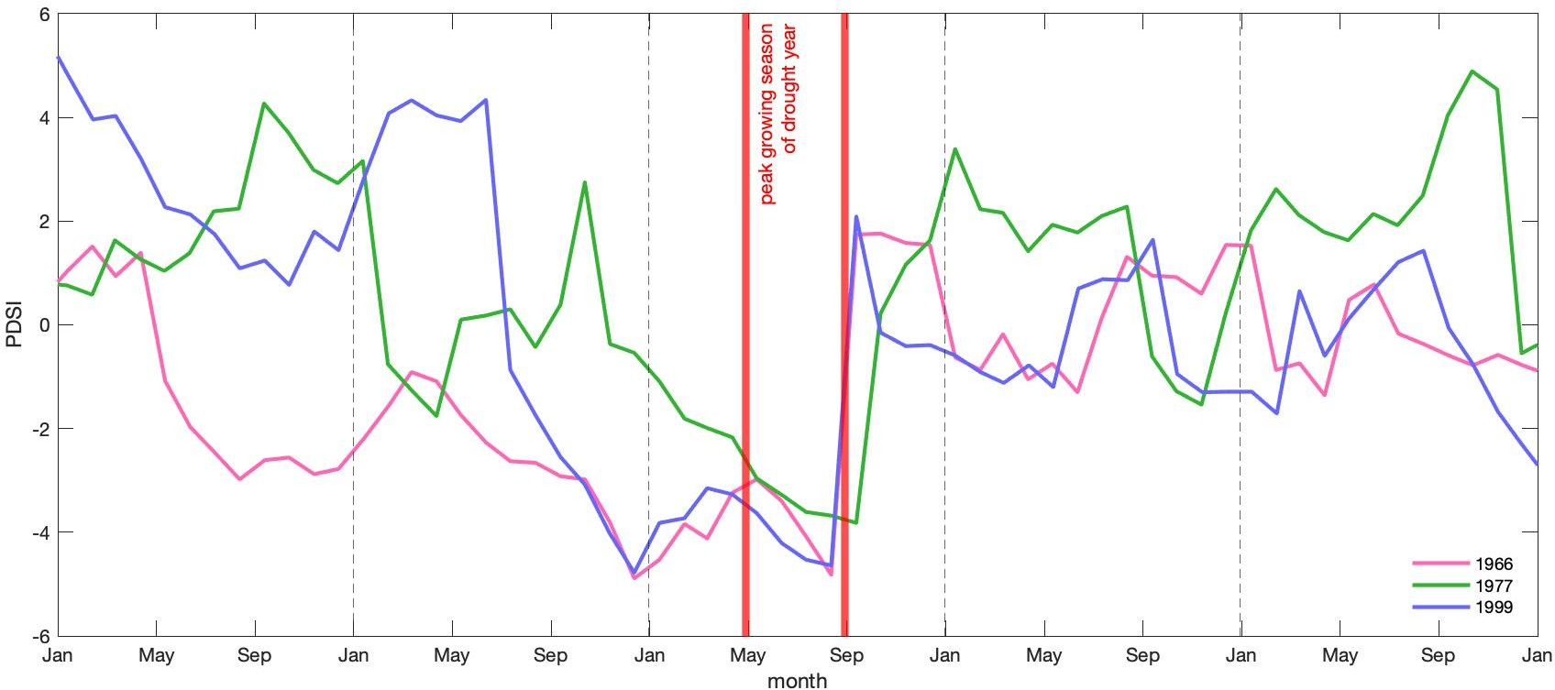

**Fig. S2** Map of ForestGEO plot showing topographic wetness index and location of cored trees. Scale units are in meters.

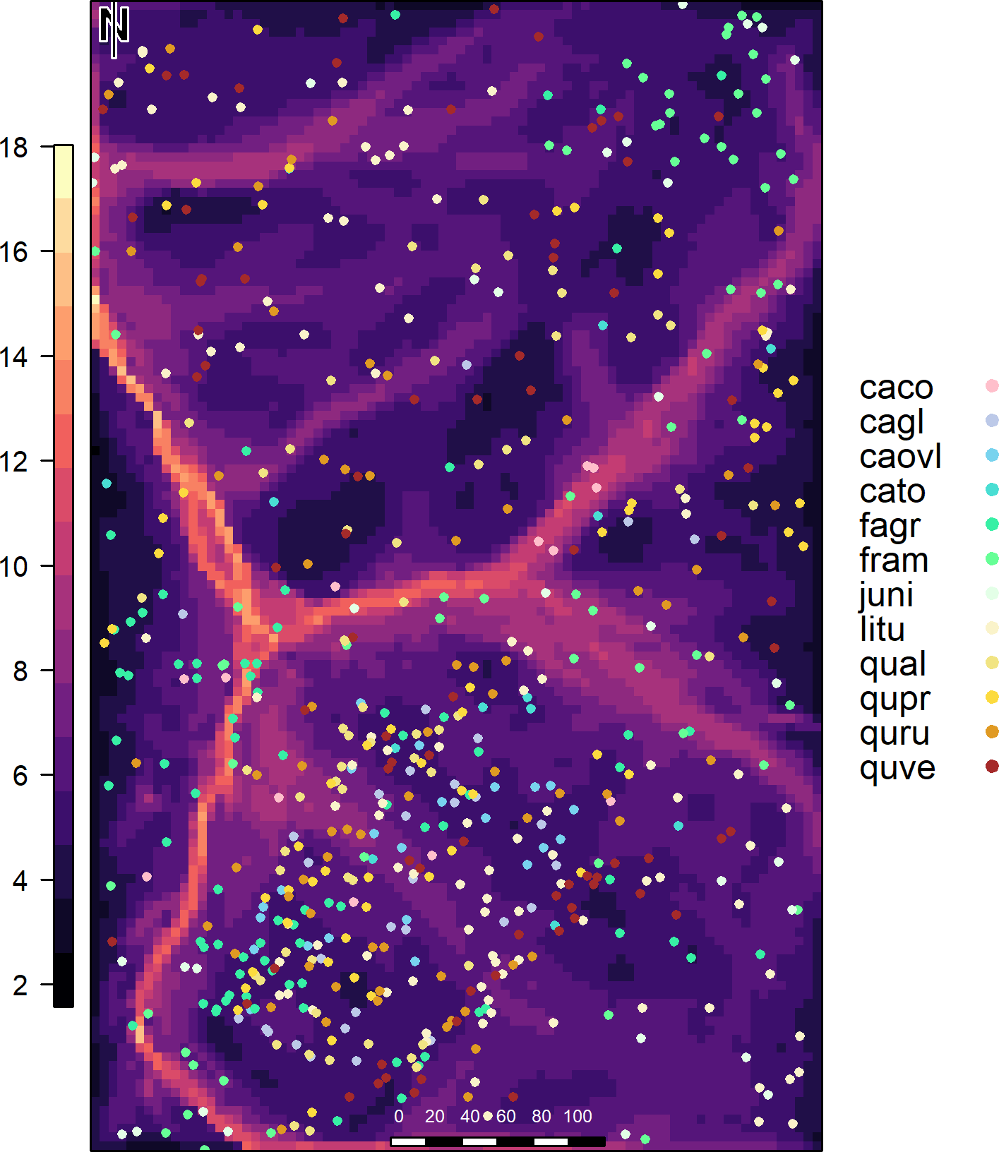

**Fig. S3** Distribution of reconstructed tree heights across drought years.

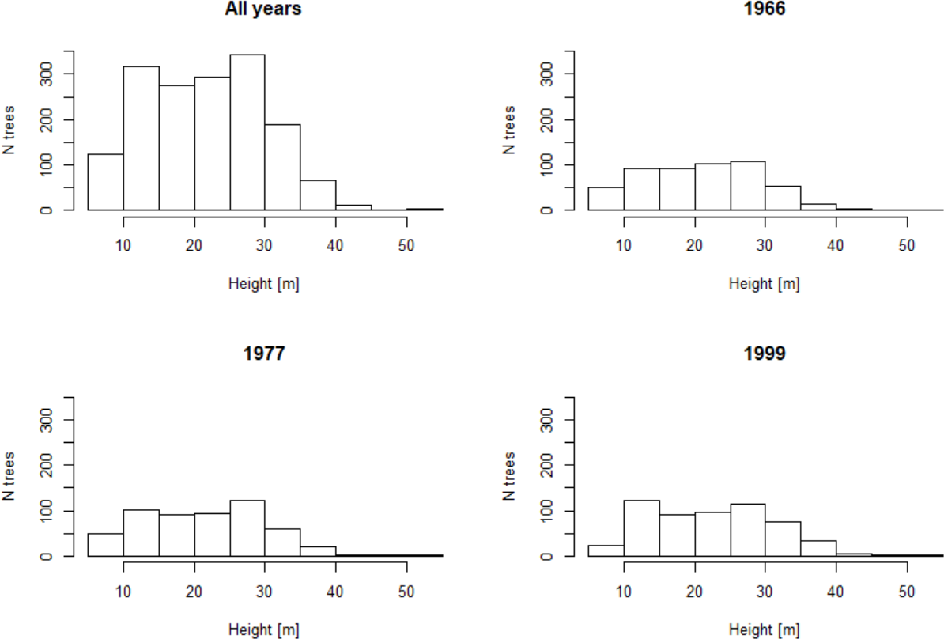

**Fig. S4** Distribution of independent variable values by species. In other words, the boxplots represent the ranges of each variable per species, with dots in (a) and (b) showing outliers. For plots (a) – (f), species that are assigned the same letter are not significantly different from each other with regard to the tested variable. Similarly, letter groupings do not transfer between variables. Meanwhile, plot (g) shows the number of trees in each crown position per species.

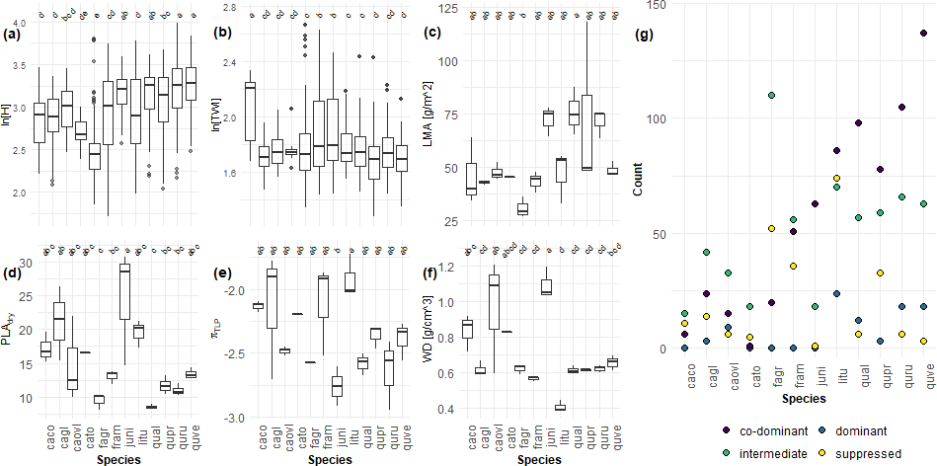

**Fig. S5** Comparisons of *Rt* and *RtARIMA* results, with residuals, for each drought scenario.

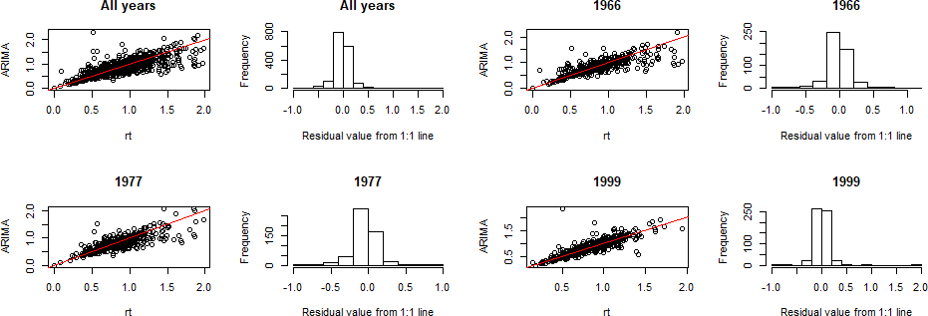

**Fig. S6** Density plot of drought recovery (*Rc*) for each focal drought year.

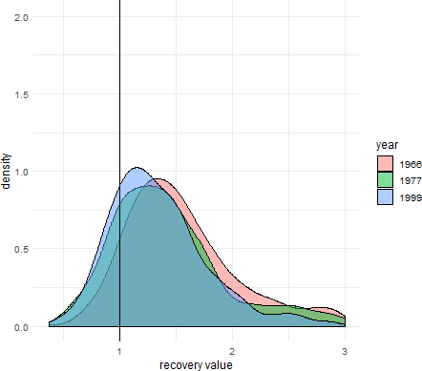

**Fig. S7** Drought recovery (*Rc*) across species for the three focal droughts. Species codes are given in Table 2, and closed dots represent outliers from the main boxplots. The dotted line at y=1 represents no change in *Rc* from the previous year. Letters illustrate significance groupings per year (colored and ordered, top to bottom, 1966, 1977, 1999). That is, a group of species with the same letter above their boxplot (e.g. "b") are statistically different from species in another group (e.g. "a"). See Fig. 4 for parallel plot for resistance (*Rt*) and resilience (*Rs*). Analysis conducted using *agricolae* package in R.

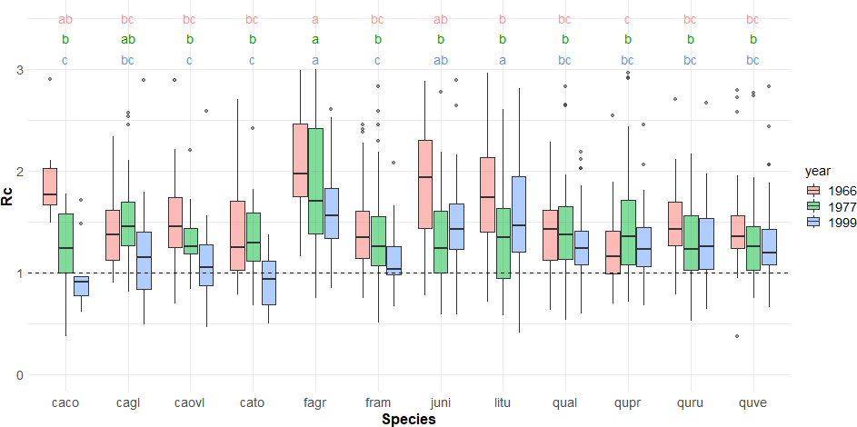

**Methods S1** Further Package Citations

While there were several R-packages we used for a specific purpose in our methods, numerous packages were immensely helpful for this research behind the scenes. As in all of science, this study is a representation of the work done by both the authors of this paper as well as countless others. While acknowledging everyone is impossible, we want to at least give thanks to those who made this work possible.

R-packages not already cited in the main manuscript include the following, listed alphabetically by corresponding package name:

R base (R Core Team, 2019); broom (Robinson & Hayes, 2020); car (Fox *et al.*, 2019); cowplot (Wilke, 2019); data.table (Dowle & Srinivasan, 2019); devtools (Wickham *et al.*, 2020b); dplR (Bunn *et al.*, 2019); dplyr (Wickham *et al.*, 2020a); extrafont (Winston Chang, 2014); ggplot2 (Wickham *et al.*, 2019); ggpubr (Kassambara, 2020); ggthemes (Arnold, 2019); gridExtra (Auguie, 2017); knitr (Xie, 2020); lubridate (Spinu *et al.*, 2018); MuMIn (Barton, 2019); piecewiseSEM (Lefcheck *et al.*, 2019); png (Urbanek, 2013); purrr (Henry & Wickham, 2019); raster (Hijmans, 2020); rasterVis (Perpinan Lamigueiro & Hijmans, 2019); RCurl (Temple Lang, 2020); readxl (Wickham & Bryan, 2019); reshape2 (Wickham, 2017); rgdal (Bivand *et al.*, 2019); rgeos (Bivand & Rundel, 2019); rmarkdown (Allaire *et al.*, 2020); sf (Pebesma, 2020); stringi (Gagolewski *et al.*, 2020); stringr (Wickham, 2019); tidyr (Wickham & Henry, 2020)

Allaire, JJ, Yihui Xie, Jonathan McPherson, Javier Luraschi, Kevin Ushey, Aron Atkins, Hadley Wickham, Joe Cheng, Winston Chang, and Richard Iannone. 2020. *Rmarkdown: Dynamic Documents for R*. <https://CRAN.R-project.org/package=rmarkdown>.

Arnold, Jeffrey B. 2019. *Ggthemes: Extra Themes, Scales and Geoms for ’Ggplot2’*. <https://CRAN.R-project.org/package=ggthemes>.

Auguie, Baptiste. 2017. *GridExtra: Miscellaneous Functions for "Grid" Graphics*. <https://CRAN.R-project.org/package=gridExtra>.

Barton, Kamil. 2019. *MuMIn: Multi-Model Inference*. <https://CRAN.R-project.org/package=MuMIn>.

Bivand, Roger, Tim Keitt, and Barry Rowlingson. 2019. *Rgdal: Bindings for the ’Geospatial’ Data Abstraction Library*. <https://CRAN.R-project.org/package=rgdal>.

Bivand, Roger, and Colin Rundel. 2019. *Rgeos: Interface to Geometry Engine - Open Source (’Geos’)*. <https://CRAN.R-project.org/package=rgeos>.

Bunn, Andy, Mikko Korpela, Franco Biondi, Filipe Campelo, Pierre Mérian, Fares Qeadan, and Christian Zang. 2019. *DplR: Dendrochronology Program Library in R*. <https://CRAN.R-project.org/package=dplR>.

Dowle, Matt, and Arun Srinivasan. 2019. *Data.table: Extension of ‘Data.frame‘*. <https://CRAN.R-project.org/package=data.table>.

Fox, John, Sanford Weisberg, and Brad Price. 2019. *Car: Companion to Applied Regression*. <https://CRAN.R-project.org/package=car>.

Gagolewski, Marek, Bartek Tartanus, other contributors; IBM, Unicode, Inc., other contributors; Unicode, and Inc. 2020. *Stringi: Character String Processing Facilities*. <https://CRAN.R-project.org/package=stringi>.

Henry, Lionel, and Hadley Wickham. 2019. *Purrr: Functional Programming Tools*. <https://CRAN.R-project.org/package=purrr>.

Hijmans, Robert J. 2020. *Raster: Geographic Data Analysis and Modeling*. <https://CRAN.R-project.org/package=raster>.

Kassambara, Alboukadel. 2020. *Ggpubr: ’Ggplot2’ Based Publication Ready Plots*. <https://CRAN.R-project.org/package=ggpubr>.

Lefcheck, Jon, Jarrett Byrnes, and James Grace. 2019. *PiecewiseSEM: Piecewise Structural Equation Modeling*. <https://CRAN.R-project.org/package=piecewiseSEM>.

Pebesma, Edzer. 2020. *Sf: Simple Features for R*. <https://CRAN.R-project.org/package=sf>.

Perpinan Lamigueiro, Oscar, and Robert Hijmans. 2019. *RasterVis: Visualization Methods for Raster Data*. <https://CRAN.R-project.org/package=rasterVis>.

R Core Team. 2019. *R: A Language and Environment for Statistical Computing*. Vienna, Austria: R Foundation for Statistical Computing. <https://www.R-project.org/>.

Robinson, David, and Alex Hayes. 2020. *Broom: Convert Statistical Analysis Objects into Tidy Tibbles*. <https://CRAN.R-project.org/package=broom>.

Spinu, Vitalie, Garrett Grolemund, and Hadley Wickham. 2018. *Lubridate: Make Dealing with Dates a Little Easier*. <https://CRAN.R-project.org/package=lubridate>.

Temple Lang, Duncan. 2020. *RCurl: General Network (Http/Ftp/...) Client Interface for R*. <https://CRAN.R-project.org/package=RCurl>.

Urbanek, Simon. 2013. *Png: Read and Write Png Images*. <https://CRAN.R-project.org/package=png>.

Wickham, Hadley. 2017. *Reshape2: Flexibly Reshape Data: A Reboot of the Reshape Package*. <https://CRAN.R-project.org/package=reshape2>.

———. 2019. *Stringr: Simple, Consistent Wrappers for Common String Operations*. <https://CRAN.R-project.org/package=stringr>.

Wickham, Hadley, and Jennifer Bryan. 2019. *Readxl: Read Excel Files*. <https://CRAN.R-project.org/package=readxl>.

Wickham, Hadley, Winston Chang, Lionel Henry, Thomas Lin Pedersen, Kohske Takahashi, Claus Wilke, Kara Woo, and Hiroaki Yutani. 2019. *Ggplot2: Create Elegant Data Visualisations Using the Grammar of Graphics*. <https://CRAN.R-project.org/package=ggplot2>.

Wickham, Hadley, Romain François, Lionel Henry, and Kirill Müller. 2020. *Dplyr: A Grammar of Data Manipulation*. <https://CRAN.R-project.org/package=dplyr>.

Wickham, Hadley, and Lionel Henry. 2020. *Tidyr: Tidy Messy Data*. <https://CRAN.R-project.org/package=tidyr>.

Wickham, Hadley, Jim Hester, and Winston Chang. 2020. *Devtools: Tools to Make Developing R Packages Easier*. <https://CRAN.R-project.org/package=devtools>.

Wilke, Claus O. 2019. *Cowplot: Streamlined Plot Theme and Plot Annotations for ’Ggplot2’*. <https://CRAN.R-project.org/package=cowplot>.

Winston Chang. 2014. *Extrafont: Tools for Using Fonts*. <https://CRAN.R-project.org/package=extrafont>.

Xie, Yihui. 2020. *Knitr: A General-Purpose Package for Dynamic Report Generation in R*. <https://CRAN.R-project.org/package=knitr>.