# Supplementary Information

## Tree height and leaf drought tolerance traits shape growth responses across droughts in a temperate broadleaf forest

Ian R. McGregor, Ryan Helcoski, Norbert Kunert, Alan J. Tepley, Erika B. Gonzalez-Akre, Valentine Herrmann, Joseph Zailaa, Atticus E.L. Stovall, Norman A. Bourg, William J. McShea, Neil Pederson, Lawren Sack, Kristina J. Anderson-Teixeira

**Methods S1. Further Package Citations**

## Warning: package 'knitr' was built under R version 3.6.3

## Warning: package 'kableExtra' was built under R version 3.6.3

We used linear regression on log-transformed data to relate $r_{bark}$ to the diameter inside bark from 2008 data. These were then used to determine $r_{bark}$ in the $DBH_{Y}$ reconstruction (DBH in year Y). No bark correction was applied for *Fagus grandifolia*, which has thin bark.

Variable abbreviations are as in Table 2. $Δ$ AICc is the AICc of a model excluding the trait minus that of the model including it.

**AICc > 2: variable considered significant as an individual predictor

Variable abbreviations are as in Table 2. AICc is the AICc of a model excluding the trait minus that of the model including it.

**AICc > 2: variable considered significant as an individual predictor

Variable abbreviations are as in Table 2. AICc is the AICc of a model excluding the trait minus that of the model including it.

**AICc > 2: variable considered significant as an individual predictor

Variable abbreviations are as in Table 2. AICc is the AICc of a model excluding the trait minus that of the model including it.

$Δ$**AICc > 2: variable considered significant as an individual predictor

Models are ranked by AICc. Shown are all models whose AICc value falls within 2.0 ($Δ$ AICc<1) of the best model (bold). $R^{2}$ refers to conditional . Year was included in the model for all drought years and appeared in all its top models, but coefficients were small (1966: 0, 1977: -0.019, 1999: -0.005; same values in all top models).

Models are ranked by AICc. Shown are all models whose AICc value falls within 2.0 ($Δ$ AICc<1) of the best model (bold). $R^{2}$ refers to conditional . Year was included in the model for all drought years and appeared in all its top models, but coefficients were small (1966: 0, 1977: -0.03, 1999: 0.008; same values in all top models).

Models are ranked by AICc. Shown are all models whose AICc value falls within 2.0 ($Δ$ AICc<1) of the best model (bold). refers to conditional $R^{2}$. Year was included in the model for all drought years and appeared in all its top models (1966: 0, 1977: -0.14, 1999: -0.217; same values in all top models).

Models are ranked by AICc. Shown are all models whose AICc value falls within 2.0 ($Δ$ AICc<1) of the best model (bold). refers to conditional $R^{2}$. Year was included in the model for all drought years and appeared in all its top models (1966: 0, 1977: -0.099, -0.099, -0.099, -0.097, -0.097; 1999: -0.174, -0.174, -0.174, -0.173, -0.172).

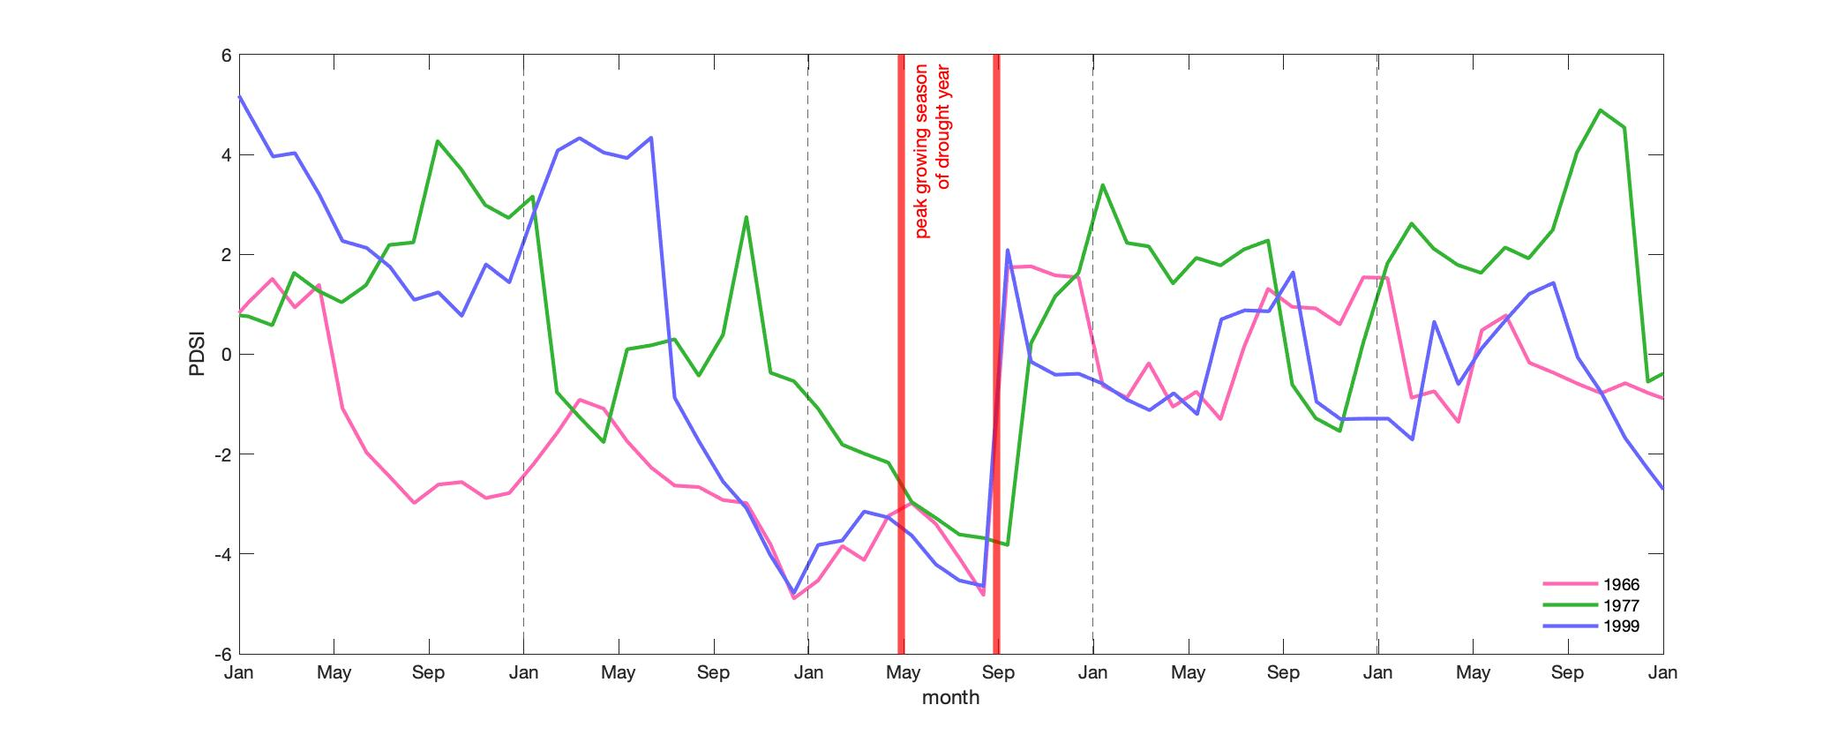

**Figure S1. Time series of Palmer Drought Severity Index (PDSI) for each focal drought year $±$ 2 years**

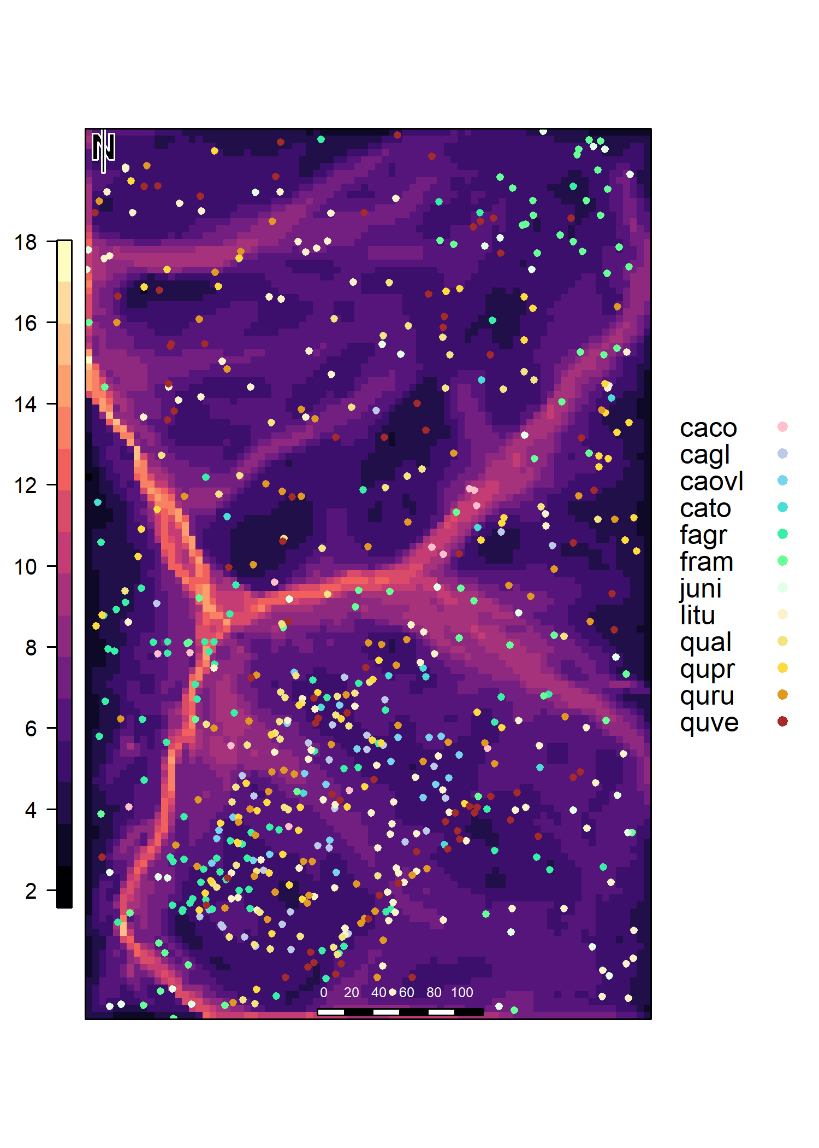

**Figure S2. Map of ForestGEO plot showing topographic wetness index (color scale) and location of cored trees.** Scale units are in meters

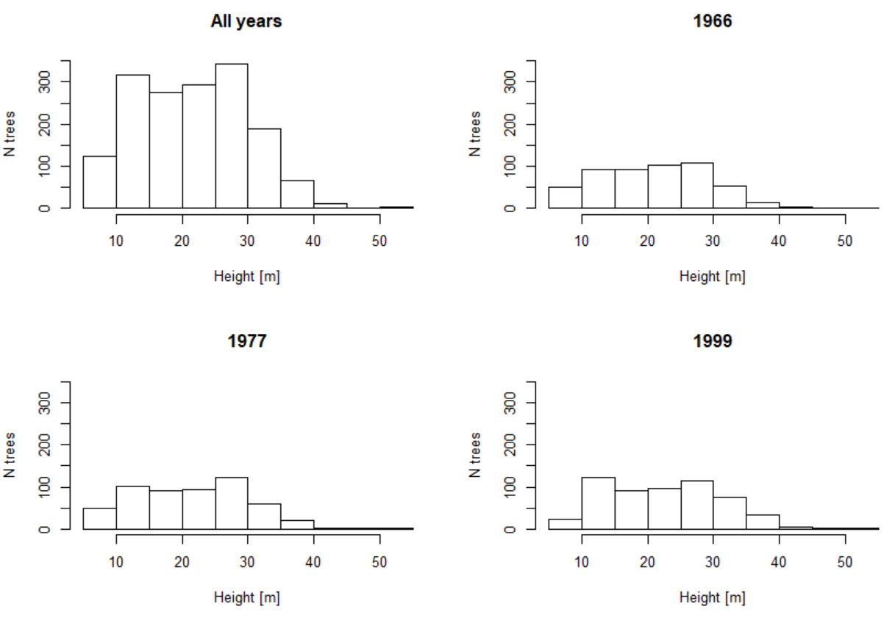

**Figure S3. Distribution of reconstructed tree heights across drought years.**

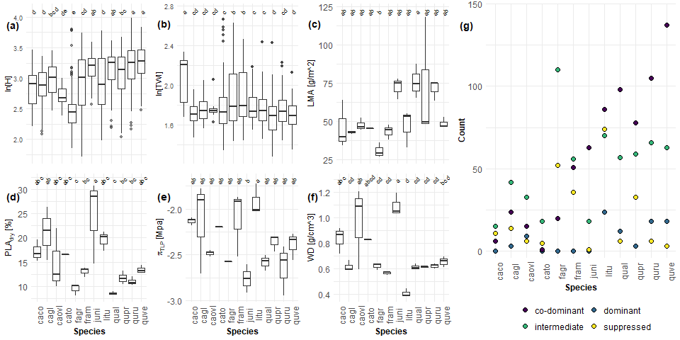

**Figure S4. Distribution of independent variables by species.** Species that are assigned the same letter are not significantly different from each other with regard to the tested variable. Letter groupings do not transfer between variables.

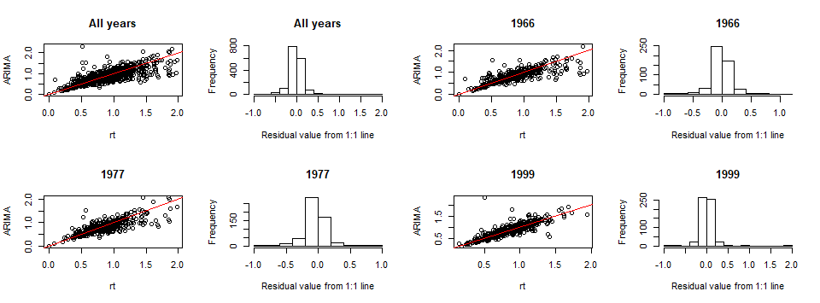

**Figure S5. Comparison of $Rt$ and $Rt_{ARIMA}$ results, with residuals, for each drought scenario**

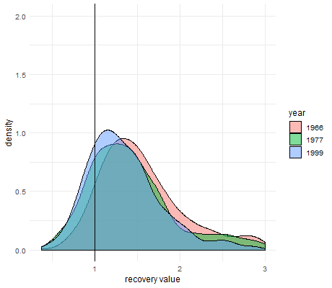

**Figure S6. Density plot of drought recovery ($Rc$) values for each focal drought year.**

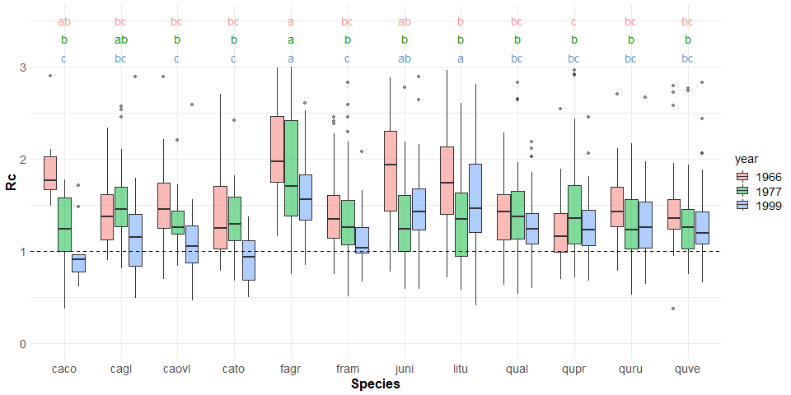

**Figure S7. Drought recovery ($Rc$) across species for the three focal droughts. Species that are assigned the same letter are not significantly different from each other with regard to the tested variable. Letter groupings do not transfer between variables.**

## Methods S1. Further Package Citations

While there were several R-packages we used for a specific purpose in our methods, numerous packages were immensely helpful for this research behind the scenes. R-packages not already cited in the main manuscript include the following, listed alphabetically by corresponding package name:

R base (R Core Team 2019); broom (Robinson and Hayes 2020); car (Fox, Weisberg, and Price 2019); cowplot (Wilke 2019); data.table (Dowle and Srinivasan 2019); devtools (Wickham, Hester, and Chang 2020); dplR (Bunn et al. 2019); dplyr (Wickham, François, et al. 2020); extrafont (Winston Chang 2014); ggplot2 (Wickham, Chang, et al. 2019); ggpubr (Kassambara 2020); ggthemes (Arnold 2019); gridExtra (Auguie 2017); knitr (Xie 2020); lubridate (Spinu, Grolemund, and Wickham 2018); MuMIn (Barton 2019); piecewiseSEM (Lefcheck, Byrnes, and Grace 2019); png (Urbanek 2013); purrr (Henry and Wickham 2019); raster (Hijmans 2020); rasterVis (Perpinan Lamigueiro and Hijmans 2019); RCurl (Temple Lang 2020); readxl (Wickham and Bryan 2019); reshape2 (Wickham 2017); rgdal (Bivand, Keitt, and Rowlingson 2019); rgeos (Bivand and Rundel 2019); rmarkdown (Allaire et al. 2020); sf (Pebesma 2020); stringi (Gagolewski et al. 2020); stringr (Wickham 2019); tidyr (Wickham and Henry 2020)

### References

Allaire, JJ, Yihui Xie, Jonathan McPherson, Javier Luraschi, Kevin Ushey, Aron Atkins, Hadley Wickham, Joe Cheng, Winston Chang, and Richard Iannone. 2020. *Rmarkdown: Dynamic Documents for R*. <https://CRAN.R-project.org/package=rmarkdown>.

Arnold, Jeffrey B. 2019. *Ggthemes: Extra Themes, Scales and Geoms for ’Ggplot2’*. <https://CRAN.R-project.org/package=ggthemes>.

Auguie, Baptiste. 2017. *GridExtra: Miscellaneous Functions for "Grid" Graphics*. <https://CRAN.R-project.org/package=gridExtra>.

Barton, Kamil. 2019. *MuMIn: Multi-Model Inference*. <https://CRAN.R-project.org/package=MuMIn>.

Bivand, Roger, Tim Keitt, and Barry Rowlingson. 2019. *Rgdal: Bindings for the ’Geospatial’ Data Abstraction Library*. <https://CRAN.R-project.org/package=rgdal>.

Bivand, Roger, and Colin Rundel. 2019. *Rgeos: Interface to Geometry Engine - Open Source (’Geos’)*. <https://CRAN.R-project.org/package=rgeos>.

Bunn, Andy, Mikko Korpela, Franco Biondi, Filipe Campelo, Pierre Mérian, Fares Qeadan, and Christian Zang. 2019. *DplR: Dendrochronology Program Library in R*. <https://CRAN.R-project.org/package=dplR>.

Dowle, Matt, and Arun Srinivasan. 2019. *Data.table: Extension of ‘Data.frame‘*. <https://CRAN.R-project.org/package=data.table>.

Fox, John, Sanford Weisberg, and Brad Price. 2019. *Car: Companion to Applied Regression*. <https://CRAN.R-project.org/package=car>.

Gagolewski, Marek, Bartek Tartanus, other contributors; IBM, Unicode, Inc., other contributors; Unicode, and Inc. 2020. *Stringi: Character String Processing Facilities*. <https://CRAN.R-project.org/package=stringi>.

Henry, Lionel, and Hadley Wickham. 2019. *Purrr: Functional Programming Tools*. <https://CRAN.R-project.org/package=purrr>.

Hijmans, Robert J. 2020. *Raster: Geographic Data Analysis and Modeling*. <https://CRAN.R-project.org/package=raster>.

Kassambara, Alboukadel. 2020. *Ggpubr: ’Ggplot2’ Based Publication Ready Plots*. <https://CRAN.R-project.org/package=ggpubr>.

Lefcheck, Jon, Jarrett Byrnes, and James Grace. 2019. *PiecewiseSEM: Piecewise Structural Equation Modeling*. <https://CRAN.R-project.org/package=piecewiseSEM>.

Pebesma, Edzer. 2020. *Sf: Simple Features for R*. <https://CRAN.R-project.org/package=sf>.

Perpinan Lamigueiro, Oscar, and Robert Hijmans. 2019. *RasterVis: Visualization Methods for Raster Data*. <https://CRAN.R-project.org/package=rasterVis>.

R Core Team. 2019. *R: A Language and Environment for Statistical Computing*. Vienna, Austria: R Foundation for Statistical Computing. <https://www.R-project.org/>.

Robinson, David, and Alex Hayes. 2020. *Broom: Convert Statistical Analysis Objects into Tidy Tibbles*. <https://CRAN.R-project.org/package=broom>.

Spinu, Vitalie, Garrett Grolemund, and Hadley Wickham. 2018. *Lubridate: Make Dealing with Dates a Little Easier*. <https://CRAN.R-project.org/package=lubridate>.

Temple Lang, Duncan. 2020. *RCurl: General Network (Http/Ftp/...) Client Interface for R*. <https://CRAN.R-project.org/package=RCurl>.

Urbanek, Simon. 2013. *Png: Read and Write Png Images*. <https://CRAN.R-project.org/package=png>.

Wickham, Hadley. 2017. *Reshape2: Flexibly Reshape Data: A Reboot of the Reshape Package*. <https://CRAN.R-project.org/package=reshape2>.

———. 2019. *Stringr: Simple, Consistent Wrappers for Common String Operations*. <https://CRAN.R-project.org/package=stringr>.

Wickham, Hadley, and Jennifer Bryan. 2019. *Readxl: Read Excel Files*. <https://CRAN.R-project.org/package=readxl>.

Wickham, Hadley, Winston Chang, Lionel Henry, Thomas Lin Pedersen, Kohske Takahashi, Claus Wilke, Kara Woo, and Hiroaki Yutani. 2019. *Ggplot2: Create Elegant Data Visualisations Using the Grammar of Graphics*. <https://CRAN.R-project.org/package=ggplot2>.

Wickham, Hadley, Romain François, Lionel Henry, and Kirill Müller. 2020. *Dplyr: A Grammar of Data Manipulation*. <https://CRAN.R-project.org/package=dplyr>.

Wickham, Hadley, and Lionel Henry. 2020. *Tidyr: Tidy Messy Data*. <https://CRAN.R-project.org/package=tidyr>.

Wickham, Hadley, Jim Hester, and Winston Chang. 2020. *Devtools: Tools to Make Developing R Packages Easier*. <https://CRAN.R-project.org/package=devtools>.

Wilke, Claus O. 2019. *Cowplot: Streamlined Plot Theme and Plot Annotations for ’Ggplot2’*. <https://CRAN.R-project.org/package=cowplot>.

Winston Chang. 2014. *Extrafont: Tools for Using Fonts*. <https://CRAN.R-project.org/package=extrafont>.

Xie, Yihui. 2020. *Knitr: A General-Purpose Package for Dynamic Report Generation in R*. <https://CRAN.R-project.org/package=knitr>.