Table 1. Summary of hypotheses, corresponding specific predictions, and results.

Prediction supported?

tree-ring drought records

|  |  |  |  |  |  |
| --- | --- | --- | --- | --- | --- |
| Hypotheses & Specific Predictions | recent  non-drought | Resistance (Rt) | Recovery (Rc) | Resilience | Results |
| **Tree size and microenvironment** |  |  |  |  |  |
| *Across the forest vertical profile, taller trees are exposed to higher evaporative demand.*  Taller trees experience higher wind speeds during the peak growing season months. | yes | Fig. 2 | | | |
| Taller trees experience lower humidity during the peak growing season months. | yes | Fig. 2 | | | |
| Taller trees experience higher air temperatures during the peak growing season months. | no | Fig. 2 | | | |
| Taller trees have more sun-exposed crowns. | yes | Fig. 2 | | | |

conditions

(Rs)

1

*At least within the forest setting, taller trees are less drought tolerant.*

Drought tolerance decreases with height (H). yes yes yes Fig. 4; Tables S8-S11

*Small trees (lower root volume) in drier microhabitats have lower drought tolerance.*

There is a negative interactive effect between H and topographic wetness index. (no) (yes) (yes) Tables

S8-S11

**Species traits**

*Species’ traits–particularly leaf drought tolerance traits–predict drought tolerance.*

|  |  |  |  |  |
| --- | --- | --- | --- | --- |
| Wood density correlates (positively or negatively) to drought tolerance. | - | - | - | Tables S4-S7 |
| Leaf mass per area correlates positively to drought tolerance. | - | - | - | Tables S4-S7 |
| Ring-porous species have higher drought tolerance than diffuse- or semi-ring- porous. | - | no | - | Tables S4-S7 |
| Percent loss leaf area upon desiccation correlates negatively with drought tolerance. | yes | (yes) | (yes) | Fig. 4; |
|  |  |  |  | Tables |
|  |  |  |  | S8-S11 |
| Water potential at turgor loss correlates negatively with drought tolerance. | (yes) | (yes) | (yes) | Fig. 4; |
|  |  |  |  | Tables |
|  |  |  |  | S8-S11 |

Parentheses indicate that the prediction was supported by at least one but not all of the top models (Tables S8, S10, S11). Dash symbols indicate that the response was not significant (Tables S4, S6, S7).

Table 2. Overview of analyzed species, listed in order of their relative contributions to woody stem productivity (*AN PPstem*) in the plot, along with numbers and sizes sampled, and species traits.

contemporary DBH (cm) species traits (mean +/- se)

species % *AN PPstem* n trees* mean range *W D* (*g cm−*3) *LMA* (*g cm−*2) xylem porosity *πtlp* (Mpa) *PLAdry* (%)

*Liriodendron tulipifera L. (LITU)* 47.1 98 36.9 10 - 100.4 0.4 *±* 0.03 46.9 *±* 12.4 diffuse -1.92 *±* 0.17 19.6 *±* 2.06

*Quercus alba L. (QUAL)* 10.7 61 47.2 11.4 - 79.1 0.61 *±* 0.02 75.8 *±* 11.1 ring -2.58 *±* 0.08 8.52 *±* 0.37

*Quercus rubra L. (QURU)* 10.1 69 54.9 11.1 - 148 0.62 *±* 0.02 71.1 *±* 6.70 ring -2.64 *±* 0.28 11.0 *±* 0.84

*Quercus velutina Lam. (QUVE)* 7.8 77 54.1 16.0 - 114.2 0.65 *±* 0.04 48.7 *±* 3.30 ring -2.39 *±* 0.15 13.42 *±* 0.84

*Quercus montana L. (QUPR)* 4.8 59 42.3 10.5 - 87.2 0.61 *±* 0.01 71.8 *±* 40.2 ring -2.36 *±* 0.09 11.75 *±* 1.37

*Fraxinus americana L. (FRAM)* 3.8 62 35.4 6.4 - 94.7 0.56 0.01 43.3 4.78 ring -2.1 0.36 13.06 1.06

*± ± ± ±*

*Carya glabra (Mill.) Sweet (CAGL)* 3.7 31 31.4 9.8 - 98.5 0.62 0.04 42.8 0.94 ring -2.13 0.50 21.09 5.48

*± ± ± ±*

*Juglans nigra L. (JUNI)* 2.1 31 48.1 24.2 - 87 1.09 0.09 72.1 7.10† semi-ring -2.76 0.21 24.64 8.72

*± ± ± ±*

*Carya cordiformis (Wangenh.) K. Koch (CACO)* 2.0 13 27.2 10.7 - 61.5 0.83 0.10 45.9 15.6 ring -2.13 0.45 17.22 2.25

*± ± ± ±*

*Carya tomentosa (Lam. ex Poir.) Nutt. (CATO)* 2.0 13 21.0 12.1 - 32.2 0.83 45.4 ring -2.2 16.56

*Fagus grandifolia Ehrh. (FAGR)* 1.5 80 23.5 11.2 - 107.2 0.62 *±* 0.03 30.7 *±* 4.94 diffuse -2.57 9.45 *±* 1.25

*Carya ovalis (Wangenh.) Sarg. (CAOVL)* 1.1 23 35.3 14.9 - 66.0 0.96 *±* 0.33 47.6 *±* 3.95 ring -2.48 *±* 0.04 14.8 *±* 6.34

* Numbers cored live versus dead are given in Table S1 of Helcoski et al. (2019).

† Semi-ring porosity is intermediate between ring and diffuse. We group it with diffuse-porous species for more even division of species between categories.

Variable abbreviations are as in Table 3. DBH measurements are from the most recent ForestGEO census in 2018 (live trees) or tree mortality censuses in 2016 and 2017 (trees cored dead).

Table 3. Summary of dependent and independent variables in our statistical models of drought tolerance, along with units, definitions, and sample sizes.

|  |  |  |  |  |  |  |
| --- | --- | --- | --- | --- | --- | --- |
| variable symbol | units | description | category | *nRt*\* | *nRc* | *nRs* |
| **Dependent variables**  drought resistance *Rt* | - | ratio of basal area increment (BAI) during | - | 1623 | - | - |

drought year to mean BAI of the 5 years prior.

*RtARIMA* - ratio of BAI during drought year to BAI

predicted by ARIMA model.

drought recovery *Rc* - ratio of mean BAI for 5 years after drought to

BAI during drought year.

drought resilience *Rs* - ratio of mean BAI for 5 years after drought to

mean BAI for 5 years before drought.

- 1654 - -

- - 1557 -

- - - 1570

**Independent variables**

|  |  |  |  |  |  |  |
| --- | --- | --- | --- | --- | --- | --- |
| drought year | *Y* | - year of drought | 1966 | 513 | 491 | 495 |
|  |  |  | 1977 | 543 | 524 | 523 |

1999 567 542 552

height *H* m estimated H in drought year - - - -

topographic wetness index *TWI* - steady-state wetness index based on slope and

upstream contributing area

- - - -

*species’ traits*

|  |  |  |  |  |  |  |  |
| --- | --- | --- | --- | --- | --- | --- | --- |
| wood density | *WD* | g cm*−*3 | dry mass of a unit volume of fresh wood | - | - | - | - |
| leaf mass per area | *LM A* | kg m*−*2 | ratio of leaf dry mass to fresh leaf area | - | - | - | - |
| xylem porosity |  | - | vessel arrangement in xylem | ring (R) | 1106 | 1079 | 1088 |
|  |  |  |  | semi-ring (SR) | 81 | 73 | 78 |
|  |  |  |  | diffuse (D) | 436 | 405 | 404 |
| turgor loss point | *πtlp* | MPa | water potential at which leaves wilt | - - - - | | | |
| percent loss area | *PLAdry* | % | percent loss of leaf area upon dessication | - - - - | | | |

Sample sizes are after removal of outliers. Dashes for sample sizes of independent variables indicate that the variable was available for all records. Xylem porosity sample sizes are sums across all drought years.

*Sample sizes of independent variables refer to the *Rt* model.

**Figure Legends**

**Figure 1. Climate and species-level growth responses over our study period, highlighting the three focal drougths (a) and community-wide growth resistance,** *Rt* **(b), and resilience,** *Rs* **(c).** Time series plot (a) shows peak growing season (May-August) climate conditions and residual chronologies for each species (see Table 3 for codes). PET and PRE data were obtained from the Climatic Research Unit high-resolution gridded dataset (CRU TS v.4.01; Harris et al. 2014). Focal droughts are indicated by dashed lines, and shading indicates the pre- and post- drought periods used in calculations of the resistance metric. Figure modified from Helcoski *et al.* (2019). Density plots (b-c) show the distribution of *Rt* and *Rs* values for each drought. See Fig. S6 for parallel plot for recovery (*Rc*).

**Figure 2. Contemporary height profiles in sun exposure and growing season microclimate under non-drought conditions.** Shown are average (*±* SD) of daily maxima and minima of (a) wind speed, (b) relative humidity (*RH*), and (c) air temperature (*Tair*) averaged over each month of the peak growing season (May-August) from 2016-2018. In these plots, heights are slightly offset for visualization purposes. Asterisks indicate significant differences between the top and bottom of the height profile. Also shown is (d) tree heights by 2018 crown position, with letters indicating significance groupings. In all plots, the dashed horizontal line indicates the 95th percentile of tree heigts in the ForestGEO plot.

**Figure 3. Visualization of top statistical models for drought resistance (***Rt***), recovery (***Rc***), and resilience (***Rs*) **for all droughts combined and for each individual drought year.** For cases where the best model includes a DBH x TWI interaction (*Rc* in all droughts and 1966, *Rs* in all droughts and 1977), we plot the best model without the interaction. Visualization of the best mixed effects model per drought scenario was created by the *visreg* package in R, and confidence intervals were defined via bootsrapping in the *bootpredictlme4* package. Model coefficients are given in Tables S8 and S10-11. Descriptions of variables (e.g. *ln*[*H*] can be found in Table 3.

**Figure 4. Drought resistance,** *Rt* **(a), and resilience,** *Rs* **(b) across species for the three focal droughts.** Species codes are given in Table 2. Shaded boxes represent the interquartile range, with horizontal line at median, whiskers represent the range within 2.7 SD, and dots represent outliers. The horizontal dotted line at y=1 represents no change in growth between the five years prior to drought and the drought year (*Rt*) or the five years following the drought (*Rs*). Letters illustrate significance groupings per year (colored and ordered, top to bottom, 1966, 1977, 1999). That is, a group of species with the same letter above their boxplot (e.g. “b”) are statistically different from species in another group (e.g. “a”). Letter groupings do not transfer across variables *Rt* and *Rs*. See Fig. S7 for parallel plot for recovery (*Rc*). Analysis conducted using *agricolae* package in R. Descriptions of variables (e.g. *ln*[*H*]) can be found in Table 3.

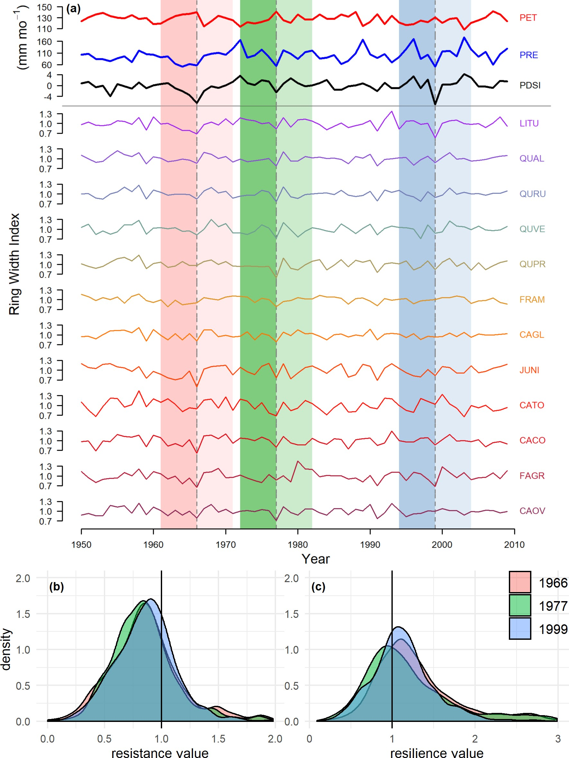

**Figure 1. Climate and species-level growth responses over our study period, highlighting the three focal drougths (a) and community-wide growth resistance,** *Rt* **(b), and resilience,** *Rs* **(c).** Time series plot (a) shows peak growing season (May-August) climate conditions and residual chronologies for each species (see Table 3 for codes). PET and PRE data were obtained from the Climatic Research Unit high-resolution gridded dataset (CRU TS v.4.01; Harris et al. 2014). Focal droughts are indicated by dashed lines, and shading indicates the pre- and post- drought periods used in calculations of the resistance metric. Figure modified from Helcoski *et al.* (2019). Density plots (b-c) show the distribution of *Rt* and *Rs* values for each drought. See Fig. S6 for parallel plot for recovery (*Rc*).

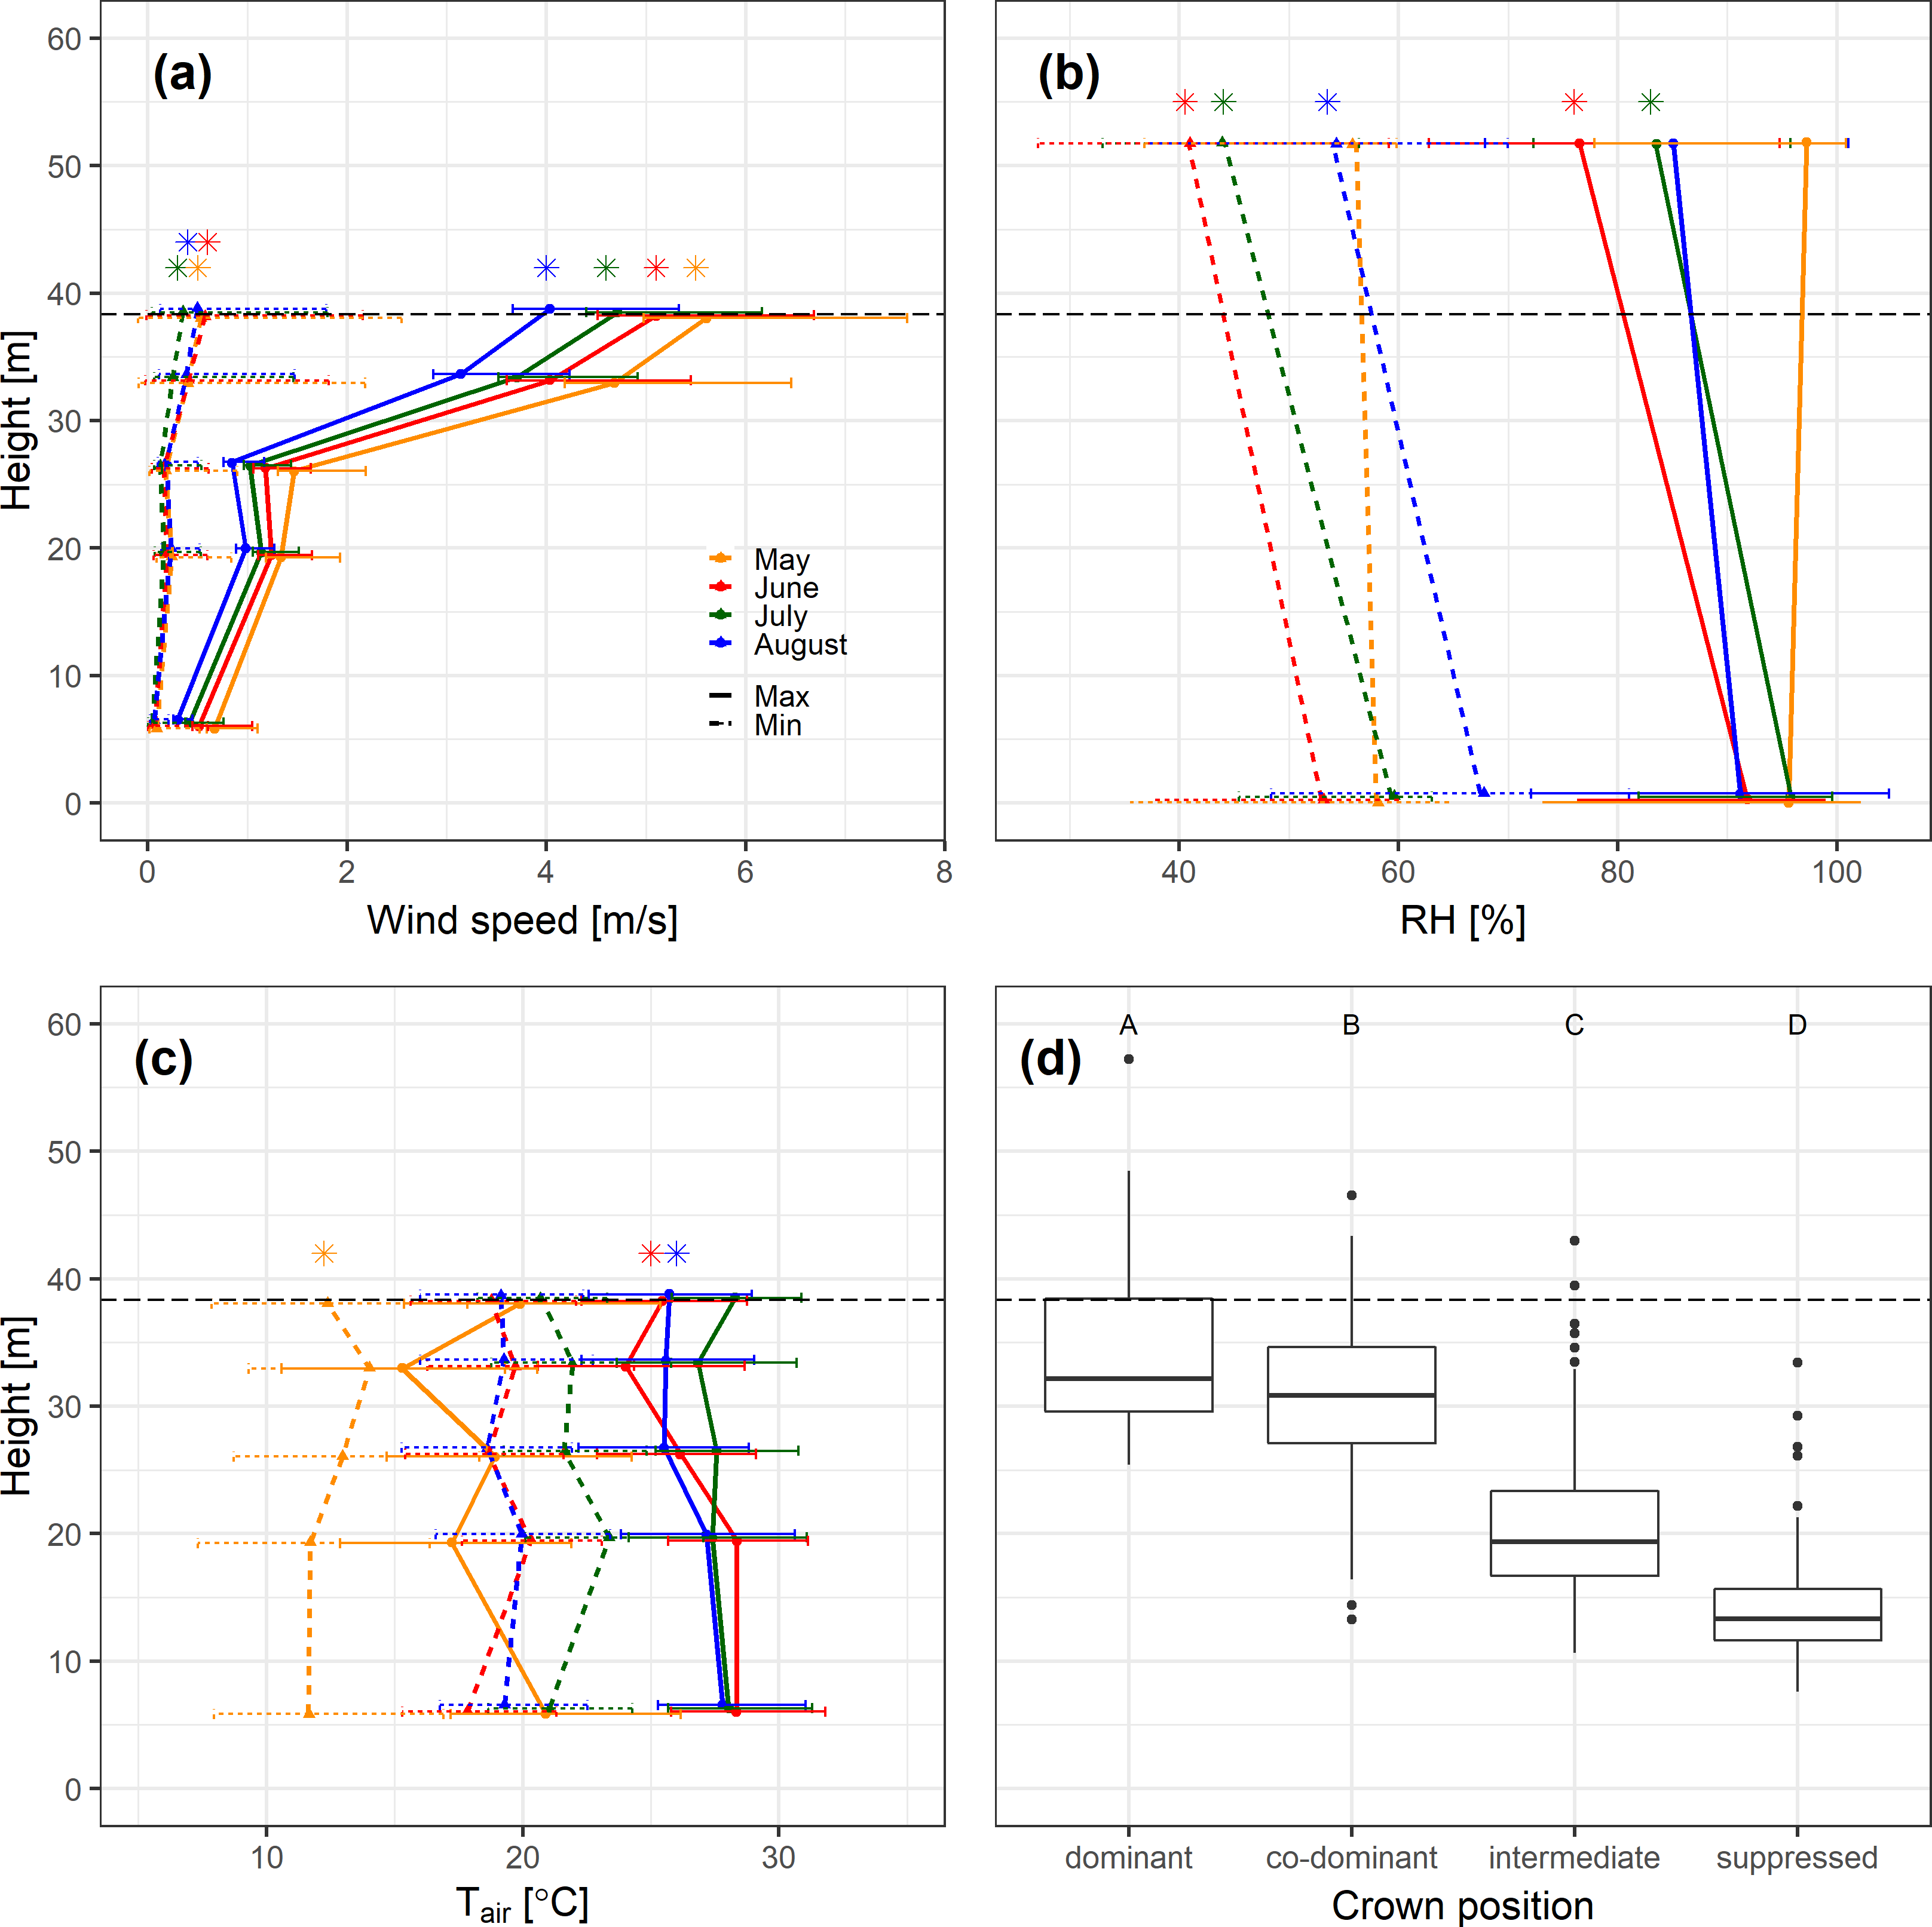

**Figure 2. Contemporary height profiles in sun exposure and growing season microclimate under non- drought conditions.** Shown are average ( SD) of daily maxima and minima of (a) wind speed, (b) relative humidity (*RH*), and (c) air temperature (*Tair* ) averaged over each month of the peak growing season (May-August) from 2016-2018. In these plots, heights are slightly offset for visualization purposes. Asterisks indicate significant differences between the top and bottom of the height profile. Also shown is (d) tree heights by 2018 crown position, with letters indicating significance groupings. In all plots, the dashed horizontal line indicates the 95th percentile of tree heigts in the ForestGEO plot.

*±*

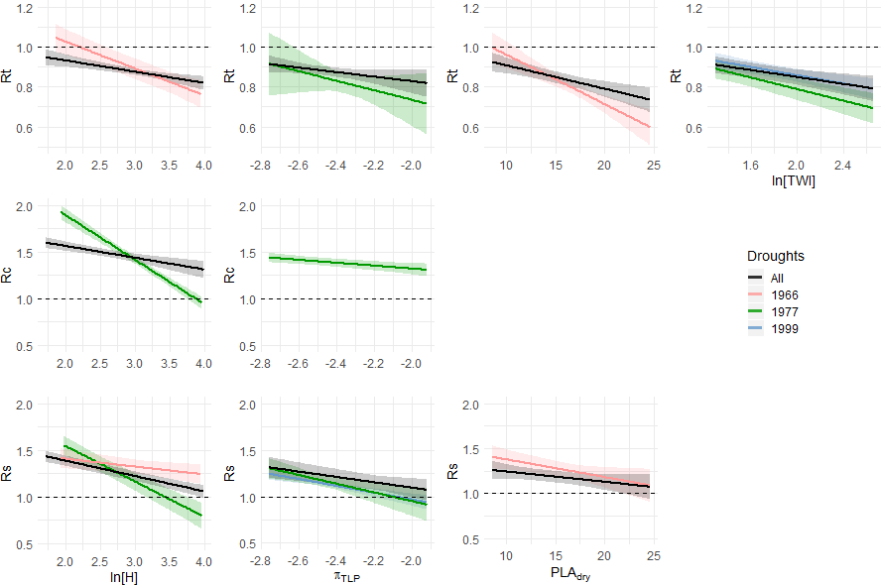

**Figure 3. Visualization of top statistical models for drought resistance (***Rt***), recovery (***Rc***), and resilience (***Rs*) **for all droughts combined and for each individual drought year.** For cases where the best model includes a DBH x TWI interaction (*Rc* in all droughts and 1966, *Rs* in all droughts and 1977), we plot the best model without the interaction. Visualization of the best mixed effects model per drought scenario was created by the *visreg* package in R, and confidence intervals were defined via bootsrapping in the *bootpredictlme4* package. Model coefficients are given in Tables S8 and S10-11. Descriptions of variables (e.g. *ln*[*H*] can be found in Table 3.)

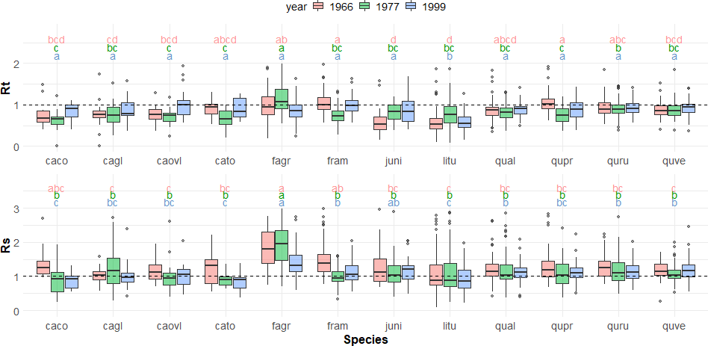

**Figure 4. Drought resistance,** *Rt* **(a), and resilience,** *Rs* **(b) across species for the three focal droughts.** Species codes are given in Table 2. Shaded boxes represent the interquartile range, with horizontal line at median, whiskers represent the range within 2.7 SD, and dots represent outliers. The horizontal dotted line at y=1 represents no change in growth between the five years prior to drought and the drought year (*Rt*) or the five years following the drought (*Rs*). Letters illustrate significance groupings per year (colored and ordered, top to bottom, 1966, 1977, 1999). That is, a group of species with the same letter above their boxplot (e.g. “b”) are statistically different from species in another group (e.g. “a”). Letter groupings do not transfer across variables *Rt* and *Rs*. See Fig. S7 for parallel plot for recovery (*Rc*). Analysis conducted using *agricolae* package in R. Descriptions of variables (e.g. *ln*[*H*]) can be found in Table 3.