# Physical Environment

The dynamic plot, first established in 2008 by Bourg et al. (2013), is located at the Smithsonian Conservation Biology Institute (SCBI) in Virginia, U.S.A. (38 degrees 53’36.6“N, 78 degrees 08’43.4”W). Elevations range from 273 to 338 meters above sea level (masl) [@gonzalezakre_patterns_2016], with a topographic relief of 65m (Bourg et al., 2013). The forest type across the 25.6-ha plot is homogeneously broadleaf, cold deciduous, with a mean annual temperature of 12.9 degrees C and a mean annual precipitation level of 1001 mm [@andersonteixeira_ctfs-forestgeo:_2015]. According to the Koppen-Geiger biome classifcation, the plot falls within the Cfa zone, which is characterized as humid subtropical/midlatitude with significant precipitation year-round (@andersonteixeira_ctfs-forestgeo:_2015). Primary disturbances at the SCBI site are natural and consist of wind and ice storms.

Do we want to include the following?

The SCBI site is within a region encompassing the northern section of the Blue Ridge Mountains and is a continuation of the Appalachian Mountain range. Shenandoah National Park (elevation range ~171 to ~1,234 masl) [@noauthor_park_nodate] lies directly to the southwest while smaller hills (of which the site is comprised) extend to the northwest. To the east of the site, the smaller hills give way to the lower Piedmont region, while in the west, they give way to the Shenandoah Valley under the Massanutten Mountains. Because part of the site is situated within a small valley and most storms approach from the west and southwest, the site is relatively sheltered.

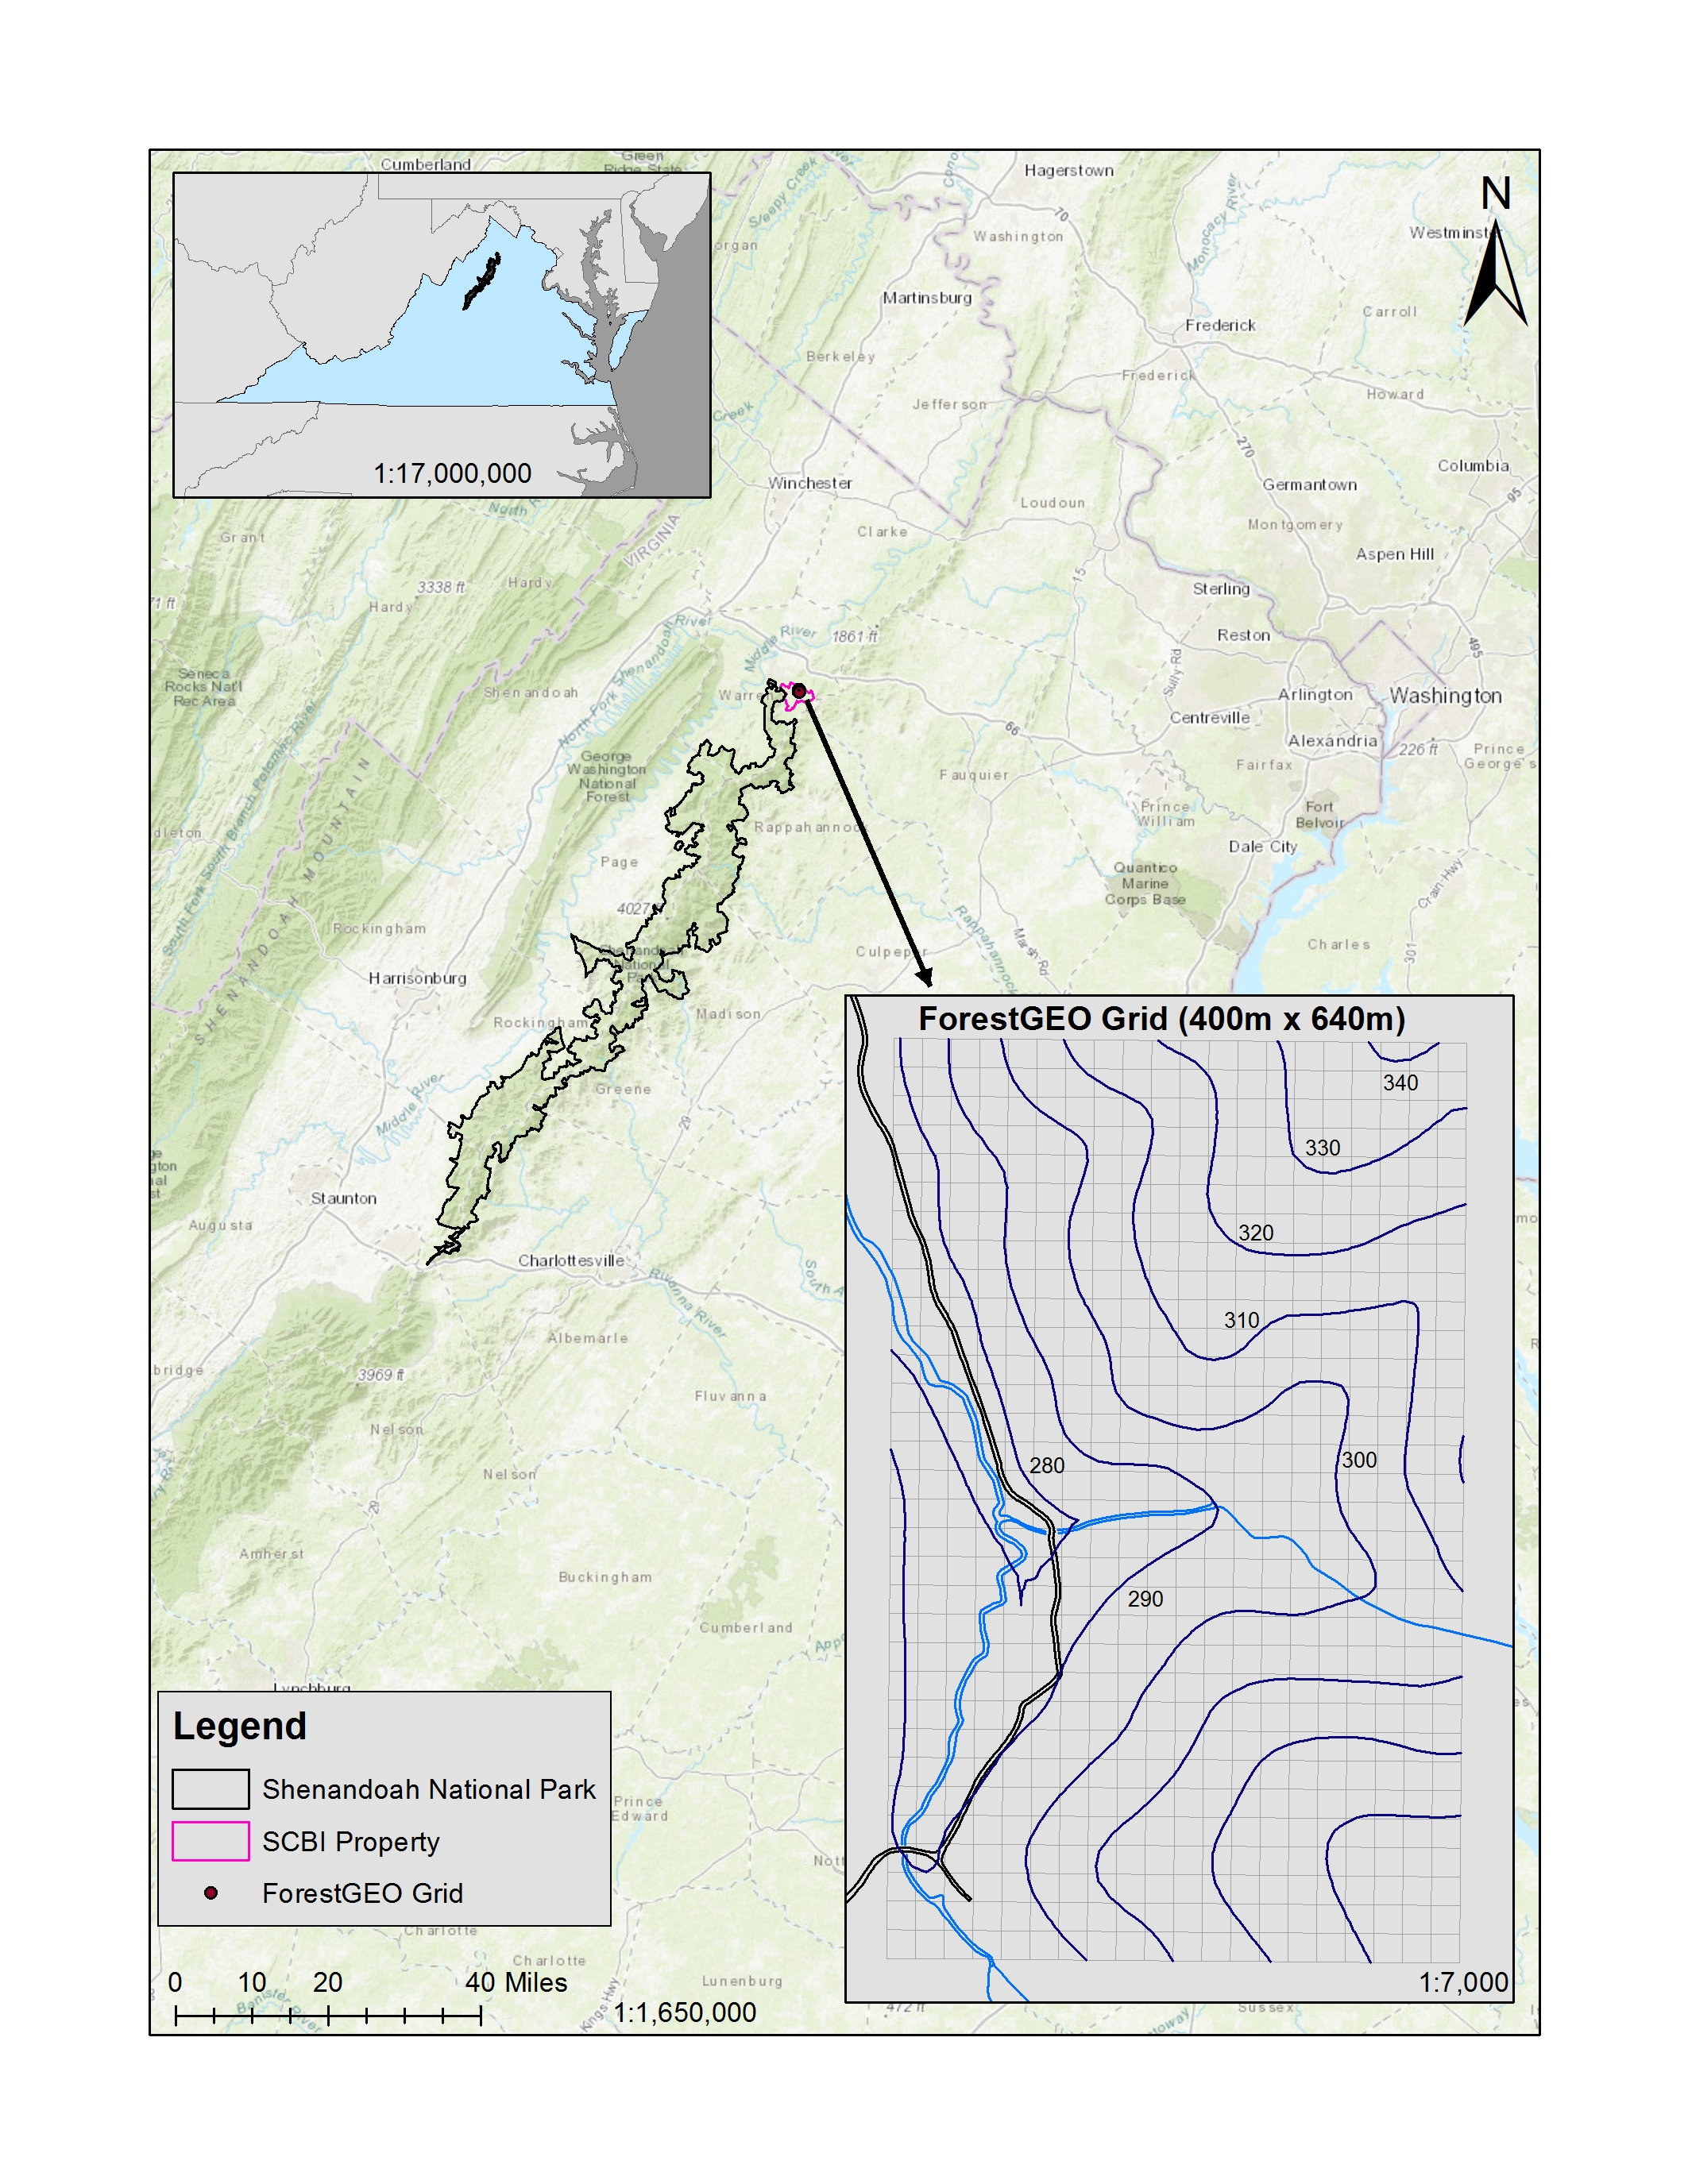

*Map of SCBI site relative to regional topography. Elevation labels in the grid are in masl.*

Other things to potentially include in this chapter:

* write (or find?) code to make graph as this one in [@stovall_assessing_2018] 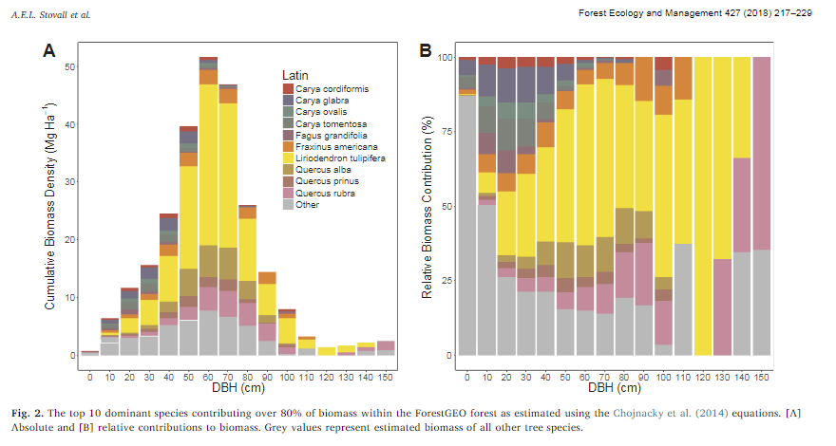
* climate data from NEON to explain biomass?
* any other data from NEON?
* are we including an overview of dendrobands anywhere (not this chapter)?

[Teixeira et al. 2015](https://onlinelibrary.wiley.com/doi/epdf/10.1111/gcb.12712)