Title: Nuisance species compromise carbon sequestration potential in an Eastern US temperate deciduous forest
Authors:
Luca L. Morreale^{1,2}* (Orcid ID: 0000-0003-2023-9150))
Rachel M. Hoffman¹
Krystal J. Bagnaschi¹
Iris A. Kennedy¹
Erin MacMonigle¹
Caroline Troy¹
Cameron Dow^{1,3}
Erika Gonzalez-Akre¹ (Orcid ID: 0000-0001-8305-6672)
Valentine Herrmann¹ (Orcid ID: 0000-0002-4519-481X)
Jennifer Jordan^{1,4} (Orcid ID: 0000-0001-5521-360X)
Lukas Magee^{1,5}
David Mitre²
Christopher Pate¹
Jessica Shue⁶
Norman A. Bourg¹
William J. McShea¹ (Orcid ID: 0000-0002-8102-0200)
Kristina J. Anderson-Teixeira^{1,2} (Orcid ID: 0000-0001-8461-9713)
Author Affiliations:
- Conservation Ecology Center, Smithsonian’s National Zoo & Conservation Biology Institute, Front Royal, Virginia 22630, USA
- Forest Global Earth Observatory, Smithsonian Tropical Research Institute, Apartado Postal 0843-03092, Panama City, Panama
- Department of Biology, West Virginia University, Morgantown, West Virginia 26506, USA
- Department of Environmental Science and Public Policy, George Mason University, Fairfax, Virginia 22030, USA
- School of Forest, Fisheries and Geomatics Sciences, University of Florida, Gainesville, Florida 32603, USA
- Forest Global Earth Observatory, Smithsonian Environmental Research Center, Edgewater, Maryland 21037, USA
*corresponding author: MorrealeLL@si.edu;
Running head: Nuisance species reduce forest carbon uptake

Summary
- The future of the critical temperate forest carbon (C) sink is contingent on the role of depends on nuisance species, including non-indigenous pests and pathogens and deer, yet their net effect on current and future C cycling C uptake is little understood. Here, we use Using 15 years of census data and annual mortality surveys (through 2026) from a 25.6-ha plot in a Mid-Atlantic temperate forest to understand mid-Atlantic forest plot, we examined how nuisance species are affecting C sequestration affect C sequestration by living trees.
- We analyzed compared live aboveground biomass change and regenerative capacity in varying sections of the plot classified by regeneration among plot regions differing in deer browsing pressure and the abundance of in abundance of canopy species vulnerable to non-indigenous pests and pathogens.
- Biomass mortality increased, driving a net reduction in aboveground C storage, particularly in areas where canopy trees were vulnerable to non-indigenous pests and pathogens. There was also severe depletion of canopy tree species in the understory in areas with high deer browsing, endangering future canopy regeneration.
- Under current trends this forest will continue to lose living biomass and be in danger of a critical transition to a lower biomass ecosystem. The C sequestration of Eastern US deciduous forests is therefore likely overestimated in current global carbon models, and these forests could even transition to a net source of C in the future.
- Mortality increased and live aboveground C stocks declined between 2018 and 2023, most strongly where vulnerable canopy species were abundant; these areas lost one third of their biomass over 2013–2023. In addition to a large mortality pulse in vulnerable canopy species (mainly ash), oak (Quercus spp.) mortality rose concurrently. Outside a deer exclosure, canopy-species recruitment was 23- to 31-fold lower and saplings were scarce, endangering future canopy regeneration.
- If deer densities remain high and pests and pathogens continue to remove canopy species, canopy trees that die may not be replaced, reducing this forest’s capacity to take up C. The C sequestration of eastern US deciduous forests is therefore potentially endangered by nuisance species.
Keywords:
Pests and pathogens; temperate forests; carbon sequestration; white-tailed deer; ecosystem processes; invasive species

Introduction
The temperate forest biome plays a critical role in the global carbon cycle (C) cycle, accounting for almost half of the net global forest C sink (Harris et al., 2021), and temperate deciduous forests alone sequester >300 Tg C yr⁻¹ (Pugh et al., 2019). Although it is currently a net C sink, the future of the temperate forest biome remains uncertain. The dominant pattern projected by Earth System Models is a continued, albeit weakening, temperate forest C sink for the remainder of the 21st century (Ahlström et al., 2012; Wu et al., 2023). Yet, global C models predict a wide range of future trajectories of carbon dioxide (CO₂) sequestration (Ahlström et al., 2012; Arora et al., 2020), and current global C models do not represent certain influential mechanisms (e.g., Fatichi et al., 2014; Clark et al., 2021). For instance, global C models do not represent the impact of nuisance species, is not represented in global C - i.e., the impact of indigenous or non-indigenous species that, as a result of human influence, have much greater abundance in an ecosystem than they did historically, leading to detrimental ecological consequences (Nuñez et al., 2010; Skandrani et al., 2014). The impact of nuisance species on forest C budgets is also not considered in machine learning or niche models that seek to project future forest distribution and C stocks, nor is it in C offset projects (Wu et al., 2023). Nuisance species, including non-indigenous insect pests and pathogens and over-abundant herbivores, are dramatically impacting carbon cycling in temperate deciduous forests around the world, and failure to account for them significantly limits understanding of future forest health and C sequestration potential. Here, we focus on two kinds of nuisance species: non-indigenous insect pests and pathogens of canopy trees, and an overabundant indigenous herbivore, white-tailed deer. Invasive non-indigenous plants are another group of nuisance species in these forests, but we do not analyze them here.
Non-indigenous pests and pathogens can have a protracted impact on forests, often modifying forest productivity, nutrient cycling and successional trajectories (Herms & McCullough, 2014; Lovett et al., 2016). Historically introduced to new ecosystems through intercontinental trade, non-indigenous forest insects and diseases will continue to proliferate with increased globalization and human movement (Brockerhoff et al., 2006; Aukema et al., 2010; Fischer et al., 2013). Many of the prominent pests and pathogens in temperate deciduous forests have dramatic effects on canopy composition and structure, decimating once-abundant canopy species (Aukema et al., 2010; Klooster et al., 2014; Ellison et al., 2018; Anderson-Teixeira et al., 2021). Since many pests and pathogens do not currently yet occupy the full extent of their host species species’ range, a significant substantial portion of the remaining forest canopy is susceptible both to their spread through the rest of that range and to future invasion by other nuisance species (Fei et al., 2019).
Mammals whose population densities have been inflated due to human activities are also considered nuisance species (Clout & Russell, 2008; Murphy et al., 2014), and in United States (US) eastern deciduous forests, this includes white-tailed deer (Odocoileus virginianus). Their populations have dramatically increased in the past 50 years (McShea et al., 2003), due in large part to global change (Brown et al., 2000; Rooney, 2001; Côté et al., 2004). White-tailed deer preferentially browse on woody plant species in the seedling and sapling life stages, which reduces woody plant survival, growth and density (McGarvey et al., 2013). Chronic white-tailed deer overabundance can reduce understory plant diversity and decrease the abundance of traditionally dominant woody species (e.g., oak, Quercus spp.;) (Bugalho et al., 2013; Habeck & Schultz, 2015) while giving an advantage to species they find less palatable, including both indigenous (e.g., pawpaw, Asimina tribola triloba; spicebush, Lindera benzoin) and non-indigenous (e.g., garlic mustard, Alliaria petiolata) species (Averill et al., 2017). The strong impact of deer browsing, exacerbated by competition with dense deer-resistant understory vegetation and possibly climate change, results in dramatic reduction of canopy tree species in the understory (McGarvey et al., 2013; Russell et al., 2017; Miller & McGill, 2019; Gorchov et al., 2021; Miller et al., 2023).
Increased canopy tree mortality in combination with reduced canopy species recruitment in the understory is likely to have profound could have lasting impacts on the deciduous forests of eastern North America. When global change pressures (e.g., climate change, nuisance species) inhibit recruitment of canopy species, the stage is set for disturbances to push forest ecosystems over a tipping point, after which there is little chance that a forest will recover to its pre-disturbance state in the foreseeable future a forest’s recovery from disturbance depends on whether enough juveniles are present to replace the canopy trees that die; where they are not, disturbances can shift forests toward altered states that may persist for decades (Anderson-Teixeira et al., 2013; McDowell et al., 2020; Turner & Seidl, 2023). In the mid-Atlantic region of the eastern US, forests face a severe regeneration debt: there are insufficient juveniles of canopy tree species to replace the mature cohort of that species when they eventually die (Miller & McGill, 2019; Miller et al., 2023). The juvenile canopy trees that are most common in contemporary mid-Atlantic forests represent a more mesophytic set of species (e.g., maple, Acer spp.; American beech, Fagus grandifolia) than historically dominated much of the region (e.g., oak, Quercus spp.; hickory, Carya spp.;) (Thompson et al., 2013; Nowacki & Abrams, 2015), but even these species associated with mesic conditions are often not present in sufficient abundance to replace the current canopy (Miller & McGill, 2019).
Understanding the combined effects of multiple nuisance species on forest ecosystem processes requires data on both the forest canopy and understory over an extended time. Here, we use 15 years of detailed tree census data from a large forest dynamics plot in the mid-Atlantic region of the eastern US, together with annual surveys of tree mortality from 2014 to 2026, to understand the effects of non-indigenous pests and pathogens and white-tailed deer on the forest C balance and C stocks and C uptake of living trees and on the forest’s regeneration potential. We test the following hypotheses: (1) canopy tree mortality and associated woody biomass loss are increasing have increased, in large part due to non-indigenous nuisance species, (2) biomass gains from tree growth and recruitment have not kept pace with tree mortality, resulting in a decline in aboveground living biomass (-∆AGB), and (3) deer browsing has decimated reduced the abundance of canopy tree saplings, suggesting that future tree mortality will result in substantial net biomass loss and sustained decrease in the C storage potential, while deer densities remain high, canopy trees lost to mortality may not be replaced, limiting the future C uptake of this ecosystem.

Materials and Methods

Site Description
The study was conducted in the 25.6-hectare Forest Dynamics plot at the Smithsonian’s National Zoo and Conservation Biology Institute (SCBI) in Front Royal, Virginia (38 53’ 36.6’‘ °53′36.6″N, 78 08’ 43.4’’W °08′43.4″W). The forest dynamics plot, which is located in the central Appalachian Mountains adjacent to Shenandoah National Park, is composed of mature secondary eastern deciduous forest. As part of the Appalachian Oak forest region, the canopy is dominated by tulip poplar (Liriodendron tulipifera), oak (Quercus spp.), and hickory (Carya spp.) and the understory is primarily composed of spicebush (Lindera benzoin), paw-paw pawpaw (Asimina triloba), American hornbeam (Carpinus caroliniana), and witch hazel (Hamamelis virginiana). Non-native woody species, including autumn olive (Elaeagnus umbellata), multiflora rose (Rosa multiflora), Japanese barberry (Berberis thunbergii) and tree-of-heaven (Ailanthus altissima), also occur in the plot (CITE: previous work at this plot). The land-use history of the site is varied, including periods of agricultural development and intensive logging, with dendrological data estimating canopy tree establishment around 1900 ( SI archives; McGarvey et al., 2013; Bourg et al., 2013). The plot, which includes a four-hectare deer exclosure that has decreased the presence of deer since 1990, is divided into 640 quadrats, each measuring 20 x 20 meters. It is one of 78 sites in the Forest Global Earth Observatory (ForestGEO), a global network of forest dynamic plots that facilitates comparative forest ecology studies around the world (Anderson-Teixeira et al., 2015; Davies et al., 2021).
In addition to our consideration of the entire forest plot, we focus further on three upland forest portions of the plot (i.e., excluding low-lying areas around streams), with varying levels of exposure to non-indigenous insects and pathogens and white-tailed deer (Fig. 1). The first focal area we define as “low deer, low canopy vulnerability”: a 4-ha portion of upland forest in the SE quarter of the plot (Fig. 1a), fenced in 1990 and maintained with only occasional deer presence over the past 24 years 33 years before the 2023 census. This portion has a low abundance of canopy species vulnerable to non-indigenous pests and pathogens (Holm et al., 2013). The second portion is “high deer, low canopy vulnerability”: 16.3 ha of upland forest area outside the deer exclosure with low abundance of canopy species affected by non-indigenous pests and pathogens (Fig. 1b). The third focal area of the plot is “high deer, high canopy vulnerability”: corresponding to 2.2 ha of upland forest outside the deer exclosure with high abundance of canopy species affected by non-indigenous pests and pathogens (Fig. 1c). We defined upland forest according to topographic wetness index (TWI), which was calculated for the forest plot at 5-m resolution by McGregor et al. (2021); quadrats containing any cell with TWI > 10 were excluded as low-lying areas around streams (77 of 640 quadrats). Quadrats with ≥ 70% of their area inside the exclosure fence formed the low deer region. We defined vulnerability to non-indigenous insects and pathogens based on the abundance (>20% of tree basal area) of canopy species affected by non-indigenous pests and pathogens at the time of plot establishment in 2008: upland quadrats outside the exclosure in which these species made up > 20% of the basal area of live stems were classed as high canopy vulnerability. The following canopy species were identified as vulnerable: ash (Fraxinus spp.), elm (Ulmus spp.), butternut (Juglans cinerea), and American chestnut (Castanea dentata) (Anderson-Teixeira et al., 2021). Inside the deer exclosure only 5 of 99 quadrats exceeded this threshold (maximum 35%), too few to form a low deer, high canopy vulnerability region. As a robustness check for the effect of topography versus canopy vulnerability, we compared each high deer, high canopy vulnerability quadrat with the three high deer, low canopy vulnerability quadrats most similar to it in topographic wetness index, slope and distance to stream (Supporting Information).
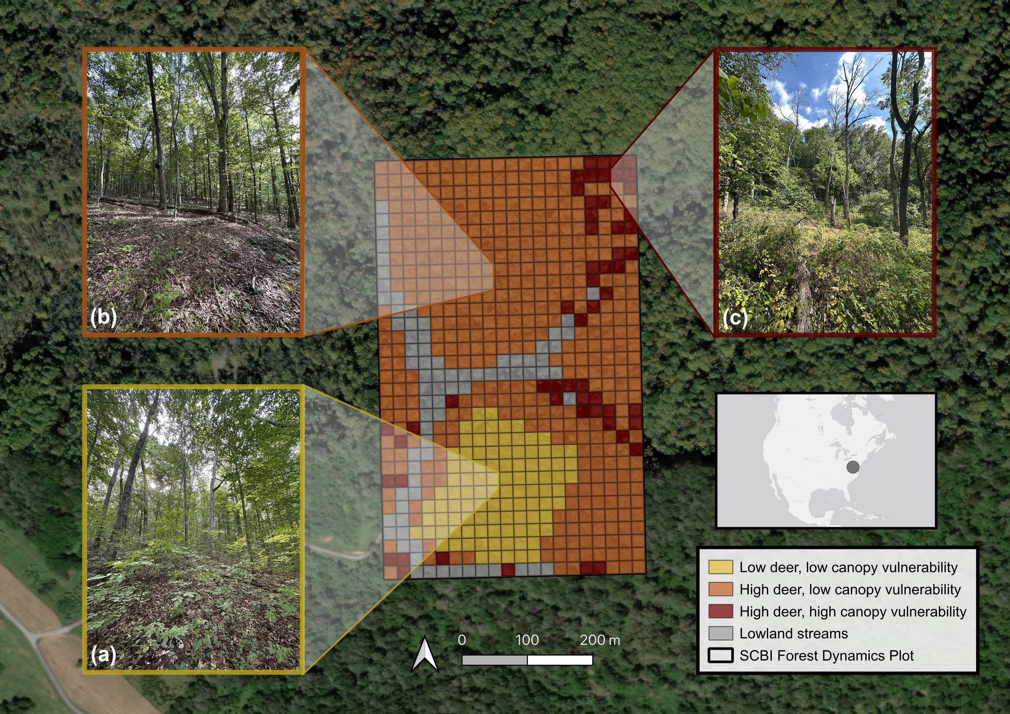
Figure 1. Map and photos of the Forest Global Earth Observatory (ForestGEO) plot at the Smithsonian’s Conservation Biology Institute (SCBI) in Virginia, USA. Our analysis focuses on three portions of the plot: (a) low deer density, low abundance of canopy trees vulnerable to non-indigenous insects & pathogens, (b) high deer density, low abundance of canopy trees vulnerable to non-indigenous insects & pathogens, and (c) high deer density, high abundance of canopy trees vulnerable to non-indigenous insects & pathogens. All photos taken September 2023 by K. Anderson-Teixeira; aerial photography from ESRI World Imagery.

Data collection
As part of the ForestGEO network, the plot undergoes a comprehensive woody plant inventory every five years following the protocol detailed in Condit (1998). This inventory, hereafter referred to as the census, includes all stems greater than one centimeter in diameter at breast height (1.3 meters; dbh). The census records the dbh, species, living status, and spatial location of each censused stem. Each individual is marked with an identifying number for sequential data collection in subsequent censuses. In multi-stemmed individuals, each additional stem that surpasses the dbh threshold receives a stem number and associated tag. The plot was established in 2008 and recensused three times since (2013, 2018, 2023), providing 15 years of forest dynamics data. In the last census, systematic data cleaning was continuously implemented 1) in an ESRI ArcGIS Field Maps application via built-in checks and 2) on a daily basis, via error reports generated through GitHub actions (Kim et al., 2022). Each stem’s location was recorded in the Field Maps application using a digitized map of the plot. In addition to the ForestGEO census, a tree health and mortality survey has been conducted annually starting in 2014 on all trees with a dbh ≥ 10 cm in the previous census (Gonzalez-Akre et al., 2016). We use the surveys from 2014 through 2026. Data were collected on the current status, canopy position, percentage of living and intact crown, and visible indicators of tree health, (e.g. physical damage, potential pathogens, insect infestation). Although the survey cannot fully attribute the cause of each death, it has monitored signs of emerald ash borer (EAB; Agrilus planipennis) on ash trees, and the large majority of ash trees that died showed signs of EAB before death.

Calculating biomass dynamics and stem recruitment
We estimated total aboveground biomass (AGB) from the dbh of each stem in each census using extra-tropical allometric equations from the R package allodb (Gonzalez-Akre et al., 2022). The allodb package creates species-specific allometric equations by weighting all applicable allometries within its database filtered by tree size, geography, and taxonomic information. Biomass was converted to carbon using a carbon fraction of 0.47. Using the calculated stem AGB, we estimated AGB stocks at each census year for each of the plot regions, as well as the entire 25.6-ha plot. We quantified trends in AGB over time by calculating annualized AGB fluxes including: 1) the net change in AGB, 2) aboveground woody growth (AWG; the addition of woody biomass from tree growth the growth of stems that survived the census interval), 3) aboveground woody mortality (AWM; the change of living biomass to necromass due to tree mortality, including stems that broke below breast height), and 4) aboveground woody recruitment (AWR; the addition of living biomass through recruitment of new stems ≤ 6 cm dbh) for each census interval and plot region. We further assessed the role of nuisance species on mortality by calculating AWM flux for each year and each species using the annual mortality survey data (excluding stems < for stems ≥ 10 cm dbh at the most recent census. Each stem was counted as dead once, in the first survey after its last record as alive. Its biomass was estimated with allodb from its dbh at the most recent census at which it was alive, converted to carbon, and divided by the time since the previous survey. In total, 1,753 stem deaths were recorded in the 2014–2026 surveys; summed over 2014–2023, they agreed with census-based mortality of stems ≥ 10 cm to within 0.2%. For 2013, we show the mean annual mortality of stems ≥ 10 cm over the 2008–2013 census interval. To compare plot regions, we averaged each quadrat’s annual mortality over three periods: 2014–2018 and 2019–2023 (matching the census intervals) and 2024–2026. To assess the rest of the forest, we calculated annual stem mortality rates (CITE: Sheil et al. 1995) and relative growth of canopy-species stems ≥ 10 cm dbh for Fraxinus, Quercus and all other canopy species in each census interval (Supporting Information).
In addition to the estimation of AWR biomass flux, we analyzed the possible effects of nuisance species on recruitment based on counts of newly recruited stems individuals, i.e., newly tagged trees of 1–6 cm dbh when first recorded (new stems on previously tagged trees were excluded; stem-based rates are given in Supporting Information). We categorized each species as either canopy or understory based on expert knowledge of life history traits according to its life form in the SCBI species list (trees were classed as canopy species, except Acer negundo); stems identified only to genus were assigned by genus, and stems that were not identified (20 stems) were excluded. Quercus spp. and Carya spp. were grouped by genera to better assess differences between the recruitment of canopy and understory species. We then calculated the number of new stems for each census interval for individuals of each species or genera genus per hectare of each plot region per year over 2008–2023 (a nominal 15-year interval), averaging over all quadrats in the region (including those without recruits). We also report canopy recruitment excluding the species vulnerable to non-indigenous pests and pathogens listed above, which are unlikely to reach the canopy. Finally, we assessed the spatial overlap of biomass loss and recruitment regeneration of canopy species. We calculated the ∆AGB of canopy trees within each 0.4 species (stems ≥ 3 cm dbh) within each 0.04 hectare quadrat between 2008 and 2023 and the AGB of canopy species in the understory in 2023. density of canopy-species saplings (stems of 1–3 cm dbh) and poles (3–10 cm dbh) in 2023. For each region we report sapling density, the share of quadrats with no sapling, and the number of saplings per canopy-species tree ≥ 20 cm dbh, as a replacement ratio. Inside the exclosure, in quadrats that lost canopy-species biomass between 2008 and 2023, we calculated the share of the biomass of canopy-species stems (≥ 3 cm dbh) that died over this period that was oak.

Statistical analysis
To quantify uncertainty we treated the 20 × 20 m quadrats as replicates, acknowledging that quadrats within a single plot are not independent replicates of the deer or vulnerability treatments (CITE: Rutishauser et al. 2020). For each plot region and the whole plot we estimated 95% confidence intervals (CIs) with a studentized (bootstrap-t) bootstrap of quadrat means with 10,000 resamples (CITE: Efron & Tibshirani 1993), which in simulations based on our data gave close to nominal coverage for skewed quadrat-level fluxes. Changes over time were tested as paired differences, bootstrapping the mean of each quadrat’s own change; differences between regions were bootstrapped from independent resamples of each region, and recruitment contrasts were also expressed as ratios (computed on the log scale). To account for spatial autocorrelation, we examined Moran’s I correlograms of quadrat-level values (residuals from region means; Supporting Information). Woody growth, mortality (including annual mortality) and net change showed negligible autocorrelation (Moran’s I ≤ 0.06) and were resampled by quadrat, whereas AGB stocks, AWR, recruitment and saplings were spatially clustered (canopy recruitment and saplings over distances up to about 60 m; understory recruitment, and hence AWR, over longer distances) and were resampled in 3 × 3-quadrat (60 × 60 m) blocks.
Growth relative to standing biomass (AWG divided by AGB at the start of each interval, % yr⁻¹), the sapling replacement ratio, per-stem mortality rates and the oak share of canopy biomass that died inside the exclosure were computed as ratios of regional totals and bootstrapped with a ratio-estimator standard error, resampling in blocks for relative growth (whose quadrat-level deviations were spatially clustered) and the replacement ratio, and by quadrat for the mortality-based ratios; changes in per-stem mortality between intervals were bootstrapped as paired differences. Sapling contrasts were also expressed as ratios, and pole density was resampled in blocks. To separate the effect of deer from the exclosure’s location, we also compared quadrats within 60 m of the fence line inside the exclosure with high-deer upland quadrats within 60 m outside it that did not overlap the fenced area. Changes in AGB between censuses were, like net change, resampled by quadrat; CIs for percentage changes were approximated by dividing the CI of the change by the starting mean. Because recruitment is clustered and the deer exclosure contains only 17 blocks, CIs for recruitment may be somewhat too narrow. CIs are therefore given for recruitment totals only (all canopy taxa, canopy taxa excluding vulnerable taxa, and all understory taxa), since taxa that recruited in few quadrats give unreliable intervals; and because understory recruitment and AWR were clustered over distances greater than the blocks, their differences between regions are described without CIs. Lower CI bounds of non-negative quantities were truncated at zero. We report effect sizes with 95% CIs rather than P-values; values in parentheses after an estimate are its 95% CI. Sensitivity analyses of the census-based variables with the alternative resampling scheme are given in Supporting Information.

Results
Consistent with hypothesis 1, all sections of the plot experienced increased mortality (AWM) since plot establishment in 2008 increased between the second and third census intervals in each of the three focal regions and in the plot as a whole ( Figure Fig. 2b). The largest increases in mortality occurred in areas with the highest vulnerability to non-indigenous pests and pathogens. Initially, plot-level AWM remained constant, maintaining rates of 1.5 and 1.4 similar at 1.58 (1.35–1.86) and 1.51 (1.30–1.77) Mg C ha⁻¹ yr⁻¹ in the first two census intervals (change −0.06 [−0.42 to 0.27]). However, in the most recent period from 2018 to 2023, AWM increased to 3 2.98 (2.61–3.44) Mg C ha⁻¹ yr⁻¹ . Despite initial uniformity in AWM across all plot regions (change 1.47 [1.03–1.96]). Although AWM was similar across plot regions in 2008–2013 (e.g., high minus low canopy vulnerability under high deer density: 0.11 [−0.59 to 1.62]), the high deer, high canopy vulnerability areas experienced substantial increases in AWM across all censuses, resulting in a three-fold increase in AWM from the first to most recent interval region experienced the largest increase in AWM, nearly five-fold (4.8×) from 2008–2013 to 2018–2023 (from 1.60 to 7.63 Mg C ha⁻¹ yr⁻¹; change 6.03 [3.74–8.37]), most of it between 2013–2018 and 2018–2023 (change 4.12 [1.86–6.46]). Low canopy vulnerability regions displayed smaller rises in AWM and only in the final survey period. census interval (inside the exclosure: 1.13 [0.31–2.15]; outside: 1.12 [0.64–1.71]), after no increase between the first two intervals (−0.65 [−1.40 to −0.02] and −0.30 [−0.75 to 0.10]). While other canopy species did not see increases in per-stem mortality (1.74% yr⁻¹ [1.54–1.96] and 1.08% yr⁻¹ [0.95–1.21] in 2008–2013 and 2018–2023), oaks, the characteristic canopy genus of this oak–hickory forest, did: Quercus stem mortality rose from 2.32% yr⁻¹ (1.95–2.73) to 3.01% yr⁻¹ (2.59–3.50), a change of 0.69 (0.12–1.27) percentage points, in addition to the far larger rise in Fraxinus (to 26.0% yr⁻¹ in 2018–2023).
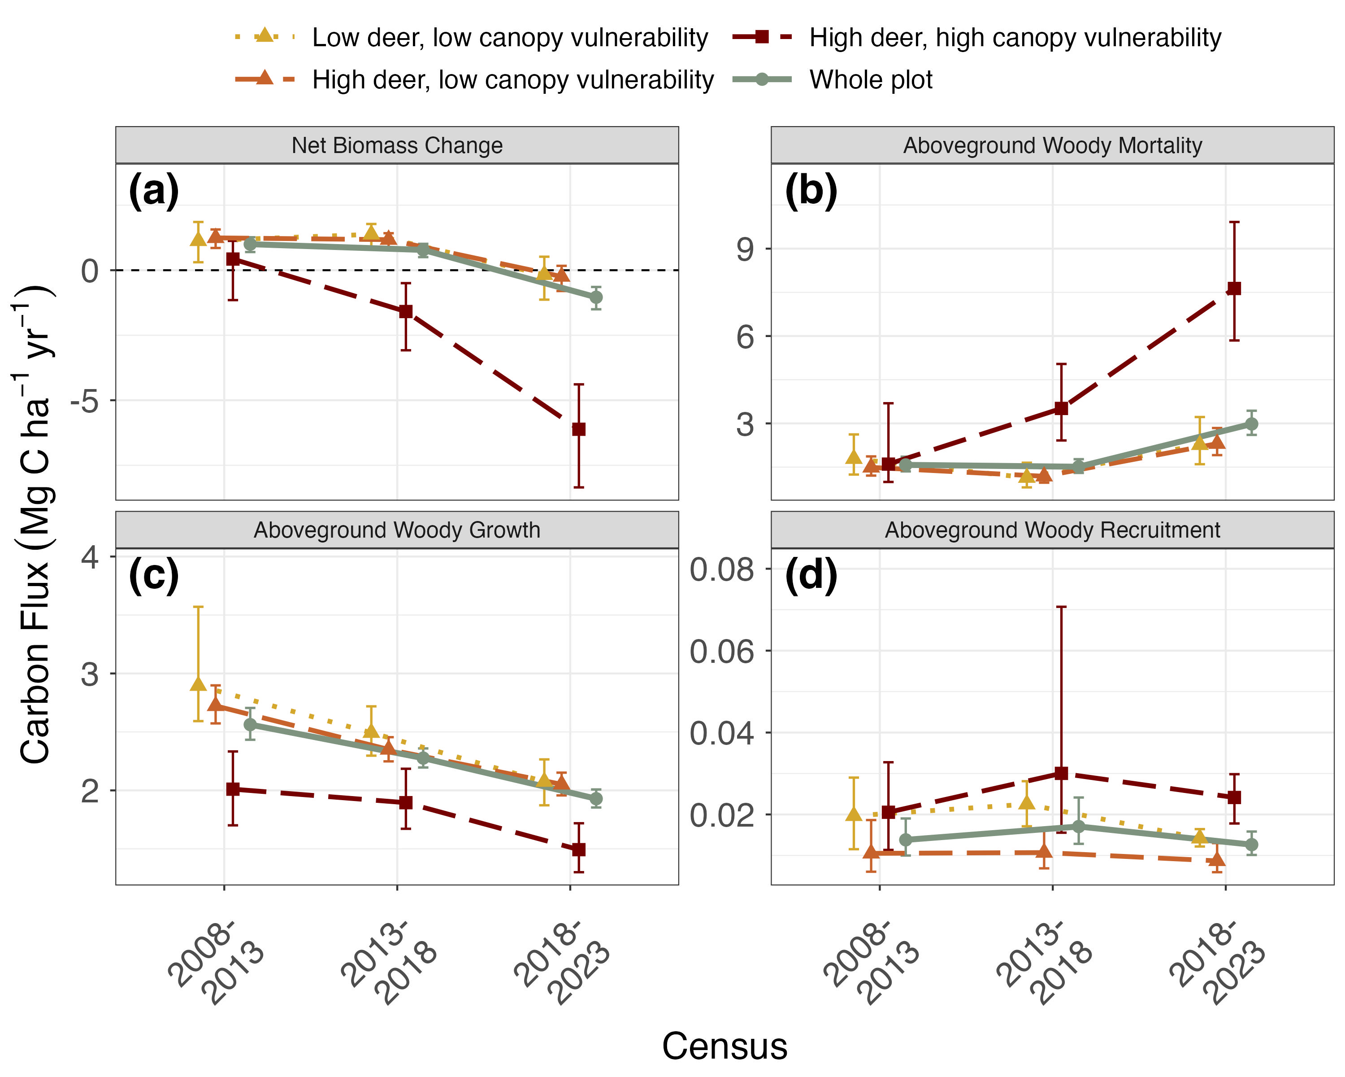
Figure 2. Changes in aboveground woody biomass at the SCBI ForestGEO plot over each census interval since 2008 establishment, including (a) net change, (b) losses to mortality, and gains from (c) woody productivity growth of surviving stems and (d) recruitment. Values are shown for the plot as a whole and for regions differentiated by intensity of deer browsing and 2008 abundance of canopy tree species vulnerable to non-indigenous pests and pathogens. Points are means across 20 × 20 m quadrats; error bars are 95% bootstrap-t confidence intervals (see Statistical analysis). Overlapping intervals do not imply no change: changes between intervals were tested with paired comparisons (see Results).
Though AWM increased throughout the plot AWM rates remained stable in a majority of individual species. The increasing trend of AWM was driven primarily by two species Two species had the highest annual mortality: white ash (Fraxinus americana) and black oak (Quercus velutina) ( Figure 3 Fig. 3a). Fraxinus americana, the host species for non-indigenous pest emerald ash borer (Agrilus planipennis) the non-indigenous EAB, had the highest annual AWM of any species present on the plot, with an average flux of 1.5 0.57 Mg C ha⁻¹ yr⁻¹ over 2013–2026 and loss peaking at 5.3 2.55 Mg C ha⁻¹ yr⁻¹ in 2020. Quercus velutina experienced the second-highest rate of AWM at a rate of 0.9 Fraxinus americana alone accounted for 41% of plot-wide AWM in 2019–2023 and 55% of its rise from 2014–2018 to 2019–2023. Quercus velutina had the second-highest AWM, at 0.45 Mg C ha⁻¹ yr⁻¹. The average annual AWM of these two species ( 2.5 1.02 Mg C ha⁻¹ yr⁻¹) , was higher than was comparable to that of all other species combined remaining species combined, including the other four species shown in Fig. 3a ( 1.2 1.00 Mg C ha⁻¹ yr⁻¹). Moreover, both species exhibited significant increases in AWM since the start of the census, a trend also observed in three other species in the Oak genera—Quercus rubra, Quercus prinus and Quercus alba By 2023 most F. americana ≥ 10 cm had died (433 live stems in 2008, 327 in 2018 and 71 in 2023; 51 were alive in the 2026 survey), so its mortality fell from 2.55 in 2020 and 1.88 in 2021 to 0.09, 0.01 and 0.03 Mg C ha⁻¹ yr⁻¹ in 2024, 2025 and 2026.
Figure 3. Annual woody mortality by species at the SCBI ForestGEO plot from 2008-2023. Shown are the six canopy taxa with highest average mortality rate in descending order and a category including all others. The census included all stems ≥ 10 cm in the most recent full census.
Annual mortality (annual surveys, stems ≥ 10 cm dbh) followed different courses in the three plot regions (Fig. 3b). In the high deer, high canopy vulnerability region, mean annual AWM rose from 2.72 (1.71–4.22) in 2014–2018 to 7.96 (6.15–10.26) Mg C ha⁻¹ yr⁻¹ in 2019–2023 and then fell to 0.51 (0.21–1.94) in 2024–2026 (change −7.45 [−9.76 to −5.43]), below its 2014–2018 level (change −2.21 [−3.72 to −1.05]). Plot-wide, AWM rose from 1.36 (1.16–1.63) in 2014–2018 to 3.00 (2.61–3.47) Mg C ha⁻¹ yr⁻¹ in 2019–2023 (change 1.64 [1.19–2.12]), then fell (change −1.33 [−1.91 to −0.68]) to 1.68 (1.30–2.25) in 2024–2026, not detectably different from its 2014–2018 level (change 0.31 [−0.14 to 0.89]). In the high deer, low canopy vulnerability region, AWM was 1.17 (0.95–1.47) in 2014–2018, 2.21 (1.81–2.76) in 2019–2023 and 1.52 (1.13–2.04) Mg C ha⁻¹ yr⁻¹ in 2024–2026 (change from 2019–2023 −0.69 [−1.32 to −0.06]). Inside the deer exclosure, AWM increased from 0.95 (0.58–1.75) in 2014–2018 to 3.21 (1.63–7.26) in 2024–2026 (change 2.26 [0.65–6.09]), with peaks in 2022 (3.7 Mg C ha⁻¹ yr⁻¹) and 2025 (6.4 Mg C ha⁻¹ yr⁻¹), of which 77% and 71%, respectively, was oak (Quercus spp.) mortality.
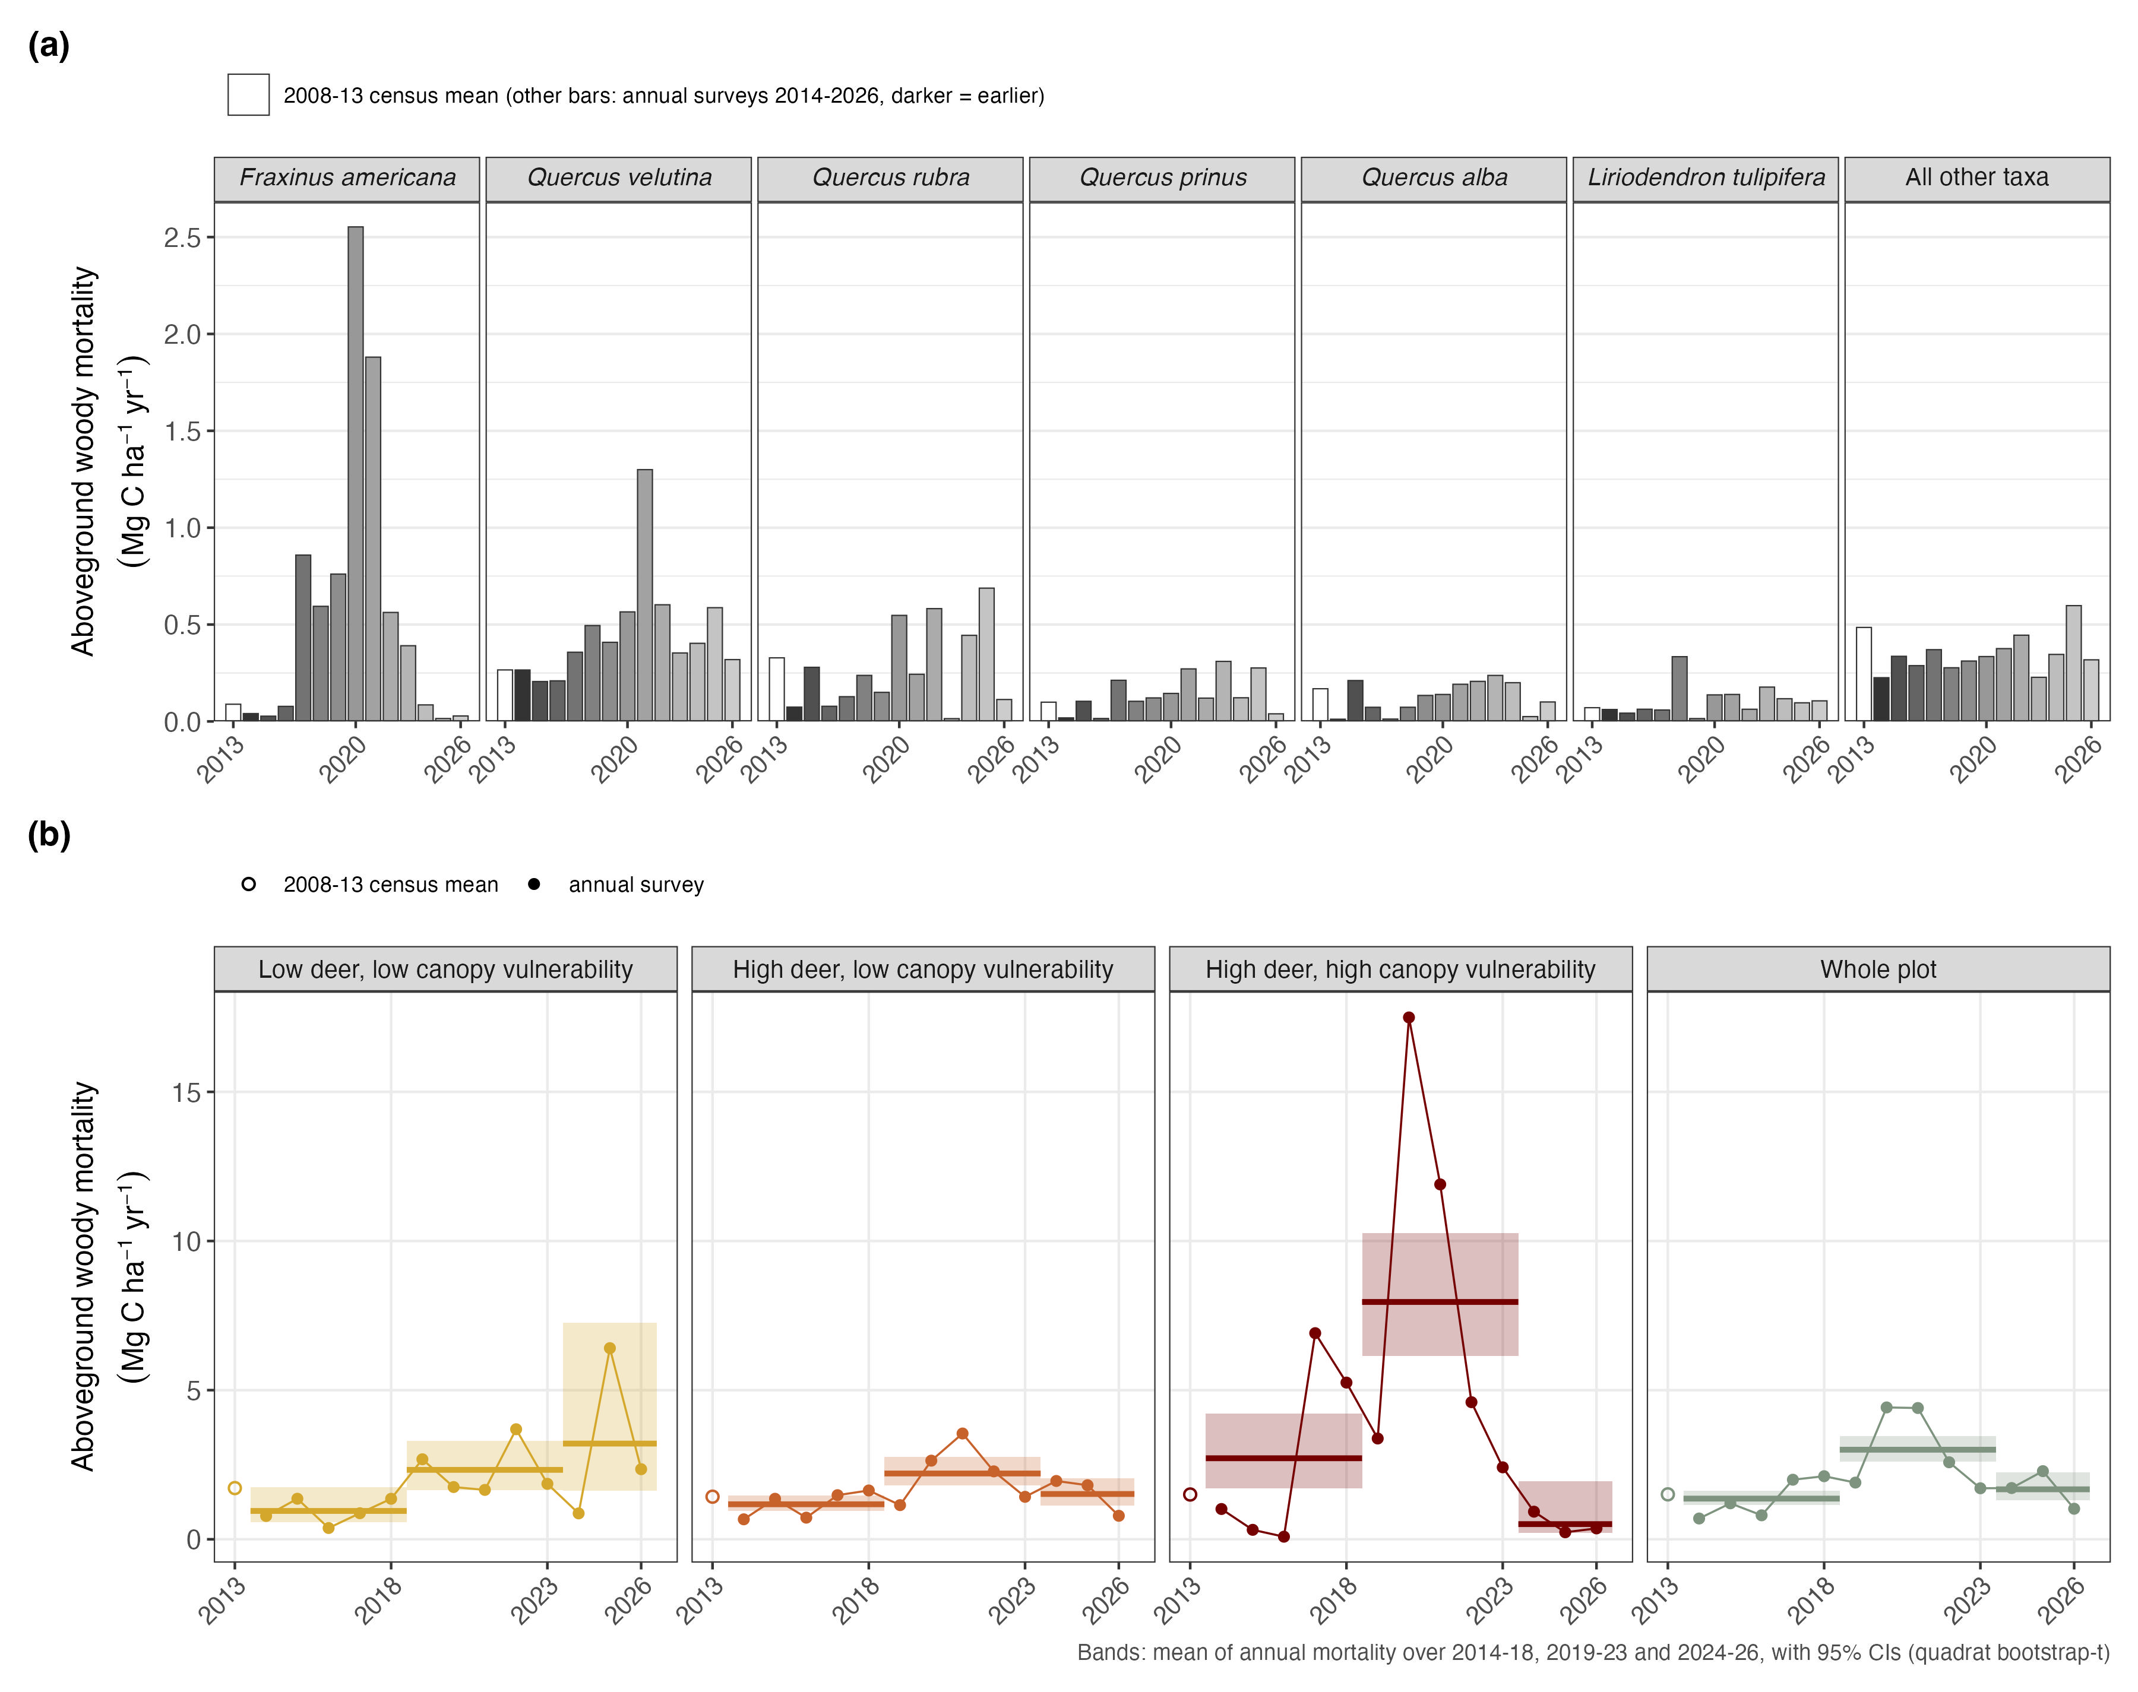
Figure 3. Annual woody mortality at the SCBI ForestGEO plot from 2013 to 2026, (a) by species and (b) by plot region. (a) Shown are the six species with the highest mean annual mortality (Carya species are counted separately; Carya spp. combined, which would rank fourth, are included in all others), in descending order, and a category including all others. The 2013 value (white bar) is the mean annual mortality over the 2008–2013 census interval; other bars are annual surveys (darker = earlier). (b) Annual mortality by plot region and for the whole plot (points; the open circle is the mean annual mortality over the 2008–2013 census interval), with the mean annual mortality over 2014–2018, 2019–2023 and 2024–2026 and its 95% bootstrap-t confidence interval (bands). Values are in Mg C ha⁻¹ yr⁻¹, per hectare of the whole plot (a) or of each region (b); the surveys include all stems ≥ 10 cm dbh in the most recent full census, and the 2013 value counts stems that broke below breast height as dead.
Consistent with hypothesis 2, biomass losses to mortality outpaced biomass gains from tree growth over the 2018 -23 –2023 census interval ( Figure net change −1.04 [−1.50 to −0.64] Mg C ha⁻¹ yr⁻¹) (Fig. 2a). For the first time since establishment of the SCBI ForestGEO plot, living aboveground C stocks (AGB) decreased between 2018 and 2023 ( Figure Fig. 4), declining from 145.9 to 140.9 Mg C ha⁻¹ (paired change −5.1 [−7.5 to −3.1] Mg C ha⁻¹, −3.5%). Prior to this period, AGB had consistently increased at a rate of 2.6 Mg C ha-1 yr -1 (net change 1.00 [0.70–1.27] and 0.78 [0.50–1.01] Mg C ha⁻¹ yr⁻¹ in 2008–2013 and 2013–2018), at an average rate of 0.88 (0.69–1.06) Mg C ha⁻¹ yr⁻¹ between 2008 and 2018 ( Figure 2a Fig. 4). The 2018–2023 decline returned whole-plot AGB to its 2013 level (2013–2023 change −1.2 [−4.0 to 1.3] Mg C ha⁻¹). In regions characterized by high deer density and the high deer, high canopy vulnerability region, > 33% about one third (33.5%; approximately 24.6–44.6%) of AGB was lost over the past two censuses: dropping from 115.8 Mg C ha⁻¹ in 2013 to 107.7 Mg C ha⁻¹ in 2018 and then to 77 77.0 Mg C ha⁻¹ in 2023 . Conversely, (paired change −38.8 [−51.6 to −28.5] Mg C ha⁻¹). Topography did not explain these losses: compared with topographically matched quadrats of the high deer, low canopy vulnerability region, the high deer, high canopy vulnerability region still had higher mortality and a larger loss of AGB (Supporting Information), although ash, its main vulnerable species, is naturally most abundant on mesic sites (CITE: ash habitat), so canopy vulnerability and topography are partly linked. Conversely, AGB did not change detectably between 2018 and 2023 in areas with low density of vulnerable canopy species experienced marginal losses of AGB between 2018 and 2023; both inside and outside of the deer exclosure, biomass decreased from, either inside the deer exclosure (164.6 to 163.6 Mg C ha⁻¹; change −1.0 [−5.9 to 2.7]) or outside it (154.3 to 153.3 Mg C ha⁻¹ and 164.6 to 163.6 Mg C ha-1, respectively; change −1.0 [−3.8 to 1.1]).
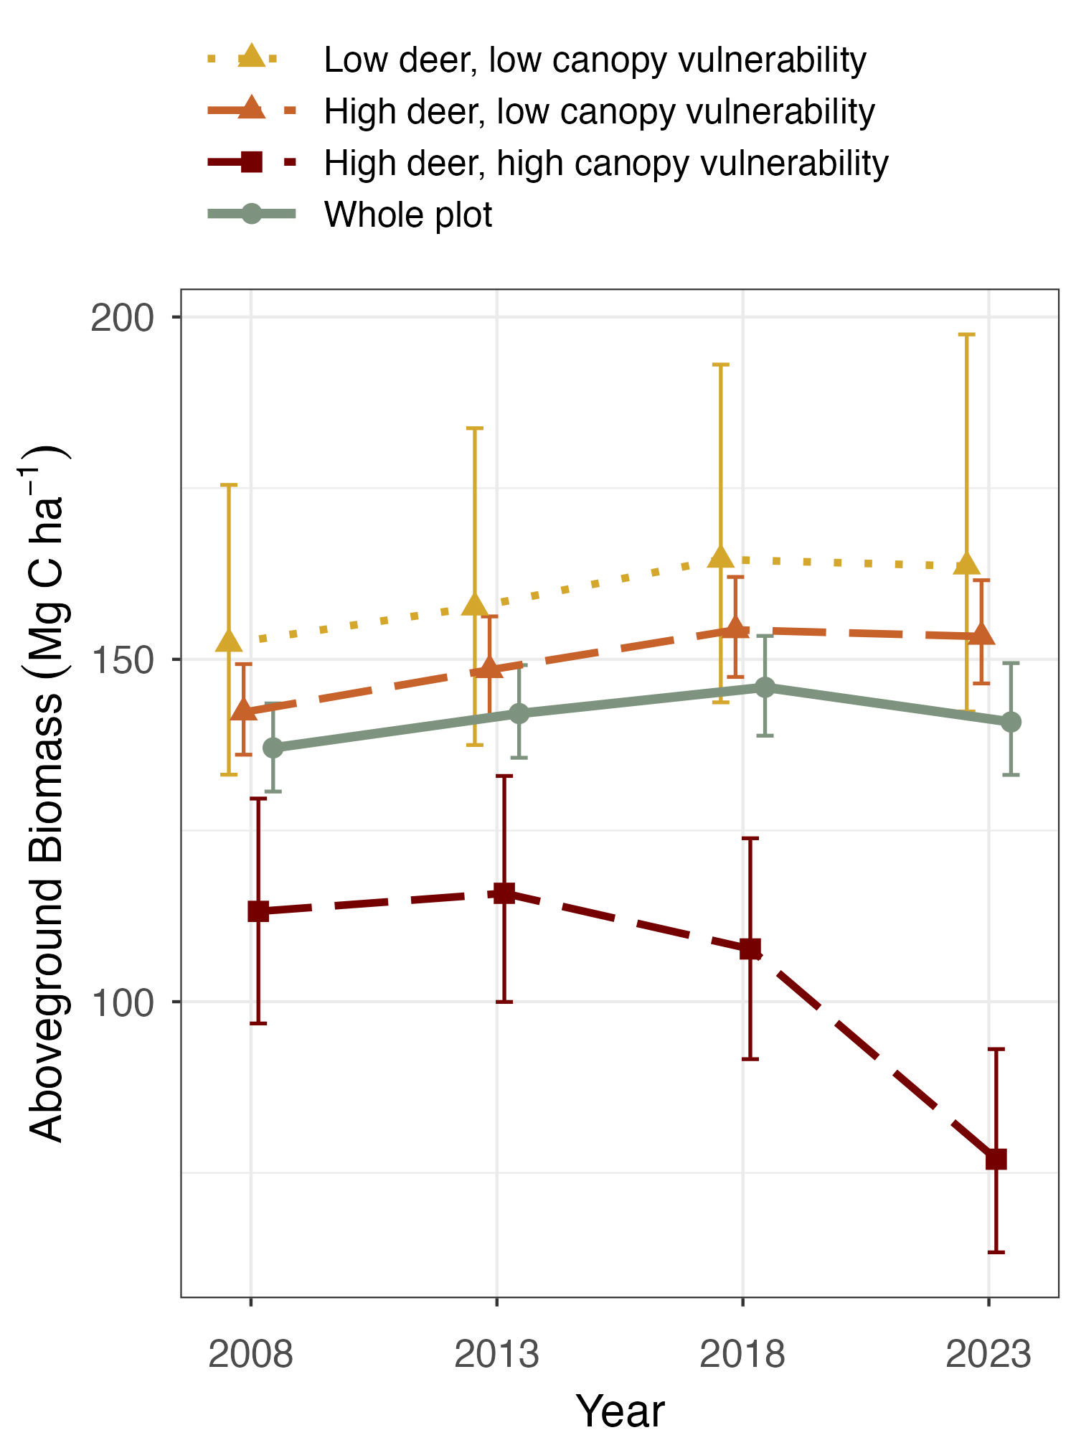
Figure 4. Aboveground biomass at the SCBI ForestGEO plot since 2008 establishment. Values are shown for the plot as a whole and for regions differentiated by intensity of deer browsing and 2008 abundance of canopy tree species vulnerable to non-indigenous pests and pathogens. Points are means across 20 × 20 m quadrats; error bars are 95% bootstrap-t confidence intervals for each year’s mean (60 × 60 m block resampling). Overlapping intervals do not imply no change: changes between censuses were tested with paired comparisons (see Results).
Transition from net AGB accumulation to loss was not solely attributable to increased mortality; biomass accrual from woody growth (AWG) declined across all census intervals between consecutive census intervals plot-wide and in both low canopy vulnerability regions, and in the high deer, high canopy vulnerability region between 2013–2018 and 2018–2023 (−0.40 [−0.67 to −0.23]; between 2008–2013 and 2013–2018: −0.12 [−0.36 to 0.13]), even when AWM did not increase ( Figure Fig. 2c). Plot-wide AWG decreased by -30 %, from 2.6 24.7% (approximately 20.4–29.8%), from 2.56 Mg C ha⁻¹ yr⁻¹ over 2008 -2013 to 1.9 –2013 to 1.93 Mg C ha⁻¹ yr⁻¹ in the 2018 -2023 interval –2023 interval (paired change −0.63 [−0.76 to −0.52]). Relative to AGB at the start of each interval, growth also declined in all regions (plot-wide from 1.87 [1.77–1.98] to 1.32 [1.26–1.38] % yr⁻¹), suggesting that the decrease in AWG is not only an effect of reduced live biomass. Areas with low canopy vulnerability consistently displayed the highest AWG (2.1 displayed higher AWG than the high deer, high canopy vulnerability region in every census interval (2018–2023: 2.07 and 2.05 vs 1.49 Mg C ha⁻¹ yr⁻¹ in the 2018-2023 period), while the AWG in the portion with high canopy vulnerability was significantly lower (1.5Mg C ha-1 yr-1; high minus low vulnerability: −0.58 [−0.86 to −0.29] relative to the exclosure and −0.56 [−0.78 to −0.32] outside it). Woody recruitment flux (AWR) , constituting constituted a minor fraction of net biomass change , showed no significant temporal trend (Figure (≤ 0.030 Mg C ha⁻¹ yr⁻¹ in every region and interval) and changed little over time (Fig. 2d). AWR consistently remained lowest in areas characterized by high deer density and low canopy vulnerability, whereas it reached its highest levels in regions with high canopy vulnerability, recording rates of 0.01 Mg C ha-1 yr-1 and 0.025 Mg C ha-1 yr-1, respectively was lowest in the high deer, low canopy vulnerability region in every interval and highest in the high deer, high canopy vulnerability region in 2013–2018 and 2018–2023.
Consistent with hypothesis 3, deer density had strong mediating effects on the composition of woody stem recruitment (Figure recruitment (Fig. 5). The region characterized by low deer density exhibited significantly higher annual recruitment of canopy taxa compared to those than areas with higher deer density — specifically, 38.7 stems ha-1 yr-1 compared to 19 ha-1 yr-1: 15.52 (10.52–23.44) new individuals ha⁻¹ yr⁻¹, compared with 0.50 (0.28–1.04) and 0.68 (0.30–1.55) in the high deer, low canopy vulnerability and high deer, high canopy vulnerability regions, respectively (ratios 31 [14–63] and 23 [9–51]). Excluding taxa vulnerable to non-indigenous pests and pathogens, which are unlikely to reach the canopy, the contrast was similar (9.19 vs 0.25 and 0.42 individuals ha⁻¹ yr⁻¹; ratios 38 [20–66] and 22 [11–48]). The contrast held across the fence: within 60 m of the fence line, canopy recruitment was 15.9 (9.7–25.0) new individuals ha⁻¹ yr⁻¹ inside and 0.40 (0.16–0.78) outside (ratio 40 [19–95]), and canopy-species saplings numbered 255 (162–382) and 10 (5–18) stems ha⁻¹ (ratio 25 [13–52]). In particular, the recruitment rate of Carya spp. and Quercus spp., late-successional taxa characteristic of this forest’s expected climax state, was reduced by > 50% more than 90% (point estimates) in areas with high deer density . The prevalence of vulnerable canopy species in regions with low deer density showed no significant impact on the total quantity of canopy species recruitment into the understory. However, recruitment of Fraxinus americana and Fagus grandifolia was higher in areas with high canopy vulnerability, while recruitment of (Carya: 4.46 vs 0.06 and 0.03; Quercus: 1.20 vs 0.02 and 0.09 individuals ha⁻¹ yr⁻¹). Outside the exclosure these taxa recruited in very few quadrats (Quercus: 2 of 408 and 2 of 56 quadrats; Carya: 10 and 1), so these percentages are approximate. Among high-deer areas, canopy vulnerability made no detectable difference to total canopy recruitment (high minus low vulnerability: 0.19 [−0.31 to 0.84] individuals ha⁻¹ yr⁻¹), and individual canopy taxa, such as Fraxinus americana, Fagus grandifolia, Ulmus rubra and Carya spp. was lower. Across all regions, the, recruited at very low rates in both regions (Fig. 5). The recruitment rate of understory taxa was nearly 10 5 times that of canopy taxa . Recruitment of Lindera benzoin was high across inside the deer exclosure, but 94–110 times that of canopy taxa outside it. Lindera benzoin recruited at similar rates in all regions ( > 100 stems 30.08, 36.18 and 42.86 individuals ha⁻¹ yr⁻¹) , and significantly increased in areas with high deer densities while peaking in areas that also had low canopy vulnerability. Asimina triloba recruitment was also lowest within the deer exclosure ( 18.6 stems 1.90 individuals ha⁻¹ yr⁻¹) but was and highest in the region with high deer density and high deer, high canopy vulnerability region ( 76.6 stems ha-1 yr-1 28.39 individuals ha⁻¹ yr⁻¹, compared with 9.06 in the high deer, low canopy vulnerability region).
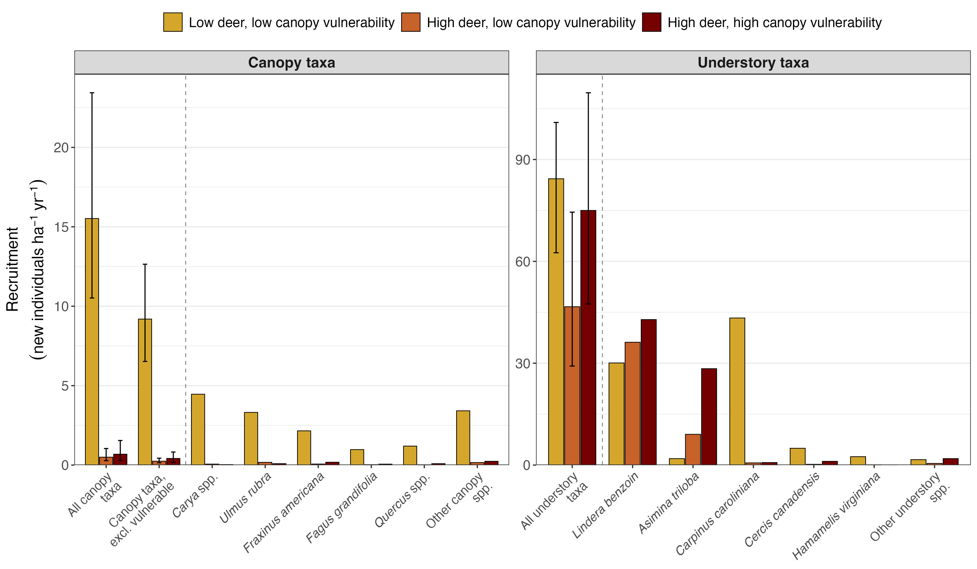
Figure 5. Average annual recruitment (2008 -2023 –2023) of canopy and understory tree species at the SCBI ForestGEO plot across areas differentiated by intensity of deer browsing and 2008 abundance of canopy tree species vulnerable to non-indigenous pests and pathogens. Recruitment is the number of new individuals (newly tagged trees reaching 1 cm dbh) per hectare per year. Each panel begins with group totals (all canopy taxa; canopy taxa excluding those vulnerable to non-indigenous pests and pathogens; all understory taxa), followed by the five most-recruited taxa and all others. Bars are means across quadrats. Error bars on the group totals are 95% bootstrap-t confidence intervals (60 × 60 m block resampling), which may be somewhat narrow because recruitment is spatially clustered; individual taxa are shown without intervals because many recruited in few quadrats. Stem-based rates are shown in Supporting Information. Note that y-axes differ , with understory species recruitment > 20 times that of canopy species recruitment.
There were significant areas of suppressed regeneration of canopy species, often coincident with decreasing AGB. Only 21.7% of the plot (mostly inside the deer exlosure) exhibited an understory with high AGB of species capable of reaching the canopy. Within the plot areas characterized by high deer density and high canopy vulnerability, 84% of the area had lost canopy biomass, only 5.4% had an understory containing high AGB of canopy taxa, and 0% of area exhibited both a healthy understory and increasing AGB. In contrast, 70.7% of the plot area with low deer density and low canopy vulnerability had high AGB of canopy species in the understory, indicating a higher likelihood of future C sequestration. Furthermore, 72.7% of the region with low deer density and low canopy vulnerability had a net increase of AGB.
Figure 6. Map of changes in canopy biomass (2008-2023) and the biomass of canopy taxa in the understory in 2023 within the SCBI ForestGEO plot. (a) Each .04 ha quadrat is classified by the ∆AGB of canopy trees over the 15-year study period and the AGB of canopy taxa in the understory in 2023. (b) The % area of each region that falls within each classification.
Regeneration of canopy species was concentrated inside the deer exclosure (Fig. 6b). There, canopy-species saplings (1–3 cm dbh) numbered 248 (172–365) stems ha⁻¹, compared with 14 (10–21) and 16 (6–45) in the high deer, low canopy vulnerability and high deer, high canopy vulnerability regions, respectively (ratios 18 [10–29] and 16 [5–36]), and only 10% of quadrats inside the exclosure had no sapling, against 72% and 68% outside it. Inside the exclosure there were 1.30 (0.90–1.88) saplings per canopy-species tree ≥ 20 cm dbh, compared with 0.08 (0.06–0.12) and 0.16 (0.07–0.44) outside it. Poles of canopy species (3–10 cm dbh) did not differ detectably between the exclosure and the high deer, low canopy vulnerability region (142 [122–173] and 125 [104–148] stems ha⁻¹; difference 17 [−13 to 48]), but were scarcer in the high deer, high canopy vulnerability region (47 [28–74]; difference from the high deer, low canopy vulnerability region −77 [−106 to −49]), which was also the only region to lose canopy biomass between 2008 and 2023 (−37.0 [−48.7 to −27.0] Mg C ha⁻¹, compared with 10.7 [3.7–16.4] and 11.1 [7.5–14.1]; Fig. 6a). Inside the exclosure, 27 of 99 quadrats lost canopy biomass between 2008 and 2023, and 80% (65–90%) of the canopy biomass that died in them was oak (Quercus velutina 46%, Q. rubra 19%); Fraxinus accounted for 4%.
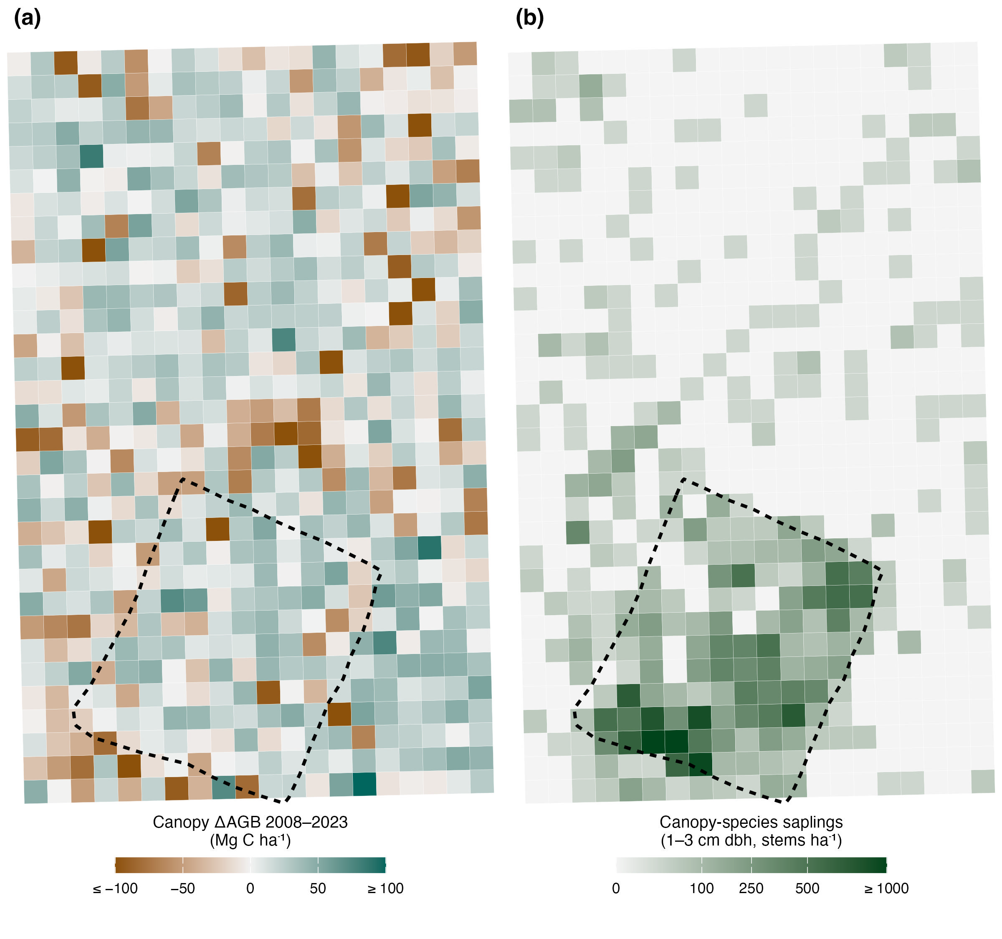
Figure 6. Canopy biomass change and regeneration of canopy species at the SCBI ForestGEO plot. (a) Change in aboveground biomass of canopy-species stems ≥ 3 cm dbh between 2008 and 2023 in each 20 × 20 m quadrat (brown, loss; teal, gain). (b) Density of canopy-species saplings (stems of 1–3 cm dbh) in 2023. The dashed line is the deer-exclosure fence. Values by plot region are given in the Results.

Discussion
Our results reveal indicate that nuisance species have compromised reduced live biomass stocks and regenerative capacity at the SCBI ForestGEO plot, reducing the recent and future carbon sink contributing to the first decline in live aboveground C stocks since plot establishment and potentially limiting the future C uptake of this forest. Canopy tree mortality and associated AWM increased, particularly in plot areas affected most heavily by non-indigenous insects and pathogens (hypothesis 1, Figs . 2- 2–3). These increases in AWM were not offset by biomass increases through AWP AWG, which decreased, or recruitment, resulting in net biomass loss (hypothesis 2, Figs .2, 4). This net AGB loss occurred despite localized increases in AGB across most of the plot, particularly in areas with low canopy vulnerability (Fig. 6 6a). Recruitment of canopy tree species was low throughout the plot ( far lower outside the deer exclosure than inside it (23- to 31-fold; Fig. 5), and there was low biomass of canopy species in the understory, particularly in areas with high deer density were few canopy-species saplings outside it (Fig. 6 6b) . Moreover, low recruitment of canopy species in areas with high canopy vulnerability suggests that heavy deer browsing on canopy species may be exacerbated in areas with canopy openings due to nuisance-species driven mortality where fast-growing understory species that are resistant to deer can take advantage, further competing with canopy recruitment. Thus, nuisance species have severely compromised both recent and future carbon sequestration reduced recent C sequestration by living trees in this forest and, contradicting if deer densities remain high, may limit its future sequestration, contrary to models projecting increases in AGB (Wu et al., 2023).
While nuisance species have had a large impact on AGB loss at our site, simultaneous changes including stand aging and climate change have also contributed to observed trends. The majority of AGB loss has occurred through increased EAB-driven mortality of Fraxinus spp F. americana (Anderson-Teixeira et al., 2021) accounted for more than half of the rise in plot-wide mortality (Results), yet mortality among oak species, which is not primarily linked to a non-indigenous nuisance species, is substantial as well and rose between census intervals (Fig. 3; Results). As is the case at our site, oak species in the region are generally found in older, relatively even aged cohorts, and this can contribute to accelerated mortality rates (CITE: Oak et al. ,2016). However, large oak mortality events, which often occur over protracted periods of time, have been common globally over the past century and are often termed “oak decline” due to the complex abiotic and biotic factors which interact to incite mortality ( Manion and Lachance, CITE: Manion & Lachance 1992). Oak decline is believed to be the result of climate-driven imbalances in carbohydrate dynamics, which weakens oak trees’ resistance to pest and pathogen invasion, eventually leading to mortality ( Manion and Lachance, 1992 CITE: Manion & Lachance 1992). Other disturbances, such as drought, windstorms and fire, can also cause pulses of tree mortality. Our censuses did not attribute the cause of each death, but the rise in mortality was concentrated in species and areas vulnerable to non-indigenous pests and pathogens (Figs 2–3), and most ash trees that died showed signs of EAB before death (Methods). Similarly, stand aging and climate change may both have contributed to the observed decline in AWP AWG (Fig. 2b 2c), which was also evident relative to standing biomass in all regions (Results) and in turn contributed to reduced AGB (Figs .2, 4). Specifically, reductions in individual tree growth rates at this site are associated with increasing stem diameters, an aging stand, and rising summer temperatures (Anderson-Teixeira et al., 2022; Dow et al., 2022). These complexities underscore the importance of multiple anthropogenic stressors, including but not limited to nuisance species, in shaping 21st century forest carbon dynamics.
Similarly, a complex chain of processes – from seed production to germination and seedling survival – affects sapling recruitment, and relying on the current understory as a proxy for future canopy presents challenges. Some canopy species, including some Quercus spp., are hypothesized to recruit in synchronized pulse events (Koenig, 2021). Moreover, white-tailed deer populations have varied greatly over the last century (Hanberry & Hanberry, 2020), and a decline in deer population that reduces browsing pressure and coincides with a recruitment pulse could allow for substantial, rapid regeneration of canopy species. However, current recruitment levels are below a rate which we would expect in maturing secondary forests. When overlaid with increasing mortality, regeneration is likely to outside the exclosure, regeneration of canopy species falls well below published thresholds for adequate regeneration (Miller et al., 2023). [CHECK: Luca to confirm the threshold and that our 1–3 cm sapling class is comparable.] Outside the exclosure most quadrats had no canopy-species sapling, and there were only 0.08–0.16 saplings per canopy-species tree ≥ 20 cm dbh (Fig. 6b). Poles of canopy species (3–10 cm dbh), which could fill canopy gaps in the near term, did not differ detectably between the exclosure and the high deer, low canopy vulnerability region, but were scarce in the high deer, high canopy vulnerability region, where canopy loss was greatest (Results). Where canopy mortality is high, as in the high deer, high canopy vulnerability region, regeneration may be insufficient to prevent extended periods without a closed canopy.
Eastern forests have lost a dominant canopy species before. In the first half of the 20th century, chestnut blight (Cryphonectria parasitica) killed nearly all canopy American chestnut (Castanea dentata), a major component of central Appalachian forests, including those of this region (CITE: chestnut loss). A census during chestnut’s decline would likely also have recorded falling live biomass, yet those forests kept a closed canopy, largely because oaks and other species already present grew into the gaps (CITE). Two differences make a similar recovery less certain today. First, deer were then scarce across much of the eastern US (McShea et al., 2003; Hanberry & Hanberry, 2020), whereas we found few canopy-species saplings outside the exclosure. Second, oaks, which largely replaced chestnut, are now themselves recruiting poorly and experiencing rising mortality (Results). Moreover, other non-indigenous pests and pathogens threaten the remaining canopy species, including beech leaf disease, which was recently discovered in our plot. [CHECK: Luca to add the long-term woody-productivity trend from this plot’s tree-ring record (CITE: Helcoski et al. 2019) for comparison with our 2008–2023 trends, as promised in the response.]
The observed trends in AGB loss, including increasing AWM and decreasing AWP AWG, will not necessarily be maintained as continuous directional trends in the future. The top driver of increasing AWM has been EAB-driven mortality of Fraxinus spp., but Fraxinus AWM has started declining as most individuals because most ash ≥ 10 cm have already died now died (Results), F. americana AWM has fallen to near zero (0.09, 0.01 and 0.03 Mg C ha⁻¹ yr⁻¹ in 2024, 2025 and 2026), and by 2024–2026 plot-wide mortality did not differ detectably from its 2014–2018 level (Fig. 3). It is possible that increasing AWM will be maintained by trends of increasing oak mortality or by AWM could rise again through oak mortality, which increased between censuses plot-wide and drove the recent rise in mortality inside the deer exclosure (Results), or through other non-indigenous insects or pathogen pathogens, which have arrived in the region in multiple waves over the past century (Anderson-Teixeira et al., 2021). The ongoing emergence of new threats endangers other important canopy species: beech leaf disease, a non-indigenous pathogen lethal to Fagus grandifolia and first detected in 2012, is rapidly spreading throughout, has spread rapidly through eastern US deciduous forests since its first detection in 2012 (Reed et al., 2022). Another non-indigenous pathogen, Sudden Oak Death sudden oak death, is currently confined to the Western US but is causing widespread mortality in multiple Oak oak species and poses huge risks if it were to successfully spread to this region (Conrad et al., 2020). Thus, we consider it likely that oak decline, additional non-indigenous insects or pathogen species, and climate stressors will continue to elevate Future trends will depend on how these pressures change. If oak decline continues and further non-indigenous pests and pathogens arrive, tree mortality at this site in the coming decades may rise again; if deer densities also remain high, canopy trees that die are unlikely to be replaced by canopy species, and live AGB would continue to decline. If, instead, deer densities fall, the recruitment of canopy species inside the exclosure suggests that canopy species could regenerate in the gaps. Similarly, the observed long-term declines at this site in AWP AWG (Fig. 2b 2c) and individual tree growth (Anderson-Teixeira et al., 2022) remain poorly understood, hindering prediction of their future trends. Overall, there remains large uncertainty as to the future trend in AGB at this site, but our analysis makes it clear shows that these trends have been and will continue to be substantially impacted substantially affected by nuisance species.
Despite inherent limitations in extrapolating findings into the future and from a single site to a broader region, we find robust evidence suggesting a broader applicability of our results several reasons to expect our results to apply more broadly. Mixed-hardwood forests, akin to our study site, are typical of the mid-Atlantic region (CITE: extent of mid-Atlantic mixed-hardwood forest, [X] million ha). Furthermore, the widespread occurrence of vulnerable species (e.g. Fraxinus spp.; CITE: range of Fraxinus) and continued spread of non-indigenous nuisance species (e.g. emerald ash borer, EAB EAB, now in [X] US states and [Y] Canadian provinces; CITE: EAB extent) reinforces the relevance of our findings to the broader regional context. EAB consistently induces near-total mortality in Fraxinus spp. once infected, to such an extent that five species in North America (including Fraxinus americana) are now critically endangered (Knight et al., 2013, IUCN Red list CITE: IUCN Red List). Similarly, temperate forests of eastern North America continue to be affected by a variety of non-indigenous pests and pathogens (Aukema et al., 2010; Fei et al., 2019; Anderson-Teixeira et al., 2021), and emerging threats (e.g., beach beech leaf disease, sudden oak death) could also have profound impacts (Conrad et al., 2020; Reed et al., 2022) on forests across the region. Also paralleling our site, persistently elevated deer populations are reported throughout eastern US forests (CITE: eastern US deer population trends), and pressures from deer brousing browsing have contributed to regneration regeneration debts of canopy species throughout the region (Miller & McGill, 2019; Miller et al., 2023). Models projecting continued C accumulation in temperate deciduous forests (Wu et al., 2023) do not account for these processes, which, as our results show, can reduce live biomass and the regeneration of canopy species.
Accounting for nuisance species in carbon models and future forest predictions is imperative. Our results underscore how ignoring nuisance species at our site, and likely much of the region, creates an expectation that temperate decidious forests will keep growing steadily and accumulating C (Wu et al., 2023). Instead, by increasing tree mortality, nusicance species alter short-term C dynamics and result in large decreases in living woody biomass that are not predicted by models that fail to account for their impact. A result of human introduction and perturbations to ecological equilibria, nuisance species co-occur with other anthropogenic changes and may have interactive effects on forest ecosystems. Through recruitment suppression, nuisance species can delay recovery from disturbances, anthropogenic or natural (Bradshaw & Waller, 2016; Harvey et al., 2023), and may even suppress regeneration into a closed-canopy for sustained periods. Unlike many other disturbances, many non-indigenous pests and pathogens not only induce mortality, but then prevent recovery of their host species (Knight et al., 2013; Conrad et al., 2020; Reed et al., 2022). Elimination of canopy species reduces biodiversity, which can decrease resilience to other disturbances (e.g. drought; (Anderegg et al., 2018)) further endagerning forest health and C sequestration potential.
Our analysis concerns C uptake and storage in living aboveground biomass, not the full C balance of the ecosystem. Trees killed by nuisance species stop taking up C, but the C in their wood is not lost immediately: it moves to standing dead trees and coarse woody debris, which decompose over decades (CITE), a pool we did not account for. Belowground biomass is expected to change roughly in proportion to aboveground biomass (CITE), so the loss of live trees likely also reduces C in live roots, and soil respiration is likely to increase under canopy gaps, through warmer soils and the decomposition of dead roots (CITE). Measurements of these pools would be needed to determine the net effect of nuisance species on ecosystem C.
Our analysis did not include non-indigenous plants, another important group of nuisance species. Invasive plants such as garlic mustard and Japanese stiltgrass (Microstegium vimineum) are widespread in eastern US forests, and deer browsing favors their spread (Averill et al., 2017; Gorchov et al., 2021). Several non-native woody species occur in our plot (Methods), and invasive understory plants can further suppress the regeneration of canopy trees (Miller et al., 2023), adding to the effects of deer that we observed. Their direct effect on forest C is less clear: invasive plants can alter litter decomposition and soil C (CITE), but invasive shrubs and herbs hold far less biomass than the canopy trees whose regeneration they may suppress.
Our study has several limitations. It comes from a single site with one deer exclosure, so the effect of deer is confounded with the exclosure’s location; the comparison across the fence line reduces but cannot remove this confounding. The exclosure contained too few vulnerable canopy trees to form a low deer, high canopy vulnerability region, so the interaction between deer and canopy vulnerability could not be estimated. Our confidence intervals treat quadrats within the plot as replicates, so they describe variation within this forest rather than among forests. Finally, the census includes only stems ≥ 1 cm dbh, so we could not assess seedlings, which are heavily browsed by deer.
Nuisance species pose a serious threat to the health of temperate forests. However, active forest management offers pathways to protect these ecosystems. At our site, increased understory recruitment recruitment of canopy species within the deer exclosure supports indicates that lowering deer populations can reduce browsing pressure. Interventions that help reduce, or even eliminate, pests and pathogens (e.g. monitoring programs, eradication technologies) exist and are improving (Simberloff et al., 2013). Management of nuisance species at the scales necessary unquestionably will require enormous investment and effort. However, protecting existing forests represents a far more effective natural climate solution than emerging efforts to plant new ones (Cook-Patton et al., 2021).

Acknowledgements
We gratefully acknowledge the many researchers who have collected data at the SCBI ForestGEO plot over the years. This research was funded by Smithsonian’s Forest Global Earth Observatory, Smithsonian’s National Zoo and Conservation Biology Institute, NSF Macrosystems grant #2106015, and grants from Virginia Native Plants Society and Shenandoah National Park Trust.

Competing Interests
The authors declare no conflict of interest.

Author Contributions
LLM, RMH, KJB, IAK, EM, CT, DM, JS, NAB, WJM, and KAT conceived the ideas and designed methodology; all researchers contributed to data collection; LLM, RH RMH, KJB, IAK, EM and VH analyzed the data; LLM and RMH led the writing of the manuscript. All authors contributed critically to the drafts and gave final approval for publication.

Data and code availability
All data and code supporting this analysis are available via the public GitHub repository “scbi_nuisance_species_biomass” within the SCBI-ForestGEO organization (https://github.com/SCBI-ForestGEO/scbi_nuisance_species_biomass). The most up-to-date versions of the data products analyzed here are publicly available via the ForestGEO data portal (https://forestgeo.si.edu/explore-data) and the SCBI-ForestGEO GitHub organization (https://github.com/SCBI-ForestGEO). Annual mortality survey data (2014–2026) are from the SCBI-ForestGEO “SCBImortality” repository (commit 760ae90).

References
Ahlström A, Schurgers G, Arneth A, Smith B. 2012. Robustness and uncertainty in terrestrial ecosystem carbon response to CMIP5 climate change projections. Environmental Research Letters 7: 044008.
Anderson-Teixeira KJ, Davies SJ, Bennett AC, Gonzalez-Akre EB, Muller-Landau HC, Joseph Wright S, Abu Salim K, Almeyda Zambrano AM, Alonso A, Baltzer JL, et al. 2015. CTFS-ForestGEO: A worldwide network monitoring forests in an era of global change. Global Change Biology 21: 528–549.
Anderson-Teixeira KJ, Herrmann V, Cass WB, Williams AB, Paull SJ, Gonzalez-Akre EB, Helcoski R, Tepley AJ, Bourg NA, Cosma CT, et al. 2021. Long-Term Impacts of Invasive Insects and Pathogens on Composition, Biomass, and Diversity of Forests in Virginia’s Blue Ridge Mountains. Ecosystems 24: 89–105.
Anderson-Teixeira KJ, Herrmann V, Rollinson CR, Gonzalez B, Gonzalez-Akre EB, Pederson N, Alexander MR, Allen CD, Alfaro-Sánchez R, Awada T, et al. 2022. Joint effects of climate, tree size, and year on annual tree growth derived from tree-ring records of ten globally distributed forests. Global Change Biology 28: 245–266.
Anderson-Teixeira KJ, Miller AD, Mohan JE, Hudiburg TW, Duval BD, DeLucia EH. 2013. Altered dynamics of forest recovery under a changing climate. Global Change Biology 19: 2001–2021.
Arora VK, Katavouta A, Williams RG, Jones CD, Brovkin V, Friedlingstein P, Schwinger J, Bopp L, Boucher O, Cadule P, et al. 2020. Carbon– concentration and carbon– climate feedbacks in CMIP6 models and their comparison to CMIP5 models. Biogeosciences (Online) 17: 4173–4222.
Aukema JE, McCullough DG, Holle BV, Liebhold AM, Britton K, Frankel SJ. 2010. Historical Accumulation of Nonindigenous Forest Pests in the Continental United States. BioScience 60(11):886-897. 2010 60: 886–897.
Averill KM, Mortensen DA, Smithwick EAH, Kalisz S, McShea WJ, Bourg NA, Parker JD, Royo AA, Abrams MD, Apsley DK, et al. 2017. A regional assessment of white-tailed deer effects on plant invasion. AoB Plants 10: plx047.
Bourg N, McShea W, Thompson J, McGarvey J, Shen X. 2013. Initial census, woody seedling, seed rain, and stand structure data for the SCBI SIGEO Large Forest Dynamics Plot. Ecology 94: 2111–2112.
Brockerhoff EG, Liebhold AM, Jactel H. 2006. The ecology of forest insect invasions and advances in their management. Canadian Journal of Forest Research 36:263-268 36.
Brown TL, Decker DJ, Riley SJ, Enck JW, Lauber TB, Curtis PD, Mattfeld GF. 2000. The Future of Hunting as a Mechanism to Control White-Tailed Deer Populations. Wildlife Society Bulletin (1973-2006) 28: 797–807.
Bugalho MN, Ibáñez I, Clark JS. 2013. The effects of deer herbivory and forest type on tree recruitment vary with plant growth stage. Forest Ecology and Management 308: 90–100.
Clark JS, Andrus R, Aubry-Kientz M, Bergeron Y, Bogdziewicz M, Bragg DC, Brockway D, Cleavitt NL, Cohen S, Courbaud B, et al. 2021. Continent-wide tree fecundity driven by indirect climate effects. Nature Communications 12: 1242.
Clout MN, Russell JC. 2008. The invasion ecology of mammals: A global perspective. Wildlife Research 35: 180–184.
Condit R. 1998. Tropical Forest Census Plots: Methods and Results from Barro Colorado Island, Panama and a Comparison with Other Plots. Berlin, Heidelberg: Springer.
Conrad AO, Crocker EV, Li X, Thomas WR, Ochuodho TO, Holmes TP, Nelson CD. 2020. Threats to Oaks in the Eastern United States: Perceptions and Expectations of Experts. Journal of Forestry 118: 14–27.
Cook-Patton SC, Drever CR, Griscom BW, Hamrick K, Hardman H, Kroeger T, Pacheco P, Raghav S, Stevenson M, Webb C, et al. 2021. Protect, manage and then restore lands for climate mitigation. Nature Climate Change 11: 1027–1034.
Côté SD, Rooney TP, Tremblay J-P, Dussault C, Waller DM. 2004. Ecological Impacts of Deer Overabundance. Annual Review of Ecology, Evolution, and Systematics 35: 113–147.
Davies SJ, Abiem I, Abu Salim K, Aguilar S, Allen D, Alonso A, Anderson-Teixeira K, Andrade A, Arellano G, Ashton PS, et al. 2021. ForestGEO: Understanding forest diversity and dynamics through a global observatory network. Biological Conservation 253: 108907.
Dow C, Kim AY, D’Orangeville L, Gonzalez-Akre EB, Helcoski R, Herrmann V, Harley GL, Maxwell JT, McGregor IR, McShea WJ, et al. 2022. Warm springs alter timing but not total growth of temperate deciduous trees. Nature 608: 552–557.
Ellison AM, Orwig DA, Fitzpatrick MC, Preisser EL. 2018. The Past, Present, and Future of the Hemlock Woolly Adelgid (Adelges tsugae) and Its Ecological Interactions with Eastern Hemlock (Tsuga canadensis) Forests. Insects 9: 172.
Fatichi S, Leuzinger S, Körner C. 2014. Moving beyond photosynthesis: From carbon source to sink-driven vegetation modeling. The New Phytologist 201: 1086–1095.
Fei S, Morin RS, Oswalt CM, Liebhold AM. 2019. Biomass losses resulting from insect and disease invasions in US forests. Proceedings of the National Academy of Sciences 116: 17371–17376.
Fischer A, Marshall P, Camp A. 2013. Disturbances in deciduous temperate forest ecosystems of the northern hemisphere: Their effects on both recent and future forest development. Biodiversity and Conservation 22: 1863–1893.
Gonzalez-Akre E, Meakem V, Eng C-Y, Tepley AJ, Bourg NA, McShea W, Davies SJ, Anderson-Teixeira K. 2016. Patterns of tree mortality in a temperate deciduous forest derived from a large forest dynamics plot. Ecosphere (Washington, D.C) 7: n/a–n/a.
Gonzalez-Akre E, Piponiot C, Lepore M, Herrmann V, Lutz JA, Baltzer JL, Dick CW, Gilbert GS, He F, Heym M, et al. 2022. Allodb: An R package for biomass estimation at globally distributed extratropical forest plots. Methods in Ecology and Evolution 13: 330–338.
Gorchov DL, Blossey B, Averill KM, Dávalos A, Heberling JM, Jenkins MA, Kalisz S, McShea WJ, Morrison JA, Nuzzo V, et al. 2021. Differential and interacting impacts of invasive plants and white-tailed deer in eastern U.S. forests. Biological Invasions 23: 2711–2727.
Habeck CW, Schultz AK. 2015. Community-level impacts of white-tailed deer on understorey plants in North American forests: A meta-analysis. AoB PLANTS 7: plv119.
Hanberry BB, Hanberry P. 2020. Regaining the History of Deer Populations and Densities in the Southeastern United States. Wildlife Society Bulletin 44: 512–518.
Harris NL, Gibbs DA, Baccini A, Birdsey RA, de Bruin S, Farina M, Fatoyinbo L, Hansen MC, Herold M, Houghton RA, et al. 2021. Global maps of twenty-first century forest carbon fluxes. Nature Climate Change: 1–7.
Herms DA, McCullough DG. 2014. Emerald ash borer invasion of North America: History, biology, ecology, impacts, and management. Annual Review of Entomology 59: 13–30.
Holm JA, Thompson JR, McShea WJ, Bourg NA. 2013. Interactive effects of chronic deer browsing and canopy gap disturbance on forest successional dynamics. Ecosphere 4: 1–23.
Kim AY, Herrmann V, Barreto R, Calkins B, Gonzalez-Akre E, Johnson DJ, Jordan JA, Magee L, McGregor IR, Montero N, et al. 2022. Implementing GitHub Actions continuous integration to reduce error rates in ecological data collection. Methods in Ecology and Evolution 13: 2572–2585.
Klooster WS, Herms DA, Knight KS, Herms CP, McCullough DG, Smith A, Gandhi KJK, Cardina J. 2014. Ash (Fraxinus spp.) mortality, regeneration, and seed bank dynamics in mixed hardwood forests following invasion by emerald ash borer (Agrilus planipennis). Biological Invasions 16: 859–873.
Knight KS, Brown JP, Long RP. 2013. Factors affecting the survival of ash (Fraxinus spp.) trees infested by emerald ash borer (Agrilus planipennis). Biological Invasions 15: 371–383.
Koenig WD. 2021. A brief history of masting research. Philosophical Transactions of the Royal Society B: Biological Sciences 376: 20200423.
Lovett GM, Weiss M, Liebhold AM, Holmes TP, Leung B, Lambert KF, Orwig DA, Campbell FT, Rosenthal J, McCullough DG, et al. 2016. Nonnative forest insects and pathogens in the United States: Impacts and policy options. Ecological Applications 26: 1437–1455.
McDowell NG, Allen CD, Anderson-Teixeira K, Aukema BH, Bond-Lamberty B, Chini L, Clark JS, Dietze M, Grossiord C, Hanbury-Brown A, et al. 2020. Pervasive shifts in forest dynamics in a changing world. Science (New York, N.Y.) 368.
McGarvey JC, Bourg NA, Thompson JR, McShea WJ, Shen X. 2013. Effects of Twenty Years of Deer Exclusion on Woody Vegetation at Three Life-History Stages in a Mid-Atlantic Temperate Deciduous Forest. Northeastern Naturalist 20: 451–468.
McGregor IR, Helcoski R, Kunert N, Tepley AJ, Gonzalez-Akre EB, Herrmann V, Zailaa J, Stovall AEL, Bourg NA, McShea WJ, et al. 2021. Tree height and leaf drought tolerance traits shape growth responses across droughts in a temperate broadleaf forest. New Phytologist 231: 601–616.
McShea WJ, Underwood HB, Rappole JH. 2003. The Science of Overabundance: Deer Ecology and Population Management. Smithsonian.
Miller KM, McGill BJ. 2019. Compounding human stressors cause major regeneration debt in over half of eastern US forests. Journal of Applied Ecology 56: 1355–1366.
Miller KM, Perles SJ, Schmit JP, Matthews ER, Weed AS, Comiskey JA, Marshall MR, Nelson P, Fisichelli NA. 2023. Overabundant deer and invasive plants drive widespread regeneration debt in eastern United States national parks. Ecological Applications 33: e2837.
Murphy MJ, Inman-Narahari F, Ostertag R, Litton CM. 2014. Invasive feral pigs impact native tree ferns and woody seedlings in Hawaiian forest. Biological Invasions 16: 63–71.
Nowacki GJ, Abrams MD. 2015. Is climate an important driver of post-European vegetation change in the Eastern United States? Global Change Biology 21: 314–334.
Nuñez MA, Bailey JK, Schweitzer JA. 2010. Population, community and ecosystem effects of exotic herbivores: A growing global concern. Biological Invasions 12: 297–301.
Pugh TAM, Lindeskog M, Smith B, Poulter B, Arneth A, Haverd V, Calle L. 2019. Role of forest regrowth in global carbon sink dynamics. Proceedings of the National Academy of Sciences 116: 4382–4387.
Reed SE, Volk D, Martin DKH, Hausman CE, Macy T, Tomon T, Cousins S. 2022. The distribution of beech leaf disease and the causal agents of beech bark disease (Cryptoccocus Fagisuga, Neonectria Faginata, N. Ditissima) in forests surrounding Lake Erie and future implications. Forest Ecology and Management 503: 119753.
Rooney TP. 2001. Deer impacts on forest ecosystems: A North American perspective. Forestry: An International Journal of Forest Research 74: 201–208.
Russell MB, Woodall CW, Potter KM, Walters BF, Domke GM, Oswalt CM. 2017. Interactions between white-tailed deer density and the composition of forest understories in the northern United States. Forest Ecology and Management 384: 26–33.
Simberloff D, Martin J-L, Genovesi P, Maris V, Wardle DA, Aronson J, Courchamp F, Galil B, García-Berthou E, Pascal M, et al. 2013. Impacts of biological invasions: What’s what and the way forward. Trends in Ecology & Evolution 28: 58–66.
Skandrani Z, Lepetz S, Prévot-Julliard A-C. 2014. Nuisance species: Beyond the ecological perspective. Ecological Processes 3: 3.
Thompson JR, Carpenter DN, Cogbill CV, Foster DR. 2013. Four Centuries of Change in Northeastern United States Forests. PLoS ONE 8.
Turner MG, Seidl R. 2023. Novel Disturbance Regimes and Ecological Responses. Annual Review of Ecology, Evolution and Systematics 54: 63–83.
Wu C, Coffield SR, Goulden ML, Randerson JT, Trugman AT, Anderegg WRL. 2023. Uncertainty in US forest carbon storage potential due to climate risks. Nature Geoscience: 1–8.

