Reverse Engineering :Track A Guide

Step 1: Install matlab and sign in with your institute email ID ,Refer the link below
Download and Install MATLAB - MATLAB & Simulink
Step 2:Install Simulink and also install Simulink Control design.
Click On add-ons->Explore add ons ->Search Simulink and install Simulink.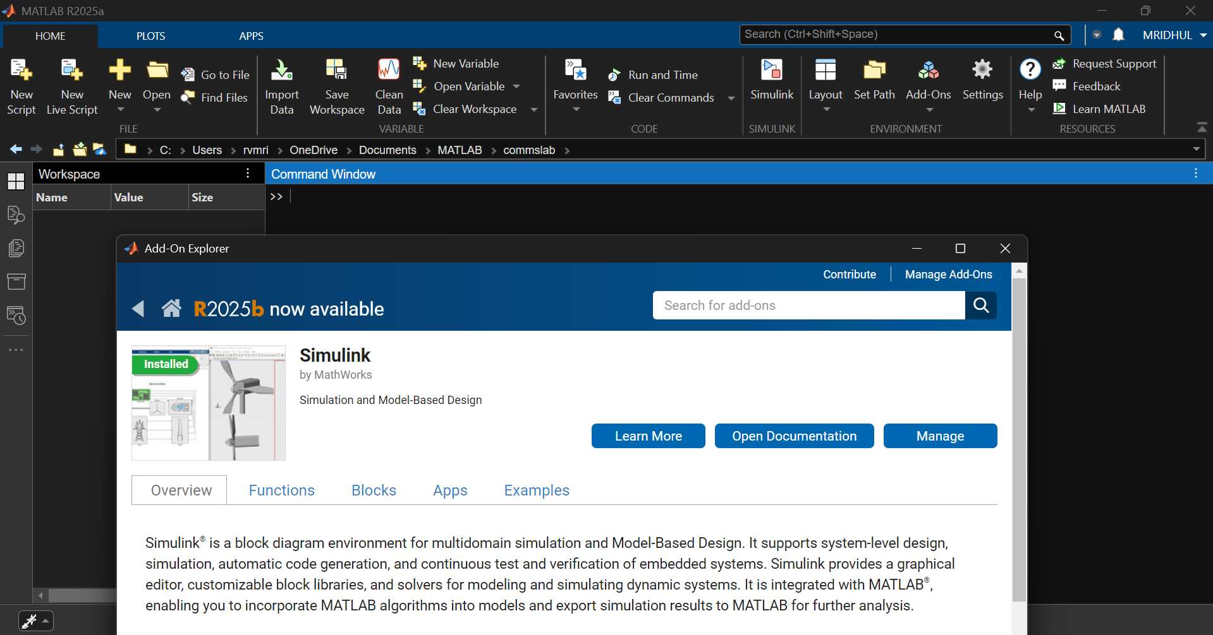
Step 3:Open Simulink
In the matlab cmd prompt type simulink.
Step 4: Open a new file and import the protected models.
Open Library browser->Simulink->Ports and Subsystems->Model
Drag and drop model to your workspace.
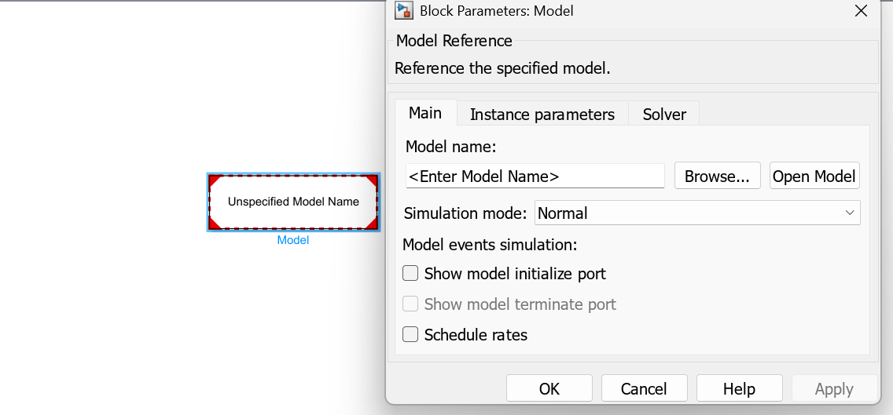
Double click on model block and a pop up window will show up, click on browse and select the .slxp file
Step5:Apply input and output
+Inputs are found in simulink->source
+Ouputs are found in Simulink->sinks (use scope block to view output.)

Note:
If you are unable to recreate the block that you found in Simulink , atleast put your findings in a word document with your methodology and submit it.

