Project 2
Infix Expression Parser

Team member:
Jason Murley

System design:
- Methods:
  - main method – has the Scanner for getting the user input and outputs the results to the console.
  - evaluateInfix method – takes the user input and puts it into two Stacks, one for the digits and one for the operators.
  - setPrecedenceMap method – sets keys and values in a TreeMap for operator precedence.
  - doCalculation method – Performs a calculation based on the operator and values passed into it.
- Data Structures:
  - TreeMap – used to store the operators as keys and the precedence as an integer
  - Stack – Two stacks are used, one stores the parsed digits and one stores the parsed operators.

UML Diagram:

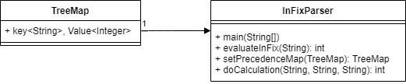
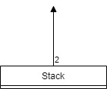

Test Cases:

- Test Case 1: 5*(4+3)+3^3/3-(2%2)
  - Expected Result: 44
  - Result: 44
- Test Case 2: 4+3 > 4 -1 && (3-1 < 3+3 || 2-1 > 4-1)
  - Expected Result: 1
  - Result: 1
- Test Case 3: 3/0
  - Expected Result: / by zero error
  - Result: / by zero error

Future Improvements:
Allow calculations of trigonometry and calculus equations.

