**Descriptive Wireframe Information**

Chosen Website

Java.com (from 2020, prior to their new website redesign)

Rationale

I think this website needs a redesign for a few different reasons. First off, this website had not been changed since at least 2015. secondly, something that really bothered me about this website was that the fact that the content was all condensed in the center of the website with very large margins. This always bugged me because I felt it was such a waste of space, and it just felt horribly outdated to me.

As for colour theory, the original website did have a concise colour palette, as well as the fact I didn't think it had many contrast issues, but I felt the overall structure of the website features should be updated as it had been many years since it had been updated; as well as the fact that html standards and css standards had changed since the original site had launched.

Item #1: Navigation

**Description:** Navigation should be pinned to the top of the page, and should include all the links mentioned in the wireframe.

Font: 12px Arial

**Color:** Background: Classic Java Red; Text: White

**Alignment:** Center

**Media:** N/A

**Interactivity:** Links in the navigation bar to appropriate areas.

Item #2: Header

**Description:** Header will include logo and Title

**Font:** 30px Arial

**Color:** Background: White with a black / gray shadow under box; Text: Black

**Alignment:** Box: Center Aligned; Text: Left Aligned

**Media:** N/A

**Interactivity:**

Item #3: Logo Box

**Description:** box to put the logo in inside the header box

**Font:** N/A (image)

**Color:** N/A (Image)

**Alignment:** Right Aligned

**Media:** Java logo

**Interactivity:** Clicking it on any page will redirect you to the homepage

Item #4: Background Box

**Description:** Can be styled to make it look a bit better; but primarily serves as a wrapper for the main text boxes.

**Font:** N/A

**Color:** White with black / gray shadow under box / OR Classic Java red with shadow

**Alignment:** Center

**Media:** N/A

**Interactivity:** N/A

Item #5: Text Box

**Description:** Box to contain the eye catching text, as well as a foundation for the primary download button.

**Font:** 20px Arial

**Color:** Text: Black; Background: clear so you can see the background color.

**Alignment:** Right Aligned

**Media:** N/A

**Interactivity:** N/A

Item #6: Download Button

**Description:** Primary button that links to the download link; so its easier for users to find the download link right when they get on the site.

**Font:** 14px Arial

**Color:** Background: Classic Java Red; Text: White OR Black

**Alignment:** Centered in the text box

**Media:** N/A

**Interactivity:** Redirects to download page

Item #7: Main Image

**Description:** This section was set up so you can include an eye catching image (that fits in the site contrast-wise!) to drag the site viewers' eyes towards the main download button.

**Font:** N/A

**Color:** N/A

**Alignment:** Center Aligned

**Media:** No picture decided, but a photo would be placed here.

**Interactivity:** N/A

Item #9: Box 1

**Description:** Vague description as I did not plan specific information for this box, but It can provide a space for either an image or text. I would probably put text myself.

**Font:** 12px Arial

**Color:** Background: Classic Java Red OR White with shadow; Text: Black

**Alignment:** Box: Right Aligned; Text: Center

**Media:** N/A

**Interactivity:** N/A

Item #9: Box 2

**Description:** Vague description as I did not plan specific information for this box, but It can provide a space for either an image or text. I would probably put text myself.

**Font:** 12px Arial

**Color:** Background: Classic Java Red OR White with shadow; Text: Black

**Alignment:** Box: Right Aligned; Text: Center

**Media:** N/A

**Interactivity:** N/A

Item #10: Footer

**Description:** Provides a few links as well as copyright information.

**Font:** 12px Arial

**Color:** Background: classic java red; Text: Black

**Alignment:** Center

**Media:** N/A

**Interactivity:** Occasional Link if needed.

**Reference Images**

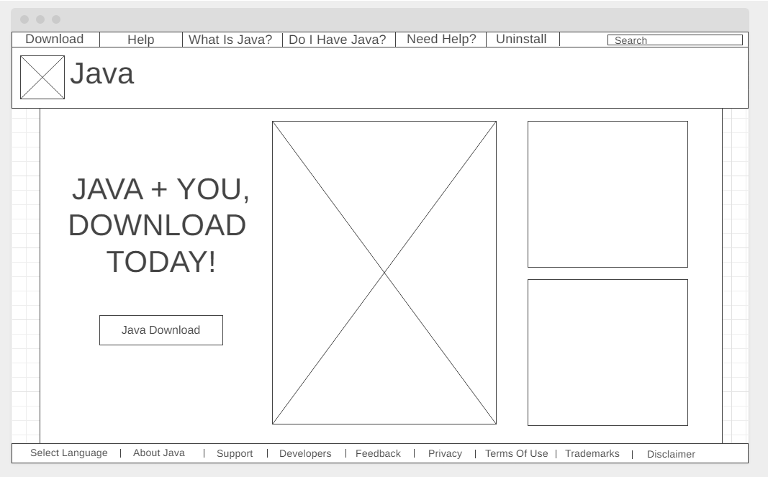

(Redesigned Wireframe)

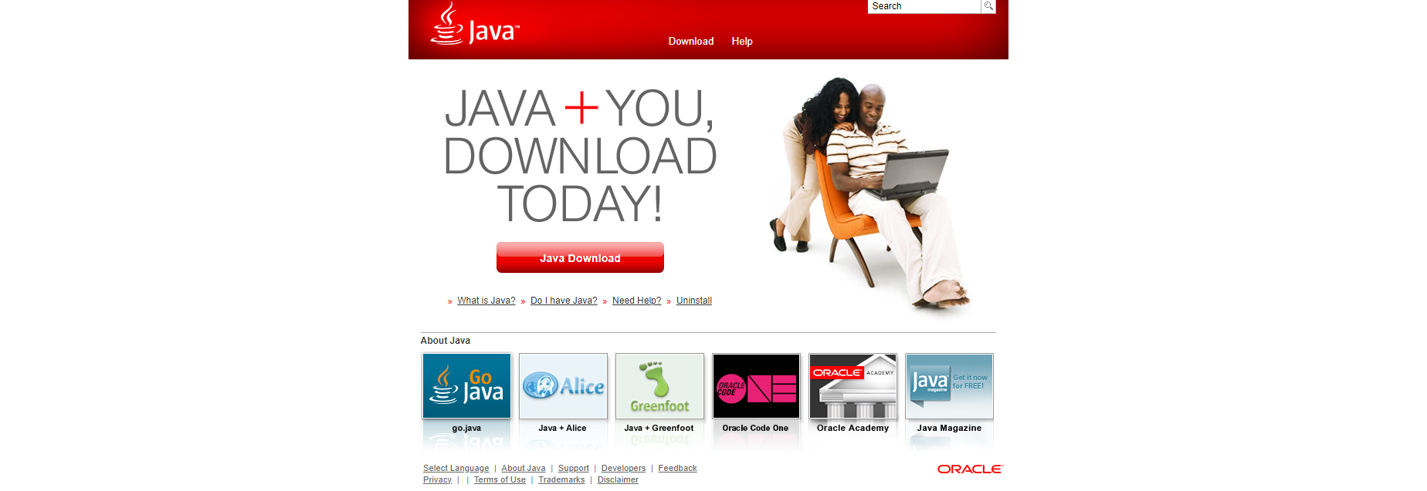

(Original 2020 Version of the Website)