**Chapter 10-6 Sample output**

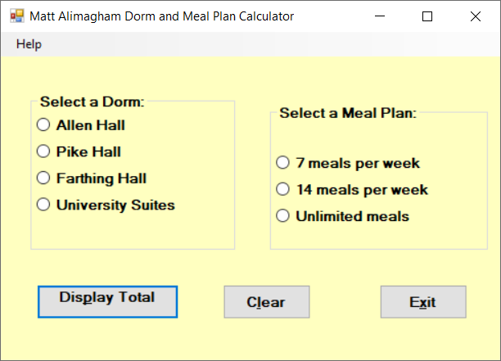

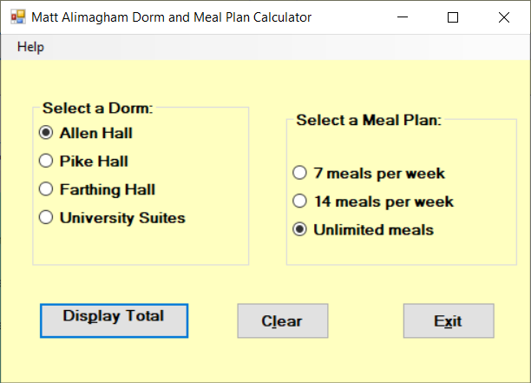

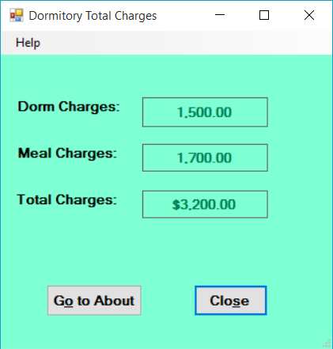

* **If no radio button was selected, popup an error message & Clear button should clear all.**
* **Do an about form of your choice and make sure you have an image related to your assignment. This about form should be linked to the button “Go to About” as well as to the Menu “Help, About”.**